**Number of pages in WG reports**

M.A. Pastoors

11/01/2019

Number of pages in WG reports of the following ICES working groups: HAWG, WGNSSK, AFWG, WGBFAS, WGCSE, WGSSDS, WGNSDS, WGWIDE, WGMHSA, WGHMM, WGBIE, WGDEEP, WGANSA, WGHANSA, WGEF, NWWG, WGNEW.

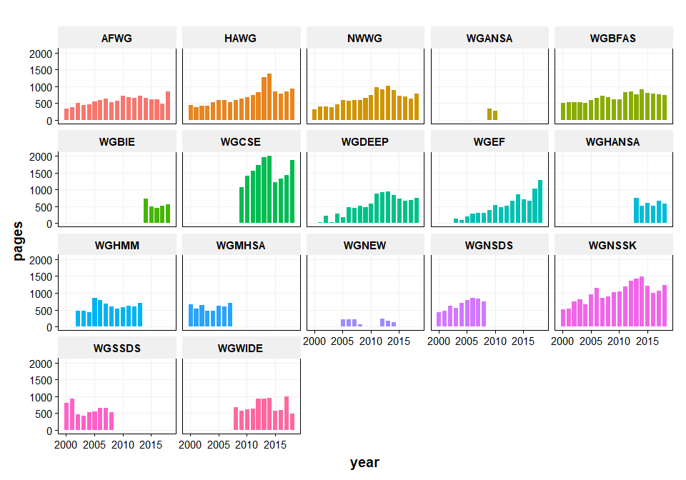

*Figure 1: Number of pages by WG*

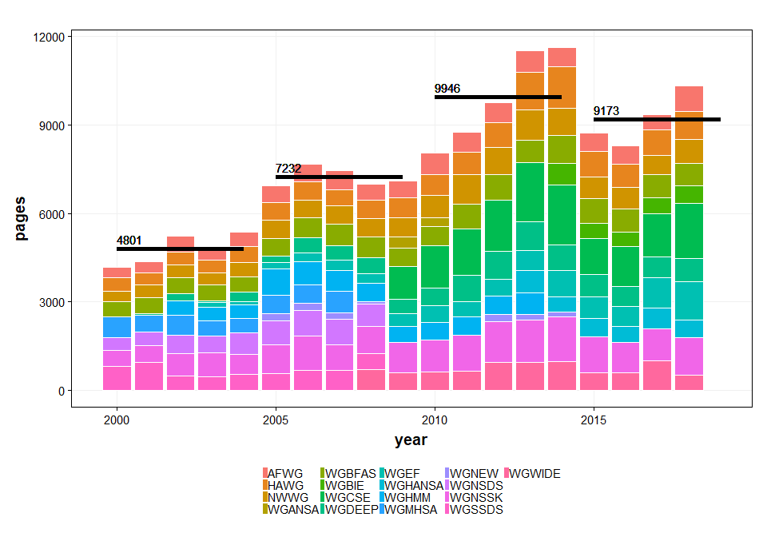

*Figure 2: Number of pages by year and averages by pentad*