# JFF rapportage voor NZO

28 mei 2025

*Overzicht van N2000/KRM gebieden in NL deel van Noordzee*

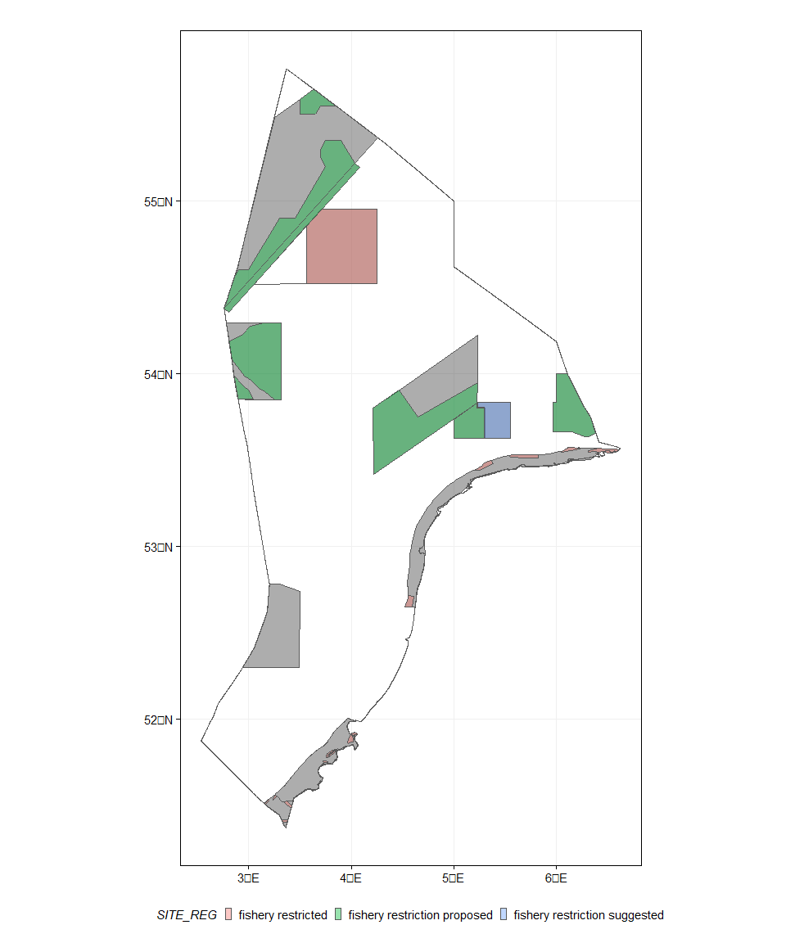

*Overzicht van diverse gebruik op de Noordzee*

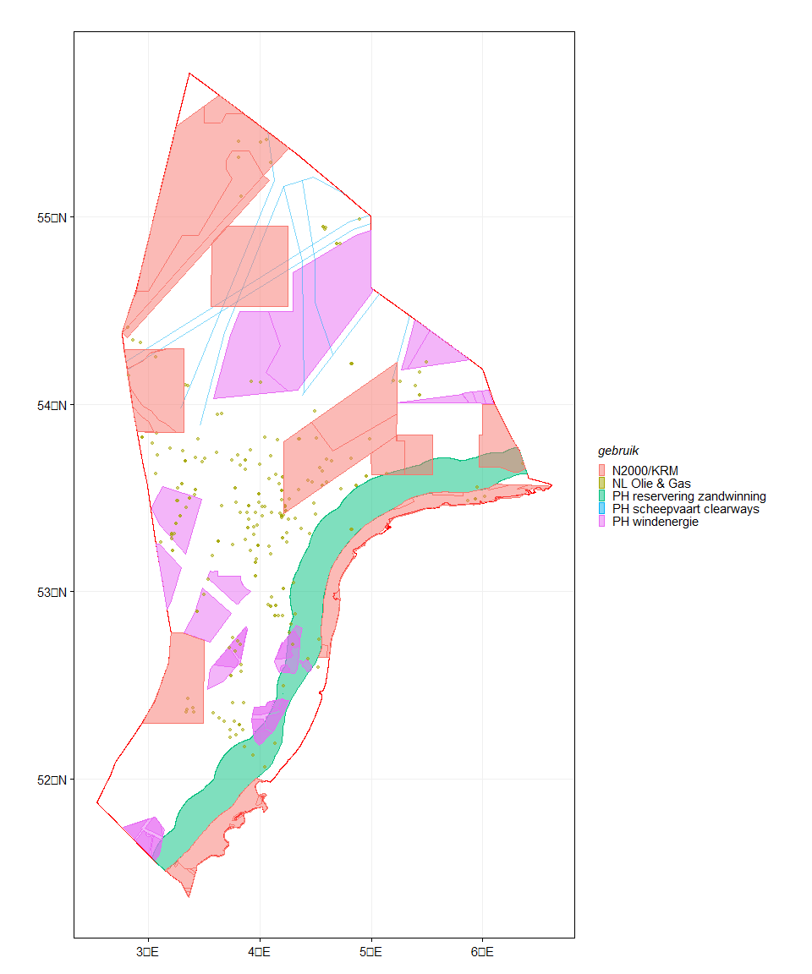

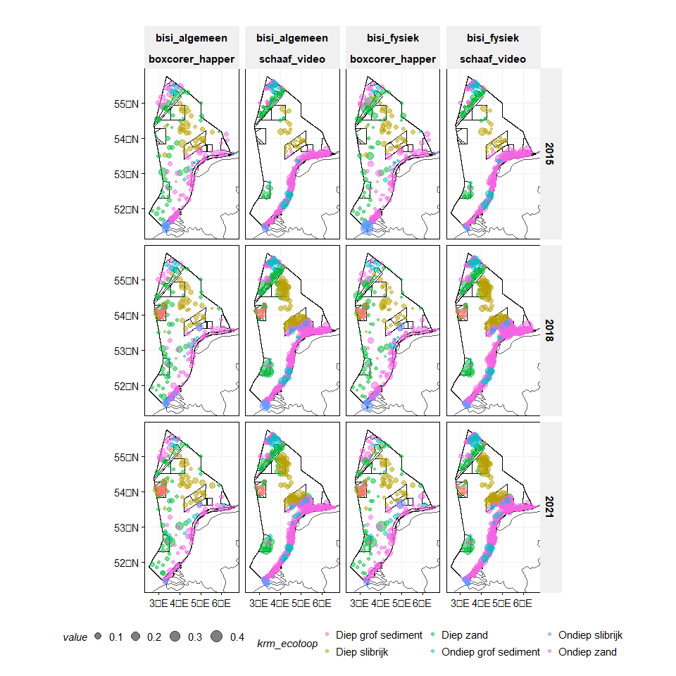

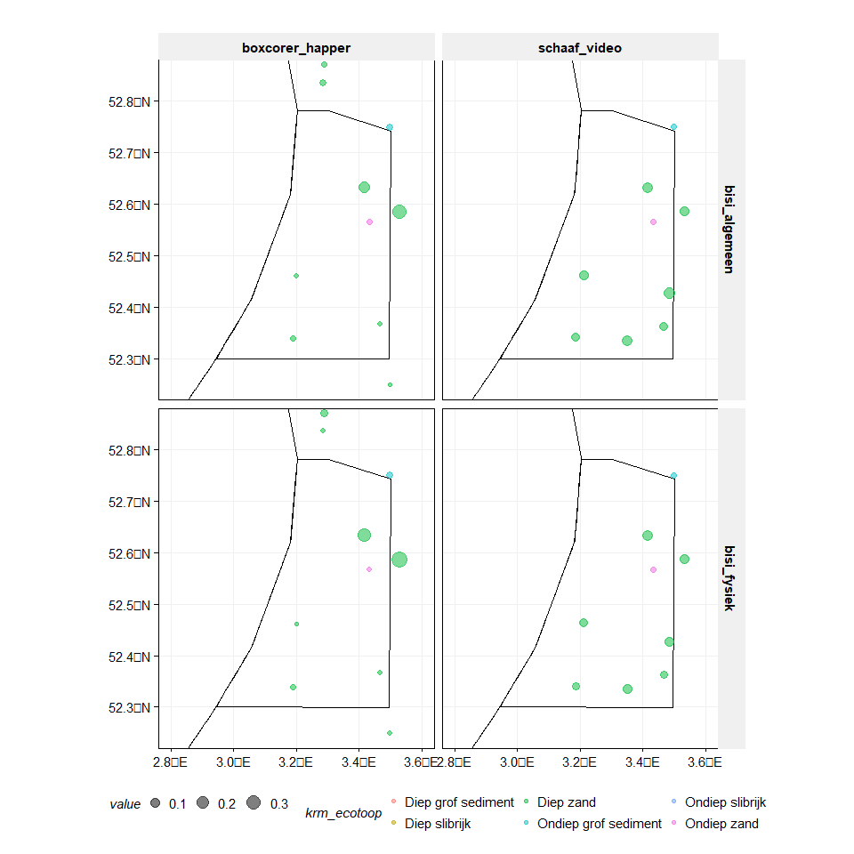

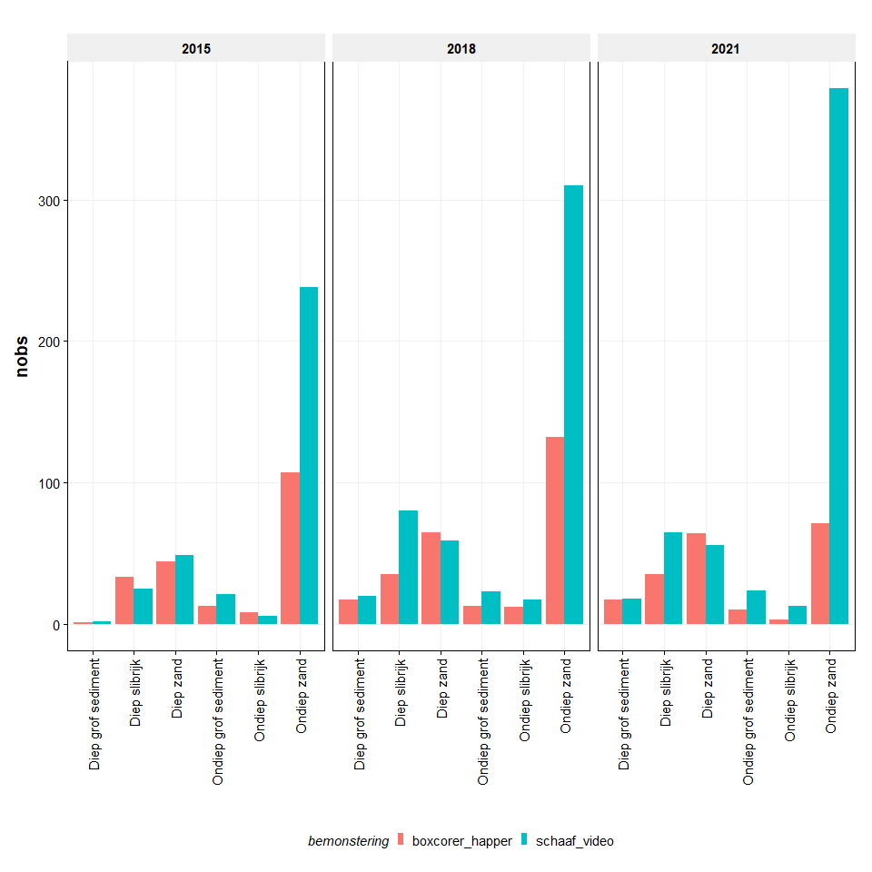

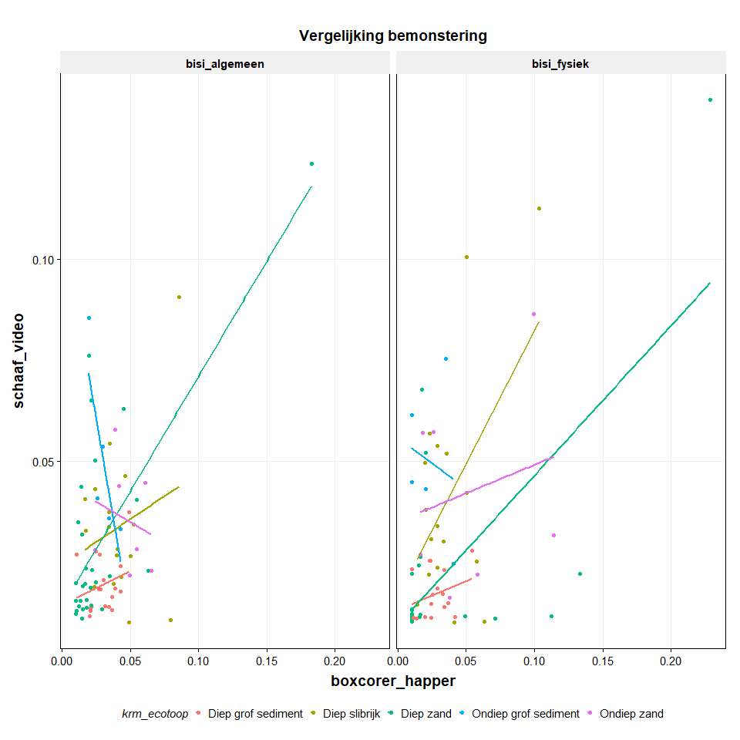

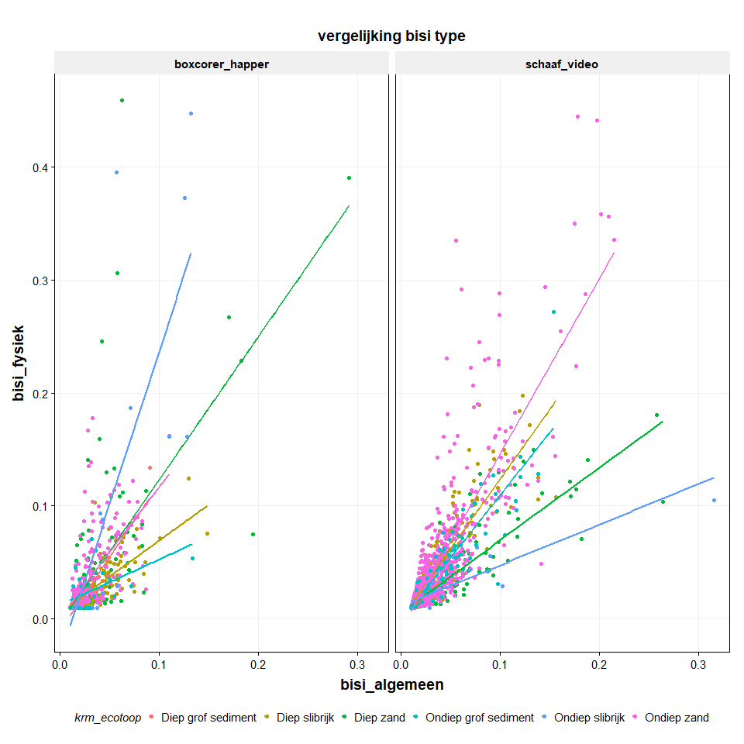

*WSER grid met dominante habitat types*

fill  
1 #A58AFF  
2 #53B400  
5 #00B6EB  
6 #C49A00  
19 #00C094  
40 #F8766D  
70 #FB61D7

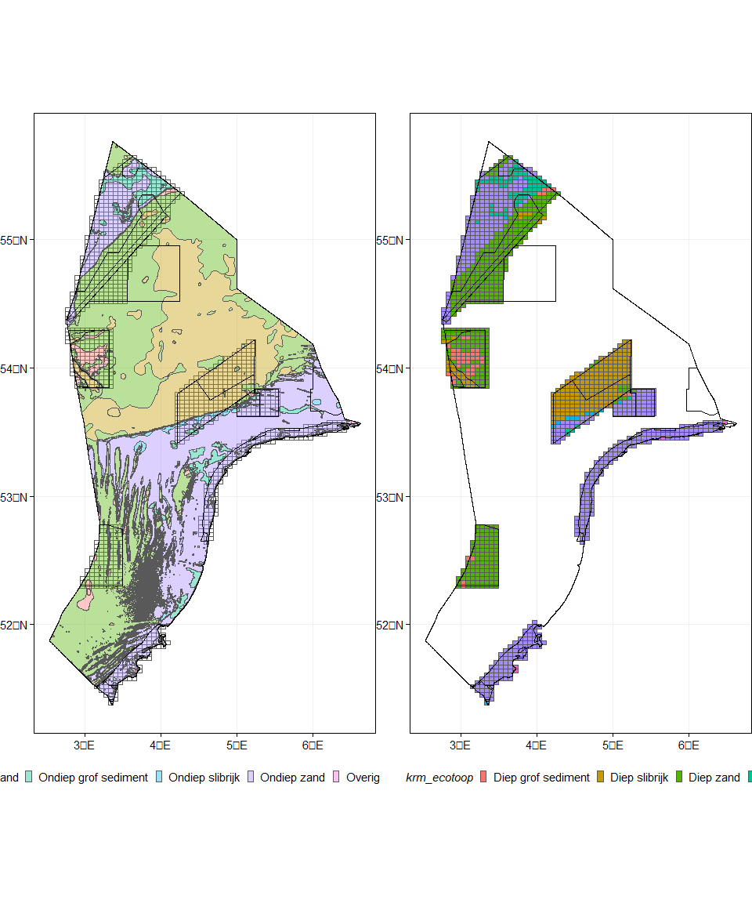

*Overzicht van gebieden, vakken en BISI waardes (2021, BISI algemeen)*

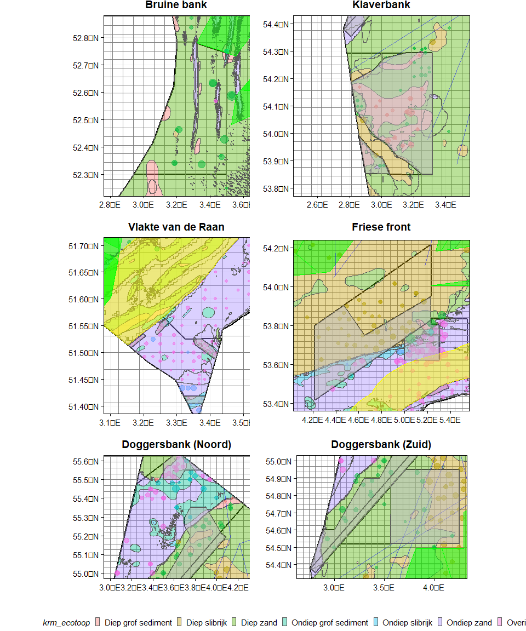

*Overzicht van visserijbeperkingen (geldend of reeds ingebracht) per habitattype*

| **SITE_REG** | **Diep grof sediment** | **Diep slibrijk** | **Diep zand** | **Ondiep grof sediment** | **Ondiep slibrijk** | **Ondiep zand** | **Overig** |
| --- | --- | --- | --- | --- | --- | --- | --- |
| **open** | **46.9%** | **84.2%** | **84.8%** | **89.8%** | **65.5%** | **91.7%** | **83.8%** |
| **visserij gesloten/in procedure** | **53.1%** | **15.8%** | **15.2%** | **10.2%** | **34.5%** | **8.3%** | **16.2%** |

| **gebied** | **Diep grof sediment** | **Diep slibrijk** | **Diep zand** | **Ondiep grof sediment** | **Ondiep slibrijk** | **Ondiep zand** | **Overig** | **(all)** |
| --- | --- | --- | --- | --- | --- | --- | --- | --- |
| **Borkumse Stenen** | **0** | **0** | **0** | **32** | **30** | **618** | **0** | **680** |
| **Bruine Bank** | **59** | **4** | **1,228** | **2** | **0** | **71** | **0** | **1,364** |
| **Centrale Oestergronden** | **0** | **881** | **1,181** | **0** | **0** | **0** | **0** | **2,062** |
| **Doggersbank** | **60** | **70** | **1,691** | **809** | **21** | **2,088** | **0** | **4,739** |
| **Friese Front** | **26** | **2,386** | **146** | **53** | **148** | **485** | **0** | **3,244** |
| **Klaverbank** | **494** | **199** | **840** | **0** | **0** | **3** | **0** | **1,536** |
| **Noordzeekustzone** | **0** | **0** | **1** | **17** | **0** | **1,327** | **17** | **1,362** |
| **Vlakte van de Raan** | **0** | **0** | **0** | **7** | **11** | **155** | **0** | **173** |
| **Voordelta** | **0** | **0** | **5** | **7** | **10** | **757** | **18** | **797** |
| **Zuidelijke Doggersbank** | **0** | **2** | **490** | **0** | **0** | **39** | **0** | **531** |
| **ZZZ_EEZ** | **340** | **10,175** | **17,343** | **1,066** | **317** | **12,860** | **40** | **42,141** |
| **(all)** | **979** | **13,717** | **22,925** | **1,993** | **537** | **18,403** | **75** | **58,629** |

*Oppervlak op het Friese Front*

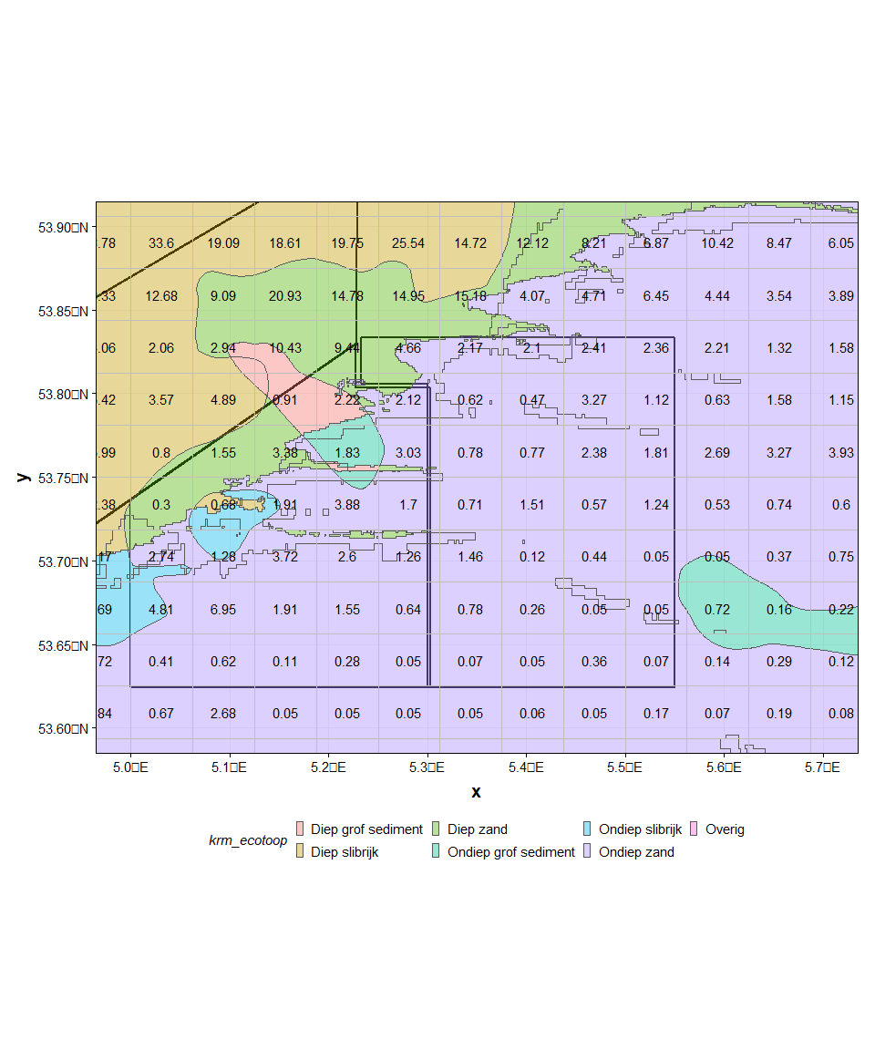

*Overzicht BISI waardes (2021, BISI algemeen, schaaf/video)*

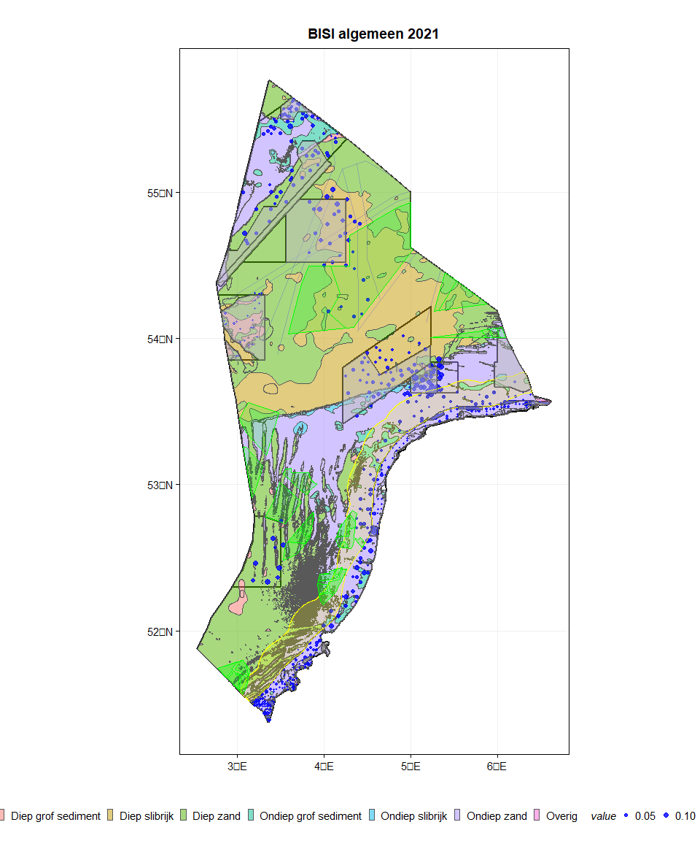

*Overzicht van gebieden en BISI waardes (2021, BISI algemeen, schaaf/video)*

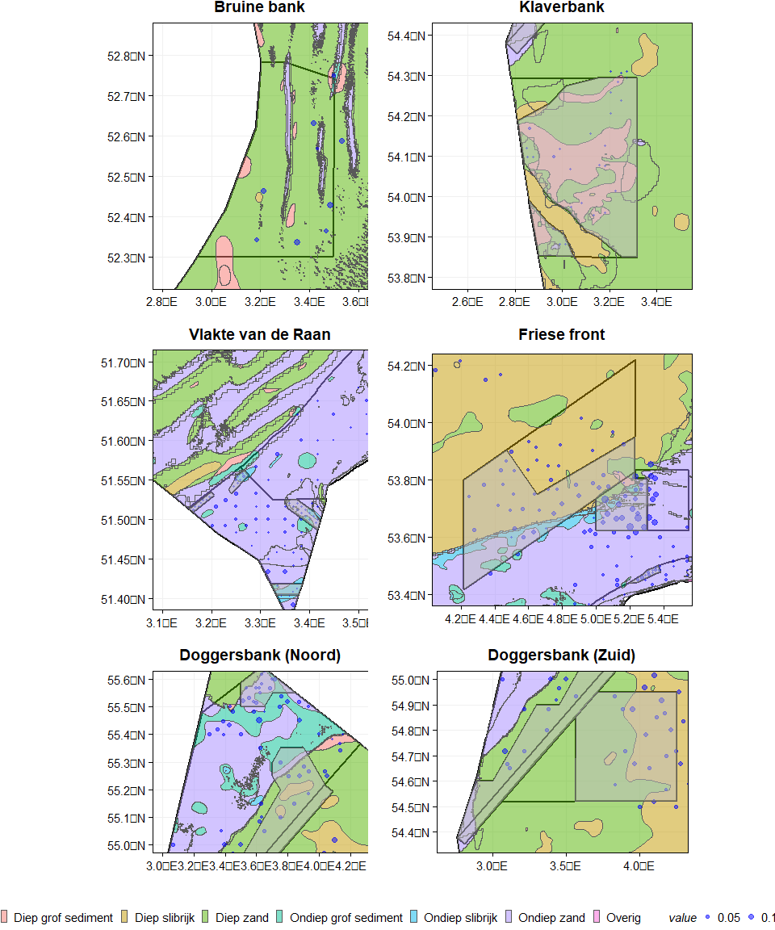

*Overzicht van gebieden, vakken en BISI waardes (2021, BISI algemeen)*

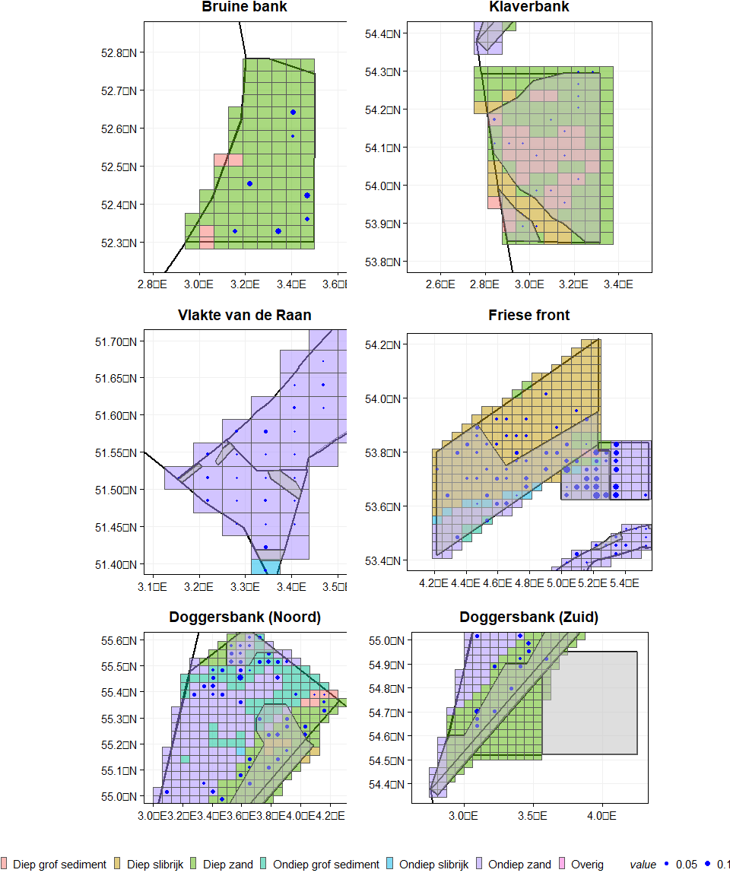

*Overzicht van Sabellaria aantallen in gebieden (2021)*

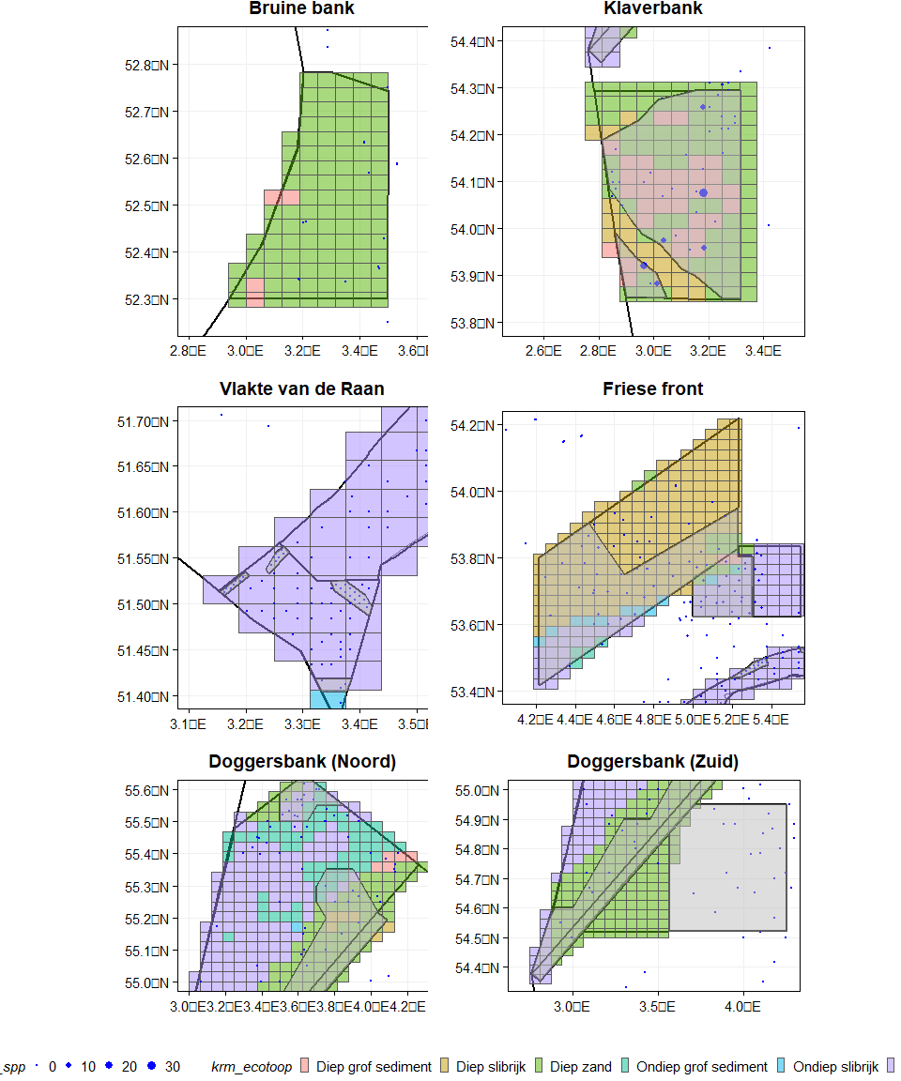

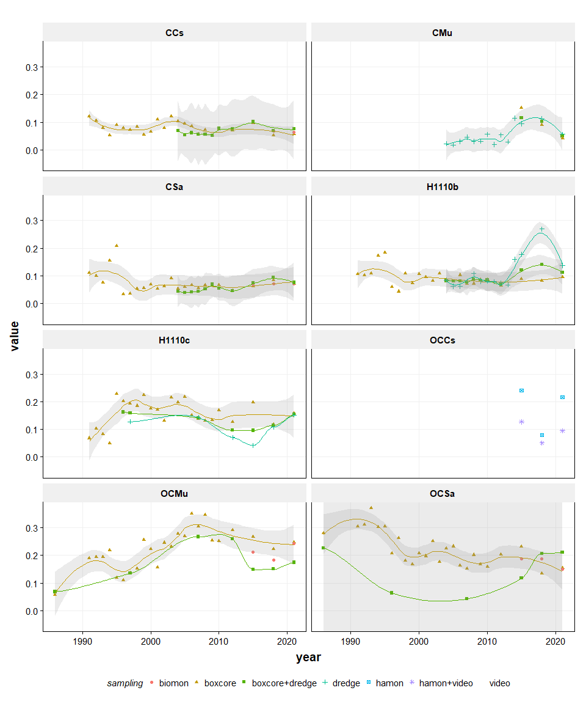

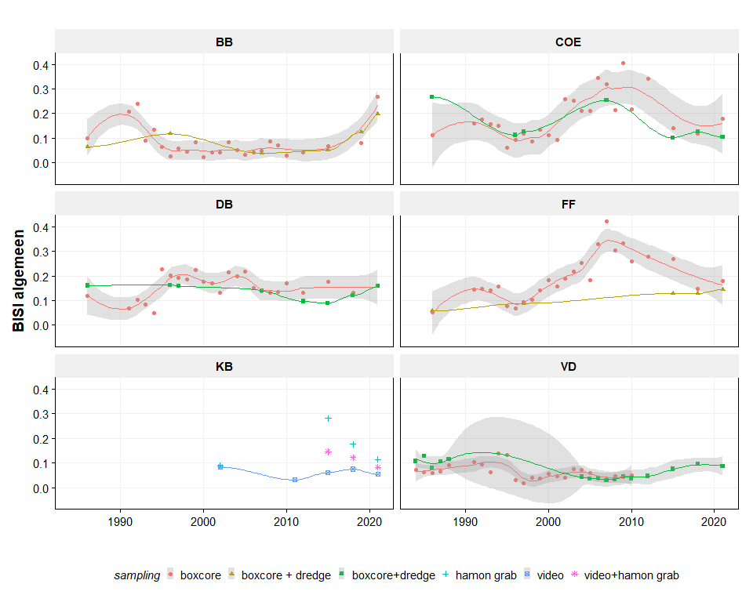

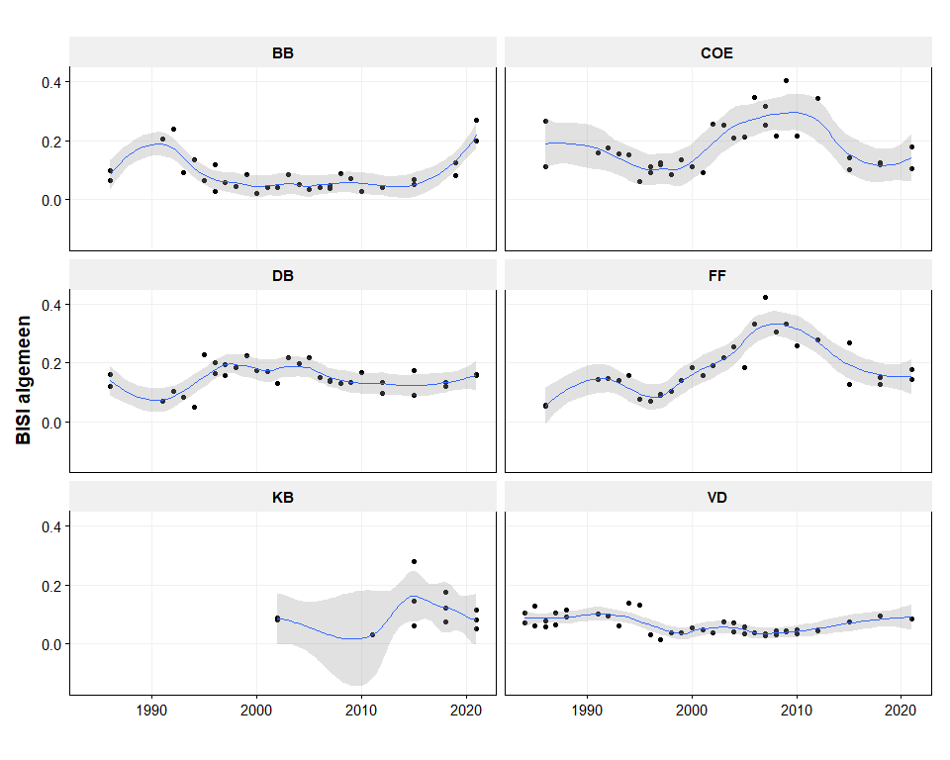

*BISI en Sabellaria riffen op de Bruine Bank*

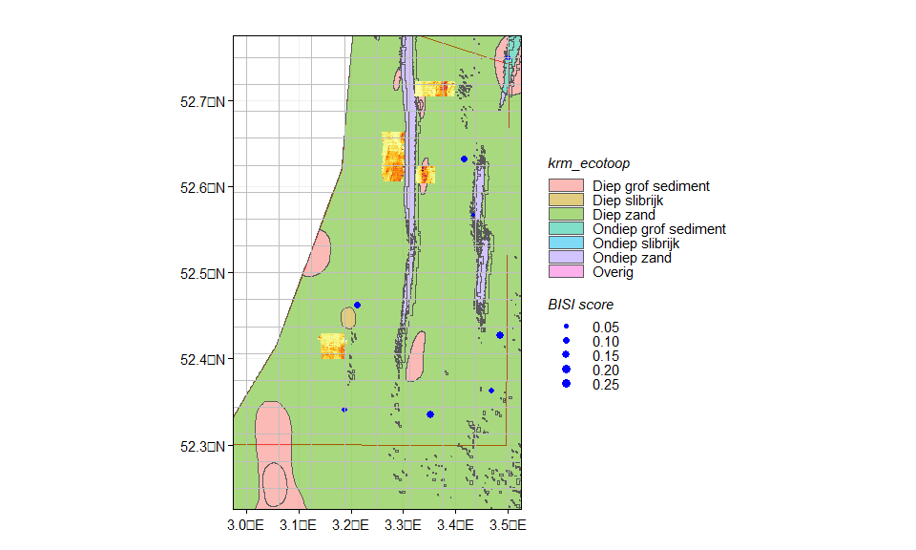

*scenario maps*

[1] "01 verdeling habitats v1.2.xlsx"  
[1] "05 BB noord v1.2.xlsx"  
[1] "06 FF DB v1.2.xlsx"

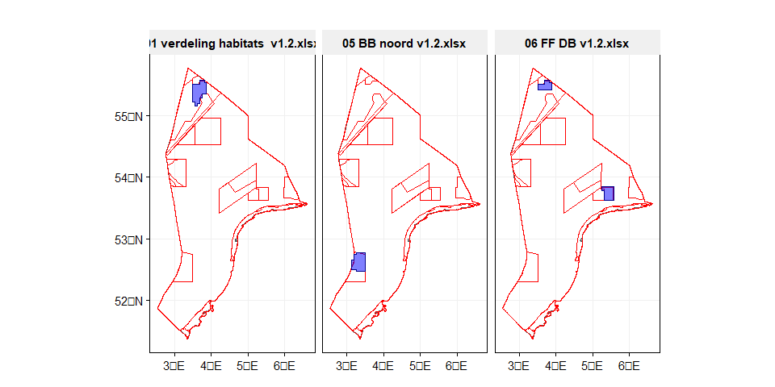

*scenario results*

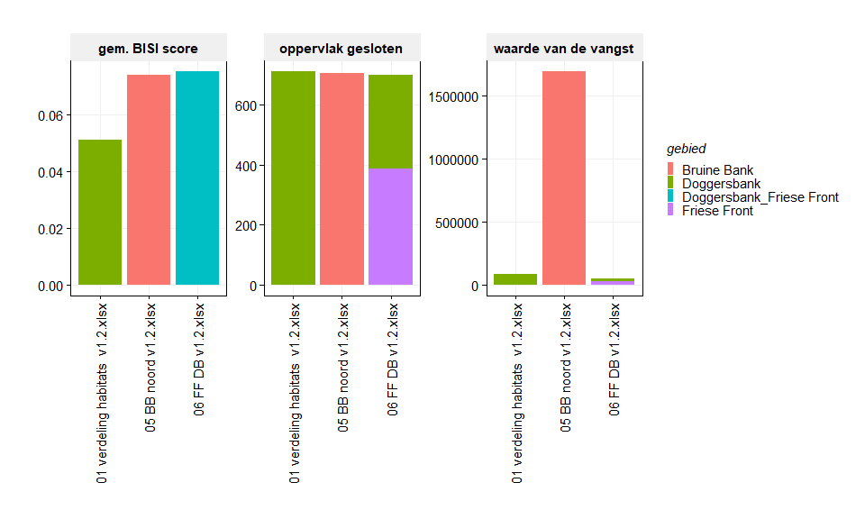

*scenario results (2)*

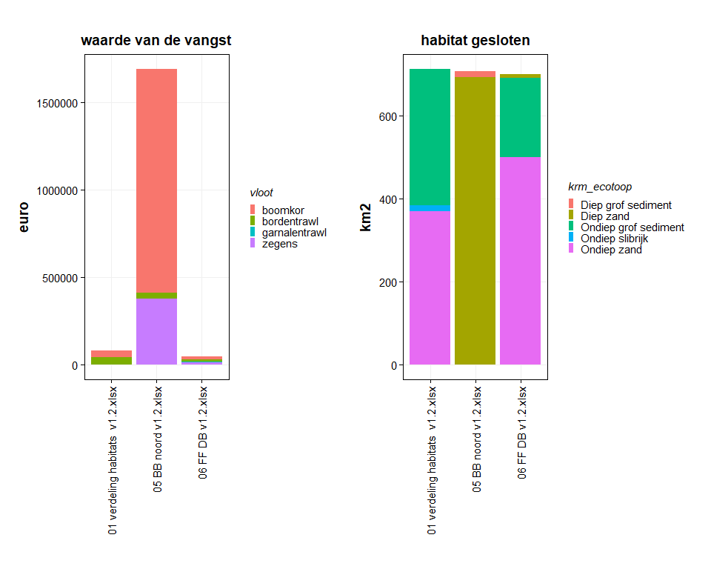

*scenario results (3)*

