

10/08/2018

**6th Meeting of the Scientific Committee**

Puerto Varas, Chili 9 - 14 September 2018

**SC6-JM07**

Standardized Jack mackerel CPUE for the offshore fleet

M.A. Pastoors1 & N.T. Hintzen (European Union)

**Abstract**

The nominal CPUE of the offshore fleet (EU, Russia, Korea and Vanuaru) fishing for Jack mackerel has previously been used as a nominal tuning index for the assessment of Jack mackerel. The index consisted of the nominal average catch per fishing day for the fleets of EU, Vanuatu and Korea. During the 2018 Jack mackerel benchmark workshop, a working document was presented describing the methods for a combined standardized CPUE of the four fleets mentioned above (SCW6-Doc5). The current working document is an extension of that work, which now includes the data for 2017. The CPUE standardization is based on a GAM model that takes into account a number of linear factors (year, vessel, month, SST) and a smoothed interaction factor between latitude and longitude. While the full exploration of different model configurations has been included in the working document to the benchmark workshop, here only the agreed model configuration has been included in the analysis.

1 [mpastoors@pelagicfish.eu](mailto:mpastoors@pelagicfish.eu)

# Introduction

The assessment of Jack Mackerel in the southern Pacific is based on many different sources of information, including the nominal Catch per Unit Effort (expressed as catch per day) of the EU fleet. The use of nominal CPUE for calibrating stock assessments is known to be potentially problematic and therefore SPRFMO (2011) recommended that to serve as indices of abundance, the CPUE should be standardized to take into account factors such as historical changes in vessels, fishing areas, seasonal fishing patterns and environmental factors. This standardization approach has already been applied by China (Li et al, 2013).

In this document, the catch and effort data for the offshore fleet (Eu, Korea, Russia, Vanuatu) is analysed with the aim to develop a standardized CPUE series. Data has been obtained from the SPRFMO secretariat after permission was granted by the different contracting parties that the data could be used for this CPUE analysis. Further details on the selection of the final model can be found in the working document to the benchmark meeting (SCW06-Doc05)

# Material and methods

Data from Korea, Russia and Vanuatu was made available by Craig Loveridge on 11 October 2017. Data for EU fisheries was already available as part of the SPRFMO database but also with the underlying spreadsheets that we used to submit the data to SPRFMO. Two vessels were removed from the dataset because of apparent problems with the units used for catch reporting.

**Number of vessels participating in the fishery**

year EU KOR RUS VUT (all)  
------- ---- ----- ----- ----- -------  
 2006 1 0 0 0 1  
 2007 6 2 0 0 8  
 2008 6 2 1 4 13  
 2009 7 2 4 4 17  
 2010 5 2 0 4 11  
 2011 2 2 2 2 8  
 2012 0 2 0 2 4  
 2013 1 1 0 2 4  
 2014 2 1 0 2 5  
 2015 2 2 1 2 7  
 2016 2 2 0 1 5  
 2017 2 1 1 0 4  
 2018* 1 0 0 0 1

*Table 1: Number of vessels participating in the Jack mackerel fishery*

'*' Year 2018 is imcomplete in this table and all subsequent tables.

**Summed haul durations in hours**

year EU KOR RUS VUT (all)  
------- ------- ------- ------- ------- --------  
 2006 1,131 0 0 0 1,131  
 2007 836 1,817 0 0 2,653  
 2008 3,529 1,559 553 8,935 14,576  
 2009 6,087 1,301 1,115 7,512 16,015  
 2010 3,219 1,381 0 6,357 10,957  
 2011 341 2,385 1,770 2,041 6,537  
 2012 0 920 0 4,253 5,173  
 2013 1,455 919 0 2,815 5,189  
 2014 2,453 649 0 2,809 5,911  
 2015 2,122 910 478 2,631 6,141  
 2016 1,333 1,775 0 1,118 4,226  
 2017 2,705 224 483 0 3,412  
 2018* 1,665 0 0 0 1,665

*Table 2: Summed haul duration (hours)*

**Number of fishing days**

year EU KOR RUS VUT (all)  
------- ----- ----- ----- ----- -------  
 2006 110 0 0 0 110  
 2007 164 145 0 0 309  
 2008 156 166 62 233 617  
 2009 160 159 83 174 576  
 2010 104 125 0 144 373  
 2011 20 155 121 100 396  
 2012 0 116 0 182 298  
 2013 137 89 0 164 390  
 2014 148 77 0 153 378  
 2015 115 95 38 122 370  
 2016 91 174 0 85 350  
 2017 196 34 51 0 281  
 2018* 129 0 0 0 129

*Table 3: Number of fishing days*

Fishing days has been defined as days when a haul has been reported. Unfortunately, it is not possible to distinguish between days searching, days steaming and days transshipping based on the data available.

**Number of hauls**

year EU KOR RUS VUT (all)  
------- ----- ----- ----- ------- -------  
 2006 240 0 0 0 240  
 2007 643 352 0 0 995  
 2008 703 398 94 1,731 2,926  
 2009 924 291 184 1,356 2,755  
 2010 490 261 0 886 1,637  
 2011 47 432 208 273 960  
 2012 0 160 0 562 722  
 2013 198 128 0 358 684  
 2014 385 125 0 392 902  
 2015 388 198 82 435 1,103  
 2016 206 325 0 180 711  
 2017 536 58 88 0 682  
 2018* 236 0 0 0 236

*Table 4: Number of hauls*

**Length of the fishing season**

year EU KOR RUS VUT (all)  
------- ----- ----- ----- ----- -------  
 2006 240 0 0 0 240  
 2007 194 162 0 0 356  
 2008 172 188 89 245 694  
 2009 168 195 120 198 681  
 2010 122 208 0 171 501  
 2011 41 197 175 149 562  
 2012 0 167 0 263 430  
 2013 233 139 0 202 574  
 2014 170 93 0 201 464  
 2015 148 120 52 159 479  
 2016 136 188 0 167 491  
 2017 277 88 75 0 440  
 2018* 181 0 0 0 181

*Table 5: Length of the fishing season (days)*

The length of the fishing season is defined as the number of days between the first haul and the last haul in a year.

##### page break

**Total annual catch (tonnes) by species**

vesselcp year BRU CJM MAC MAS UBA (all)  
---------- ------- ------- --------- ------- -------- ----- ---------  
 EU 2006 0 25,486 0 1,123 0 26,609  
 EU 2007 0 88,253 0 3,157 0 91,410  
 EU 2008 0 72,572 0 2,288 0 74,860  
 EU 2009 407 91,926 0 4,134 0 96,467  
 EU 2010 108 31,207 0 266 0 31,581  
 EU 2011 14 1,184 0 0 0 1,198  
 EU 2013 63 10,011 0 226 0 10,300  
 EU 2014 65 20,509 0 742 88 21,404  
 EU 2015 152 28,006 0 893 52 29,103  
 EU 2016 40 11,469 0 791 176 12,476  
 EU 2017 74 23,590 0 1,447 73 25,184  
 EU 2018* 289 9,619 0 117 207 10,232  
 EU (all) 1,212 413,832 0 15,184 596 430,824  
 KOR 2007 0 10,523 0 1,199 0 11,722  
 KOR 2008 0 12,377 0 961 0 13,338  
 KOR 2009 0 13,759 0 715 0 14,474  
 KOR 2010 0 8,182 0 84 0 8,266  
 KOR 2011 0 9,253 0 24 0 9,277  
 KOR 2012 0 5,491 0 0 0 5,491  
 KOR 2013 0 5,266 0 110 0 5,376  
 KOR 2014 0 4,077 0 21 0 4,098  
 KOR 2015 0 5,748 0 79 0 5,827  
 KOR 2016 0 6,429 77 408 0 6,914  
 KOR 2017 0 1,235 0 190 0 1,425  
 KOR (all) 0 82,340 77 3,791 0 86,208  
 RUS 2008 0 4,799 0 386 0 5,185  
 RUS 2009 0 8,503 0 534 0 9,037  
 RUS 2011 0 8,228 0 12 0 8,240  
 RUS 2015 0 2,523 0 573 11 3,107  
 RUS 2017 1 3,188 0 37 0 3,226  
 RUS (all) 1 27,241 0 1,542 11 28,795  
 VUT 2008 0 101,955 0 8,458 0 110,413  
 VUT 2009 0 80,165 0 4,667 0 84,832  
 VUT 2010 0 45,934 0 639 0 46,573  
 VUT 2011 0 7,627 0 0 0 7,627  
 VUT 2012 0 16,462 0 0 0 16,462  
 VUT 2013 0 15,525 0 0 0 15,525  
 VUT 2014 0 15,473 0 0 0 15,473  
 VUT 2015 0 21,224 607 0 0 21,831  
 VUT 2016 0 7,385 553 0 0 7,938  
 VUT (all) 0 311,750 1,160 13,764 0 326,674

*Table 6: Total estimated catch by species*

The total catch by species is derived from the estimated catch in the haul by haul data from the contracting parties. Table 6 only includes species where the cumulated catch over all fleets and years is more than ton).

According to SC01-14 (European Union 2013 Annual Report) there is a difference between the haul-by-haul estimated catch by the skipper and the overall catch reported to SPRFMO for the earlier years of the time series. No attempt has been made to change the haul-by-haul data and therefore the overall quantities cannot be directly compared with the total catch in the SPRFMO catch series.

**Total catch of jack mackerel**

year EU KOR RUS VUT (all)  
------- -------- -------- ------- --------- ---------  
 2006 25,486 0 0 0 25,486  
 2007 88,253 10,524 0 0 98,777  
 2008 72,573 12,377 4,800 101,955 191,705  
 2009 91,927 13,759 8,504 80,166 194,355  
 2010 31,207 8,183 0 45,934 85,324  
 2011 1,185 9,253 8,229 7,628 26,294  
 2012 0 5,492 0 16,463 21,954  
 2013 10,012 5,267 0 15,526 30,804  
 2014 20,510 4,078 0 15,473 40,061  
 2015 28,007 5,749 2,524 21,224 57,503  
 2016 11,470 6,430 0 7,385 25,284  
 2017 23,591 1,235 3,188 0 28,014  
 2018* 9,620 0 0 0 9,620

*Table 7: Total estimated catch of Jack mackerel*

**Mean catch per week of jack mackerel**

year EU KOR RUS VUT (all)  
------- ------- ----- ----- ----- -------  
 2006 1,062 . . . 1,062  
 2007 1,025 263 . . 644  
 2008 789 269 282 658 500  
 2009 686 362 274 612 484  
 2010 452 282 . 429 388  
 2011 148 193 150 173 166  
 2012 . 203 . 206 205  
 2013 313 239 . 310 288  
 2014 410 314 . 303 342  
 2015 718 303 281 424 431  
 2016 358 189 . 352 300  
 2017* 429 112 228 . 256

*Table 8: Mean catch per week of Jack Mackerel*

Mean catch per week is the metric that is being used as an indicator of abundance.

**Mean number of days fished per week**

year EU KOR RUS VUT (all)  
------ ----- ----- ----- ----- -------  
 2006 4.6 . . . 4.6  
 2007 4.5 5.1 . . 4.8  
 2008 4.5 4.9 3.6 4.5 4.4  
 2009 4.2 4.5 3.6 4.5 4.2  
 2010 4 4.2 . 4.1 4.1  
 2011 4 4.1 3.3 3.8 3.8  
 2012 . 4.2 . 4 4.1  
 2013 4.1 4 . 4.4 4.2  
 2014 4.6 5.3 . 4.5 4.8  
 2015 4.5 5.1 4.1 4.3 4.5  
 2016 3.6 5 . 4 4.2  
 2017 4.1 3 3.6 . 3.6

*Table 10:*

##### page break

**Spatial distribution of the fishery by year**

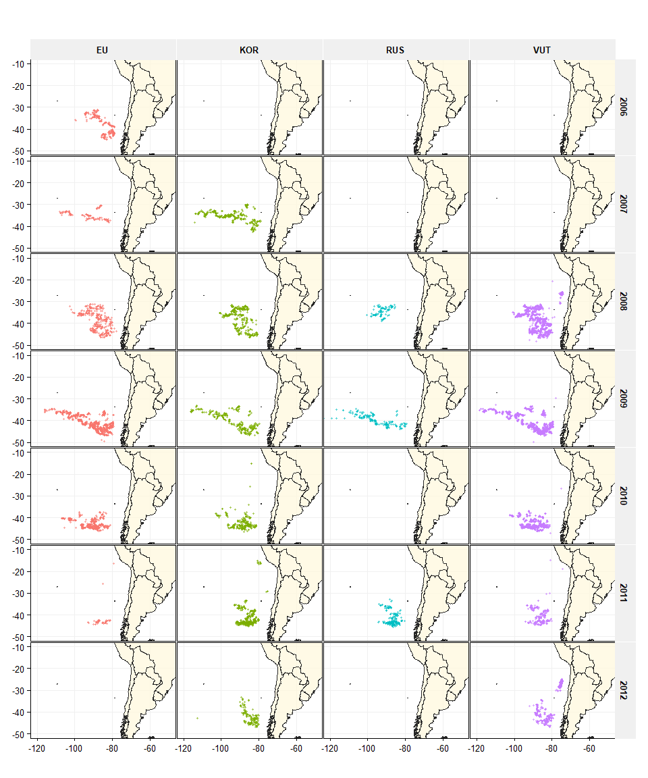

*Figure 1: Jack mackerel Haul positions per year for EU, Korea, Russia and Vanuatu. - continued on next page*

##### page break

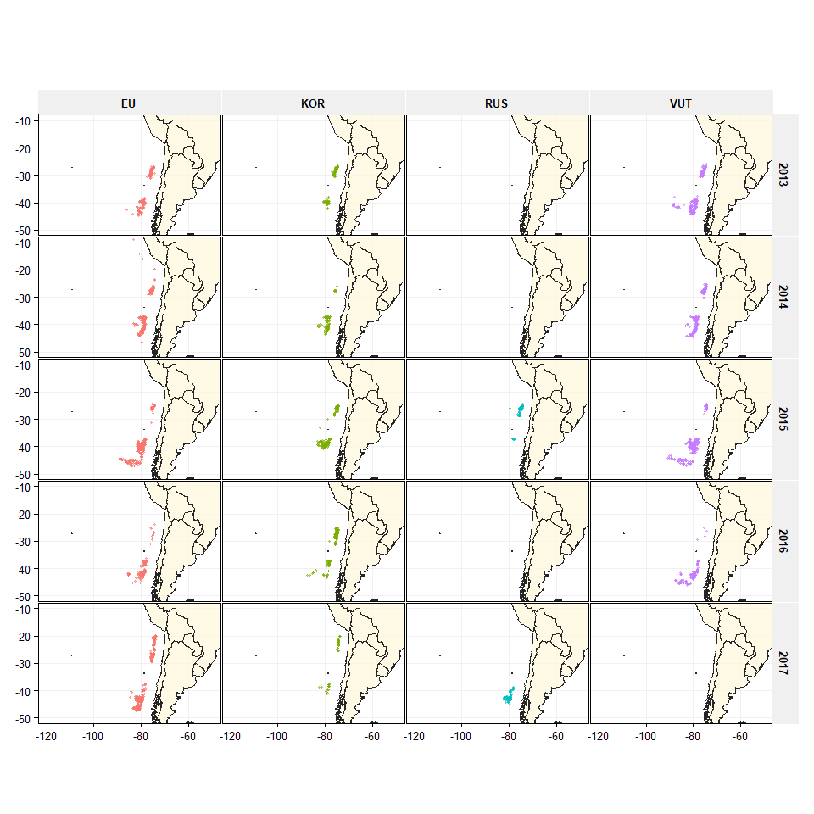

*Figure 1: Jack mackerel Haul positions per year for EU, Korea, Russia and Vanuatu. - continued from previous page*

##### page break

**Mean catch per week of jack mackerel per rectangle**

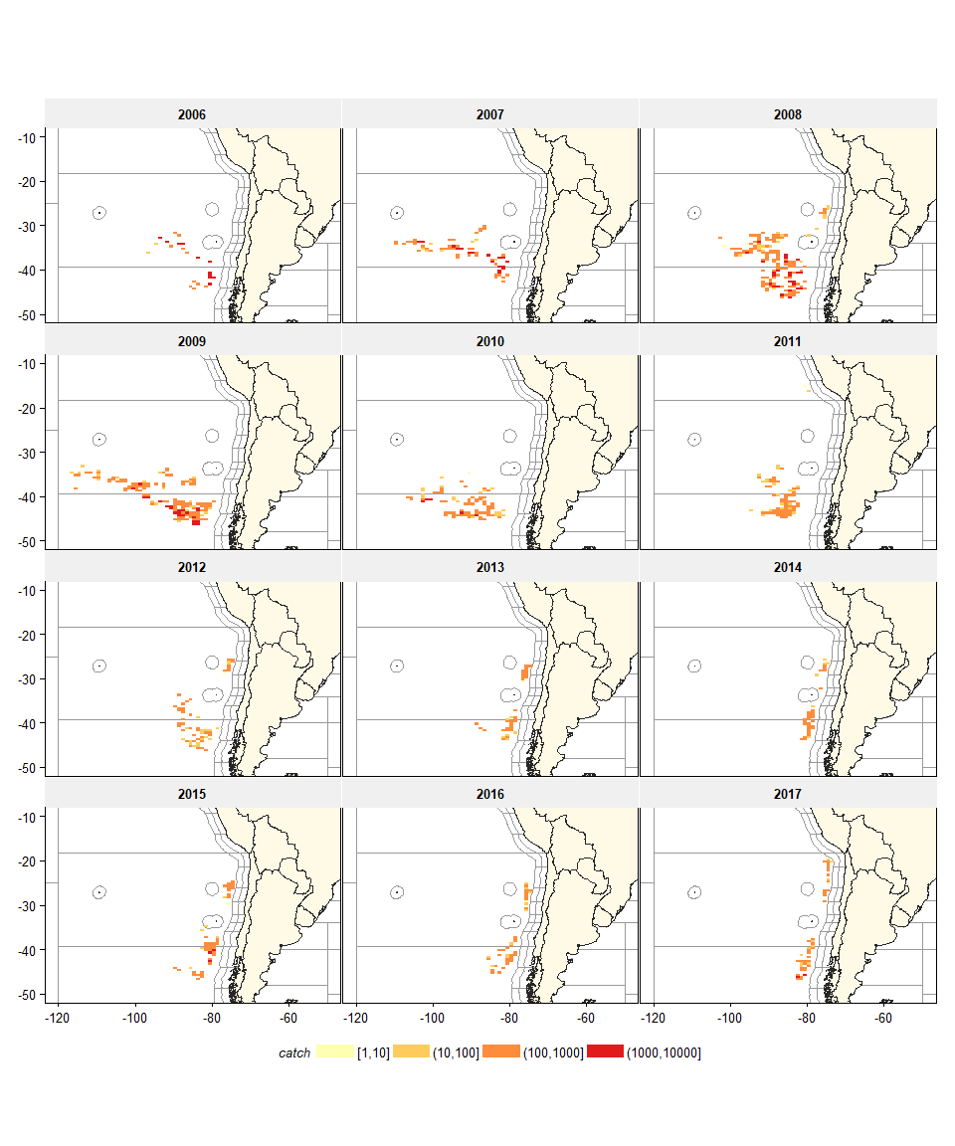

*Figure 3:*

##### page break

**El Nino effect and Humbold_current index**

It has been hypothesized that the catch rate of jack mackerel by area and season could be dependent on the climatic situation, characterized by El Nino events (NOAA, <https://www.esrl.noaa.gov/psd/data/correlation/oni.data>) or the Humboldt Current Index (<http://www.bluewater.cl/HCI/>). In the final model selected during SCW06, only the temperature anomaly has been included in the analysis.

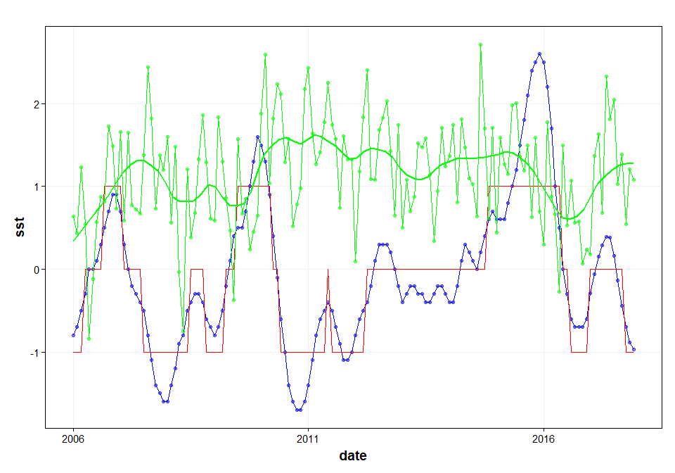

*Figure 4: El Nino temperature anomaly (blue line) and estimated ELE indicator (red line). Humboldt Current Index (green line).*

# Results

The general modelling approach has been to use GAM models to assess the dependency on the weekly catch of jack mackerel on different variables. The final model consists of catch (per week) as the main variable, the year effect (as factor) as the main explanatory variable and the log of effort (number of fishing days per week) as the offset (the log is taken because of the log-link function). The linear explanatory variables are vessel, month and sea surface temperature anomaly. The GAM smoothing function is applied to latitude in combination with longitude.

*Catch ~ offset(log(effort)) + year + vessel + month + sst + s(lat-lon)*

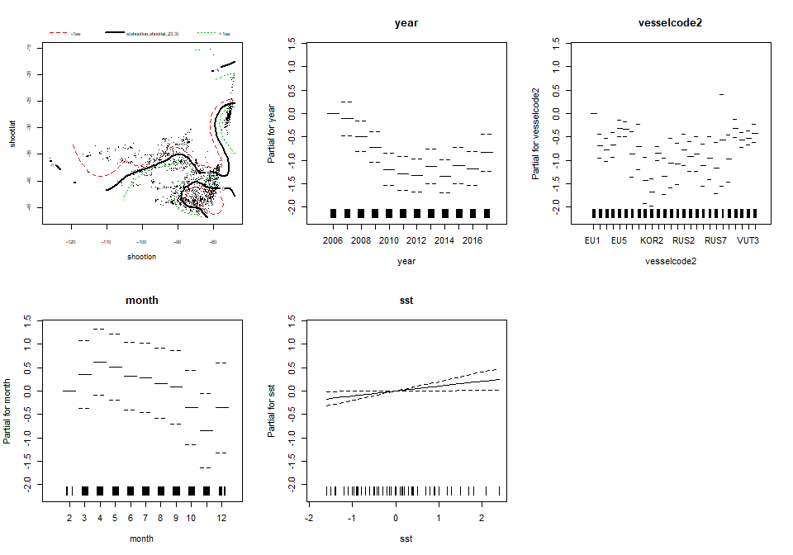

*Figure 5: Final GAM model: Estimates of the different effects*

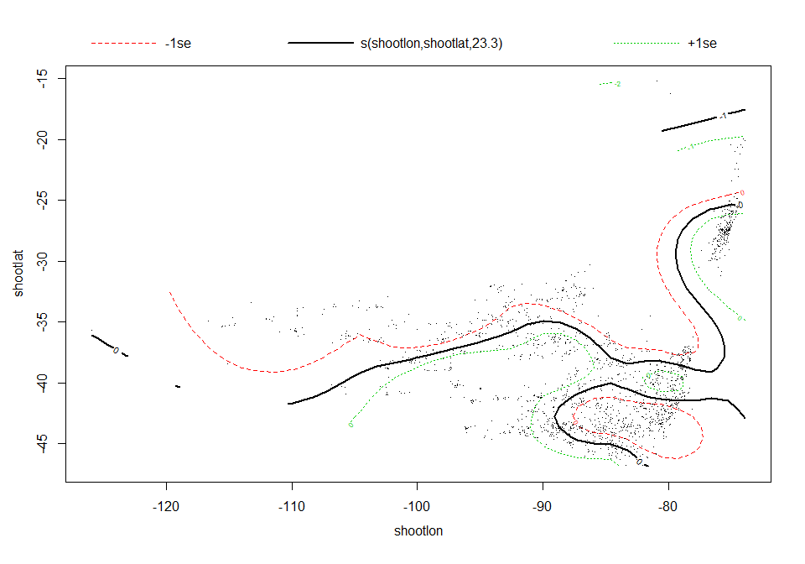

*Figure 6: Final GAM model: Estimates of the spatial smoother effects*

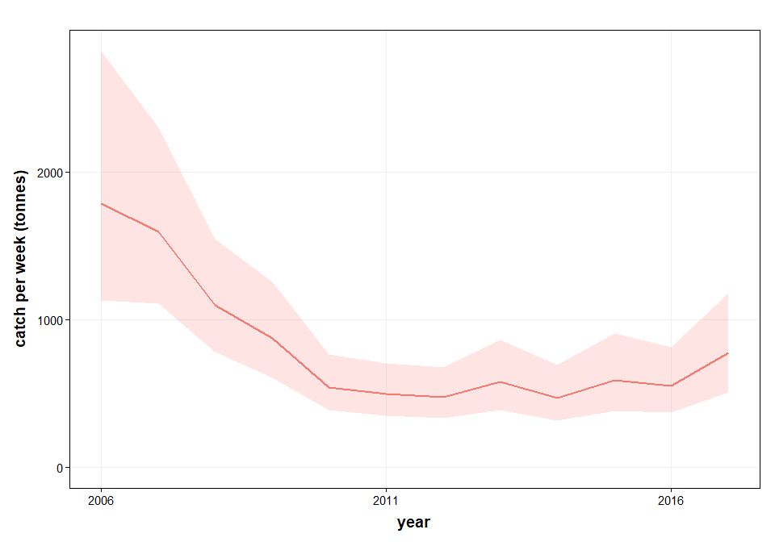

*Figure 7: Final GAM model: standardized CPUE for jack mackerel*

##### page break

**ANOVA results**

The ANOVA results of the final model are shown below. Note that while SST was a marginally significant effect during the benchmark workshop in 2018, after adding the 2017 it is no longer a significant effect. However, SST has been maintained in the final model so as not to change the model configuration.

Family: Negative Binomial(2.155)   
Link function: log   
  
Formula:  
catch ~ year + vesselcode2 + month + sst + s(shootlon, shootlat) +   
 offset(log(effort))  
  
Parametric Terms:  
 df Chi.sq p-value  
year 11 244.370 <2e-16  
vesselcode2 25 320.657 <2e-16  
month 10 102.506 <2e-16  
sst 1 4.563 0.0327  
  
Approximate significance of smooth terms:  
 edf Ref.df Chi.sq p-value  
s(shootlon,shootlat) 23.30 27.19 126.2 7.87e-15

**Jack mackerel Standardized CPUE for offshore fleets**

year cpue upr lwr  
------ ------ ------ ------  
 2006 1788 2819 1134  
 2007 1595 2298 1107  
 2008 1099 1547 781  
 2009 873 1254 608  
 2010 543 763 386  
 2011 497 706 349  
 2012 476 680 333  
 2013 580 862 390  
 2014 468 692 317  
 2015 589 910 381  
 2016 551 814 373  
 2017 775 1179 509

*Table 12: Final GAM model: Predicted year effects and confidence intervals*

##### page break

# Discussion and conclusions

The nominal CPUE of the offshore fleet fishing for Jack mackerel has previously been used as a tuning index for the assessment. The index consisted of the nominal average catch per fishing day for the fleets of EU, Vanuatu and Korea. The nominal CPUE series of Russia was also being used in the assessment. China has standardized their CPUE series in 2013 which is also part of the assessment.

A working document has been presented to the Scientific Committee Workshop in May 2018 (SCW6-Doc05) with the methodology to standardize the offshore fleets CPUE for Jack mackerel. THe new standardized CPUE series applies to the fleets of EU, Korea, vanuatu and Russia based on the haul-by-haul data contained in the SPRFMO database. Permission to utilize that information was granted by the delegations of Korea, Vanuatu and Russia while the analysis was carried out by scientists from the EU delegation. The methodology is largely similar to the methodology being used for the Chinese CPUE standardization.

The final model for standardizing the CPUE of these fleets models the catch by week and takes into account of the vessel, month, sea surface temperature anomaly and a smooth interaction between latitude and longitude with an offset of log effort (in number of days per week). The new standardized CPUE series starts in 2006 as this is the first year for which haul by haul information was available to carry out this analysis.

Although SST is no longer a significant effect after adding the 2017 data, it has been maintained in the final model so as not to change the model configuration. The effect of SST on the model outcome is expected to be negligable.

# Acknowledgements

We would like to acknowledge the permission granted by the delegations of Russia, Vanuatu and Korea to utilize their haul-by-haul data for the analysis of standardized CPUE of the offshore fleet fishing for Jack mackerel. Sharing access to vessel data has made it possible to improve the indicator that can be used in the assessment.

# References

Li, G., X. Zou, X. Chen, Y. Zhou and M. Zhang (2013). "Standardization of CPUE for Chilean jack mackerel (Trachurus murphyi) from Chinese trawl fleets in the high seas of the Southeast Pacific Ocean." Journal of Ocean University of China 12(3): 441-451.

SPRFMO (2011) Report of the Jack Mackerel Subgroup. Tenth Science Working Group of SPRFMO, 19 – 23 September 2011, Port Vila, Vanuatu.

SPRFMO (2013) REFERENCE TO BE ADDED; EU national report 2013!!

SPRFMO (2018) CPUE standardization for the offshore fleet fishing for Jack mackerel in the SPRFMO area (SCW6-Doc05). Sixth Science Committee Workshop, 28-30 May 2018, Valparaiso, Chile.