**CPUE standardization for the offshore fleet fishing for Jack mackerel in the SPRFMO area, including China**

M.A. Pastoors & N.T. Hintzen (European Union)

Corresponding author: [mpastoors@pelagicfish.eu](mailto:mpastoors@pelagicfish.eu)

17/09/2019

*Note: ALL THE TEXT NEEDS TO BE UPDATED STILL !!*

**Abstract**

*Now includes China*

The nominal CPUE of the offshore fleet fishing for Jack mackerel is currently being used as a tuning index for the assessment. The index consists of the nominal average catch per fishing day for the fleets of EU, Vanuatu and Korea. China has standardized their CPUE series in 2013. This working document describes the work aimed to standardizing the CPUE series of EU, Korea, vanuatu and Russia based on the haul-by-haul data contained in the SPRFMO database. Permission to utilize that information was granted by the delegations of Korea, Vanuatu and Russia while the analysis was carried out by scientists from the EU delegation. The working document consists of a description of the data available for the analysis and the methods towards model choice to select the optimal model configuration for CPUE standardization. The final GAM model consists of a number of discrete factors (year, vessel and month) and a smoothed interaction between latitude and longitude. No significant relationships were found with El Nino indicators or sea surface temperatures. The new standardized CPUE series starts in 2006 as this is the first year for which haul by haul information was available to carry out this analysis.

# Introduction

The assessment of Jack Mackerel in the southern Pacific is based on many different sources of information, including the nominal Catch per Unit Effort (expressed as catch per day) of the EU fleet. The use of nominal CPUE for calibrating stock assessments is known to be potentially problematic and therefore SPRFMO (2011) recommended that to serve as indices of abundance, the CPUE should be standardized to take into account factors such as historical changes in vessels, fishing areas, seasonal fishing patterns and environmental factors. This standardization approach has already been applied by China (Li et al, 2013).

In this document, the catch and effort data for the offshore fleet (Eu, Korea, Russia, Vanuatu) is analysed with the aim to develop a standardized CPUE series. Data has been obtained from the SPRFMO secretariat after permission was granted by the different contracting parties that the data could be used for this CPUE analysis.

# Material and methods

Data from Korea, Russia, Vanuatu and China was made available by Craig Loveridge on 12 August 2019. Data from China has been included for the first time this year, which has promped a new full analysis, similar to the analysis that was carried out during the benchmark meeting in 2018. Data for EU fisheries was already available as part of the SPRFMO database but also with the underlying spreadsheets that we used to submit the data to SPRFMO. Two vessels were removed from the dataset because of apparent problems with the units used for catch reporting.

**Number of vessels participating in the fishery**

year CHN EU KOR RUS VUT (all)  
------ ----- ---- ----- ----- ----- -------  
 2005 0 1 0 0 0 1  
 2006 0 1 0 0 0 1  
 2007 0 6 0 0 0 6  
 2008 0 7 2 1 4 14  
 2009 13 10 2 4 4 33  
 2010 9 7 2 0 4 22  
 2011 6 3 2 2 2 15  
 2012 3 0 2 0 2 7  
 2013 2 1 1 0 2 6  
 2014 3 2 1 0 2 8  
 2015 6 2 2 1 2 13  
 2016 2 2 2 0 1 7  
 2017 2 2 1 1 0 6  
 2018 2 1 2 1 0 6  
 2019 0 1 0 0 0 1

*Table 1: Number of vessels participating in the Jack mackerel fishery by Contracting Party*

##### page break

**Total annual catch (tonnes) by contracting party (cp), year and species (only species with more than 10 ton catch overall)**

As derived from the estimated catch in the haul by haul data from the contracting parties.

vesselcp year ALF BF BRA BRU CJM EMM EMT GIS MAC MAS MZZ POA  
---------- ------- ------- ---- ----- ------- --------- ----- ----- ----- ----- -------- ----- -----  
 CHN 2009 0 0 0 0 117,963 0 0 0 0 0 0 0  
 CHN 2010 0 0 0 0 63,606 0 0 0 0 2,583 0 0  
 CHN 2011 0 0 0 0 32,862 0 0 0 0 666 0 0  
 CHN 2012 0 0 0 0 13,011 0 0 0 0 226 0 0  
 CHN 2013 0 0 0 0 8,329 0 0 0 0 173 0 0  
 CHN 2014 0 0 0 0 21,154 0 0 0 0 0 0 0  
 CHN 2015 0 0 0 0 29,179 0 0 0 0 0 0 0  
 CHN 2016 0 0 0 0 20,207 0 0 0 0 0 0 0  
 CHN 2017 0 0 0 0 16,585 0 0 0 0 547 0 0  
 CHN 2018 0 0 0 0 24,366 0 0 0 0 311 0 0  
 CHN (all) 0 0 0 0 347,262 0 0 0 0 4,506 0 0  
 EU 2005 0 0 0 0 5,381 0 0 0 0 108 0 0  
 EU 2006 0 0 0 0 25,486 0 0 0 0 1,123 0 0  
 EU 2007 0 0 0 0 88,253 0 0 0 0 3,157 0 0  
 EU 2008 1,313 0 0 0 93,462 0 0 0 0 3,788 2 0  
 EU 2009 0 0 0 861 203,139 0 0 0 0 9,174 33 0  
 EU 2010 0 0 0 540 91,502 0 0 0 0 738 6 0  
 EU 2011 0 0 0 38 3,028 0 0 0 0 0 0 0  
 EU 2013 0 0 0 127 20,023 0 0 0 0 453 0 0  
 EU 2014 0 0 0 131 41,019 0 0 0 0 1,485 0 0  
 EU 2015 0 0 0 304 56,013 0 0 0 0 1,786 0 0  
 EU 2016 0 0 0 81 22,939 0 0 0 0 1,583 1 12  
 EU 2017 0 0 0 158 51,242 0 0 0 0 3,283 0 0  
 EU 2018 0 0 0 579 19,239 0 0 0 0 234 0 0  
 EU 2019 0 27 0 98 8,318 0 0 0 0 3 0 0  
 EU (all) 1,313 27 0 2,917 729,044 0 0 0 0 26,915 42 12  
 KOR 2008 0 0 0 0 12,377 0 0 0 0 961 0 0  
 KOR 2009 0 0 0 0 13,759 0 59 0 0 715 0 0  
 KOR 2010 0 0 0 0 8,182 0 0 0 0 84 0 0  
 KOR 2011 0 0 0 0 9,253 0 0 99 0 24 0 0  
 KOR 2012 0 0 0 0 5,491 0 0 0 0 0 0 0  
 KOR 2013 0 0 0 0 5,266 0 0 0 0 110 0 0  
 KOR 2014 0 0 0 0 4,077 0 0 0 0 21 0 0  
 KOR 2015 0 0 0 0 5,748 0 0 0 0 79 0 0  
 KOR 2016 0 0 0 0 6,429 0 0 0 0 485 0 0  
 KOR 2017 0 0 0 0 1,235 0 0 0 0 190 0 0  
 KOR 2018 0 0 0 0 3,717 0 0 0 0 245 0 0  
 KOR (all) 0 0 0 0 75,534 0 59 99 0 2,914 0 0  
 RUS 2008 0 0 0 0 4,799 0 0 0 0 386 0 0  
 RUS 2009 0 0 0 0 8,503 0 0 0 0 534 0 0  
 RUS 2011 0 0 0 0 8,228 0 0 0 0 12 0 0  
 RUS 2015 0 0 1 0 2,523 30 0 0 0 573 0 0  
 RUS 2017 0 0 0 1 3,188 0 0 0 0 37 0 0  
 RUS 2018 0 0 81 0 4,685 0 0 0 0 52 0 0  
 RUS (all) 0 0 82 1 31,926 30 0 0 0 1,594 0 0  
 VUT 2008 0 0 0 0 101,955 0 0 0 0 8,458 0 0  
 VUT 2009 0 0 0 0 80,165 0 0 0 0 4,667 0 0  
 VUT 2010 0 0 0 0 45,934 0 0 0 0 639 0 0  
 VUT 2011 0 0 0 0 7,627 0 0 0 0 0 0 0  
 VUT 2012 0 0 0 0 16,462 0 0 0 0 0 0 0  
 VUT 2013 0 0 0 0 15,525 0 0 0 0 0 0 0  
 VUT 2014 0 0 0 0 15,473 0 0 0 0 0 0 0  
 VUT 2015 0 0 0 0 21,224 0 0 0 303 304 0 0  
 VUT 2016 0 0 0 0 7,385 0 0 0 553 0 0 0  
 VUT (all) 0 0 0 0 311,750 0 0 0 856 14,068 0 0  
  
Table: Table continues below  
  
   
  
 RBM SLT UBA (all)  
----- ----- ------- ---------  
 0 0 0 117,963  
 0 0 0 66,189  
 0 0 0 33,528  
 0 0 0 13,237  
 0 0 0 8,502  
 0 0 0 21,154  
 0 0 0 29,179  
 0 0 0 20,207  
 0 0 0 17,132  
 0 0 0 24,677  
 0 0 0 351,768  
 0 0 0 5,489  
 0 0 0 26,609  
 0 0 0 91,410  
 0 0 0 98,565  
 24 0 0 213,231  
 0 0 0 92,786  
 0 0 0 3,066  
 0 0 0 20,603  
 0 0 177 42,812  
 0 58 104 58,265  
 0 0 352 24,968  
 0 0 153 54,836  
 0 0 415 20,467  
 0 0 2 8,448  
 24 58 1,203 761,555  
 0 0 0 13,338  
 0 0 0 14,533  
 0 0 0 8,266  
 0 0 0 9,376  
 0 0 0 5,491  
 0 0 0 5,376  
 0 0 0 4,098  
 0 0 0 5,827  
 0 0 0 6,914  
 0 0 0 1,425  
 0 0 0 3,962  
 0 0 0 78,606  
 0 0 0 5,185  
 0 0 0 9,037  
 0 0 0 8,240  
 0 0 11 3,138  
 0 0 0 3,226  
 0 0 50 4,868  
 0 0 61 33,694  
 0 0 0 110,413  
 0 0 0 84,832  
 0 0 0 46,573  
 0 0 0 7,627  
 0 0 0 16,462  
 0 0 0 15,525  
 0 0 0 15,473  
 0 0 0 21,831  
 0 0 0 7,938  
 0 0 0 326,674

*Table 1: Number of vessels participating in the Jack mackerel fishery by Contracting Party*

##### page break

**Summed haul durations in hours (when available)**

I.e. numbers of hours fished. The data for 2017 are incomplete.

year CHN EU KOR RUS VUT (all)  
------ -------- ------- ------- ------- ------- --------  
 2005 0 650 0 0 0 650  
 2006 0 1,131 0 0 0 1,131  
 2007 0 836 0 0 0 836  
 2008 0 6,784 1,559 553 8,935 17,831  
 2009 12,622 9,026 1,301 1,115 7,512 31,576  
 2010 8,213 5,514 1,381 0 6,357 21,465  
 2011 6,463 667 2,385 1,770 2,041 13,326  
 2012 3,256 0 920 0 4,253 8,429  
 2013 1,917 1,642 919 0 2,815 7,293  
 2014 3,655 2,650 713 0 2,809 9,827  
 2015 3,704 2,406 910 441 2,631 10,092  
 2016 3,122 1,505 1,775 0 1,097 7,499  
 2017 1,482 5,471 214 483 0 7,650  
 2018 2,605 3,305 892 793 0 7,595  
 2019 0 540 0 0 0 540

*Table 3: Summed haul duration (hours) by contracting party*

##### page break

**Number of fishing days (defined as days when a haul has been reported)**

year CHN EU KOR RUS VUT (all)  
------ ----- ----- ----- ----- ----- -------  
 2005 0 44 0 0 0 44  
 2006 0 110 0 0 0 110  
 2007 0 164 0 0 0 164  
 2008 0 185 166 62 233 646  
 2009 189 179 159 83 174 784  
 2010 195 164 125 0 144 628  
 2011 161 23 155 121 100 560  
 2012 171 0 116 0 182 469  
 2013 175 137 89 0 164 565  
 2014 153 148 85 0 153 539  
 2015 165 115 95 38 122 535  
 2016 157 91 175 0 85 508  
 2017 93 208 31 51 0 383  
 2018 126 137 78 71 0 412  
 2019 0 46 0 0 0 46

*Table 4: Number of fishing days by contracting party*

**Number of hauls**

year CHN EU KOR RUS VUT (all)  
------ ------- ------- ----- ----- ------- -------  
 2005 0 81 0 0 0 81  
 2006 0 240 0 0 0 240  
 2007 0 643 0 0 0 643  
 2008 0 1,320 398 94 1,731 3,543  
 2009 2,331 1,440 291 184 1,356 5,602  
 2010 1,518 895 261 0 886 3,560  
 2011 997 96 432 208 273 2,006  
 2012 446 0 160 0 562 1,168  
 2013 269 223 128 0 358 978  
 2014 485 416 137 0 392 1,430  
 2015 614 439 198 80 435 1,766  
 2016 500 233 326 0 180 1,239  
 2017 294 1,050 54 88 0 1,486  
 2018 377 468 157 134 0 1,136  
 2019 0 90 0 0 0 90

*Table 5: Number of hauls by contracting party*

##### page break

**Length of the fishing season (defined as the number of days between the first haul and the last haul in a year)**

year CHN EU KOR RUS VUT (all)  
------ ----- ----- ----- ----- ----- -------  
 2005 0 51 0 0 0 51  
 2006 0 240 0 0 0 240  
 2007 0 194 0 0 0 194  
 2008 0 271 188 89 245 793  
 2009 216 190 195 120 198 919  
 2010 256 193 208 0 171 828  
 2011 194 41 197 175 149 756  
 2012 271 0 167 0 263 701  
 2013 228 233 139 0 202 802  
 2014 182 170 93 0 201 646  
 2015 217 148 120 52 159 696  
 2016 241 136 188 0 167 732  
 2017 166 277 81 75 0 599  
 2018 181 182 130 111 0 604  
 2019 0 84 0 0 0 84

*Table 6: Length of the fishing season (days) by Contracting Party*

##### page break

**Total catch of jack mackerel per year**

As derived from the haul-by-haul estimated catches. According to SC-01-14 (European Union 2013 Annual Report) there is a difference between the haul-by-haul estimated catch by the skipper and the overall catch reported to SPRFMO for the earlier years of the time series. No attempt has been made to change the haul-by-haul data and therefore the overall quantities cannot be directly compared with the total catch in the SPRFMO catch series.

year CHN EU KOR RUS VUT (all)  
------ --------- --------- -------- ------- --------- ---------  
 2005 0 5,381 0 0 0 5,381  
 2006 0 25,486 0 0 0 25,486  
 2007 0 88,253 0 0 0 88,253  
 2008 0 93,462 12,377 4,800 101,955 212,594  
 2009 117,963 203,139 13,759 8,504 80,166 423,531  
 2010 63,606 91,503 8,183 0 45,934 209,226  
 2011 32,862 3,028 9,253 8,229 7,628 61,000  
 2012 13,012 0 5,492 0 16,463 34,966  
 2013 8,329 20,024 5,267 0 15,526 49,145  
 2014 21,155 41,019 4,078 0 15,473 81,725  
 2015 29,180 56,014 5,749 2,524 21,224 114,690  
 2016 20,208 22,940 6,430 0 7,385 56,962  
 2017 16,586 51,243 1,235 3,188 0 72,252  
 2018 24,366 19,240 3,717 4,686 0 52,009  
 2019 0 8,318 0 0 0 8,318

*Table 2.7. Total catch per year of Jack Mackerel by EU, Korea, Russia and Vanuatu based on the haul-by-haul estimates.*

##### page break

**Mean catch of jack mackerel per day**

year CHN EU KOR RUS VUT (all)  
------ ----- ------- ----- ----- ----- -------  
 2005 . 122 . . . 122  
 2006 . 232 . . . 232  
 2007 . 538 . . . 538  
 2008 . 519 75 77 439 278  
 2009 624 1,135 87 102 461 482  
 2010 326 558 65 . 319 317  
 2011 204 132 60 68 76 108  
 2012 76 . 47 . 90 71  
 2013 48 148 59 . 95 87  
 2014 138 279 53 . 101 143  
 2015 177 487 61 68 174 193  
 2016 129 252 37 . 87 126  
 2017 178 246 40 63 . 132  
 2018 193 140 48 67 . 112  
 2019 . 189 . . . 189

*Table 2.8. Mean catch per day of Jack Mackerel by EU, Korea, Russia and Vanuatu.*

##### page break

**Comparison of different CPUE metrics: by haul, by day and by week**

Average CPUE by year and contracting party has been calculated by haul, by day and by week. Each of the series has been scaled to the maximum of the time series. This indicates that the nominal CPUE by day and by week give the same overall pattern which is differing from the CPUE by haul.

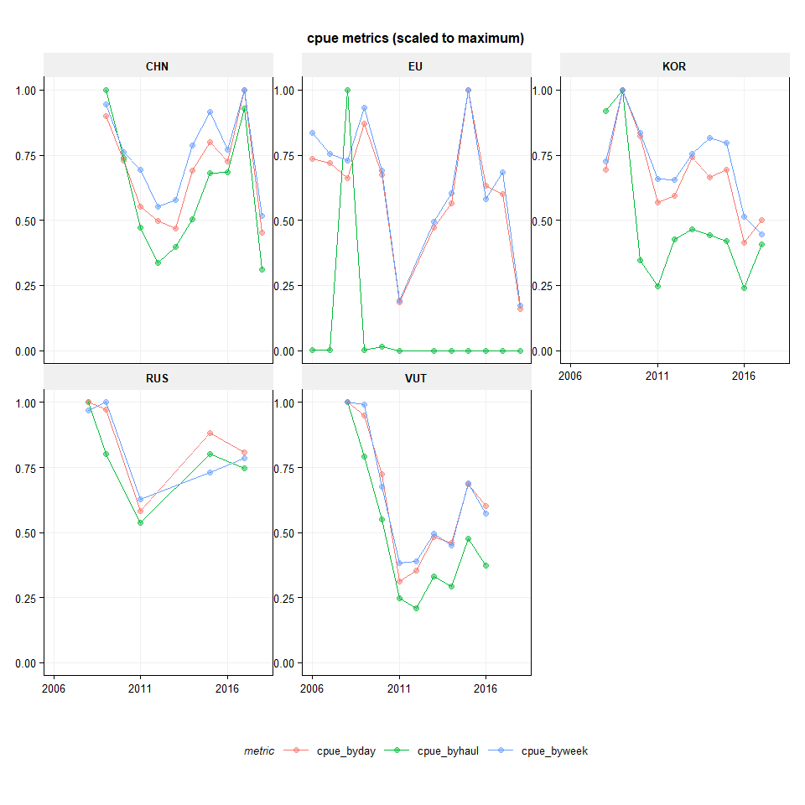 *Figure 2.1. Three different CPUE metrics for EU, Korea, Russia and Vanuatu, scaled to the maximum of the time series.*

##### page break

**All hauls of all years on one map**

All haul positions for all years where Jack mackerel has been caught.

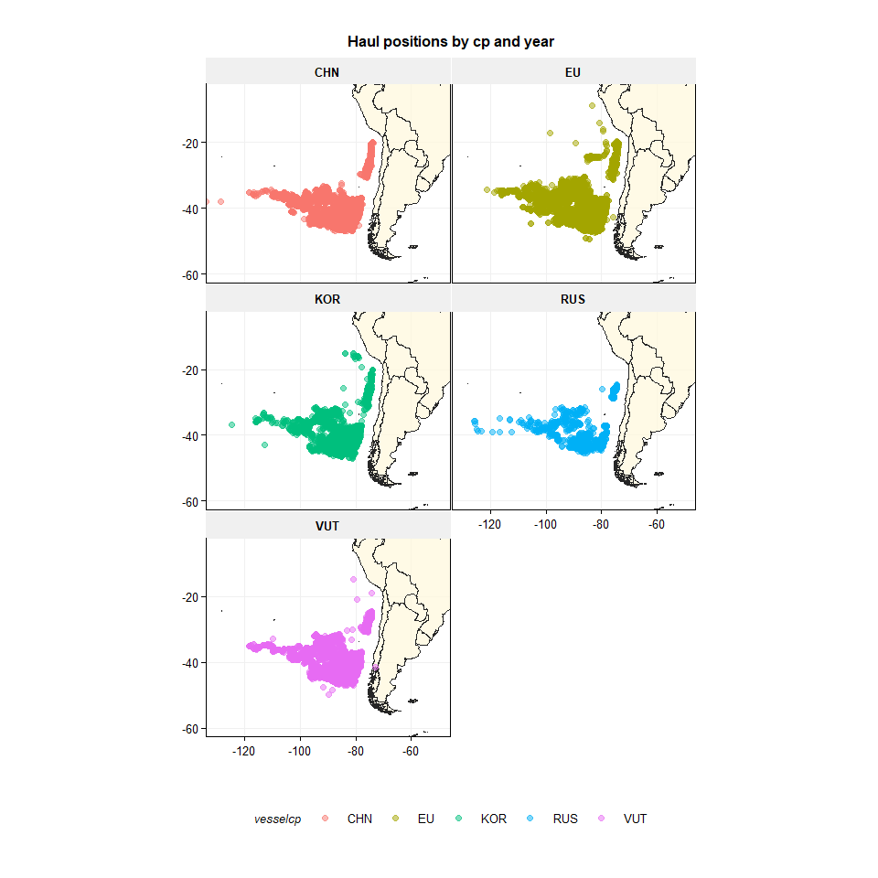

*Figure 2.2. CJM Haul positions (all years combined) for EU, Korea, Russia and Vanuatu.*

##### page break

**Haul positions by contracting party and year**

The yearly postions of Jack mackerel fishery of the offshore fleets.

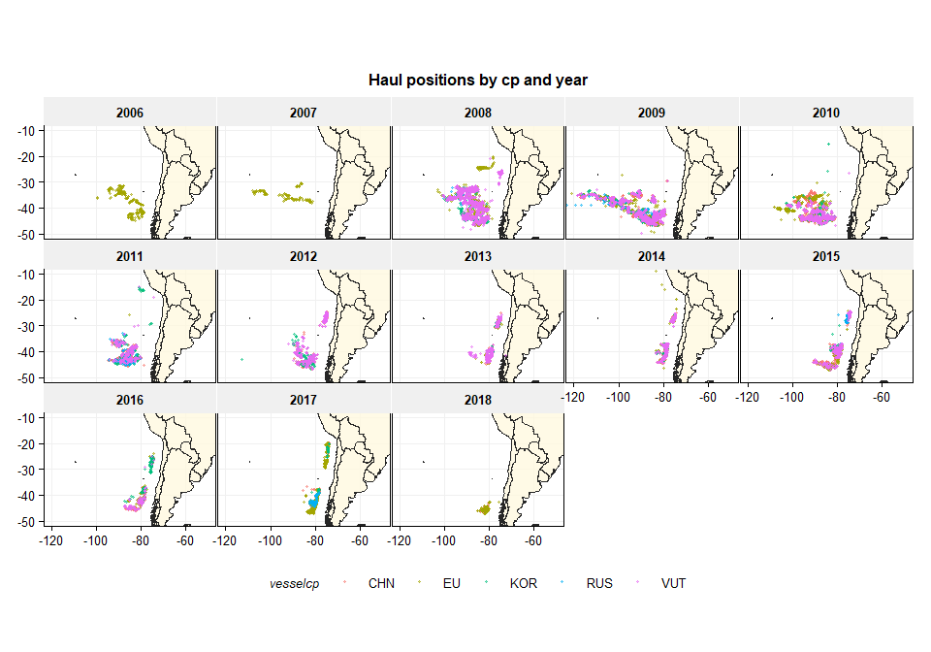

*Figure 2.3. Haul positions by contracting party. Colours indicate the different contracting parties participating.*

##### page break

**Mean catch per day of jack mackerel per one degree longitude and 1/2 degree latitude**

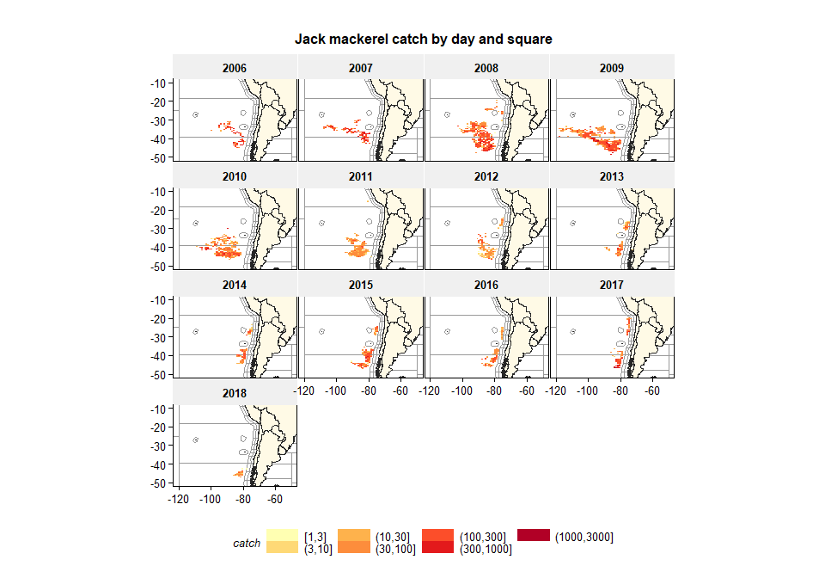

*Figure 2.4. Catch per day of Jack mackerel (summed by 1 degree longitude and 0.5 degree latitude). Catch in tonnes expressed on a log scale.*

##### page break

**Jack mackerel log CPUE by day against latitude and longitude**

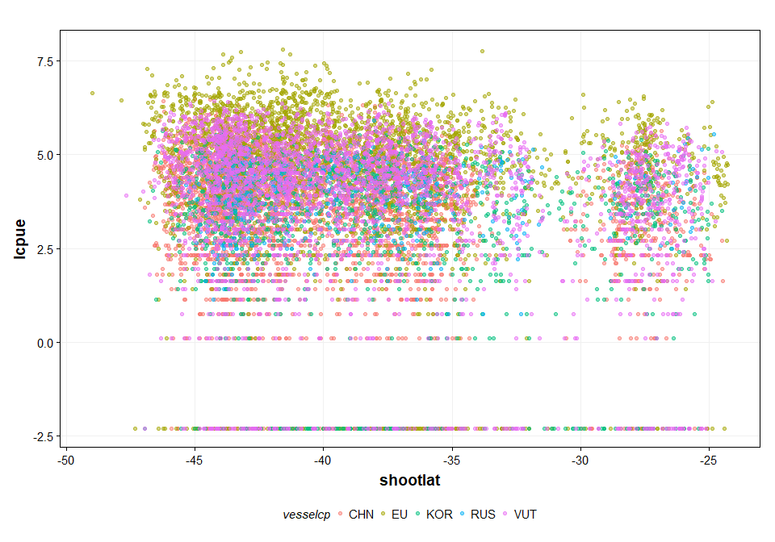

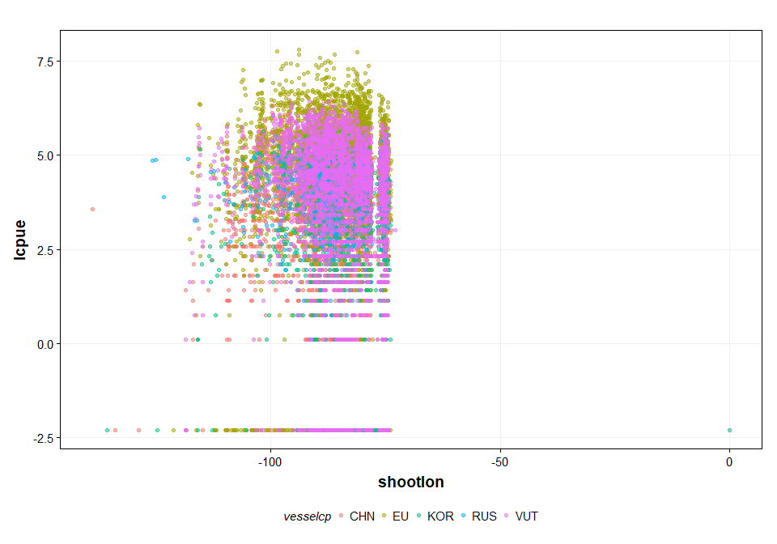

*Figure 2.5. Log Catch per day of Jack mackerel against longitude and latitude.*

##### page break

**Jack mackerel catch per day and yearly average catch per day**

The plot below shows the distributions of catch per day and by contracting party. The average catch per day is drawn as a dashed black line. The average catch per day of Korea shows a rather different pattern compared to the non-zero catches. This is due to the number of zero hauls in the dataset (see figure 2.7). This will need to be looked at into in more detail but for now the data from Korea has been included in the analyses, because the catch per unit effort has been aggregated per week.

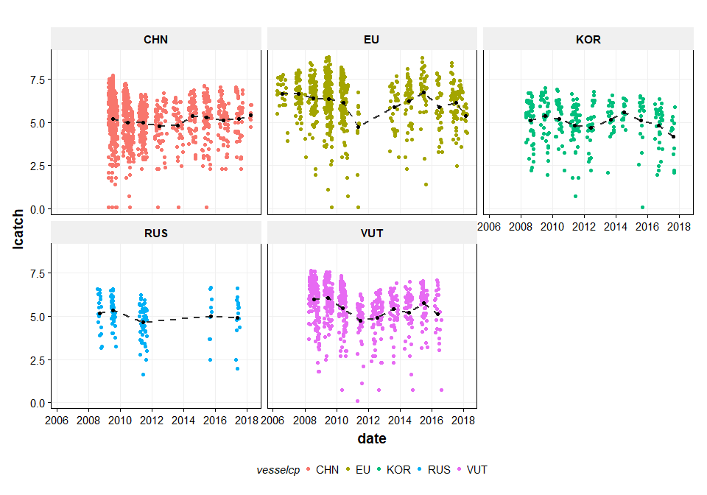

*Figure 2.6. Jack mackerel CPUE (log(catch / day)). Colours indicate the different contracting parties.*

##### page break

**Proportion of fishing days with zero catch**

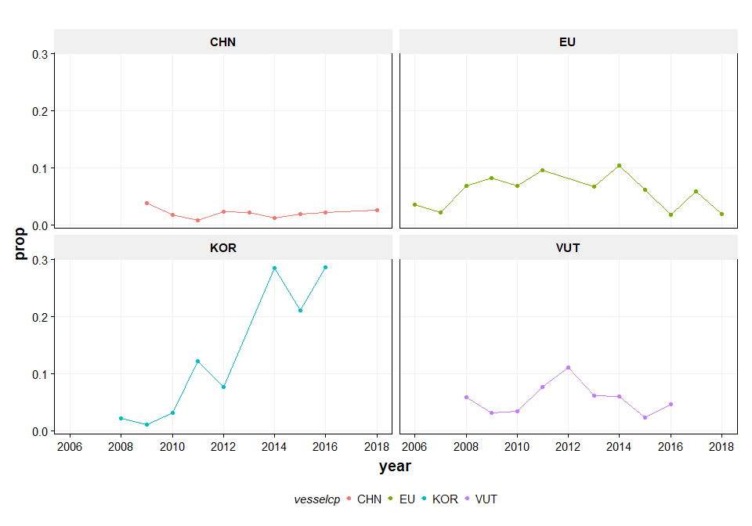

*Figure 2.7. Jack mackerel: proportion of zero hauls per year and contracting party. For Russia there were too few years to plot the proportion zero hauls.*

##### page break

**El Nino effect and Humbold_current index**

It has been hypothesized that the catch rate of jack mackerel by area and season could be dependent on the climatic situation, characterized by El Nino events (NOAA, <https://www.esrl.noaa.gov/psd/data/correlation/oni.data>) or the Humboldt Current Index (<http://www.bluewater.cl/HCI/>)

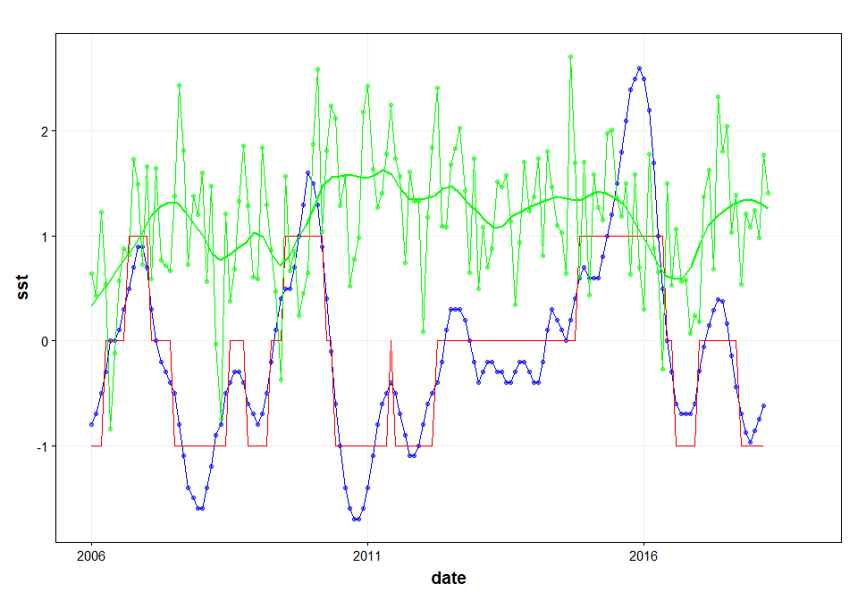

*Figure 2.8. El Nino temperature anomaly (blue line) and estimated ELE indicator (red line). Humboldt Current Index (green line).*

**Modelling approach**

The general modelling approach has been to use GAM models to assess the dependency on the weekly catch of jack mackerel on different variables. In the first instance a test has been carried out to apply a negative binomial distribution to the weekly catch data

The basic model consists of catch (per week) as the main variable, the year effect (as factor) as the main explanatory variable and the log of effort as the offset (the log is taken because of the log-link function). Then the other potential explanatory variables are explored (month, vessel, contracting party, sea surface temperature anomaly, el nino effect and interaction between lat and long). Based on the AIC criteria, the best fitting second, third etc. variable have been selected.

A leave-one-out analysis was carried out to assess the year trends in CPUE if the data from one of the contracting parties was left out.

# Results

**Negative binomial distribution of catch by week**

The catch per week data fits closely to a negative binomial distribution.

Note: weeks with zero catches have been removed from the analysis but this warrants a further look into the data.

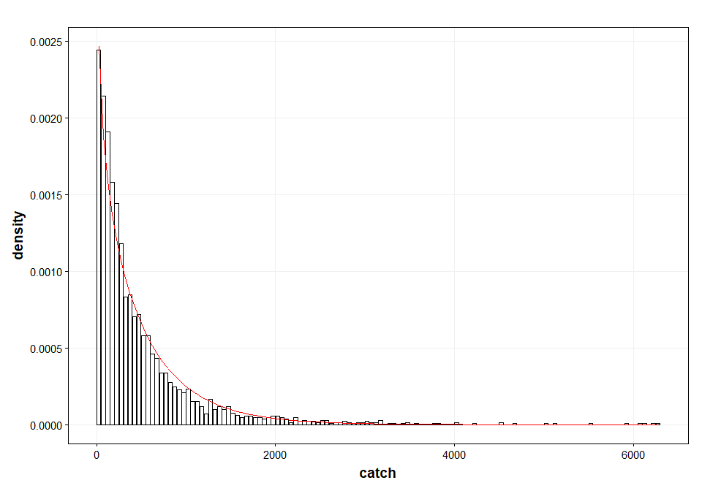

##### page break

**Modelling the first linear effect next to the year trend**

The basic model consists of catch (per week) as the main variable, the year effect (as factor) as the main explanatory variable and the log of effort as the offset (the log is taken because of the log-link function). Then the other potential explanatory variables are explored (month, vessel, contracting party, sea surface temperature anomaly, el nino effect and interaction between lat and long). Based on the AIC criteria, the best fitting second variable has been selected, which was the vesselcode.

*Catch ~ offset(log(effort)) + year + first linear effect*

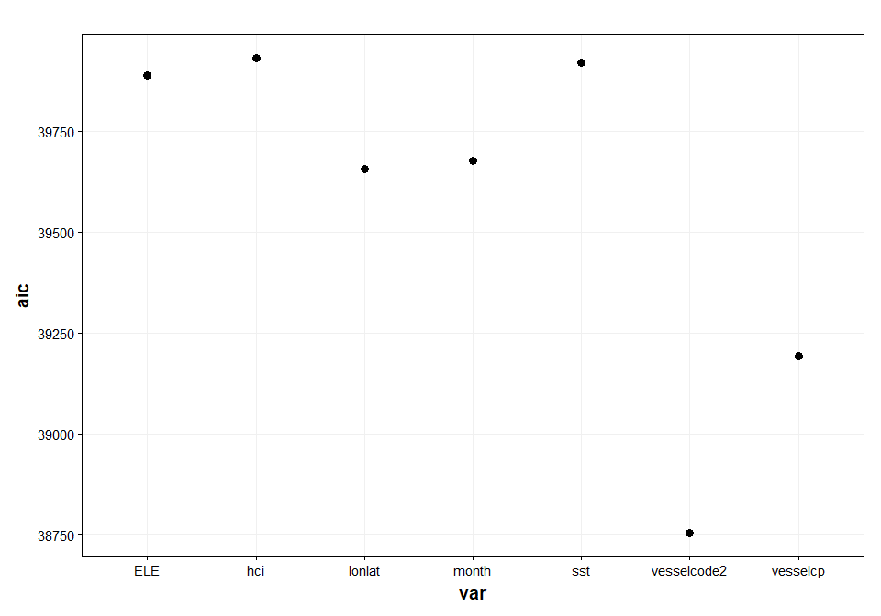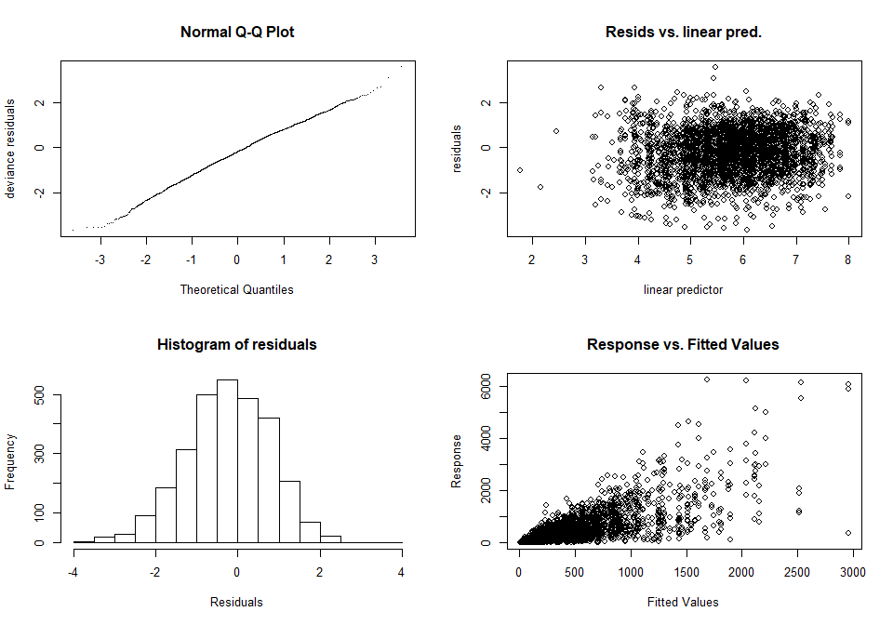

'gamm' based fit - care required with interpretation.  
Checks based on working residuals may be misleading.

Analysis of Deviance Table  
  
Model: Negative Binomial(1.9271), link: log  
  
Response: catch  
  
Terms added sequentially (first to last)  
  
 Df Deviance Resid. Df Resid. Dev Pr(>Chi)   
NULL 2900 5411.7   
year 12 725.6 2888 4686.1 < 2.2e-16 ***  
vesselcode2 40 1524.0 2848 3162.1 < 2.2e-16 ***  
---  
Signif. codes: 0 '***' 0.001 '**' 0.01 '*' 0.05 '.' 0.1 ' ' 1

##### page break

**Modelling the second linear effect next to the year and vessel effect**

*Catch ~ offset(log(effort)) + year + vessel + second linear effect*

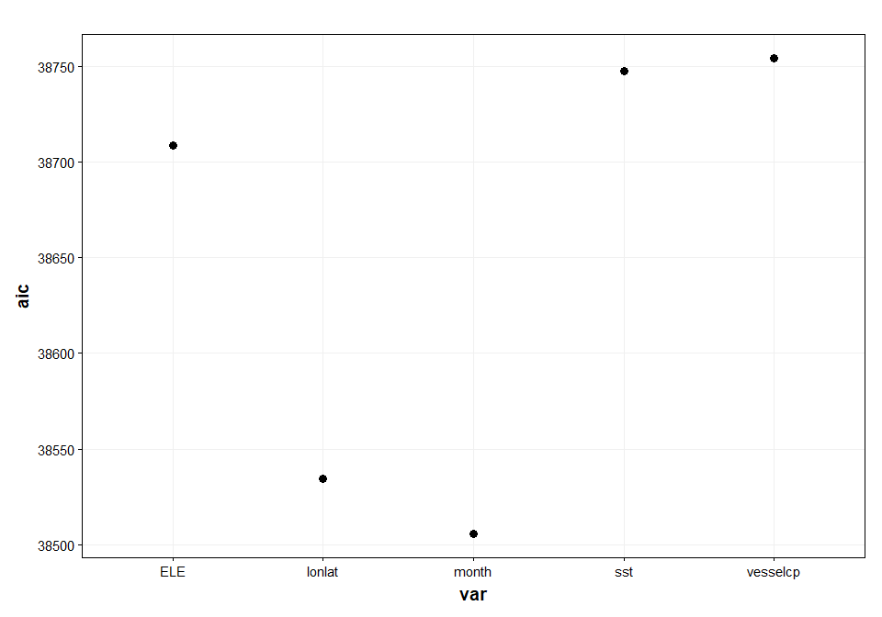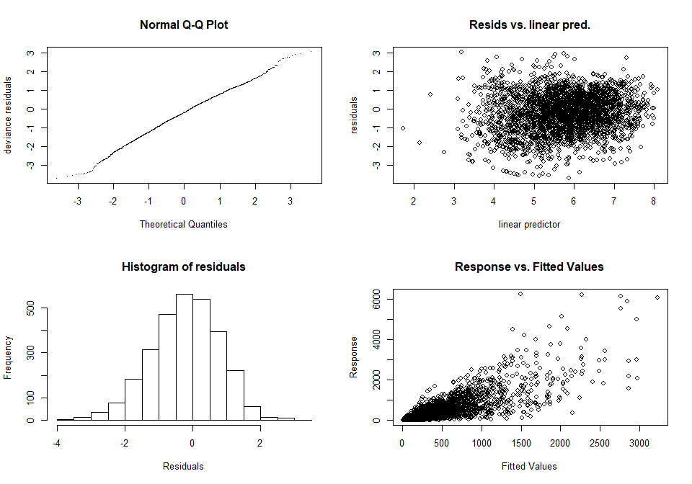

'gamm' based fit - care required with interpretation.  
Checks based on working residuals may be misleading.

Analysis of Deviance Table  
  
Model: Negative Binomial(2.0961), link: log  
  
Response: catch  
  
Terms added sequentially (first to last)  
  
 Df Deviance Resid. Df Resid. Dev Pr(>Chi)   
NULL 2900 5876.6   
year 12 788.78 2888 5087.9 < 2.2e-16 ***  
vesselcode2 40 1656.36 2848 3431.5 < 2.2e-16 ***  
month 11 282.33 2837 3149.2 < 2.2e-16 ***  
---  
Signif. codes: 0 '***' 0.001 '**' 0.01 '*' 0.05 '.' 0.1 ' ' 1

##### page break

**Modelling the third linear effect next to the year, vessel and month effect**

*Catch ~ offset(log(effort)) + year + vessel + month + third linear effect*

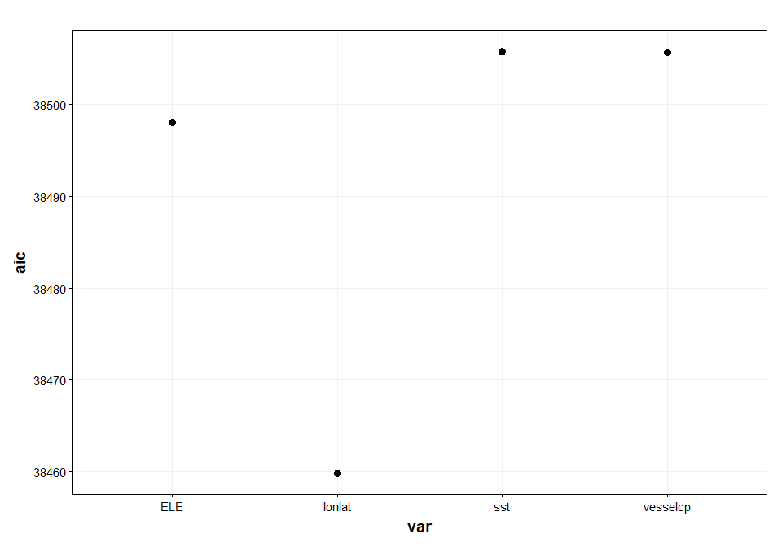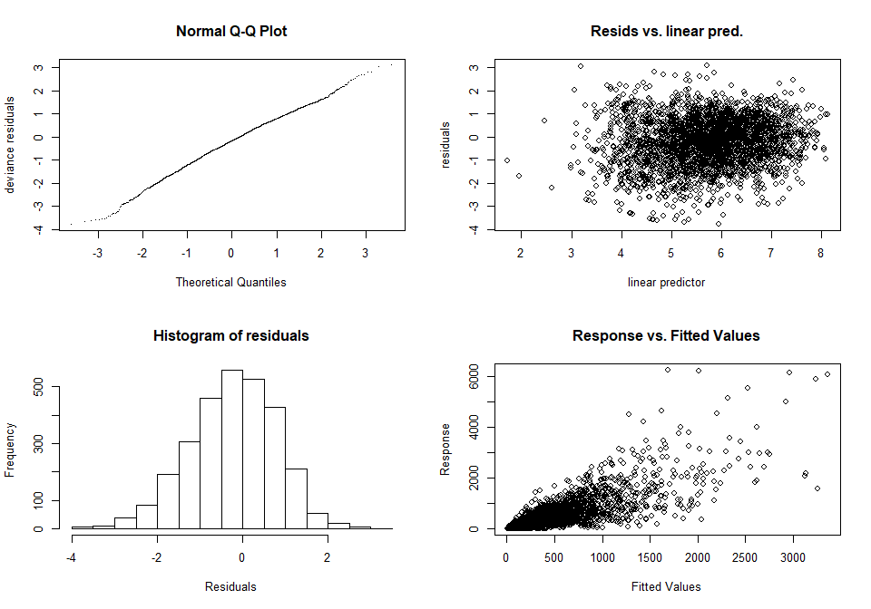

'gamm' based fit - care required with interpretation.  
Checks based on working residuals may be misleading.

Analysis of Deviance Table  
  
Model: Negative Binomial(2.1303), link: log  
  
Response: catch  
  
Terms added sequentially (first to last)  
  
 Df Deviance Resid. Df Resid. Dev Pr(>Chi)   
NULL 2900 5970.6   
year 12 801.56 2888 5169.1 < 2.2e-16 ***  
month 11 422.82 2877 4746.2 < 2.2e-16 ***  
vesselcode2 40 1547.21 2837 3199.0 < 2.2e-16 ***  
shootlon 1 1.79 2836 3197.2 0.18033   
shootlat 1 6.07 2835 3191.2 0.01372 *   
shootlon:shootlat 1 44.39 2834 3146.8 2.695e-11 ***  
---  
Signif. codes: 0 '***' 0.001 '**' 0.01 '*' 0.05 '.' 0.1 ' ' 1

##### page break

**Exploring the El Nino effect**

*Catch ~ offset(log(effort)) + year + vessel + month + lat-lon + ‘El Nino’ or Humboldt Current Index*

The El Nino effect can be taken in as the sea surface temperature anomaly or as the El Nino indicator (-1, 0, 1). The Humboldt Current index is taken as the pressure difference between Easter island and Antofagasta. The only significant effects was observed for the El Nino Sea Surface Anomaly (sst)

Analysis of Deviance Table  
  
Model: Negative Binomial(2.1388), link: log  
  
Response: catch  
  
Terms added sequentially (first to last)  
  
 Df Deviance Resid. Df Resid. Dev Pr(>Chi)   
NULL 2900 5994.1   
year 12 804.75 2888 5189.3 < 2.2e-16 ***  
month 11 424.50 2877 4764.8 < 2.2e-16 ***  
vesselcode2 40 1553.34 2837 3211.5 < 2.2e-16 ***  
shootlon 1 1.80 2836 3209.7 0.179524   
shootlat 1 6.10 2835 3203.6 0.013533 *   
ELE 2 9.96 2833 3193.6 0.006887 **   
shootlon:shootlat 1 47.37 2832 3146.2 5.866e-12 ***  
---  
Signif. codes: 0 '***' 0.001 '**' 0.01 '*' 0.05 '.' 0.1 ' ' 1

Analysis of Deviance Table  
  
Model: Negative Binomial(2.1314), link: log  
  
Response: catch  
  
Terms added sequentially (first to last)  
  
 Df Deviance Resid. Df Resid. Dev Pr(>Chi)   
NULL 2900 5973.6   
year 12 801.96 2888 5171.6 < 2.2e-16 ***  
month 11 423.03 2877 4748.6 < 2.2e-16 ***  
vesselcode2 40 1547.98 2837 3200.6 < 2.2e-16 ***  
shootlon 1 1.80 2836 3198.8 0.1802   
shootlat 1 6.08 2835 3192.7 0.0137 *   
sst 1 1.69 2834 3191.0 0.1939   
shootlon:shootlat 1 44.26 2833 3146.8 2.878e-11 ***  
---  
Signif. codes: 0 '***' 0.001 '**' 0.01 '*' 0.05 '.' 0.1 ' ' 1

Analysis of Deviance Table  
  
Model: Negative Binomial(2.1303), link: log  
  
Response: catch  
  
Terms added sequentially (first to last)  
  
 Df Deviance Resid. Df Resid. Dev Pr(>Chi)   
NULL 2900 5970.7   
year 12 801.57 2888 5169.1 < 2.2e-16 ***  
month 11 422.82 2877 4746.3 < 2.2e-16 ***  
vesselcode2 40 1547.23 2837 3199.1 < 2.2e-16 ***  
shootlon 1 1.79 2836 3197.3 0.18033   
shootlat 1 6.07 2835 3191.2 0.01372 *   
hci 1 0.02 2834 3191.2 0.89101   
shootlon:shootlat 1 44.40 2833 3146.8 2.672e-11 ***  
---  
Signif. codes: 0 '***' 0.001 '**' 0.01 '*' 0.05 '.' 0.1 ' ' 1

##### page break

*Modelling the spatial and year smoothers*

In this section we explore the added benefits of using the interaction between lat, long and year and whether the smoothers available in GAM provide additional benefits over GLMs. Four different models are compared.

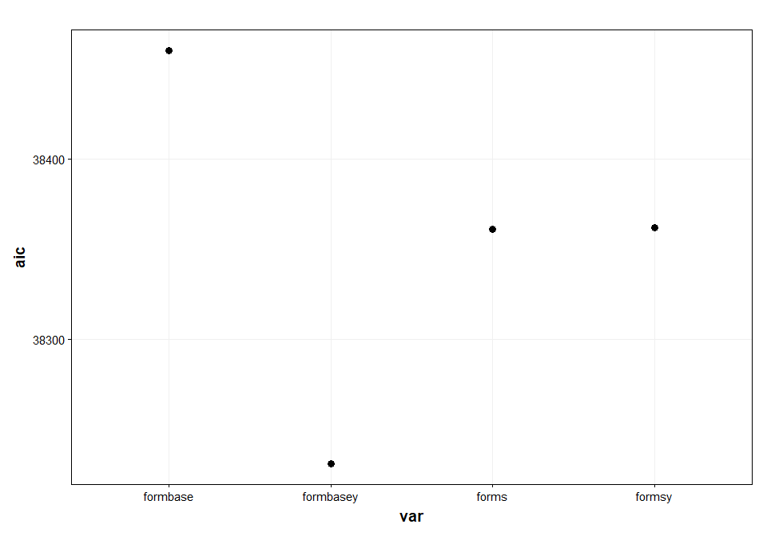

##### page break

catch ~ year + month + vesselcode2 + sst + shootlon * shootlat +   
 offset(log(effort))

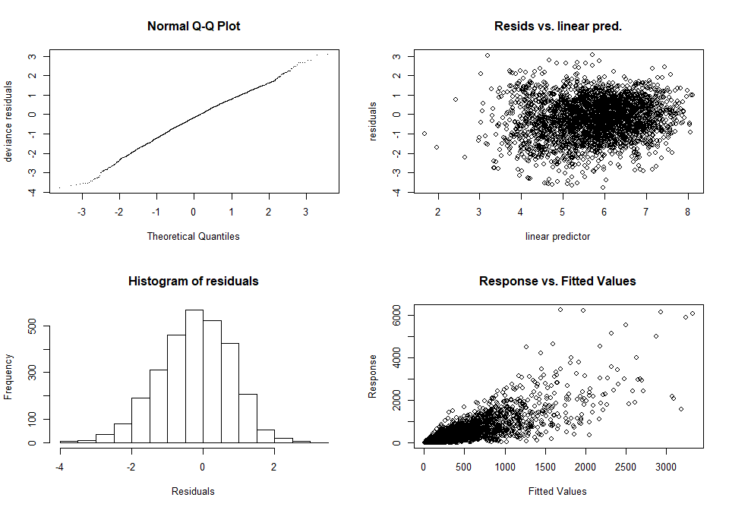

'gamm' based fit - care required with interpretation.  
Checks based on working residuals may be misleading.

##### page break

catch ~ year + month + vesselcode2 + sst + shootlon * shootlat *   
 year + offset(log(effort))

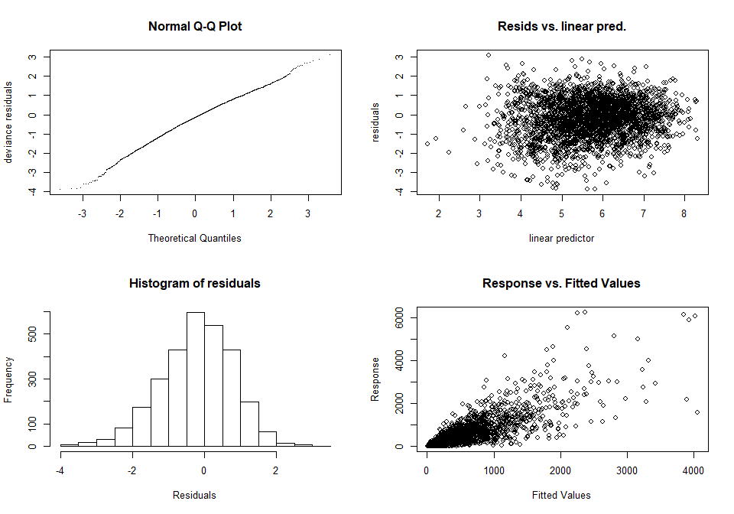

'gamm' based fit - care required with interpretation.  
Checks based on working residuals may be misleading.

##### page break

catch ~ year + month + vesselcode2 + sst + s(shootlon, shootlat) +   
 offset(log(effort))

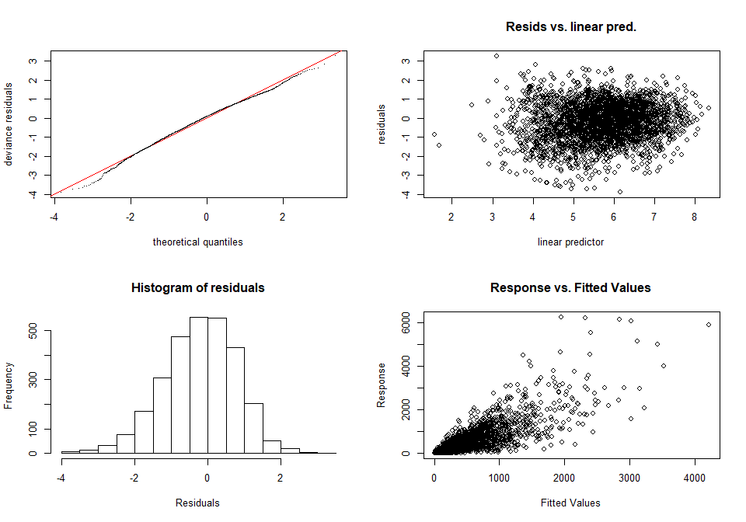

Method: UBRE Optimizer: outer newton  
full convergence after 7 iterations.  
Gradient range [-9.131205e-08,-9.131205e-08]  
(score 0.09819002 & scale 1).  
Hessian positive definite, eigenvalue range [0.001530056,0.001530056].  
Model rank = 94 / 94   
  
Basis dimension (k) checking results. Low p-value (k-index<1) may  
indicate that k is too low, especially if edf is close to k'.  
  
 k' edf k-index p-value   
s(shootlon,shootlat) 29.0 24.6 0.74 <2e-16 ***  
---  
Signif. codes: 0 '***' 0.001 '**' 0.01 '*' 0.05 '.' 0.1 ' ' 1

##### page break

catch ~ year + month + vesselcode2 + sst + s(shootlon, shootlat,   
 by = year) + offset(log(effort))

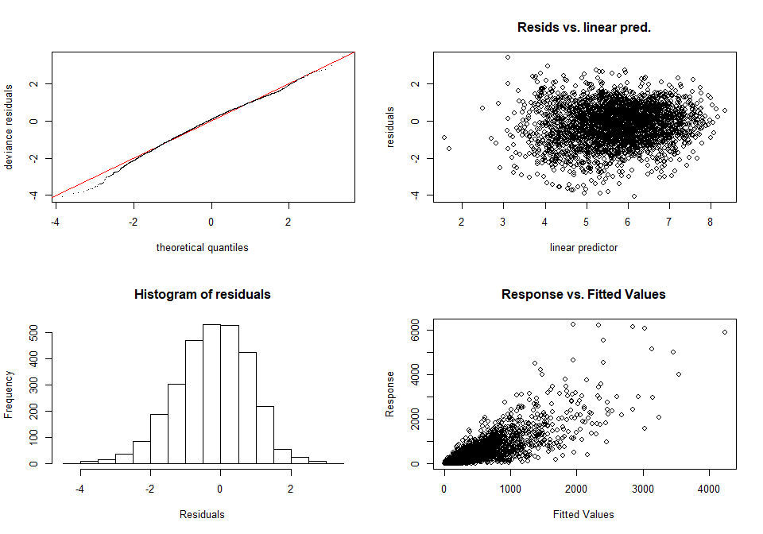

Method: UBRE Optimizer: outer newton  
step failed after 4 iterations.  
Gradient range [3.177403e-05,3.177403e-05]  
(score 0.1978389 & scale 1).  
Hessian positive definite, eigenvalue range [0.00153663,0.00153663].  
Model rank = 94 / 94   
  
Basis dimension (k) checking results. Low p-value (k-index<1) may  
indicate that k is too low, especially if edf is close to k'.  
  
 k' edf k-index p-value   
s(shootlon,shootlat) 29 25 0.74 <2e-16 ***  
---  
Signif. codes: 0 '***' 0.001 '**' 0.01 '*' 0.05 '.' 0.1 ' ' 1

##### page break

**Final model**

The final model was selected as the following model:

*Catch ~ offset(log(effort)) + year + vessel + month + sst + s(lat-lon)*

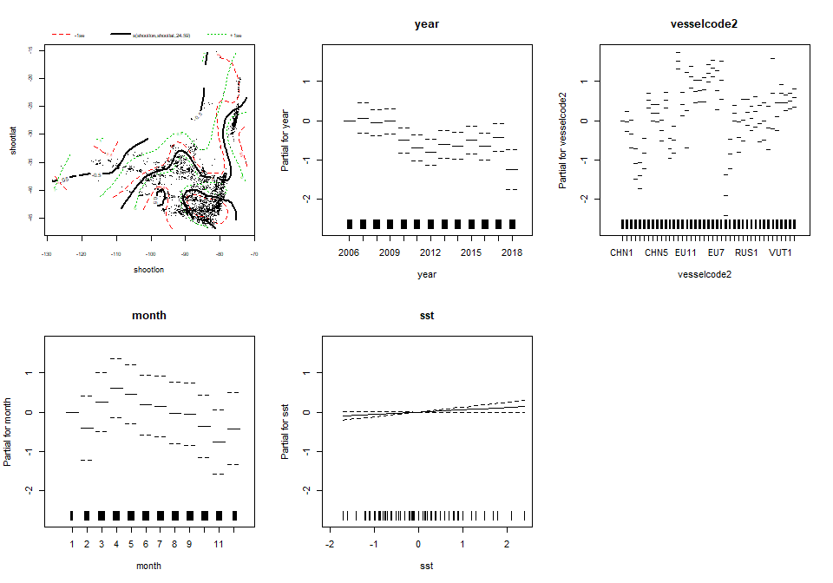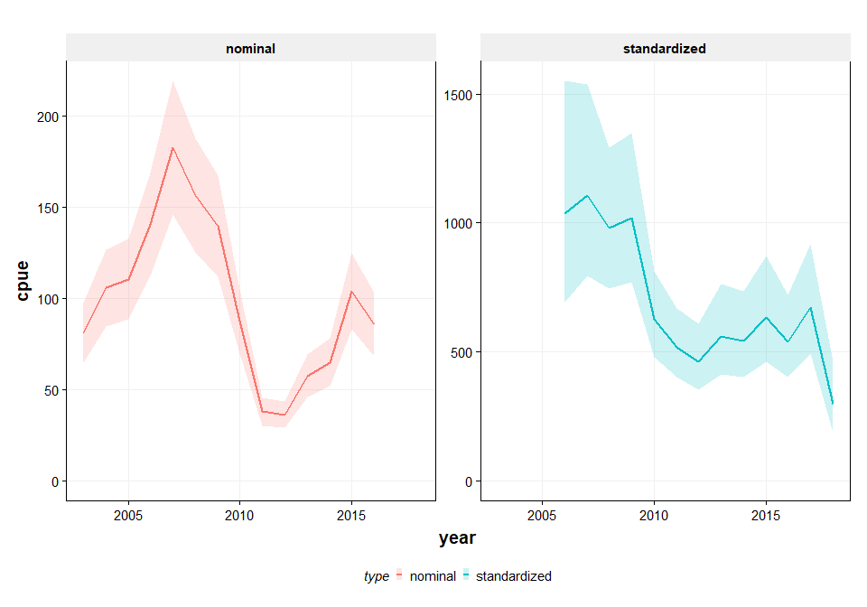

[1] "New standardized CPUE series"

year cpue upr lwr  
1 2006 1036 1549 693  
2 2007 1106 1538 796  
3 2008 980 1290 745  
4 2009 1018 1348 769  
5 2010 625 811 481  
6 2011 518 668 402  
7 2012 464 608 353  
8 2013 560 762 412  
9 2014 543 734 402  
10 2015 635 871 463  
11 2016 539 723 403  
12 2017 673 917 495  
13 2018 297 463 190

##### page break

**leave one out analysis**

The leave-one-out analysis shows that the signal of standardized CPUE is largely similar if data of one of the contracting parties is left out. Notably when the EU data is left out, the pattern and the variance is somewhat different from the other situations.

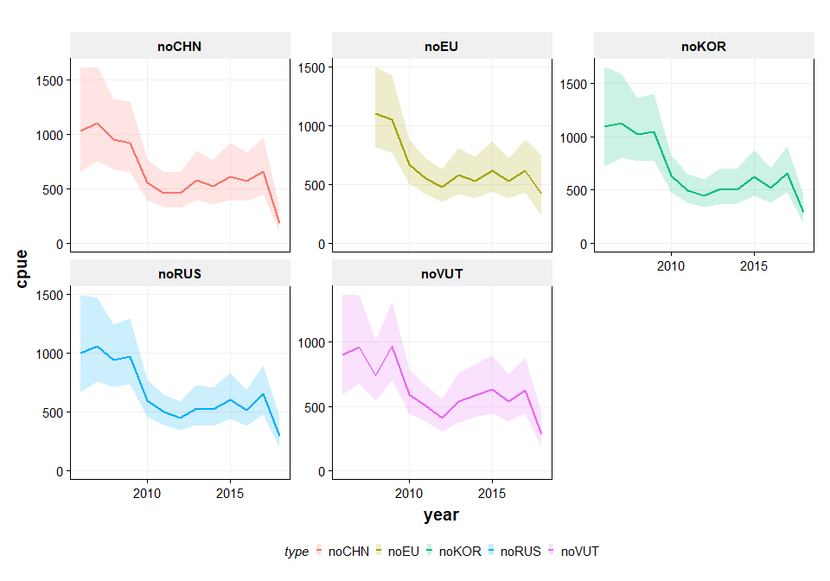

##### page break

**Only single fleet analyses**

The leave-one-out analysis shows that the signal of standardized CPUE is largely similar if data of one of the contracting parties is left out. Notably when the EU data is left out, the pattern and the variance is somewhat different from the other situations.

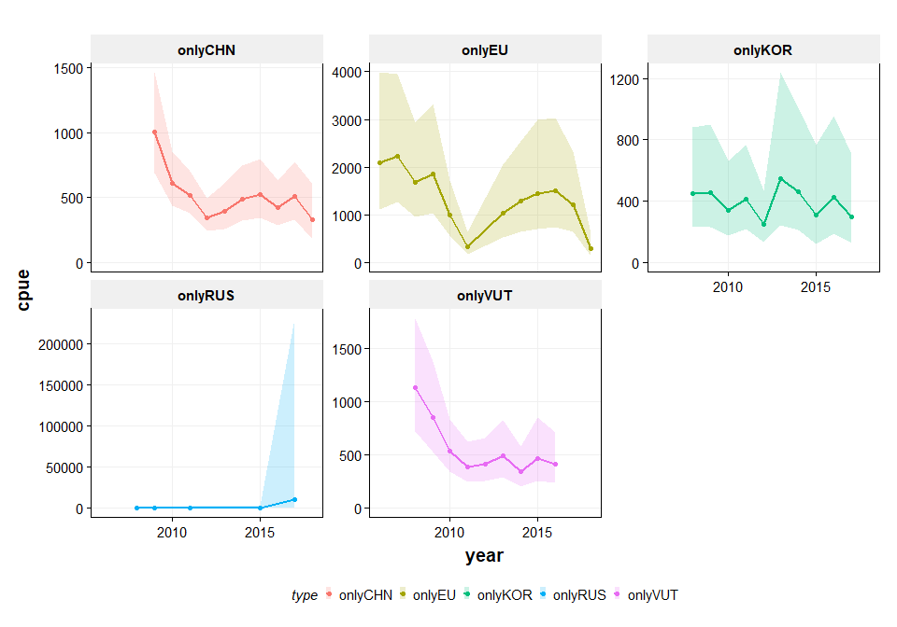

# Discussion and conclusions

[ THIS NEEDS TO BE UPDATED STILL !!]

The nominal CPUE of the offshore fleet fishing for Jack mackerel has so far beenused as a tuning index for the assessment. The index consists of the nominal average catch per fishing day for the fleets of EU, Vanuatu and Korea. China has standardized their CPUE series in 2013. The nominal CPUE series of Russia is also being used in the assessment.

This working document described the work aimed to standardizing the CPUE series of EU, Korea, vanuatu and Russia based on the haul-by-haul data contained in the SPRFMO database. Permission to utilize that information was granted by the delegations of Korea, Vanuatu and Russia while the analysis was carried out by scientists from the EU delegation.

The final model for standardizing the CPUE of these fleets models the catch by week and takes into account of the vessel, month, sea surface temperature anomaly and a smooth interaction between latitude and longitude with an offset of log effort (in number of days per week). The new standardized CPUE series starts in 2006 as this is the first year for which haul by haul information was available to carry out this analysis.

A ‘leave-one-out analysis’ was carried out by removing the data of one of the contracting parties from the analysis to explore the sensitivity of the results to the data being used. The conclusion from that analysis is that there is some sensitivity, especially when not using the EU data in the analysis.

# Acknowledgements

We would like to acknowledge the permission granted by the delegations of Russia, Vanuatu and Korea to utilize their haul-by-haul data for the analysis of standardized CPUE of the offshore fleet fishing for Jack mackerel. Sharing access to vessel data has made it possible to improve the indicator that can be used in the assessment.

# References

Li, G., X. Zou, X. Chen, Y. Zhou and M. Zhang (2013). “Standardization of CPUE for Chilean jack mackerel (Trachurus murphyi) from Chinese trawl fleets in the high seas of the Southeast Pacific Ocean.” Journal of Ocean University of China 12(3): 441-451.

SPRFMO (2011) Report of the Jack Mackerel Subgroup. Tenth Science Working Group of SPRFMO, 19 – 23 September 2011, Port Vila, Vanuatu.