PFA Horse mackerel move-on rule (closed area)
08/11/2019 12:55
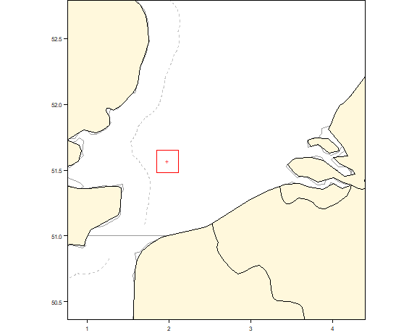
var data
------------ -----------------------
date 07 November 2019
bottomleft 01 50 59 E / 51 29 00
topright 02 07 00 E / 51 38 59
testing
More information
Please contact Gerard van Balsfoort (gbalsfoort@pelagicfish.eu) if you have any questions on the PFA horse mackerel move-on rule

