**Overview of SAM assessments for Greater argentine in 5b and 6a**

**ARU.27.5b6a_WGDEEP_2021; ARU.27.5b6a_WGDEEP_2022**

Martin Pastoors, 28/04/2022

**Catch numbers (Crayola)**

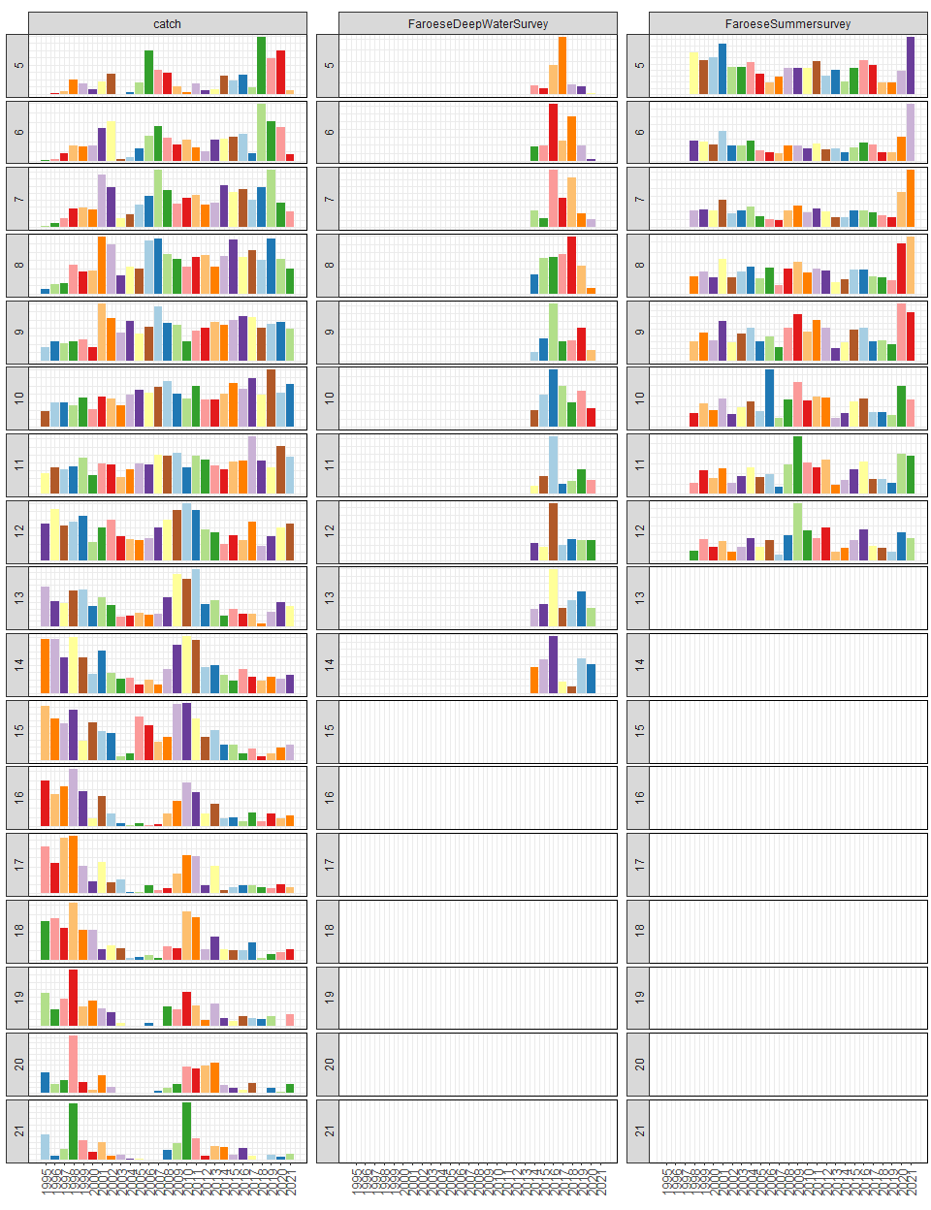

**Catch weights**

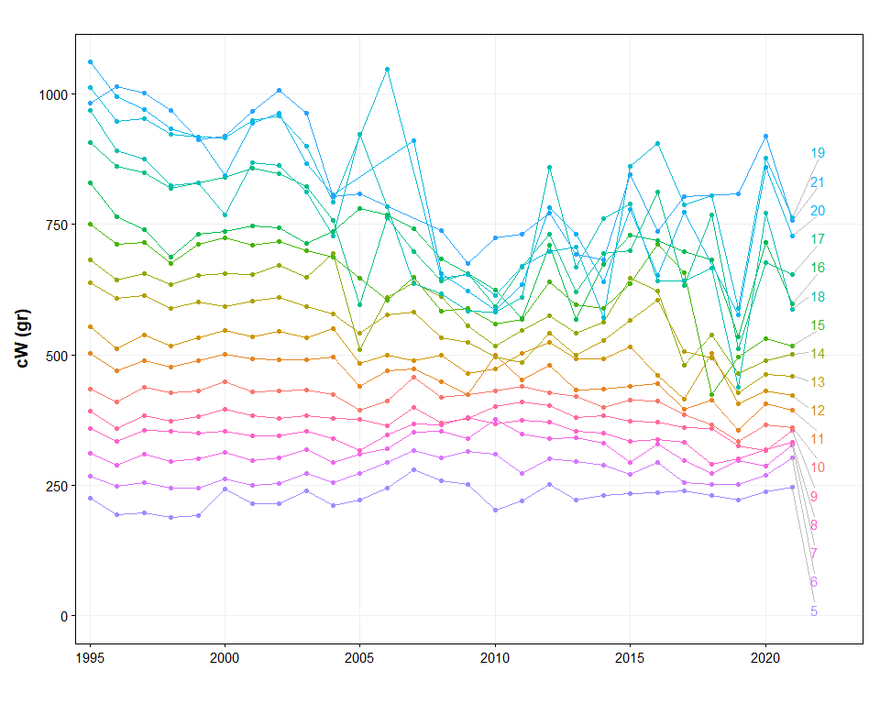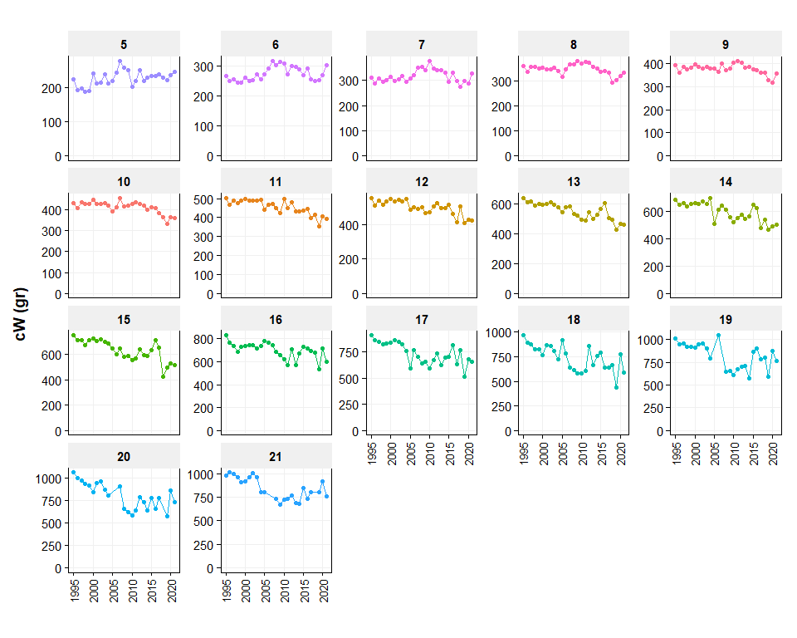

**fit the assessment**

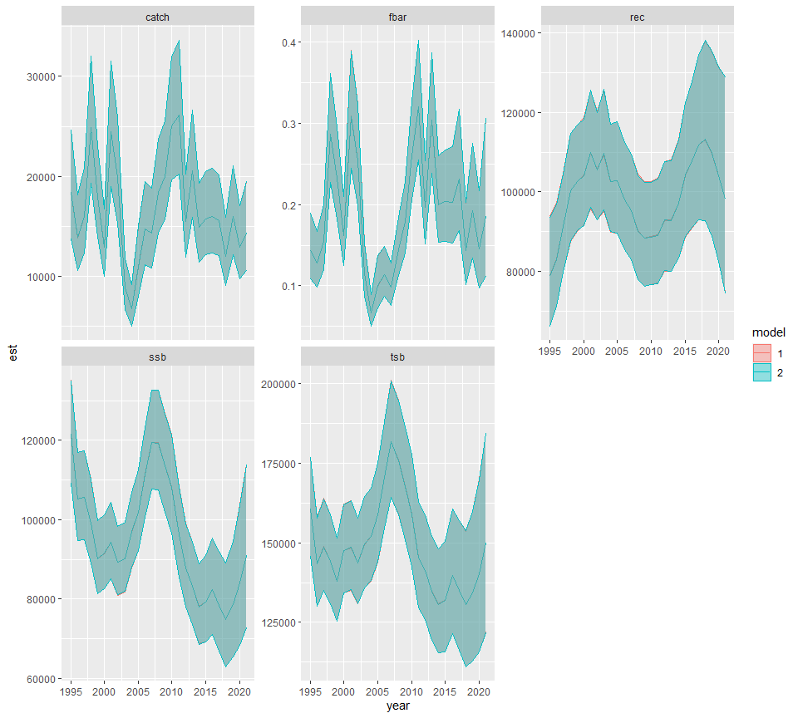

**Observed and predicted (logscale): catch**

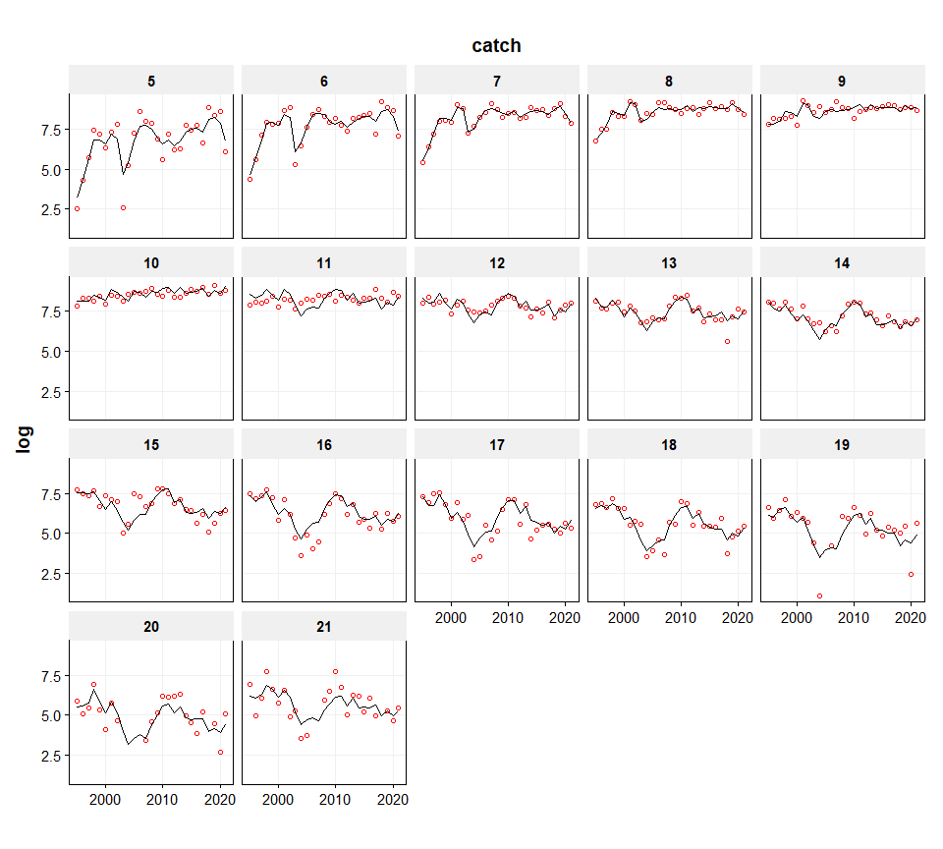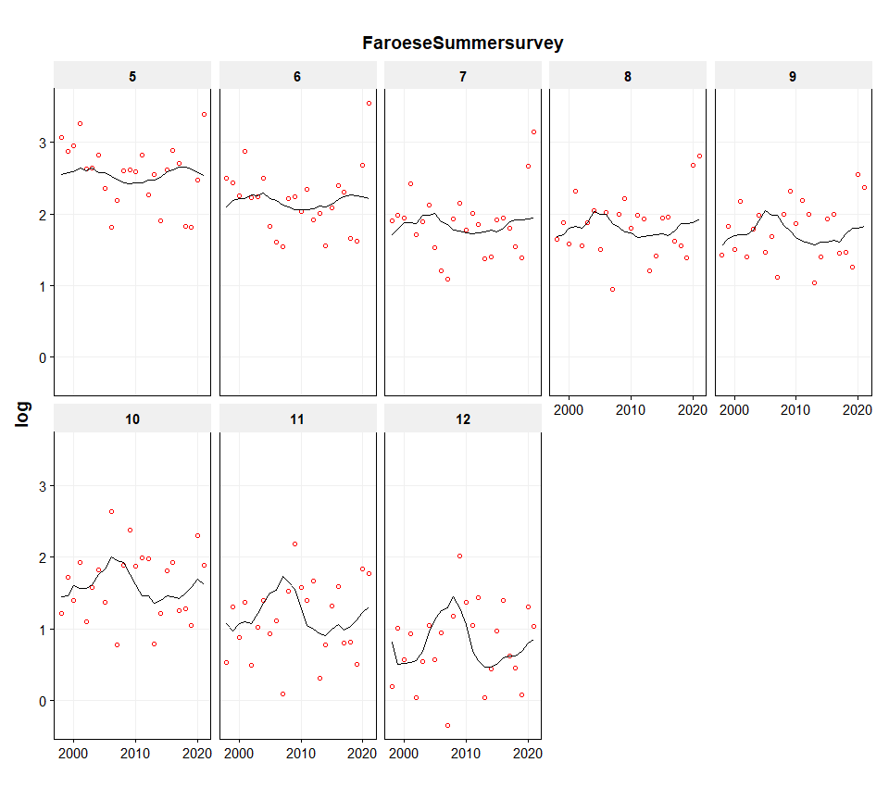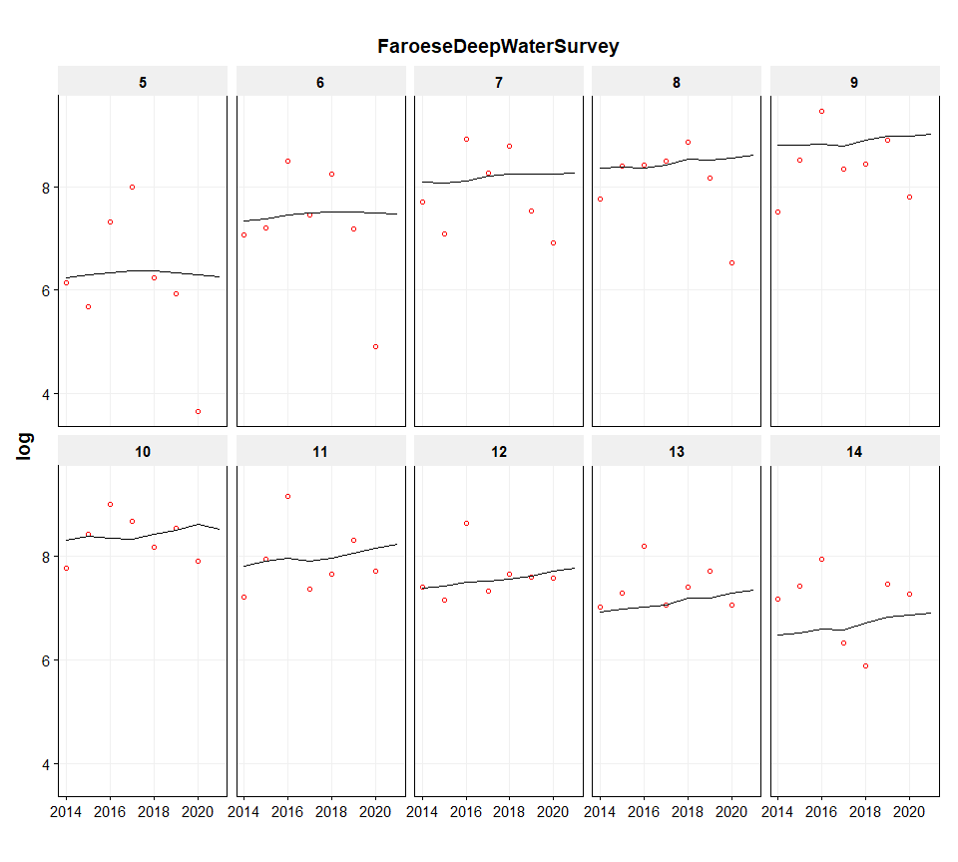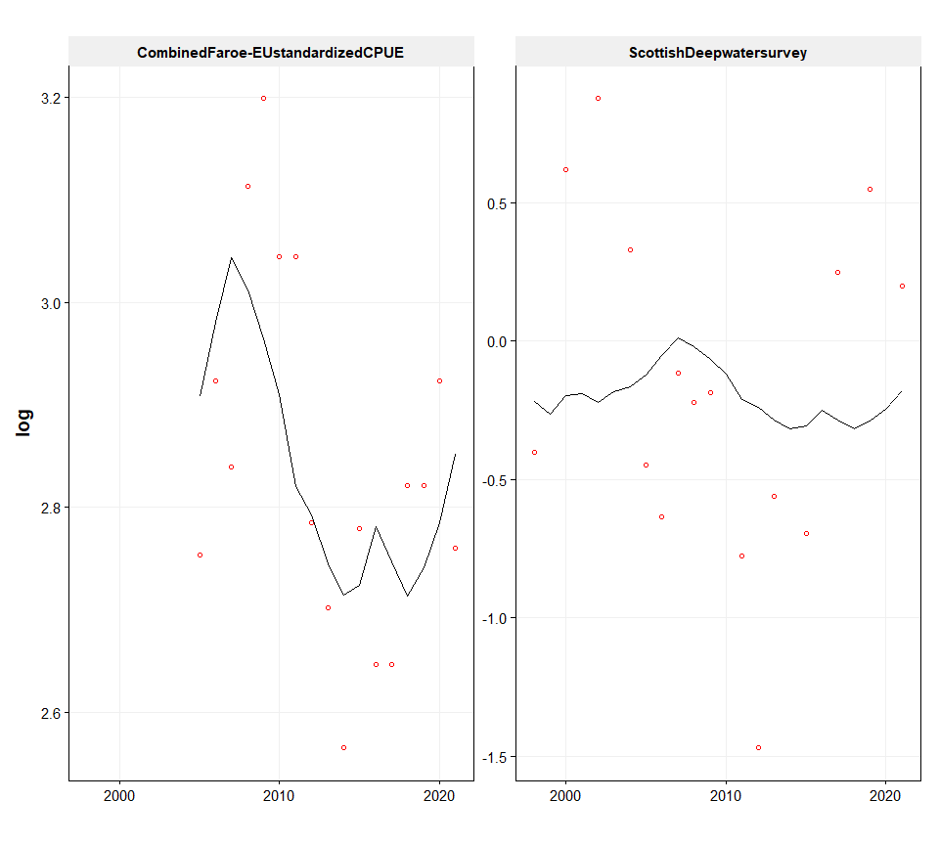

**Residuals**

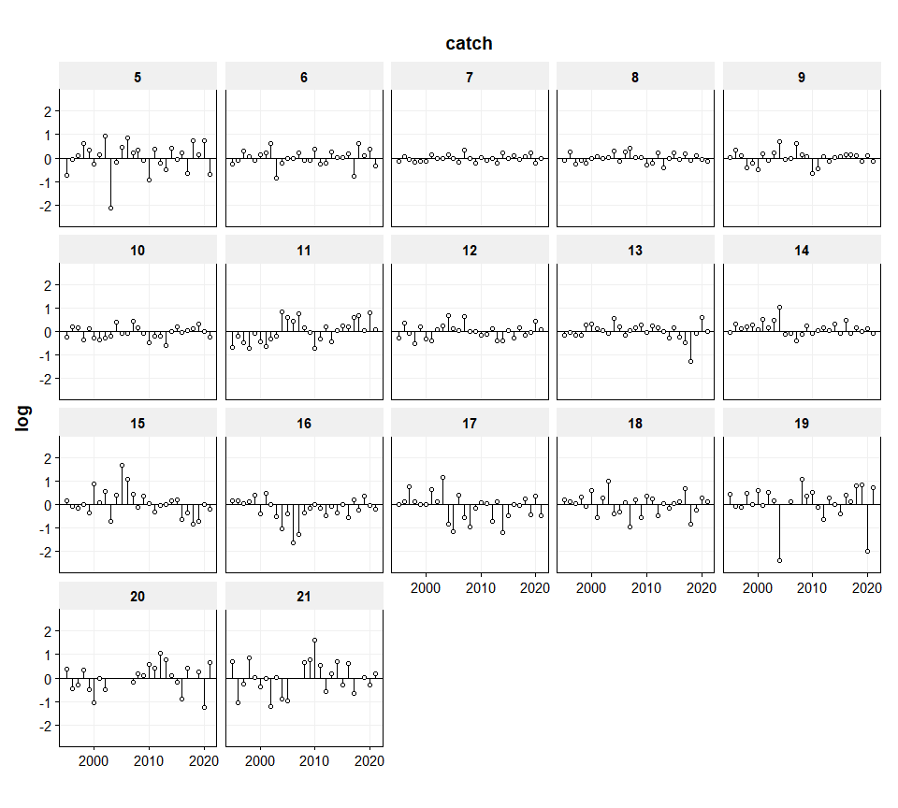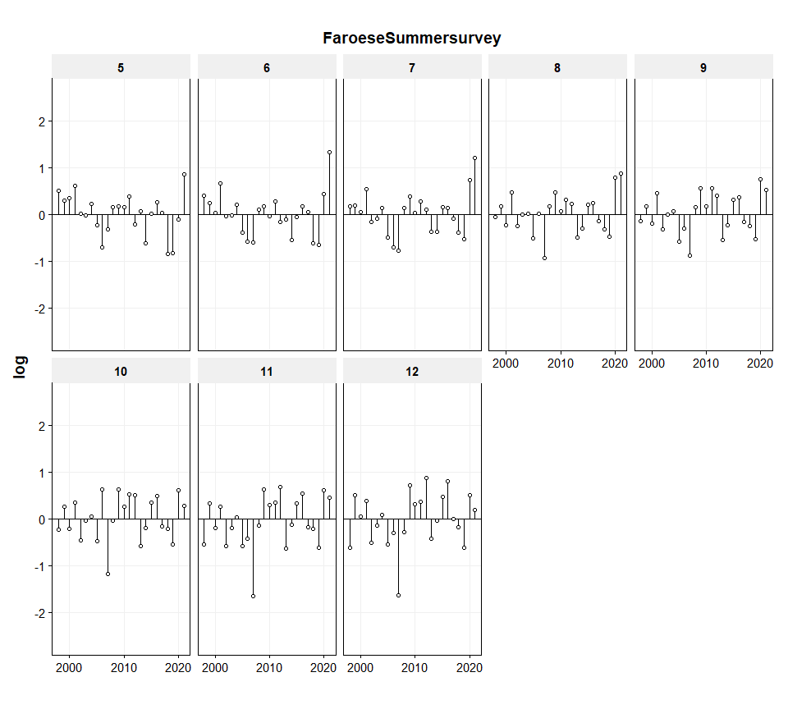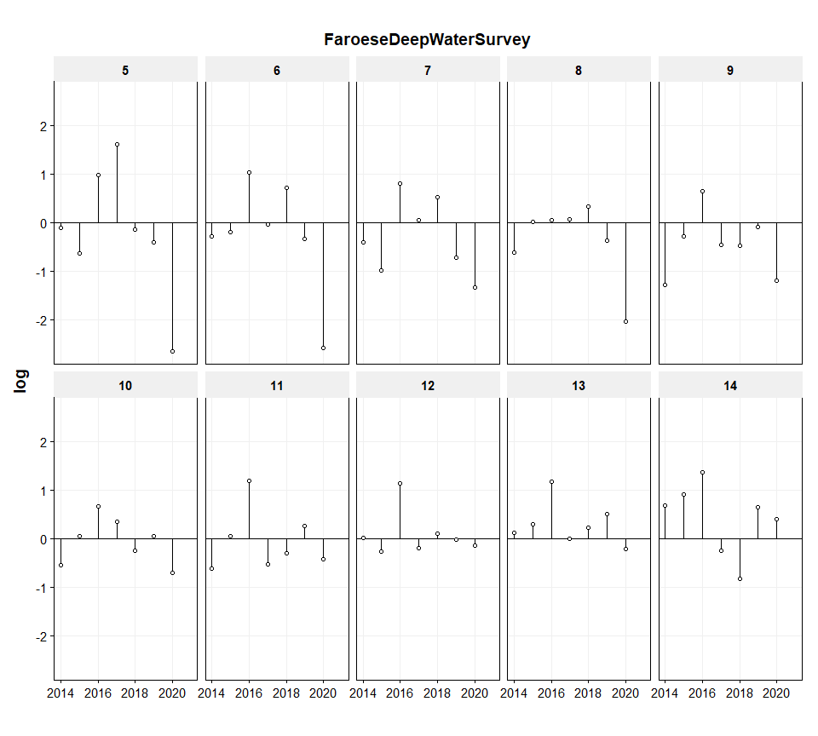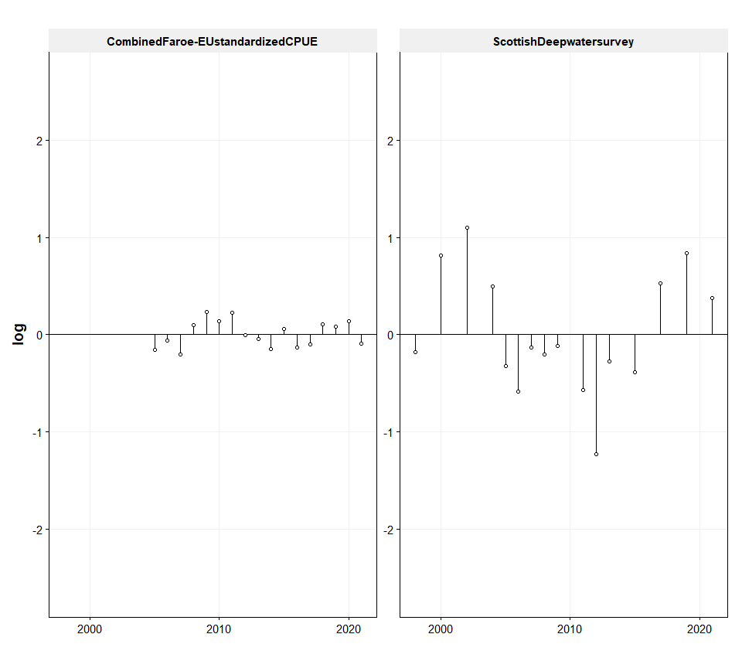

**One step ahead residuals**

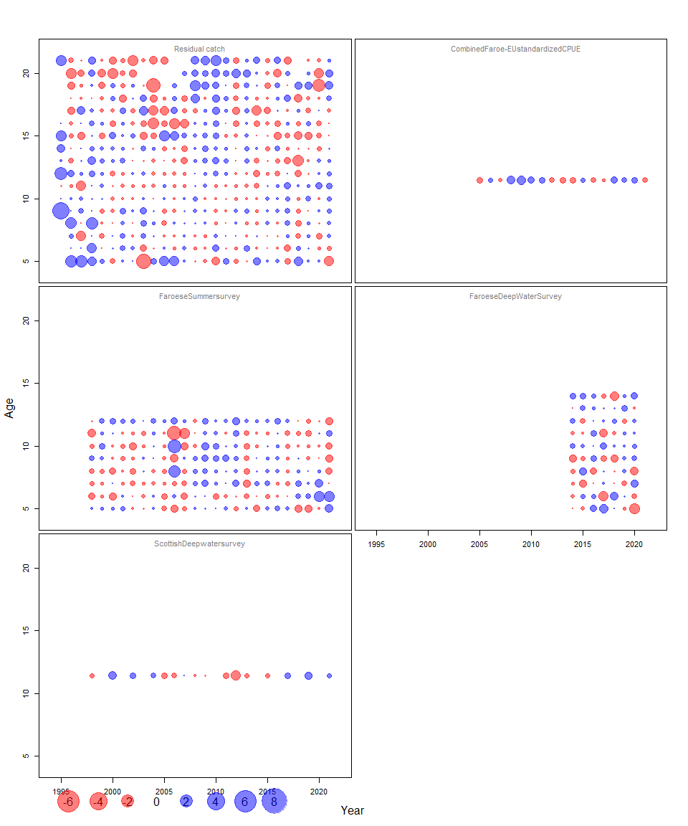

**Process residuals**

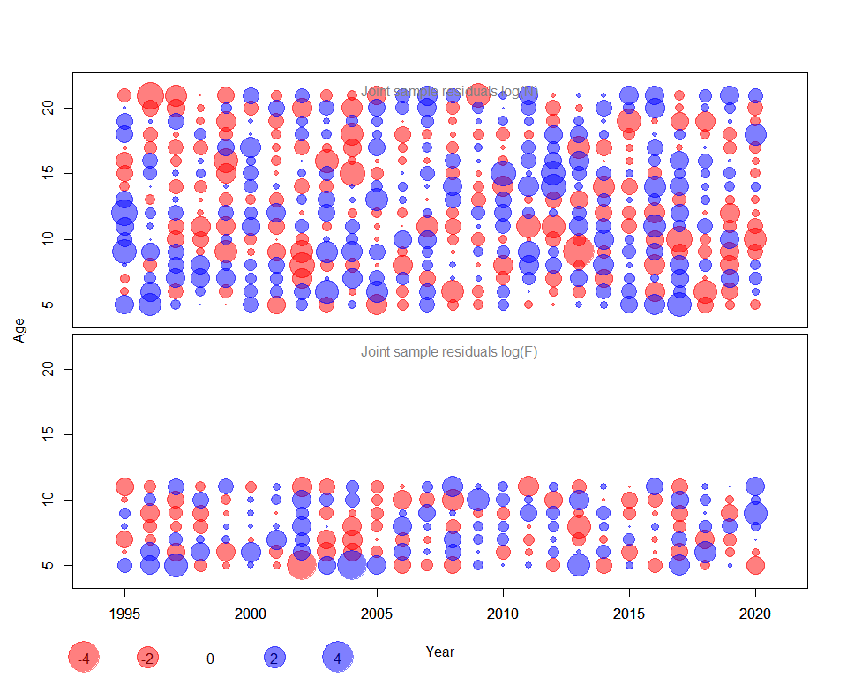

**Parameter estimates**

parameter parnumber par sdpar exppar low high  
---------------- ----------- --------- --------- ----------- ----------- -----------  
 logFpar 0 -8.86 0.1103 0.000142 0.0001139 0.0001771  
 logFpar 1 -9.052 0.1097 0.0001171 9.405e-05 0.0001458  
 logFpar 2 -9.16 0.1095 0.0001052 8.451e-05 0.0001309  
 logFpar 3 -8.921 0.1097 0.0001336 0.0001072 0.0001663  
 logFpar 4 -8.662 0.1105 0.000173 0.0001387 0.0002158  
 logFpar 5 -8.402 0.1124 0.0002244 0.0001792 0.0002809  
 logFpar 6 -5.123 0.3375 0.005959 0.003035 0.0117  
 logFpar 7 -3.785 0.331 0.02271 0.01171 0.04403  
 logFpar 8 -2.816 0.3214 0.05987 0.03148 0.1139  
 logFpar 9 -2.229 0.3076 0.1076 0.05818 0.1991  
 logFpar 10 -1.441 0.2894 0.2367 0.1327 0.4222  
 logFpar 11 -12.1 0.1579 5.574e-06 4.065e-06 7.644e-06  
 logFpar 12 -9.067 0.06504 0.0001154 0.0001014 0.0001315  
 logSdLogFsta 0 -0.4458 0.1391 0.6403 0.4849 0.8456  
 logSdLogN 0 -2.682 0.2837 0.06841 0.03879 0.1207  
 logSdLogObs 0 -0.6489 0.04111 0.5226 0.4814 0.5674  
 logSdLogObs 1 -0.7091 0.1174 0.4921 0.3891 0.6223  
 logSdLogObs 2 -0.1297 0.1779 0.8783 0.6153 1.254  
 logSdLogObs 3 -0.5014 0.1784 0.6057 0.424 0.8653  
 logSdLogObs 4 -1.958 0.1846 0.1412 0.09757 0.2042  
 transfIRARdist 0 -2.07 0.2671 0.1262 0.07395 0.2153  
 transfIRARdist 1 -1.189 0.4321 0.3047 0.1284 0.723  
 itrans rho 1.32 0.1658 3.743 2.687 5.216

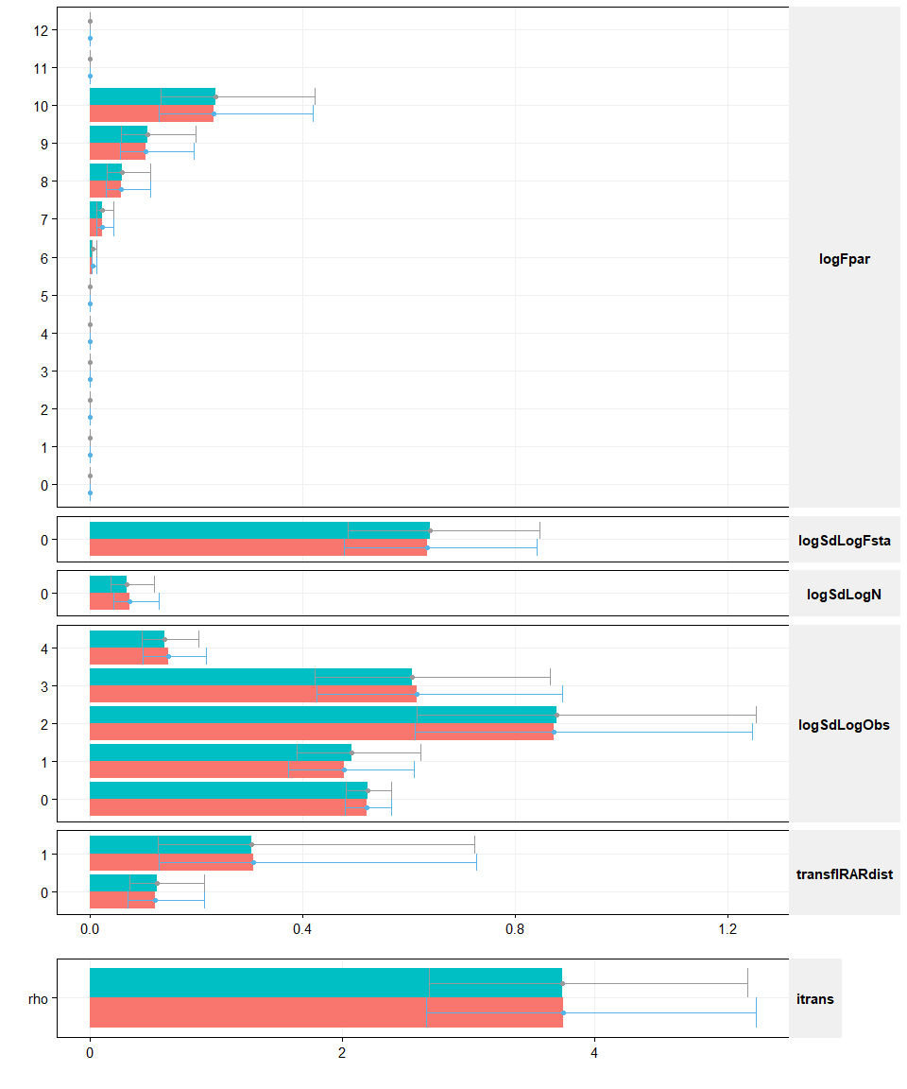

**Parameter estimates (by fleet)**

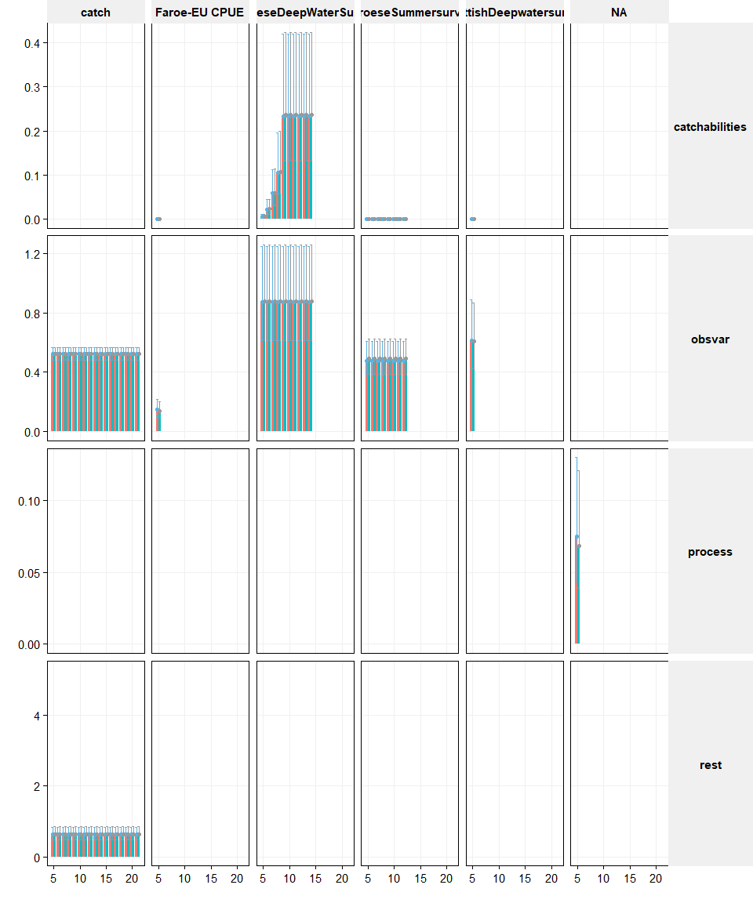

**Comparisons of the Assessments**

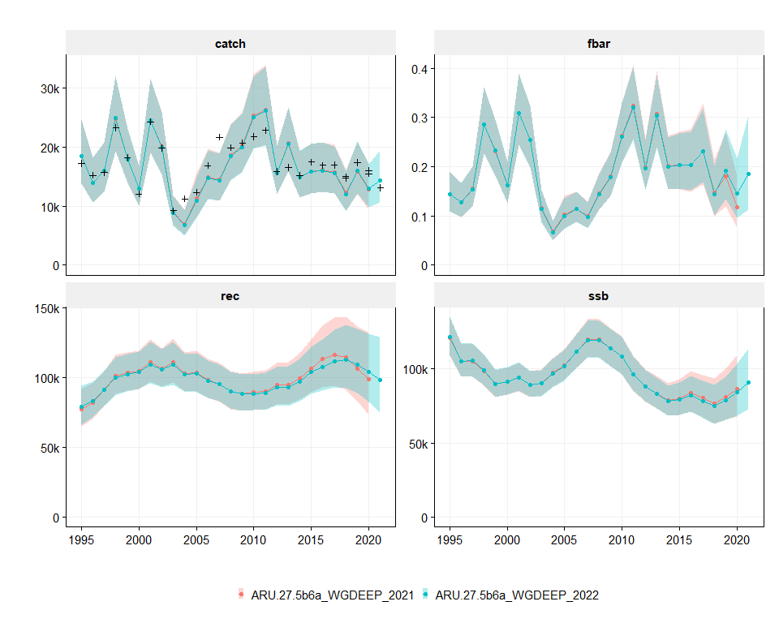

**Summary of the assessment**

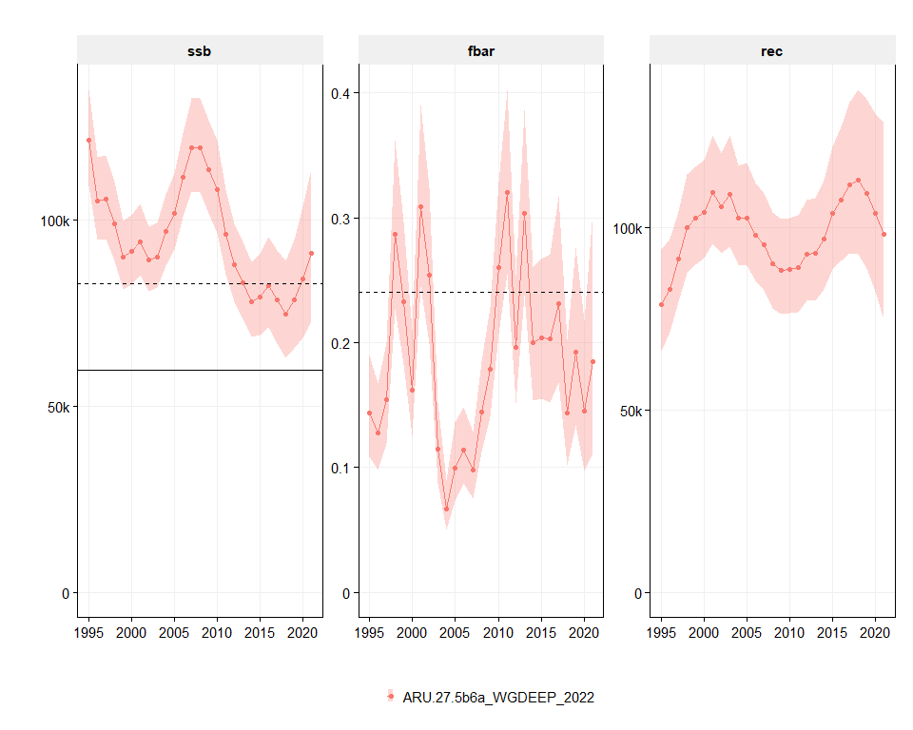

**Retro of the Assessments**

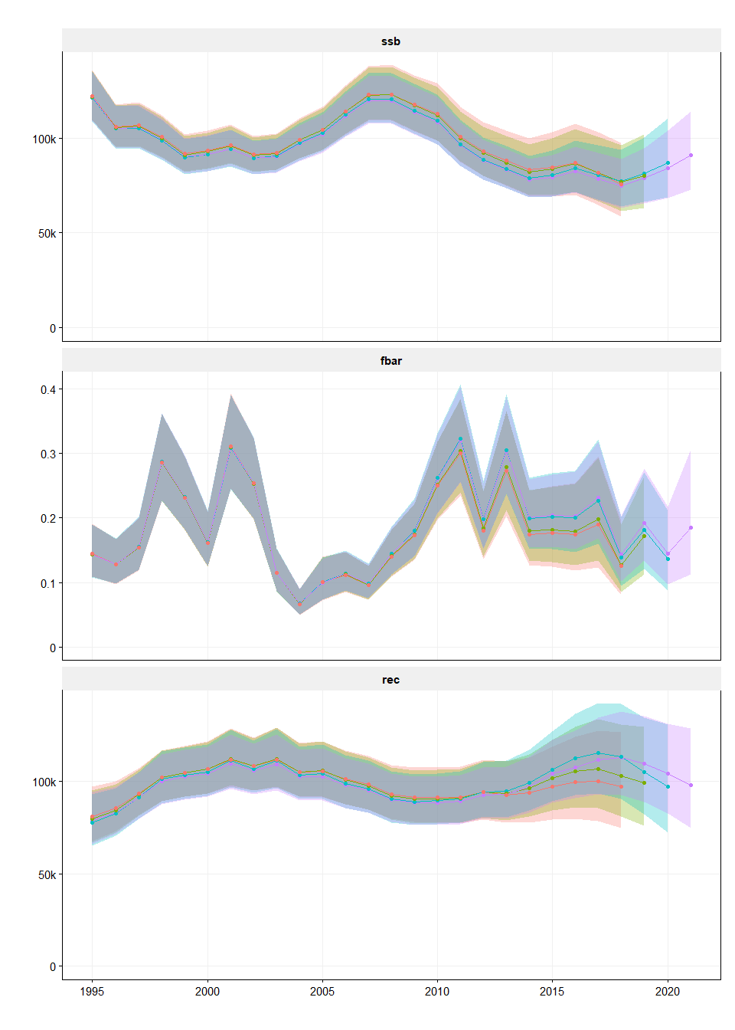

**Leave one out runs**

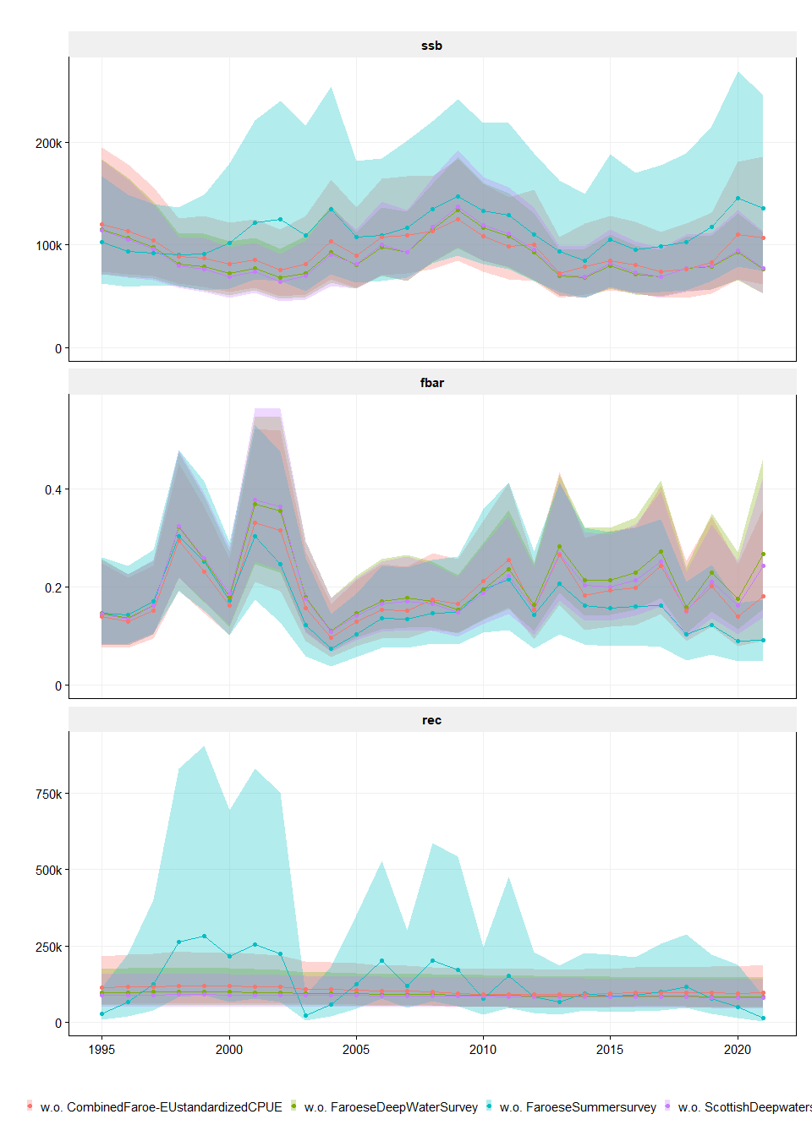

Forecast (Fsq)

year ft label var value  
------ ------- ------- ------- -----------------------  
 2022 0.185 Fsq fbar 0.185 (0.115-0.307)  
 2022 0.185 Fsq rec 104078 (89261-113113)  
 2022 0.185 Fsq ssb 89158 (69611-114233)  
 2022 0.185 Fsq catch 14238 (11037-17906)

ft label catch_2023 ssb_2023 ssb_2024  
------- -------- --------------------- ---------------------- -----------------------  
 0.185 Fsq 14497 (11511-17842) 89674 (68678-116086) 89768 (69028-116768)  
 0.0 Fzero 0 (0-0) 89674 (68678-116086) 103401 (83511-130180)  
 0.24 Fmsy 18195 (14609-21928) 89674 (68678-116086) 86376 (65664-113367)  
 0.33 Fp0.5 23728 (19393-28090) 89674 (68678-116086) 81192 (61106-108095)  
 0.01 F=0.01 874 (670-1141) 89674 (68678-116086) 102618 (82505-129432)  
 0.02 F=0.02 1738 (1335-2253) 89674 (68678-116086) 101847 (81655-128690)  
 0.03 F=0.03 2590 (1995-3352) 89674 (68678-116086) 101032 (80755-127953)  
 0.04 F=0.04 3432 (2651-4420) 89674 (68678-116086) 100231 (79846-127221)  
 0.05 F=0.05 4266 (3301-5457) 89674 (68678-116086) 99464 (78950-126495)  
 0.06 F=0.06 5090 (3947-6460) 89674 (68678-116086) 98658 (78075-125774)  
 0.07 F=0.07 5902 (4581-7459) 89674 (68678-116086) 97944 (77268-125060)  
 0.08 F=0.08 6702 (5207-8452) 89674 (68678-116086) 97134 (76481-124352)  
 0.09 F=0.09 7494 (5825-9398) 89674 (68678-116086) 96392 (75708-123505)  
 0.1 F=0.1 8272 (6439-10353) 89674 (68678-116086) 95606 (74900-122610)  
 0.11 F=0.11 9037 (7058-11269) 89674 (68678-116086) 94909 (74205-121725)  
 0.12 F=0.12 9789 (7673-12215) 89674 (68678-116086) 94196 (73472-120847)  
 0.13 F=0.13 10537 (8272-13124) 89674 (68678-116086) 93471 (72755-120133)  
 0.14 F=0.14 11289 (8862-14023) 89674 (68678-116086) 92739 (72050-119509)  
 0.15 F=0.15 12026 (9451-14838) 89674 (68678-116086) 92086 (71357-118890)  
 0.16 F=0.16 12747 (10044-15681) 89674 (68678-116086) 91450 (70677-118275)  
 0.17 F=0.17 13452 (10634-16557) 89674 (68678-116086) 90783 (70008-117668)  
 0.18 F=0.18 14156 (11220-17420) 89674 (68678-116086) 90094 (69352-117067)  
 0.19 F=0.19 14837 (11801-18224) 89674 (68678-116086) 89456 (68724-116470)  
 0.2 F=0.2 15517 (12378-18935) 89674 (68678-116086) 88805 (68089-115877)  
 0.21 F=0.21 16193 (12947-19712) 89674 (68678-116086) 88172 (67455-115289)  
 0.22 F=0.22 16858 (13506-20435) 89674 (68678-116086) 87559 (66884-114703)  
 0.23 F=0.23 17522 (14060-21175) 89674 (68678-116086) 86963 (66282-114089)  
 0.24 F=0.24 18195 (14609-21928) 89674 (68678-116086) 86376 (65664-113367)  
 0.25 F=0.25 18840 (15153-22680) 89674 (68678-116086) 85779 (65057-112651)  
 0.26 F=0.26 19480 (15694-23371) 89674 (68678-116086) 85148 (64482-111941)  
 0.27 F=0.27 20110 (16237-24097) 89674 (68678-116086) 84574 (63941-111360)  
 0.28 F=0.28 20729 (16776-24754) 89674 (68678-116086) 84008 (63446-110785)  
 0.29 F=0.29 21340 (17304-25476) 89674 (68678-116086) 83425 (62960-110142)  
 0.3 F=0.3 21946 (17827-26165) 89674 (68678-116086) 82849 (62483-109576)

Forecast (TAC constraint)

year var value  
------ ------- -----------------------  
 2022 fbar 0.434 (0.271-0.72)  
 2022 rec 104078 (89261-113113)  
 2022 ssb 90180 (70842-115253)  
 2022 catch 29626 (23728-35753)

ft label catch_2023 ssb_2023 ssb_2024  
------- ----------- --------------------- ---------------------- ----------------------  
 0.185 TC-Fsq 11793 (9800-13911) 76498 (56986-102339) 79827 (60768-106247)  
 0 TC-Fzero 0 (0-0) 76498 (56986-102339) 90670 (71465-116799)  
 0.24 TC-Fmsy 14850 (12399-17327) 76498 (56986-102339) 77013 (58128-103311)  
 0.33 TC-Fp0.5 19424 (16319-22508) 76498 (56986-102339) 72828 (54719-99145)  
 0.01 TC-F=0.01 707 (572-886) 76498 (56986-102339) 89994 (70739-116056)  
 0.02 TC-F=0.02 1408 (1140-1757) 76498 (56986-102339) 89377 (70030-115452)  
 0.03 TC-F=0.03 2100 (1703-2603) 76498 (56986-102339) 88768 (69342-114872)  
 0.04 TC-F=0.04 2781 (2260-3434) 76498 (56986-102339) 88176 (68839-114295)  
 0.05 TC-F=0.05 3456 (2813-4231) 76498 (56986-102339) 87577 (68230-113719)  
 0.06 TC-F=0.06 4125 (3360-5044) 76498 (56986-102339) 87001 (67595-113146)  
 0.07 TC-F=0.07 4786 (3899-5821) 76498 (56986-102339) 86365 (66977-112467)  
 0.08 TC-F=0.08 5435 (4439-6582) 76498 (56986-102339) 85752 (66339-111762)  
 0.09 TC-F=0.09 6077 (4972-7337) 76498 (56986-102339) 85170 (65703-111063)  
 0.1 TC-F=0.1 6710 (5499-8070) 76498 (56986-102339) 84561 (65083-110534)  
 0.11 TC-F=0.11 7331 (6023-8773) 76498 (56986-102339) 83967 (64480-110021)  
 0.12 TC-F=0.12 7943 (6540-9503) 76498 (56986-102339) 83415 (63902-109517)  
 0.13 TC-F=0.13 8555 (7054-10220) 76498 (56986-102339) 82862 (63452-108989)  
 0.14 TC-F=0.14 9154 (7569-10928) 76498 (56986-102339) 82272 (63008-108483)  
 0.15 TC-F=0.15 9755 (8083-11627) 76498 (56986-102339) 81690 (62537-107981)  
 0.16 TC-F=0.16 10346 (8568-12310) 76498 (56986-102339) 81131 (62037-107481)  
 0.17 TC-F=0.17 10925 (9063-12973) 76498 (56986-102339) 80615 (61532-106985)  
 0.18 TC-F=0.18 11502 (9555-13609) 76498 (56986-102339) 80088 (61021-106492)  
 0.19 TC-F=0.19 12083 (10050-14240) 76498 (56986-102339) 79568 (60518-106002)  
 0.2 TC-F=0.2 12646 (10529-14895) 76498 (56986-102339) 79044 (60024-105514)  
 0.21 TC-F=0.21 13216 (11005-15550) 76498 (56986-102339) 78549 (59538-105030)  
 0.22 TC-F=0.22 13769 (11472-16119) 76498 (56986-102339) 78044 (59060-104521)  
 0.23 TC-F=0.23 14315 (11935-16729) 76498 (56986-102339) 77545 (58589-103914)  
 0.24 TC-F=0.24 14850 (12399-17327) 76498 (56986-102339) 77013 (58128-103311)  
 0.25 TC-F=0.25 15368 (12846-17961) 76498 (56986-102339) 76540 (57757-102749)  
 0.26 TC-F=0.26 15885 (13295-18589) 76498 (56986-102339) 76038 (57345-102286)  
 0.27 TC-F=0.27 16413 (13741-19209) 76498 (56986-102339) 75545 (56920-101826)  
 0.28 TC-F=0.28 16928 (14200-19823) 76498 (56986-102339) 75051 (56529-101370)  
 0.29 TC-F=0.29 17444 (14660-20411) 76498 (56986-102339) 74580 (56153-100918)  
 0.3 TC-F=0.3 17949 (15068-20957) 76498 (56986-102339) 74127 (55784-100470)

Forecast (Catch constraint)

---------- --------- -----------  
 **year** **var** **value**  
---------- --------- -----------

ft label catch_2023 ssb_2023 ssb_2024  
------- ----------- --------------------- ---------------------- ----------------------  
 0.185 CC-Fsq 13617 (11003-16427) 85233 (64500-111776) 86573 (66127-113379)  
 0 CC-Fzero 0 (0-0) 85233 (64500-111776) 99353 (79272-126263)  
 0.24 CC-Fmsy 17081 (13947-20271) 85233 (64500-111776) 83291 (63031-109893)  
 0.33 CC-Fp0.5 22299 (18421-26045) 85233 (64500-111776) 78424 (58903-105288)  
 0.01 CC-F=0.01 821 (640-1041) 85233 (64500-111776) 98619 (78490-125543)  
 0.02 CC-F=0.02 1632 (1275-2059) 85233 (64500-111776) 97891 (77706-124828)  
 0.03 CC-F=0.03 2430 (1905-3057) 85233 (64500-111776) 97121 (76877-124120)  
 0.04 CC-F=0.04 3222 (2531-4044) 85233 (64500-111776) 96341 (76012-123245)  
 0.05 CC-F=0.05 4004 (3153-5015) 85233 (64500-111776) 95572 (75156-122347)  
 0.06 CC-F=0.06 4776 (3771-5960) 85233 (64500-111776) 94852 (74325-121458)  
 0.07 CC-F=0.07 5532 (4384-6893) 85233 (64500-111776) 94145 (73601-120578)  
 0.08 CC-F=0.08 6278 (4985-7799) 85233 (64500-111776) 93428 (73023-119766)  
 0.09 CC-F=0.09 7016 (5579-8674) 85233 (64500-111776) 92698 (72292-119146)  
 0.1 CC-F=0.1 7739 (6166-9585) 85233 (64500-111776) 92052 (71506-118530)  
 0.11 CC-F=0.11 8453 (6748-10435) 85233 (64500-111776) 91381 (70744-117941)  
 0.12 CC-F=0.12 9168 (7327-11265) 85233 (64500-111776) 90695 (70050-117316)  
 0.13 CC-F=0.13 9867 (7909-12082) 85233 (64500-111776) 90016 (69407-116718)  
 0.14 CC-F=0.14 10563 (8486-12911) 85233 (64500-111776) 89355 (68779-116125)  
 0.15 CC-F=0.15 11238 (9060-13727) 85233 (64500-111776) 88716 (68137-115537)  
 0.16 CC-F=0.16 11928 (9630-14529) 85233 (64500-111776) 88091 (67567-114952)  
 0.17 CC-F=0.17 12612 (10184-15252) 85233 (64500-111776) 87473 (66982-114369)  
 0.18 CC-F=0.18 13286 (10732-16034) 85233 (64500-111776) 86869 (66409-113738)  
 0.19 CC-F=0.19 13941 (11266-16806) 85233 (64500-111776) 86265 (65849-113020)  
 0.2 CC-F=0.2 14568 (11797-17500) 85233 (64500-111776) 85647 (65273-112308)  
 0.21 CC-F=0.21 15192 (12342-18229) 85233 (64500-111776) 85028 (64692-111604)  
 0.22 CC-F=0.22 15827 (12880-18922) 85233 (64500-111776) 84431 (64124-111075)  
 0.23 CC-F=0.23 16460 (13416-19602) 85233 (64500-111776) 83849 (63571-110532)  
 0.24 CC-F=0.24 17081 (13947-20271) 85233 (64500-111776) 83291 (63031-109893)  
 0.25 CC-F=0.25 17681 (14475-20982) 85233 (64500-111776) 82740 (62504-109354)  
 0.26 CC-F=0.26 18278 (14989-21703) 85233 (64500-111776) 82165 (61989-108858)  
 0.27 CC-F=0.27 18863 (15500-22382) 85233 (64500-111776) 81628 (61514-108366)  
 0.28 CC-F=0.28 19450 (16022-23006) 85233 (64500-111776) 81078 (61058-107877)  
 0.29 CC-F=0.29 20045 (16525-23593) 85233 (64500-111776) 80574 (60611-107392)  
 0.3 CC-F=0.3 20608 (17030-24254) 85233 (64500-111776) 79984 (60173-106910)