WD xx, WGDEEP 2022

**Overview of InterCatch files 2021 for Greater argentine in 5b and 6a**

aru.27.5b6a_2021_ 2022-4-13 13_35_18

Martin Pastoors, 28/04/2022

**Catch in tonnes by division**

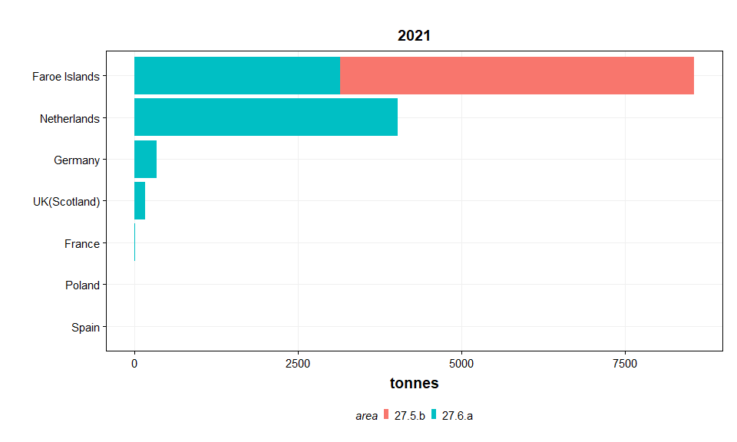

**Sampled age distributions by division and country**

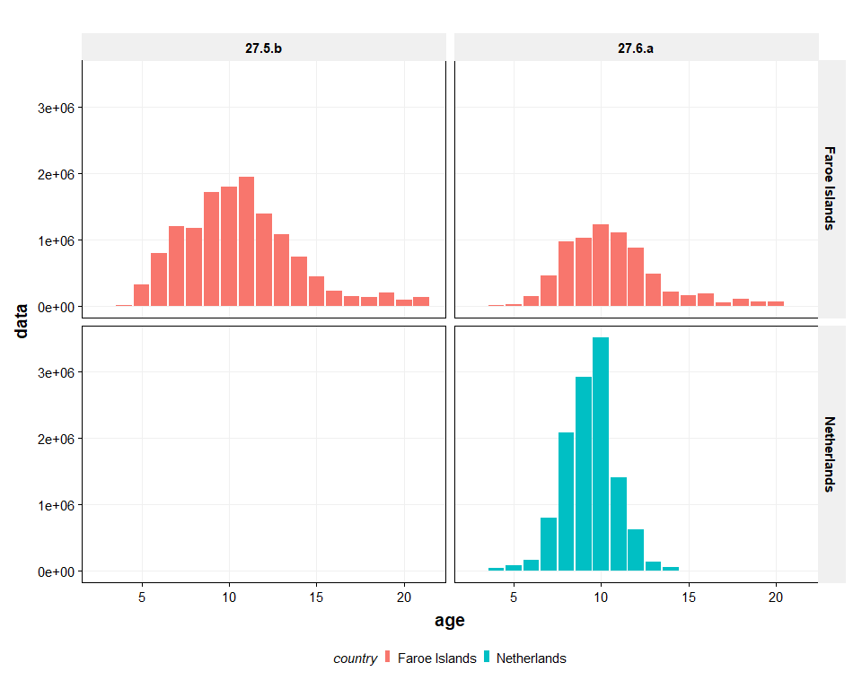

*Figure 1: Sampled distributions of Greater argentine in 2021*

**Sampled age distributions by division and country**

