Red Pulse MVP Database Design
SCRUM-47 - Initial relational schema and ER model
Red Pulse - Management Analytics Dashboard
Database design baseline for the MVP analytics platform.

1. Purpose and scope
This document defines the initial PostgreSQL relational model for Red Pulse. The model is intentionally lean: it supports the seven MVP analytics areas (Revenue, Players, Retention, Games, Bonus, Geography and Technical) without attempting to reproduce a full transactional casino platform database.
The model stores pseudonymised player identifiers only. Direct personal information such as name, email, phone number or postal address is out of scope for this analytics database.

2. Design principles
- PostgreSQL-native types: BIGSERIAL keys, TIMESTAMPTZ timestamps and NUMERIC(18,2) monetary values.
- UTC-oriented event timestamps so all dashboard date filtering is consistent.
- Reference/master tables for markets, providers, games and players; fact tables for bets, cash transactions, bonuses and technical metrics.
- Market/provider identifiers are retained on high-volume fact rows where they provide a stable reporting snapshot and efficient filtering.
- Derived dashboard metrics such as GGR, retention and activation rate are calculated from facts rather than persisted as duplicated totals.
- The initial schema is development/MVP focused and can later be extended with brands, wallets, sessions, payment fees, taxes or warehouse aggregates.

3. Entity-relationship diagram
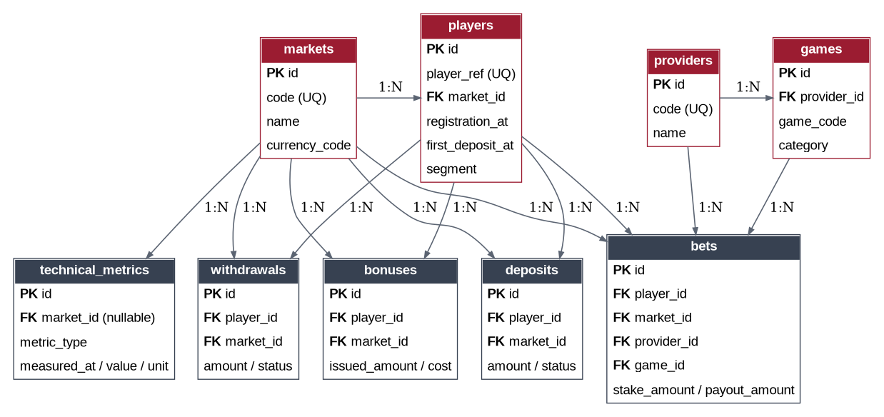
Figure 1. Red Pulse MVP entity relationships. Fact tables are shown in dark grey; master/reference entities use the Red Pulse accent.

4. Table catalogue
Table | Role | Purpose
markets | Reference | Reporting market / jurisdiction and reporting currency.
players | Master | Pseudonymised player record used for cohorts, segmentation and activity.
providers | Reference | Game/content provider.
games | Reference | Game catalogue belonging to providers.
bets | Fact | Betting activity; primary source for turnover, GGR, RTP and game activity.
deposits | Fact | Deposit lifecycle; supports successful deposits and FTD analysis.
withdrawals | Fact | Withdrawal lifecycle and cash-out reporting.
bonuses | Fact | Bonus issue/activation/cost data.
technical_metrics | Fact | Hourly or periodic platform health measurements.

markets
Column | Type | Constraint | Meaning
id | BIGSERIAL | PK | Surrogate key
code | VARCHAR(10) | UQ, NOT NULL | Stable market code, e.g. GB
name | VARCHAR(100) | NOT NULL | Display name
region | VARCHAR(100) | Nullable | Reporting region
currency_code | CHAR(3) | NOT NULL | ISO-style currency code
is_active | BOOLEAN | NOT NULL | Soft availability flag
created_at / updated_at | TIMESTAMPTZ | NOT NULL | Audit timestamps

players
Column | Type | Constraint | Meaning
id | BIGSERIAL | PK | Surrogate key
player_ref | VARCHAR(64) | UQ, NOT NULL | Pseudonymised external reference
market_id | BIGINT | FK, NOT NULL | Home/reporting market
registration_at | TIMESTAMPTZ | NOT NULL | Cohort registration timestamp
first_deposit_at | TIMESTAMPTZ | Nullable | First successful deposit timestamp
status | VARCHAR(30) | CHECK | active/blocked/closed/self_excluded
is_test | BOOLEAN | NOT NULL | Development/test-account exclusion flag
segment | VARCHAR(30) | CHECK, Nullable | VIP/Regular/Casual/Dormant
created_at / updated_at | TIMESTAMPTZ | NOT NULL | Audit timestamps

providers
Column | Type | Constraint | Meaning
id | BIGSERIAL | PK | Surrogate key
code | VARCHAR(50) | UQ, NOT NULL | Provider code
name | VARCHAR(100) | NOT NULL | Provider display name
is_active | BOOLEAN | NOT NULL | Availability flag
created_at / updated_at | TIMESTAMPTZ | NOT NULL | Audit timestamps

games
Column | Type | Constraint | Meaning
id | BIGSERIAL | PK | Surrogate key
provider_id | BIGINT | FK, NOT NULL | Owning provider
game_code | VARCHAR(100) | UQ per provider | Provider game identifier
name | VARCHAR(150) | NOT NULL | Game name
category | VARCHAR(50) | NOT NULL | Slots/Table/Live Casino etc.
is_active | BOOLEAN | NOT NULL | Availability flag
created_at / updated_at | TIMESTAMPTZ | NOT NULL | Audit timestamps

bets
Column | Type | Constraint | Meaning
id | BIGSERIAL | PK | Surrogate key
bet_ref | VARCHAR(100) | UQ, NOT NULL | Synthetic/external bet reference
player_id | BIGINT | FK, NOT NULL | Player
market_id | BIGINT | FK, NOT NULL | Reporting market snapshot
provider_id | BIGINT | FK, NOT NULL | Provider snapshot
game_id | BIGINT | FK, NOT NULL | Game
placed_at / settled_at | TIMESTAMPTZ | Placed required | Bet lifecycle timestamps
status | VARCHAR(30) | CHECK | open/settled/void/cancelled
currency_code | CHAR(3) | NOT NULL | Transaction currency
stake_amount | NUMERIC(18,2) | >= 0 | Amount wagered
payout_amount | NUMERIC(18,2) | >= 0 | Amount paid back
bonus_bet_amount | NUMERIC(18,2) | >= 0 | Bonus-funded component
is_real_money | BOOLEAN | NOT NULL | Real-money flag

deposits
Column | Type | Constraint | Meaning
id | BIGSERIAL | PK | Surrogate key
deposit_ref | VARCHAR(100) | UQ, NOT NULL | Deposit reference
player_id / market_id | BIGINT | FK, NOT NULL | Player and market
requested_at / processed_at | TIMESTAMPTZ | Requested required | Lifecycle timestamps
status | VARCHAR(30) | CHECK | pending/successful/failed/reversed
currency_code | CHAR(3) | NOT NULL | Transaction currency
amount | NUMERIC(18,2) | >= 0 | Deposit value
payment_method | VARCHAR(50) | Nullable | Payment channel
is_first_deposit | BOOLEAN | NOT NULL | True only for first successful deposit

withdrawals
Column | Type | Constraint | Meaning
id | BIGSERIAL | PK | Surrogate key
withdrawal_ref | VARCHAR(100) | UQ, NOT NULL | Withdrawal reference
player_id / market_id | BIGINT | FK, NOT NULL | Player and market
requested_at / processed_at | TIMESTAMPTZ | Requested required | Lifecycle timestamps
status | VARCHAR(30) | CHECK | pending/successful/failed/rejected/reversed
currency_code | CHAR(3) | NOT NULL | Transaction currency
amount | NUMERIC(18,2) | >= 0 | Withdrawal value
payment_method | VARCHAR(50) | Nullable | Payment channel

bonuses
Column | Type | Constraint | Meaning
id | BIGSERIAL | PK | Surrogate key
bonus_ref | VARCHAR(100) | UQ, NOT NULL | Bonus reference
player_id / market_id | BIGINT | FK, NOT NULL | Player and market
bonus_type | VARCHAR(50) | NOT NULL | Welcome/Free Spins/Reload/etc.
campaign_name | VARCHAR(100) | Nullable | Campaign label
issued_at / activated_at / expired_at | TIMESTAMPTZ | Issued required | Lifecycle timestamps
status | VARCHAR(30) | CHECK | issued/activated/expired/cancelled/consumed
issued_amount | NUMERIC(18,2) | >= 0 | Granted value
bonus_cost_amount | NUMERIC(18,2) | >= 0 | Recognised bonus cost

technical_metrics
Column | Type | Constraint | Meaning
id | BIGSERIAL | PK | Surrogate key
market_id | BIGINT | FK, Nullable | Null means global metric
metric_type | VARCHAR(50) | CHECK | availability/api_error_rate/game_launch_failure_rate/p95_response_time
service_name | VARCHAR(100) | Nullable | Measured service
measured_at | TIMESTAMPTZ | NOT NULL | Observation timestamp
numerator / denominator | NUMERIC(18,4) | Nullable | Optional rate components
value | NUMERIC(18,4) | NOT NULL | Observed value
unit | VARCHAR(20) | CHECK | pct/ms/count

5. Metric support and calculation notes
Metric | Primary source | Rule / note
GGR | bets | SUM(stake_amount - payout_amount) for settled real-money bets.
NGR | bets + bonuses | Commercial definition must be finalised. Current schema can support an MVP approximation such as GGR less recognised bonus cost; taxes, fees and other deductions require additional facts.
Active Players | bets | COUNT(DISTINCT player_id) with qualifying activity in the selected period.
Registrations | players | COUNT(*) by registration_at.
FTD | deposits / players | First successful deposit per player, recorded by is_first_deposit and first_deposit_at.
D1/D7/D30 Retention | players + bets | Registration cohort joined to subsequent qualifying player activity.
Turnover / RTP / Average Bet | bets | SUM(stake), payout/stake, and AVG(stake) on qualifying settled bets.
Bonus Activation Rate | bonuses | Activated bonuses divided by issued bonuses under the agreed status rules.
Geography | markets + facts | Market filters and groupings from market_id.
Technical KPIs | technical_metrics | Metric type, measured_at, value and unit support the four MVP technical KPIs.

6. Data integrity and privacy rules
- No direct player PII is stored. player_ref is a pseudonymised reporting identifier.
- Test accounts (players.is_test = true) must be excluded from commercial KPIs unless explicitly requested.
- Only settled, non-void, non-cancelled real-money bets should contribute to commercial betting metrics.
- Successful deposits determine FTD; failed/reversed deposits do not.
- All event timestamps are TIMESTAMPTZ and should be written/read consistently in UTC.
- Foreign-key deletes use RESTRICT for MVP safety; analytics facts should not disappear because a master record is deleted.
- The generated seed data supplied separately is synthetic and must not be mixed with production data.

7. Known MVP trade-offs / future extensions
- market_id and provider_id are denormalised onto selected fact rows to simplify reporting and preserve a reporting snapshot. Application/ETL logic must keep them consistent with player/game relationships.
- The schema does not yet model wallets, brands, sessions, taxes, payment fees, chargebacks, jackpot contributions or regulatory reporting.
- If bet volume grows significantly, consider date partitioning and/or pre-aggregated daily fact tables rather than adding premature complexity now.
- If metric definitions become configurable, introduce a metric catalogue and semantic layer instead of duplicating formulas across endpoints.

