**PRACTICA DE EMERGENTES 2**



NOMBRE: MARTIN VICTOR CALLE VERA

DOCENTE: ING. MARIO TORREZ CUPITICONA

MATERIA: EMERGENTES 2

GESTION: 2/2021

1. CREAR EL INFO CABECERAS

package com.emergentes;

import java.io.IOException;

import java.io.PrintWriter;

import java.util.Enumeration;

import javax.servlet.ServletException;

import javax.servlet.annotation.WebServlet;

import javax.servlet.http.HttpServlet;

import javax.servlet.http.HttpServletRequest;

import javax.servlet.http.HttpServletResponse;

@WebServlet(name = "infoCabeceras", urlPatterns = {"/infoCabeceras"})

public class infoCabeceras extends HttpServlet {

protected void processRequest(HttpServletRequest request, HttpServletResponse response)

throws ServletException, IOException {

}

@Override

protected void doGet(HttpServletRequest request, HttpServletResponse response)

throws ServletException, IOException {

response.setContentType("text/html;charset=UTF-8");

PrintWriter out = response.getWriter();

try {

out.println("<!DOCTYPE html>");

out.println("<html>");

out.println("<head>");

out.println("<title>Servlet InfoCabeceras</title>");

out.println("</head>");

out.println("<body>");

Enumeration e = request.getHeaderNames();

while (e.hasMoreElements()) {

String cabe = (String) e.nextElement();

String value = request.getHeader(cabe);

out.println(cabe + " = " + value + "<br>");

}

out.println("</body>");

out.println("</html>");

} finally {

out.close();

}

}

@Override

protected void doPost(HttpServletRequest request, HttpServletResponse response)

throws ServletException, IOException {

}

}

1. USO DE COOKIES

package com.emergentes;

import java.io.IOException;

import java.io.PrintWriter;

import javax.servlet.ServletException;

import javax.servlet.annotation.WebServlet;

import javax.servlet.http.Cookie;

import javax.servlet.http.HttpServlet;

import javax.servlet.http.HttpServletRequest;

import javax.servlet.http.HttpServletResponse;

@WebServlet(name = "UsoCookies", urlPatterns = {"/UsoCookies"})

public class UsoCookies extends HttpServlet {

@Override

protected void doGet(HttpServletRequest request, HttpServletResponse response)

throws ServletException, IOException {

response.setContentType("text/html;charset=UTF-8");

PrintWriter out = response.getWriter();

try {

out.println("<!DOCTYPE html>");

out.println("<html>");

out.println("<head>");

out.println("<title>Servlet UsoCookies</title>");

out.println("</head>");

out.println("<body>");

//Mostrar todas las cookies

Cookie[] cookies = request.getCookies();

for (int i = 0; i < cookies.length; i++) {

Cookie c = cookies[i];

String name = c.getName();

String value = c.getValue();

out.println(name + " = " + value + "<br>");

}

//adicionar cookie

String name = request.getParameter("nombre");

if (name != null && name.length() > 0) {

String value = request.getParameter("valor");

Cookie c = new Cookie(name, value);

c.setMaxAge(3600);

response.addCookie(c);

}

out.println("</body>");

out.println("</html>");

} finally {

out.close();

}

}

}

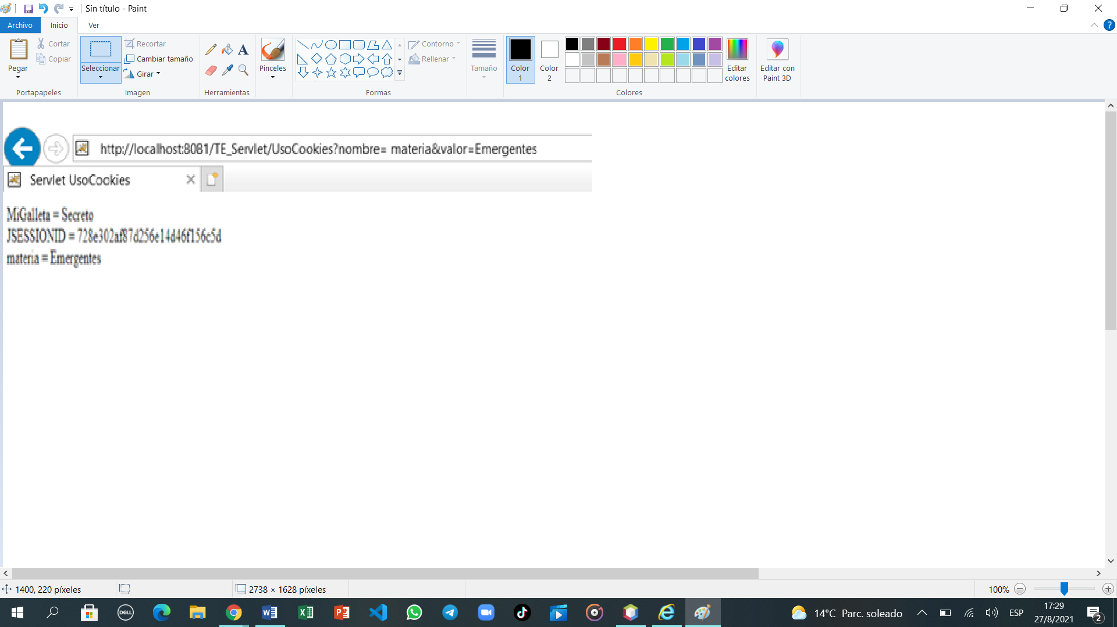

1. USOSESSION

package com.emergentes;

import java.io.IOException;

import java.io.PrintWriter;

import java.util.Date;

import javax.servlet.ServletException;

import javax.servlet.annotation.WebServlet;

import javax.servlet.http.HttpServlet;

import javax.servlet.http.HttpServletRequest;

import javax.servlet.http.HttpServletResponse;

import javax.servlet.http.HttpSession;

@WebServlet(name = "UsoSession", urlPatterns = {"/UsoSession"})

public class UsoSession extends HttpServlet {

protected void processRequest(HttpServletRequest request, HttpServletResponse response)

throws ServletException, IOException {

}

@Override

protected void doGet(HttpServletRequest request, HttpServletResponse response)

throws ServletException, IOException {

response.setContentType("text/html;charset=UTF-8");

PrintWriter out = response.getWriter();

try {

/*todo output ypour page here. you may use following sample code.*/

out.println("<!DOCTYPE html>");

out.println("<html>");

out.println("<head>");

out.println("<title>Servlet UsoSession</title>");

out.println("</head>");

out.println("<body>");

HttpSession session = request.getSession(true);

//datos de session

Date created = new Date(session.getCreationTime());

Date accessed = new Date(session.getLastAccessedTime());

out.println("ID: " + session.getId() + "<br>");

out.println("creado: " + created + "<br>");

out.println("Ultimo acceso: " + created + "<br>");

//introducir un dato de ssesion

String nomDato = request.getParameter("nomDato");

if (nomDato != null && nomDato.length()> 0) {

String valor = request.getParameter("valor");

session.setAttribute(nomDato, valor);

}

out.println("</body>");

out.println("</html>");

} finally {

out.close();

}

}

@Override

protected void doPost(HttpServletRequest request, HttpServletResponse response)

throws ServletException, IOException {

}

}

