AX-12/CDS55xx Driver Board

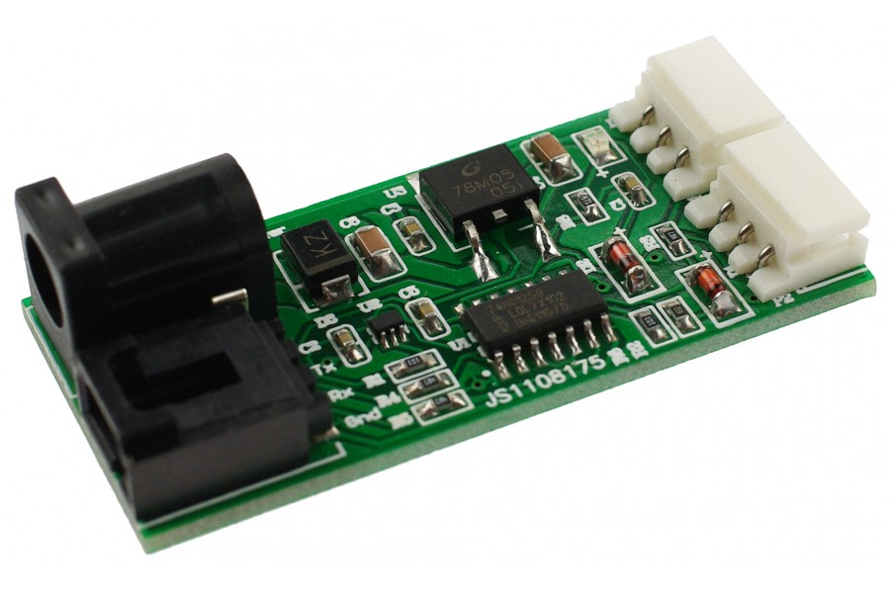
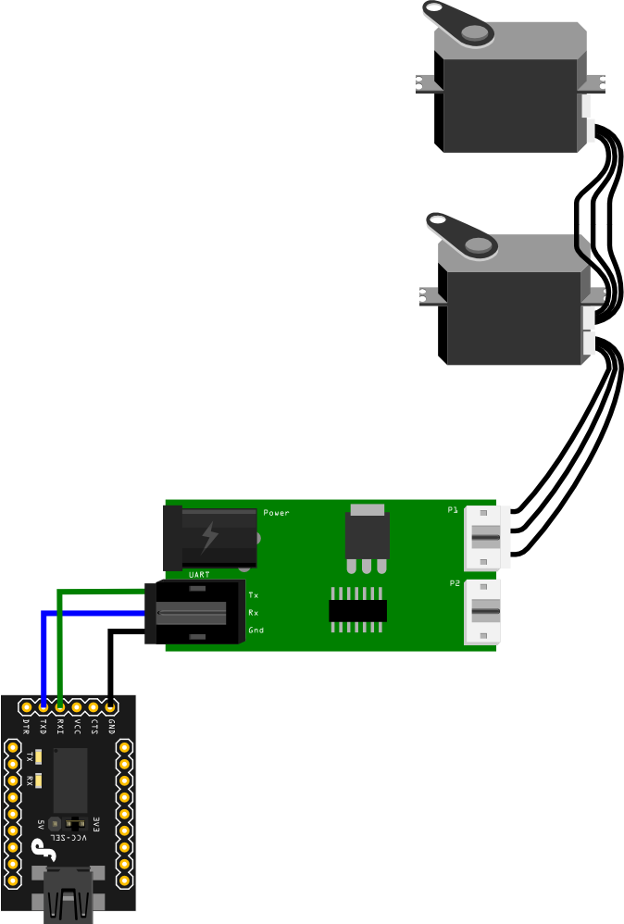
Power supply: 7-16v (7.4V LiPo battery recommended)
Interface: UART
Size: 50x25x12mm

http://www.dfrobot.com/wiki/index.php?title=AX12_CDS55xx_Driver_Board(SKU:DRI0016)

