OSI model

Open Systems Interconnect

(TOP DOWN)

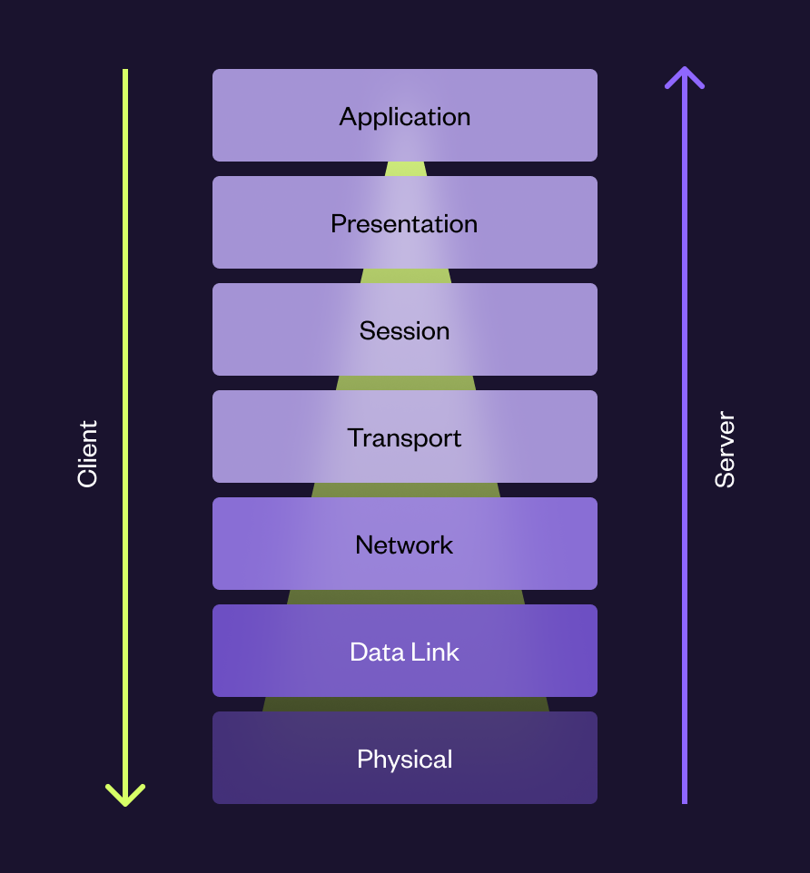

# OSI description

**OSI = Open Systems Interconnect**

*The OSI-model was created by ISO to give an overview of all phases of the transition. The model consists of 7 layers which are the following: Application, Presentation, Session, Transport, Network, Data Link and Physical. Each of these layers are described under.*

*Can also be remembered as:*

**P**robably **P**hysical

**D**idn't  **D**ata link

**N**eed  **N**etwork

**T**hose  **T**ransport

**S**tupid **S**ession

**P**ackets **P**resentation

**A**nyway **A**pplication

# OSI-Layers

***The layers transfer and receives to the closest layer***

**Application**

Provides network services to the end user for example (HTTP, FTP)

Example apps: Google chrome, Outlook or skype

**Presentation**

Syntax processing converting one form of data, for example from human-readable to binary (1-0-1)

**Session**

Responsible for authentication and reconnection if network interruption should occur.

**Transport**

Coordinates how much data to send, how fast, where it goes.

Normally uses Transmission Control Protocol / **TCP** or user datagram protocol **UDP**

**Network**

Handles routing, manages mapping between logical and physical addresses uses Address Resolution Protocol also known as **ARP**.

**Data Link**

Checks for transmission errors

Turns bits into data frames

Divided into sub-layers:

* Media Access Control (**MAC**)
* Logical Link Control (**LLC**)

**(THIS IS ONE FRAME)**

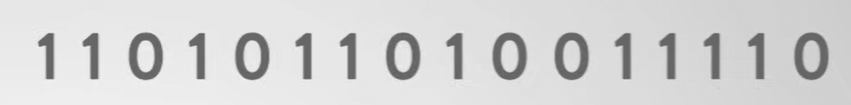

**Physical**

The primary physical connection between devices such as:

Network cables, power plugs, cable pinouts, radio frequency, transceivers, receivers, repeaters, pulses of light, volts. Etc.

# DOD-model

*For TCP/IP there is a simplified model used called the DOD-model and is only distinguished with 4 steps. The different peer layers communicate with its individual type of addressing.*

*The DOD model consists of:*

* **Process / Application** *- (Ports are used)*
* **Transport -** *(Protocols are addressed directly)*
* **Internet** *- (IP-addresses are used)*
* **Network access** *- (Mac-addresses are used)*