**Ethics Policy**

You will need to complete an Ethics Release form when you submit your Project Outline. Information about Ethnic clearance is available on the Portal and the form creator can be found at <https://ethics.app.solent.ac.uk/>

|  |  |
| --- | --- |
| Q1. | Will the project involve human participants other than the investigator(s)?  Q1a Will the project involve vulnerable participants such as children, young people, disabled people, the elderly, people with declared mental health issues, prisoners, people in health and social care settings, addicts, or those with learning difficulties or cognitive impairment either contacted directly or via a gatekeeper (for example a professional who runs an organisation through which participants are accessed; a service provider, a care-giver, a relative or a guardian)?  Q1b Will the project involve the use of control groups or the use of deception?  Q1c Will the project involve any risk to the participants’ health (e.g. intrusive intervention such as the administration of drugs or other substances, or vigorous physical exercise), or involve psychological stress, anxiety, humiliation, physical pain or discomfort to the investigator(s) and/or the participants?  Q1d Will the project involve financial inducement offered to participants other than reasonable expenses and compensation for time?  Q1e Will the project be carried out by individuals unconnected with the University but who wish to use staff and/or students of the University as participants? |
| Q2. | Will the project involve sensitive materials or topics that might be considered offensive, distressing, politically or socially sensitive, deeply personal or in breach of the law (for example criminal activities, sexual behaviour, ethnic status, personal appearance, experience of violence, addiction, religion, or financial circumstances)? |
| Q3. | Will the project have detrimental impact on the environment, habitat or species? |
| Q4. | Will the project involve living animal subjects? |
| Q5. | Will the project involve the development for export of ‘controlled’ goods regulated by the Export Control Organisation (ECO)?  (This specifically means military goods, so called dual-use goods (which are civilian goods but with a potential military use or application), products used for torture and repression, radioactive sources.) |

**SCENARIO 1** - ‘NO’ to Q1, Q2, Q3, Q4, and Q5 an Ethics Release applies to the project (supervisor sign off)

**SCENARIO 2** - ‘YES’ to Q1 and ‘NO’ to ALL other questions, including Q1a thru Q1e, an

Ethics Release applies to the project. (supervisor sign off)

**SCENARIO 3** - Any other combination of ‘YES’ and ‘NO’. The proposal must be submitted for a Full Ethical Review Panel

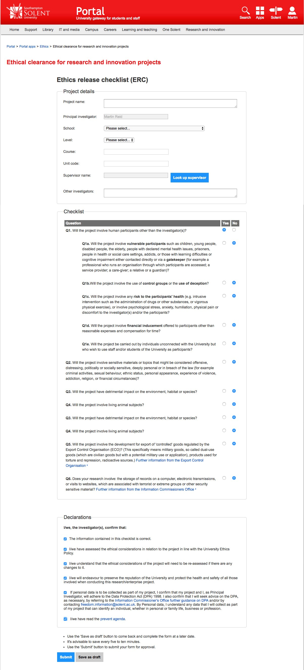

Fill in your project name

You name as Principal

Investigator should auto-fill

Select Dept: Science & Engineering

Level: Undergraduate or Postgraduate

Add your degree course title.

Add the Module Code

Look up and add your

supervisor

You will be the ONLY

investigator so leave this field

blank



This shows the form

filled in with

**Scenario**

2

at listed

above