**Synoptic Project Report   
& Presentation**

EPA Assessor Overview

**BSc Digital and Technology Solutions Professional**   
Apprenticeship Standard: [ST0119 v1.1 (2015)](https://skillsengland.education.gov.uk/apprenticeships/st0119-v1-1)  
Overview Document (Version: 1 - September 2025)  
Created by martin.reid@solent.ac.uk  
Southampton Solent University - SO14 0YN  
[**End Point Assessor Organisation (EPAO) ID: EPA0325**](https://find-epao.apprenticeships.education.gov.uk/courses/25/assessment-organisations/epa0325)

**Synoptic Project Assessment Approach (Legacy Standard ST0119 v1.1)**

The Synoptic Project is undertaken during the final six months of the apprenticeship. Apprentices are required to complete and document a work-based project, supported by their employer and Solent University tutors.

A 10,000-word report must be submitted using a standard template. Within this report, apprentices are expected to demonstrate how they have met the Knowledge, Skills and Behaviours (KSBs) required for the assessment. Evidence of this should be included both in the main body of the report and in a mapping table located in the appendices.

Apprentices on the Digital and Technology Solutions apprenticeship will also complete a mapping matrix that outlines learning across all credited modules, including assessed work-based learning. This matrix (not directly assessed) provides assurance that the apprentice has achieved broad coverage of the KSBs defined in the apprenticeship standard.

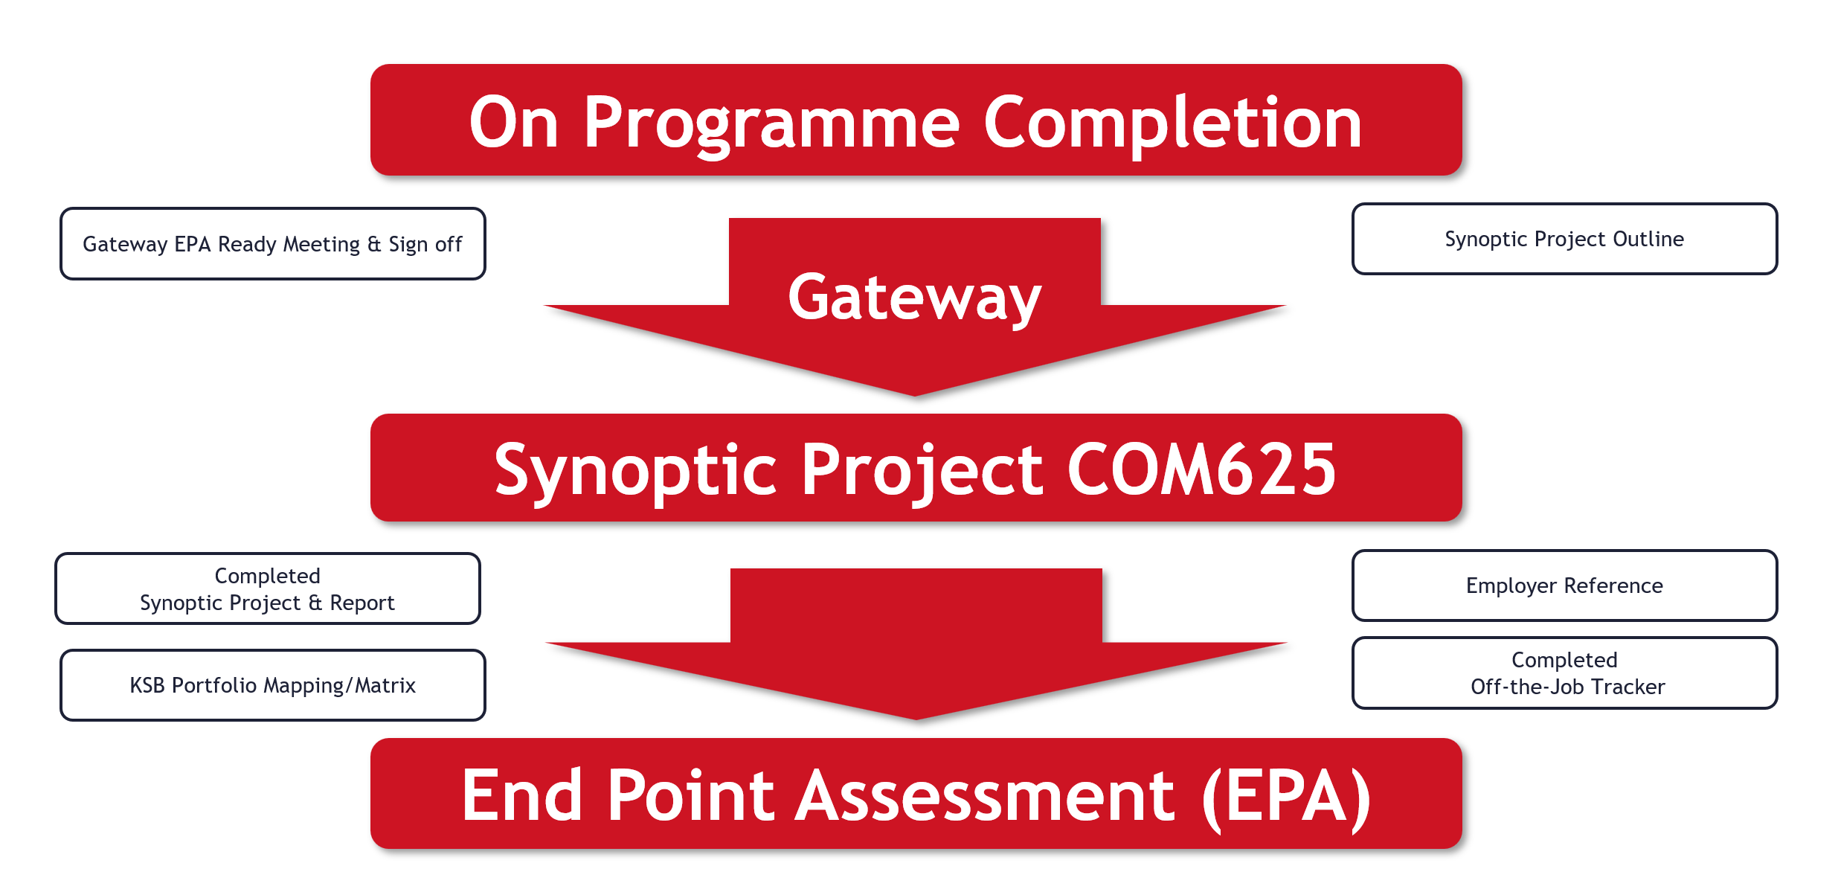

The assessment structure for the synoptic project under the legacy version of the Digital & Technology Solutions Degree Apprenticeship. Unlike newer standards that rely solely on independent assessors to conduct and grade the End Point Assessment (EPA) Assessment, this version involves a **collaborative assessment model** with university module assessor/s, employer input and external examiner processes.

**Evidence of Competency**

The Synoptic Project is designed to demonstrate **full coverage of the Knowledge, Skills, and Behaviours (KSBs)**.

Evidence is drawn from:

* The **main body of the report**
* The **appendix KSB mapping**
* The **KSB mapping portfolio**, which documents learning throughout the apprenticeship

The EPA interview serves as a **capstone validation** of the apprentice’s competencies, supported by their submitted work.

**Assessment Structure & Delivery**

**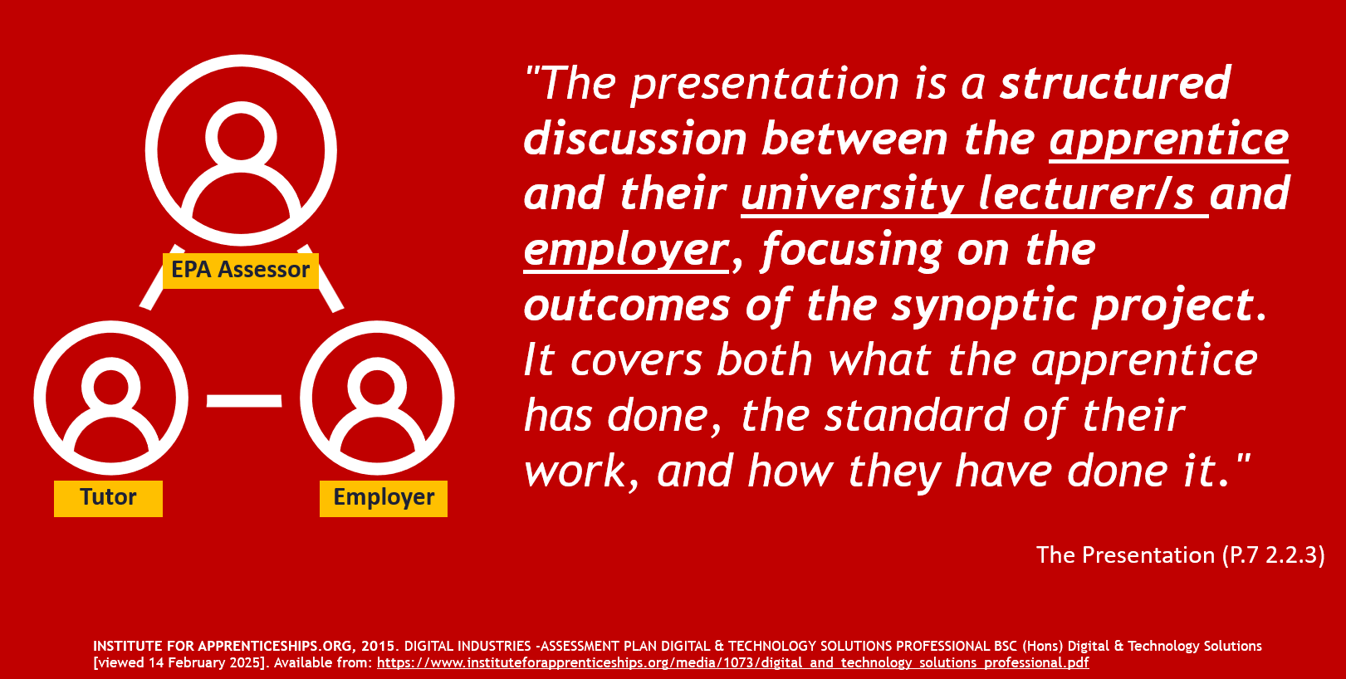  
SKILLS ENGLAND GOV, 2015. DIGITAL INDUSTRIES -ASSESSMENT PLAN DIGITAL & TECHNOLOGY SOLUTIONS PROFESSIONAL BSC (Hons) Digital & Technology Solutions  
 [viewed 14 September 2025]. Available from:** [**digital_and_technology_solutions_professional.pdf**](https://skillsengland.education.gov.uk/media/1073/digital_and_technology_solutions_professional.pdf)

The **Synoptic Project** is assessed through a **structured discussion** involving:

* The **apprentice**
* Their **university lecturer(s)**
* Their **employer**

This discussion focuses on:

* What the apprentice has done
* The standard of their work
* How they have done it  
  *(As outlined in the official assessment plan:* [*Assessment Plan – DTS*](https://skillsengland.education.gov.uk/apprenticeship-standards/st0119-v1-1)*)*



**Role of the Independent Assessor**

An **independent assessor** will be introduced to strengthen the integrity and consistency of grading. This assessor:

* Will not have taught or worked with the apprentice previously.
* Independent Assessor can be from within the institution but will act independently.
* Will serve as a **second marker**, applying university guidelines for 40-credit modules.
* Will collaborate with the **employer** and **support tutor** to agree the final grade and feedback.

**Assessment Process**

* The Independent Assessor will already have received the apprentice’s report and slide deck.
* They will have read the report, worked out provisional grading and feedback based on the assessment rubrics, and drafted some initial questions using the question bank.
* The Solent support tutor will also have read the report and worked out provisional grading and feedback.
* Assessors will check portfolio mapping matrix for good coverage of KSB's throughout the apprenticeship. This is not directly assessed but will be signed off on EPA feedback form.
* The assessment will take place online and will last for one hour (plus 10%).
* Presentation will need to be recorded for moderation
* Apprentices will deliver a 25–30-minute presentation on their Synoptic Project.
* This will be followed by a 25–30-minute structured interview, led by the Independent Assessor, who will ask 4–6 questions with appropriate follow-ups.
* There will also be an opportunity for the employer to summarise the apprentice’s performance on the project, based on the reference included in the report.
* The apprentice will then leave the meeting. The Independent Assessor, Solent tutor, and employer will discuss and agree to the final grade and complete feedback.

**Guidance for Assessors – Use of Question Bank**  
  
The question bank is provided as a starting point for independent assessors conducting the End Point Assessment (EPA) for the BSc (Hons) Digital & Technology Solutions Professional (integrated degree). The questions listed under each criterion are illustrative examples only. They are designed to reflect the types of knowledge, skills, and behaviours (KSBs) outlined in the apprenticeship standard and are generic in nature.  
  
Apprentices will be coming from different occupational pathways and will have different synoptic project focuses. Assessors will conduct a 25–30-minute interview, asking between 4–6 questions with appropriate follow-up questions. This interview follows the apprentice’s 25–30-minute presentation.  
  
The Synoptic Project submitted by the apprentice is designed to demonstrate full coverage of the core KSBs, both within the body of the report and the appendix project KSB mapping. In addition, apprentices will have submitted a comprehensive KSB mapping portfolio that evidence learning throughout the apprenticeship on all their credited modules. This ensures that the apprentice has achieved complete KSB coverage and provides a clear link between their work and the EPA assessment. The EPA interview is a capstone assessment to validate their competencies with reference to the submitted work.  
  
**Note:** These questions are not tailored to any specific specialism, apprentice’s project report or presentation. Instead, they serve as a foundation to help assessors craft contextualised and relevant questions that align with the actual content of the apprentice’s submitted work and presentation.  
  
Assessors are encouraged to:

* Use these examples to inspire and structure their own questions.
* Adapt the phrasing and focus based on the apprentice’s specialism, project scope, and organisational context.
* Ensure that the final questions used during the EPA interview are directly linked to the apprentice’s demonstrated work and mapped learning outcomes.
* Use them in conjunction with grade mark rubrics for the Synoptic Project EPA

|  |  |
| --- | --- |
| **KSB** | **Criteria & bank questions** |
| **Core Skills** | |
| **CS1** | **Information Systems-** *Can critically analyse a business domain (Core functions & processes of a company) to identify the role of information systems, highlight issues and identify opportunities for improvement through evaluating information systems in relation to their intended purpose and effectiveness* |
| 1. How did you analyse our business domain (Core functions & processes of a company) in your project to determine the role of information systems? What issues did you identify, and what opportunities for improvement did you highlight based on your evaluation of these systems?  2. Can you explain how the information systems in your project supported or hindered the core business functions? What improvements would you recommend based on your findings?  3. What methods did you use to evaluate the effectiveness of the information systems in your organisation, and how did your findings influence your project decisions? |
| **CS2** | **Systems Development -** *analyses business and technical requirements to select and specify appropriate technology solutions. Designs, implements, tests, and debugs software to meet requirements using contemporary methods including agile development. Manages the development and assurance of software artefacts applying secure development practises to ensure system resilience. Configures and deploys solutions to end users.* |
| 1. In your project, how did you analyse both business and technical requirements to select and specify the appropriate technology solutions? Can you describe your process for designing, implementing, testing, and debugging the software? How did you apply contemporary methods like Agile development?  2. How did your choice of development methodology (e.g. Agile) influence the delivery of your technology solution within the company?  3. Can you describe a challenge you faced during software implementation and how you resolved it using development best practices? |
| **CS3** | **Data -** *Identifies organisational information requirements and can model data solutions using conceptual data modelling techniques. Can implement a database solution using an industry standard database management system (DBMS). Can perform database administration tasks and is cognisant of the key concepts of data quality and data security. Can manage data effectively and undertake data analysis.* |
| 1. What organisational information requirements did you identify during your project, and how did you model your data solutions using conceptual data modelling techniques? Can you explain how you implemented a database solution and your approach to database administration, particularly regarding data quality and security?  2. How did your data modelling approach align with the company’s operational needs and data governance policies?  3. What steps did you take to ensure data quality and security during the implementation of your database solution? |
| **CS4** | **Cyber Security -** *can undertake a security risk assessment for a simple IT system and propose resolution advice. Can identify, analyse and evaluate security threats and hazards to planned and installed information systems or services (e.g. Cloud services).* |
| 1. How did you conduct a security risk assessment for the IT system involved in your project? What resolution advice did you propose, and how did you identify and evaluate potential security threats or hazards to the information systems or services you implemented?  2. What tools or frameworks did you use to identify and assess security risks in your project?  3. How did your proposed security measures align with the organisation’s existing cybersecurity policies or standards? |
| **CS5** | **Business Organisation -** *can apply organisational theory, change management, marketing, strategic practice, human resource management and IT service management to technology solutions development. Develops well-reasoned investment proposals and provides business insights.* |
| 1. In your project, how did you apply organisational theories such as change management, marketing, and strategic practice to the development of your technology solutions? Can you discuss how you developed your investment proposal and the insights it provided for the business?  2. How did stakeholder engagement influence your approach to organisational change within the project?  3. Can you describe how your investment proposal reflected both strategic goals and operational constraints of the business? |
| **CS6** | **IT Project Management -** *follows a systematic methodology for initiating, planning, executing, controlling, and closing technology solutions projects. Applies industry standard processes, methods, techniques and tools to execute projects. Can manage a project (typically less than six months, no inter-dependency with other projects and no strategic impact) including identifying and resolving deviations and the management of problems and escalation processes.* |
| 1. Can you describe the methodology you followed for initiating, planning, executing, controlling, and closing your technology solutions project? What industry-standard processes, methods, techniques, and tools did you apply, and how did you manage any deviations or problems that arose during the project?  2. How did your chosen project management methodology help you manage risks and changes throughout the project lifecycle?  3. Can you share an example of how you handled a deviation from the original project plan and what tools or techniques you used to resolve it? |
| **CS7** | **Computer and Network Infrastructure -** *can plan, design and manage computer networks with an overall focus on the services and capabilities that network infrastructure solutions enable in an organisational context. Identifies network security risks and their resolution.* |
| 1. In your project, how did you plan and design the computer and network infrastructure to support the organisational services and capabilities? What considerations did you consider ensuring that the network infrastructure met the company’s needs? Additionally, how did you identify potential network security risks, and what strategies did you propose to address these risks?  2. What factors influenced your design decisions for the network infrastructure, and how did you ensure alignment with business requirements?  3. How did you assess and mitigate network security risks during the planning and implementation stages of your project? |
| **Core Technical Knowledge** | |
| **CTK1** | **How business exploits technology** *solutions for competitive advantage.* |
| 1. In your project, how did you identify and leverage (optimise) technology solutions to create a competitive advantage for the company? What specific strategies did you implement?  2. What specific technologies did you choose to enhance the company’s market position, and why were they effective?  3. How did your project outcomes contribute to long-term strategic advantages for the organisation? |
| **CTK2** | **Technology Investment & Business Case** - *The value of technology investments and how to formulate a business case for a new technology solution, including estimation of both costs and benefits.* |
| 1. How did you assess the value of the technology investments made during your project? Can you describe how you formulated a business case for any new technology solutions, including your approach to estimating both costs and benefits  2. What metrics or evaluation methods did you use to justify the cost-benefit of your proposed solution?  3. How did stakeholder feedback influence the development of your business case for the technology solution? |
| **CTK3** | **Contemporary techniques** *for design, developing, testing, correcting, deploying and documenting software systems from specifications, using agreed standards and tools.* |
| 1. What contemporary techniques did you use in your project for designing, developing, testing, correcting, deploying, and documenting software systems? How did you ensure compliance with agreed standards and tools throughout the process?  2. How did you ensure consistency and quality across the software development lifecycle in your project?  3. Can you describe how you balanced speed and reliability when deploying your solution using modern development practices? |
| **CTK4** | **How teams work** *effectively to produce technology solutions.* |
| 1. Can you discuss how your team worked effectively together to produce the technology solutions in your project? What practices or tools did you employ to facilitate collaboration?  2. What collaboration tools or practices did you use to ensure smooth communication and task management within your team?  3. How did you resolve any conflicts or misalignments in your team during the project delivery? |
| CTK5 | **The role of data management** *systems in managing organisational data and information.* |
| 1. How did you incorporate data management systems in your project to manage organisational data and information? What impact did these systems have on the overall effectiveness of your project?  2. What role did data governance play in your project, and how did you ensure compliance with organisational standards?  3. How did your data management approach improve operational efficiency or decision-making within the company? |
| **CTK6** | **Common vulnerabilities** *in computer networks including unsecure coding and unprotected networks.* |
| 1. In your project, what common vulnerabilities in computer networks did you identify, such as insecure coding or unprotected networks? How did you address these vulnerabilities?  2. How did you prioritise and address the most critical vulnerabilities in your network design or implementation?  3. What preventative measures did you put in place to reduce future risks related to insecure coding or network exposure? |
| **CTK7** | **The various roles, functions** *and activities related to technology solutions within an organisation.* |
| 1. What roles, functions, and activities related to technology solutions did you encounter within the organisation during your project? How did these roles contribute to the project's success?  2. How did collaboration between different technology roles influence the success of your project?  3. Can you describe how understanding these roles helped you navigate organisational processes more effectively? |
| **CTK8** | **How strategic decisions are made** *concerning acquiring technology solutions resources and capabilities including the ability to evaluate the different sourcing options.* |
| 1. How were strategic decisions made in your project? What criteria did you use to evaluate different sourcing options?  2. How did you assess the trade-offs between internal development and external sourcing in your project?  3. What strategic factors (e.g. cost, scalability, vendor reliability) influenced your sourcing decisions? |
| **CTK9** | **How to deliver a technology solutions** *project accurately consistent with business needs.* |
| 1. How did you ensure that your technology solutions project was delivered accurately and consistently aligned with the business needs of the organisation? What processes did you follow?  2. What techniques did you use to validate that your project outcomes met stakeholder expectations and business goals?  3. How did you adapt your project scope or deliverables to stay aligned with evolving business needs? |
| **CTK10** | ***The issues of quality, cost and time*** *for projects, including contractual obligations and resource constraints.* |
| 1. What challenges did you face regarding quality, cost, and time during your project? How did you manage contractual obligations and resource constraints to keep the project on track?  2. How did you balance competing priorities of cost, quality, and time while maintaining contractual obligations?  3. Can you describe a situation where resource constraints impacted your project and how you managed it? |
|  | **Core Behaviours** |
| **CBS3** | **Able to deal with different, competing interests** *within and outside the organisation with excellent negotiation skills.* |
| 1. Can you describe a situation in your project where you had to navigate competing interests within the organisation? How did you use your skills to address these different perspectives?  2. How did you adapt your negotiation approach to different stakeholders with conflicting priorities?  3. What techniques did you use to reach a compromise that satisfied both business and technical needs? |
| **CBS4** | **Can identify the preferences, motivations, strengths and limitations** *of other people and apply these insights to work more effectively with and to motivate others.* |
| 1. How did you identify the preferences, motivations, strengths, and limitations of your team members during the project? In what ways did you apply these insights to work more effectively with them and to motivate others?  2. How did you tailor your communication or leadership style to motivate different team members?  3. Can you share an example of how recognising someone’s strengths improved project outcomes? |
| **CBS5** | **Competent in active listening and in leading, influencing and persuading others.** |
| 1. Can you discuss how you practiced active listening in your project? How did you lead, influence, or persuade others to achieve your project goals?  2. How did you use persuasion or influence to gain support for a key decision in your project?  3. What leadership behaviours helped you maintain team morale and focus under pressure |
| **CBS6** | **Able to give and receive feedback** *constructively and incorporate it into his/her own development and life-long learning.* |
| 1. How did you approach giving and receiving feedback during your project? Can you provide an example of how you incorporated feedback into your own development?  2. Can you describe a moment when feedback led to a significant change in your approach or solution?  3. How did you create a feedback culture within your team or project environment? |
| **CBS7** | **Applies analytical and critical thinking skills** *to Technology Solutions development and to systematically analyse and apply structured problem-solving techniques to complex systems and situations.* |
| 1. In what ways did you apply analytical and critical thinking skills to the development of your technology solutions? Can you share an example of how you used structured problem-solving techniques to address a complex issue?  2. How did you break down a complex problem into manageable parts during your project?  3. What structured problem-solving techniques did you use to evaluate alternative solutions? |
| **CBS8** | **Able to put forward, demonstrate value and gain commitment** *to a moderately complex technology-oriented solution, demonstrating understanding of business need, using open questions and summarising skills and basic negotiating skills.* |
| 1. How did you put forward and demonstrate the value of your technology-oriented solution to gain commitment from stakeholders? What techniques did you use to understand business needs and facilitate discussions?  2. How did you tailor your messaging to different stakeholders to gain their buy-in?  3. What role did summarising and questioning techniques play in securing support for your solution? |
| **CBS10** | **Have demonstrated that they have mastered basic business disciplines, ethics and courtesies**, *demonstrated timeliness and focussed when faced with distractions and the ability to complete tasks to a deadline with high quality.* |
| 1. How did you demonstrate mastery of basic business disciplines, ethics, and professionalism throughout your project? Can you discuss how you managed your time effectively to meet deadlines while maintaining high-quality work?  2. How did you manage competing priorities while maintaining ethical standards and professionalism?  3. Can you share how you ensured high-quality work under tight deadlines or distractions? |
| **CBS11** | **Flexible Attitude** |
| 1. Can you provide an example of how you demonstrated a flexible attitude during your project? How did this help you adapt to changes or challenges?  2. How did flexibility help you respond to unexpected changes or feedback during the project?  3. What adjustments did you make to your original plan, and what was the outcome? |
| **CBS12** | **Performing Under Pressure** |
| 1. Describe a situation in your project where you had to perform under pressure. How did you manage this, and what strategies did you use to maintain your focus?  2. What coping strategies or tools did you use to maintain performance under pressure?  3. How did you prioritise tasks when facing tight deadlines or high-stakes decisions? |
| **CBS13** | **Thorough approach to work** |
| 1. How did you ensure a thorough approach to your work throughout the project?  2. What quality assurance or review processes did you implement to maintain thoroughness?  3. How did attention to detail impact on the success of your final deliverables? |
| **CBS14** | **Logical thinking** *and creative approach to problem-solving* |
| 1. Can you discuss how you applied logical thinking and creativity to solve any problems?  2. Can you share an example where combining logic and creativity led to an innovative solution?  3. How did you evaluate multiple options before selecting the most effective problem-solving approach? |

**Guidance for Assessors – Giving written feedback**Written feedback plays a vital role in the End-Point Assessment (EPA) process. It should be clear, constructive and aligned with the assessment criteria. The aim is to provide apprentices with a fair and transparent summary of their performance, while also supporting quality assurance and moderation.

Best Practice for Written Feedback:

* **Be specific and evidence-based:** Feedback should refer directly to the apprentice’s work, using examples where possible. Avoid vague statements and focus on what was done well or where improvement is needed.
* **Link to the grading criteria**: Clearly explain how the apprentice has met (or not met) the requirements of the standard. Use the language of the grading descriptors to support consistency and clarity.
* **Balance strengths and areas for development**: Highlight what the apprentice did well, as well as areas that could be improved. This helps ensure feedback is balanced and developmental.
* **Use accessible language**: Avoid jargon or overly technical terms unless they are relevant to the assessment. The feedback should be easy to understand for the apprentice and other stakeholders.
* **Be comprehensive but concise**: Feedback should cover all relevant aspects of the assessment, including technical knowledge, skills, behaviours and professional practice. However, it should remain focused and avoid unnecessary repetition.
* **Maintain a professional tone**: Feedback should be respectful, impartial and supportive. It should reflect the seriousness of the EPA process and the importance of the apprentice’s achievement.
* **Support moderation and audit**: Ensure feedback is detailed enough to support internal and external quality assurance. It should justify the grade awarded and be consistent with the evidence presented.

There is a blank feedback sheet titled **BLANK_EPA_1-1_FEEDBACK**, and a partially populated sheet called **RESPONSE_EPA_1-1_FEEDBACK**. The latter includes example responses from the apprentice, based on questions from the question bank and the grade mark criteria. You will also use the Excel grade calculator to come up with an overall average numeric value.

**Guidance for Assessors - Grading the Assessment**

The Synoptic Project module is a credited part of the Digital and Technology Solutions degree. Apprentices must pass this module to complete the degree and they must pass the degree to complete the apprenticeship.

**Final Assessment and Grading**  
All apprentices will be studying for a BSc Honours degree in Digital & Technology Solutions. It is the achievement of the Honours degree that demonstrates that the standard has been met, and which provides the grading.

**The grading of the degree award is significantly made up of the synoptic project assessment together with module assessments.** The Honours degree award and classification is based on a weighted average mark of the assessed work the apprentice has completed. The synoptic project contributes greatly to the final year marks. The final year overall contributes to the grading typically in the ratio of 3 – 5 times that of second year modules (based on a three-year model). The synoptic project must be passed in all cases to achieve the degree award.

Apprentices will be graded using Honours degree classifications for English universities. All UK universities must follow the QAA (Quality Assurance Agency for Higher Education) Code of practice for the assurance of academic quality and standards in higher education. This ensures continued consistency across universities.

**The national degree award outcomes are shown below with apprenticeship grading equivalence. These typically are as follows:**  
  
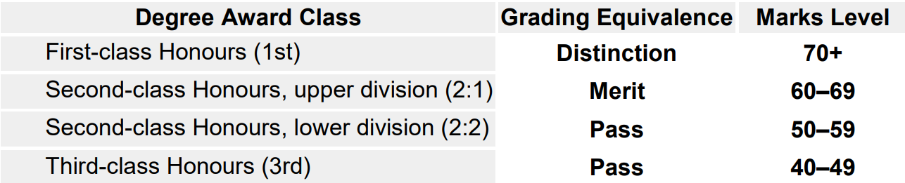

At Solent University, assessments are marked using a numeric grading system. Individual assessments use “stepped” grading, as shown below:

**Solent Numeric Grading**

|  |  |  |  |
| --- | --- | --- | --- |
| **1st (Distinction)** | | | |
| **100** | **90-99** | **80-89** | **70-79** |
| **10** | **9** | **8** | **7** |
| **100** | **92** | **83** | **74** |
| **Extraordinary, flawless,** | **Superb, outstanding** | **Excellent** | **Strong, proficient, very good** |

|  |  |  |  |  |  |  |  |  |
| --- | --- | --- | --- | --- | --- | --- | --- | --- |
| **(2:1) (Merit)** | | | **(2:2) (Pass)** | | | **3rd (Pass)** | | |
| **60-69** | | | **50-59** | | | **40-49** | | |
| **6** | | | **5** | | | **4** | | |
| **68** | **65** | **62** | **58** | **55** | **52** | **48** | **45** | **42** |
| **Competent, good, effective, capable** | | | **Reasonable, fair, appropriate** | | | **Basic, satisfactory, acceptable** | | |

|  |  |  |
| --- | --- | --- |
| **Fail** | | |
| **0-39** | | |
| **3** | **2** | |
| **35** | **20** | **15** |
| **Inadequate, incomplete, limited** | **Poor, unsatisfactory, weak** | **No attempt, No submission, Absent** |

**Solent Grading Criteria**

**Extraordinary 100%**: This grade is for work that is truly exceptional in every way. The project demonstrates groundbreaking innovation and has a significant impact on the organisation. The report is meticulously detailed, and the presentation is highly engaging and professional.

* **Outstanding 92%**: This grade is for work that is significantly above average. The project shows a high level of creativity and effectiveness. The report is thorough and well-organised, and the presentation is clear and confident.
* **Excellent 83%**: This grade indicates very high-quality work. The project is well-executed and meets all the objectives effectively. The report is comprehensive and well-written, and the presentation is polished and informative.
* **Strong/Very Good 74%**: This grade is for work that is above average. The project is solid and achieves its goals. The report is detailed and clear, and the presentation is well-prepared and delivered.
* **Competent, good, effective, capable 62-65-69%**: This grade is for work that meets the basic requirements. The project is adequately executed and achieves its main objectives. The report is clear and covers the necessary points, and the presentation is satisfactory.
* **Reasonable, fair, appropriate 52-55-58%**: This grade is for work that is acceptable but has some shortcomings. The project meets most objectives but lacks depth or thoroughness. The report is adequate but may be missing some details, and the presentation is clear but not particularly engaging.
* **Basic, satisfactory, acceptable 42-45-48%**: This grade is for work that meets the minimum requirements. The project is completed but lacks depth and impact. The report covers the basics but is not detailed, and the presentation is clear but lacks enthusiasm.
* **Inadequate, incomplete, limited 35**: This grade is for work that does not meet the required standards. The project fails to achieve its main objectives. The report is incomplete or poorly organised, and the presentation is unclear or unprofessional.
* **Poor, unsatisfactory, weak 15-20%**: This grade is for work that is significantly below the required standards. The project is poorly executed and has little to no impact. The report is very incomplete or poorly written, and the presentation is unclear and unengaging.

**Module Learning Outcomes (LO) and Corresponding Apprentice KSB  
  
COM625 Synoptic Report AE2 (70%) & Presentation AE3 (20%)**

|  |
| --- |
| **Project Report (70%)** |
| **1. Presentation, Reporting, Referencing & Citation. Introduction, Background/context, Requirements/Specification** **Degree Module LO:** 2, 3, & 4  **KSB:** CS1, CS5, CS6, CTK1, CTK2, CTK5, CTK7, CTK8, CTK10, CBS1, CBS2, CBS3, CBS5, CBS6, CBS9, CBS10, CBS11, CBS12, CBS13, CBS8) |
| **2. Project Methodology, Project Management & Professional Practice, Design/Implementation, Testing, Artefact/s & supporting Documentation** **Degree Module LO:** 1 & 6  **KSB:** CS2, CS3, CS4, CS6, CS7, CTK3, CTK4, CTK5, CTK6, CTK9, CTK10, CBS7, CBS14 |
| **›3. Evaluation, conclusions & Recommendations** **Degree Module** LO: 5  **KSB:** CS2, CS5, CS6, CTK2, CTK9, CBS8 |
|
| **Presentation AE3 (20%)** |
| **4. Presentation** **Degree Module LO:** 4  **KSB:** CBS1, CBS2, CBS3, CBS5, CBS8 |
| **5. Demonstration of Product** **Degree Module LO:** 1,2,3,5  **KSB:** CS1, CS2, CS5, CS6, CS7, CTK1, CTK2, CTK3, CTK5, CTK7, CTK8, CTK9, CTK10, CBS6, CBS8, CBS9, CBS10, CBS11, CBS12, CBS13, CBS14) |
| **6. Demonstration/presentation of Product** **Degree Module LO:** 6 **KSB: CS3, CS4, CTK4, CTK5, CBS7, CBS14** |

**Degree (Module) Learning Outcome**

1. Select, apply and evaluate the appropriateness of methods, tools and technologies in the synthesis of meaningful project outcomes.
2. Undertake a significant self-managed project in a planned and systematic fashion.
3. Identify, interpret and integrate theory drawn from a range of appropriate sources.
4. Communicate complex ideas fluently both verbally and in writing.
5. Deliver a technology solution project accurately consistent with business needs
6. Apply analytical and critical thinking skills to Technology Solutions development

**Knowledge, Skills and Behaviours (KSB) codes and criteria list**

**Core Skills (CS)**

|  |  |
| --- | --- |
| **CS1** | Information Systems: can critically analyse a business domain to identify the role of information systems, highlight issues and identify opportunities for improvement through evaluating information systems in relation to their intended purpose and effectiveness. |
| **CS2** | Systems Development: analyses business and technical requirements to select and specify appropriate technology solutions. Designs, implements, tests, and debugs software to meet requirements using contemporary methods including agile development. Manages the development and assurance of software artefacts applying secure development practises to ensure system resilience. Configures and deploys solutions to end-users. |
| **CS3** | Data: identifies organisational information requirements and can model data solutions using conceptual data modelling techniques. Can implement a database solution using an industry standard database management system (DBMS). Can perform database administration tasks and is cognisant of the key concepts of data quality and data security.  Can manage data effectively and undertake data analysis. |
| **CS4** | Cyber Security: can undertake a security risk assessment for a simple IT system and propose resolution advice. Can identify, analyse and evaluate security threats and hazards to planned and installed information systems or services (e.g. Cloud services). |
| **CS5** | Business Organisation: can apply organisational theory, change management, marketing, strategic practice, human resource management and IT service management to technology solutions development. Develops well- reasoned investment proposals and provides business insights. |
| **CS6** | IT Project Management: follows a systematic methodology for initiating, planning, executing, controlling, and closing technology solutions projects. Applies industry-standard processes, methods, techniques, and tools to execute projects. Can manage a project (typically less than six months, no inter-dependency with other projects and no strategic impact) including identifying and resolving deviations and the management of problems and escalation processes. |
| **CS7** | Computer and Network Infrastructure: can plan, design and manage computer networks with an overall focus on the services and capabilities that network infrastructure solutions enable in an organisational context. Identify network security risks and their resolution. |

**Core Technical Knowledge - Knows and understands (CTK):**

|  |  |
| --- | --- |
| **CTK1** | How business exploits technology solutions for competitive advantage. |
| **CTK2** | The value of technology investments and how to formulate a business case for a new technology solution, including estimation of both costs and benefits. |
| **CTK3** | Contemporary techniques for design, developing, testing, correcting, deploying, and documenting software systems from specifications, using agreed standards and tools. |
| **CTK4** | How teams work effectively to produce technology solutions. |
| **CTK5** | The role of data management systems in managing organisational data and information. |
| **CTK6** | Common vulnerabilities in computer networks including unsecure coding and unprotected networks. |
| **CTK7** | The various roles, functions and activities related to technology solutions within an organisation. |
| **CTK8** | How strategic decisions are made concerning acquiring technology solutions resources and capabilities including the ability to evaluate the different sourcing options. |
| **CTK9** | How to deliver technology solutions project accurately consistent with business needs. |
| **CTK10** | The issues of quality, cost and time for projects, including contractual obligations and resource constraints. |

**Professional, interpersonal, and business skills**

|  |  |
| --- | --- |
| **CBS1** | Fluent in written communications and able to articulate complex issues. |
| **CBS2** | Makes concise, engaging, and well-structured verbal presentations, arguments and explanations. |
| **CBS3** | Able to deal with different, competing interests within and outside the organisation with excellent negotiation skills. |
| **CBS4** | Can identify the preferences, motivations, strengths and limitations of other people and apply these insights to work more effectively with and to motivate others. |
| **CBS5** | Competent in active listening and in leading, influencing, and persuading others. |
| **CBS6** | Able to give and receive feedback constructively and incorporate it into your own development and life-long learning. |
| **CBS7** | Applies analytical and critical thinking skills to Technology Solutions development and to systematically analyse and apply structured problem-solving techniques to complex systems and situations. |
| **CBS8** | Able to put forward, demonstrate value and gain commitment to a moderately complex technology-oriented solution, demonstrating understanding of business need, using open questions and summarising skills and basic negotiating skills. |
| **CBS9** | Able to conduct effective research, using literature and other media, into IT and business-related topics. |

**Attributes and Behaviours**

|  |  |
| --- | --- |
| **CBS10** | Have demonstrated that they have mastered basic business disciplines, ethics and courtesies, demonstrated timeliness and focused when faced with distractions and the ability to complete tasks to a deadline with high quality. |
| **CBS11** | Flexible attitude. |
| **CBS12** | Ability to perform under pressure. |
| **CBS13** | A thorough approach to work. |
| **CBS14** | Logical thinking and creative approach to problem-solving. |

**Guidance for Assessors - Grade Calculator for the Synoptic Project EPA (1.1)**

This grade calculator is designed to support assessors in evaluating apprentices’ performance in the **Synoptic Project EPA on AE2 & AE3**. The spreadsheet includes a KSB learning outcomes across three domains: **Core Skills (CS)**, **Core Technical Knowledge (CTK)** and **Core Behavioural Skills (KBS)**

**Module Name: Synoptic Project and Presentation COM625**

* AE2: Synoptic Project Report (70% weighting)
* AE3: Presentation (20% weighting)

**Structure of the Workbook -**The workbook contains 6 sheets, each serving a specific purpose: 

**1. Feedback Breakdown AE2**

Divides AE2 into three criteria:

* + - Presentation, Reporting, Referencing & Citation
    - Methodology, Project Management, Design, Testing, Artefact
    - Evaluation, Conclusions & Recommendations

Each criterion is linked to Learning Outcomes (LOs) and Knowledge, Skills, Behaviours (KSBs).

**2. Rubric AE2**

* Detailed marking rubric for AE2.
* Describes performance levels from Distinction (1st) to Fail, with descriptors for each criterion.
* Includes step marks (e.g., 92, 83, 74, etc.) and qualitative descriptors (e.g., “Superb, outstanding, original”).

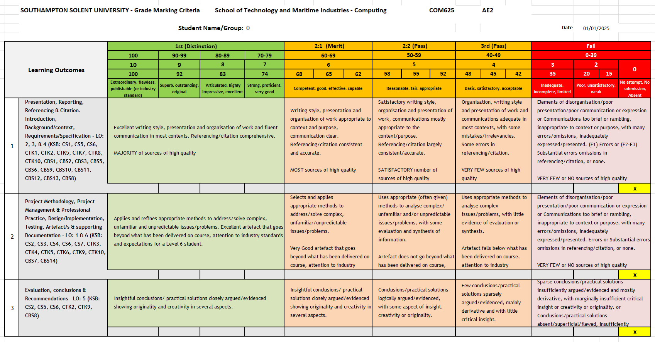

**3. Overall Grade Mark AE2**

* Allows assessors to input individual criterion scores (0–10).
* Converts these into step marks and an overall grade.
* Includes a space for qualitative feedback.

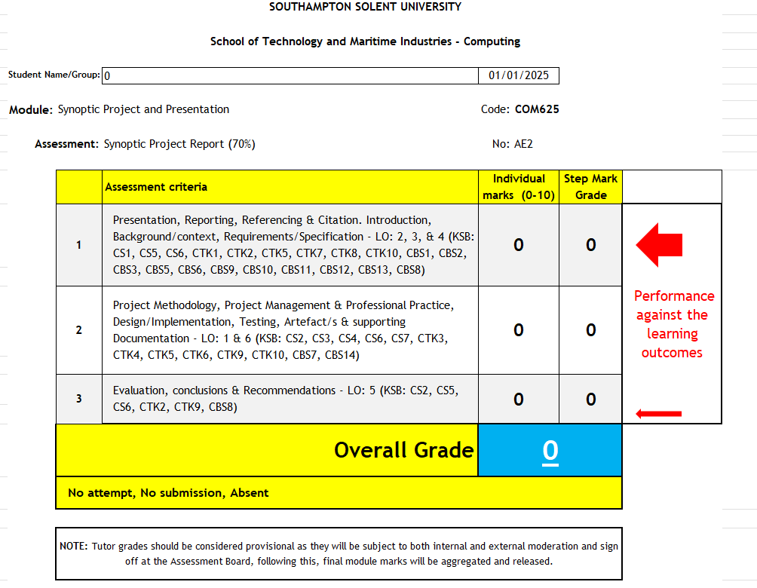

**4. Feedback Breakdown AE3**

Like AE2 but tailored for the Presentation assessment:

* Presentation
* Demonstration of Product (LOs 1,2,3,5)
* Demonstration/Presentation of Product (LO 6)

**5. Rubric AE3**

* Marking rubric for AE3 with descriptors for each performance band.
* Aligns with the same grading scale and structure as AE2.

**6. Overall Grade Mark AE3**

* Input sheet for AE3 scores.
* Converts criterion scores into step marks and overall grade.
* Includes space for feedback.

**This Excel-based grader is designed to:**

* Standardise assessment across multiple assessors.
* Provide transparent, criterion-based grading.
* Ensure alignment with Learning Outcomes and KSBs.
* Facilitate moderation and feedback processes.
* Support apprenticeship and degree classification decisions.

**The numeric value for this module will contribute to the overall grade average for the final degree and apprenticeship classifications, in line with Southampton Solent’s grading regulations, to determine the final Apprenticeship degree classification. This might take up to 2 weeks to be confirmed**

End of Document