Southampton Solent University – Computing  BSc Digital Technology Solutions Professional  EPA Work-Based Project AE1 - Proposal Template  End Point Assessor Organisation (EPAO) ID: EPA0325 | 

Apprentice Name: | Jo Blogs
Apprenticeship | BSc Digital Technology Solutions Professional ST0119 Version: 1.2 | Software Engineer
Project Title: | Optimising Apprenticeship Programme Management through a Digital Workflow Solution
Word Count 500 words (approx.) Submit in COM627 at Gateway (More information on COM627 Assessment Brief & SOL)
The project is expected to demonstrate good and appropriate coverage of the relevant Knowledge, Skills and Behaviours (KSBs) associated with the Software Engineer pathway and the core standard. While it is recognised that not all KSBs may be evidenced to the same depth within a single work-based project, the proposal must show that the project provides clear, planned opportunities to address most of the mapped KSBs in a meaningful and integrated way, appropriate to the project scope and context. Any KSBs not fully addressed within the project should be justifiably out of scope and must not disadvantage the apprentice’s ability to demonstrate overall occupational competence in the EPA.
KSBs Mapped to Project - Ensure the project demonstrates sufficient opportunity to meet the following:
Knowledge (K): K1, K2, K3, K4, K5, K15, K17, K18, K25, K26, K27
Skills (S): S1, S2, S3, S5, S6, S13, S14, S16, S17, S18, S19, S22
Behaviours (B): B3, B5
Software Engineer Themes KSB Alignment
Theme | Focus | KSBs Covered
A | Underlying Principles | K1, K2, K3, K4, K15, K17, K18, S2, S13, S14, B5
B | Technical Solutions | K5, K25, K26, K27, S5, S6
C | Innovation and Response | S1, S16, S17, S18, S19, S22
D | Legal, Ethics & Landscape | S3, B3

This document is provided as an illustrative example only of a completed EPA work-based project proposal. It is intentionally generic and does not reflect a real organisation, apprentice, or live project. Its purpose is to help apprentices understand the expected structure, level of detail, presentation, and academic–professional tone required at the proposal stage.
The example demonstrates how a project can be clearly framed within an organisational context, how objectives and scope can be articulated, and critically how the proposed work can be explicitly mapped to the relevant Knowledge, Skills and Behaviours (KSBs) for the standard and pathway.
Apprentices should not attempt to replicate or adapt the content directly. Instead, they should use this example to guide the format, coherence, and KSB linkage of their own proposal, which must be specific to their role, organisation, and genuine business need, and agreed with their employer and training provider prior to Gateway.
The following sections should be written and presented in the future tense.

Project Summary
Provide a clear and concise overview of the project, including:
- Organisational Context:
Briefly describe the organisation, its digital strategy, and how the project aligns with its goals (K1, K2).
- Project Purpose and Objectives:
Outline the problem or opportunity being addressed, and the intended outcomes. Ensure the proposal is legal, ethical, and secure (S3, B3).
- Scope of Work:
Summarise what the project will cover, including key deliverables, stakeholders, and expected impact.
- Strategic Use of Digital Technology:
Explain how digital tools and decision-making principles will be applied (K1, K2, S1).

This project aims to improve the efficiency and transparency of apprenticeship programme management by implementing a digital workflow solution within the organisation. The current process relies heavily on manual tracking, email communication, and fragmented data sources, which leads to delays, errors, and limited visibility for stakeholders.
The proposed solution will introduce a centralised digital platform that automates key tasks such as apprentice onboarding, progress tracking, milestone reporting, and communication between programme managers, mentors, and apprentices. This aligns with the organisation’s strategic goal of leveraging digital tools to enhance operational efficiency and learner experience (K1, K2)
The project will be scoped to cover the design, development, and deployment of the solution, including stakeholder engagement, risk assessment, and evaluation of outcomes. It will be delivered in a secure, ethical, and legally compliant manner (S3, B3), and will demonstrate innovation in solving non-routine problems (S16, S17, S18, S19, S22)

KSBs | K1, K2, S16, S17, S18, S19, S22

Project Plan
Planning and Resources:
Describe how the project will be planned, including:
  - Risk mitigation strategies (K3, K4, S2)
  - Business case evaluation (K15)
  - Innovation and research activities (S14)
Execution and Delivery:
Detail how the project will be delivered using digital tools and techniques (K5, S5, S6). Include:
  - Software tools and artefacts (K25, K26, K27)
  - Quality assurance measures (K25, K26, K27)
Milestones
Do not use dates. Present the information using a timeframe of weeks. (S6)
Innovation and Problem Solving:
Describe how the project will address non-routine problems and propose innovative digital solutions (S16–S22).
Ethical and Legal Considerations:
Ensure compliance with legal and ethical standards (S3, B3) and outline responsible practices.
Evaluation and Communication:
Include methods for evaluating project success and communicating findings to stakeholders (K17, K18, S13).
Planning and Resources: The project will begin with stakeholder analysis and requirements gathering. A business case will be developed to justify the investment (K15), followed by risk mitigation planning (K3, K4, S2) Time and cost estimates will be created using agile planning tools (S14).
Execution and Delivery: The solution will be developed using Microsoft Power Platform and integrated with existing systems. Project delivery will follow agile methodology, with iterative testing and feedback loops (K5, S5, S6). Artefacts such as wireframes, prototypes, and dashboards will be produced (K5, K25, K26, K27).

Milestones
The project will be delivered over approximately 12 weeks, structured using a Sprint-based approach to support iterative development, testing, and evaluation of improvements. Do not use dates. Present the information using a timeframe of weeks. (S6)

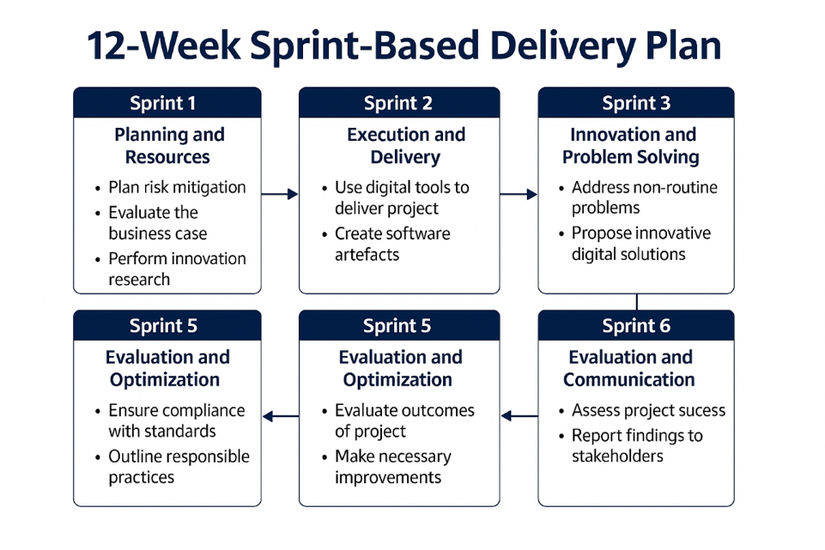
Innovation and Problem Solving: The project will address non-routine challenges such as data integration, user adoption, and process redesign. Innovative features like automated alerts and real-time dashboards will be explored (S1, S16, S17, S18, S19, S22)
Ethical and Legal Considerations: Data protection, accessibility, and ethical use of technology will be embedded throughout the project lifecycle (S3, B3)
Evaluation and Communication: Success will be measured through KPIs such as time saved, error reduction, and user satisfaction. Findings will be communicated via a final report and presentation (K17, K18, S13)
KSBs | K3, K4, K5, K15, K17, K18, K25, K26, K27, S1, S2, S3, S5, S6, S13, S14, S16, S17, S18, S19, S22, B3

Research Requirements
Research Methods:
Outline the research approach, including:
  - Data collection and analysis (K3, S2, S14)
  - Stakeholder engagement: meeting, interviews or surveys (S1, S13, B5)
  - Survey of supporting literature/documentation (discovery of information useful to your project) and benchmarking (K4, S14, S22)
Expected Outcomes:
Describe how research will inform the solution and support decision-making. (K2, K17, S3, S17, S22, B3)
Research Requirements
Engagement will take place through meetings, interviews and surveys. These interactions will help gather insights, understand needs, and ensure the solution is shaped by those it affects most (S1, S13, B5)
A review of supporting literature and documentation will be carried out to discover relevant information and best practices. Benchmarking against similar projects or industry standards will help identify gaps and opportunities for improvement (K4, S14, S22)
Data will be gathered through a combination of qualitative and quantitative methods. This includes collecting feedback from stakeholders, reviewing existing documentation, and analysing trends and patterns to support the project’s objectives (K3, S2, S14)
The research will directly inform the development of the solution. It will provide evidence to support decision-making, highlight risks and opportunities, and ensure the final outcome is both practical and effective. Insights gained will guide the design, implementation and evaluation stages, helping to align the solution with stakeholder needs and organisational goals (K2, K17, S3, S17, S22, B3)
KSBs | K2, K3, K4, K17, S1, S2, S3, S13, S14, S17, S22, B3, B5

Timeline and Milestones
“The project may be undertaken pre-Gateway; however, the Project Report must be completed after the apprentice has gone through the Gateway.” EPA Assessment Plan - Project Report with presentation, questions and answers - Overview
Any practical elements of the project can be completed before Gateway; however, the 6,000-word project report, presentation, and Q&A preparation must be completed during the EPA period, which begins after Gateway.
You will submit your completed six-item work-based portfolio in early September. After this, you will go through Gateway sign-off. You will then complete your 6,000-word project report and your slide deck for the project presentation, both of which must be submitted in early November. This allows time to complete the EPA assessments, including the work-based project presentation and the professional discussion with the independent assessor, by the end of November. You will be in the official Gateway for approximately three months, from September to November. Your results will then go to the assessment board in mid-December, with a contingency to complete this in January if needed.
You will be given exact deadlines within the assessment briefs, but a rough timeline structure is outlined below.
Milestone | Date
Gateway - Submit 6 Item Portfolio | Beginning of September
Submit Work based Project Report | Early November
Prepare for EPA Assessments with support. | Mid-November
EPA – AE1 & AE2 | End-November

Highlight all KSB you project will reference to
Knowledge (K): | K1 | K2 | K3 | K4 | K5 | K15 | K17 | K18 | K25 | K26 | K27
Skills (S): | S1 | S2 | S3 | S5 | S6 | S13 | S14 | S16 | S17 | S18 | S19 | S22
Behaviours (B): | B3 | B5

Apprentice Declaration
I confirm that I have developed this project proposal and understand the expectations for the work-based project report and presentation. I believe this project will allow me to demonstrate the required knowledge, skills, and behaviours (KSBs) as outlined in the assessment plan.
Apprentice Name
Student ID
Pathway
Company
Date
Sign

Employer Declaration
I confirm that this project proposal has been reviewed and approved. I agree that the project will bring measurable business benefit to the organisation and provides the apprentice with the opportunity to meet the required KSBs.
Name
Position
Company
Date
Sign

Southampton Solent University (EPAO) Approval
I confirm that this project proposal has been reviewed and approved by Southampton Solent University the End-Point Assessment Organisation (EPAO). It provides sufficient scope for the apprentice to meet the KSBs mapped to this assessment method.
Name
Position
Company | Southampton Solent University
Date
Sign

