Set-up
Create a new Design document call it Buttons
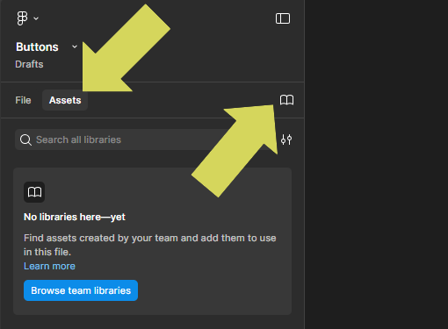
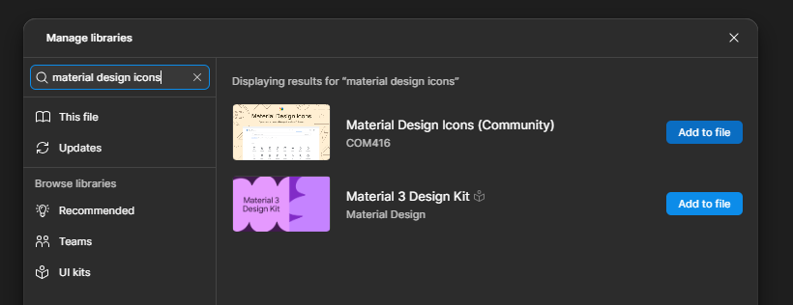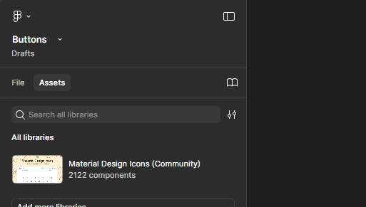
Create a frame either from the Tool bar or press F on keyboard and drag out a frame w:150 x h:38 (best to adjust in the properties panel on the right) with corner radius 6 & add a Fill colour. Finally give the frame the name Button either in the layers panel or on the frame label
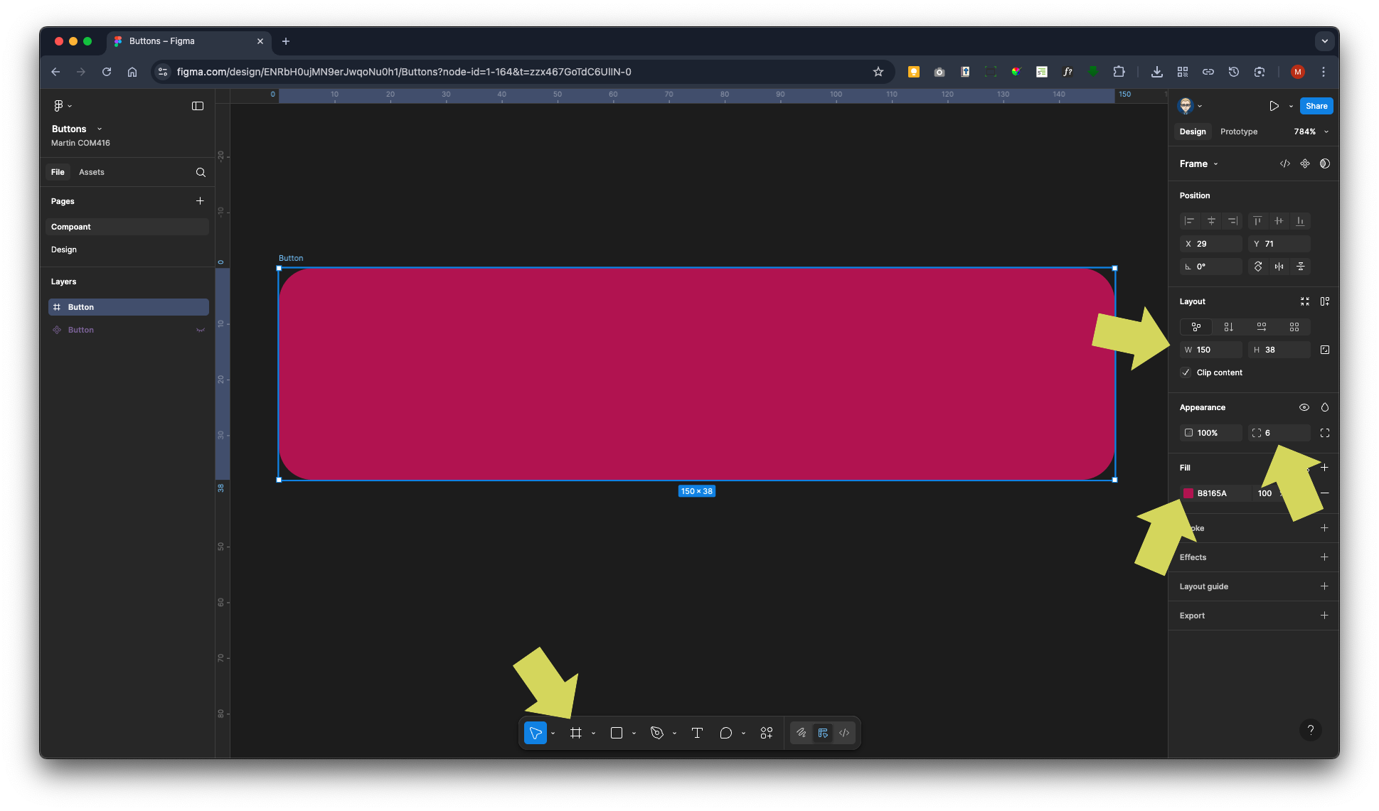

Select Assets from the right panel, select the MaterialDesign icons & drag drop an icon on top of the Button frame making sure it is inside the frame (indented in the layers outline) drag drop laters if not
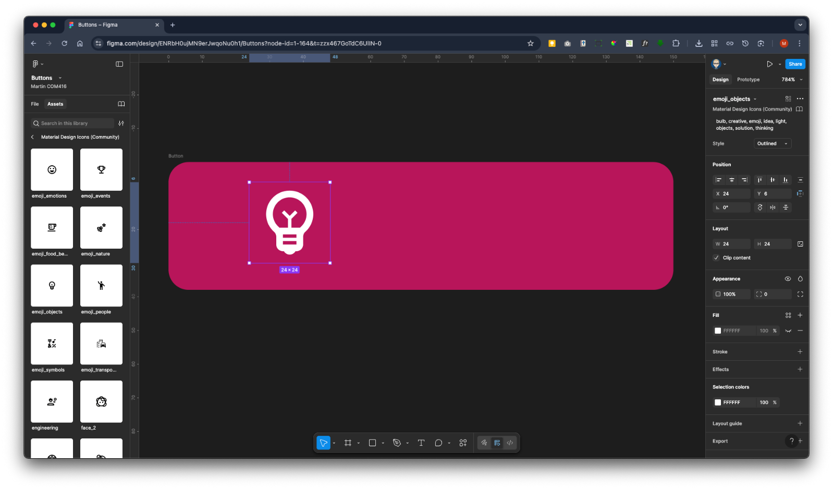

Either select the text tool of press T on the keyboard click in the Button frame and type the word BUTTON – in Typography section on right Font: Roboto – Bold – 18pt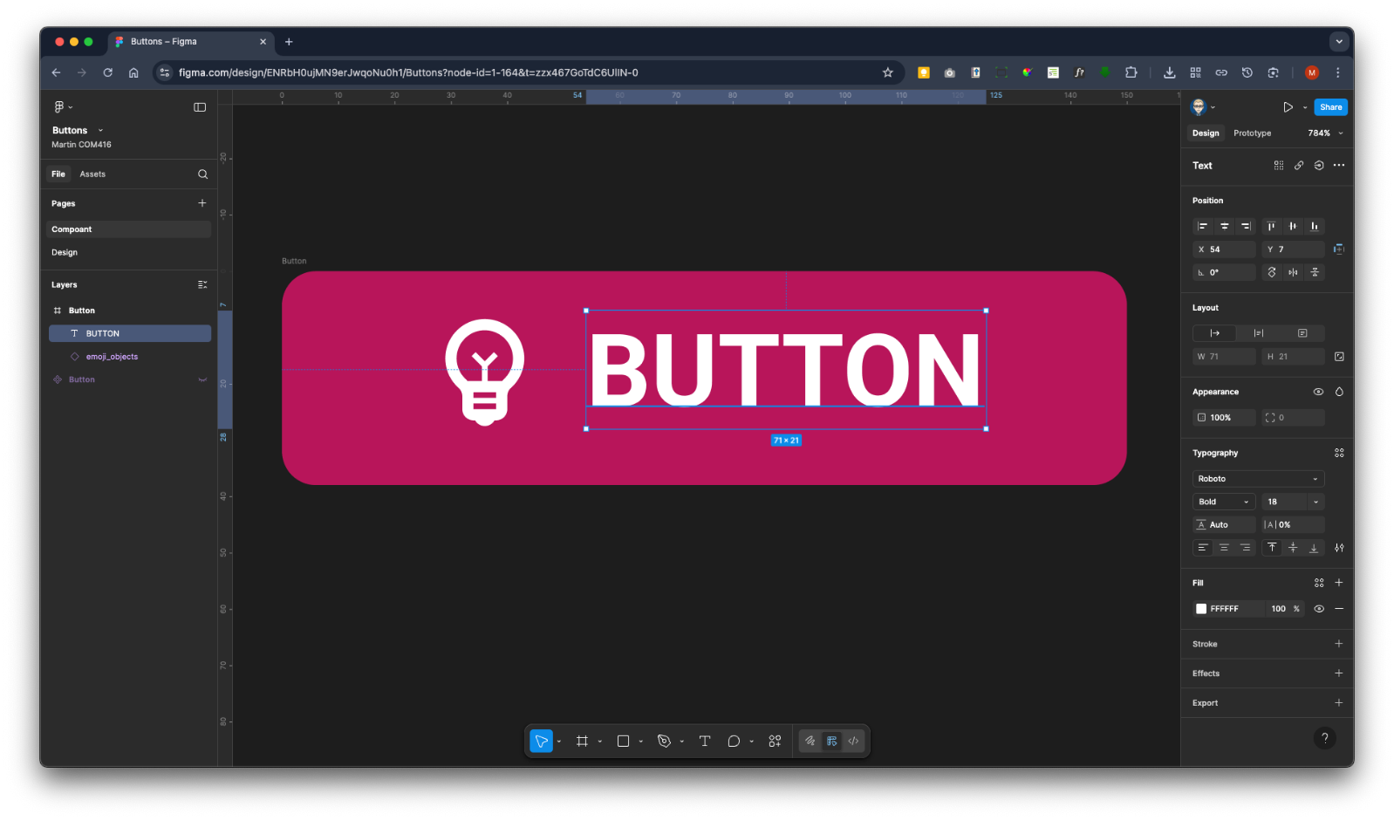
Auto Layout
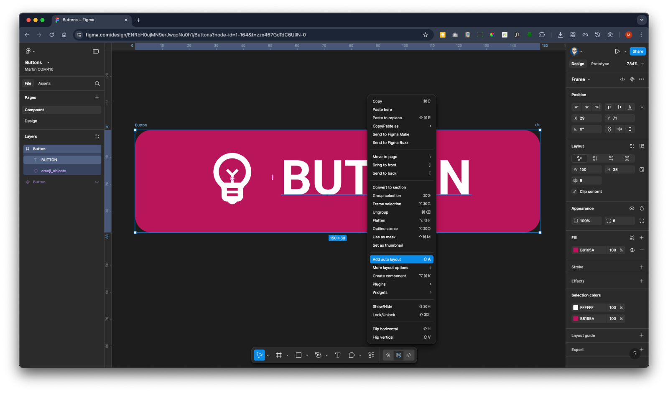

With the frame (button) selected, in the right properties panel in the Auto Layout Section Align Centre
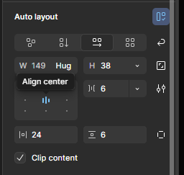 | 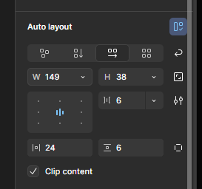

Adjust frame (button) height if not 38 & change Hug to Add max height to fix it at 38
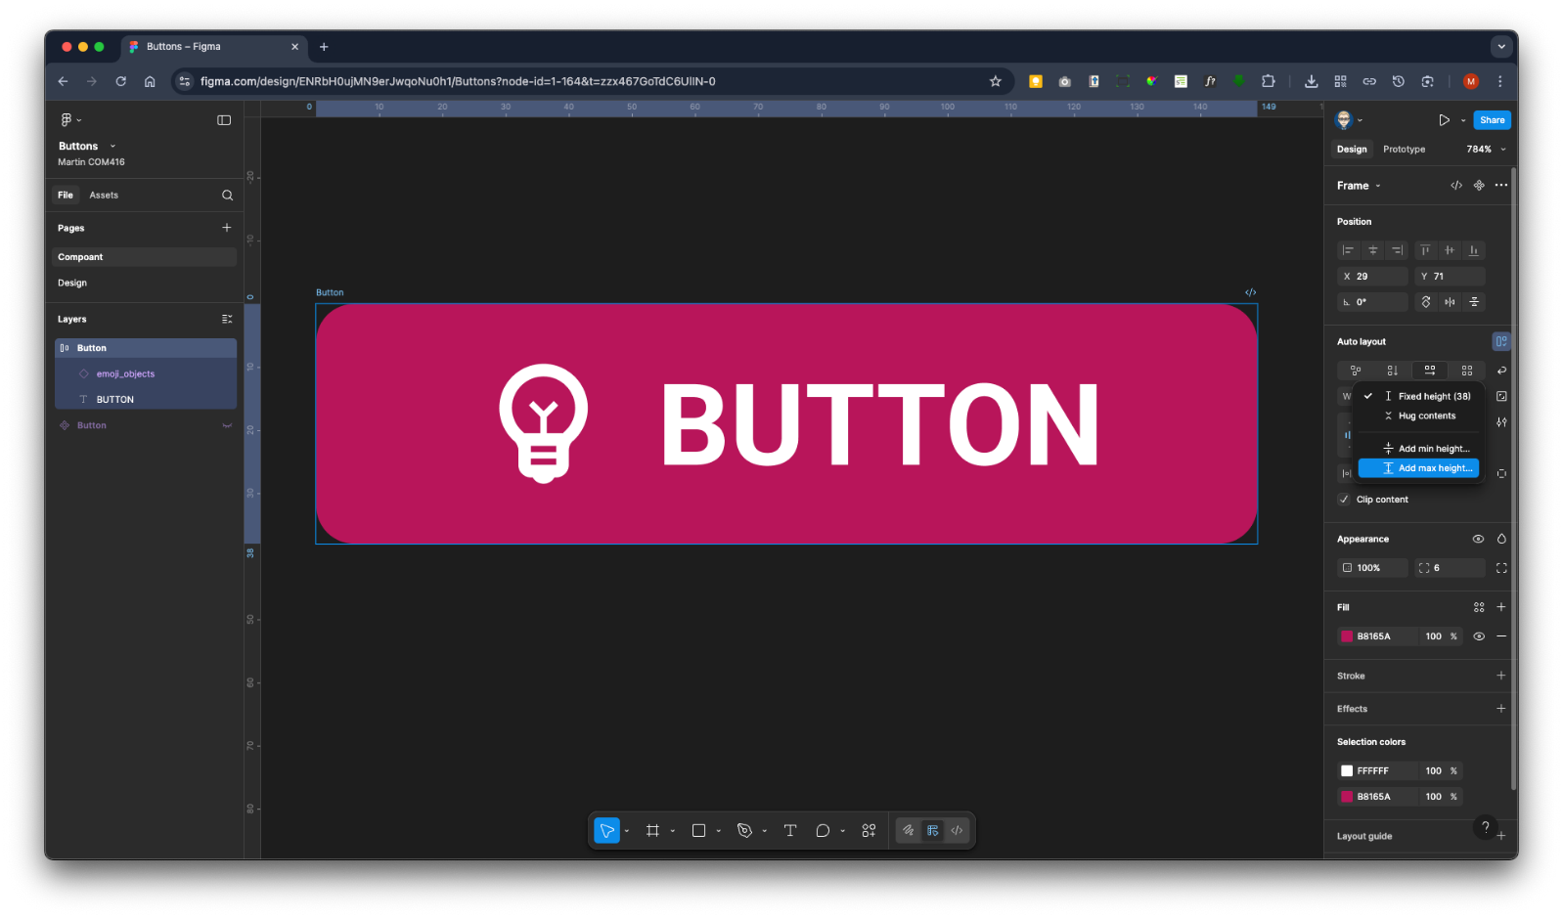

Change frame (button) into a Component either frame the right properties panel in the Frame section or by right mouse clicking it
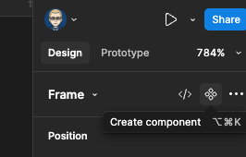

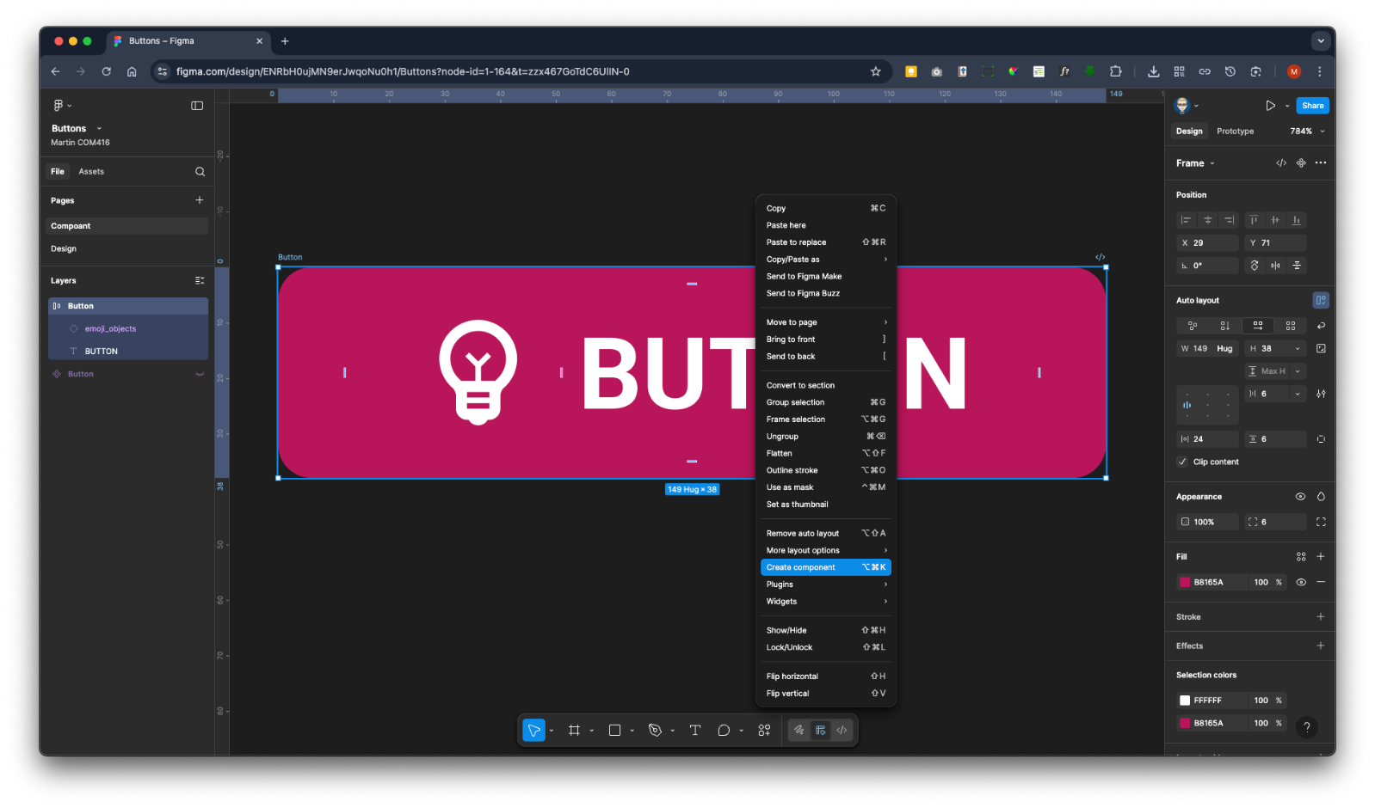

Icon on-off switch
Select the icon within the button frame you might have to click a number of time to drill down the layer or select it in layers panel
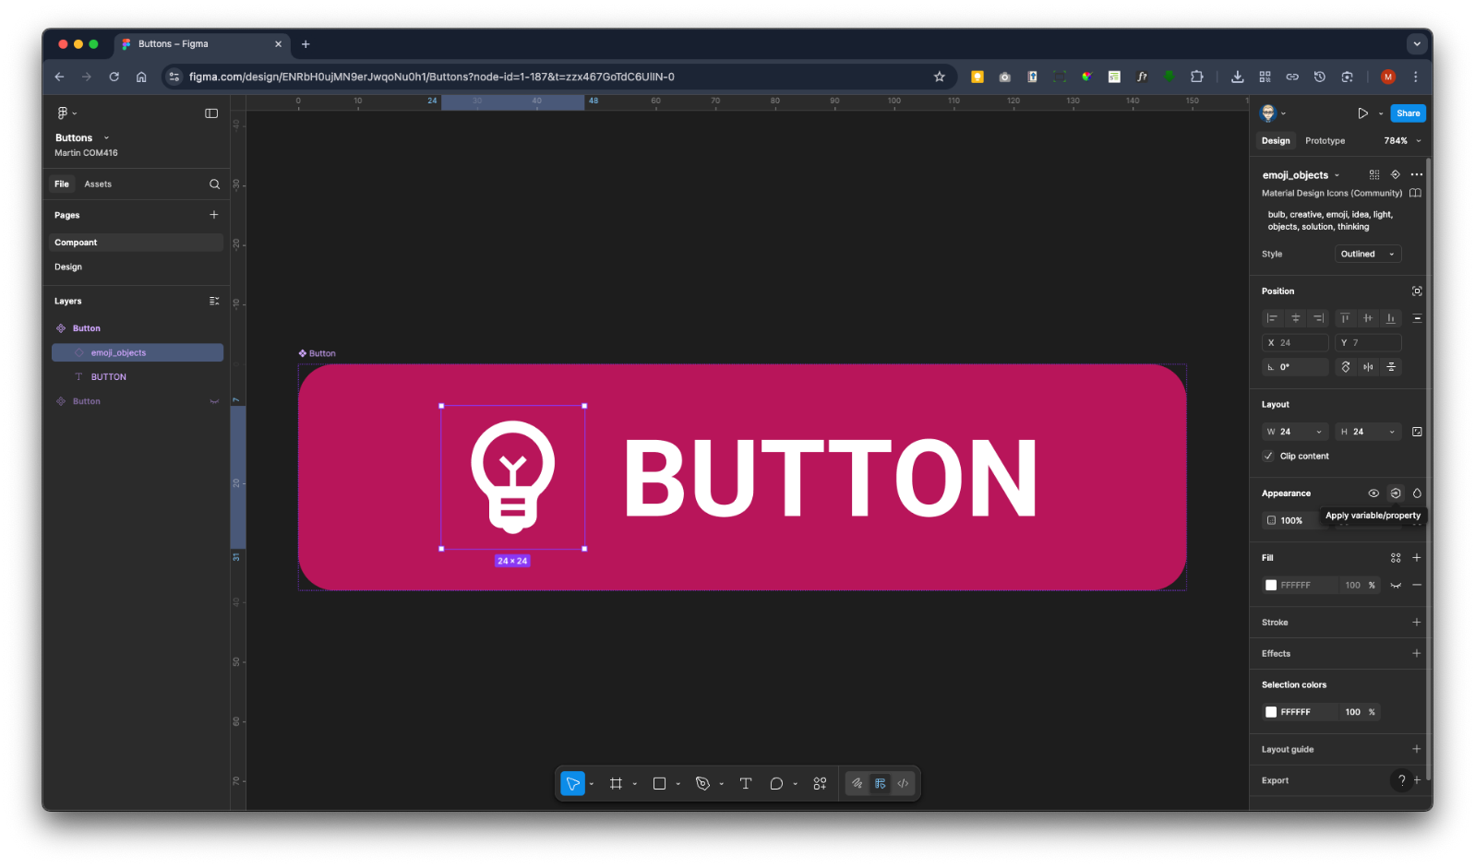
In the right Properties panel in the Appearance Section click on + New variable/property
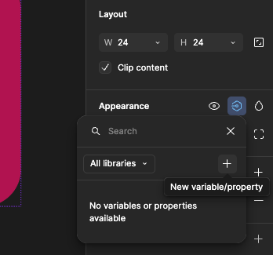

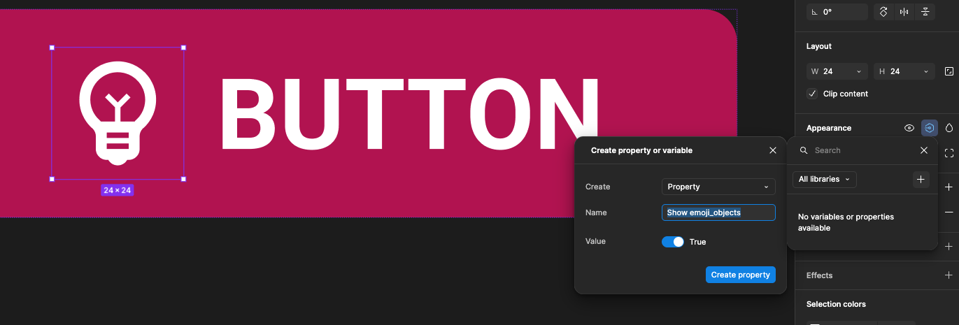

In name field type in Show icon and click Create Property button

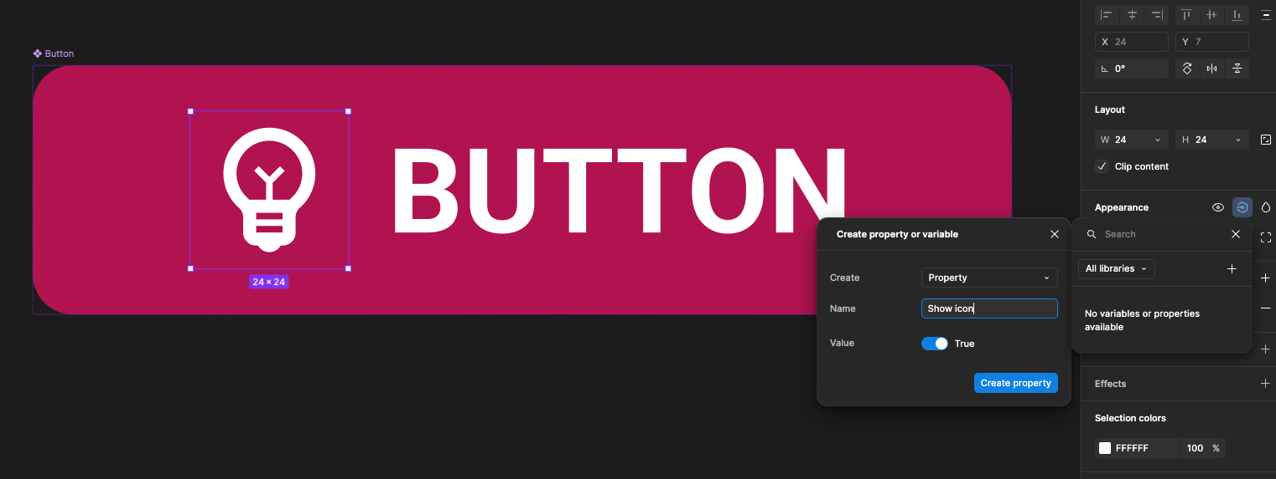

Editable Text Label
Select the button text either on the frame or in the layers, in the right Properties panel in the Text section click the Add variable/property

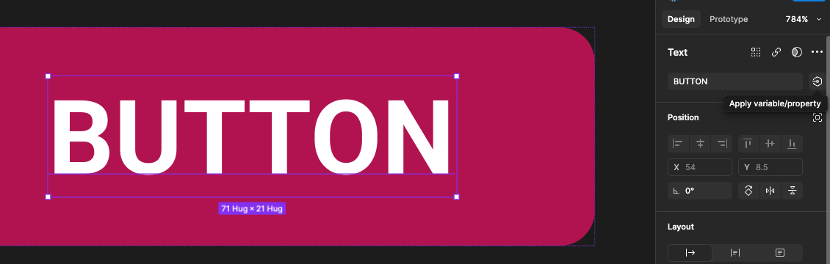

Click the + New variable/property
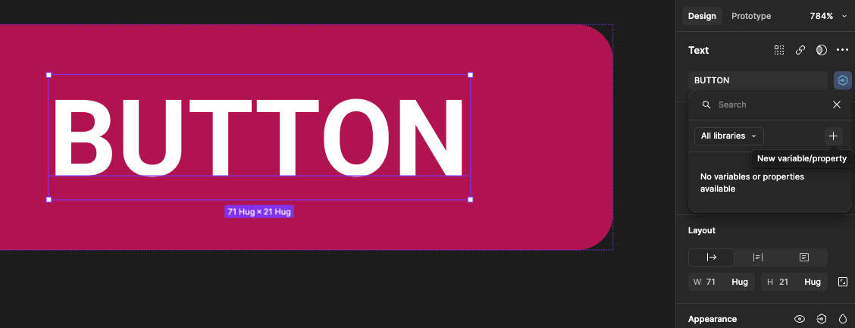
You will see this panel

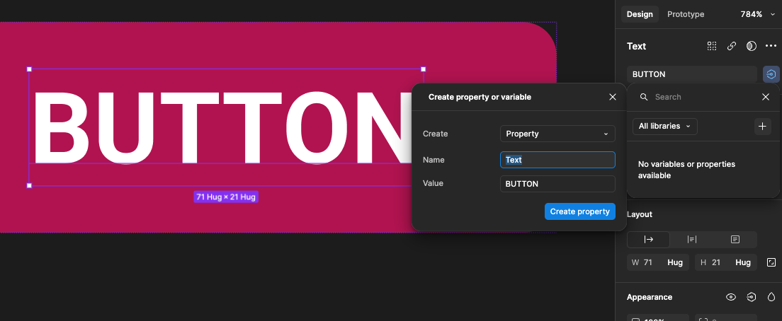

Change Text to Label

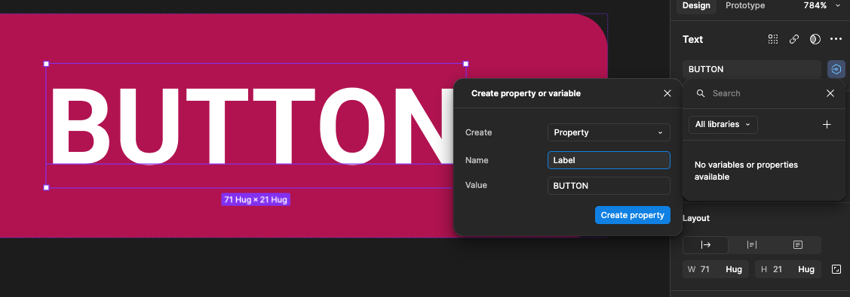

You will now see the Label has been added
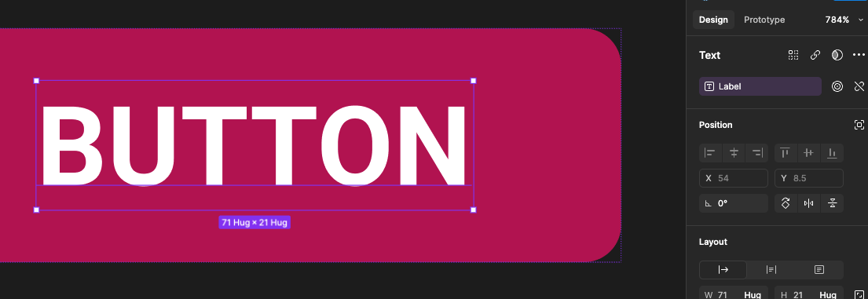

Icon Swop
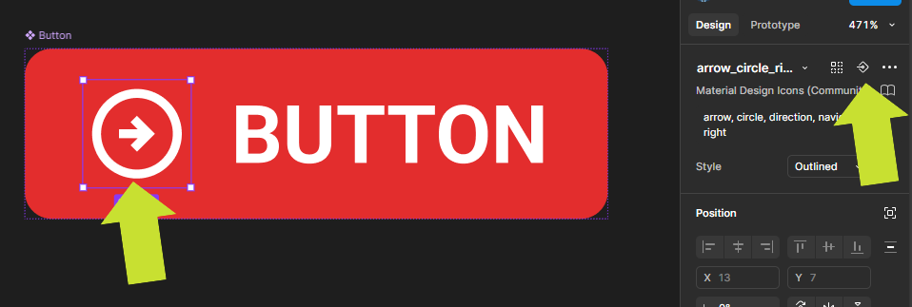
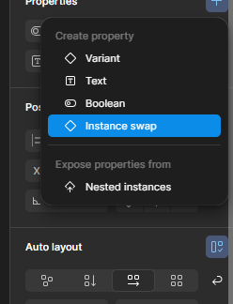
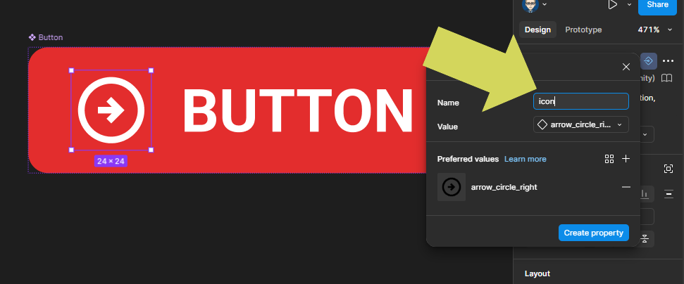
To recap:

- Create a Frame w:150 x h38
- Added text box with BUTTON text – Roboto – Bold – 18pt
- Added icon
- Auto Layout added
- Frame turned into Component
- Property added for Label text
- Property added for icon change swop
- Property added for icon show/hide

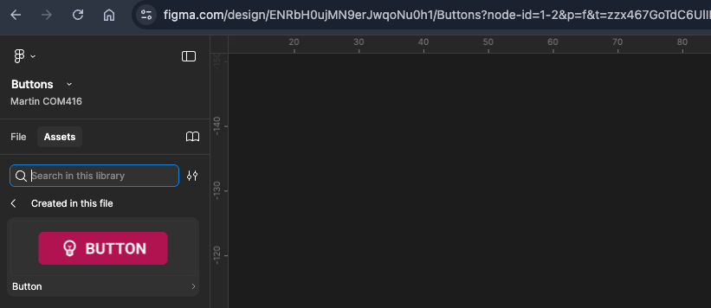

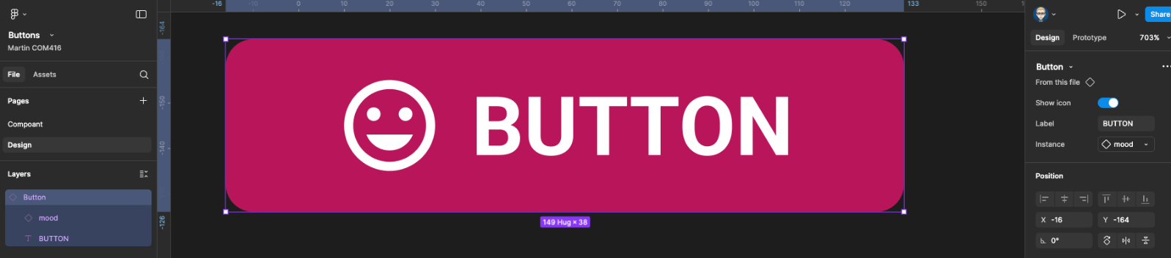

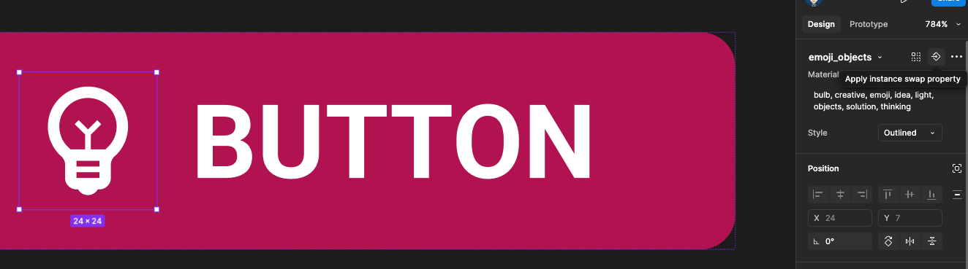

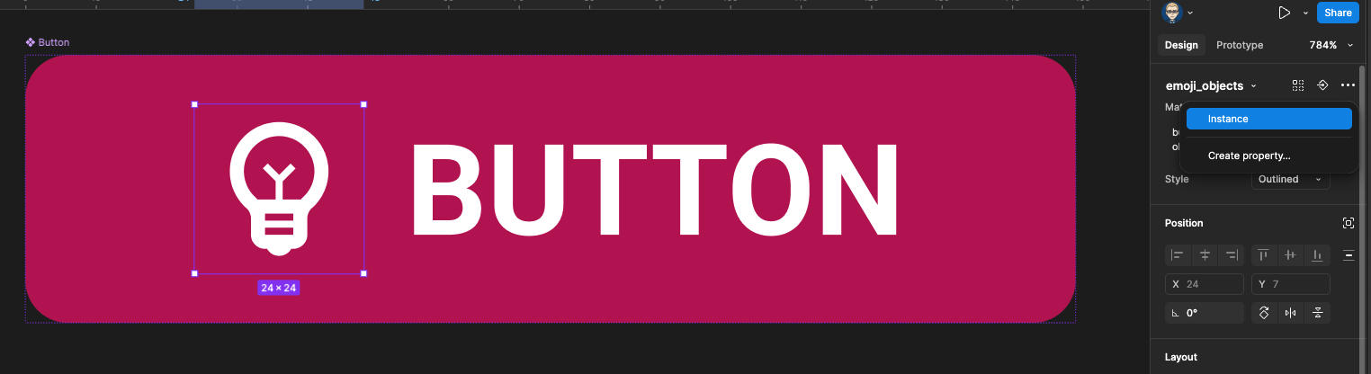

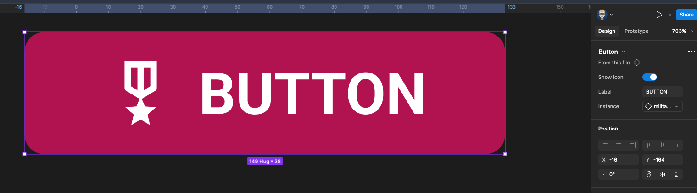

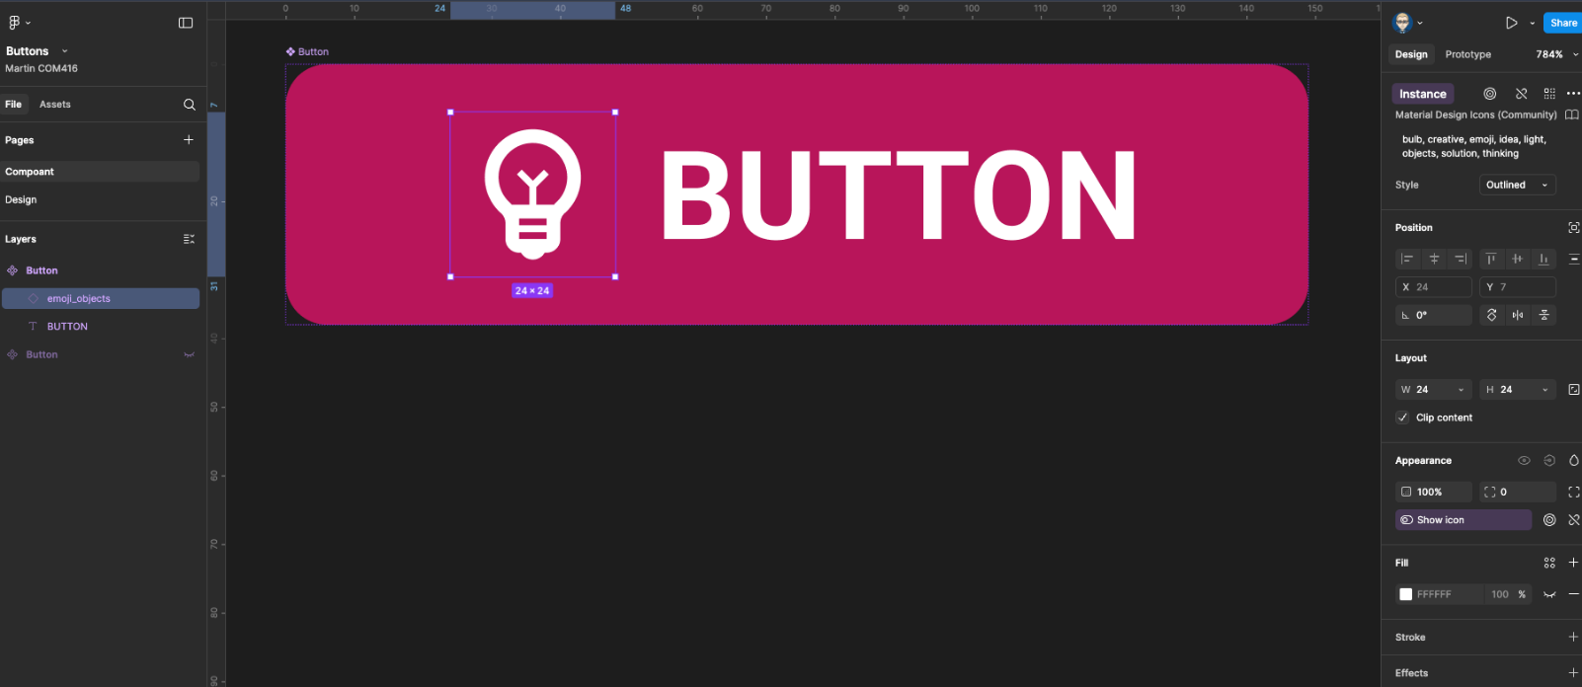
https://www.youtube.com/watch?v=1ucLq6JTxac

https://www.youtube.com/watch?v=k1iwiHJrAWI

How to Create a Button Component in Figma
1. Set Up Your Document
- Open a new design file and name it Buttons.
2. Create the Button Frame
- Use the toolbar or press F on your keyboard to draw a frame.
- Set the size to 150 x 38 in the properties panel.
- Add a corner radius of 6.
- Choose a fill colour.
- Name the frame Button in the layers panel or directly on the frame label.
3. Add an Icon
- Open the Assets panel on the right.
- Find the Material Design icons.
- Drag and drop an icon onto the Button frame.
- Make sure the icon is inside the frame (check the layers panel for indentation).
- If it’s not, drag it into place manually.
4. Add Text
- Select the text tool or press T.
- Click inside the Button frame and type BUTTON.
- In the Typography section, set the font to Roboto, style Bold, size 18pt.
5. Apply Auto Layout
- Select the Button frame.
- In the Auto Layout section of the properties panel, set alignment to Centre.
6. Fix the Frame Height
- Make sure the frame height is exactly 38.
- Change the layout setting from Hug to Add max height to lock it at 38.
7. Convert to Component
- Right-click the frame and choose Create Component.
- Or use the Frame section in the properties panel to do the same.

Add Properties to Make It Interactive
8. Icon On/Off Switch
- Select the icon inside the Button frame (you may need to drill down in the layers panel).
- In the Appearance section, click + New variable/property.
- Name it Show icon and click Create Property.
9. Editable Text Label
- Select the button text.
- In the Text section, click Add variable/property.
- Click + New variable/property.
- In the panel that appears, change Text to Label.
- The Label property will now be added.
10. Icon Swap (Optional)
- You can also add a property to swap the icon if needed, using the same method as above.

Quick Summary
- Frame: 150 x 38
- Text: BUTTON – Roboto – Bold – 18pt
- Icon added
- Auto Layout applied
- Frame converted to Component
- Label text property added
- Icon swap property added
- Icon show/hide property added

