**Electronic Design Automation (EDA)  
 for Arduino & Raspberry Pi Projects**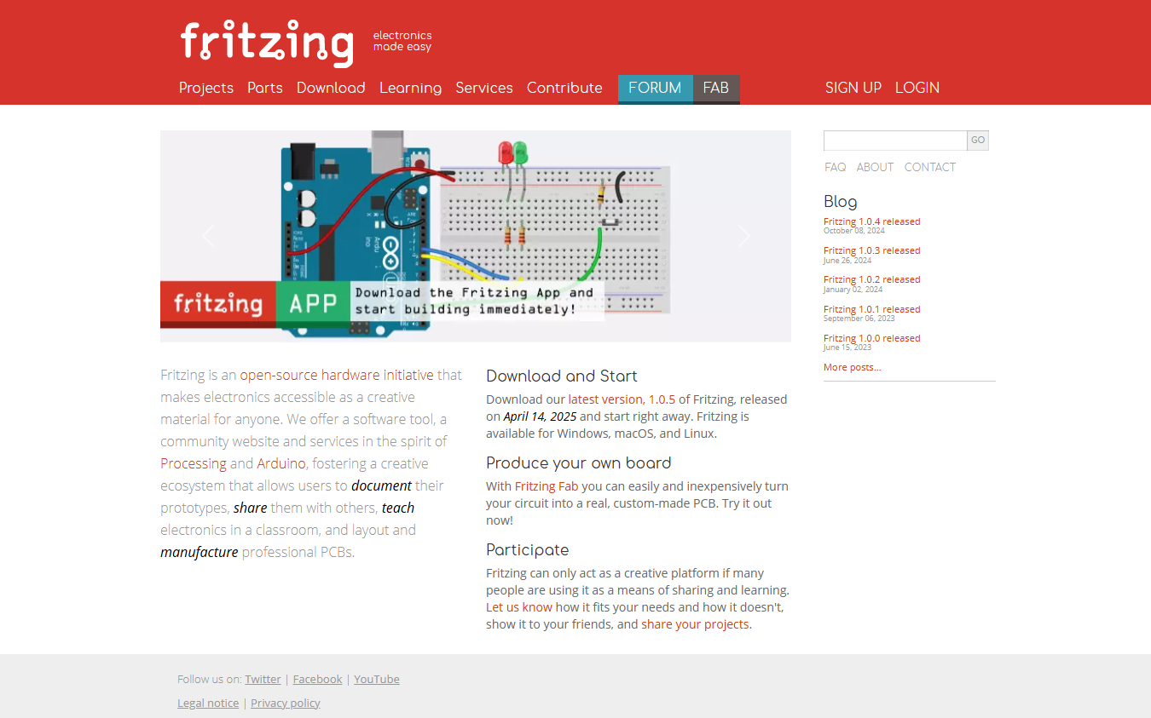  
[Welcome to Fritzing](https://fritzing.org/)

**Fritzing is a user-friendly tool for designing and documenting electronics projects, including those involving the Raspberry Pi**. It allows you to visually lay out circuits using a breadboard view, create schematic diagrams, and even design printed circuit boards (PCBs) for fabrication.

[Fritzing - electronics made easy](https://fritzing.org/projects/)

For Raspberry Pi projects, Fritzing can help you:

* **Map out connections** between the Pi and components like sensors, LEDs, and motors.
* **Create clear diagrams** for sharing with others or for use in teaching and presentations.
* **Prototype circuits** before physically assembling them, reducing errors and improving understanding.
* **Design custom PCBs** if you're building a more permanent or professional version of your project.

It’s particularly useful for beginners and educators, as it simplifies the process of circuit design and makes electronics more accessible.  
  
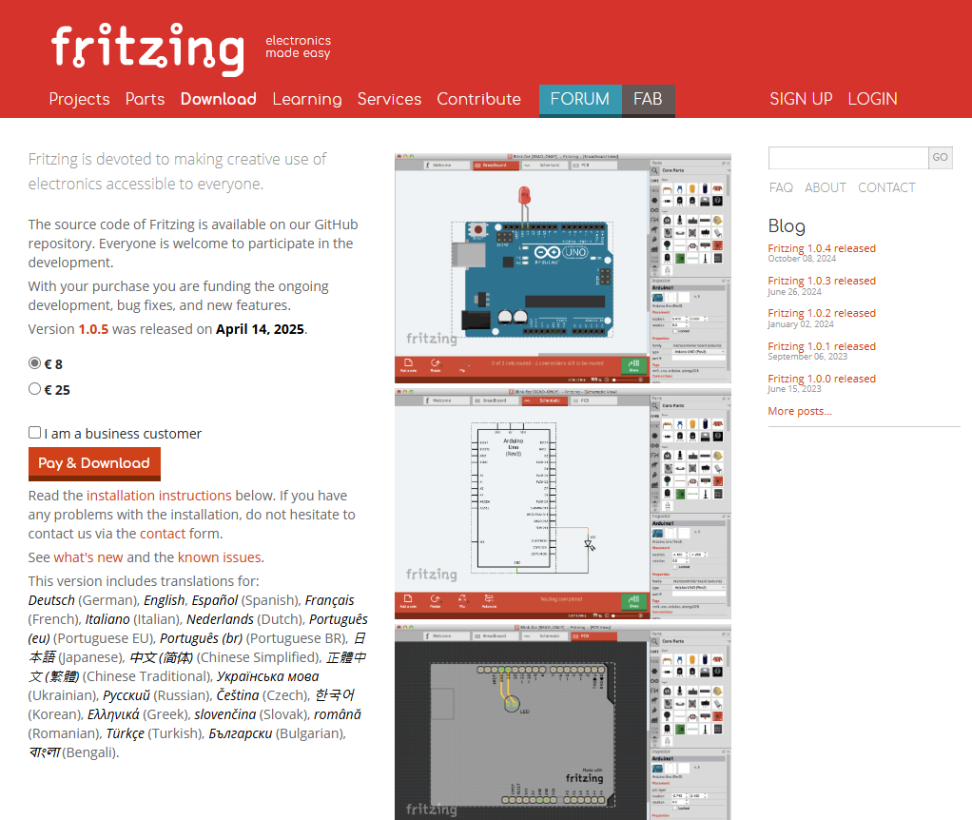

**Using Fritzing**

Fritzing Use Case

|  |  |
| --- | --- |
| **Element** | **Description** |
| **Actor** | Beginner Python learner or student |
| **Goal** | Design and test electronic circuits to use in Raspberry Pi projects |
| **Preconditions** | Fritzing is installed Raspberry Pi setup is ready- Learner knows basic Python syntax |
| **Main Steps** | 1. Open Fritzing 2. Create a new breadboard project 3. Add components (LEDs, sensors, resistors, etc.) 4. Connect components in the workspace 5. Export or view the circuit diagram 6. Build the circuit on a breadboard connected to the Raspberry Pi.  7. Write and run a Python script to control or read from the circuit 8. Test and refine the design or code |
| **Postconditions** | Working circuit diagram- Functional Raspberry Pi project controlled by Python |
| **Alternative Path** | If the circuit fails, use Fritzing to trace and fix wiring errors before retesting |

**Practical application of using Fritzing or other similar packages and platforms.**

Now we look at the practical steps of using diagrams to support our learning projects. This example focuses on a simple project to make an LED light blink.  
  
The first start or any learning when it comes to tech and digital is getting support from online tutorials there are lot out there for projects with project Raspberry pi and circuit boards.  
  
The diagram below is from a tutorial website [sunfounder.com Tutorials & Support](https://docs.sunfounder.com/projects/davinci-kit/en/latest/python_pi5/pi5_1.1.1_blinking_led_python.html) Many of these tutorials will not only offer you how to set up your circuit boards for also how to implement your code and get your project working  
  
**Fritzing Tutorial Walkthrough**

**Tutorial Walkthrough video:**  
<https://solent.cloud.panopto.eu/Panopto/Pages/Viewer.aspx?id=6a3c00ed-bc20-4156-809c-b37b00e5d189>

Download for modified GPIO Extension Board:  
[Adafruit-T-Cobbler-Plus-modified.fzpz](https://forum.fritzing.org/uploads/short-url/9uM2X2SXXQxtvSymgfsDWazsf9N.fzpz)

**Reference list**

**ERIC BREDDER, 2018.** *Intro to Arduino: Part 1 - Fritzing* [viewed 18 October 2025]. Available from: <https://youtu.be/QqRfAlI2Xh8?si=suqppn7eaBByHGXn>

**BAVERSTOCK, T., 2019.** Fritzing Tutorial - A Beginners Guide to Making Circuit & Wiring Diagrams. *YouTube*

FRITZING, 2025. *Fritzing* [viewed 19 October 2025]. Available from: <https://youtu.be/-saXw1EipX0?si=cqBS7uS2wpqkn_mF>

**FRITZING FORUM, 2020.** *My Parts disappeared* [viewed 19 October 2025]. Available from: <https://forum.fritzing.org/t/my-parts-disappeared/9321>

**FRITZING FORUM, 2021**. *T-Cobbler blocks breadboard, how to connect wires?* [viewed 19 October 2025]. Available from: <https://forum.fritzing.org/t/t-cobbler-blocks-breadboard-how-to-connect-wires/12461/11>

**FRITZING FORUM, 2023.** *Pins Not Lining Up With Breadboard* [viewed 19 October 2025]. Available from: <https://forum.fritzing.org/t/pins-not-lining-up-with-breadboard/19380>

**FRITZING.ORG, 2024.** *Fritzing Blog* [viewed 19 October 2025]. Available from: https://blog.fritzing.org/

NERD MUSICIAN, 2021. *Fritzing Tutorial for Beginners - How to Design your Circuits and Diagrams* [viewed 18 October 2025]. Available from: <https://www.youtube.com/watch?v=P-OdzSiqRm8>

**REENOVE.COM, 2025.** *Raspberry Pi Starter Kits* [viewed 19 October 2025]. Available from: <https://store.freenove.com/collections/for-raspberry-pi>

**SUN FOUNDER , 2022.** *Raspberry Pi GPIO Extension Board — SunFounder super-kit-v2-for-pi documentation* [viewed 19 October 2025]. Available from: <https://docs.sunfounder.com/projects/superkit-v2-pi/en/latest/Raspberry_Pi_GPIO_Extension_Board.html>