

Project Report with Presentation, Questions and Answers AE1
EPA Assessor Overview
Pathway: Cyber Security

BSc Digital and Technology Solutions Professional
Apprenticeship Standard: ST0119 v1.2 (2023)
EPA AE1 Overview Document (Version: 2 - October 2026)
Created by martin.reid@solent.ac.uk
Southampton Solent University - SO14 0YN
End Point Assessor Organisation (EPAO) ID: EPA0325

Table of Contents
1. Understanding the Assessment 4
1.1 Purpose of this Guidance 4
1.2 The Wider EPA Context 4
1.3 Project Lifecycle and EPA Timeline 5
1.4 Project Approval and Assessor Involvement 5
1.5 Structure of AE1 6
1.6 Understanding the Nature of the Project 6
1.7 Key Principle: Assess the Apprentice, Not the Team 7
1.8 The Four Assessment Themes 7
1.9 Purpose of the Project Report and Presentation 8
1.10 Report Structure and Assessor Expectations 9
1.11 KSB Tagging and Mapping 10
1.12 Appendices A-D: Guidance for Assessors 11
1.13 Evaluating the Presentation 11
1.14 STAR-Based Responses and Discussion Technique 12
1.15 Conducting Effective Questioning 12
2. Making Assessment Decisions 13
2.1 Grading Principles 13
2.2 Pass and Distinction Decision Making 13
2.3 The Assessor's Golden Rule 14
2.4 Grading EPA AE1 14
3. Conducting the Assessment 17
3.1 Presentation with Questions and Answers – Operational Guidance 17
3.2 Assessor Assessment Pack 18
3.3 Training Videos 21
3.4 Use of the Question Bank and Assessment Questioning 22
3.5 EPA Assessment Feedback Sheet 23
4. Evidence and KSB Mapping 24
4.2 Grader Sheet Guidance 24
4.2. KSB Grade Criteria to Report Section. 25
4.1 EPA AE1 Grader Sheet 35
4.2 Using the EPA AE1 Grader Sheet 36
5. Completion 39
5.1. Giving Written Feedback 39
5.2. Final Assessment Considerations 39

BSc Digital and Technology Solutions Professional
Assessment Element 1: Project Report with Presentation, Questions and Answers (AE1)

1. Understanding the Assessment

1.1 Purpose of this Guidance
This document has been developed to support independent End-Point Assessors in conducting Assessment Element 1 (AE1) for the Digital and Technology Solutions Professional Degree Apprenticeship (ST0119 v1.2, 2023). It is intended to promote consistency, fairness and validity in assessment decisions.
AE1 consists of two components:
Component 1: Project and Project Report
Component 2: Presentation with Questions and Answers (Q&A)
Assessors should view AE1 as a single holistic assessment rather than two separate assessments. Evidence may be demonstrated through the Project Report, Presentation or Q&A, and grading decisions should be based on the cumulative evidence gathered across both components.
The assessor's role is to determine whether the apprentice has demonstrated the required Knowledge, Skills and Behaviours (KSBs) through the evidence presented across the assessment. Assessment should focus on the apprentice's individual contribution, decision-making, professional competence and application of knowledge within a workplace context.

1.2 The Wider EPA Context
The Project Report with Presentation and Questions and Answers (AE1) is one of two End-Point Assessment methods within the Digital and Technology Solutions Professional apprenticeship standard. The second assessment method is the Professional Discussion underpinned by a Portfolio (AE2). Both assessments are conducted by an independent EPA Assessor and are graded separately before contributing to the apprentice's overall EPA outcome.
Assessors should recognise that AE1 does not assess every KSB within the apprenticeship standard. Assessment decisions should only be made against the KSBs mapped to this assessment method.
The project should be directly linked to the apprentice's occupational role and undertaken as part of normal workplace responsibilities. It is not an academic project completed solely for assessment purposes. The project should demonstrate how the apprentice applies professional knowledge, skills and behaviours to deliver value within a genuine workplace environment

1.3 Project Lifecycle and EPA Timeline
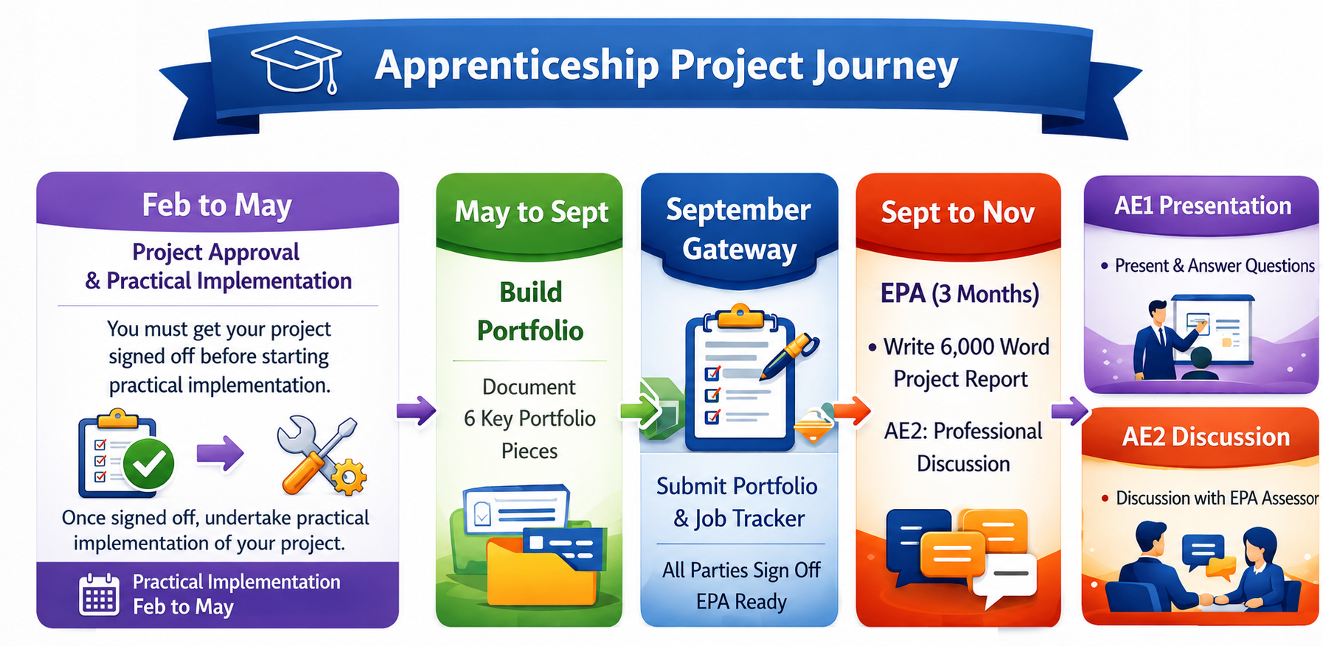
Apprentices may complete some or all practical implementation activity before Gateway and the formal EPA period. This aligns with the requirements of the apprenticeship standard.
Whilst project delivery activities may occur before Gateway, the project report must be completed during the EPA period. The report provides a retrospective account of the work undertaken and enables the apprentice to analyse, evaluate and reflect on their project.
The completed report must be submitted during the EPA period in accordance with published deadlines.

1.4 Project Approval and Assessor Involvement
Before practical project work begins, the proposed project must be agreed between the apprentice and employer and approved through the formal project approval process. Approval confirms that the proposed project is appropriate in scope, complexity, occupational relevance and assessment coverage.
The individual involved in project approval may not necessarily be the same independent assessor who subsequently conducts the final AE1 assessment.

1.5 Structure of AE1
AE1 contains two integrated components:
- A Project Report (approximately 6,000 words)
- A Presentation followed by Questions and Answers
The Project Report should be reviewed before the apprentice undertakes the Presentation and Q&A. The report provides the primary source of evidence and enables assessors to understand the project context, the work undertaken, the decisions made and the outcomes achieved.
The Presentation and Q&A allow the apprentice to:
- Expand upon evidence contained within the report.
- Demonstrate implemented functionality where appropriate.
- Clarify project decisions.
- Justify approaches and solutions.
- Evaluate outcomes and lessons learned.
- Provide additional evidence of personal contribution and ownership.
The presentation should broadly align with the report structure, enabling the apprentice to guide assessors through the project lifecycle whilst reinforcing and validating evidence already submitted.
Assessors should recognise that whilst most evidence will normally be contained within the report, the Presentation and Q&A may provide additional supporting evidence, strengthen existing evidence and confirm the apprentice's understanding, decision-making and ownership.
A single grading sheet should be used across both assessment components. Grading decisions should be based on cumulative evidence gathered across the entirety of AE1.

1.6 Understanding the Nature of the Project
The project should represent a significant and defined piece of work with genuine business value and relevance to the employer. It may address a specific problem, recurring issue or business opportunity.
Assessors should recognise that projects are undertaken within live commercial environments and may involve confidentiality, intellectual property restrictions, commercially sensitive information, security classifications, contractual obligations or customer data.
Where information has been redacted or anonymised, assessors should focus on whether sufficient evidence remains available to evaluate competence against the relevant KSBs.
Projects may result in implementation, optimisation, enhancement, proof of concept or recommendation. Any of these outcomes can provide valid evidence where competence has been demonstrated.

1.7 Key Principle: Assess the Apprentice, Not the Team
Many apprentices work within multidisciplinary teams. Whilst collaboration is expected, assessment decisions must focus upon the apprentice's individual contribution.
Assessors should continually consider:
- What specifically did the apprentice do?
- What decisions did they make?
- How did they influence project outcomes?
- What evidence demonstrates their competence?
Apprentices may present their project report in the first person, third person, or a combination of both, where this is appropriate to the style, structure and context of the report. Assessors should not disadvantage an apprentice for using first-person writing where it helps to clarify individual contribution, ownership, decision-making, reflection or learning. Phrases such as “I analysed”, “I selected”, “I implemented” or “I evaluated” may provide useful evidence of the apprentice’s personal role in the project, particularly where the work was undertaken within a wider team. Third-person writing may also be appropriate when describing organisational context, project background, technical outcomes or wider business impact. The key assessment consideration is not the writing style itself, but whether the apprentice’s own actions, decisions, contribution and competence are clearly evidenced. Where ownership or individual contribution is unclear, assessors should use the presentation and questioning opportunity to validate the apprentice’s role and establish the extent to which the evidence demonstrates the relevant KSBs.

1.8 The Four Assessment Themes
Assessment is organised around four overarching themes. These themes provide the framework through which evidence should be evaluated.
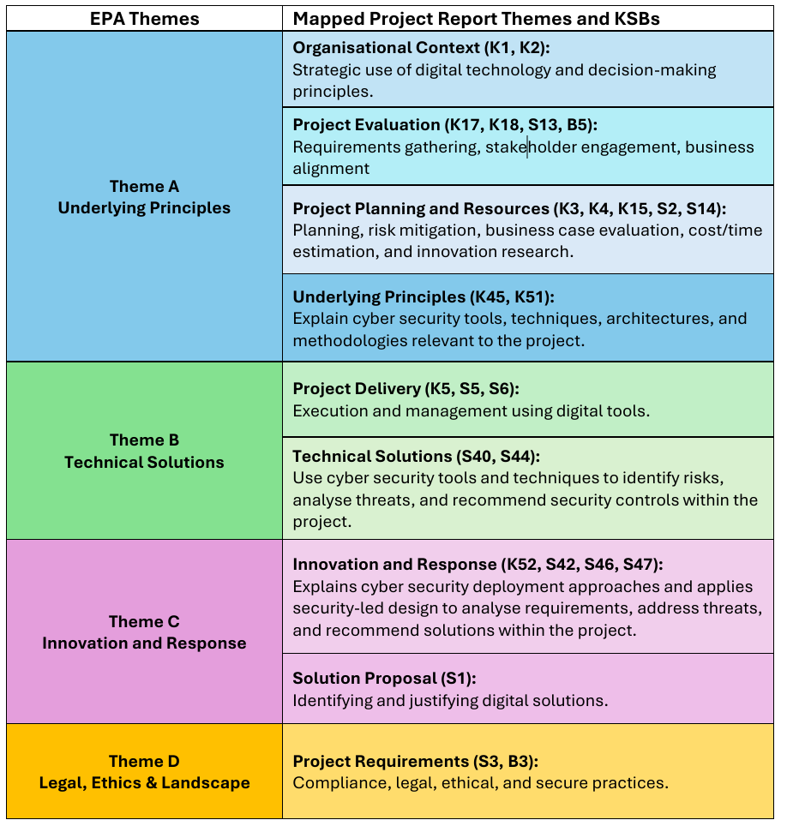
Theme A: Underlying Principles - This theme focuses on organisational context, planning, stakeholder engagement, project evaluation and strategic decision-making. The apprentice should demonstrate an understanding of why the project was required, how it supports organisational objectives and how decisions were informed through research and evaluation. Evidence should also show effective planning, consideration of risks and opportunities, and appropriate estimation of resources, timescales and costs.
Strong evidence typically includes clear justification for decisions, evaluation of options, stakeholder considerations and reflection on project performance.
Theme B: Technical Solutions - This theme concerns the delivery of the technical solution and the application of software engineering practices. Assessors should look for evidence that the apprentice selected and applied appropriate methods, tools and techniques to deliver the project. Attention should be paid to product quality, coding standards, security considerations, software tools and the use of software engineering artefacts.
The apprentice should demonstrate not only what was implemented but also why specific approaches were selected and how quality was managed throughout the project lifecycle.
Theme C: Innovation and Response - This theme assesses the apprentice's ability to analyse business problems, define non-routine software engineering challenges and propose suitable solutions.
Evidence should demonstrate critical thinking, analysis, innovation and professional judgement.
Theme D: Legal, Ethics and Landscape - This theme focuses on legal, ethical, regulatory and security considerations. Apprentices must demonstrate awareness of data protection, privacy, information security and professional responsibilities relevant to the project.
Assessors should expect evidence showing that compliance considerations were actively analysed and incorporated into project decisions rather than simply acknowledged.

1.9 Purpose of the Project Report and Presentation
The Project Report should read as a professional project report rather than a collection of KSB responses.
Apprentices should evidence KSBs naturally through the narrative of the report.
Apprentices should: | Apprentices should avoid:
- Explain what they did.  - Explain why they did it.  - Explain what happened.  - Explain what they learned. | - Writing directly to KSB wording.  - Copying learning outcomes into the report.  - Creating sections solely for individual KSBs.  - Including academic theory without linking it to project activity.
Assessors should focus on the quality of evidence and application of knowledge rather than the explicit use of KSB terminology.

1.10 Report Structure and Assessor Expectations
This section describes what assessors could typically expect to see within each report section.
1. Introduction and Objectives
Purpose:  Why was the project needed and why was this solution chosen? | Assessors should expect:  - Organisation context  - Apprentice role  - Business problem  - Project objectives  - Project scope  - Expected benefits
2. Research
Purpose:  How was the solution selected? | Assessors should expect:  - Research methods  - Alternative solutions  - Business case considerations  - Technology evaluation  - Innovation and emerging approaches
3. Requirements
Purpose:  What problem needed solving and what did the solution need to achieve? | Assessors should expect:  - Stakeholder requirements  - Functional requirements  - Non-functional requirements  - Success criteria
4. Methods, Tools and Technologies
Purpose:  How was the project analysed and what methods, tools and technologies were selected? | Assessors should expect:  - Analysis techniques  - Development methods  - Design approaches  - Technology stack  - Software tools
5. Professional, Legal and Ethical Issues
Purpose:  What governance requirements applied? | Assessors should expect evidence relating to:  - Data protection  - Security  - Privacy  - Regulatory compliance  - Ethical considerations
6. Project Management
Purpose:  How was the project planned, monitored and managed? | Assessors should expect:  - Planning activities  - Risk management & Mitigation  - Cost considerations (if applicable)  - Timescales/Milestones

7. Implementation, Design, Testing and Evaluation
Purpose:  How was the solution designed, developed, tested and evaluated? | Assessors should expect:  - Design decisions  - Development activities  - Testing activities  - Quality assurance  - Software engineering artefacts  - Evidence of implementation
8. Project Outcomes and Results
Purpose:  What was achieved? | Assessors should expect:  - Final solution  - Outcomes achieved  - Test results  - Benefits realised  - Stakeholder impact  - Evidence that objectives were met
9. Conclusions and Recommendations
Purpose:  What was learned and what could be improved? | Assessors should expect:  - Reflection  - Lessons learned  - Strengths and weaknesses  - Recommendations  - Future enhancements

1.11 KSB Tagging and Mapping
Apprentices use KSB tagging throughout their 6,000-word Work-Based Project Report to identify where they have demonstrated the Knowledge, Skills and Behaviours (KSBs) allocated to Assessment Element 1. Relevant KSB codes are added in square brackets at the end of a sentence, paragraph or section where evidence is presented, for example [K1], [S6], or [K1, S6, B3].
For example:
I learned to manage scope creep, prioritised tasks, and adjust timelines effectively while maintaining quality. [S6, S19, B5]
Apprentices also complete Appendix A, which provides a checklist of the KSBs evidenced within the report and gives an overview of KSB coverage across the project.
KSB tags and Appendix A are intended to help assessors locate evidence efficiently. However, they should be used as a guide only. Assessors must apply professional judgement when determining whether the evidence demonstrates achievement of the relevant KSBs. The presence of a tag does not in itself confirm attainment; the assessor must be satisfied that the evidence is sufficient, relevant and of an appropriate standard.

1.12 Appendices A-D: Guidance for Assessors
The Work-Based Project Report template contains four appendices. Appendices A-C form part of the EPA submission and should be reviewed alongside the report. Appendix D supports University academic requirements and is not assessed as part of the EPA.
Appendix A: Knowledge, Skills and Behaviours (KSB) Mapping
Appendix A contains the KSBs allocated to Assessment Element 1. Apprentices use the mapping table to record the KSBs they are claiming within their report.
For assessors, it provides a concise overview of the assessment criteria being claimed and the breadth of KSB coverage across the submission.
Appendix B: Employer Reference
The Employer Reference provides workplace validation of the apprentice's contribution, performance and professional practice. It outlines how the apprentice has applied their knowledge, skills and behaviours within the workplace and project.
Assessors should use this as supporting evidence to help contextualise and corroborate evidence presented within the report and presentation.
Appendix C: Apprenticeship Statement of Authenticity
This statement confirms that the submitted work is the apprentice's own and has been completed in accordance with apprenticeship requirements.
It provides assurance regarding the authenticity and ownership of the submission.
Appendix D: AI Declaration Statement
Appendix D records any use of artificial intelligence (AI) tools and is included to meet University academic regulations associated with the degree programme.

1.13 Evaluating the Presentation
The presentation should provide a concise overview of the project lifecycle, including project scope, objectives, key decisions, activities undertaken and outcomes achieved.
The presentation is not a separate assessment of presentation skills. It provides additional evidence of occupational competence and forms the basis for subsequent questioning.
Assessors should consider whether the apprentice demonstrates:
- Ownership of the project.
- Professional communication.
- Confidence in explaining decisions.
- Consistency between report and presentation evidence.
Any significant inconsistencies should be explored during questioning.

1.14 STAR-Based Responses and Discussion Technique
Apprentices may use the STAR approach when answering questions or discussing project evidence. STAR stands for:
- Situation
- Task
- Action
- Result
Assessors should focus particularly on the apprentice's explanation of their individual actions, decision-making and resulting impact. Higher-quality responses typically include critical reflection, lessons learned and future improvements.

1.15 Conducting Effective Questioning
Questioning is intended to validate evidence, confirm authenticity and provide opportunities for apprentices to demonstrate KSBs that may not be fully evidenced within the report.
Questions should explore: | Effective questions often begin with:
- Understanding  - Decision-making  - Technical competence  - Alternative approaches  - Reflection  - Professional judgement | - Why?  - How?  - What influenced your decision?
Examples include:
- Why was this approach selected?
- How were project risks managed?
- What alternatives were considered?
- How did compliance requirements influence decisions?
- What would you do differently in future?

2. Making Assessment Decisions

2.1 Grading Principles
Principle 1 – Grade the Evidence, Not the Heading
Assessment decisions should be based on evidence presented rather than report section titles.
Good Practice - The apprentice demonstrates how they researched, evaluated and selected a solution.
Poor Practice - The apprentice has included a section titled "Research”; therefore, the criterion has been met.
Principle 2 – Look for Demonstration, Not Mention
Competence is demonstrated through application.
Weak Evidence - "Agile was used."
Strong Evidence - "Agile was selected because requirements were expected to evolve throughout development. Sprint reviews enabled stakeholder feedback to be incorporated regularly."
Principle 3 – Expect Project-Specific Evidence
Evidence should relate directly to the apprentice's project.
Weak Evidence - "GDPR is important."
Strong Evidence - "Personal data was restricted through role-based access controls and authenticated access to support GDPR compliance."

2.2 Pass and Distinction Decision Making
Awarding a Pass - A Pass should be awarded where:
- The criterion is clearly addressed.
- Evidence is project specific.
- The apprentice explains what they did.
- The apprentice demonstrates understanding.
- Sufficient evidence exists to demonstrate competence.
Pass Decision Questions
- Has the apprentice addressed the criterion?
- Have they demonstrated understanding?
- Can evidence be identified without making assumptions?

Awarding a Distinction
A Distinction should only be awarded where the distinction criterion is fully evidenced.
Assessors should typically expect | Common Distinction Indicators
- Evaluation  - Justification  - Comparison  - Critical reasoning  - Reflection | Look for evidence that the apprentice:  - Selected between alternatives.  - Evaluated options.  - Compared approaches.  - Justified decisions.  - Reflected critically on outcomes.  - Identified future improvements.

2.3 The Assessor's Golden Rule
When assessing any criterion, ask:
Has the apprentice described what they did, explained why they did it and evaluated the outcome?

2.4 Grading EPA AE1
This module is both a credited module for the degree and the end-point assessment for the apprenticeship. A Pass, Merit or Distinction grade must be awarded for the apprenticeship component, and a numerical grade awarded for the degree component. The degree grade will contribute to the apprentice's overall average, which is then used to determine the final degree classification, such as a 1st, 2:1, 2:2 or 3rd.
The apprentice will receive two certificates: one from Skills England for the apprenticeship, and one from the university for the Bachelor of Science (BSc) in Digital and Technology Solutions.
This grading sheet produces two separate outcomes:
1. University Module Grade (BSc Award)
- The degree component is assessed in the normal way and produces a numeric grade based on Solent’s ‘step’ marking practice (for example, 55%, 68%, or 74%)
- This grade contributes towards the apprentice's BSc degree classification.

2. Apprenticeship Outcome (EPA/KSB Assessment)
- The apprenticeship component does not produce a numeric mark.
- Instead, the outcome is either Pass or Distinction.
- To achieve a Pass, the apprentice must meet all Pass-level Knowledge, Skills and Behaviours (KSB) criteria.
- To achieve a Distinction, the apprentice must meet all Pass criteria and all Distinction criteria.
- This is an all-or-nothing assessment; there is no partial distinction.
Because the degree grade and apprenticeship outcome are assessed separately, the results may not always align. For example, an apprentice could achieve a Distinction for the apprenticeship component by meeting all the required Pass and Distinction KSB criteria, while receiving a lower numeric mark for the BSc module. Equally, an apprentice could achieve a high university mark for the BSc module but receive only a Pass for the apprenticeship component if not all Distinction criteria have been met.
Awarding EPA Distinctions
Distinction can only be awarded if ALL Pass criteria are met AND ALL Distinction criteria are met
The grader sheet explicitly defines the Distinction requirements with higher-order verbs
Examples:
Pass Requirement | Distinction Requirement
Analyses business problem (S1) | Justifies digital solution choice (S1)
Research justification (K18) | Compares chosen solution against alternatives
Applies analysis methods (S18/SES3) | Justifies analysis methods
Evaluates approach and outcomes (S22/SES7) | Compares implementation with alternatives
Distinction Decision Rules
Result | Apprenticeship Grade
All Pass criteria only | Pass
All Pass + all Distinction criteria | Distinction
Missing any Pass criterion | Fail

EPA Mark Descriptors
Distinction | Strong Pass
Evidence:  - Critical and evaluative  - Strongly justified  - Demonstrates comparison of alternative approaches  - Shows sophisticated decision-making  - Well supported by evidence  - Reflective and analytical | Evidence:  - Comprehensive  - Accurate  - Well-reasoned  - Good technical application  - Limited critical comparison
Typically achieves all EPA Distinction criteria. | Pass criteria comfortably achieved.

Pass | Threshold Pass
Evidence:  - Competent  - Appropriate  - Meets occupational requirements  - Adequate justification | Evidence:  - Meets minimum standard  - Descriptive rather than analytical  - Limited evaluation
Pass criteria achieved but depth is limited. | Pass criteria narrowly achieved.

3. Conducting the Assessment

3.1 Presentation with Questions and Answers – Operational Guidance
The assessment:
- Must take place online.
- Lasts 60 minutes.
- Start with introductions and assessment expectations and check Photo ID
- Start recording
- Apprentice presents for approximately 25–30 minutes.
- Approximately 20–25 minutes of assessor questioning.
- Assessor asks minimum of four questions plus follow-ups.
- A question bank containing generic and core questions will be provided. However, assessors are free to develop and use their own questions based off the report and presentation.
- Assessment time may be extended by up to 10% where appropriate.
- Do not give any indication of the grading outcome to the apprentice during the assessment session.
Prior to the assessment, assessors should:
- Review the project report and presentation slides.
- Familiarise themselves with the KSBs mapped to this assessment method.
- Download the EPA Assessor Pack, including all required documentation and grading sheets.
- Review the grading documentation and assessor guidance.
- Prepare questions aligned to the assessment themes, project evidence, and KSBs.
- Identify areas that require further exploration or clarification.
- Plan opportunities to probe and clarify evidence where required to support holistic assessment decisions.
- Ensure the meeting platform and all assessment documentation are ready for use.

Delivery Requirements
Southampton Solent University’s Apprentice Team will set up a video assessment meeting in Microsoft Teams and send an invite to both the assessor and the apprentice. The assessor will be given organiser rights so they can let in the apprentice and record the assessment for moderation purposes. The recording will be saved securely on Solent University's systems.
What we have told the apprentice:
Book or be in a quiet, private room
- Use a computer with a webcam, microphone, and stable internet connection
- Have slides prepared and their report available for reference
- Have photo ID ready to show the assessor to prove your identity.
3.2 Assessor Assessment Pack
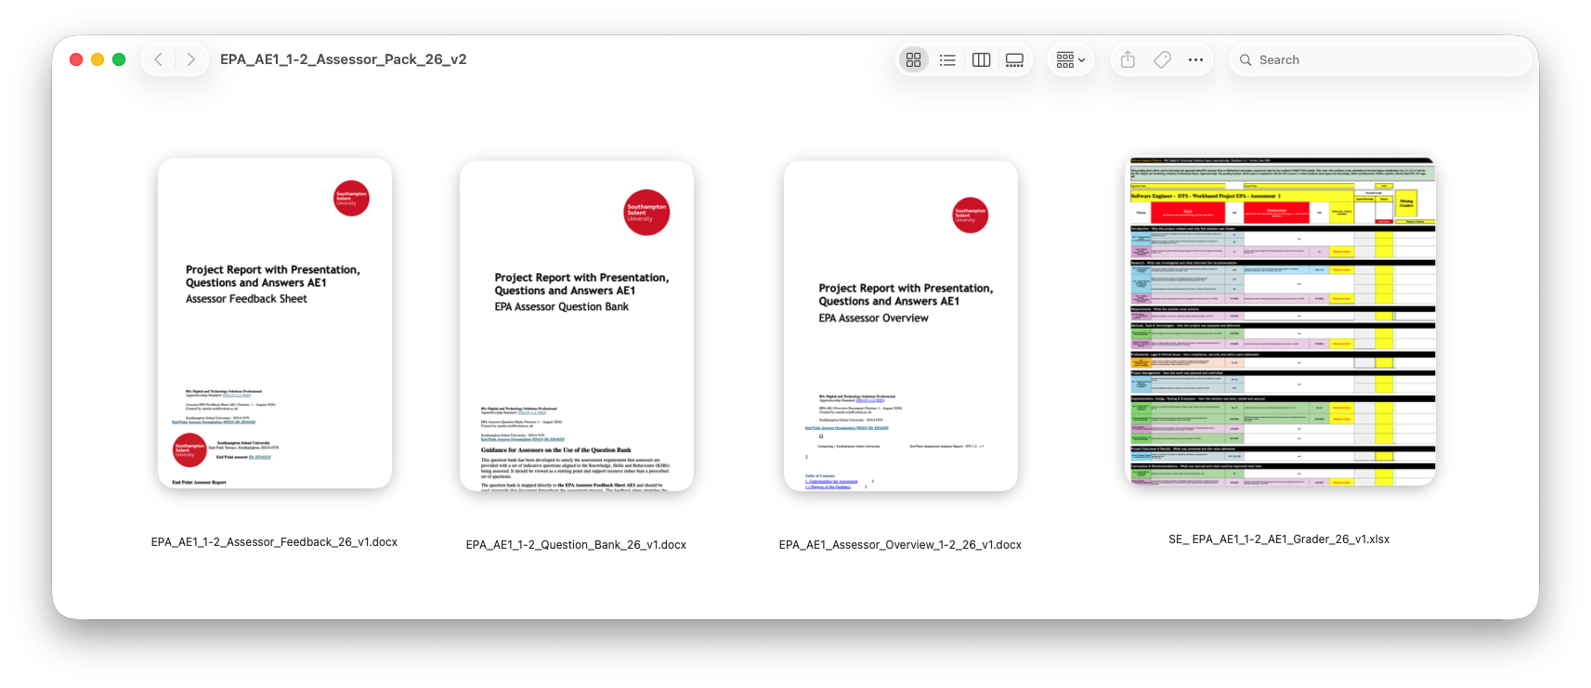
The EPA Assessor Assessment Pack 4 (EPA AE1) contains four documents:
- Assessor Overview Document (Word document)
- Question Bank (Word document)
- Assessor Feedback Sheet (Word document)
- Grader Sheet (Excel spreadsheet)
These documents provide the information, assessment materials, feedback templates and grading criteria required to complete the assessment process.
 | EPA Assessor Overview  This document is an assessor guide for AE1 of the BSc Digital and Technology Solutions Professional apprenticeship. It explains how assessors should review the apprentice’s project report, presentation and Q&A, judge evidence against the required KSBs, apply Pass/Distinction grading, and complete the assessment paperwork consistently.
 | EPA Assessor Question Bank  This is an EPA assessor question bank for the BSc Digital and Technology Solutions Professional apprenticeship, providing indicative Q&A prompts mapped to KSB assessment criteria for the AE1 project report and presentation.
 | Assessor Feedback Sheet  This is an End Point Assessment assessor feedback template for the BSc Digital and Technology Solutions Professional apprenticeship, focused on the AE1 project report, presentation, questions and answers assessment.
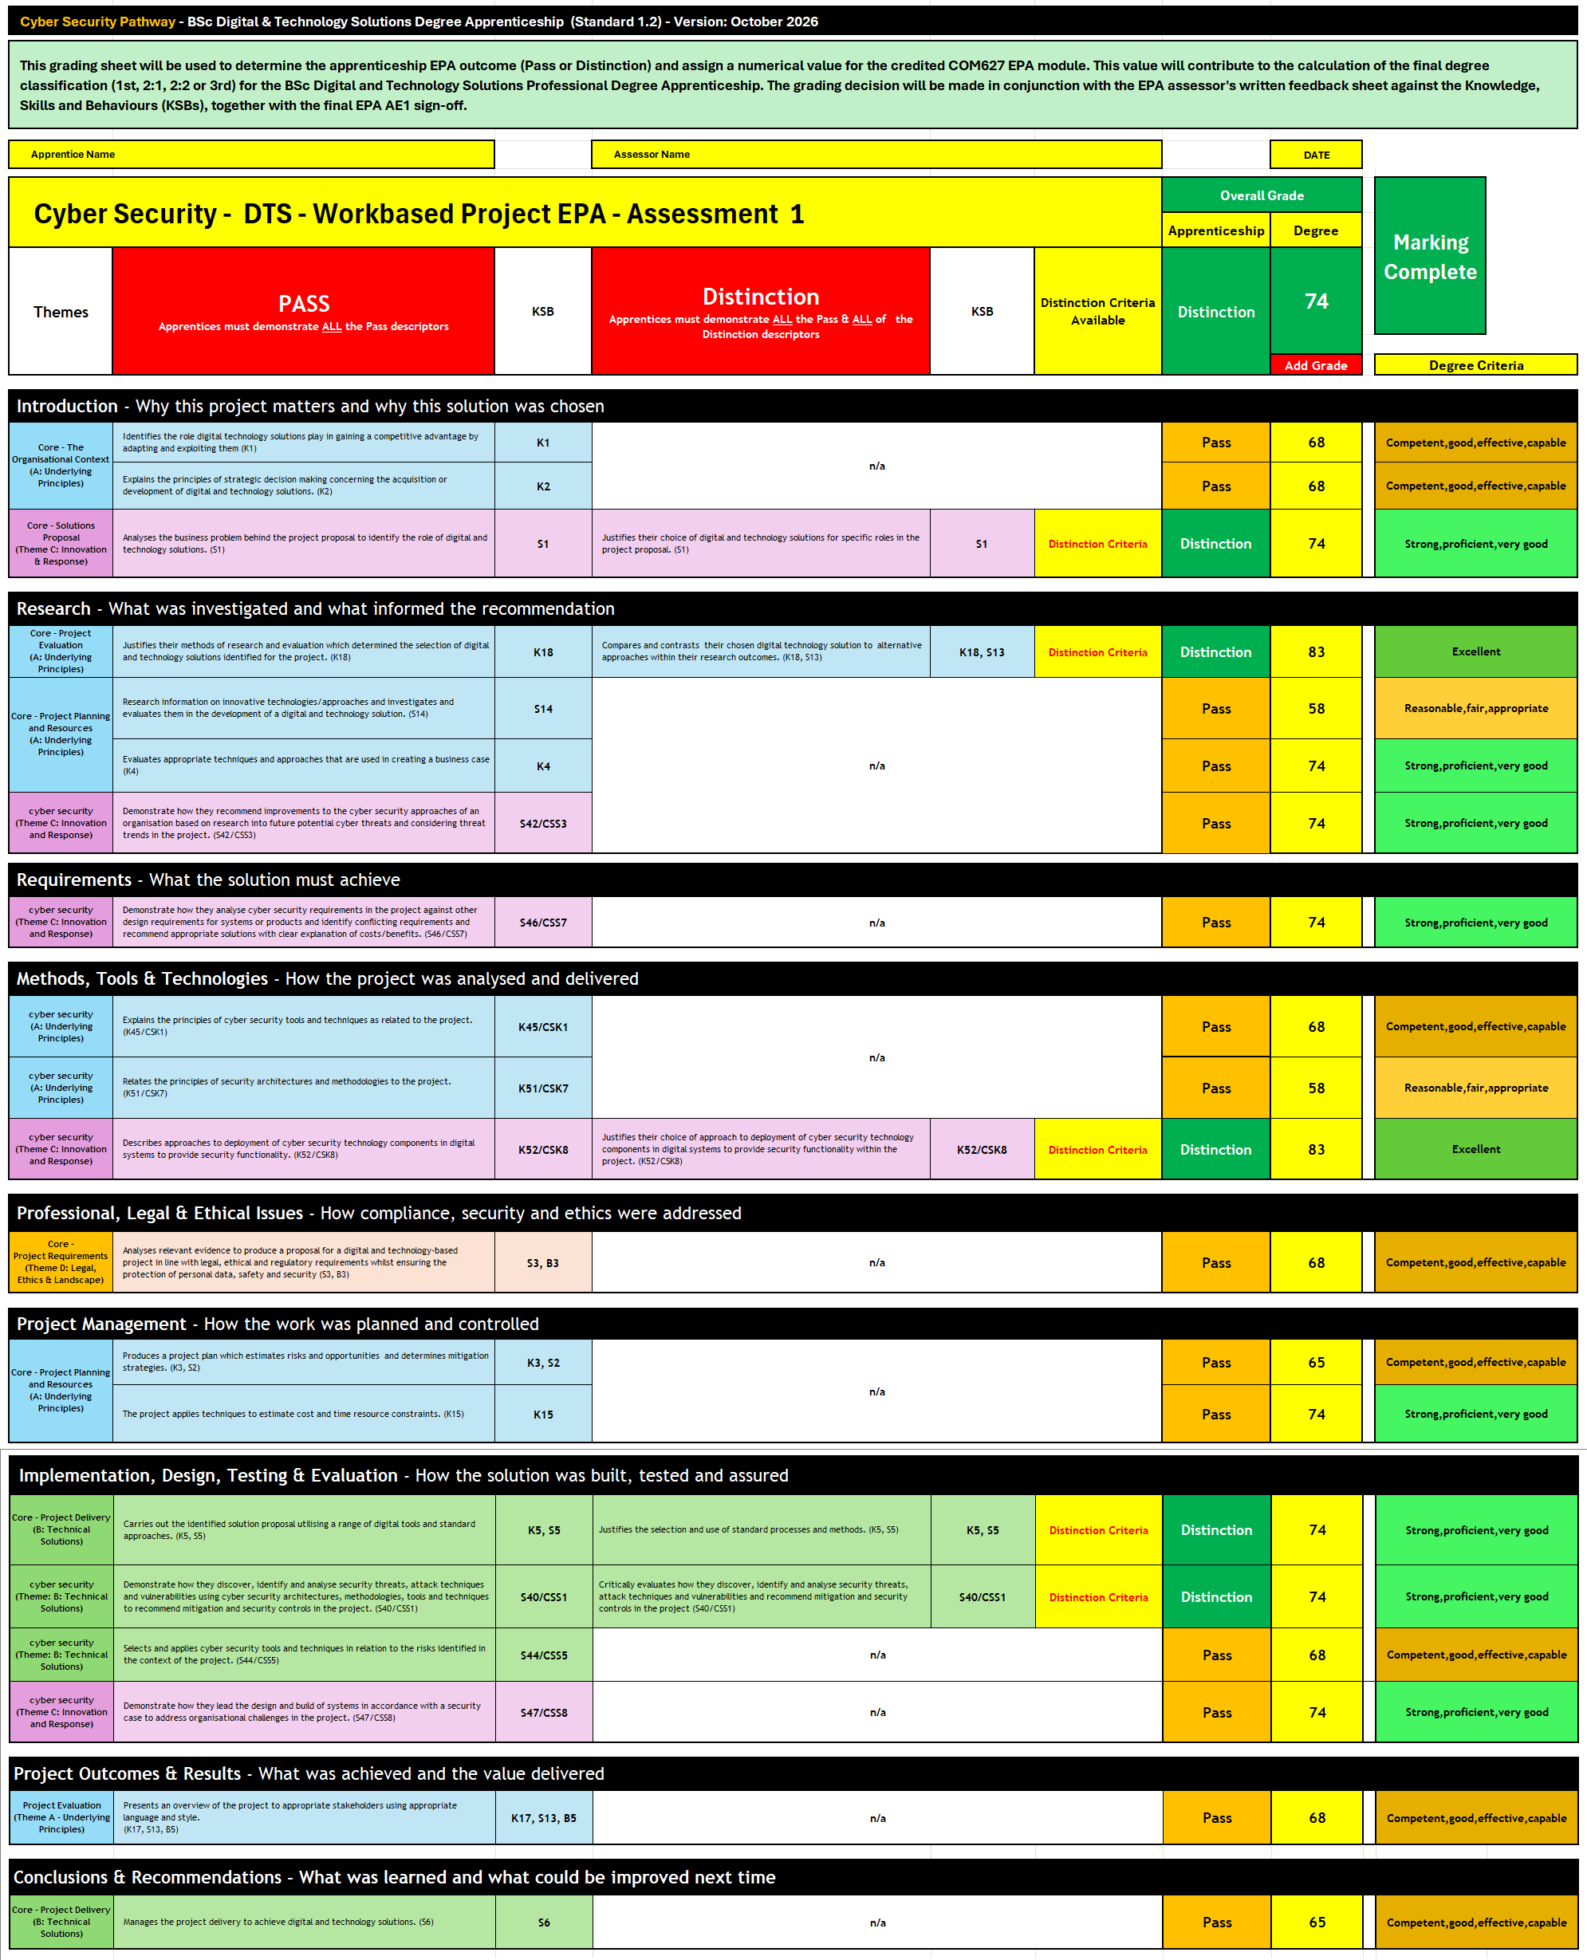 | EPA AE1 Grade Calculator  The EPA AE1 Grade Calculator used for the Software Engineer Pathway in the BSc Digital & Technology Solutions Degree Apprenticeship (Standard 1.2). It’s essentially a grading framework that assessors use to determine:  - Whether an apprentice passes or achieves a distinction in the EPA (End Point Assessment)  - The numerical score awarded for the COM627 EPA module  - How that score contributes to the apprentice’s final degree classification  The document lays out all the Knowledge, Skills and Behaviours (KSBs) that must be demonstrated, grouped into themes that mirror the structure of the EPA project report.

3.3 Training Videos
Training videos are available for all aspects of the EPA assessment process. These cover each assessment method and component, including conducting assessments, questioning apprentices, documenting evidence, and grading. Guidance is also provided on how to use the grading sheets to support assessors in making consistent and accurate grading decisions.
Links to EPA Assessor Training videos:
EPA Overview AE1 & AE2 - This video provides an apprentice focused overview of both EPA assessments for the Digital and Technology Solutions Degree Apprenticeship. It outlines the guidance given to the apprentice and explains how each assessment maps to the criteria and the KSBs within the apprenticeship standard.
EPA AE1 Overview - This video provides guidance for the apprentice on the first assessment element, which is the work-based project and report, followed by a questions-and-answers session.
EPA Assessor Pack AE1
EPA Assessor Download Pack AE1 - This video provides an overview of the contents of the EPA Assessor Download Pack for AE1, explaining the key documents included and how assessors should use them during the assessment process.
EPA Assessor Overview - This video gives assessors a brief overview of the AE1 assessor guide for the BSc Digital and Technology Solutions Professional apprenticeship. It explains how the guide supports assessors in reviewing the project report, presentation and Q&A, judging evidence against the relevant KSBs, applying grading criteria, and completing assessment paperwork consistently.
EPA Assessor Question Bank - This video introduces the EPA Assessor Question Bank for the BSc Digital and Technology Solutions Professional apprenticeship. It explains how the question bank provides indicative Q&A prompts mapped to the KSB assessment criteria for the AE1 project report and presentation.
EPA Assessor Feedback Sheet - This video introduces the Solent University End Point Assessment assessor feedback sheet for the BSc Digital and Technology Solutions Professional apprenticeship. It explains how the template supports assessors in recording feedback for the AE1 project report, presentation, questions and answers assessment, validating the apprentice’s role, and confirming how far the evidence demonstrates the relevant KSBs.
Overview of the EPA AE1 Grading Sheet for the Digital and Technology Solutions Degree Apprenticeship. It explains how assessors use the sheet to evaluate the work-based project, map evidence against apprenticeship criteria, and determine both the apprenticeship outcome (Pass or Distinction) and the corresponding academic grade
Adding Grades - This video demonstrates how to enter grades into the EPA AE1 grading sheet, showing how individual assessment scores contribute to both the apprenticeship outcome (Pass or Distinction) and the overall academic grade for the degree programme
Grade Calculation - This video explains how the EPA AE1 grading sheet calculates the overall academic mark, using average scores across assessment components and applying step-marking rules to produce a final degree grade
EPA assessor training 1.2 Online Support - Access all assessor training materials in one place, including embedded videos. This should be used if you experience any issues with the individual video links above.
3.4 Use of the Question Bank and Assessment Questioning
The apprenticeship standard requires the EPAO to provide a question bank to support delivery of the assessment. The question bank is intended as a support tool and source of indicative questions rather than a prescribed script.
Assessors can use the question bank alongside the apprentice’s report, presentation and grading documentation to identify opportunities to confirm evidence, explore decisions, clarify understanding and gather additional evidence where required.
Questions may be adapted, expanded or replaced to reflect the individual apprentice’s project, responsibilities and evidence presented. Follow-up questions should be used where appropriate to explore responses in greater depth, confirm authenticity, and provide the apprentice with the opportunity to demonstrate the full extent of their knowledge, skills and behaviours.
Assessment decisions remain the responsibility of the independent assessor, who should consider evidence from the report, presentation and questioning holistically when determining achievement and grade outcomes.
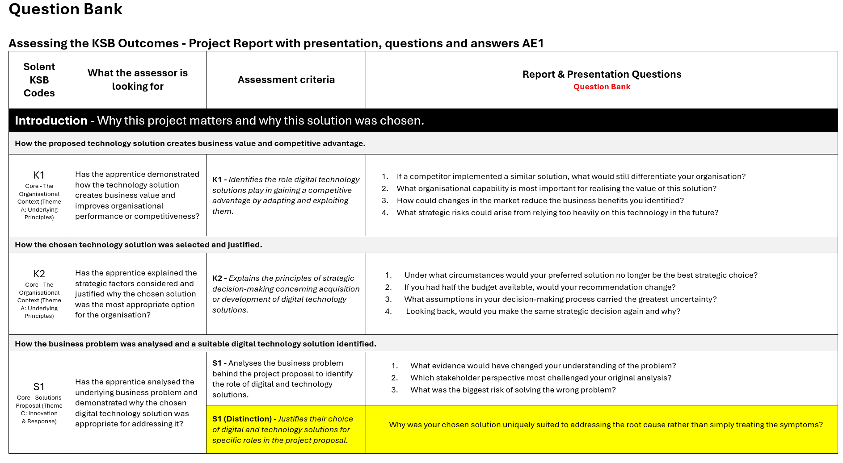
3.5 EPA Assessment Feedback Sheet
Assessor Feedback Template provides a structured framework for independent assessors to evaluate an apprentice's Project Report, Presentation, and Question and Answer Session (AE1) against the required Knowledge, Skills and Behaviours (KSBs). It is used to record evidence, assessment decisions and feedback.
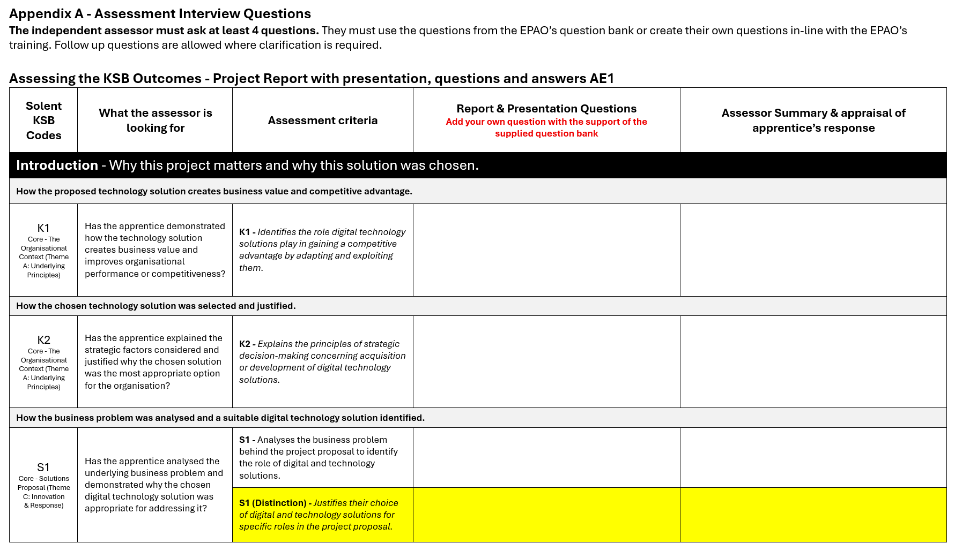
The standard requires assessors to ask a minimum of four questions, along with any appropriate follow-up questions needed to explore the apprentice's knowledge, skills and behaviours in more depth.
Add your questions in the Question column. These may be questions you have developed yourself or selected from the question bank. In the Assessor Summary section, record the apprentice's responses clearly and accurately in the Apprentice Answers field.
Where relevant, use follow-up questions to gather evidence against the Distinction criteria. This should include deeper questioning that allows the apprentice to explain their reasoning, justify decisions, evaluate outcomes and demonstrate a broader understanding of their work. This will help ensure there is sufficient evidence to support a distinction judgement where appropriate.
At the end of the assessment, you will need to sign off the cover sheet with the appropriate grade: Fail, Pass or Distinction, whichever is applicable. You will have used the grading sheet to help you determine the correct grade based on the assessment criteria.
You will also need to provide clear written feedback in the feedback section to support and justify the grade awarded. This feedback should explain how the learner has met, or not met, the assessment criteria and highlight any areas for improvement where relevant.

4. Evidence and KSB Mapping

4.2 Grader Sheet Guidance
The grader sheet and supporting guidance have been structured to align the Knowledge, Skills and Behaviours (KSBs) to the report and presentation sections where evidence is most likely to be found. This mapping is intended to support consistent assessment decisions but should not be applied rigidly.
Apprentices may demonstrate a KSB in different sections of their report, presentation, questioning, or supporting evidence. In some cases, the same piece of evidence may contribute to multiple KSBs. Assessors should therefore take a holistic approach to assessment and consider all available evidence when making grading decisions.
The examples, evidence indicators and assessor considerations included within this section are illustrative rather than exhaustive. Apprentices may present valid evidence in different ways, and assessors should use professional judgement to determine whether the intent and requirements of the KSB have been met. Apprentices will also provide KSB references within their report and mapping grid to support evidence identification, although assessors should not rely solely on apprentice signposting when determining achievement.
The information on the following pages provides guidance on the types of evidence commonly associated with each KSB and where that evidence may typically be found within the project report and presentation.

4.2. KSB Grade Criteria to Report Section.
Introduction - Why this project matters and why this solution was chosen.
How the proposed technology solution creates business value and competitive advantage.
K1 - Identifies the role digital technology solutions play in gaining a competitive advantage by adapting and exploiting them.
Core - The Organisational Context: Theme A: Underlying Principles
What the assessor is looking for: The apprentice understands how digital technology solutions create business value, improve organisational performance, and provide a competitive advantage.
Typical Evidence
- Introduce your company, the industry it operates in, and your role within the organisation.
- Explanation of current business challenges.
- Discussion of how the chosen solution improves performance.
- Explanation of benefits
Good evidence - The organisation experienced increasing cyber security risks arising from remote working and cloud adoption. The proposed security solution reduced exposure to cyber threats whilst improving compliance and strengthening customer confidence.
Assessment consideration: Has the apprentice demonstrated how the proposed solution supports business objectives and organisational resilience?

How the chosen technology solution was selected and justified.
K2 - Explains the principles of strategic decision-making concerning acquisition or development of digital technology solutions.
Core - The Organisational Context: Theme A: Underlying Principles
What the assessor is looking for: Evidence that the apprentice evaluated solution options and justified the chosen approach based on business needs, resources, risks, costs, and long-term organisational objectives.
Typical evidence
- Buy versus build discussions.
- Resource considerations.
- Long-term business needs.
- Scalability and maintainability considerations.
- Long-term organisational needs.
- Justification for the chosen solution.
Good Evidence - A commercial off-the-shelf solution was evaluated but rejected because licensing costs exceeded project budgets and custom workflows could not be supported.
Assessment consideration: Has the apprentice explained the strategic factors considered and justified why the chosen solution was the most appropriate option for the organisation?

How the business problem was analysed and a suitable digital technology solution identified.
S1 - Analyses the business problem behind the project proposal to identify the role of digital and technology solutions.
S1 (Distinction) - Justifies their choice of digital and technology solutions for specific roles in the project proposal.
Core – Solutions: Proposal: Theme C: Innovation & Response
What the assessor is looking for: Evidence that the apprentice analysed the underlying business problem, identified where digital technology could add value, and selected an appropriate solution to address the identified need.
Typical evidence
- Stakeholder feedback
- Root cause analysis.
- Current process analysis.
- Problem statement.
- Business needs analysis.
- Identification of inefficiencies, risks, or opportunities.
- Evaluation of solution options.
- Justification for the chosen digital technology solution
Good Evidence - Stakeholder interviews identified duplicated manual data entry across three systems, creating reporting inconsistencies and increasing administrative workload. Analysis demonstrated that a digital solution could automate data transfer, improve accuracy, and reduce administrative effort.

Distinction-level Evidence - Several solution options were evaluated, including continued use of spreadsheets, a commercial off-the-shelf platform, and a bespoke web application. The bespoke solution was selected as it provided the best alignment with stakeholder requirements, integrated with existing systems, reduced long-term operational effort, and could be delivered within organisational constraints. Alternative approaches were discounted due to limitations in functionality, scalability, or cost.
Assessment consideration: Has the apprentice analysed the underlying business problem and demonstrated why the chosen digital technology solution was appropriate for addressing it?

Research - What was investigated and what informed the recommendation.
How research and evaluation informed the selection of the solution.
K18 - Justifies their methods of research and evaluation which determined the selection of digital and technology solutions identified for the project.
K18, S13 (Distinction) - Compares and contrasts their chosen digital technology solution to alternative approaches within their research outcomes.
Core - Project Evaluation: A: Underlying Principles
What the assessor is looking for: Evidence that appropriate research and evaluation methods were selected, justified, and used to inform the selection of the proposed digital technology solution.
Typical evidence
- Literature survey.
- Analysis of technical documentation.
- Market research.
- Surveys or questionnaires.
- Interviews.
- Stakeholder engagement.
- Benchmarking of alternative solutions.
- Analysis of research findings.
- Comparison of solution options.
- Justification for the chosen solution.
Good Evidence - Semi-structured interviews were selected because they enabled detailed exploration of user requirements that could not be captured using closed questionnaires. The findings identified key workflow issues and informed the selection of the proposed solution.
Distinction-level Evidence - Three alternative solutions were evaluated against business requirements, cost, scalability, and maintainability. The chosen solution was selected because it provided the best balance between functionality, implementation effort, and long-term organisational needs.
Assessment consideration: Has the apprentice justified their choice of research and evaluation methods and demonstrated how the findings informed the selection of the proposed solution, including consideration of alternative approaches?

What technologies/approaches were investigated.
S14 - Research information on innovative technologies/approaches and investigates and evaluates them in the development of a digital and technology solution.
Core - Project Planning and Resources: A: Underlying Principles
What the assessor is looking for: Evidence that the apprentice researched, investigated and evaluated relevant technologies or approaches, and considered their suitability within the project context.
Typical evidence
- Zero Trust approaches
- Cloud-native security
- Automation
- Security orchestration
- AI-assisted threat detection
- Emerging cyber security technologies
Good Evidence - The apprentice investigated Security Information and Event Management (SIEM) platforms incorporating machine learning capabilities to improve threat detection. Several platforms were compared against the organisation's security requirements, costs, integration capabilities and operational complexity. The research demonstrated that an AI-assisted monitoring solution could improve detection of anomalous activity whilst reducing manual investigation effort, leading to its recommendation within the project.
Assessment consideration: Has the apprentice researched and evaluated relevant technologies or approaches and demonstrated how the findings influenced the development of the solution?

How the business case demonstrated that the project was worthwhile and viable.
K4 - Evaluates appropriate techniques and approaches that are used in creating a business case
Core - Project Planning and Resources: Theme C: Innovation & Response
What the assessor is looking for: Evidence that the apprentice evaluated the viability, benefits, costs, risks and organisational impact of the proposed cyber security solution using appropriate business case techniques.
Typical evidence
- Cost-benefit analysis
- Risk assessment
- Business impact assessment
- Return on investment (ROI)
- Cost avoidance calculations
- Compliance benefits
- Resource requirements
- Feasibility studies
- Strategic alignment
- Operational benefits
Good Evidence - The apprentice completed a business case comparing the cost of implementing enhanced
endpoint detection and response (EDR) tooling against the potential financial and operational impact of a cyber security incident. The analysis demonstrated that the proposed investment would significantly reduce organisational risk, improve compliance obligations and lower the potential costs associated with data breaches and service disruption. The findings supported approval of the project and prioritisation of the recommended controls.
Assessment consideration: Has the apprentice demonstrated that appropriate business case techniques were used to evaluate project viability and justify the investment, benefits and expected organisational value of the proposed cyber security solution?

The final recommendation and justification.
S42 / CSS3 Recommends improvements to an organisation's cyber security approaches based on research into future potential cyber threats and considering threat trends.
Cyber Security – Theme C: Innovation and Response
What the assessor is looking for: Evidence that threat trends, emerging attack methods and intelligence sources informed recommendations.
Typical evidence
- Threat reports
- Vulnerability trends
- Industry intelligence
- Ransomware analysis
- Supply-chain threats
- Emerging attack vectors
Good evidence - Research into ransomware growth identified weaknesses in backup resilience and incident response preparedness. Recommendations included immutable backups, improved monitoring and regular recovery testing.
Assessment consideration: Has the apprentice used research into future threats to justify cyber security improvements?

Requirements - What the solution must achieve.
How a specific problem, recurring issue, or business opportunity was investigated, scoped and translated into requirements.
S46 / CSS7 Analyses cyber security requirements against competing design requirements and recommends appropriate solutions with clear explanation of costs and benefits.
Cyber Security – Theme C: Innovation and Response
What the assessor is looking for: Evidence that cyber security requirements were balanced against business and technical constraints.
Typical Evidence
- Security requirements
- Functional requirements
- Usability considerations
- Performance requirements
- Regulatory requirements
- Cost-benefit analysis
- Trade-off decisions
Good Evidence - A strong authentication solution was required, however excessive user friction was likely to impact productivity. A risk-based authentication approach was selected to balance security and usability.
Assessment consideration: Has the apprentice demonstrated how conflicting requirements were identified and resolved?

Methods, Tools & Technologies - How the project was analysed and delivered.
How cyber security tools and techniques were applied and their relevance to achieving security outcomes within the project.
K45 / CSK1 - Explains the principles of cyber security tools and techniques as related to the project.
Cyber Security Theme A: Underlying Principles
What the assessor is looking for: Evidence that the apprentice understands the purpose, operation and application of cyber security tools and techniques and can explain how they were relevant to the project.
Typical Evidence
- Vulnerability scanning tools
- Penetration testing techniques
- Endpoint protection solutions
- Access control mechanisms
- Encryption technologies
- Security logging and auditing
Good Evidence - The apprentice explains how vulnerability scanning identified security weaknesses within the project environment and describes how endpoint protection, access controls and monitoring tools were used to reduce risk. The explanation demonstrates understanding of the principles behind the tools rather than simply describing their use.
Assessment consideration: Has the apprentice demonstrated an understanding of the cyber security tools and techniques used within the project and clearly explained their purpose and contribution to security outcomes?

How security architecture principles and methodologies informed the design and security approach of the project.
K51/CSK7 - Relates the principles of security architectures and methodologies to the project.
Cyber Security Theme A: Underlying Principles
What the assessor is looking for: Evidence that recognised security architecture principles and methodologies were considered and applied within the project context.
Typical Evidence
- Zero Trust principles
- Secure-by-design methodologies
- Risk-based security frameworks
- Network segmentation designs
- Layered security controls
- Reference to recognised standards or frameworks
Good Evidence - The apprentice explains how a defence-in-depth approach was incorporated into the solution through multiple security controls, such as network segmentation, access management and monitoring. The project demonstrates how security architecture principles influenced design decisions and reduced identified risks.
Assessment consideration: Has the apprentice linked recognised security architecture principles or methodologies to decisions made within the project and demonstrated how they contributed to the overall security posture?

How cyber security technologies were deployed to provide security functionality within the project solution.
K52/CSK8 - Describes approaches to deployment of cyber security technology components in digital systems to provide security functionality
K52/CSK8 (Distinction) - Justifies their choice of approach to deployment of cyber security technology components in digital systems to provide security functionality within the project
Cyber Security Theme A: Underlying Principles
What the assessor is looking for: Evidence that the apprentice can describe how cyber security technologies were deployed within the project and, at distinction level, justify why the chosen deployment approach was appropriate.
Typical Evidence
- Identity and access management implementation
- Endpoint security deployment
- Cloud security controls
- Security monitoring solutions
- Network security technologies
- Deployment configurations and design decisions
Good Evidence - The apprentice describes how security technologies were deployed across the project environment, including configuration choices and implementation considerations. For distinction, the apprentice justifies why the selected deployment approach was chosen over alternatives, considering factors such as risk reduction, operational requirements, scalability, cost, system architecture and security effectiveness.
Assessment consideration: Has the apprentice clearly described how cyber security technologies were deployed within the project and, where distinction is being evidenced, justified why the selected deployment approach was the most appropriate solution for the identified requirements and risks?

Professional, Legal & Ethical Issues - How compliance, security and ethics were addressed.
How legal, ethical, regulatory, privacy and security requirements influenced the project.
S3 / B3 - Analyses relevant evidence to produce a proposal for a digital and technology-based project in line with legal, ethical and regulatory requirements whilst ensuring the protection of personal data, safety and security.
Core - Project Requirements: Theme D: Legal, Ethics & Landscape
What the assessor is looking for: Evidence that legal, ethical, regulatory, privacy, safety and security considerations were analysed and applied when proposing and developing the solution.
Typical Evidence
- GDPR and data protection considerations.
- Cyber security requirements.
- Accessibility standards and inclusive design.
- Data handling and storage decisions.
- User privacy considerations.
- Regulatory or organisational compliance requirements.
- Risk assessments.
- Design or implementation decisions influenced by legal, ethical or security requirements.
Good Evidence - User data was classified as personal data under GDPR requirements. As a result, role-based access controls were implemented, data retention periods were defined, and sensitive information was encrypted both in transit and at rest.
Assessment consideration: Has the apprentice demonstrated how legal, ethical, regulatory, privacy, safety or security requirements influenced project decisions and the final solution?

Project Management - How the work was planned and controlled.
How the project was planned, monitored and managed, including risks and opportunities.
K3 / S2 - Produces a project plan which estimates risks and opportunities and determines mitigation strategies.
Core - Project Planning and Resources: Theme A: Underlying Principles
What the assessor is looking for: Evidence that the project was planned, monitored and controlled through effective management of activities, risks, opportunities, resources and delivery milestones.
Typical Evidence
- Project plan.
- Gantt charts or delivery schedules.
- Product or sprint backlogs.
- Risk registers.
- Sprint plans or iteration plans.
- Milestones and deliverables.
- Risk mitigation strategies.
- Progress monitoring and plan updates.
- Evidence of responding to risks, issues or changes.
Good Evidence
A project plan was created to define key milestones and delivery activities. Risks such as stakeholder availability and data access delays were identified in a risk register, with mitigation actions implemented and monitored throughout the project.
Assessment consideration: Has the apprentice demonstrated how the project was planned, monitored and controlled, including the identification and mitigation of risks and opportunities?

How time, effort, cost and resource requirements were estimated.
K15 - The project applies techniques to estimate cost and time resource constraints.
Core - Project Planning and Resources: Theme A: Underlying Principles
What the assessor is looking for: Evidence that appropriate techniques were used to estimate the time, effort, cost* and resources required to deliver the project within identified constraints.

*Note: Not all apprentices will have access to project costing data. Where this is the case, evidence should focus on how time, effort, resources, capacity and delivery constraints were estimated and managed throughout the project.
Typical Evidence
- Effort estimates.
- Time estimates.
- Budget considerations.
- Resource allocation.
- Capacity planning.
- Assumptions and dependencies.
- Estimation techniques (e.g. expert judgement, historical data, story points).
- Comparison of estimated and actual effort or timescales.
- Constraints affecting project delivery.
Good Evidence Effort estimates were produced using previous project data and stakeholder input. The estimates identified that development could be completed within the available timescale and resource constraints, allowing realistic project milestones to be established.
Assessment consideration: Has the apprentice demonstrated how time, effort, cost and resource requirements were estimated and used to support project planning?

Implementation, Design, Testing & Evaluation - How the solution was built, tested and assured.
How the proposed solution was implemented using appropriate tools, methods and processes.
K5 / S5 – Carries out the identified solution proposal utilising a range of digital tools and standard approaches.
K5 / S5 (Distinction) - Justifies the selection and use of standard processes and methods.
Core - Project Delivery: Theme B: Technical Solutions
What the assessor is looking for: Evidence that the proposed solution was implemented using appropriate digital tools, processes and standard approaches to meet project requirements.
Typical Evidence
- Application of the approved design.
- Development activities.
- Configuration activities.
- Testing activities.
- Deployment activities.
- Use of digital tools and platforms.
- Use of development methodologies or processes.
- Evidence of iterative improvements.
- Implementation decisions and outcomes.
Good Evidence The approved design was implemented using appropriate development tools and technologies. Source control, testing and structured deployment processes were used to develop, verify and release the solution in line with project requirements.

Distinction Evidence - An Agile approach was selected because stakeholder requirements were expected to evolve throughout the project, allowing regular feedback and iterative refinement of the solution. Git was chosen to provide version control and change traceability, while automated testing was implemented to improve software quality and reduce manual testing effort. These methods and tools were selected because they aligned with project requirements, timescales, and quality objectives.
Assessment consideration: Has the apprentice demonstrated how the proposed solution was implemented using appropriate tools, processes and methods, and justified the choices made during delivery?

How security threats, vulnerabilities and attack techniques were identified, analysed and used to recommend appropriate security controls and mitigations.
S40 / CSS1 – Demonstrate how they discover, identify and analyse security threats, attack techniques and vulnerabilities using cyber security architectures, methodologies, tools and techniques to recommend mitigation and security controls in the project.
S40 / CSS1 (Distinction) - Critically evaluates how they discover, identify and analyse security threats, attack techniques and vulnerabilities and recommend mitigation and security controls in the project
Cyber Security Theme: B: Technical Solutions
What the assessor is looking for: Evidence that the apprentice has systematically identified and analysed security threats, attack techniques and vulnerabilities relevant to the project, using appropriate cyber security architectures, methodologies, tools and techniques. Evidence should demonstrate how this analysis informed recommendations for mitigation measures and security controls.
Typical Evidence
- Vulnerability assessments and scans
- Risk assessments
- Attack surface analysis
- Penetration testing results
- Security architecture reviews
- Threat intelligence research
- Security control recommendations
Good Evidence - The apprentice identifies relevant threats, vulnerabilities and attack techniques within the project environment and demonstrates how recognised cyber security methodologies, architectures and tools were used to analyse risks. Recommendations for mitigation and security controls are clearly linked to the identified security issues and project requirements.

Distinction Evidence - The apprentice critically evaluates the effectiveness and limitations of the approaches, methodologies and tools used to identify threats and vulnerabilities. They compare alternative mitigation strategies, justify their recommendations and demonstrate a deeper understanding of risk, trade-offs and the wider impact of security decisions on the project.

Assessment consideration: Has the apprentice demonstrated a structured approach to discovering, identifying and analysing threats, attack techniques and vulnerabilities, and used this analysis to justify appropriate mitigation actions and security controls?

How cyber security tools and techniques were selected and applied to address identified project risks.
S44 / CSS5 – Selects and applies cyber security tools and techniques in relation to the risks identified in the context of the project.
Cyber Security Theme: B: Technical Solutions
What the assessor is looking for: Evidence that the apprentice selected appropriate cyber security tools and techniques based on identified risks and applied them effectively within the project context.
Typical Evidence
- Security monitoring solutions
- Endpoint protection technologies
- Identity and access management controls
- Log analysis tools
- Network security tools
- Encryption techniques
- Configuration management and hardening activities
Good Evidence - The apprentice selects security tools and techniques that are appropriate to the risks identified within the project and demonstrates how they were applied to address specific security requirements. The rationale for selection is evident and links directly to identified threats or vulnerabilities.
Assessment consideration: Has the apprentice selected and applied appropriate cyber security tools and techniques that directly address the risks identified within the project?

How the system was designed and built in line with a security case to address organisational and security requirements.
S47 / CSS8 – Demonstrate how they lead the design and build of systems in accordance with a security case to address organisational challenges in the project.
Cyber Security Theme: B: Technical Solutions
What the assessor is looking for: Evidence that the apprentice has led or taken significant responsibility for the design and build of a system, ensuring that security requirements and the security case informed design decisions and implementation activities throughout the project.
Typical Evidence
- Security-by-design decisions
- Security case documentation
- Design specifications
- Implementation plans
- Security requirements mapping
- Technical decision records
- Evidence of stakeholder engagement
Good Evidence - The apprentice demonstrates how the system design and build were guided by a defined security case and organisational requirements. Security requirements are reflected in design decisions, implementation activities and the final solution. Evidence shows leadership or significant ownership of technical decisions throughout the project.
Assessment consideration: Has the apprentice demonstrated how they led the design and build of the system, using a security case to inform decisions and address the organisational challenges and security requirements of the project?

Conclusions & Recommendations - What was learned and what could be improved next time.
How progress, risks, issues and changes were managed during delivery.
S6 - Manages the project delivery to achieve digital and technology solutions
Core - Project Delivery: Theme B: Technical Solutions
What the assessor is looking for: Evidence that project delivery was actively monitored, controlled and adapted throughout the lifecycle to ensure successful delivery of the solution.
Typical Evidence
- Monitoring progress against milestones.
- Managing risks and issues.
- Managing scope and change requests.
- Stakeholder communication.
- Resource coordination.
- Adapting plans in response to project developments.
- Tracking dependencies and blockers.
- Decision-making during project delivery.
- Evidence of actions taken to keep delivery on track.
Good Evidence - Progress was reviewed against planned milestones throughout the project. Risks relating to stakeholder availability were monitored, mitigation actions were implemented, and delivery plans were adjusted to minimise project delays.
Assessment consideration: Has the apprentice demonstrated how project delivery was monitored, controlled and adapted throughout the project?
Note: Evidence for S6 is likely to be found across multiple sections of the report. Apprentices should demonstrate active project management throughout delivery rather than describing project management activities retrospectively in the Conclusions section only.
Consider cross-referencing S6 to: Project Management, Implementation & Conclusions

4.1 EPA AE1 Grader Sheet
The Excel grading sheet is available in the Assessor EPA AE1 Assessment Pack. It is used to calculate both the EPA classification grade (Merit or Distinction) and a numeric value used to calculate the overall average grade for the Bachelor of Science degree

4.2 Using the EPA AE1 Grader Sheet
This grade mark calculator should be used alongside the written feedback, observation and assessment sign-off sheet.
Tip: The Presentation and Question & Answer assessment will be conducted online and recorded for moderation purposes. You can use the recording playback to complete the grading sheet and written feedback, allowing you to focus on observing the assessment. However, you should still take notes throughout the presentation in case there are any issues with the recording.
The grade sheet is structured around the KSBs for this assessment element and has been aligned to the sections of the 6,000-word report. It also reflects the order and delivery of the presentation.
It may be the case that an apprentice provides evidence demonstrating fulfilment of a KSB in a different section from the one listed on the grade sheet. In these situations, you should be flexible when grading and recognise achievement of the criteria, even if the evidence appears elsewhere in the report, presentation, or is clarified through questioning.
The EPA AE1 Grader Sheet columns.
Themes | Breakdown of the four themes that align with this assessment element
Pass | Lists the KSB pass criteria for the assessment.
KSB | Identifies the KSB code linked to the pass criteria.
Distinction | Lists the distinction criteria, where applicable.
KSB | Identifies the KSB code linked to the distinction criteria.
Distinction Criteria Available | Indicates where distinction criteria can be applied.
Overall Grade (Apprenticeship) | Calculates the overall EPA grade based on the pass and distinction criteria achieved.
Overall Grade (Degree) | Calculates the numerical value for the EPA module, which contributes to the overall degree classification average.
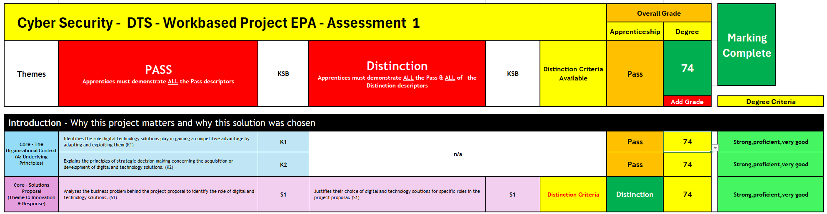

1. Add the apprentice's name, your name as the assessor, and the date of the assessment.

2. Review the KSB criteria linked to the assessment
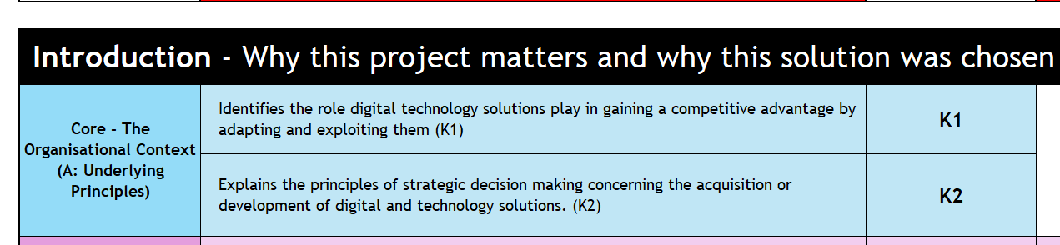
3. To add a grade, click in the yellow box under the Add Grade column. Then select the step mark you want to award for that criterion from the drop-down list.
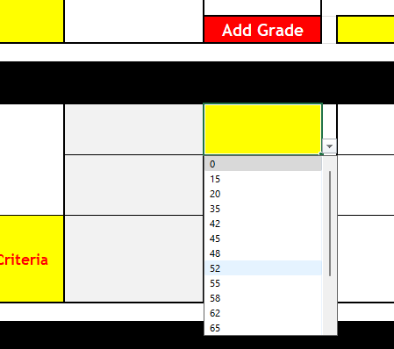

4. Repeat for all assessed KSBs

5. Award Distinction grades where appropriate
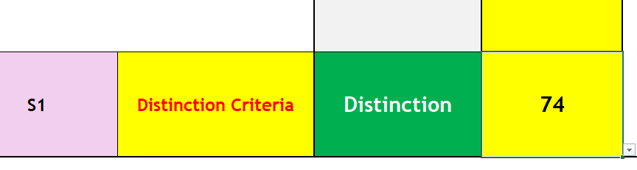
6. Make sure you have added a grade against all assessment criteria. If a grade is missing, a warning will appear to highlight this. Once all grades have been entered, the system will show that marking is complete.
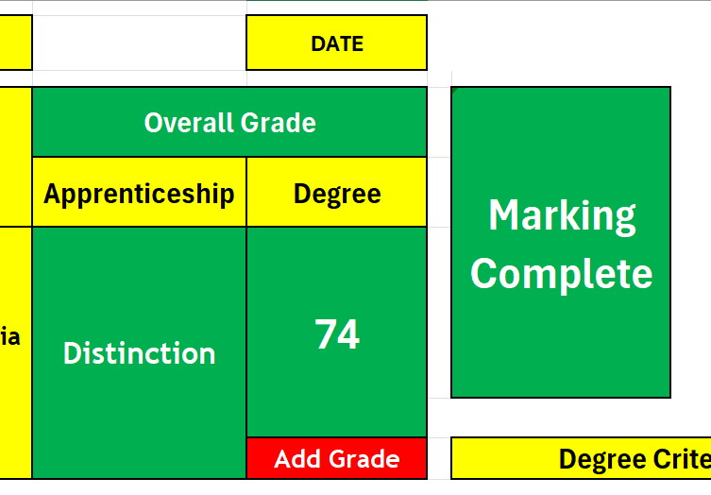 | 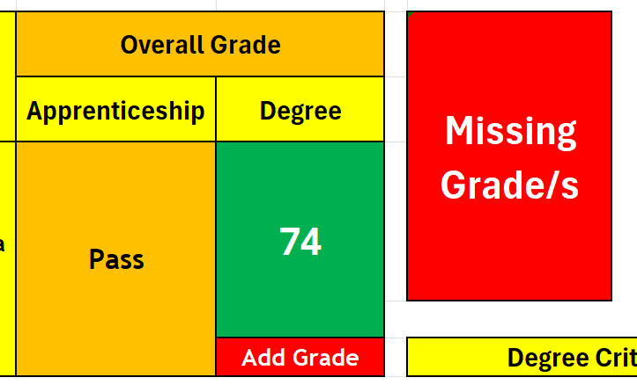
- Check that all distinction criteria have been met.
- Review the calculated academic degree average mark.
- Verify the EPA outcome: Fail, Pass or Distinction.
- Confirm the university module numeric grade. An average mark of 39 or below is a fail and should be flagged in red.
- Save and complete the EPA Feedback sheet add Fail, Pass or Distinction And written feedback.

5. Completion

5.1. Giving Written Feedback
Written feedback should be clear, constructive, evidence-based and aligned to the assessment criteria.
Best Practice
- Be specific and evidence based.
- Link feedback to the relevant KSBs and grading criteria.
- Balance strengths and areas for development.
- Use clear and accessible language.
- Be comprehensive but concise.
- Maintain a professional and impartial tone.
- Provide sufficient detail to support moderation and quality assurance.
- Where an apprentice has not achieved an overall Pass, clearly identify the areas that did not meet the required standard and explain the reasons for the Refer (Fail) outcome.
- Where a Distinction is awarded, clearly identify the evidence demonstrating performance above the Pass standard and explain how the relevant distinction criteria were met.
Feedback should clearly justify the grade awarded and enable transparent review by apprentices, moderators and external quality assurance representatives. Where a Refer (Fail) outcome is awarded, feedback should provide sufficient information to help the apprentice understand the areas requiring improvement before reassessment. Where a Distinction is awarded, feedback should clearly demonstrate why the apprentice's performance exceeded the Pass standard.

5.2. Final Assessment Considerations
Before finalising grades, assessors should be satisfied that:
- The project is relevant to the apprentice's occupational role.
- The evidence is authentic.
- The work reflects the apprentice's own contribution.
- All required KSBs have been sufficiently demonstrated.
- The apprentice can explain and justify decisions, methods and outcomes.
- Where a Distinction is awarded, there should be clear evidence of evaluation, comparison and critical reflection beyond Pass-level expectations.
- Remember do not give any indication of the grading outcome to the apprentice during the assessment session.

 | Southampton Solent University  East Park Terrace, Southampton, SO14 0YN  End Point assessor ID: EPA0325

End of document

