Goal
Develop consumer software, such as games, personal productivity tools, and online stores.

Profile
I am a skilled, self-directed software developer. I learn quickly. I have an advanced degree in computer science, intimate knowledge of Linux systems, practical leadership experience, superior writing and editing skills (see below for a list of published works), an affable personality, and a long history of delivering complex products on demanding schedules.

Experience

Principal, Locomotive, LLC, an international Rails consultancy,

Raleigh, NC; Founded 2007
Four years of experience developing complex, custom Ruby on Rails applications.
Favorite tools include Rails (3.2), Ruby (1.9), Sunspot, Thinking Sphinx, Factory Girl, RSpec (traditional and fast specs), Shoulda, Haml & Sass, Devise, OmniAuth, Paperclip, jQuery, Heroku, Tddium, AWS, SendGrid, Redis, Git, Mongoid, MySQL, Ubuntu, Mac OS X.
Truck, a technical blog,
January 2012-Present



A daily blog featuring Ruby and Ruby on Rails best practices, observations, useful gems & tools, tips, and tricks. Recent posts describe introspection of Sunspot fields, a quick way to move from Macports to Homebrew, updates with Rails’ update_all, and a technique to find where a specific query is called from.
Martin Streicher

Therapydia (in public beta),

Mill Valley, CA, April 2012-Present
Senior developer for a community web site dedicated to physical therapists and their practices. Rails and Redis powers an RSS content aggregation engine, providing up-to-date news and information. The site also ties users together by area, alma mater, and specialization, and allows users to connect with each other to bolster the profession.

Kinfolio (in private alpha),
New York, NY, May 2011-March 2012
Lead developer for Floating University and Big Think Careers, online education portals for college students and working professionals, respectively. The store and single-sign on service is a custom Rails application integrated with Chargify. The learning management system is a customized version of Instructure Canvas. A third web site is based on Refinery CMS.

Federated Media,

San Francisco, CA, August 2010-March 2012
Lead developer of an RSS, content, and image aggregation system for the company’s Daily Buzz and Foodbuzz sites. System continuously processes 30,000 feeds and can accurately predict what images are most relevant for any blog post. System is built on Redis, Resque, Active Admin, and custom code.

Big Think,
New York, NY, May 2011-Present
Lead developer for Floating University and Big Think Careers, online education portals for college students and continuing education, respectively. Online store, subscription, and single-sign on service is a custom Rails application integrated with Chargify. Learning management system is a customized version of Canvas. Web site is based on Refinery.

Remix Learning, Inc.,

Chicago, IL, August 2010-September 2011
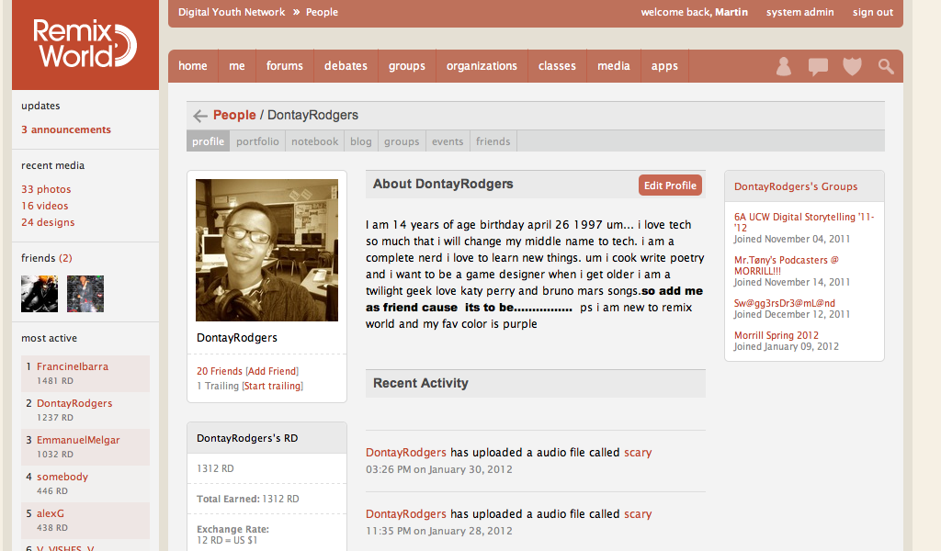

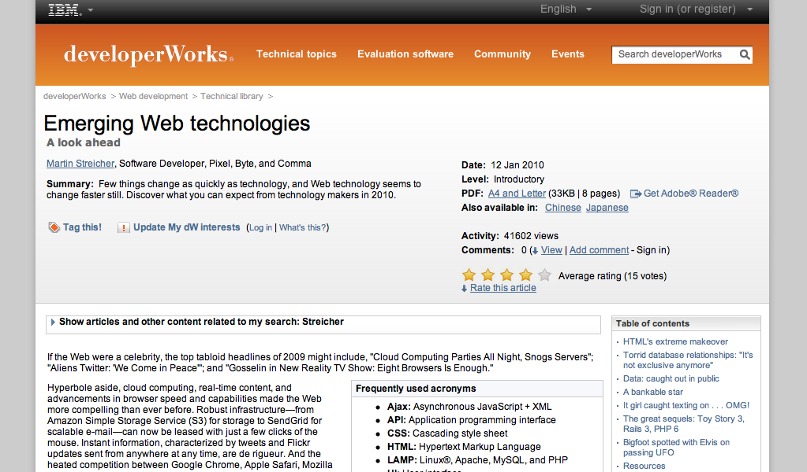


Chief architect and lead developer for iRemix, a social and collaborative learning network for students and youths, funded by the Gates and Macarthur foundations. iRemix shares media, encourages debates and discussion, includes messaging, and supports an extensive rights management system. iRemix is deployed entirely in the Heroku cloud.

Speaking Unix, IBM developerWorks,

March 2006-Present
Founding and ongoing monthly columnist and featured author. Each installment of the column illuminates open source and Unix tools and techniques. Recent topics include the Ruby Version Manager, emerging web technologies, text search, Unix shells, and dynamic kernel patching.

Global Concepts, a division of McKinsey and Company,

Atlanta, GA, March 2010-October 2010
Developed two applications: an internal tool to survey the usage of personal and business checks in cooperation with the Federal Reserve, and an e-commerce application to market and sell the company’s research reports and intelligence on payment systems and the payments industry.

Security Ninjas, The Ninja Network,

Durham, NC, May 2010-August 2010
Bootstrapped a Rails-based marketplace to connect website owners with security experts to conduct for-fee site security audits.

DataXu, DataXu,

Boston, MA, February 2010-May 2010
Developed complex jQuery-based forms and a Rails back-end for an advanced advertising campaign management application.

Learn Something New, LSN LLC,

Charlotte, NC, September 2009-February 2010
Created a Rails e-commerce web site from scratch to market and broker local continuing education classes.

On It, FifthRail, LLC,

Houston, TX, September 2009-July 2010
Lead developer for a commercial Rails software-as-a-service case management application for individual attorneys and small- to medium-size law firms.

dC Auto Online,
Rocky Mount, NC, September 2005-June 2010
Developed three generations of this e-commerce website, which sells more than 250,000 new and used Porsche automobile parts. I also wrote the suite of data mining tools that initially created the inventory database from 15,000 PDF files.

Terra Networks, S.A.,

Brazil, January 2009-May 2009

Created the infrastructure for email and address book import and unification for the Terra Task Bar. Integrated Google, Yahoo, and MSN single-sign-on and APIs.

Elegant Baby, Inc.,

Burlington, NC, October 2008-December 2008
I was hired to improve the search engine optimization (SEO) for the site and to fix a number of bugs in the company’s existing inventory management application.

McClatchy Interactive,

Raleigh, NC, March 2006-December 2006
I was hired to build a Perl-based distributed content sharing system to cross-pollinate stories among all editorial properties.

Editor-in-Chief, Linux Magazine (United States),

San Francisco, CA; March 2002-September 2007
Solely responsible for managing, assigning, and editing (or rewriting, as necessary) the content of Linux Magazine, an internationally-published periodical, featuring news, op-ed, fourteen topical columns and three features each month. I produced 64 consecutive issues. and developed a set of compiler-like tools to automate production.

Associate Editorial Director, Apress Books,

Berkeley, California; January 2003-January 2004
Acquired more than seventy Apress books, spanning all facets of Open Source, including programming languages, servers, and networking..
Director of Development, MoodLogic,
San Francisco, CA; August 2000-January 2002
Managed the design, development, testing, and deployment of a desktop music recognition application for Windows machines.

Executive Producer, Producer, Technical Manager, Berkeley Systems,
Berkeley, CA; April 1993-June 2000
Over a seven year period, I directed the development of fourteen (14) CD-ROM and online software products. The teams I managed were interdisciplinary, including artists and writers.
- Technical Director, Producer & Project Manager of the award-winning YOU DON'T KNOW JACK trivia game series (credits include Volume 1, XL, Volume 2, Movies, Volume 3); Disney Screen Saver for Windows, After Dark 3 for Windows, Launch Pad for Windows, Austin Powers: Operation Trivia, and The Ultimate Rock Trivia Game.
- Named a Top 100 Multimedia Producer by Video & Multimedia Producer Magazine.


Strategic Planner, Development Manager, Micrografx,

Richardson, TX; July 1992- March 1993
I managed the development of the Mirrors Windows emulation system for OS/2.

Software Developer, Development Manager, CONVEX Computer Corporation;

Richardson, TX; June 1986-June 1992
I was a full-time UNIX systems programmer and co-founded an internal team to produce visualization software for the supercomputer. I earned the company's CONVEX Star Top 10% employee award twice.

Teaching Assistant, Department of Computer Science,

Purdue University Graduate School; West Lafayette, IN; 1984-1986
Taught freshman and sophomore computer curricula, including Assembly Language Programming, Data Structures and Algorithms, and Introduction to Programming with Pascal.
Education
Master of Science, Computer Science (GPA: 5.3/6.0),
Purdue University, West Lafayette, Indiana, May, 1986
Bachelor of Science, Computer Science (GPA: 5.9/6.0),
Purdue University, West Lafayette, Indiana, May, 1984
Associate of Arts, Highest Honors, Computer Science (GPA: 3.98/4.0),
Miami-Dade Junior College, Miami, Florida, May, 1982

