**Design Document**

**Date:** May 6, 2015

**Version: v1.5**

**Team: Team - A**

**1.0 Architectural Model**

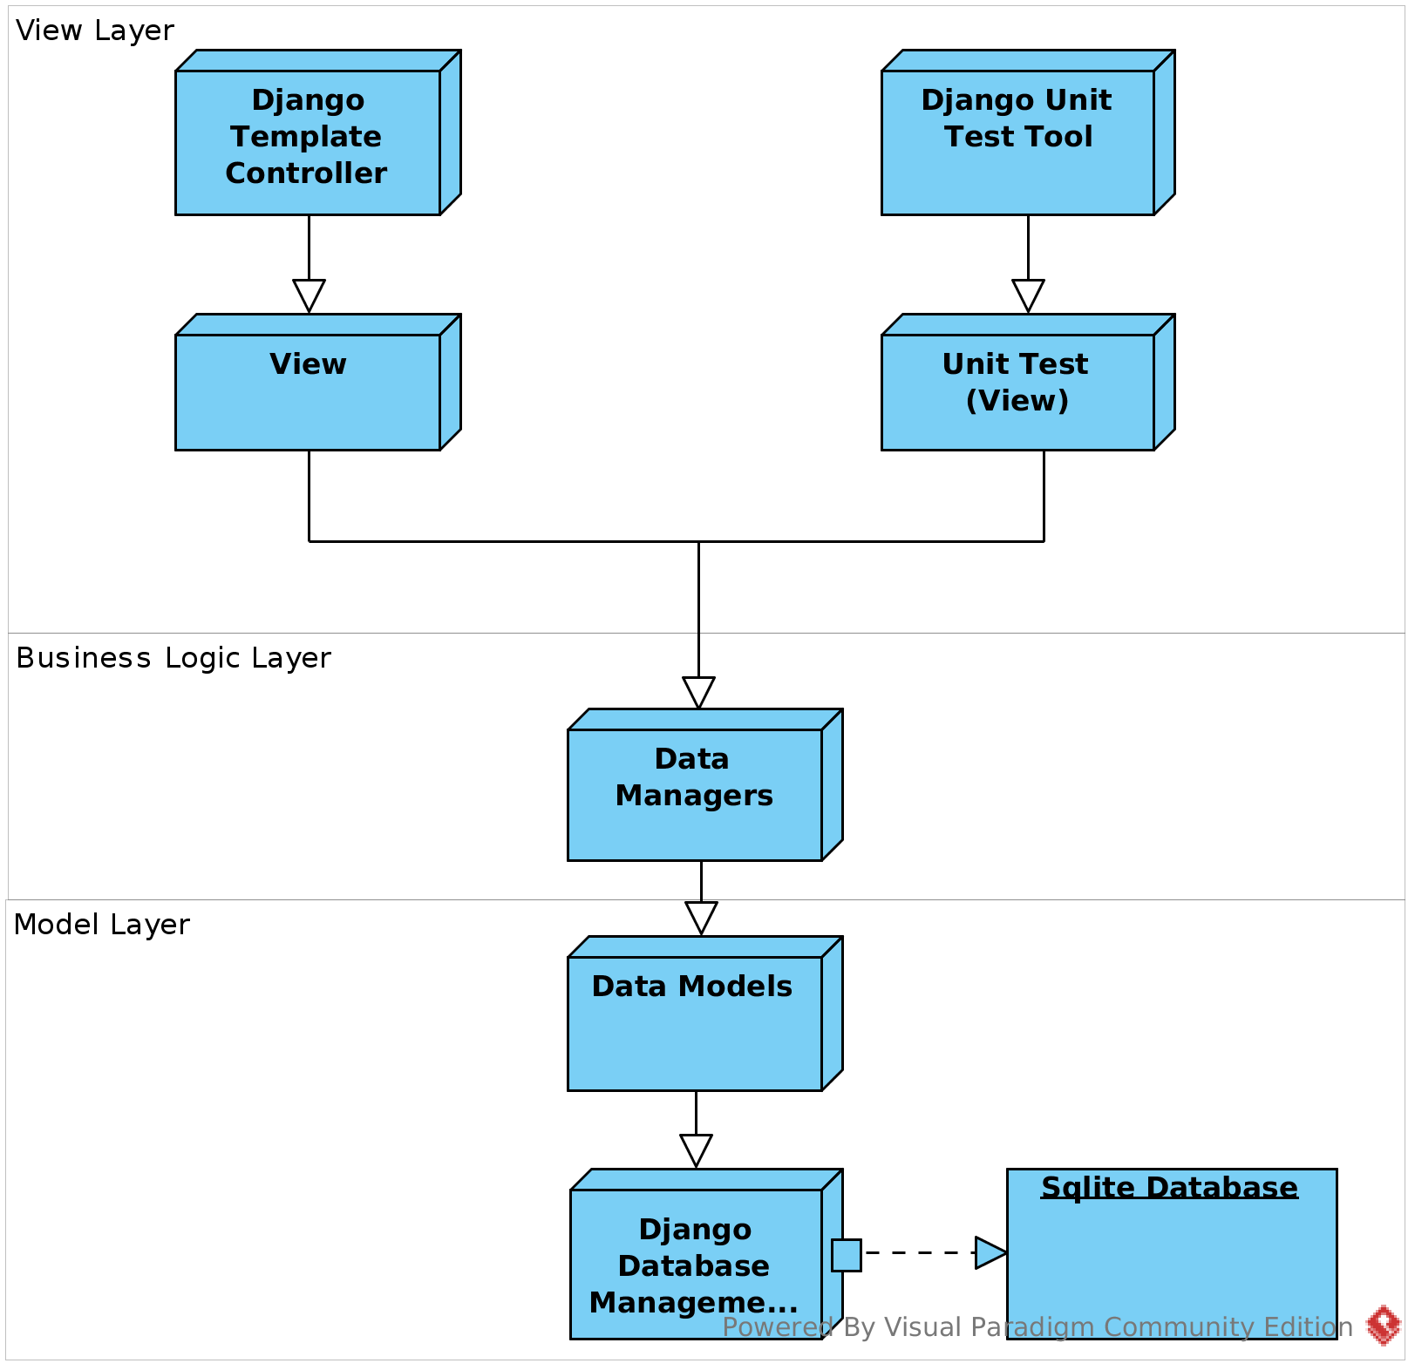

**2.0 Deployment Diagram**

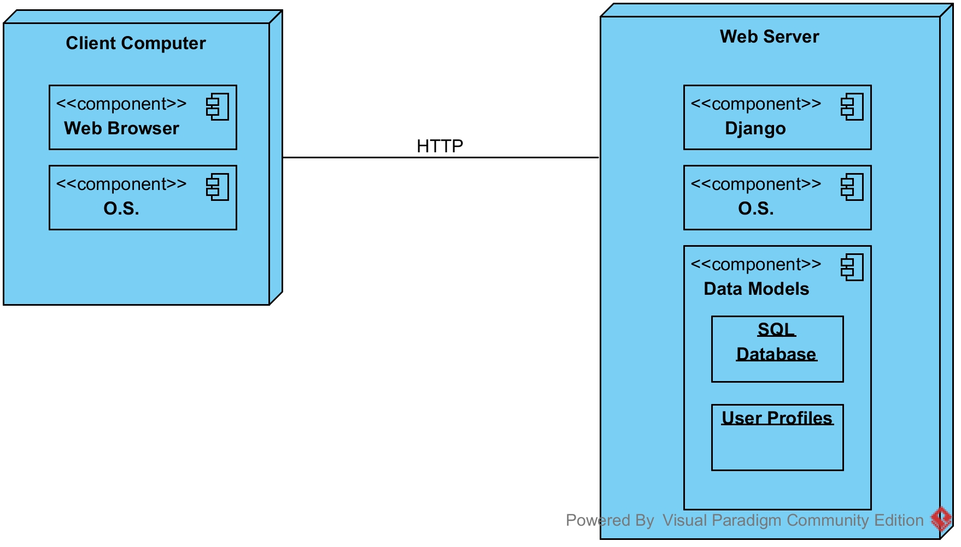

# **3.0 Components and Classes**

|  |  |
| --- | --- |
| **Component ID** | **Description** |
| **DES-001** | **User**  **Component states**   * Idle * New User * Authenticated User * Destroyed User   **Component behavior**   * Register * View * Update * Destroy |
| **DES-002** | **Patient**  **Component state**   * Idle * New Patient (UC-01-01) * Authenticated Patient (UC-01-01) * Appointment Scheduled * Admitted Patient (UC-13-01) * Destroyed Patient   **Component behavior**   * Register (UC-01-01) * Log In * Log Out * Update Profile (UC-03-01) * Export Info (UC-05-01) * Create Appointment (UC-06-01) [collab. with Appointment] * Update Appointment (UC-06-01) [collab. with Appointment] * Cancel Appointment (UC-07-01) [collab. with Appointment] * View Medical Info (UC-10-01) * Admitted To Hospital (UC-13-01) [collab. with Doctor, Nurse] * Discharged From Hospital (UC-13-02) [collab. with Doctor, Nurse] * Deactivate Account |
| **DES-003** | **Doctor**  **Component state**   * Idle * New Doctor * Authenticated Doctor * Assigned Patients * Destroyed Doctor   **Component behavior**   * Register (UC-02-01) * Log In * Log Out * Update Patient Medical History (UC-03-01) * Create Patient Appointment (UC-06-01) * Assign Patient |
| **DES-004** | **MedProfile**  **Component state**   * Idle * New Profile (UC-01-01) * Authenticated User * Appointment Calendar(UC-08-01) * View Prescriptions (UC-09-03) * Viewing Patent’s Medical Information (UC-10-01) * Destroy Patient Information   **Component behavior**   * Registered (UC-01-01) * Modify Profile (UC-03-01) * Update Profile (UC-03-01) * Export Information (UC-05-01) * Create Appointment (UC-06-01) * Update Appointment (UC-06-01) * Cancel Appointment (UC-07-01) * Add Prescription(UC-09-01) * Remove Prescription (UC-09-02) * Release Test Results (UC-11-01) * Upload Patient Information (UC-17-01) |

# **3.1 Class Diagram**

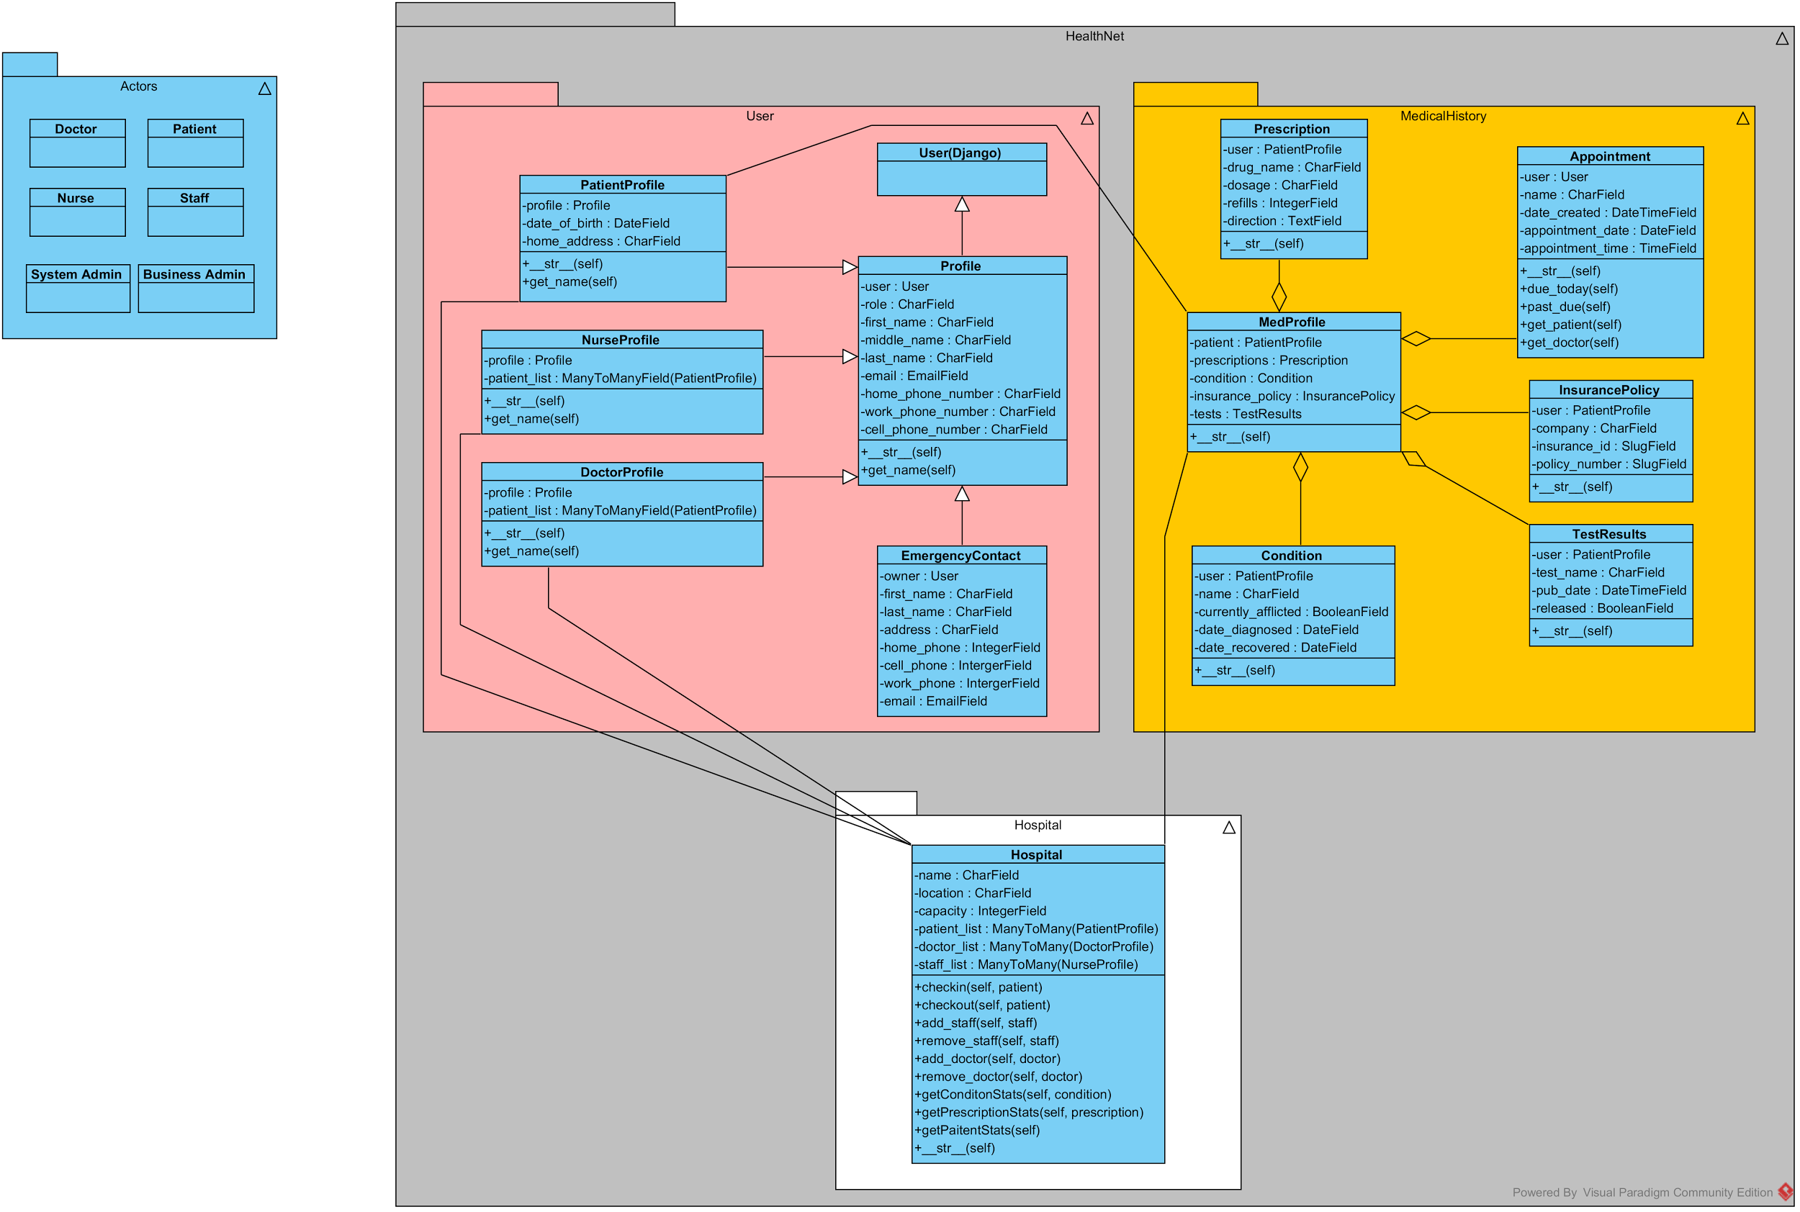

# 3**.2 Sequence Diagram(s)**Patient Registration.pngHealthNet Appointment.jpgSequence Diagram.jpgsequence-diagram (Draft).png

# 

# **3.3 State Diagram(s) - Screen (Web Page) Flow Diagram**

**Adding a Emergency Contact**

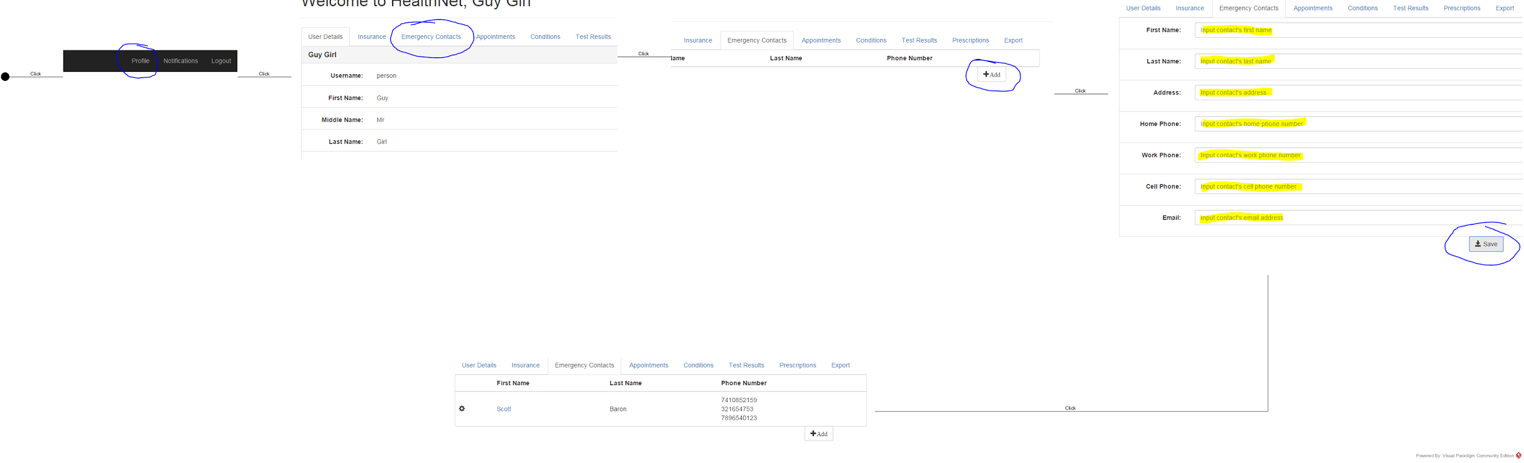

**Adding a Insurance Policy**

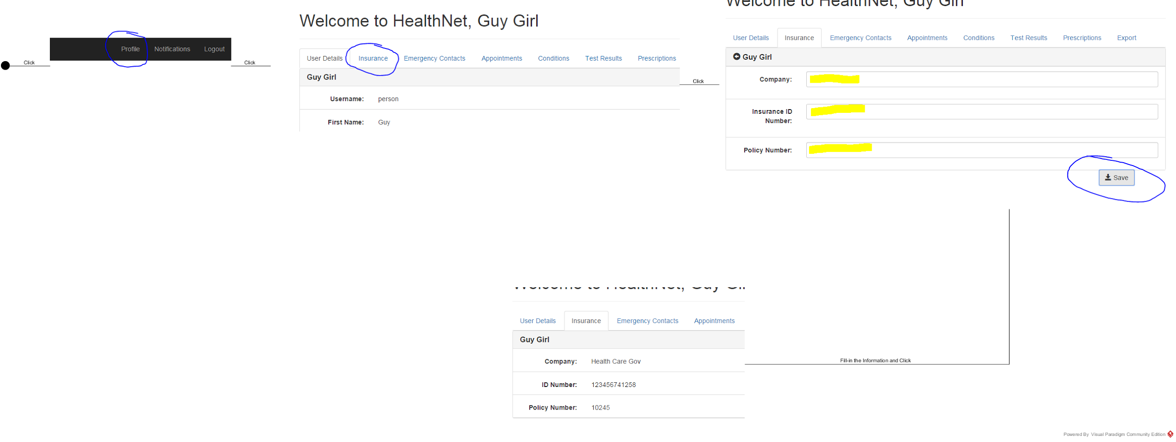

**Adding a Patient to a Hospital**

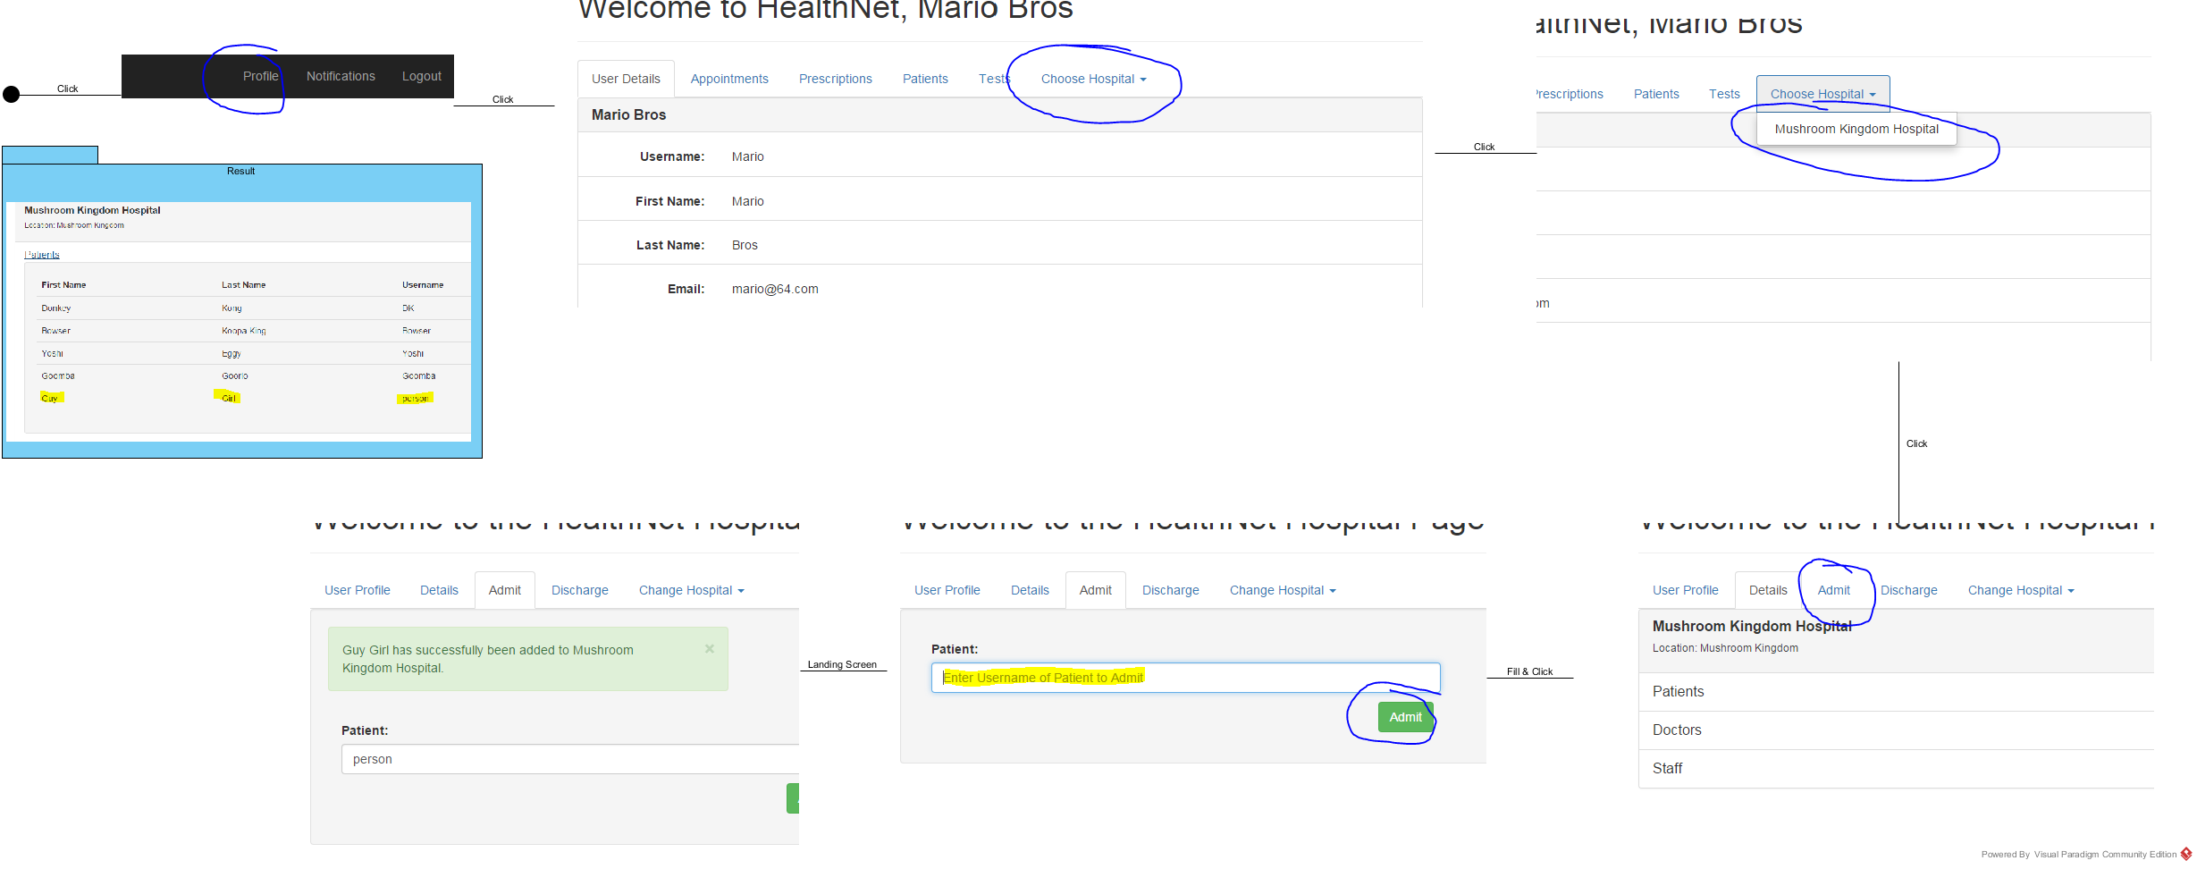

**Doctor Views Patient Profile**

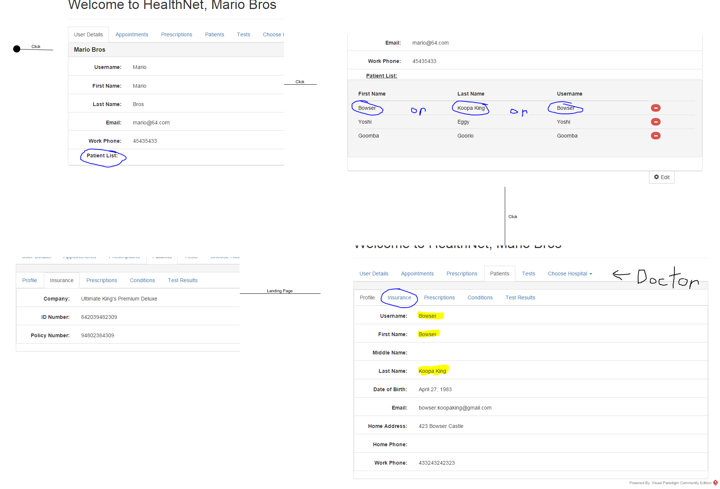

**Patient Updating there Information**

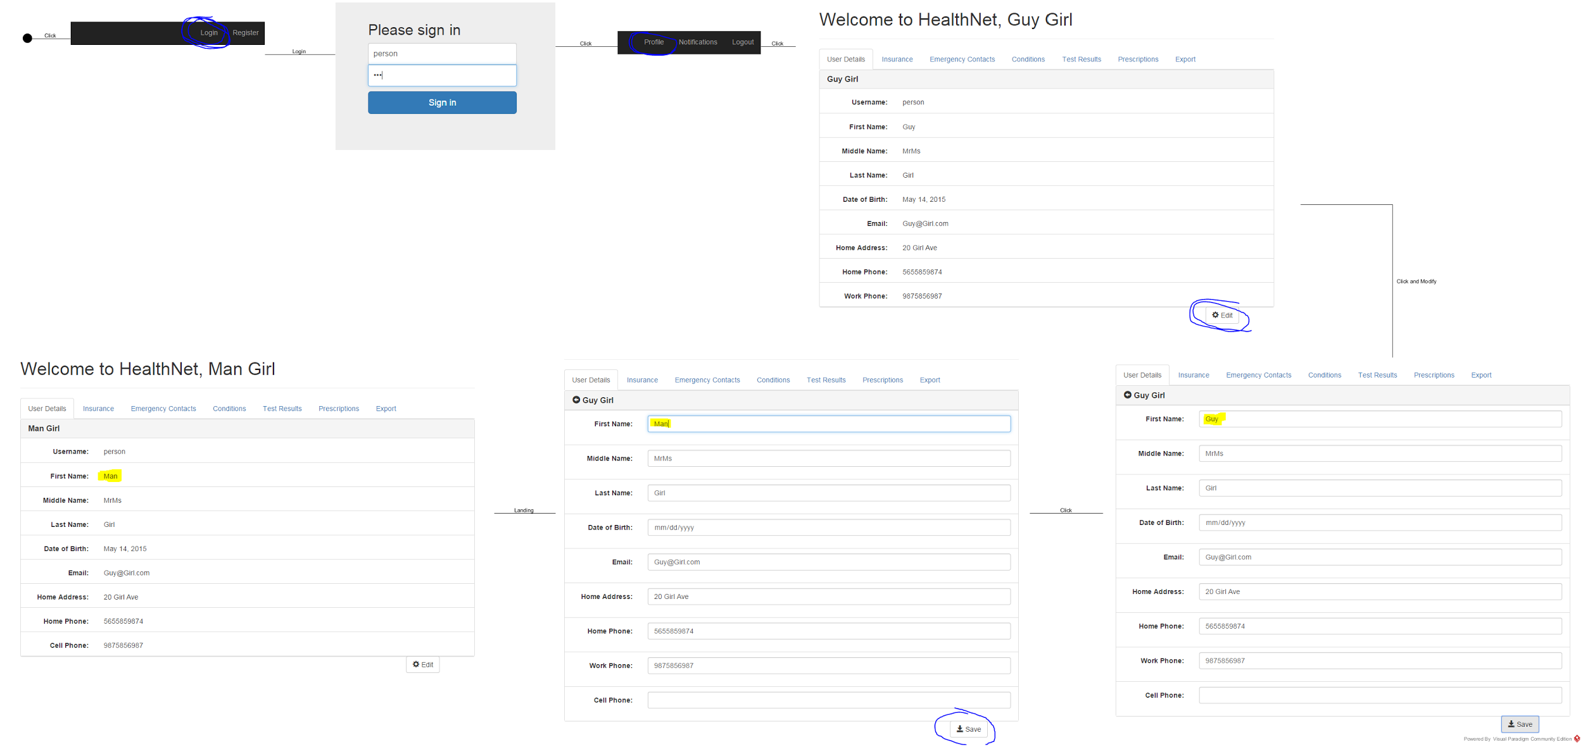

**4.0 Design Rationale**

Our original plan for our design was to organize each element, Medical Data, Personal Information, ect. into its own isolated group. A validation process would be applied to determine whether a user has read or write privileges. This validation process would have executed in the background and the user would, hopefully for resource reasons, never need to know what was going on in the background. After we started to implement the code, we decided to instead execute that validation process once the user logged in. This process will only show the user what he/she has access to. One of the main reasons that we decided to do this was for the number of pointless resources that would be spend validating a user just to do something as simple as refreshing a page. Also, the implementation of this would require less resources to develop.

**5.0 Document Change Log**

|  |  |  |  |
| --- | --- | --- | --- |
| ***Document Version Number*** | ***Revision Date*** | ***Summary of Changes*** | ***Author(s)*** |
| *Initial / v0.0* | *02/23/2015* | *Initial revision.* | *Scott Baron, Martin Suarez, Zachary Glassner, Han Thu, Brian Mejorado* |
| *v0.1* | *02/28/2015* | *Changed color of diagrams in Clauses 1.0 and 2.0 to black in preparation for further adjustment. Adjusted Clause 3.1 title to reflect single class diagram. Removed URL from Clause 3.2. Updated sequence diagrams in Clause 3.2 to fit the same visual style.* | *Brian Mejorado* |
| *v0.2* | *03/06/2015* | *Modified the following Design Components and Classes in Clause 3.0: DES-001, DES-002, DES-003, DES-004. Formatted table in Clause 3.0 for better readability.* | *Brian Mejorado* |
| *v0.3* | *03/07/2015* | *Modifications to the following Design Components and Classes in Clause 3.0: DES-001, DES-002, DES-004.* | *Brian Mejorado, Scott Baron* |
| *v1.0* | *03/09/2015* | *Class Diagram and Deployment Diagram updated; State Diagrams added. Design Rational Added.* | *Scott Baron, Brian Mejorado* |
| *v1.1* | *04/04/2015* | *Class Diagram was updated to include the system and also the outside actors* | *Scott Baron* |
| *v1.2* | *04/05/2015* | *Sequence Diagrams were updated to better fit the project* | *Han Thu* |
| *v1.3* | *04/05/2015* | *Our Architectural Model was added to the document* | *Han Thu* |
| *v1.4* | *04/21/2015* | *Updated the class Diagram to reflect the Project* | *Scott Baron* |
| *v1.5* | *05/05/2015* | *Changed State Diagrams to Screen Shot Diagrams* | *Scott Baron* |