Introduction
This part of the project focuses on dynamic testing techniques applied to the Electronic Store system. The objective of Part 2 is to verify the correctness, robustness, and reliability of selected methods through unit testing, boundary value analysis, and code coverage testing.
All tests were performed without modifying the production code, ensuring that testing activities did not introduce functional changes to the system.

Tested Component Description
The selected component for testing is the class CashierDashboardView, which belongs to the View layer of the system. This class supports cashier-related operations and contains logic that processes item data while ensuring null-safety and preventing runtime exceptions.
The following method was selected for detailed testing due to its importance in item handling:
static int getItemQuantityFromList(List<Item> items, String itemName)
This method searches for an item in a list and returns its quantity if found, otherwise returning a default value.

Unit Testing
Objective
The objective of unit testing is to verify that the selected method behaves correctly under normal and expected operating conditions.

Test Implementation
Unit tests were implemented using JUnit 5 in the following test class:
CashierDashboardViewTest
The test cases focus on validating the functional logic of the method when provided with valid inputs.

Test Scenarios
- Item exists in the list and quantity is returned correctly
- Item does not exist in the list and the method returns 0
- Input list is null
- List contains valid items only
- Correct handling of typical search values
Results
All unit tests executed successfully and produced the expected results, confirming the correctness of the method’s functionality under normal usage.
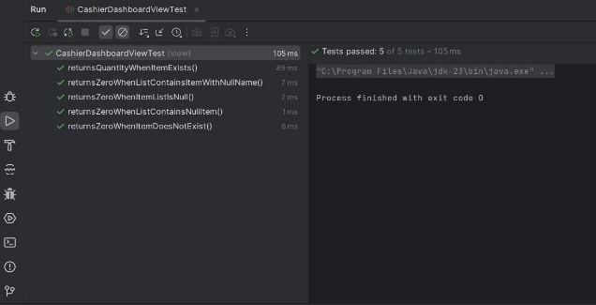
Boundary Value Testing

Objective
Boundary Value Analysis (BVA) was applied to validate the method’s behavior at input extremes and edge cases, where defects are more likely to occur.
To maintain clarity and good testing practice, boundary value tests were implemented in a separate test class.
Test Implementation
Boundary tests were implemented using JUnit 5 in the following class:
CashierDashboardViewBoundaryTest
Boundary Conditions Tested
- Null item list
- Empty item list
- List containing null elements
- Item with a null name
- Null search string
- Empty search string
- Quantity boundary values (0 and 1)
Results
All boundary value tests passed successfully, demonstrating that the method is robust and safely handles invalid, extreme, and unexpected inputs.
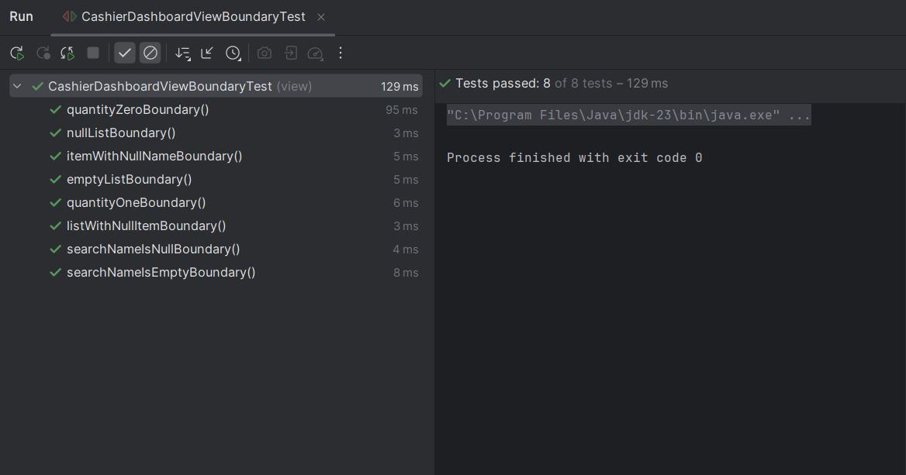

Code Coverage Testing
Code coverage testing was conducted to verify that the written test cases actually execute the selected method and its internal decision paths.
Tool Used
IntelliJ IDEA – Run with Coverage
Coverage Analysis
- The coverage results confirm that:
- The null-list condition was executed
- The iteration over the item list was executed
- Null item and null name checks were executed
- Both matching and non-matching return paths were executed
This indicates that all logical branches of the selected method were exercised during testing.

