Assignment 3 SE3309 2017 clientBanking

Exercise 2:

customer

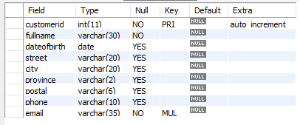

branch

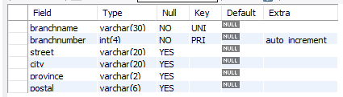

Accountdescription

Accounttype => CHECKING, SAVINGS, CREDIT, STUDENT, YOUTH

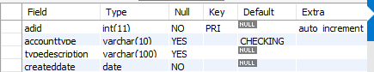

customeraccount

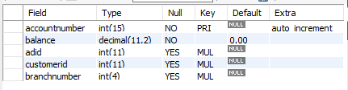

Transactiontype

Transactiontype => GOODS/MATERIALS, SERVICES, SALES, WAGES, TAX

Method => CHECK, ATM, ONLINE, TRANSFER, POS

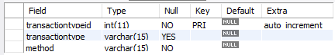

transactionhistory

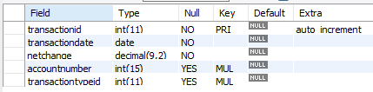

Exercise 3:

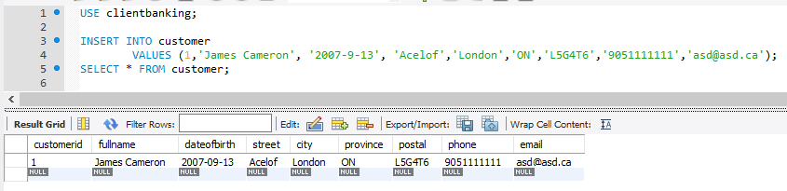

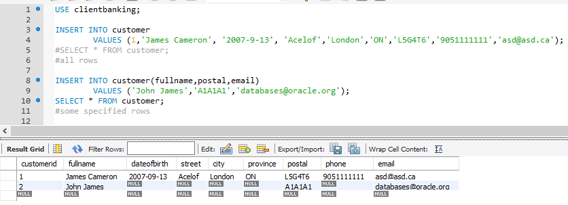

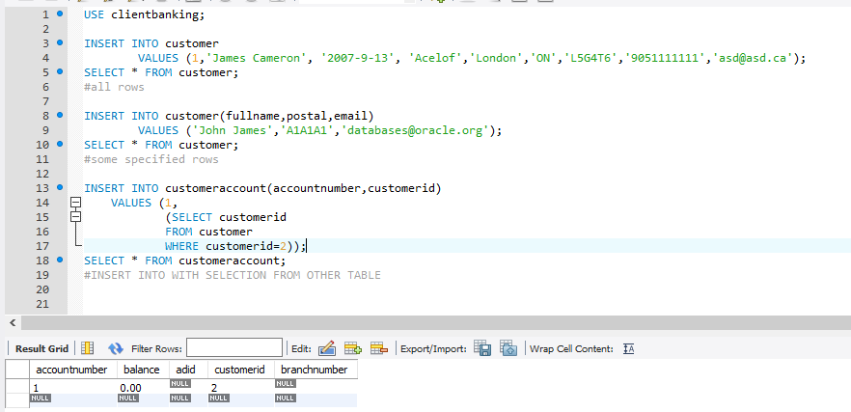

Exercise 4

The code below was written in c++ and randomizes strings for each tuple, which are exported to individual .csv files for each relation. The C++ code is located in assignment3/src/FabData/FabData/FabricatedData.cpp. All of the csv files were saved in assignment3/src/FabData/FabData/ .

The foreign keys were linked based on the information below.

This code is also screenshotted in the next few pages.

The .csv files were appended with a starting row which has random information (although it should be the column headers)

Customer 2000 touples

no fk

Branch 5 touples

no fk

customeraccount 500 touples

no fk

Account Description 500 touples

first 100 customers have a random number of accounts

account has random branch from 1 to 5

customeraccountid = adid

Transaction type 2000

No fk

Transaction History 2000

Transactionid = transactiontypeid

Customer accounts have random number of transactions

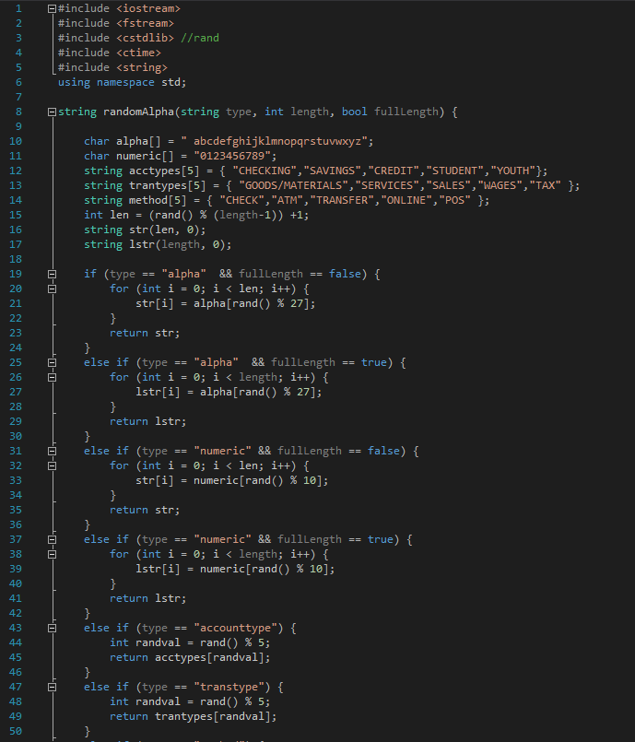

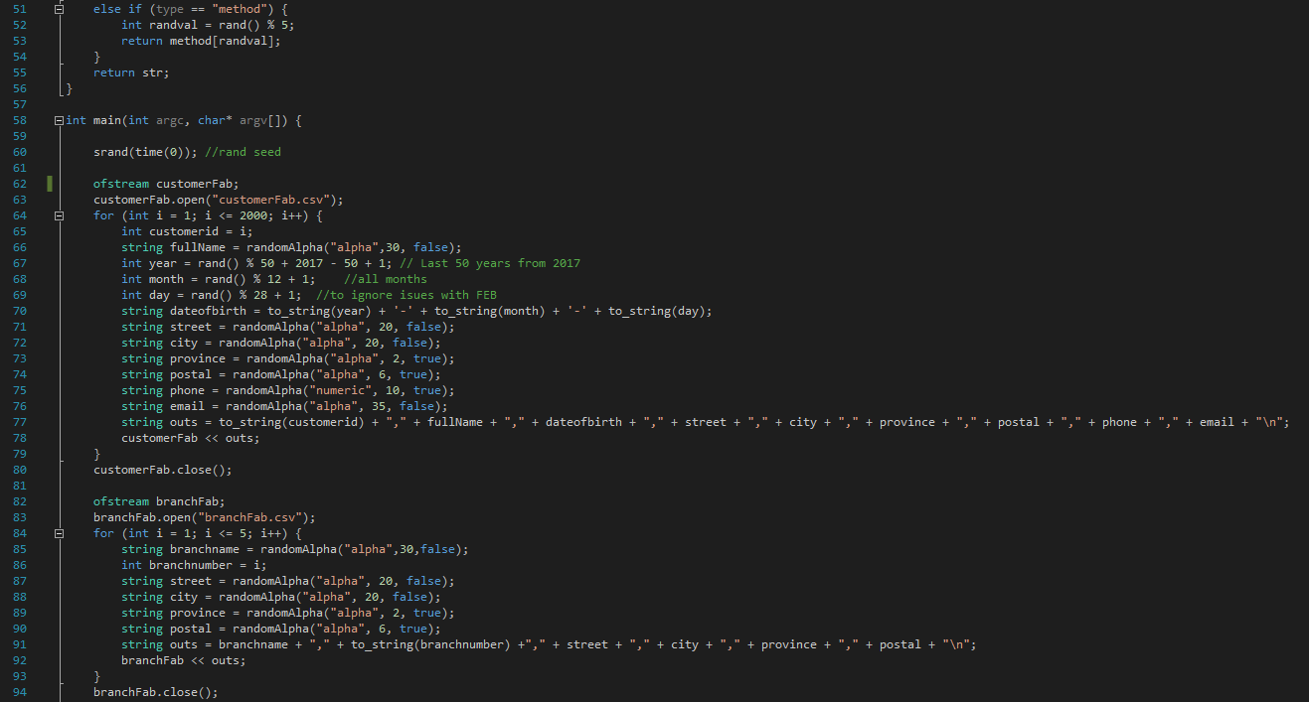

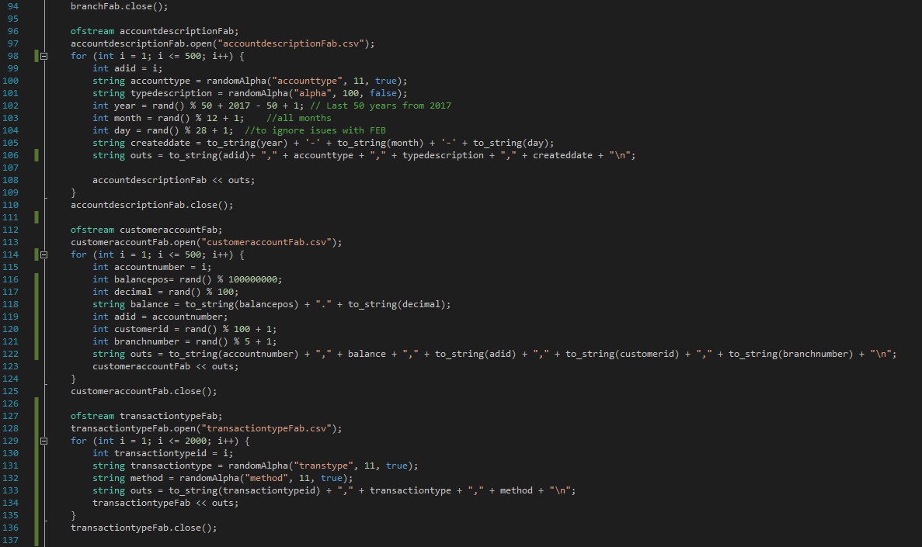

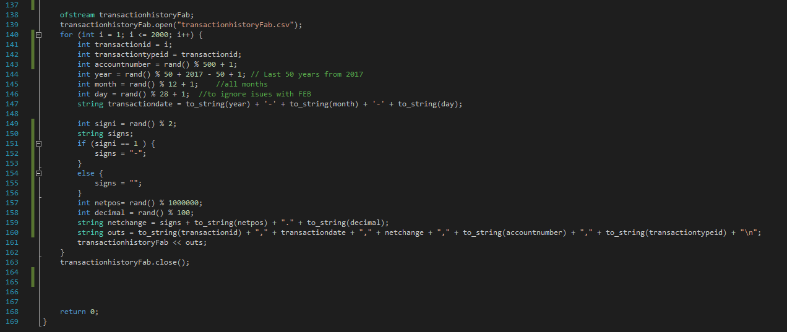

Here are a few small samples from each relation

customer

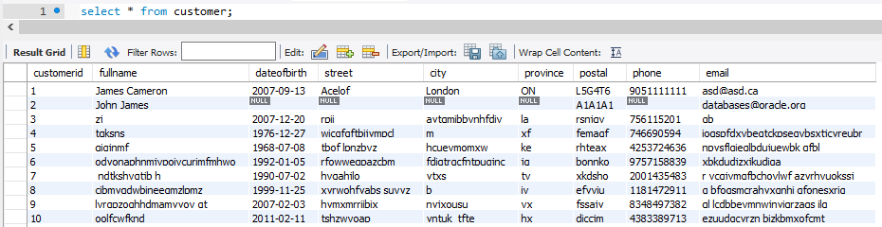

branch

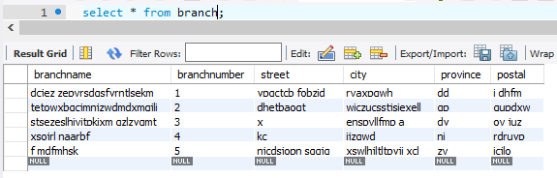

Customeraccount

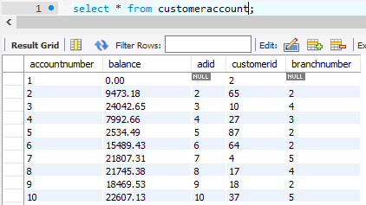

Accountdescription

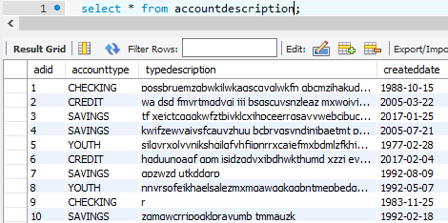

transactiontype

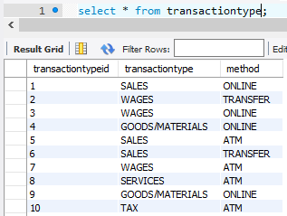

Transactionhistory

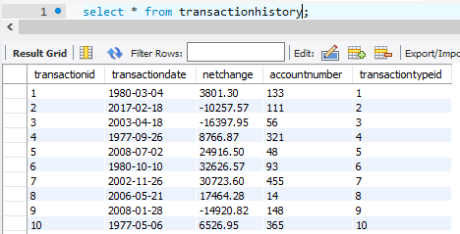

Exercise 5

Using an aggregate less than and an order by we can find all accounts with a balance under $1000. Close to being in the red, in order

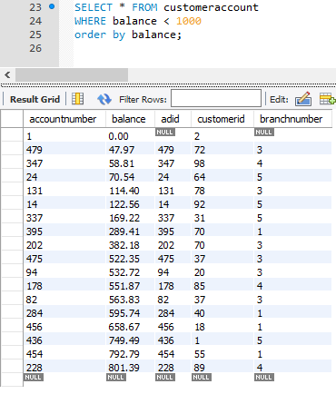

Using a subquery, we can see below,

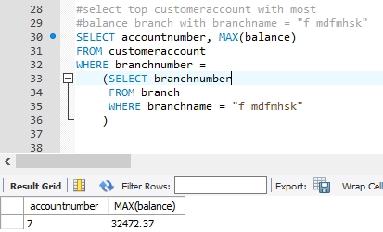

Using a grouped by and a COUNT, we can see below,

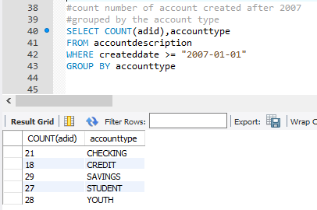

Below uses Group by, Order by, and more than 1 relation

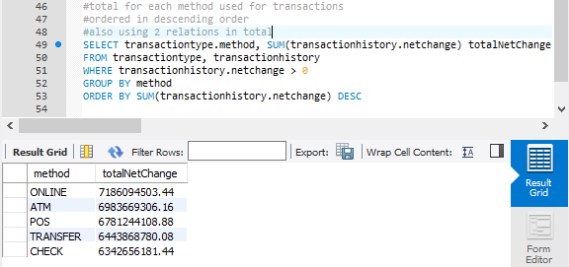

Below has 2 nested subqueries

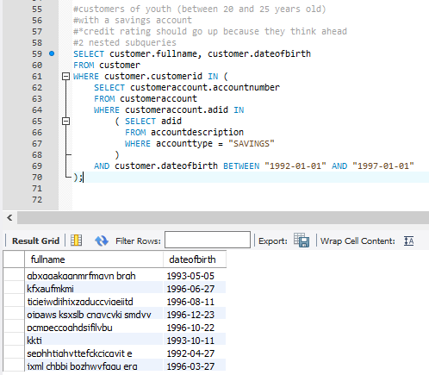

The wildcard and the LIKE operations

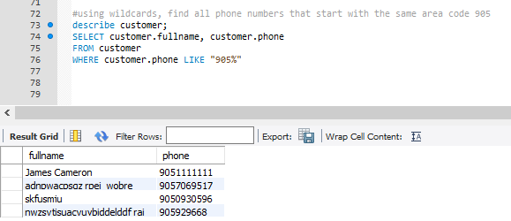

Ex 6

Due to various reasons, it’s kind of hard to show the response of the system when you forget to screenshot the results at the end and can’t redo anything without quite a bit of effort. I’ll screenshot the code, and whichever ones will work after applying them the second time

P1

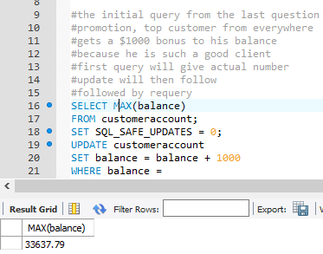

P2



P3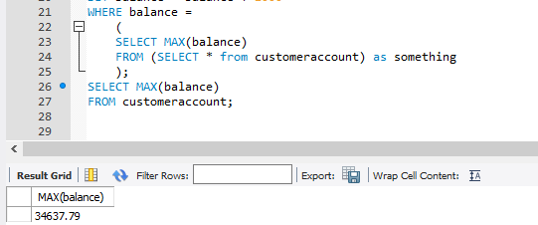

P1 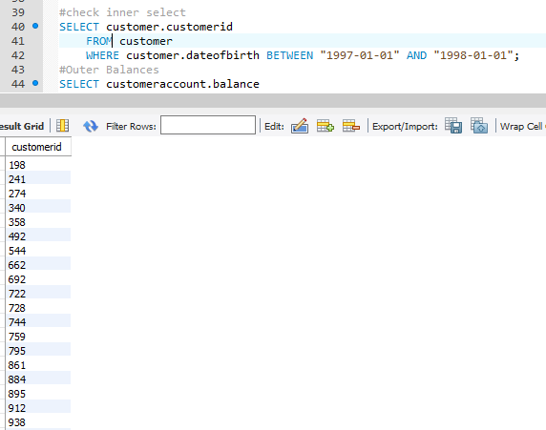returns quite a bit

P2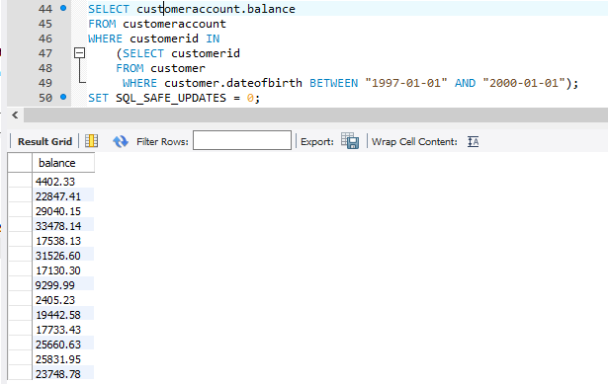

P3 

P4 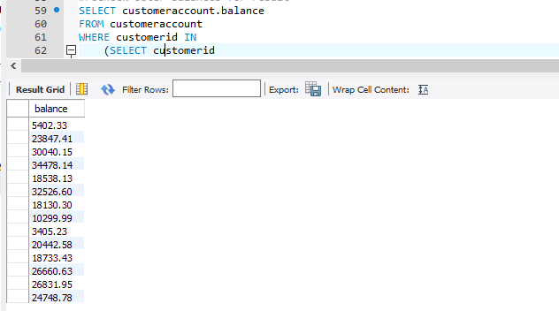

P1

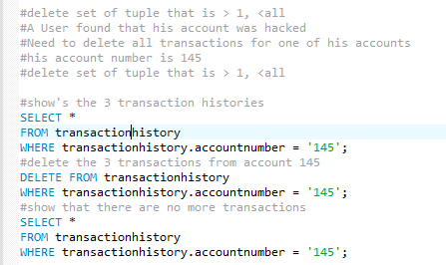

Can’t show the deletion as it already happened. The 3 transactions really do get deleted, test with my code to see

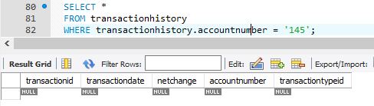

Q7

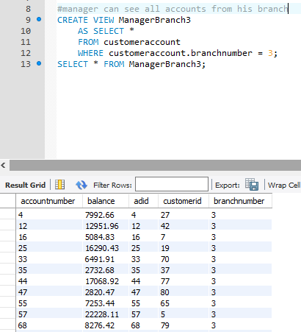

The update works, as shown below. The updated accountnumber 3 changed to branch 3, which caused for the view to update. Also because it only affect the base table

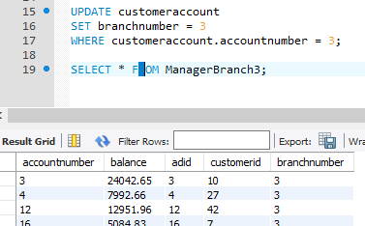

P2 as commented

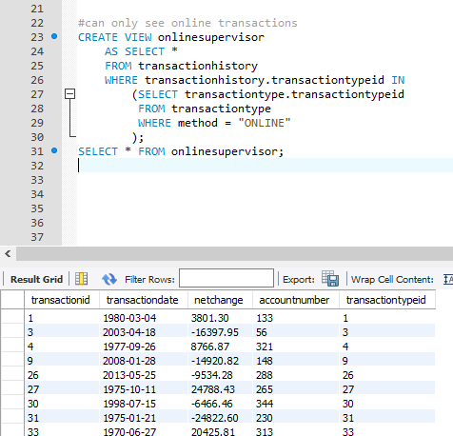

A view for the person with account number 14. Can see the 3 transaction’s he/she has made for the account

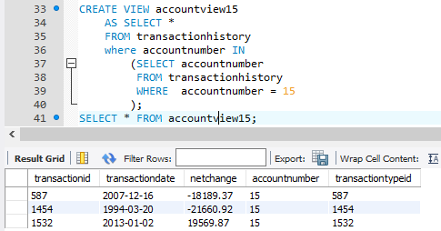

Ex 8

The domain does not work in mysql

After researching, this seems to work in most other sql implementations. This isn’t to important of a difference however, as it just saves some “time” in a well organized product. Domain is effectively used to create user-defined types/groups of user defined types, which does not exist. Sql Server seems to include this functionality