Tiantian Zhong  
3200110643

# Objectives

1. Analyze the stability of the dynamic system: inverted pendulum cart.
2. Design the appropriate compensator to balance the inverted pendulum.

# Observations

## Calculated Parameters

### Correction Part



### Closed-Loop Transfer Function After Correction



## Analysis on the Open-Loop Frequency Characteristics after Compensation

1. System Cut-Off Frequency: .
2. Stability Margin: .

## Plots

Figure and shows the Bode Diagrams of the correction part, , and the corrected closed-loop function of the system.

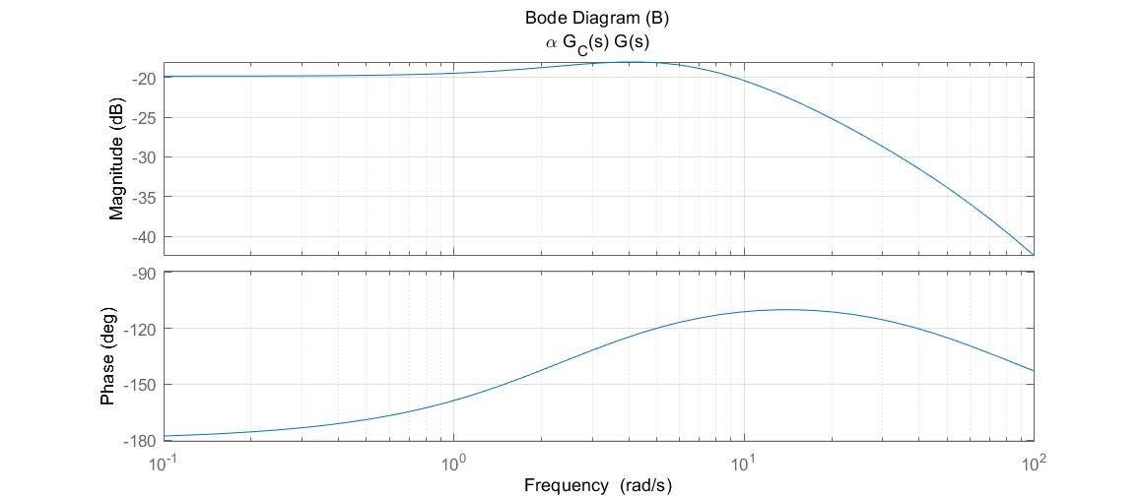

Figure : Open-Loop Frequency Characteristic Diagram for the Corrected System

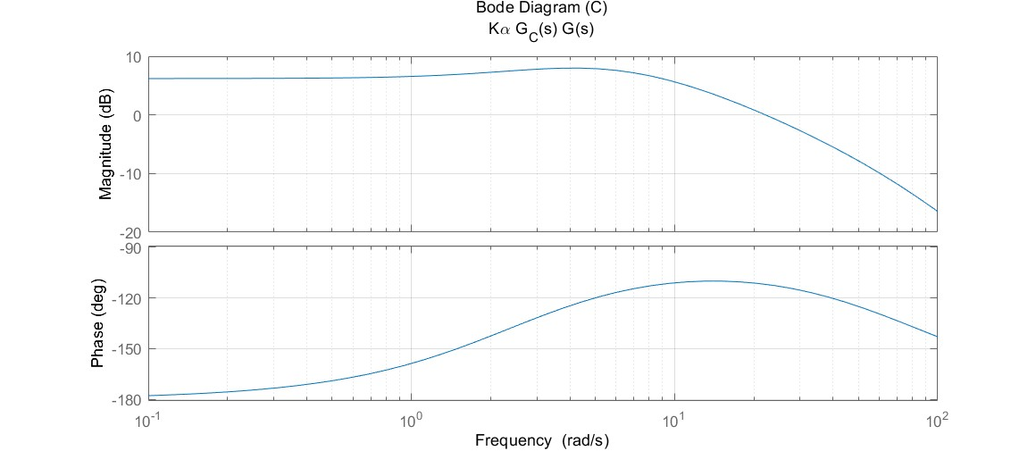

Figure : Open-Loop Frequency Characteristic Diagram for the Corrected System after Compensation

# Discussion

## Beside lead compensator, what other compensation approach(es) using frequency response are there? What are features and differences?

## How shall we select the right compensator?