Kontrolltöö

Martin Hõbesalu

insert into Employee values(newId(),'Darren','Vanaküla','Mustamäe51','12345','darren@Gmail.com')

insert into Employee values(newId(),'Hannes','Plado','Mustamäe1','12346','Hannes@Gmail.com')

insert into Employee values(newId(),'Hannes','Malter','Mustamäe6','1237','HannesMalter@Gmail.com')

insert into Employee values(newId(),'Mihkel','Hain','Mustamäe2','12348','Mihkel@Gmail.com')

insert into Employee values(newId(),'Henri','Jervson','Mustamäe3','12349','Henri@Gmail.com')

insert into Employee values(newId(),'Moris','Vider','Mustamäe4','12310','Moris@Gmail.com')

insert into Employee values(newId(),'Eric','Hyo','Mustamäe5','12311','Eric@Gmail.com')

insert into Employee values(newId(),'Risto','Koort','Mustamäe7','12312','Risto@Gmail.com')

insert into Employee values(newId(),'Kregor','Latt','Mustamäe8','12313','Kregor@Gmail.com')

insert into Employee values(newId(),'Karl','Kats','Mustamäe9','12314','Karl@Gmail.com')

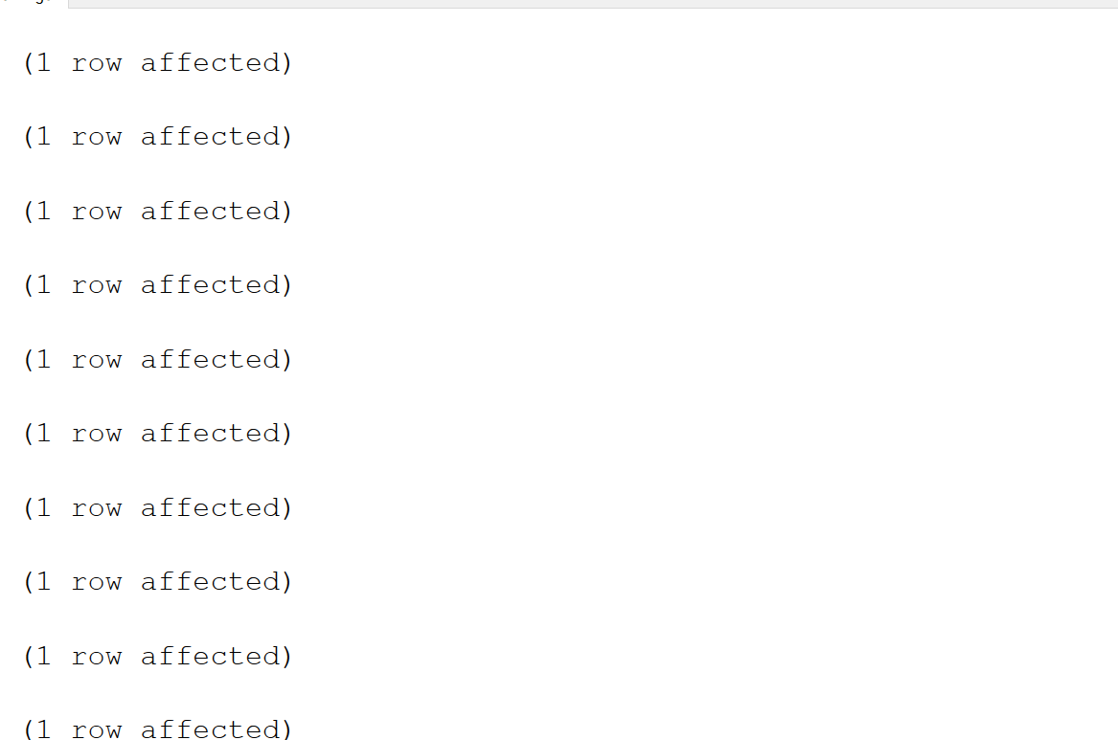

select * from Employee

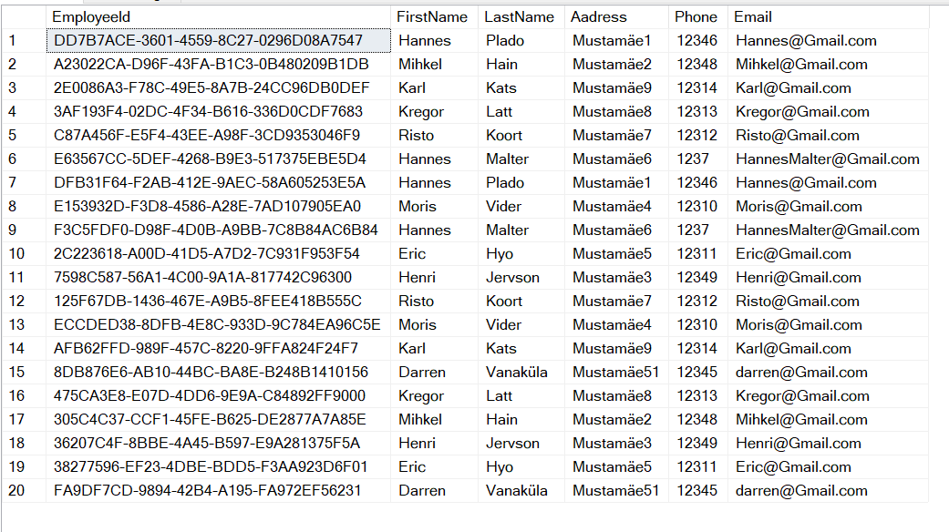

insert into Client values(newId(),'Male','Homer','Homer@gmail.com')

insert into Client values(newId(),'Male','Gus','Gus@gmail.com')

insert into Client values(newId(),'Male','Alek','Alek@gmail.com')

insert into Client values(newId(),'Male','Al','Al@gmail.com')

insert into Client values(newId(),'Male','Hugh','Hugh@gmail.com')

insert into Client values(newId(),'Male','Albert','Albert@gmail.com')

insert into Client values(newId(),'Male','Eddie','Eddie@gmail.com')

insert into Client values(newId(),'Male','Otis','Otis@gmail.com')

insert into Client values(newId(),'Male','Christopher','Chrisopher@gmail.com')

insert into Client values(newId(),'Male','Rafael','Rafael@gmail.com')

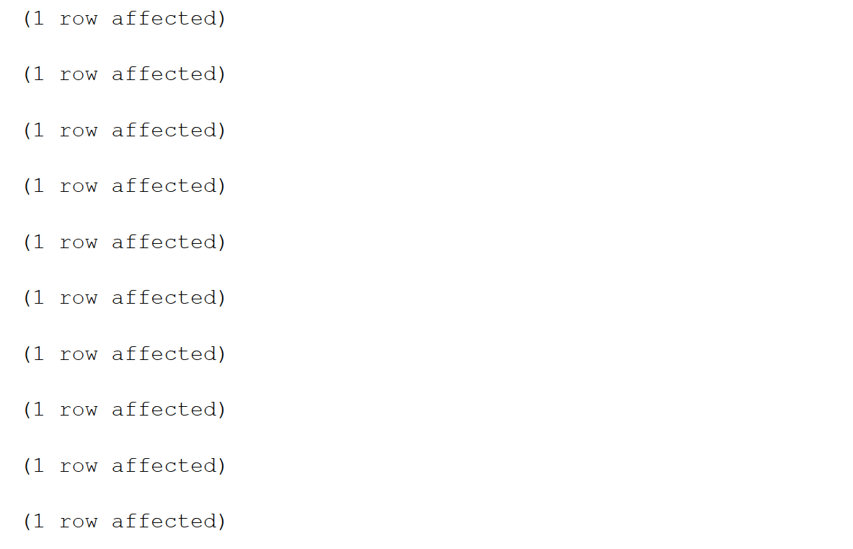

create procedure spGetClient

as

Begin

Select Name,Gender from Client

End

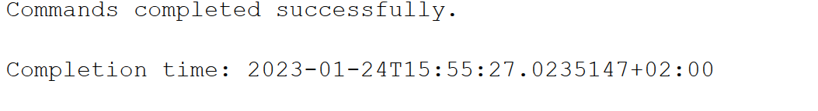

select * from Client

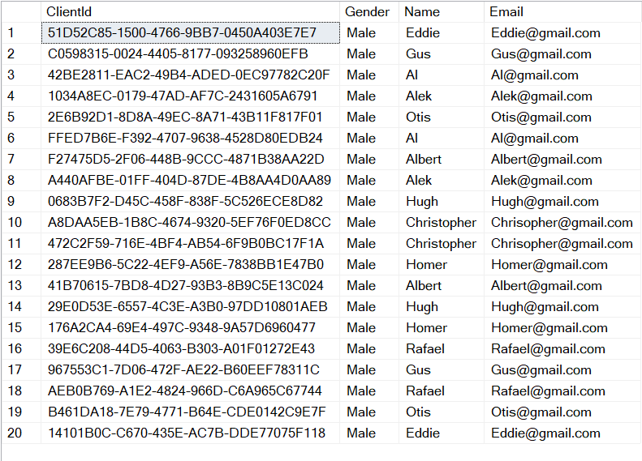

insert into EmployeeSales values(newId(),'4','Orbital key')

insert into EmployeeSales values(newId(),'1','XPress Bottle')

insert into EmployeeSales values(newId(),'2','InstaPress')

insert into EmployeeSales values(newId(),'3','Uno Wear')

insert into EmployeeSales values(newId(),'5','Allure Kit')

insert into EmployeeSales values(newId(),'6','Swish Wallet')

insert into EmployeeSales values(newId(),'7','Onovo Supply')

insert into EmployeeSales values(newId(),'8','Sharpy Knife')

insert into EmployeeSales values(newId(),'9','Towlee')

insert into EmployeeSales values(newId(),'10','Rhino Case')

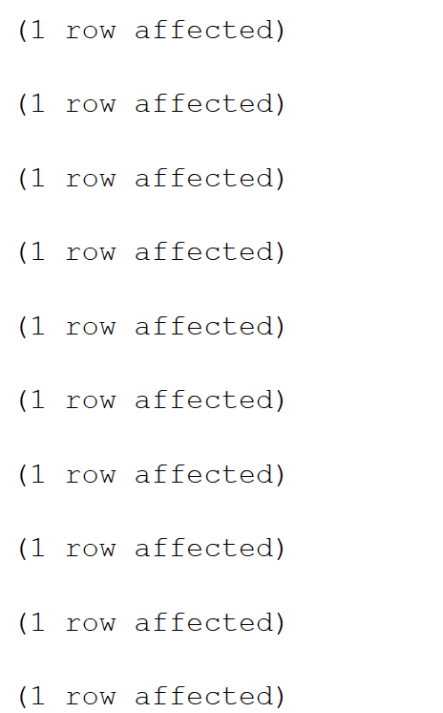

select * from EmployeeSales

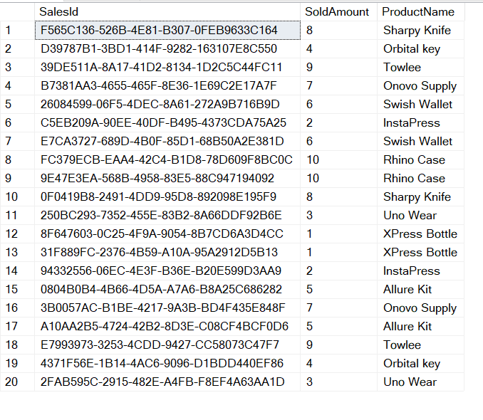

insert into Products values(newId(),'Orbital key','1','red')

insert into Products values(newId(),'XPress Bottle','2','blue')

insert into Products values(newId(),'InstaPress','3','yellow')

insert into Products values(newId(),'Uno Wear','4','green')

insert into Products values(newId(),'Allure Kit','5','brown')

insert into Products values(newId(),'Swish Wallet','6','purple')

insert into Products values(newId(),'Onovo Supply','7','black')

insert into Products values(newId(),'Sharpy Knife','8','white')

insert into Products values(newId(),'Towlee','9','pink')

insert into Products values(newId(),'Rhino Case','10','orange')

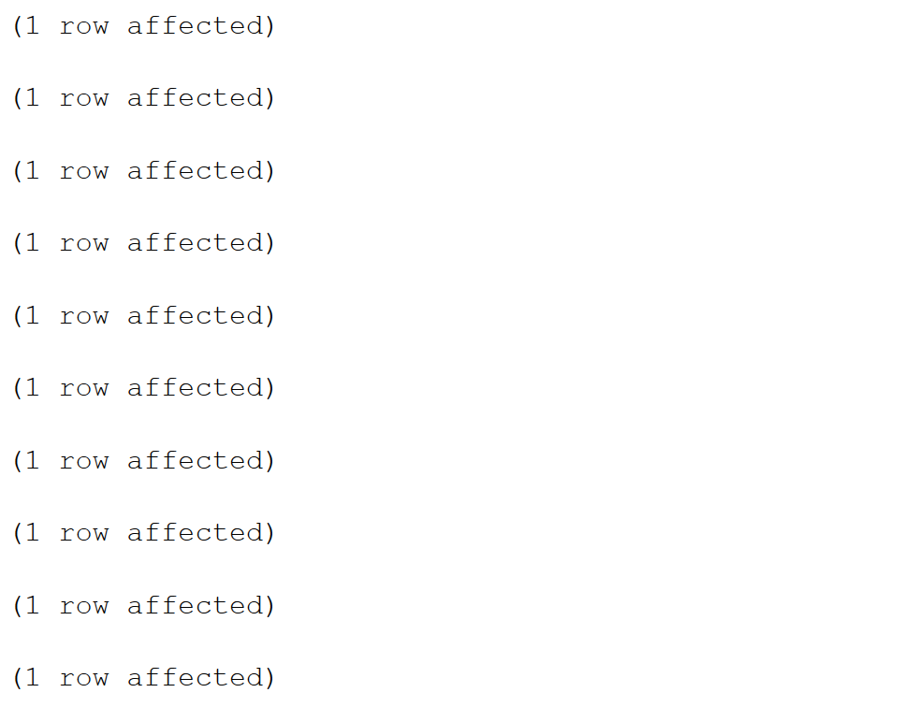

select * from Products

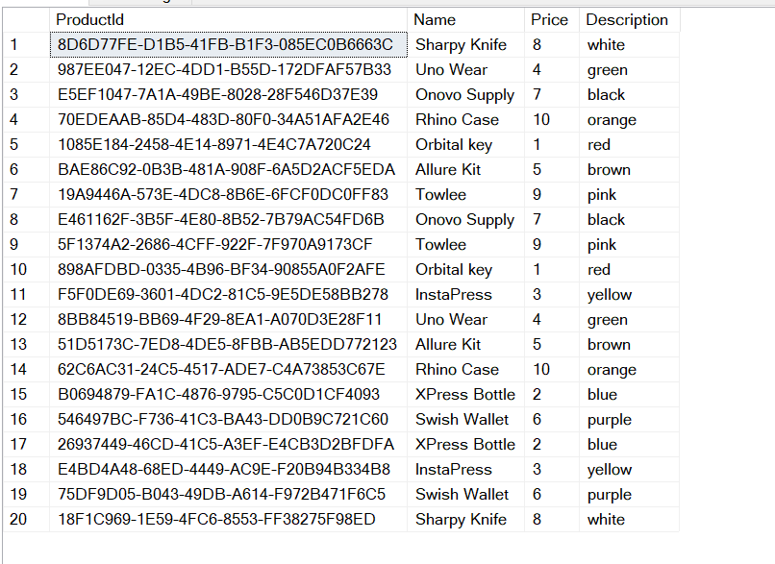

insert into Pudi_Padi values(newId(),'Pudi Padi','Busy','209 Vine St')

insert into Pudi_Padi values(newId(),'Pudi Padi','Empty','794 Greystone St')

insert into Pudi_Padi values(newId(),'Pudi Padi','Closed','9239 Golden Star Ave')

insert into Pudi_Padi values(newId(),'Pudi Padi','Open','7121 East Arcadia St')

insert into Pudi_Padi values(newId(),'Pudi Padi','Busy','347 SE Howard Street')

insert into Pudi_Padi values(newId(),'Pudi Padi','Busy','552 Proctor Dr')

insert into Pudi_Padi values(newId(),'Pudi Padi','Closed','461 Gregory Court')

insert into Pudi_Padi values(newId(),'Pudi Padi','Open','520 Coffee Court')

insert into Pudi_Padi values(newId(),'Pudi Padi','Empty','767 Gulf St')

insert into Pudi_Padi values(newId(),'Pudi Padi','Open','7763 Addison St')

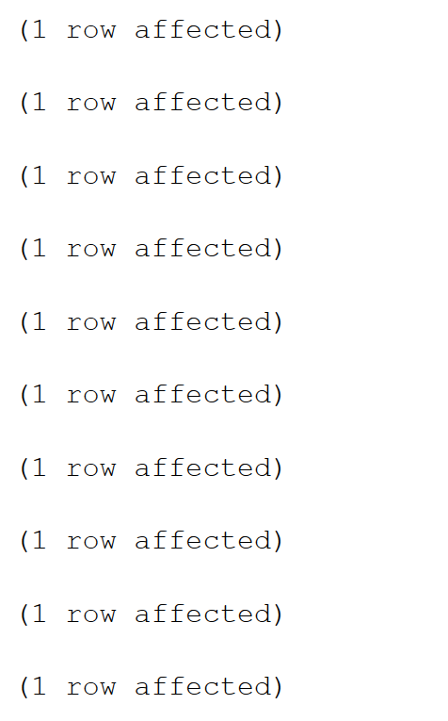

select * from Pudi_Padi

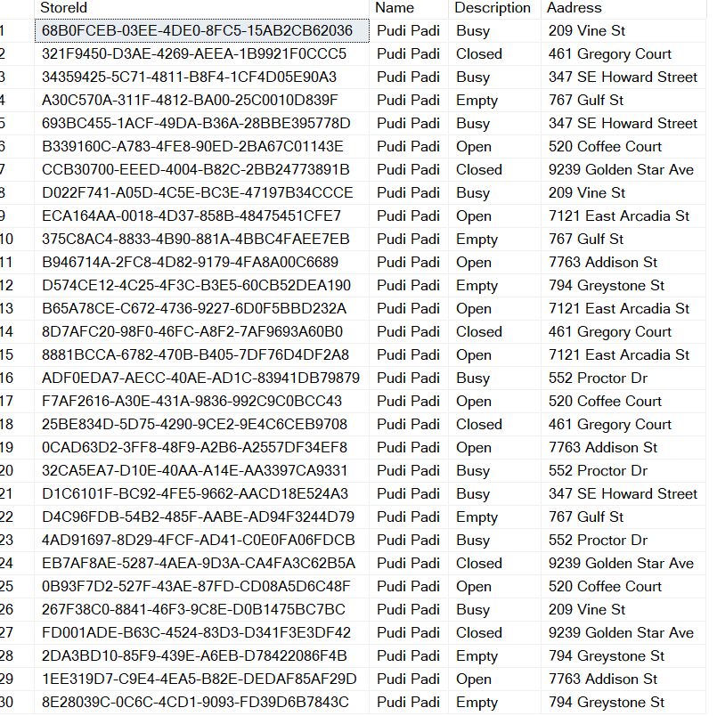

select employee.FirstName, Products.Description,Employee.Aadress

from Employee

inner join Products on Employee.EmployeeID = Products.ProductId

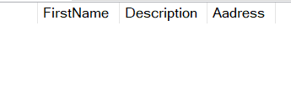

select employee.FirstName, Products.Description,Employee.Aadress

from Employee

Right join Products on Employee.EmployeeID = Products.ProductId

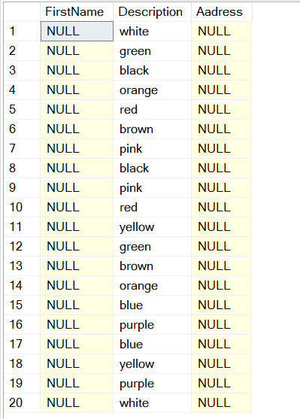

select employee.FirstName, Products.Description,Employee.Aadress

from Employee

left join Products on Employee.EmployeeID = Products.ProductId

