

IDENTIFYING THE PRIMARY FACTORS DRIVING AIR POLLUTION BASED ON AN ANALYSIS OF A DATASET OF 41 US CITIES FROM A 1970 CENSUS
Multivariate Data Analysis Project

Students
Sara Vasques FC58163 | Rita Pinto FC57490 | Juan Aldana FC66459
Masters
Master in Bioinformatic and Computational Biology
Master in Biostatistics
Faculdade de Ciências
Departamento de Estatística e Investigação Operacional

Index

Index 1
Introduction 2
Preliminary Data Analysis & Pre-Processing 4
Principal Component Analysis (PCA) 6
Comprehensive and Comparative Cluster Analysis 11
Conclusion 16
References 18

Introduction
In the current days, the air quality has become a big problem worldwide. Especially in the cities, air pollution has become a significant public health concern.
As urban areas continue to expand and industrial activities intensify, the concentration of harmful pollutants in the atmosphere has increased dramatically. Pollutants like carbon monoxide, ozone and sulphur dioxide can have a severe impact not only on the environment but also on human health, contributing to respiratory diseases and cardiovascular problems, amongst others. These health complications that shorten life expectancy exist in both economically developing and developed countries [1].
Moreover, climate change has further aggravated air quality issues, with heat waves and changing weather patterns that create conditions that favor the accumulation of pollutants. As a result, governments, scientists, researchers and environmental organizations are increasingly focused on monitoring air quality and developing strategies to reduce emissions.
Due to the reasons mentioned before, this project aims to analyze a dataset of 41 US cities to identify underlying patterns and relationships between pollution levels, climatic conditions, and demographic or industrial factors.
Making a preliminary analysis of the data, conducting a principal component analysis and conducting a cluster analysis are different types of analytical approaches that can help researchers better understand the complexity of air pollution. These techniques allow the identification of hidden patterns, the reduction of data dimensionality and the grouping of the variables that most contribute to the pollution. By applying these statistical methods, it becomes possible to distinguish the main factors that contribute to poor air quality, detect pollution hotspots and assess how different pollutants interact with each other. Ultimately, these analyses provide valuable insights that support policy development, environmental planning and the creation of targeted interventions aimed at improving air quality and protecting public health.
In this study, we have as a goal analyzing a dataset of 41 US cities from 1970 to identify the primary factors driving air pollution.
Using a combination of dimensionality reduction, like Principal Component Analysis (PCA) and clustering techniques like Hierarchical Clustering (HCL), we aim to uncover which are the main factors that contribute to air pollution, climate contamination, and other population metrics. The final step of this analysis involves investigating the geographic distribution of these city types to determine if any spatial patterns exist.
Through a preliminary analysis, we can explore the relationships between all the variables and gain an initial understanding of how these factors may influence air pollution. By applying a principal component analysis (PCA), we aim to reduce the dimensionality of the dataset and determine which combination of variables explains most of the variability in pollution levels [2]. At the end, using cluster analysis, we can group cities or regions with similar environmental and industrial profiles, allowing us to detect patterns regarding the areas more prone to higher SO2 concentrations.

The Dataset
The analysis is based on a dataset containing seven variables for each of the 41 cities: the sulphur dioxide content (μg/m³) (SO2), the average annual temperature (°F) (Temp), the number of manufacturing enterprises (Manuf), population size (in thousands) (Pop), the average annual wind speed (mph) (Wind), the average annual precipitation (inches) (Precip), and the average number of days with precipitation (Days).
The analysis is based on a dataset that contains the sulphur dioxide levels for 41 cities in the United States, and other 6 variables related to pollution, from a census carried out in 1970.
At this time, the SO2 emissions coming from the most industrialized cities were one of the main factors contributing to air pollution, due to coal combustion emissions. [3]

Until the 1970s, the regulation of air pollution was more specific, by states, for example, which caused the air quality to vary a lot between regions, depending on whether or not those regions had many industries and on the population density levels [4]. Over time, as scientists were trying to understand air pollution, and the emissions of pollutants were increasing, the development of air pollution legislation was also growing at all levels, mainly at the state level and city level [4].
With this dataset and specific variables, the analysis that will be carried out in this specific study will allow us to identify the main environmental, demographic and industrial factors associated with sulphur dioxide levels, for this specific time.

Preliminary Data Analysis & Pre-Processing

A preliminary review of the data reveals significant differences in the scale and distribution of the variables. As we can see in Table 1:
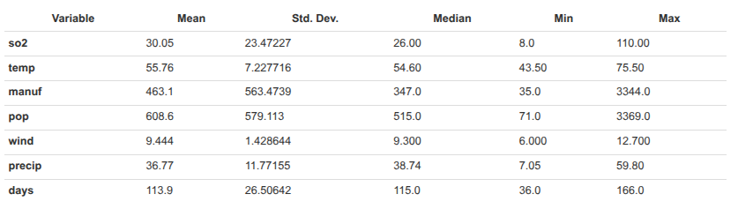
Table 1 - Summary of the main statistics of our dataset

The standard deviation of `pop` and `manuf` are orders of magnitude larger than the other variables like `wind` or `precip`. Furthermore, `pop` and `manuf` exhibit significant right-skew, which means that they are larger than their medians.

These observations are the first step to guide our analysis, because performing a PCA on the raw dataset would lead to a completely invalid result. The first principal component would be dominated by the variables with the largest variance, which in our case are `pop` and `manuf`, ignoring the contributions of other variables more directly related to the climate, like `precip` and `wind` variables.

To ensure that each variable contributes to the analysis based on its correlation with other variables, not based on the measurement scale, we used the correlation matrix for PCA instead of the covariance matrix.

Correlation Structure
To better view the correlations between all the variables, we created these two plots: a Pairs Plot and a HeatMap.

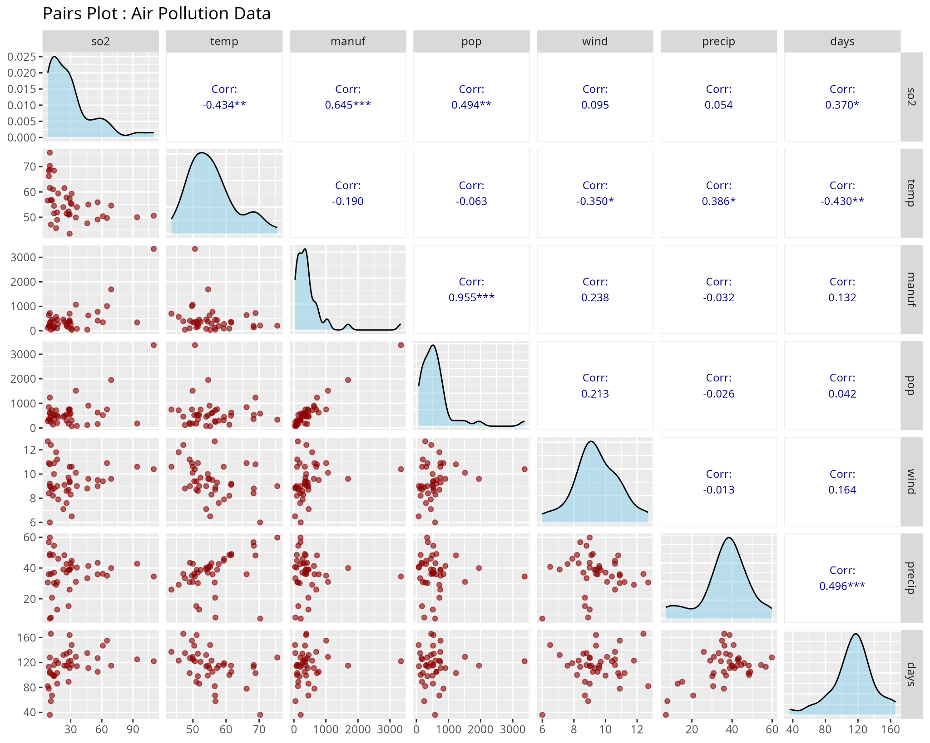
Figure 1 - Correlation structure of the data that shows how the variables are correlated. We can see that there are some strong correlations, like pop/manuf that is close to 0.95 and negative correlations like the S02 production and the temperature, indicating
The correlation structure of the data shown in Figure 1 reveals two important patterns. There is a near linear relationship between `pop` and `manuf` = 0.96, indicating that the 1970s cities that had bigger populations, had more industries and therefore more manufacturing. These suggest a socioeconomic structure centered on industrial employment.

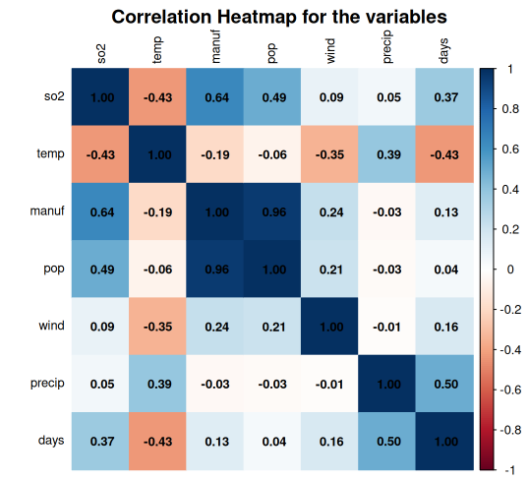
The second highest correlation that we can observe between the data is the relationship between `manuf` and `SO2` = 0.65. This provides enough reason to suspect (hypothesis) that the industrial activity can be one of the major causes of SO2 production. Nevertheless, we need to consider other variables, like the climate conditions (`temp`, `wind`, `days` and `precip`), that can have a role in influencing the pollution levels, as we can see in the negative correlation between the `temp` (temperature) and the `SO2` production = -0.434. There are other smaller but important correlations between climate variables (`precip` and `days`) and between population and pollution (`pop` and `SO2`).

Figure 2 - HeatMap that shows the correlation between the variables, like the graphic in Figure 1

Principal Component Analysis (PCA)

PCA is a mathematical method that reduces the multidimensional structure of a dataset into a two-dimensional map, explaining the observed variance with minimal components. Highly correlated variables can be combined into a component that accounts for the most data variance. The second component explains the second most variation independently of the first [1], and so on. To reduce the dimensionality of the dataset from 7 variables to a smaller, more interpretable set of components, we evaluated three criteria:

- Kaiser's Criterion: Retain components with eigenvalues greater than 1.
- Scree Plot: Identify the "elbow point" where the variance explained by subsequent components sharply decreases.
- Cumulative Variance: Ensure a sufficient percentage >70-80% of the total variance is explained.
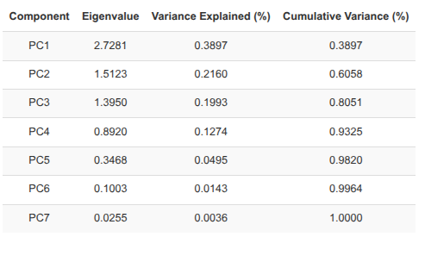
Table 2 - Summary of the principal components characteristics

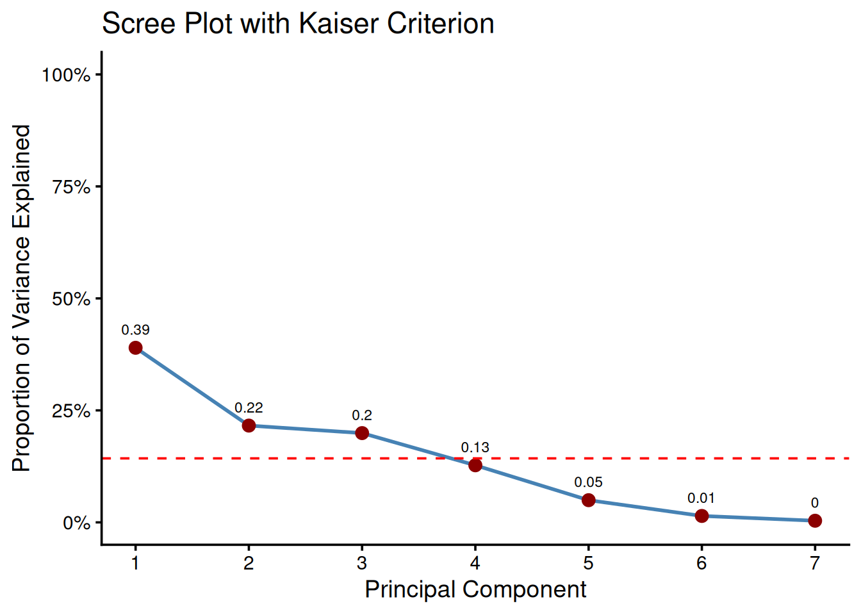
Figure 3 - Scree plot with a combination of the Kaiser Criteria

According to the first criterion (Kaiser’s Criterion), since there are three eigenvalues >1, we should retain 3 PCs. According to the second one (Scree Plot) present in Image 3, although the “main” elbow point suggests 2PCs, retaining only two components would explain a mere 60.6% of the total variance, discarding almost 40% of the information in the dataset. The inclusion of PC3 increases the Cumulative Variance (third criterion) explained to a much more acceptable 80.5%. This demonstrates that PC3 significantly describes our data. We therefore decided to proceed with a 3-component solution.

Interpreting the Principal Components

The retained principal components represent new, uncorrelated axes that capture the main directions of variation in the data. To interpret them and attribute a meaning, we used the variable loadings [2]. As we can see in Table 3, we have the loadings of the 3 PCs that we have selected.

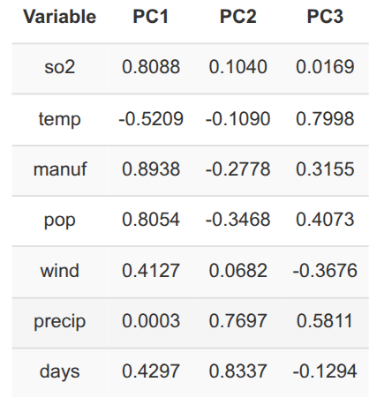
Table 3 - Loadings for the 3 principal components (PCA) selected that represent the dataset
In PC1, we can see variables that represent Industrial and Urban Scale. This component confirms the hypothesis that we have set in the previous section, in our preliminary analysis. We have 3 strong positive loadings for `manuf`, `pop`, and `SO2` with a value of 0.89, 0.81 and 0.81, respectively, showing that these three variables move together. This axis represents the primary source of variation in our dataset; it shows that there can be a significant difference between the large, dense industrial cities and the other, smaller, less industrial ones, since having a bigger population entails having more manufacturing industries.

PC2 can be described as the Precipitation Level. As described in Table 3, this is a pure climate component. It is defined by high positive loadings, like `days` and `precip` with a value of 0.83 and 0.77, respectively. These axes help us to distinguish between humid cities with many days of precipitation from dry and arid ones. Another important aspect of this component is its independence from the temperature due to the loading value of -0.109, which makes it almost negligible for this component.

Our last PC3 can be described as Temperature and Coastal Factor. In contrast with the PC2, this component is primarily a temperature axis, with a dominant positive loading for `temp` of 0.80. It also shows a moderate positive loading for `precip` of 0.58, which suggests that this component captures a different set of climate profiles than PC2 alone, and likely can help us to distinguish between hot and humid cities, typical of southern or coastal regions, from colder and drier ones, more related to the interior of the country.

Visualization PCA Biplot of US cities

PC1: Industrialization/Urbanization
PC2: Climate Gradient.
PC3: Temperature.
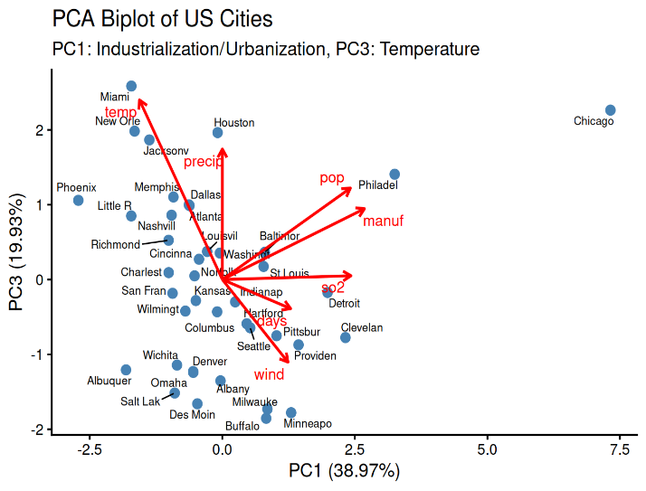
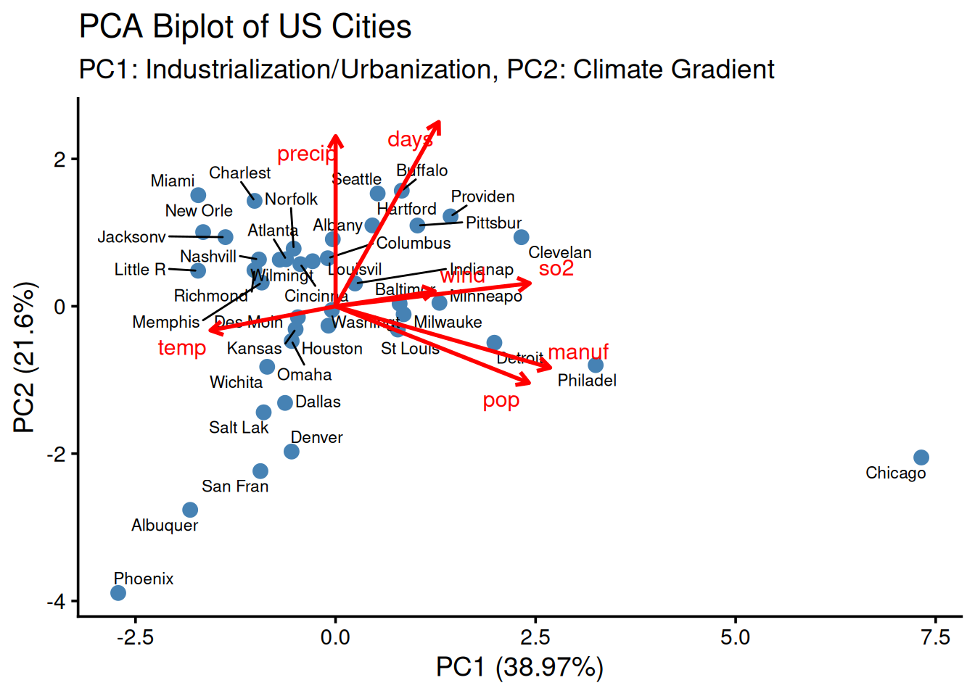
(a) (b)

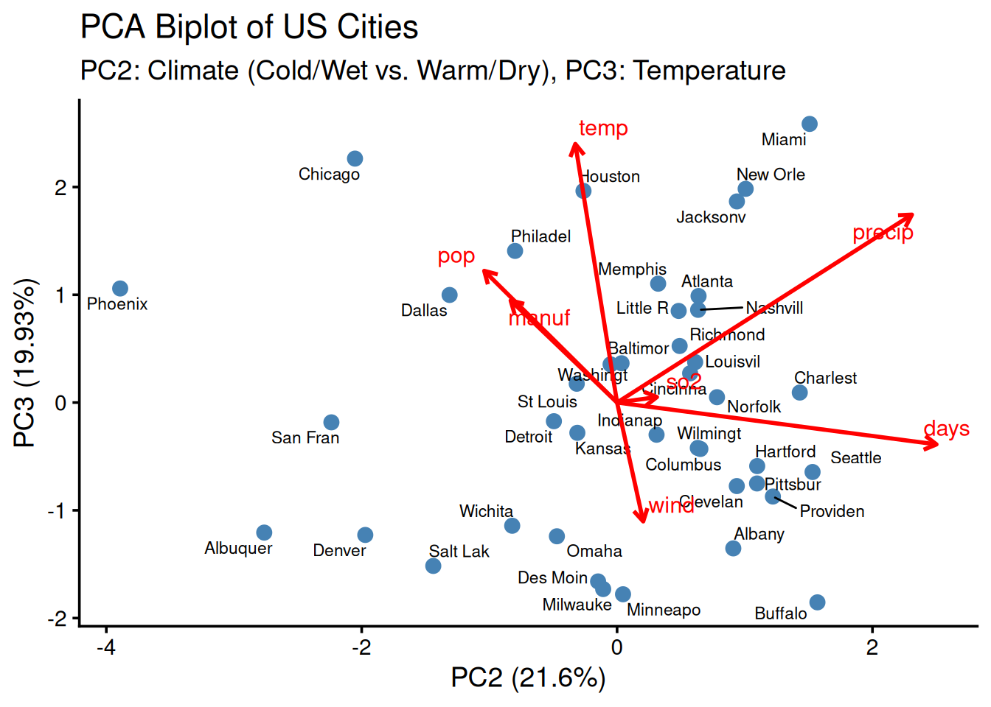
(c)

Figure 4 - shows three biplots (a) PC1 vs PC2 , (b) PC2 vs PC3 and (c) PC1 vs PC3 with variable loadings. Variable vectors originate at the origin; their direction indicates correlation with the components, and their length indicates the strength of the contribution. In panel (a) the small angle between `manuf` and `pop` confirms their strong positive correlation and their dominant contribution to PC1. Graphic (b) and (c) reveal additional structure: PC3 captures variance not visible in PC1–PC2 and clarifies relationships such as the (near) negative alignment of temp and wind

Interpreting the figures further:
Figure 4 (a) PC1 vs PC2, shows some outliers; there are some cities like Chicago, that in the x-axis have a value of 7.5 and that positions it as an outlier. In the context of our PC1, identified as Industrial and Urbanisation, Chicago was a big metropolitan area with an important industrial centre in 1970. Followed by Philadelphia as the second most important and industrial city, explained by the PC1. On the other hand, cities like Albuquerque, Phoenix, and San Francisco show a negative score regarding the PC1 and PC2, which means a low value in `pop`, `manuf` and `precip` and days respectively. This negative correlation means that in the 1970s these cities were less populated and smaller cities, with fewer industrial complexes and environmental impact.

Other important cities in this case for the PC2 were Miami, Charleston, Norfolk and Buffalo. Their score regarding the PC1 was negative, implying that these cities were less populated and with a low industrial complex. However, their high score in PC2 near 2 means a high value of `precip` and `days` in the 1970s.

Figure 4 (b) PC1 vs PC3 (Temperature), we have a positive score close to 3, for cities like Miami, being one of the main outliers for PC3. Followed by Chicago, New Orleans and Houston. Based on this, a high value in PC3 scores means high `temp` and `precip`. There is a notorious difference between the weather of Miami, New Orleans, Houston and Chicago; the difference in their climates makes it strange that all of them share a high score in the PC3 axis. It seems to be a contradiction that can be explained due to the fact of the other two more important variables of the PC3, which are `manuf` (0.32) and `pop` (0.41). Chicago is an outlier, as we saw in Image 4 (a), which means that it has a high population and more manufacturing industries. So it's a 'Hot, Wet, and Densely Populated' city.

Figure 4 (c) PC2 vs PC3. This graphic displays insightful information regarding the climate profiles of the cities, independent of dominant urban and industrial scale coming from PC1. Based on their climate alone, we found cities like Miami, New Orleans and Jackson in the 1970s were hot and wet cities, which makes sense, being Miami the city that presents higher scores, in PC2 and PC3, due to its tropical climate. And we can start to make some groups, like Hot & Wet (High PC3, High PC2).
Other important groups that we can make are Cold & Wet: (Low PC3, High PC2) and Cities like Buffalo and Albany. Another important group that we can form is Hot & Dry cities, which have High PC3, Low PC2. In this group, the most representative city is Phoenix. Nevertheless, the last group formed was Cold and Dry cities, with low PC2 and PC3. In this group, we have cities, like Albuquerque, Denver, Salt Lake City are more desert-like and very dry areas.

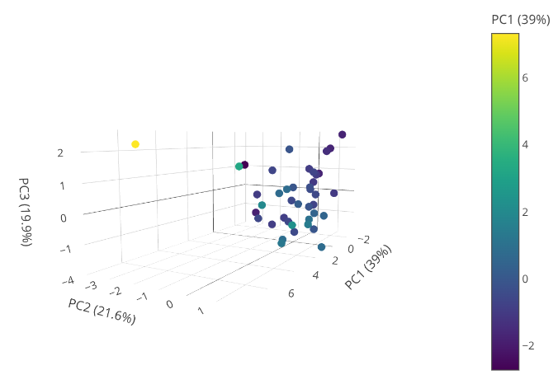
Figure 5 - 3D representation of the combination of our observations in the new coordinate axes PC1, PC2, and PC3

In Figure 5, we have a 3D view of our observations, in the three new axes PC1, PC2, and PC3. And summarize all that we have identified with our 3 principal components, and also how each component is affected by the 7 variables. With this information, we can start to make correlations or group cities based on the 3 pc scores, as we saw in Figure 4 (c). Because each observation has different characteristics, using the scores that adjust our observations to the new PC components axis will help us to group them and start to find patterns. Also, understanding the loadings, we identify some characteristics that will lead us to make new groups or clusters.

Concluding, for the cluster analysis, we can use the scores that we found for these three PCs, however we can also use the 7 variables. But the first option offers a more robust analysis because it already removed the noise associated with variables that are deeply correlated or that at the end will explain the same phenomena as `pop` and `manuf`, so grouping them will let us discover more data that can be jeopardized for these two variables. Another reason is that we can group and cluster the observations, using their weather, as we have two components that are strongly correlated with the climate changes of the observations. So using the scores, we can already start to separate the groups of variables, and with the loadings as we saw before the variables with a close angle between them tend to explain the same phenomena. But we will experiment with both approaches -the 7 variables and the pca scores- to verify which the best one is.

Comprehensive and Comparative Cluster Analysis

In this section, we aim to develop a rigorous, multi-stage comparison of clustering methodologies to identify the most robust and interpretable grouping of the 41 US cities. Our goal is not just to apply a single method, but to understand and justify our choices at each step.

Methodological Framework

The process of clustering involves several key decisions. We systematically explored and compare the following:

- Input Data: We will compare results from clustering on the original 7 standardized variables versus the 3 decorrelated PC scores. This will test our hypothesis that PCA-based clustering yields superior results by reducing noise and handling multicollinearity.
- Distance Metric: We will briefly discuss the choice of distance metric used to quantify dissimilarities between cities.
- Clustering Algorithm: We will compare 3 different linkage criteria (Ward, Complete, Single) to explore Hierarchical Clustering to understand how the definition of "cluster distance" impacts the results.

This framework allowed us to select a final, optimal combination of input data and algorithm, justified by both theory and empirical results.

Hierarchical Clustering Exploration

Hierarchical clustering builds a nested hierarchy of clusters, visualized as a dendogram. The structure of this tree is highly dependent on the chosen distance metric and linkage criterion; it is a tree-like structure that captures the relationships among all data points in the system [5]. There is the advantage of not needing to specify a predefined number of clusters. The generated dendogram can have a horizontal cut through the structure that defines individual clusters at the highest level in the system, as shown in Figure [6]. Each resulting child branch below this cut represents a distinct cluster.

Distance Metric

Distance Metric for PCA
The first step is to calculate a distance matrix between all pairs of cities. Given our continuous, standardized variables, the Euclidean Distance is the most common and intuitive choice, representing the straight-line distance between two points in n-dimensional space.

Distance Metric for Original Variables
In order to find the optimal distance between our original 7 variables and observations, we will use the Euclidean distance for the reasons mentioned before; however, in this case, we will need to perform a data standardization, because our variables are in different units.

We decided to use the two types of data (pca scores and original variables) so we can compare clustering with (Euclidean on Raw Standardized Data) vs. (Euclidean on PC Scores). Adding up to this, we explicitly acknowledge the limitations of the Euclidean distance for the dataset provided, as there are some variables that show strong correlation, as is shown in the Pair Plot, like `manuf` and `pop`. However, using it allows for a direct comparison that will help us to confirm the superiority of the PCA-based method

Nevertheless, the usage of other distances like Mahalanobis, which uses the covariance matrix as the core of its calculation to correct these problems, is notoriously sensitive to outliers. Extreme observations like Chicago or Phoenix will affect the calculation. For this reason, we will discard it and we will move forward with the Euclidean Distance for standardised data.

Linkage Criteria Comparison

The linkage criterion defines how the distance between clusters is measured. We will compare the three methods, both using the raw data and the PCA scores, to see how each technique "builds" the hierarchy.

Linkage Criteria on Raw data scores and PCA scores

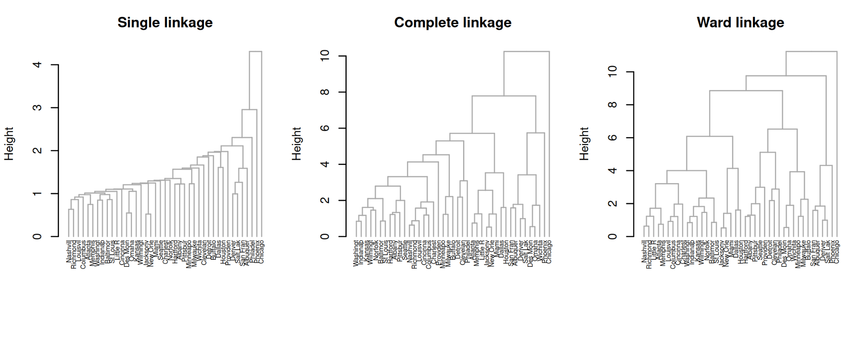
(a)
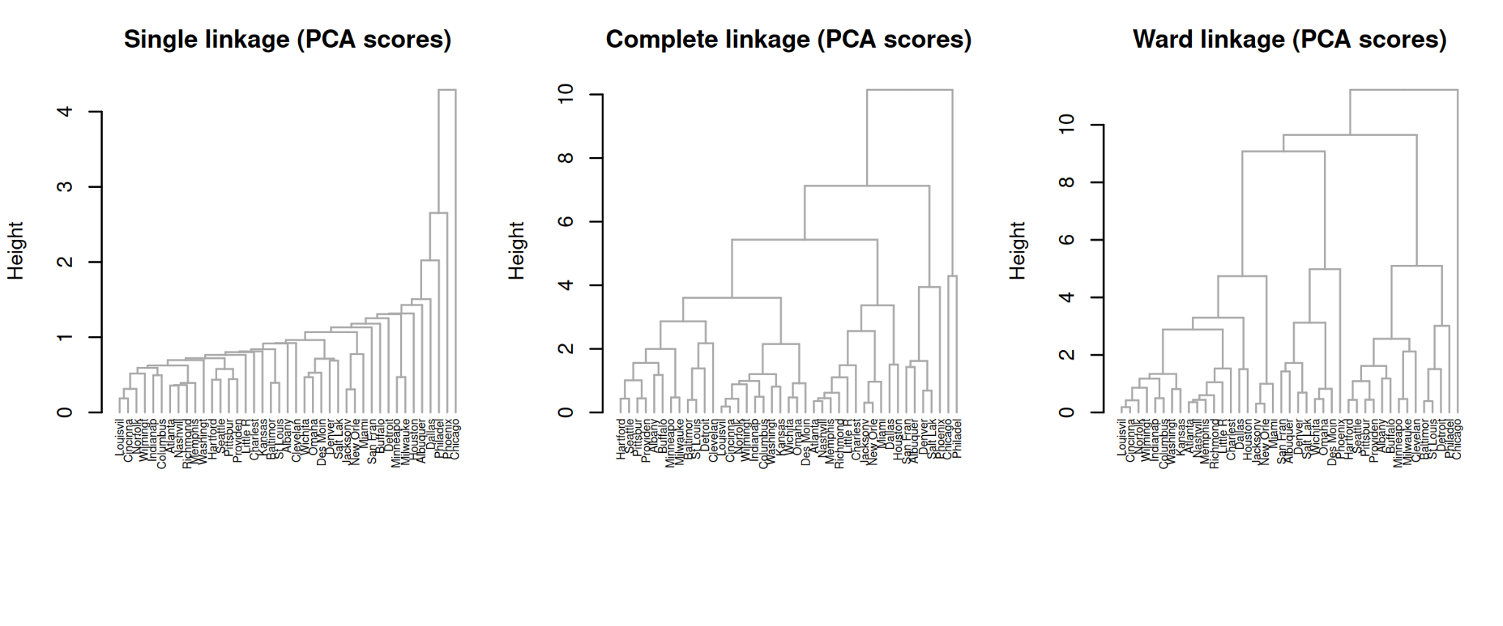
(b)

Figure 6 - This figure displays the dendograms of different linkage methods. We can see the use of Single Linkage, Complete Linkage and Ward. (a) The dataset used to build this dendogram was the standardized raw variables, using the Euclidean distance. On the other hand, part (b) shows the use of the PCA scores to build the dendograms.

To analyze Figure 6 and select the best linkage method, we can use different metrics; the most important in this case were the Agglomerative coefficient (AC) and the Cophenetic Correlation Coefficient (CCC), both measure different things and can provide useful information about each method. The AC measures clustering structure produced for each clustering method, meaning the stronger clustering when its value gets closer to 1. On the other hand, the CCC measures how accurately a hierarchical clustering dendogram preserves the original distance between data points [7].

As we can see in Table 4a and 4b, we summarize the values of the AC and the CCC for the raw variables and the pca scores.
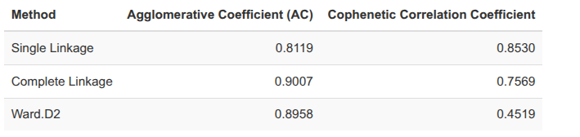

(a)
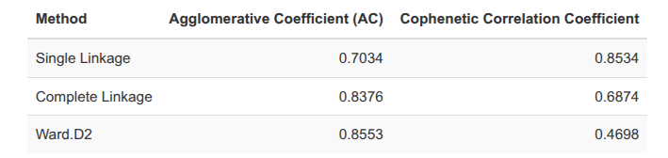
(b)

Table 4 - Summary of the Agglomerative Coefficient (AC), which measures the strength of the clustering structure, and the Cophenetic Correlation Coefficient (CCC), which measures how well the dendogram preserves the original pairwise distances, respectively.

Based on a visual inspection of the dendograms of Figure 6, and a quantitative analysis of the metrics in Table 4, Complete Linkage is selected as the Best Linkage method for both the naive and robust approaches.

The decision is the result of a trade-off analysis. Single Linkage, while exhibiting the highest Cophenetic Correlation Coefficient (0.8534), was discarded. Visually, it produces a heavily "chained" and uninterpretable structure, likely by following the path of least resistance along the strong `pop`/`manuf` correlation. Its lower Agglomerative Coefficient (0.7034) confirms it fails to find a strong clustering structure. Ward's method, conversely, produces a visually clean cluster (figure 6) and has high Agglomerative Coefficients (0.8553 and 0.8530) for raw data and PCA scores, respectively. However, this is achieved at the cost of a significantly lower Cophenetic Correlation (0.4698) and (0.4519) for raw data and PCA scores, respectively, indicating that the dendrogram is a poor, distorted representation of the true pairwise distances.

Complete Linkage, therefore, offers the best balance. It achieves a high Agglomerative Coefficient in both cases, raw data and PCA scores (0.8376–0.9007), comparable to or even exceeding Ward's method, while maintaining a much higher Cophenetic Correlation. It successfully identifies a strong, compact clustering structure without excessively distorting the underlying data, making it the most reliable and defensible choice.

Determining the Optimal Number of Clusters (k)

After selecting the best linkage criterion, the Complete Method, for both approaches, we now proceed to determine the optimal number of clusters, `k`, for this specific method, with the estimation methods Elbow Method, Gap Statistics and Silhouette Method. While visual inspection of the dendogram can be suggestive, we used robust quantitative methods to make a better choice. We used the Average Silhouette, however we also calculated the `k` with the Elbow method, and the Gap Statistic on the results obtained before (although we reached the conclusion that they were not that adequate for this specific project).

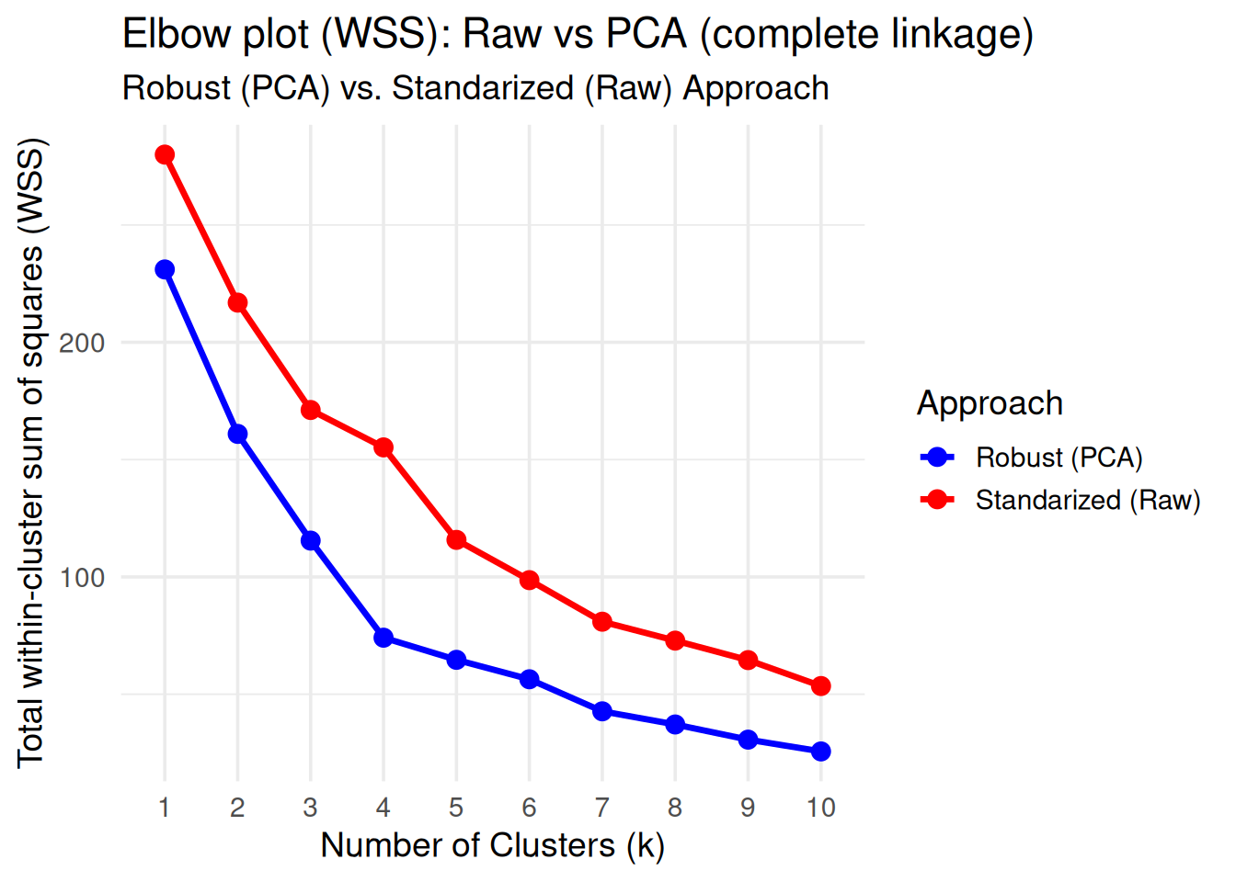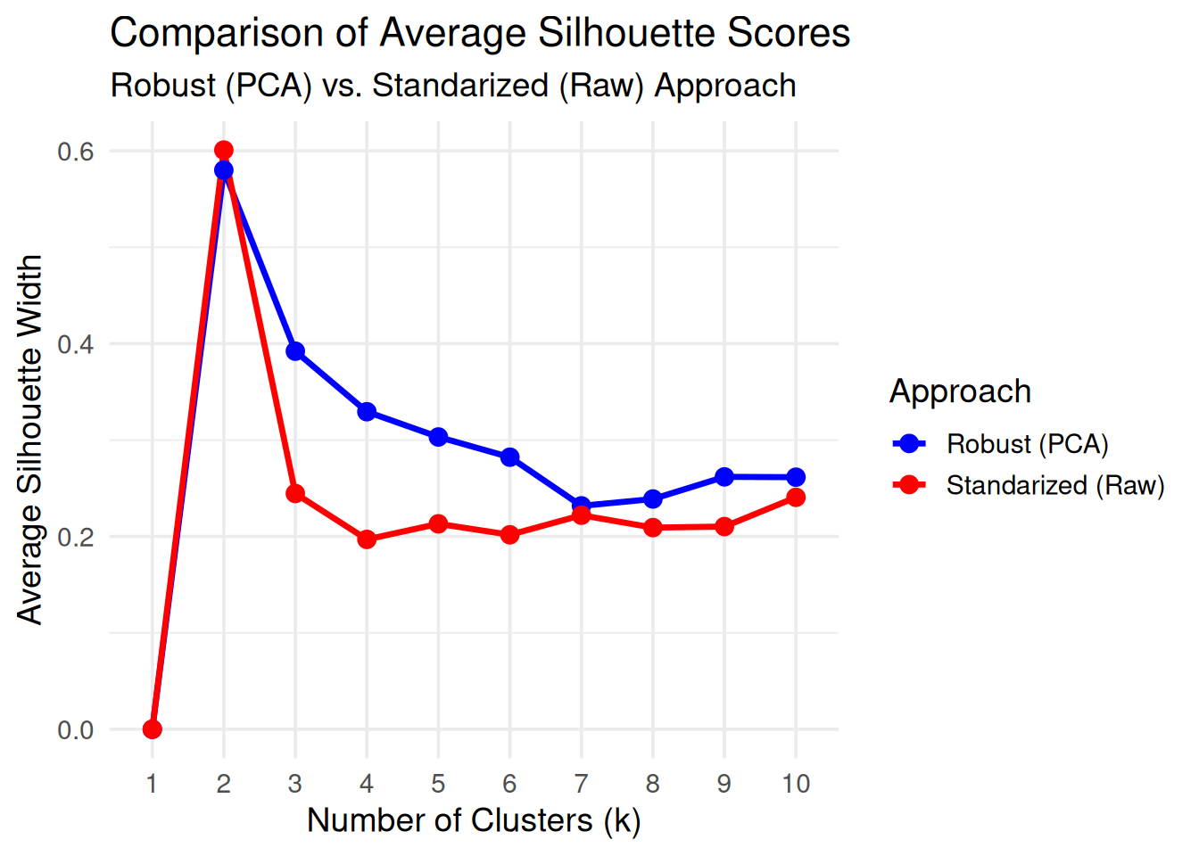
Figure 7 – Graphics to determine the optimal number of clusters in both raw data as well as pca scores
(Note: The gap statistic graphic is only on the RMarkdown file as Additional Graphics).

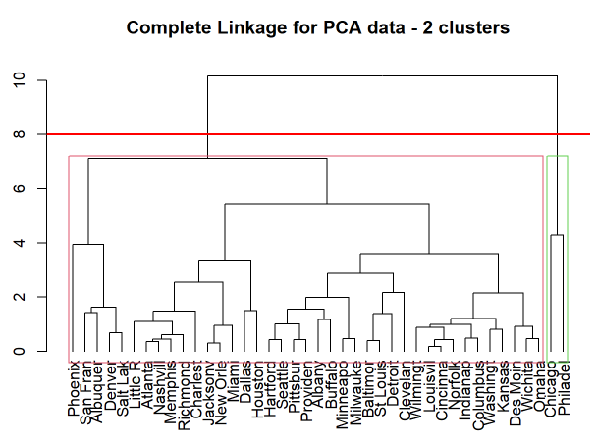
As we can see using the figure x, the three methods for determining the optimal number of clusters provide conflicting initial results. The Elbow Method is ambiguous, suggesting either 2 or 3 clusters. The Average Silhouette Method, which prioritizes clean separation, peaks at `k=2`. In contrast, the Gap Statistic, which is the most statistically robust of the three methods, clearly identifies an optimal structure at `k=1`. This disagreement is itself insightful. It suggests that the data has a primary split into two major groups (hence the `k=2` result from the Silhouette Method).
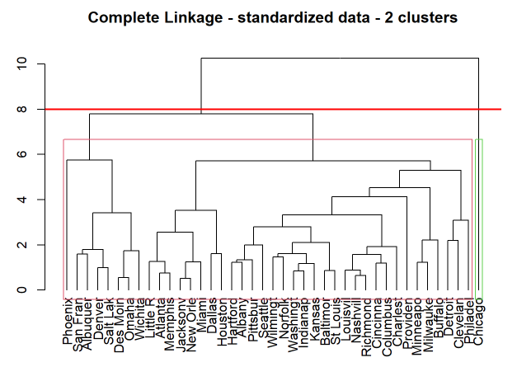
Figure 8 – Dendograms done for the Complete Linkage Method with 2 clusters, the left one with original data and the right one with PCA Scores

Moreover, to better visualize the clusters, we can get these two graphics:
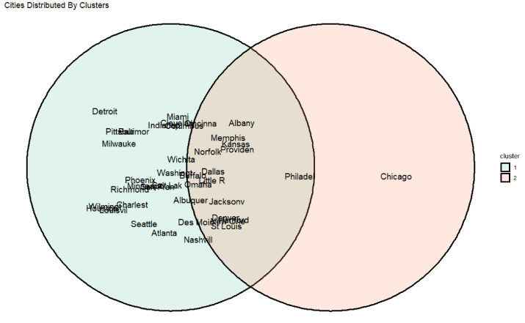
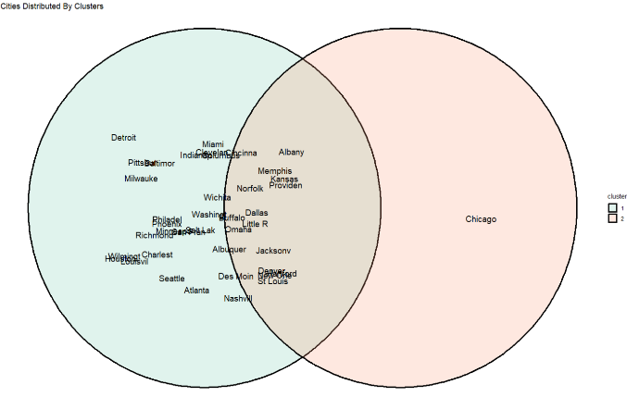
Figure 9 – Graphics done for the Complete Linkage Method with 2 clusters, the left one with original data and the right one with PCA Scores

That’s why we decided to go with 2 clusters, like the Silhouette Method advised.

Conclusion

As mentioned before, the dataset used to do our statistical analysis consisted of data related to environmental, demographic and industrial variables, for 41 US cities in 1970. In order to understand better the relationship between these variables, we performed a PCA Analysis as well as a Cluster Analysis.

In the PCA Analysis performed, we retained 3 principal components - PC1 ( that represented `manuf`, `pop` and `SO2`), PC2 (that represented `days` and `precip`) and PC3 (that represented `temp`). Comparing the principal components we were able to conclude that some cities were considered outliers - Chicago was a common outlier we could observe in some of the plot representations.

The Cluster Analysis using hierarchical clustering was performed for both initial data and PCA data obtained before. By calculating both the Agglomerative Coefficient and the Cophenetic Correlation Coefficient and observing the dendograms, we concluded that the Complete Linkage was the most adequate linkage method for our data types. After understanding this, we determined that the optimal number of clusters (k) in our case would be 2 clusters. This was decided using the average Silhouette Scores. We ended up deciding to use this method instead of the others we tried because of several reasons: the Elbow Point Method is the less reliable method, because it depends on our observation (ambiguous) and the Gap Statistics Method, although more efficient, it showed that, in our case, the cities in the dendrogram would be clustered only in one group (optimal number of clusters, k=1). Because of this, our group reached the conclusion that it would be better to use the Silhouette method.

Looking at the clustering results and to the PCA analysis, we can reach some conclusions:
- Chicago consistently emerged as the most atypical city in the dataset. In the cluster analysis with original data, it formed a cluster by itself, indicating that no other city shared a similar combination of high pollution, large population, strong industrial activity and climatic conditions.
- On another hand, Chicago and Philadelphia stood out together when analysing the clusters with PCA Scores. In the PC1-PC2 biplot, both cities appeared as clear outliers due to their exceptionally high values of population and manufacturing industries, reflecting their status as the major industrial centers in the 70s.

- Across other PCA dimensions, Chicago continues to behave as an outlier. high temperature, population and manufacturing industries values, reinforcing the idea that it had a unique profile compared with the rest of the cities.

- Summing this part up, PCA and Clustering confirm clear separation between highly industrialized and urbanization. Their repeated appearance as outliers reinforces how dominant their population size and manufacturing power were compared to the rest of the country. By contrast, cities (like Albuquerque, Phoenix and San Francisco) with lower population activity, fewer industries and drier climates (with lower levels of precipitation) tend to cluster together.
- The PCA Analysis demonstrates that variability in SO2 levels is tied to multiple factors, for example, industrial activity and population size (represented by PC1) shape the environmental profile of the cities, making the air pollution as worse as the size of the population and the level of industrial activity in the area.

- In terms climate-related patterns that are only visible in the biplot from PC2 and PC3, the cities get separated into four climatic groups:
  - Hot & Wet cities: Miami, New Orleans and Jackson - all showing high precipitation and high temperatures
  - Cold & Wet cities: Buffalo and Albany - showing low temperatures but high precipitation
  - Hot & Dry cities: in this case, Phoenix stands out strongly here
  - Cold & Dry cities: Albuquerque, Denver and Salt Lake City - various cities that are dry, more continental (not close to a large body of water) and desert climates

Taking everything into consideration, in conclusion, the results that the group obtained show that air pollution levels cannot be explained by a single variable. Instead, the mix of variables plus their interactions were therefore essential to uncover the complex structure underlying the dataset and to reveal how cities differed from one another across multiple dimensions.

References

Our whole project is on GitHub as a way to maintain it updated between all the members of the group: https://github.com/martinzx13/pca_analysis/tree/main/Multivariate_Data_Analysis_Project. The correct RMarkdown file is Code_Project.Rmd

To help us interpret the results of the project, we used these websites and references:

- https://www.sciencedirect.com/science/article/pii/S0019452225005461#fig3
- https://www.sciencedirect.com/science/article/pii/S0883292724001355#bib59
- Hoekman, S. K., Welstand, J. S., Hoekman, S. K., & Welstand, J. S. (2021). Vehicle Emissions and Air Quality: The Early Years (1940s–1950s). Atmosphere 2021, Vol. 12, 12(10). https://doi.org/10.3390/ATMOS12101354
- Stern, A. C., & Professor, E. (1982). History of Air Pollution Legislation in the United States. Journal of the Air Pollution Control Association, 32(1), 44–61. https://doi.org/10.1080/00022470.1982.10465369;WGROUP:STRING:PUBLICATION
- Yin, H., Aryani, A., Petrie, S., Nambissan, A., Astudillo, A., & Cao, S. (2024). A rapid review of clustering algorithms. arXiv preprint arXiv:2401.07389. Recover by: https://arxiv.org/pdf/2401.07389
- https://www.sciencedirect.com/science/article/pii/S0048969712009850?casa_token=TGUMBHfIAi8AAAAA:0TpfkiDULqsxoOqj3aqDIwzsbUGcIXZCOOucLv2NXbXsXmc1YJ1QgnIJD_l7ZJyjzf83cr1O2g
- Saraçli, S., Doǧan, N., & Doǧan, I. (2013). Comparison of hierarchical cluster analysis methods by cophenetic correlation. Journal of Inequalities and Applications 2013 2013:1, 2013(1), 203-. https://doi.org/10.1186/1029-242X-2013-203

