## Part 1

1. John copies Mary’s homework.
   1. Confidentiality – Mary should not share her homework to be copied.
   2. Prevent – Set permissions on who can read files.
2. Paul crashes Linda’s system.
   1. Availability – John is making Linda’s system unavailable.
   2. Prevent – Isolate user instances so that another user may not modify another user’s system. Provide redundancy for users to make system more robust.
3. Carol changes the amount of Angelo’s check from $100 to $1000.
   1. Integrity – Carol is compromising the amount of money on Angelo’s check.
   2. Detect – Create usernames and track who reads/writes files so that if an amount is modified where it shouldn’t be, the person who modified it may be punished.
4. Gina forges Roger’s signature on a deed.
   1. Integrity – Gina is falsifying Roger’s signature and his approval of a deed.
   2. Prevent – Ask for ID when a signature is provided to ensure person who allegedly signs is aware.
5. Rhonda deletes all web services from university’s web servers.
   1. Availability – Rhonda is making all web services unavailable
   2. Prevent – Do not allow normal users to delete vital system files. Require login w/ tracked usernames.
6. Henry spoofs Julie’s IP address to gain access to her computer.
   1. Integrity – Henry is gaining unauthorized control of Julie’s system.
   2. Prevent – Require usernames and passwords to log in instead of an easily spoofed IP address.

## Part 2

1. From PC to Internet, whole packet  
   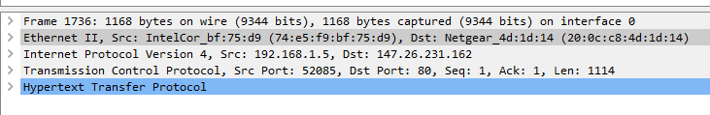

From Internet to PC, whole packet

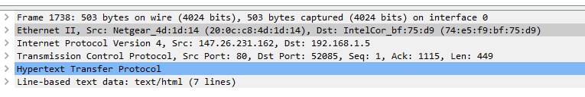

1. MAC from SRC & DEST: From my computer: **SRC:** 74:E5:F9:BF:75:D9 **DST:** 20:0C:C8:4D:1D:14
2. IP: **SRC:** 192.168.1.5 **DST:** 147.26.231.162
3. TCP: **SRC:** 52085 **DST:** 80
4. **Request:** GET HTTP **Response:** HTTP Found
   1. From PC
   2. From Web

## Part 3

1. 147.26.156.12
2. http://fuxi.cs.txstate.edu/~download/tools/  
   http://fuxi.cs.txstate.edu/~download/tools/Kali.vbox/  
   http://fuxi.cs.txstate.edu/~download/tools/Kali.vbox/readme.txt  
   <http://fedoraproject.org/static/hotspot.txt>
3. **Text from CS Website**

=== How to install ===\n

\n

Download all files into a folder.\n

Edit installvboxtoall.sh to set users at the top.\n

Run ./installvboxtoall.sh as root in this folder.\n

\n

=== About this VM ===\n

\n

root:toor\n

\n

Need to configure its static IP. It uses DHCP right now.\n

\n

Start metasploit framework by clicking the MF icon on the left pannel.\n

**Text from fedoraproject.org**

OK

## Part 4

1. Ports open for services  
   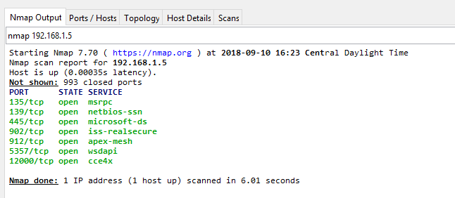
2. 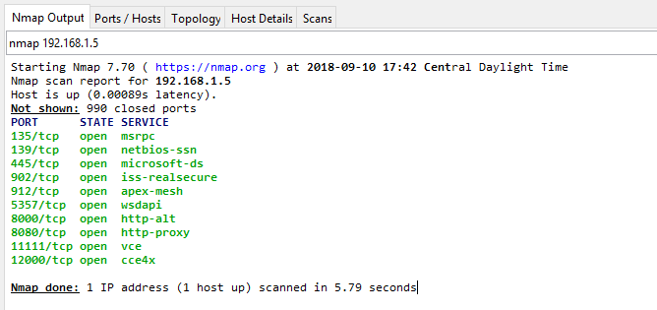

## Part 5