1. PT: WHEN IN THE COURES OF HUMAN EVENTS  
   Key = 3
2. Because either key can be trivially derived from the other.

((35^7)mod83)*11)mod83  
  
**import** java.util.Scanner;

**import** java.lang.Math;

**public** **class** ModularExponentiator {

**public** **static** **void** main() {

Scanner reader = **new** Scanner(System.in);

System.out.println("Enter x: ");

System.out.println("Enter y: ");

System.out.println("Enter n: ");

**int** x = reader.nextInt();

**int** y = reader.nextInt();

**int** n = reader.nextInt();

**int** i = 0;

**for** (i = 2; i < y; i++) {

**if** (y % i == 0)

**break**;

}

**if** (i == 0)

System.out.println("Cannot be reduced");

**else** {

**int** j = (y/i);

**int** sol = (**int**)

(((Math.pow((**double**)x, (**double**)i))%n) * j)%n;

System.out.println("Answer: " + sol);

}

}

}

43

1. No, certain combinations can result in the same result. Eg. In: 1111 Hash: 0000 = 1111  
   It would also be prone to collisions.
2. b197 d3af e713 8165 82ee 988b 276f 6358 00f7 28f1 18f5 125d e1c7 c1e5 7f27 3835 1de8 ac64 3c11 8a54 80f8 67b6 d875 6021 9118 18e4 7095 2bd0 a526 2ed8 6b4f c4c2 b796 2cd1 97a8 bd8d 8ae3 f821 ad71 2a42 285d b67c 8598 3581 c4c3 9f80 dbb2 1bf7 00db d2ae 9709 f7e3 0776 9b5c 0e62 4b66 1441 c1dd b62e f1fe 7684 bbe6 1d8a 19e7
3. **P35 = 17963604736595708916714953362445519  
   P35 = 20016431322579245244930631426505729**
4. 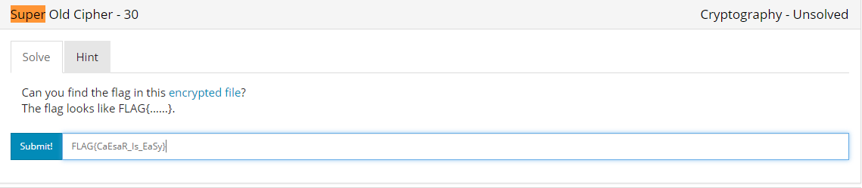
5. 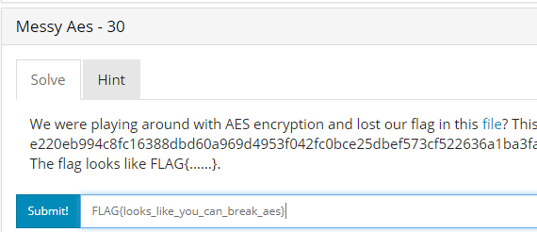
6. 