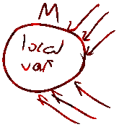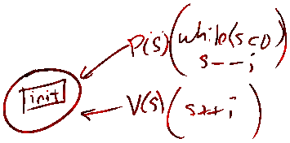Semaphore Monitor





May get barrier and dependency problems for programming. No classical problems.

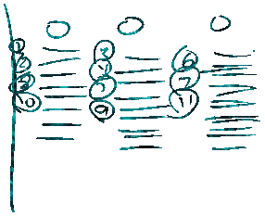



Fork



Scheduling – Preemption etc.



Redirection