User Manual

The following program is a Single Cycle simulator using MIPS. The program supports the following instructions in MIPS J,BEQ, ADD, ADDI, SUB,SW, LW ,SLL, SRL, MUL, AND, OR NOP.

Getting started

* When executing the program, the Sincy Control Panel and an enter instruction window

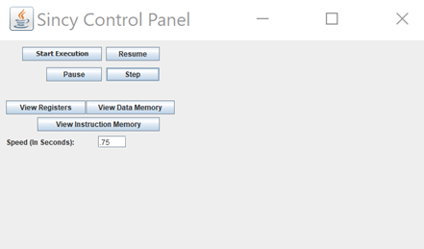 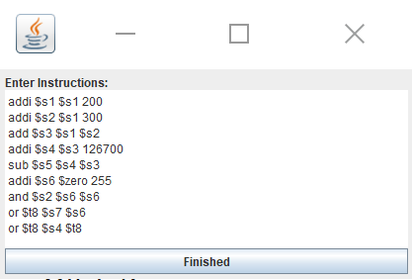

To start execution enter a valid MIPS instruction into the “Enter Instruction” window

 Click Finished when done with putting in the instruction.

To view the register and memory components

click to open the register

The window below opens when pressing “view registers”

Which displays the register in binary, register name, data in

Binary and data in decimal value.

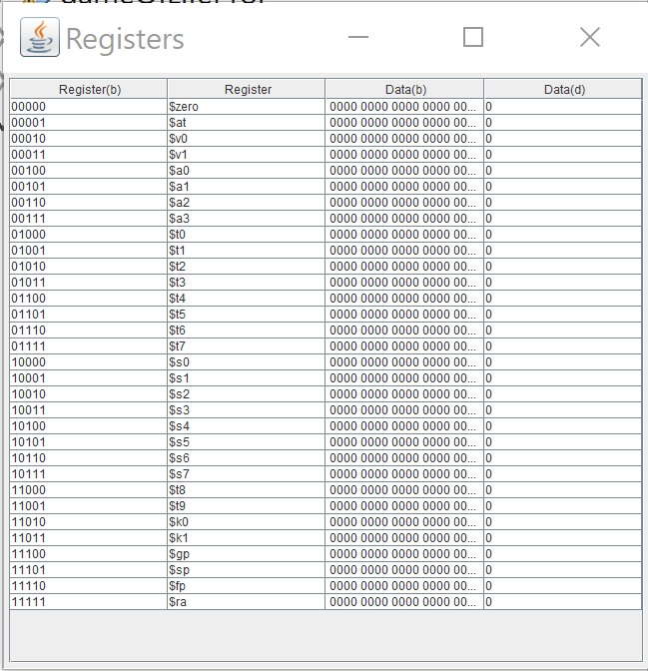

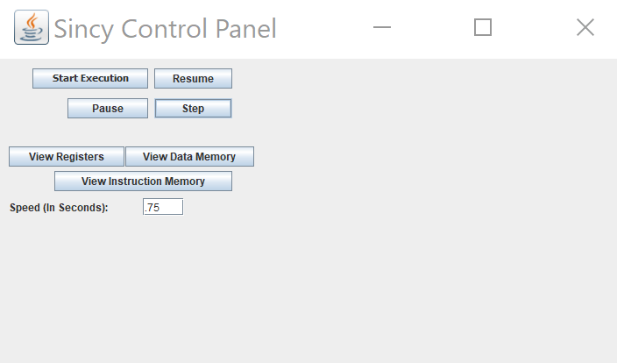

Allows the user to increment or decrement

the speed in seconds, that the register and memory move trough the program.

to Open Data Memory

The below window is the Dataa memory window that

Shows the adress and value in memory

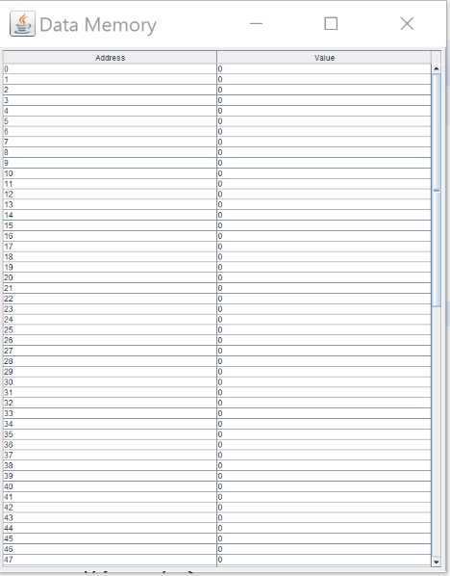



Opens Instruction Memory Window which shows the Address, instruction and Binary Value.

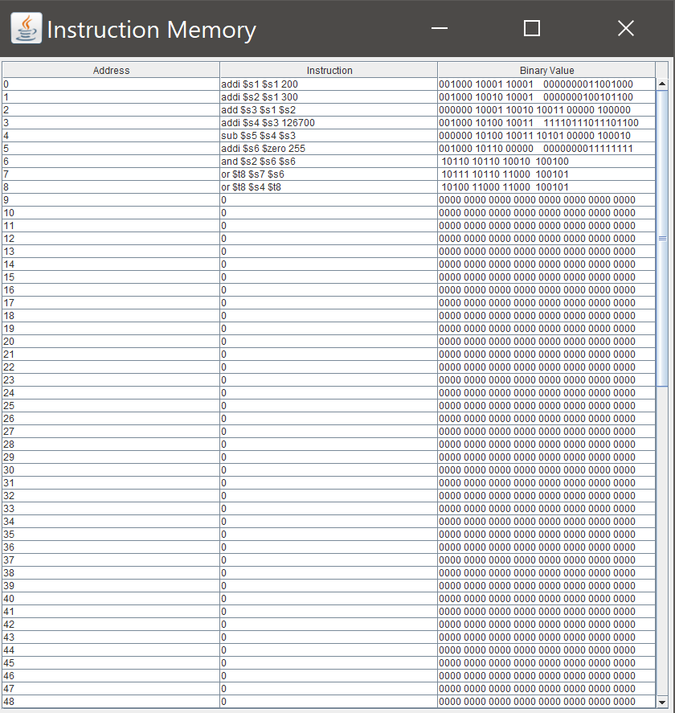



The following buttonns allow the user to control the execution of the program.

“Strat Execution” – starts the execution of the program.

If the use is runing trough the program step by step the “pause” button will allow the user to stop at the desired memory or register.

“resume” will allow the user to continue the execution.

“Step” button giges the user the control of stepping trough the execution step by step at their own pase.