
ENROLLMENT SUMMER A & C 2011
FACT SHEET 2010-2011 Academic Year, Issue 3
Office of Institutional Research http://irweb.erau.edu Daytona Beach, FL 32114-3900 (386) 226-6225

This fact sheet presents unduplicated headcount figures (each student counted once, even if concurrently in an undergraduate and graduate program, or both the A and C terms). Compared to last summer, enrollment has changed as follows: Daytona Beach undergraduates increased 2.9% (from 1472 to 1514); Daytona Beach graduate students increased 3% (from 266 to 274); Prescott undergraduates increased 30% (from 423 to 550); Prescott graduate students decreased 31.3% (from 16 to 11).
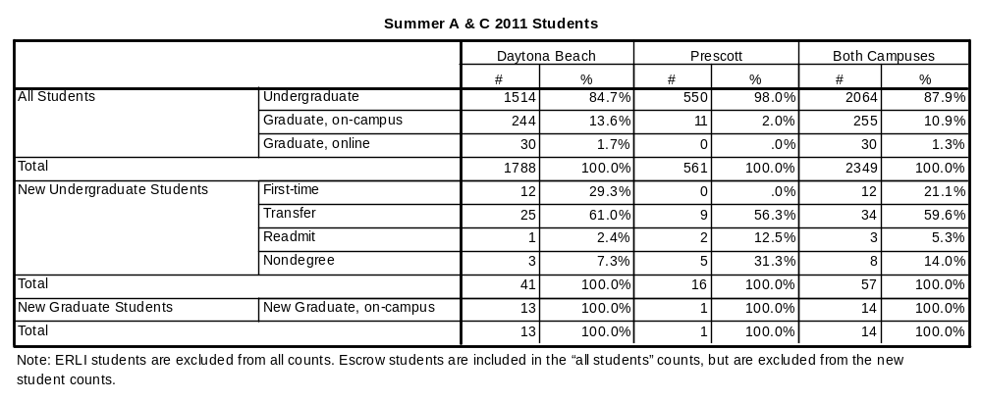

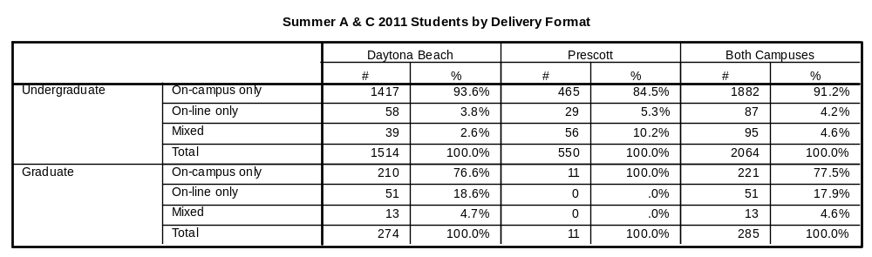

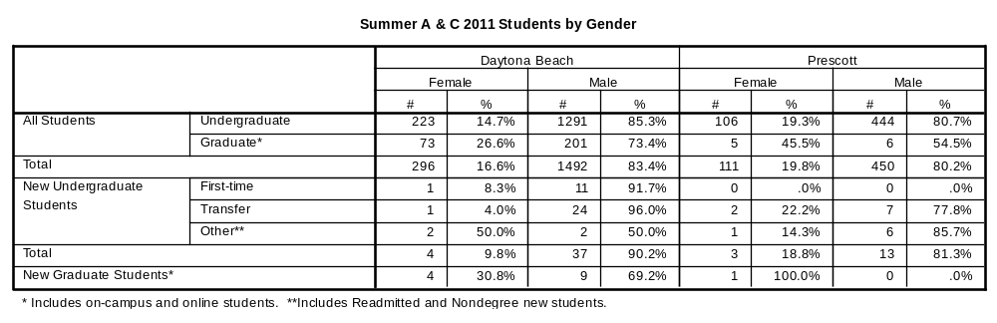

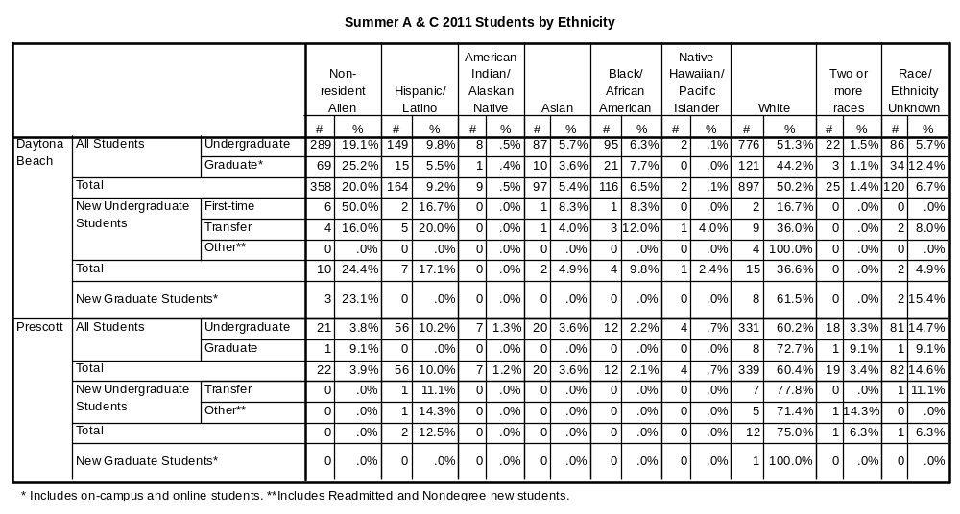

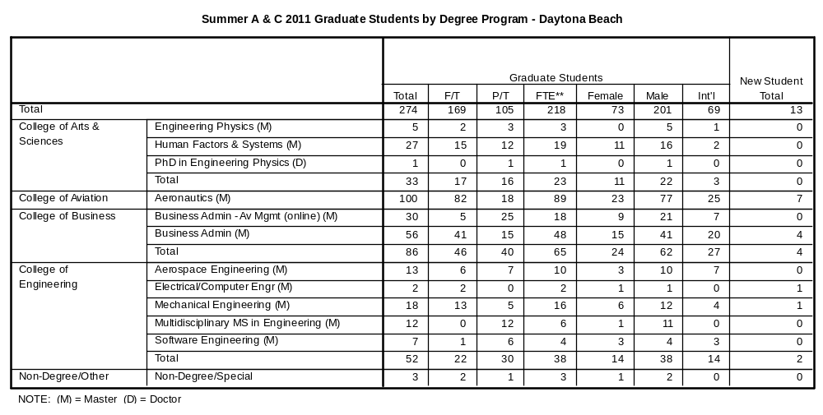

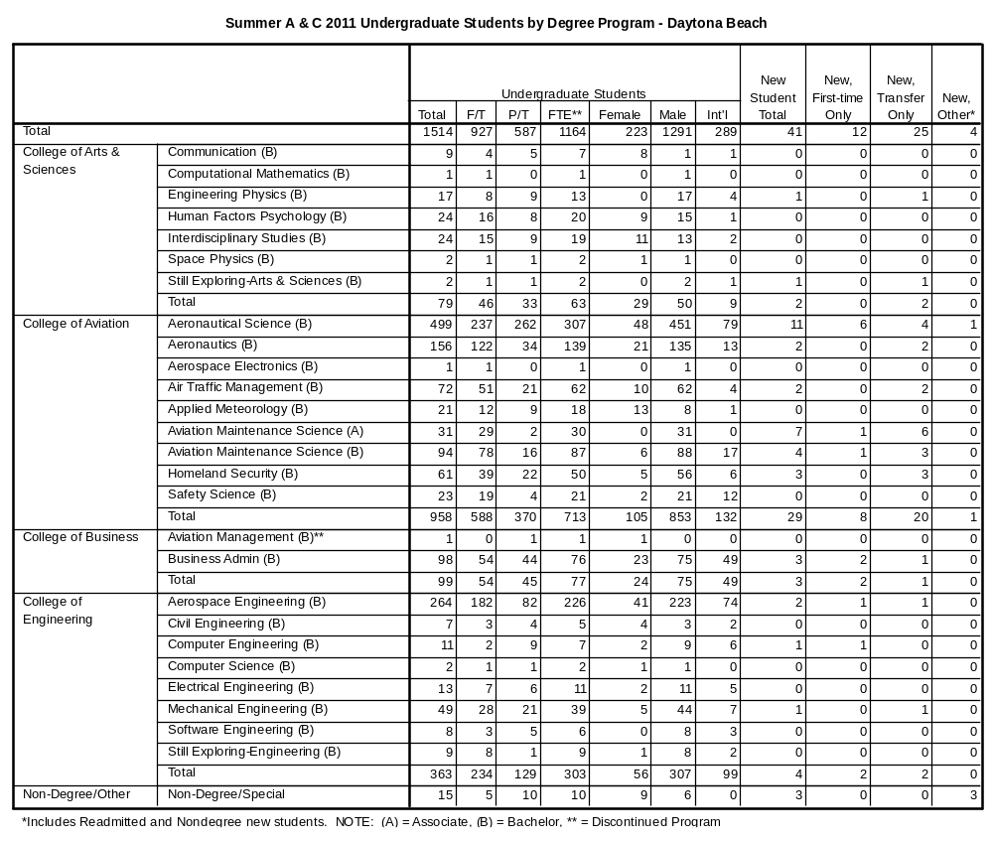

**Definition of full-time and full-time equivalent (FTE): Undergraduate students must be enrolled for a minimum credit load of 6 hours for full-time status during each summer term. Graduate students must be enrolled for at least 3 hours in Summer A or at least 6 hours in Summer C to be considered full-time. FTE is calculated by adding up the total number of hours for part-time students, dividing that sum by the standard definition of full-time status (3 or 6 hours, depending on the term and program level), then adding the result to the total number of full-time students.

(Prescott Summer A & C 2011 Undergraduate & Graduate tables – on next page)

