
ENROLLMENT SPRING 2011
FACT SHEET 2010-2011 Academic Year, Issue 2
Office of Institutional Research http://irweb.erau.edu Daytona Beach, FL 32114-3900 (386) 226-6225

Overall figures for unduplicated headcount are presented in this fact sheet. Each student is counted only once, even if concurrently enrolled in both an undergraduate and graduate program. Since Spring 2010, Daytona Beach’s new undergraduate enrollment has increased by 10.5% (from 191 to 211), while overall undergraduates increased .5% (from 4127 to 4149). Prescott’s new undergraduate enrollment has increased by 11.5% (from 52 to 58), while overall undergraduates increased 2.1% (from 1498 to 1530). The graduate enrollment at Daytona Beach has increased by 17.3% (from 498 to 584), while Prescott’s graduate enrollment shows an increase of 8.9% (from 45 to 49).
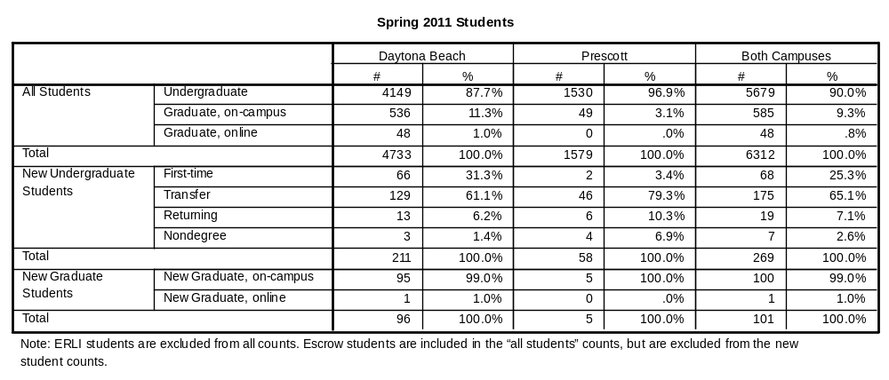

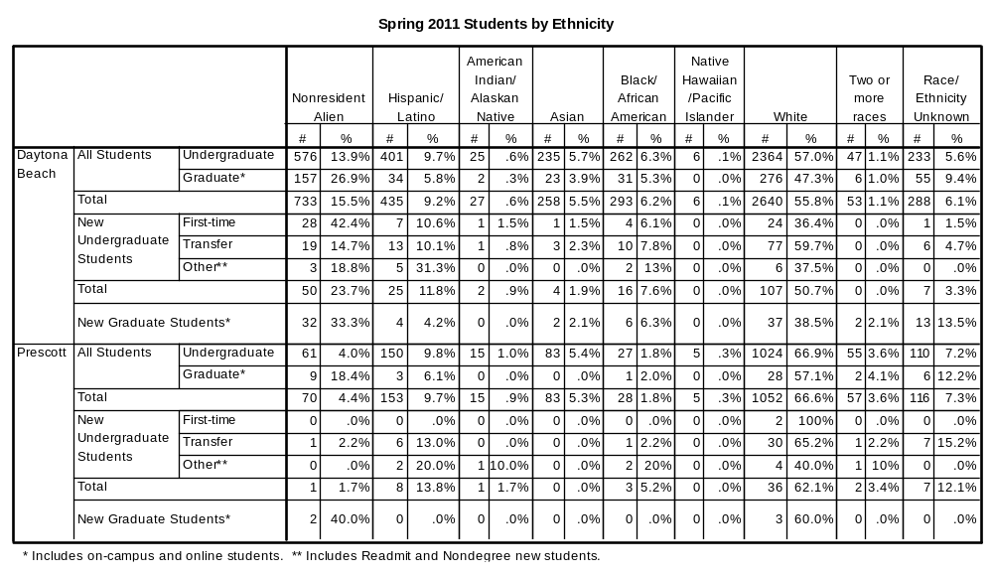

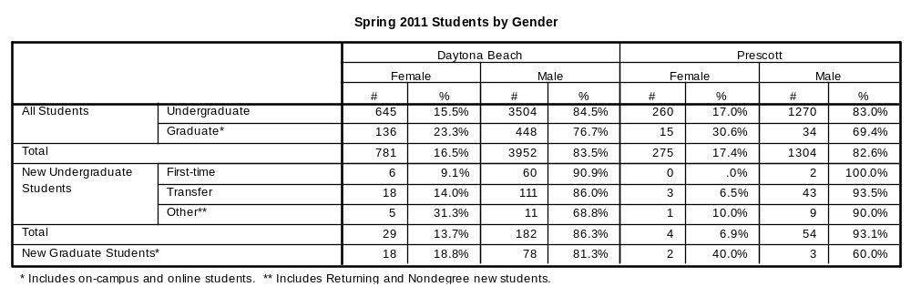

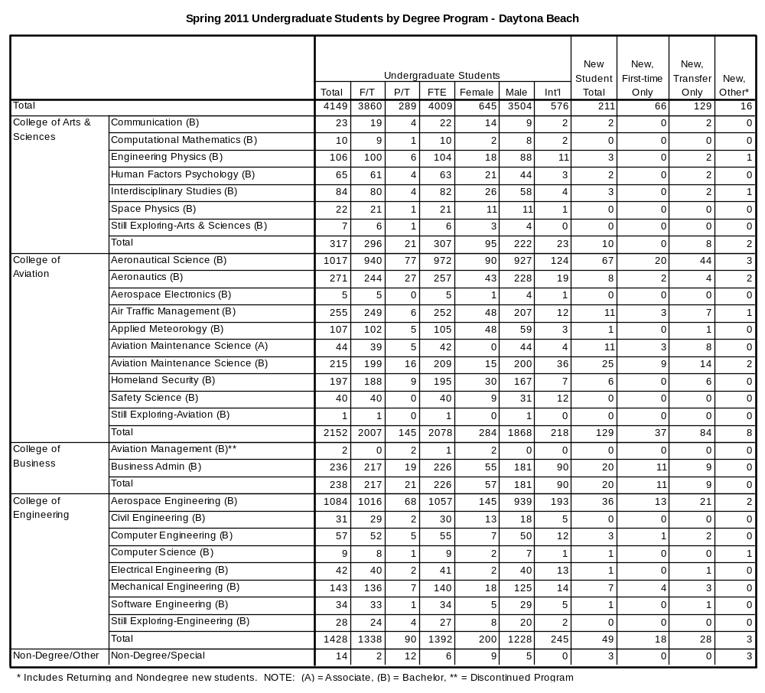

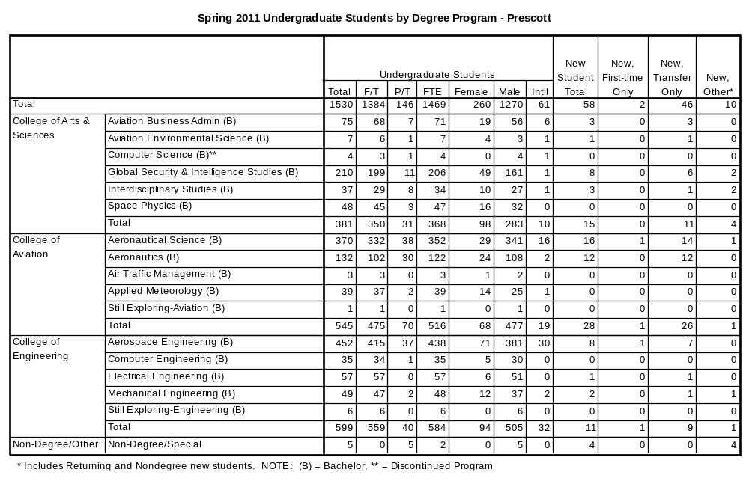
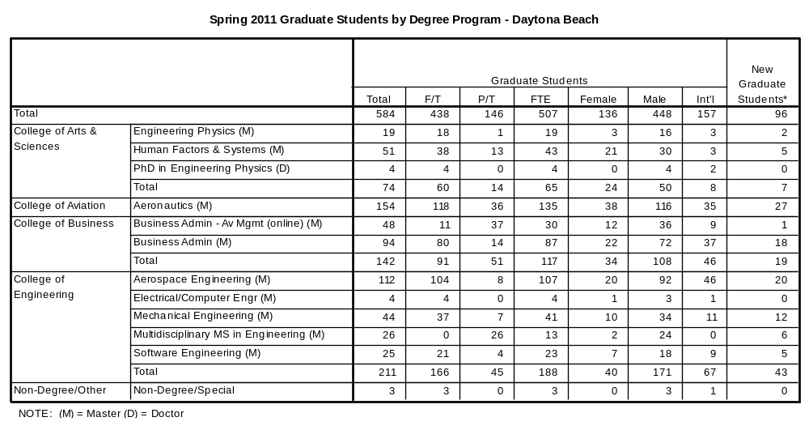
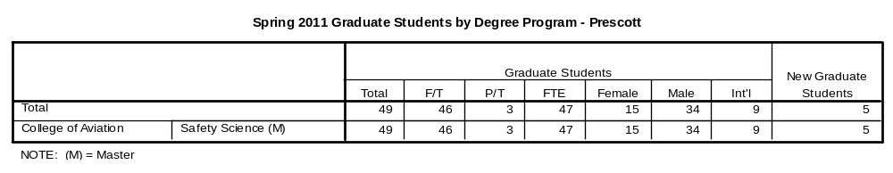

The remaining tables describe first-time college students only.

