
ENROLLMENT SUMMER A & C 2010
FACT SHEET 2009-2010 Academic Year, Issue 3
Office of Institutional Research http://irweb.erau.edu Daytona Beach, FL 32114-3900 (386) 226-6225

This fact sheet presents unduplicated headcount figures (each student counted once, even if concurrently in an undergraduate and graduate program, or both the A and C terms). Compared to last summer, enrollment has changed as follows: Daytona Beach undergraduates decreased 4.6% (from 1543 to 1472); Daytona Beach graduate students increased 5.6% (from 252 to 266); Prescott undergraduates decreased 10.8% (from 474 to 423); Prescott graduate students increased 60% (from 10 to 16).
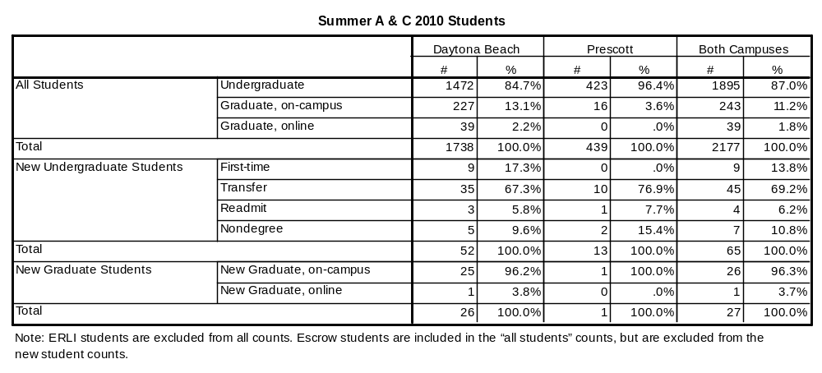

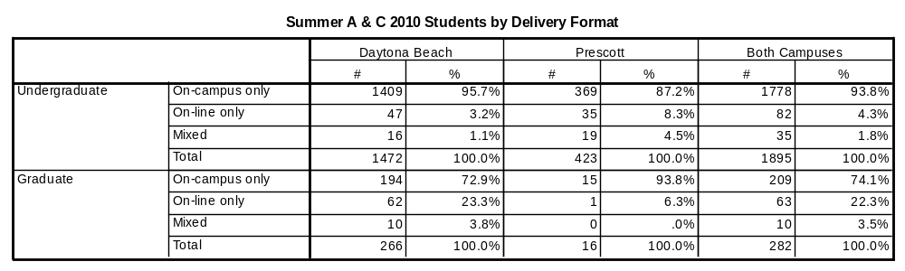

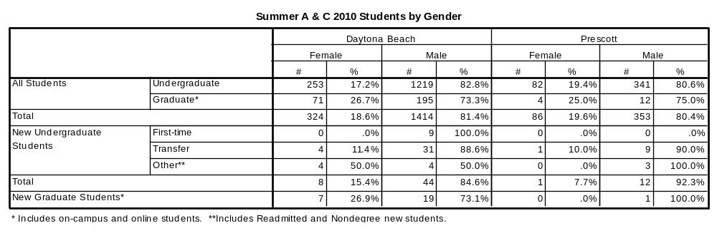
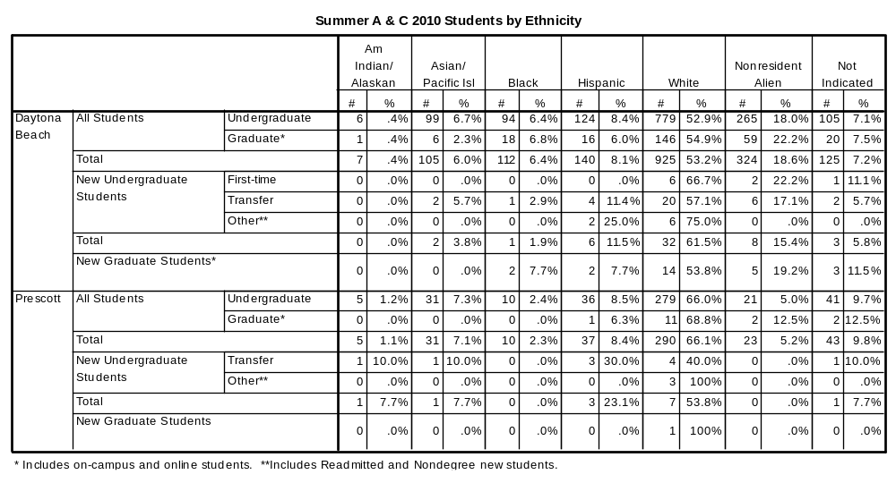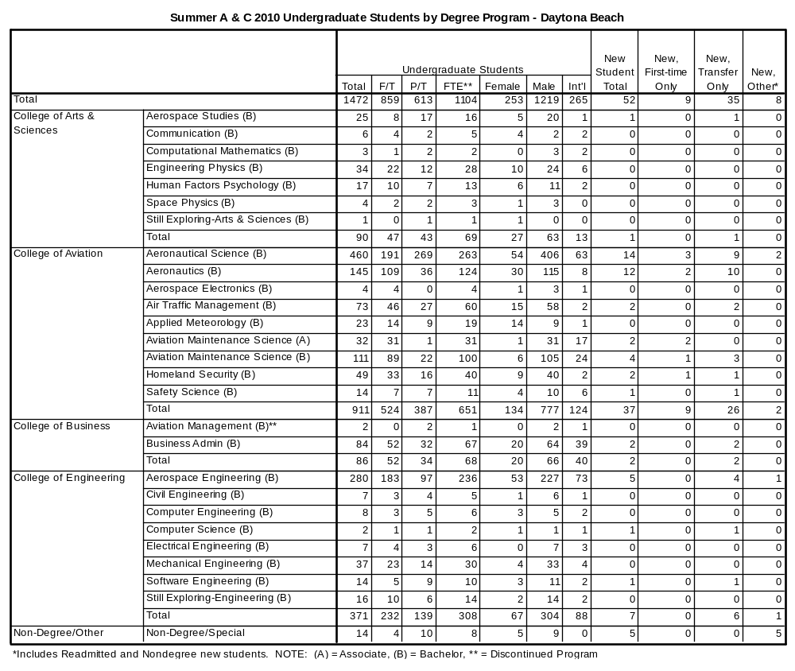
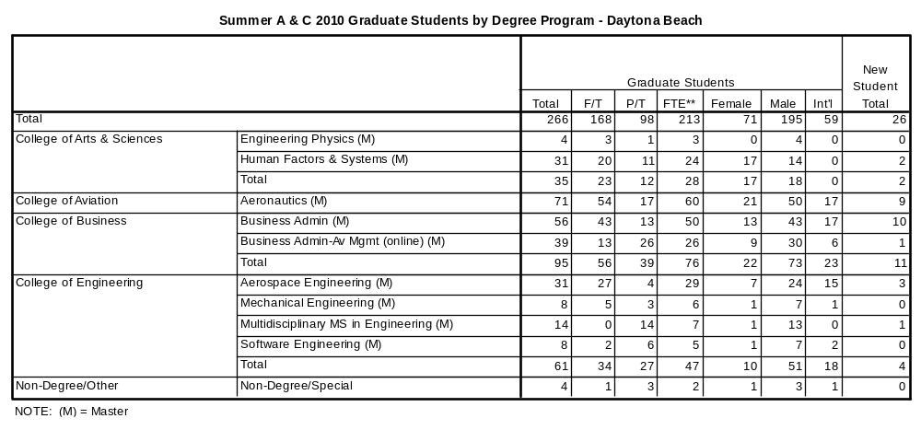
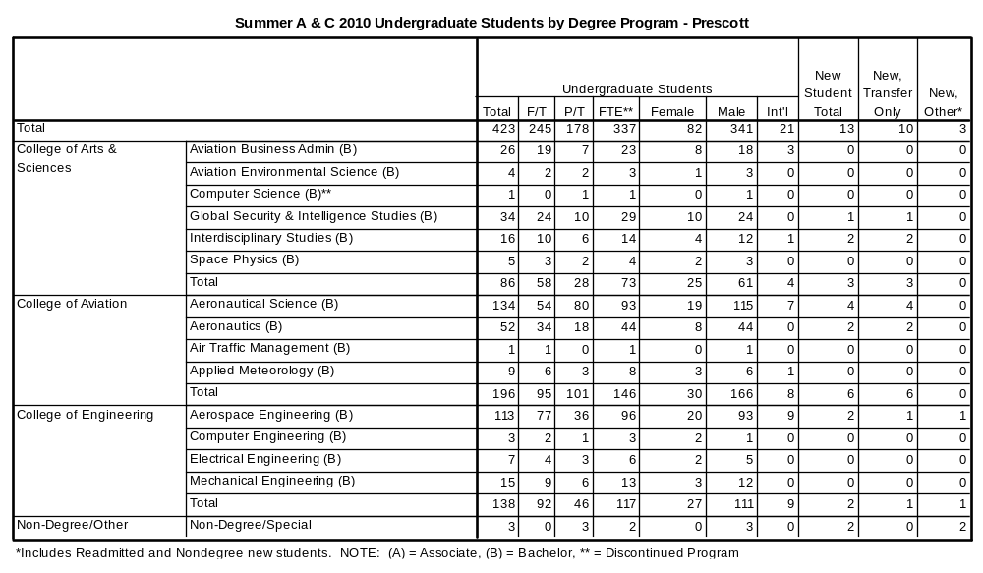
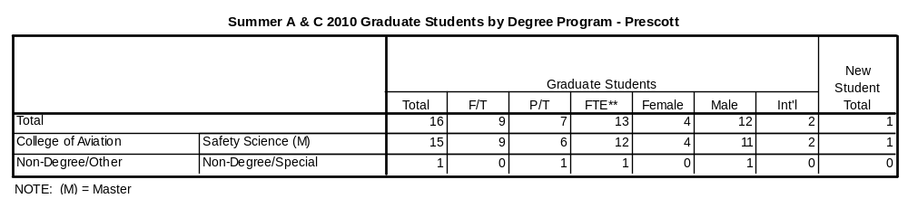

**Definition of full-time and full-time equivalent (FTE): Undergraduate students must be enrolled for a minimum credit load of 6 hours for full-time status during each summer term. Graduate students must be enrolled for at least 3 hours in Summer A or at least 6 hours in Summer C to be considered full-time. FTE is calculated by adding up the total number of hours for part-time students, dividing that sum by the standard definition of full-time status (3 or 6 hours, depending on the term and program level), then adding the result to the total number of full-time students.

