
ENROLLMENT SUMMER B 2009
FACT SHEET 2008-2009 Academic Year, Issue 4
Office of Institutional Research http://irweb.erau.edu Daytona Beach, FL 32114-3900 (386) 226-6225

Overall figures for unduplicated headcount are presented in this fact sheet. Each student is counted only once, even if concurrently enrolled in both an undergraduate and graduate program. Since last summer, Daytona Beach’s undergraduate enrollment has decreased by 6.8% (from 1165 to 1086), and Prescott’s undergraduate enrollment has decreased by 12.9% (from 140 to 122). The graduate enrollment at Daytona Beach has increased by 20.5% (from 73 to 88), while Prescott shows an increase of 27.3% (from 11 to 14).

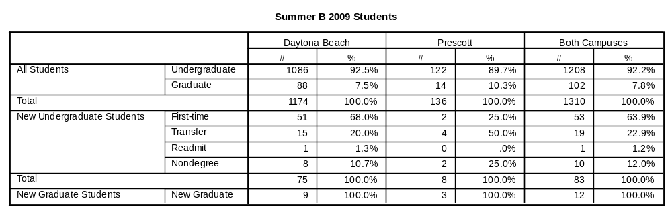

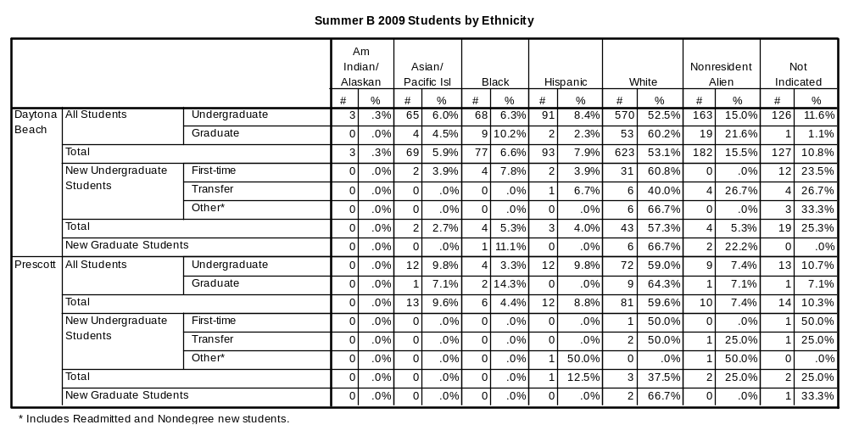

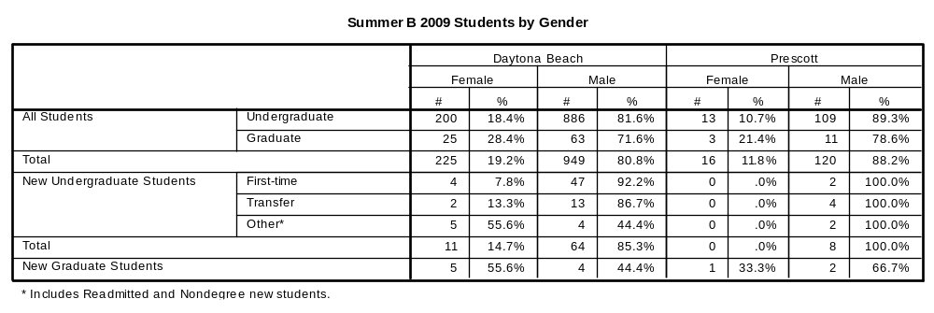

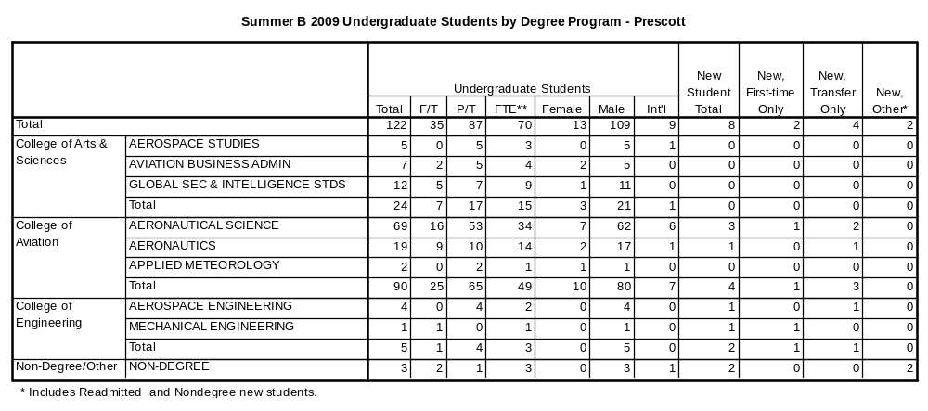

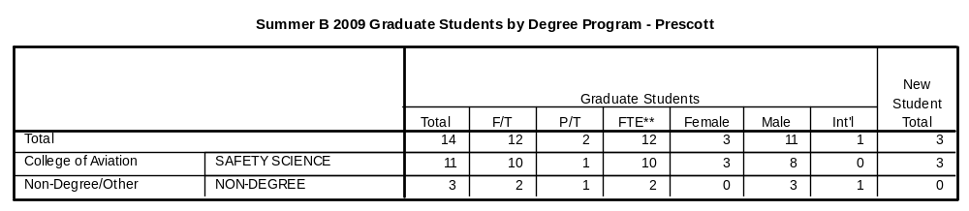

**Definition of full-time and full-time equivalent (FTE): Undergraduate students must be enrolled for a minimum credit load of 6 hours for full-time status during summer terms, and graduate students must be enrolled for at least 3 hours to be considered full-time. FTE is calculated by adding up the total number of hours for part-time students, dividing that sum by the standard definition of full-time status (3 or 6 hours, depending on the program level), then adding the result to the total number of full-time students.

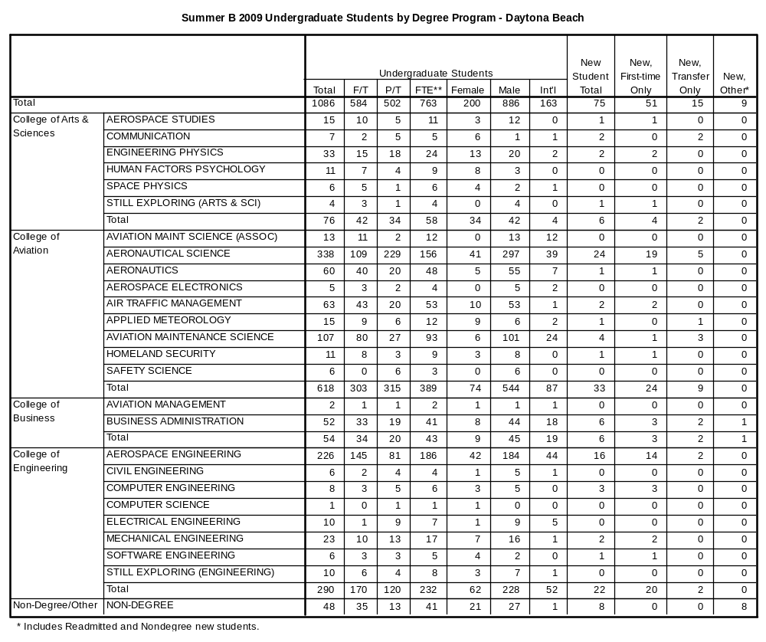

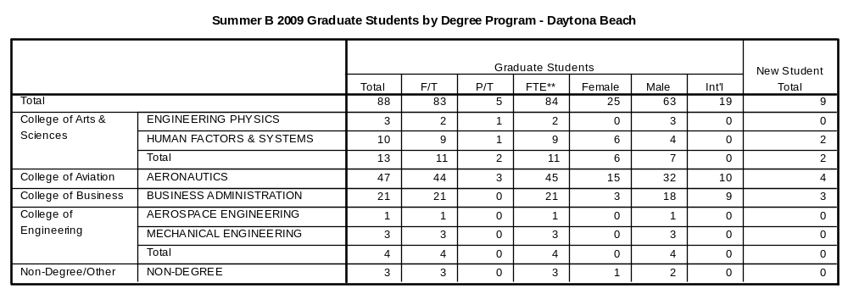

The remaining tables describe first-time college students only.

