
ENROLLMENT Summer C 2013
FACT SHEET 2012-2013 Academic Year, Issue 4
Office of Institutional Research http://irweb.erau.edu Daytona Beach, FL 32114-3900 (386) 226-6225

Overall figures for unduplicated headcount are presented in this fact sheet. Each student is counted only once, even if concurrently enrolled in both an undergraduate and graduate program. Course offerings in Summer C typically span the entire summer and include courses such as: internships, coops, special topics, and flight. There were no new students enrolled in the Summer C term.

Please note the following methodology change from prior summer term fact sheets: Previously, students enrolled in Summer A or Summer C courses were summarized in a single Summer A/C fact sheet, as an unduplicated count (i.e. counted once, regardless of whether or not they were enrolled in one or both terms). As of 2013, separate fact sheets and counts will be produced for Summer A and Summer C (Summer B was already a separate fact sheet, and will remain so). As such, trend comparisons to previous Summer A/C figures are not plausible; trend comparisons will commence again next year.

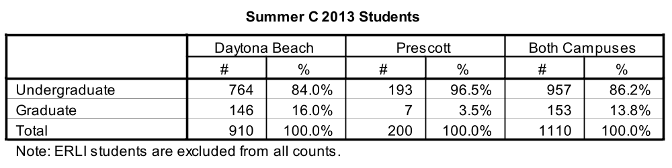

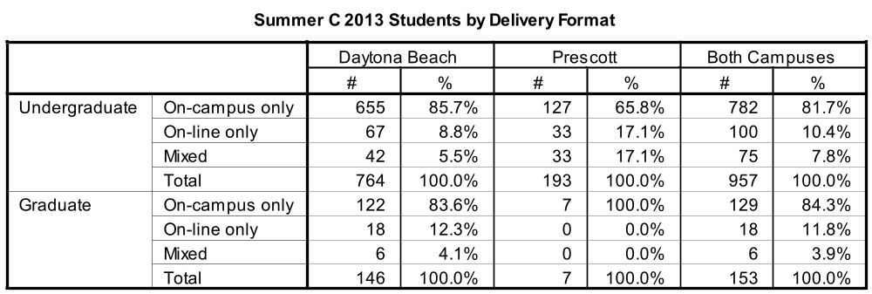

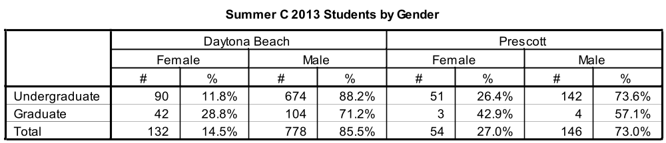

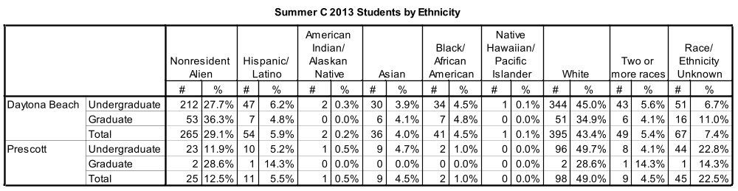

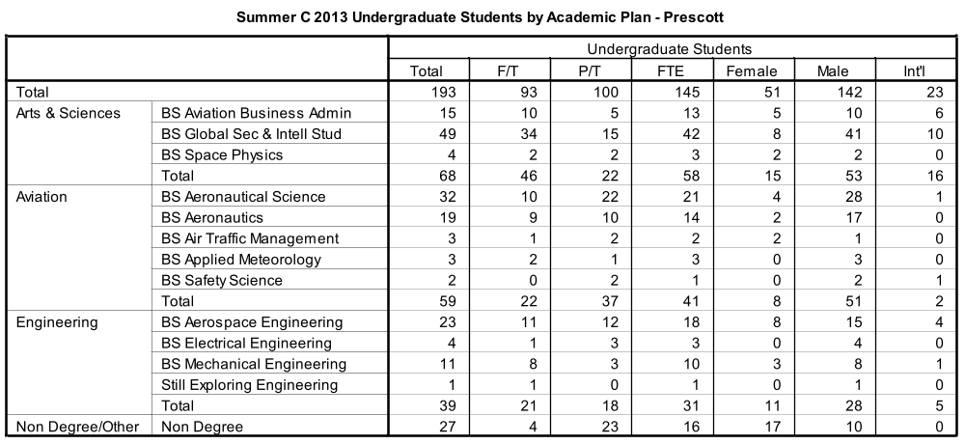

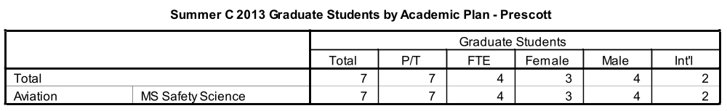

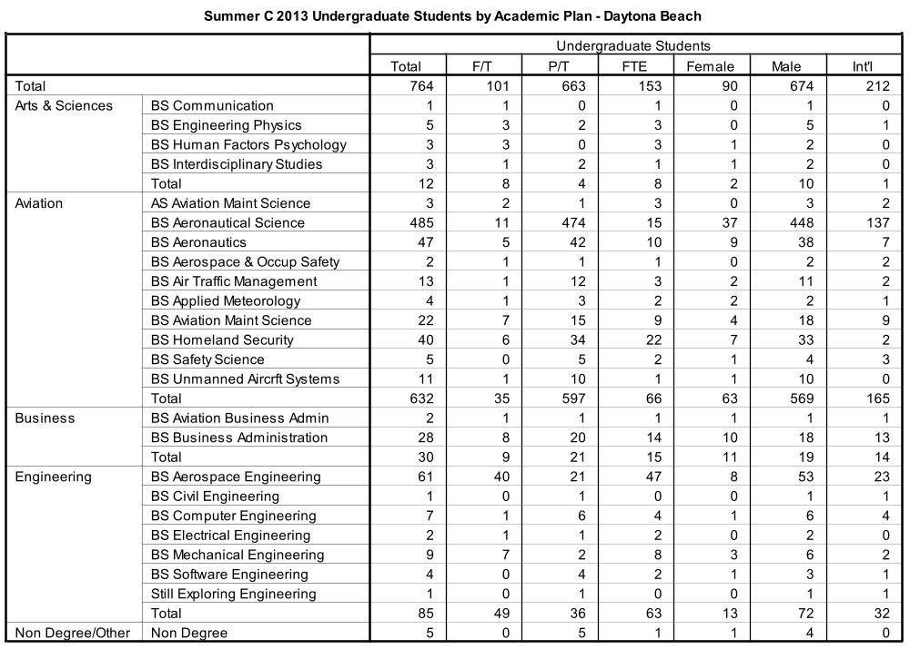

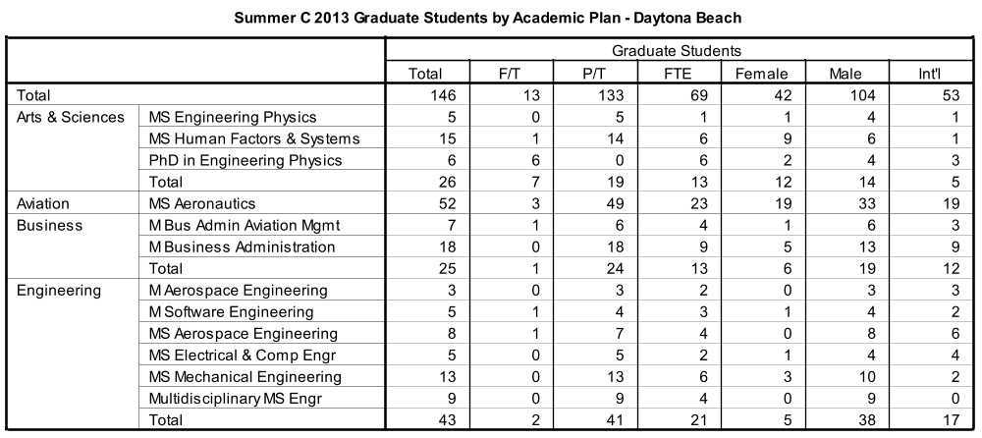

**Definition of full-time and full-time equivalent (FTE): Undergraduate students must be enrolled for a minimum credit load of 6 hours for full-time status during each summer term. Graduate students must be enrolled for at least 6 hours during the summer C term to be considered full-time. FTE is calculated by adding up the total number of hours for part-time students, dividing that sum by the standard definition of full-time status (6 hours), then adding the result to the total number of full-time students.

(Published 7/2/13)

