

M E M O R A N D U M

TO: Embry-Riddle Aeronautical University Board of Trustees

FROM: Irene McReynolds (Human Resources) and Maria Franco (Institutional Research)

DATE: March 21, 2005

SUBJECT: Initial Summary of Overall Results from the Spring 2005 Climate Survey

In preparation for the fourth administration of the Climate Survey in Spring 2005, the previous survey instrument (Fall 2003 administration) was reviewed. 11 items were reworded and/or expanded, and 3 items were deleted. 10 additional items were incorporated, to include a new section titled “University Progress”, intended to measure perceptions of the extent that progress has been made toward the following issues: marketing and promotion of ERAU, communication among the campuses, improvement of facilities, security of staff and students, hiring of women and underrepresented groups, and improvement of pay/benefits. The survey remained a web-based instrument, with 28 “agreement” items (5-point scale: Strongly Agree to Strongly Disagree), 7 “progress” items (5-point scale: Very Large Extent to None), 6 demographic items, and 5 open-ended comment boxes designed to elicit elaboration on each of the sections (Your Job, The ERAU Organization, The ERAU Environment, University Progress, Other).

The survey was conducted from February 22, 2005 through March 8, 2005. An email invitation to participate was sent on February 22 from Human Resources to all ERAU employees, and a reminder message was sent on March 4. All employees were urged to participate, regardless of status, location, etc.
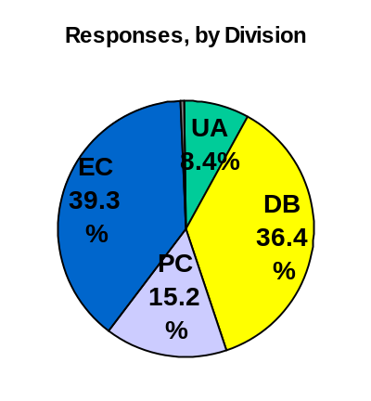
There were a total of 1,021 respondents – the highest number yet. Increases in staff participation across all divisions, as well as faculty participation from the Extended Campus, contributed to this year’s record response rate. Responses by division were as follows (with estimated response rates):
- University Administration = 86 (26% response rate)
- Daytona Beach Campus = 372 (44% response rate)
- Prescott Campus = 155 (41% response rate)
- Extended Campus = 401 (response rate not available)
- Not Indicated = 7

The four charts that follow display the overall results from all divisions combined: one chart for the 28 “agreement” items, one chart for the 7 “progress” items, and 2 charts comparing the results from this survey to the last (as applicable). In summary, respondents continued to express strong support for the University’s vision, mission, goals, and values. Furthermore, this year’s respondents were more positive in all comparable items. Likewise, there were also fewer negative responses. Items garnering the most notable improvement included those pertaining to the overall ERAU work environment, University leadership, and the use of Climate Survey results for decision-making.

Human Resources and Institutional Research continue to compile and analyze the results. A full report will be generated, to include breakouts and trends by division, location, gender, faculty vs. staff, full-time vs. part-time, and supervisory vs. non-supervisory. The report will be posted to the Institutional Research website (password protected). The posted report will not include a listing of the open-ended comments, however, comments will be reviewed and feedback provided to individuals and/or departments as appropriate.
