ERAU FACULTY & STAFF CLIMATE SURVEY
SPRING 2006 – OVERALL RESULTS
(Produced by the offices of Human Resources and Institutional Research, April 2006)

Administration

In preparation for the fifth administration of the Climate Survey in Spring 2006, the previous year’s survey instrument was reviewed by a consultant from the Hay Group, Human Resources, Institutional Research, and the Cabinet. As a result, 10 items were added, 9 were reworded, and 7 were deleted. The survey remained a web-based instrument, with 31 “agreement” items (5-point scale: Strongly Agree to Strongly Disagree), 7 “progress” items (revised 5-point scale: Very Good to Very Poor), 6 demographic items, and 5 open-ended comment boxes designed to elicit elaboration on each of the sections (Your Job, The ERAU Organization, The ERAU Environment, University Progress, Other).

The survey was conducted from February 21, 2006 through March 7, 2006. An email invitation to participate was sent on February 21 from Human Resources to all ERAU employees, and a reminder message was sent on February 28. All employees were urged to participate, regardless of status, location, etc.
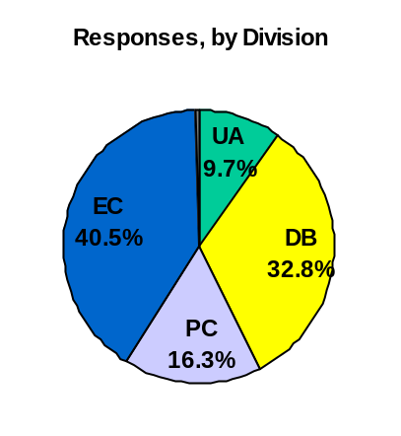
Response Rates

There were a total of 962 respondents – the second highest number of participants over the five years of this survey’s existence (last year’s was the highest). This equates to an estimated 35% response rate. Responses by division were as follows:
- University Administration = 93 (30% response rate)
- Daytona Beach Campus = 316 (38% response rate)
- Prescott Campus = 157 (44% response rate)
- Extended Campus = 390 (31% response rate)
- Not Indicated = 6

Results

The four charts that follow display the overall results from all divisions combined: one chart for the 31 “agreement” items, one chart for the 7 “progress” items, and 2 charts comparing the results from this survey to the last (as applicable).

In summary, participants responded most positively (89%) to a new question -- “I am proud to be associated with the University”. Furthermore, 14 additional items garnered at least 75% “approval”, to include items reflecting communication, performance feedback and planning, having the materials needed to do the job, attention to safety and diversity issues, and the overall perception that Embry-Riddle is a “good place to work”. About half of the items were still rated positively by a majority of respondents, between 50% and 75%. Only seven items received less than 50% approval: leadership progress, assessment and strategic planning, budget allocation decision-making, marketing, pay, and communication among the campuses.

When compared to last year’s results (which had earned the most positive ratings to date), about two-third’s of the responses were similar, while the remaining one-third were less positive. Items in this category include: the assessment and strategic planning processes, campus leadership, support for the “One University” concept, and workload.

The full report contains this overall summary as well as breakouts by division (University Administration, Daytona Beach, Prescott, Extended Campus), gender, and position (faculty, staff). It is posted on the Institutional Research website (password protected). The posted report does not include a listing of the open-ended comments; however, comments were be delivered to select Cabinet members for review and feedback to individuals and/or departments, as appropriate.
