ERAU FACULTY & STAFF CLIMATE SURVEY
SPRING 2007 – OVERALL RESULTS
(Produced by the offices of Human Resources and Institutional Research, March 2007)

Administration

In preparation for the sixth administration of the Climate Survey in Spring 2007, the previous year’s survey instrument was reviewed by Human Resources, Institutional Research, and the Cabinet. As a result, 1 item was added, 2 were reworded, and 3 were deleted. The survey remained a web-based instrument, with 29 “agreement” items (5-point scale: Strongly Agree to Strongly Disagree), 7 “rating” items (revised 5-point scale: Very Good to Very Poor), 6 demographic items, and 1 open-ended comment box.

The survey was conducted from February 6, 2007 through February 20, 2007. An email invitation to participate was sent on February 6 from Human Resources to all ERAU employees, and a reminder message was sent on February 13. All employees were urged to participate, regardless of status, location, etc.
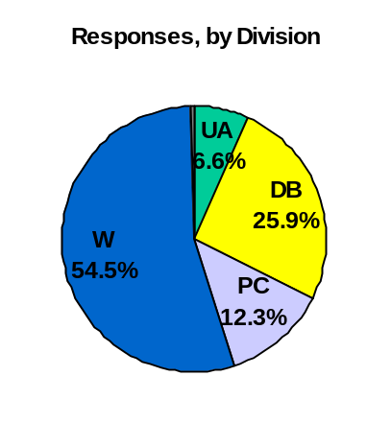
Response Rates

There were a total of 1176 respondents – the highest number of participants over the six years of this survey’s existence. This equates to an estimated 46% response rate. Responses by division were as follows:
- University Administration = 78 (28% response rate)
- Daytona Beach Campus = 305 (34% response rate)
- Prescott Campus = 145 (37% response rate)
- Worldwide = 641 (65% response rate)
- Not Indicated = 7

Results

The four charts that follow display the overall results from all divisions combined: one chart for the 29 “agreement” items, one chart for the 7 “rating” items, and 2 charts comparing the results from this survey to the last (as applicable).

In summary, participants responded most positively (89%) to -- “I am proud to be associated with the University”. Furthermore, 17 additional items garnered at least 75% “approval”, to include items reflecting technology, communication, performance feedback and planning, having the materials needed to do the job, attention to diversity issues, and the overall perception that Embry-Riddle is a “good place to work”. 14 items were still rated positively by a majority of respondents, between 50% and 75%. Only five items received less than 50% approval: the impact of the Climate Survey results, marketing and promotion, communication among the campuses, pay, and budget allocation decision-making.

When compared to last year’s results 14 items were more positive, including items regarding performance of the President and Chancellors, communication among the campuses, hiring women and underrepresented groups, marketing and promotion, the strategic planning and assessment process, budget allocation decision-making, and the mission, goals, and vision of the University. Just under half of the responses were similar to last year, and the remaining 5 were less positive. Items in this category showed between a 0.5% and 4.0% decrease in agreement, they include: available benefits, communication of University and departmental news, overall rating of the University as being a good place to work, opportunities to learn and grow, and the availability of materials and equipment.

The full report includes breakouts and trends by division (University Administration, Daytona Beach, Prescott, Worldwide Campus), gender, and position (faculty, staff).The full report is posted on the Institutional Research website (password protected). The posted report does not include a listing of the open-ended comments; however, comments have been delivered to select Cabinet members for review and feedback to individuals and/or departments, as appropriate.

