Introduction

This report reveals the findings of the 2004/2005 Student Satisfaction Survey–Daytona Beach and Prescott Campuses. This study marks the fourth administration of the Student Satisfaction Inventory™ (SSI); previous administrations were conducted in 2002, 2000 and 1998. This survey, created by the consulting firm Noel-Levitz, Inc. and administered by the Office of Institutional Research (IR) to students at both the Daytona Beach and Prescott campuses, was used in order to get a snapshot of the environment of the residential ERAU campuses. The SSI questionnaire consists of approximately 100 items expressed as statements of expectation that cover the full range of college experiences. Survey respondents rate each statement both in terms of their satisfaction that the expectation is being met, and the importance they place on the expectation. In addition to these items the SSI allowed for 10 additional institutional specific questions, which IR tailored to the needs of the university. Students responded to each questionnaire statement on a seven-point Likert response scale. The survey instrument also included a space for comments, in an attempt to provide an opportunity for students to elaborate on their perceptions of their ERAU experience.

The SSI was administered during October 2004 to a sample of students at the Prescott campus and in October 2004 and February 2005 to a sample of students at the Daytona Beach campus. Part of this study was delayed to February 2005 because hurricanes disrupted the fall calendar. The process of the 2004/2005 survey distribution was similar to the process used in previous administrations. The surveys were distributed to selected class sections and students completed the survey during the class period. IR would like to thank all faculty and staff who helped facilitate this survey administration (see Methodology section for a further discussion of the research methods).

Results of this study are based on the responses of 865 Daytona Beach and 540 Prescott survey respondents. This represents approximately 19% of the Daytona Beach total student population and 32% of the total student population in Prescott. SSI data have been statistically weighted to represent the actual student population at the time the surveys were administered. Where applicable, SSI findings are compared to national scores, for which only average responses are available from Noel-Levitz. The national results are based on 276,006 student responses from private, four-year institutions that recently participated in the SSI. In addition to average responses, ERAU results are presented in a percentage response format, which were obtained by collapsing the seven-point Likert response scale into three categories (see Appendix F for a sample of the SSI questionnaire).

This report is divided into eighteen sections. The first section is the introduction, executive summary and methodology section. The second section of this report presents a profile of survey respondents: students’ school preference, factors influencing students’ decision to enroll at ERAU, educational goals, employment status, and learning disabilities. The third section displays overall satisfaction ratings of ERAU students. The fourth section uses scatterplot graphs to analyze the data. The fifth through sixteenth sections of the report present detailed SSI findings, trends and national comparisons, organized into 11 topical categories called scales. Finally, the last sections present the reader with data tables, a sample of the SSI survey instrument, and the IR Preview Volume 6, Number 2.

This report is organized as follows:
- Introduction, Executive Summary, and Methodology
- Profile of Respondents
- Overall Satisfaction
- Scatterplot Analysis
- Academic Advising
- Campus Climate
- Campus Life
- Campus Support Services
- Concern for the Individual
- Instructional Effectiveness
- Recruitment and Financial Aid
- Registration Effectiveness
- Responsiveness to Diverse Populations
- Safety and Security
- Service Excellence
- ERAU Specific Items
- Data Tables
- Survey Materials
- IR Preview (Highlights)

Executive Summary

This report summarizes results of the student satisfaction study conducted at ERAU by the Office of Institutional Research (IR). Data were collected using the Noel-Levitz survey instrument: The Student Satisfaction Inventory™ (SSI). The SSI was administered to a sample of students at the residential campuses of ERAU in Daytona Beach, Florida and Prescott, Arizona in October 2004 and February 2005. Results of the Student Satisfaction Inventory are based on the responses of 865 Daytona Beach and 540 Prescott survey respondents. The following summary of results focuses on five major areas: 1) overall satisfaction, 2) ERAU’s importance and satisfaction ratings, 3) top areas of satisfaction and dissatisfaction, 4) results of items grouped thematically into 11 composite scales, 5) 2004/05 ERAU survey findings vs. national scores (national results are based on 276,006 student records from 378 four-year, private institutions who recently participated in the SSI), 6) 2002 vs. 2004/05 ERAU survey findings, and 7) student comments.

Overall Satisfaction

When asked to rate their overall college experience thus far a majority of ERAU students are satisfied. 66% of respondents in Daytona Beach and 75% in Prescott replied “somewhat satisfied,” “satisfied” or “very satisfied”. These results exhibit a slight increase in satisfaction from 2002 (63% in Daytona Beach and 74% in Prescott) and 2000 (63% in Daytona Beach and 72% in Prescott). The 2004/05 results were lower than the highest satisfaction level recorded by this study in 1998 (70% in Daytona Beach and 81% in Prescott). Results from the national comparative group of private four-year colleges and universities suggest the satisfaction in Daytona is below the national average, while satisfaction in Prescott is slightly higher that the national average.

Importance and Satisfaction Ratings

Students from Daytona Beach and Prescott rated instructional issues among the most important. More than 95% of students at both campuses rated the following areas as important: knowledgeable faculty, valuable course content, excellent instruction, commitment to academic excellence, and faculty availability. At least 70% of ERAU students indicated satisfaction in each of these areas related to academics.

Top Areas of Satisfaction and Dissatisfaction

The following are the five areas in which students most frequently indicated satisfaction and dissatisfaction.

Top Areas of Satisfaction, Daytona Beach  - Computer labs are adequate and accessible (90% satisfied)  - Nearly all of the faculty are knowledgeable in their field (87%)  - Class sizes are appropriate relative to the types of courses (86%)  - The campus is safe and secure for all students (86%)  - Faculty are usually available after class and during office hours (86%) | Top Areas of Satisfaction, Prescott  - Nearly all of the faculty are knowledgeable in their field (93% satisfied)  - Class sizes are appropriate relative to the types of courses (92%)  - Faculty are usually available after class and during office hours (89%)  - The instruction in my major field is excellent (88%)  - There is a commitment to academic excellence on this campus (88%)
Top Areas of Dissatisfaction, Daytona Beach  - The amount of student parking space on campus is adequate (73% dissatisfied)  - I seldom get the 'run-around' when seeking information on this campus (58%)  - Adequate financial aid is available for most students (43%)  - There is an adequate selection of food available in the cafeteria (40%)  - Tuition paid is a worthwhile investment (39%) | Top Areas of Dissatisfaction, Prescott  - There is an adequate selection of food available in the cafeteria (70% dissatisfied)  - The intercollegiate athletic programs contribute to a strong sense of school spirit (39%)  - I seldom get the 'run-around' when seeking information on this campus (36%)  - Adequate financial aid is available for most students (35%)  - The amount of student parking space is adequate (33%)

Satisfaction by Scales Compared to National Average

In order to easily summarize the survey results into more general terms, the individual items were collapsed into 11 composite scales based on the topic of the question. This permits a global analysis of the relative level of satisfaction with some of the general important areas on campus. The results are reported in mean scores based a seven point scale in which 1 = not at all satisfied 4 = neutral and 7 = very satisfied.

- Academic Advising:
The level of satisfaction with academic advising in Daytona Beach (5.04) was lower than the national average of 5.20. Students in Daytona were significantly less satisfied that their advisor is concerned about their success as an individual and that their advisor helps to set goals to work toward than were their counterparts nationally.

Students in Prescott (5.37) were more satisfied with issues related to advising than the national average of 5.20. Prescott students were significantly more likely to be satisfied that their advisor is knowledgeable about requirement in the student’s major than the national average.

- Campus Climate:
Students in Daytona Beach (4.71) were less satisfied with items related to campus climate than the average of students nationally (5.08). Daytona students were significantly less satisfied than the national average on a number of campus climate related survey items, including: feeling a sense of belonging, having pride in the campus, tuition as a worthwhile investment, and the availability of channels for expressing students’ concerns.

The level of satisfaction with the campus climate for students in Prescott (5.10) was roughly equal to the national average for this scale (5.08); although Prescott students were significantly less satisfied than the national average that their institution has a good reputation within the community.

- Campus Life:
Students in Daytona Beach were less satisfied (4.59) with items related to campus life that were their counterparts nationally (4.72). Compared to the national average, students in Daytona were more satisfied with on-campus activities. These students were significantly more satisfied with the variety of intramural activities and on-campus organizations than the national average. However, they were less satisfied with the student center, disciplinary procedures and the use of S.G.A. fees.

On the Prescott campus students were nearly as satisfied (4.64) as the national average (4.72). Prescott students were significantly more satisfied than students nationally with living conditions in the residence halls and with on campus organizations. They were significantly less satisfied with the food in the cafeteria and intercollegiate athletics and school spirit.

- Campus Support Services:
With a mean of 5.36, students at the Daytona Beach campus were more satisfied than students nationally (5.14) with campus support services. In particular, students were significantly more satisfied with the services and resources in the library, computer labs, and the library and bookstore staff.

The students in Prescott were also more satisfied (5.29) than the national average (5.14) with campus support services. The students were significantly more satisfied with computer labs, career services, and the service in the bookstore than students nationally.

- Concern for the Individual:
Students in Daytona were less satisfied (4.77) than students nationally (5.60) regarding the University’s concern for the individual. The students expressed significantly less satisfaction that the institution shows concern for individuals or that faculty are concerned for students as individuals.

Prescott campus students were also less satisfied (5.18) with the concern for the individual than the national average (5.60). These students were significantly less satisfied that the faculty and residence hall staffs are concerned for students as individuals.

- Instructional Effectiveness:
The mean for the instructional effectiveness scale for students in Daytona Beach (5.08) was below the mean for all students nationally (5.24). The Daytona Beach students were significantly less satisfied than their counterparts with the variety of courses provided, their ability to experience intellectual growth, and the faculty’s appreciation of students’ differences.

The students at the Prescott campus (5.44) had a higher mean on the instructional effectiveness scale than did all students nationally (5.24). The students had significantly higher satisfaction than the national average on items such as: valuable course content, quality of instruction, and a commitment to academic excellence. The Prescott students were significantly less satisfied with the variety of courses offered.

- Recruitment and Financial Aid:
The Daytona Beach campus mean for the recruitment and financial aid scale (4.26) is below the national mean of 4.83. Daytona students were less satisfied than the national average and statistically significant differences were found on all of the items contributing to this scale. The largest difference between the national average and the Daytona Beach mean was found on items such as: adequate financial aid is available to most students, financial aid awards are announced in time for college planning, and recruiters accurately portray the campus in recruiting practices.

The Prescott campus mean for the recruitment and financial aid scale (4.76) is slightly below the mean for all students nationwide. The only item significantly different from the national average was the lower satisfaction indicated by Prescott students with the item: adequate financial aid is available for most students.

- Registration Effectiveness:
Students in Daytona Beach had a lower mean on the registration effectiveness scale (4.50) compared to the national average (4.90). Daytona Beach students were significantly less satisfied than the average with items such as: the hours of the cashier’s office, billing policies, add/drop policies, and the ability to register for needed classes with few conflicts.

The mean for registration effectiveness for Prescott campus students (4.97) is higher than the national average (4.90). Although there were no significant differences, the average level of satisfaction was higher in Prescott than the national average on all of the items in this scale except billing policies.

- Service Excellence:
The Daytona Beach campus mean for the service excellence scale (4.69) was below the national average of 4.92. Daytona students expressed significantly less satisfaction that they seldom get the ‘run-around’ when seeking information. However, they expressed higher satisfaction with the staff in health services than the national average.

Prescott campus students were more satisfied (5.00) than the national average (4.92) with the service excellence scale. Just like the students in Daytona, Prescott students were more satisfied with the health services staff, but less satisfied with the run-around than the national average.

- Safety and Security:
With a mean of 4.41, Daytona Beach students were less satisfied with safety and security on campus than the national average of 4.68. The students were significantly less satisfied than the national average with the amount of student parking on campus, but were more satisfied that the campus is safe and secure.

Prescott students were more satisfied with safety and security (4.92) than the national average (4.68). The students were significantly more satisfied with the amount of student parking, the security of parking lots, and that the campus is safe and secure than the average of all students nationally.

ERAU vs. National Average

Figures 1 through 4 show the areas with the largest difference between the ERAU campus mean and the national mean. ERAU responses are compared to those of recent SSI participants at other private, four-year institutions. Survey results from the national comparison group are available only as mean scores.

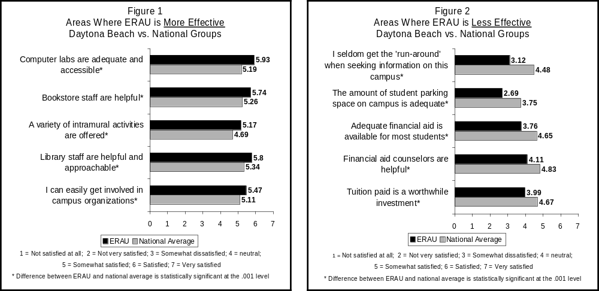

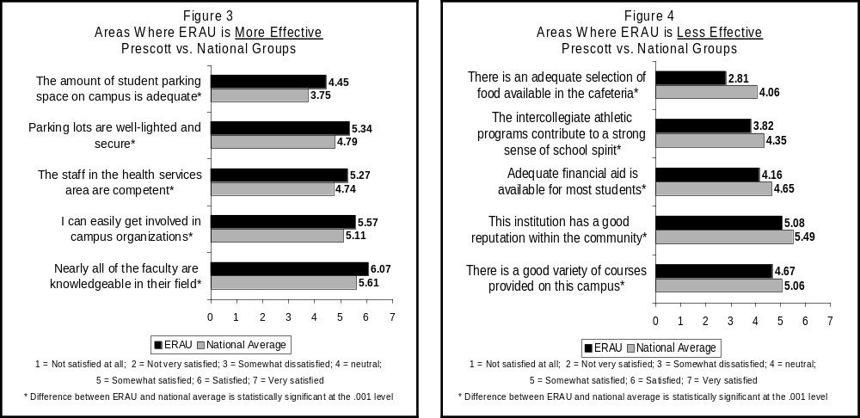

ERAU 2004/05 vs. 2002 Survey Results

Comparing the responses from all of the items from the 2004/2005 administration to the responses from the 2002 administration determines the areas where student satisfaction has improved or declined the most. Figures 5 and 6 provide the results for Daytona Beach, while Figures 7 and 8 display the results from Prescott.

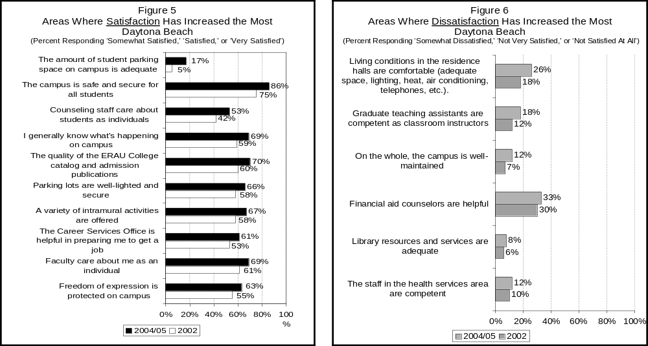

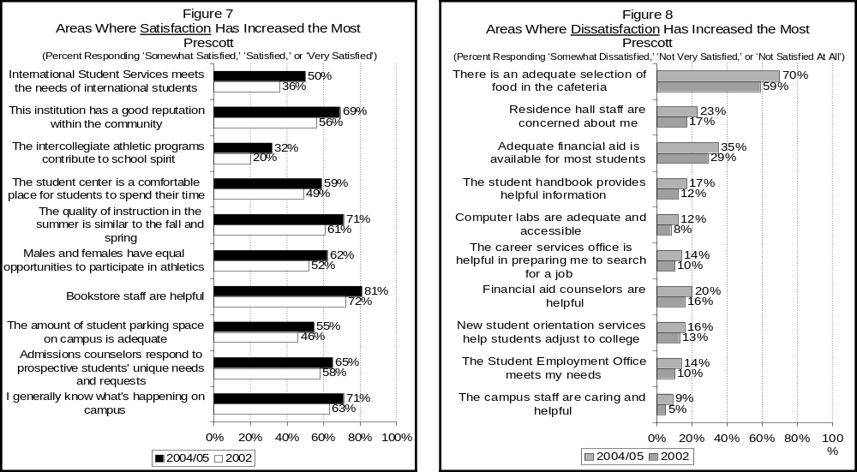
Comment Summary
Survey respondents were given the opportunity to provide additional comments regarding their satisfaction with ERAU. Out of 1,405 surveys completed, 268 offered additional comments. After conducting content analysis, most of the comments fall into one of four broad categories.

Overall Satisfaction
Many students expressed general satisfaction with ERAU. Sentiments such as: “Overall, I am very satisfied with ERAU” and “Overall, I have had a good experience at this school” were common. Some student expressed general satisfaction with the university, but noted particular areas of dissatisfaction. A number of students noted that increasing tuition costs make an ERAU education less affordable, “Overall a great school. Unfortunately the cost of tuition and flight training is outrageously high.” A large number of students expressed dissatisfaction with financial aid. Students noted that there was not enough aid available to those who need it. In addition, they also registered complaints about poor record keeping and lost paperwork, uncaring staff, missed deadlines, and getting the ‘run-around’ in the financial aid office. Lastly, some students felt that the university administrators are unresponsive to students and disconnected from student concerns.

Academic Experience
Many students commented that they chose ERAU because of its academic record and its sterling reputation within the aviation and aerospace industry. Some students noted that while their instructors are very knowledgeable, some are ineffective as teachers. “They might know a lot in their area, but they don’t know how too teach.” Some students remarked that some instructors “look down on you” if you don’t know something, or “get mad when you ask them questions about something you don’t understand”. A number of students were pleased with the small class sizes, while some students expressed dissatisfaction with the availability of core courses, “there were three semesters in a row that I was unable to get all the classes I needed, so I have to stay an extra semester to finish my degree.” Students were also frustrated with the limited variety of non-aviation elective courses available.

Student Life
A number of student comments call for a more balanced male to female ratio. Also, students expressed a desire for expanded hours for library and computer labs. At the Daytona Beach campus inadequate parking was an issue addressed by a number of students: “Safety is more concerned with writing tickets than keeping thieves out of my car.” Prescott students expressed dissatisfaction with the quality of the food and the all you can eat set-up of the cafeteria.

Flight Department
Most of the comments regarding the flight department were negative, as students were dissatisfied with the cost of instruction and a perception of rude treatment by the staff: “Flight line is arrogant and overly expensive.” Some students suggested that they would continue their education with ERAU, but take flight training elsewhere.
Methodology

Overview

This report summarizes results of the student satisfaction study conducted at Embry-Riddle Aeronautical University’s residential campuses in Daytona Beach, Florida and Prescott, Arizona by the Office of Institutional Research (IR). The purpose of this study is to obtain data on students’ perceptions of various aspects of their college experience. The results of the study are used to identify institutional strengths and areas in need of improvement; as well as to pinpoint more precisely the institution’s effectiveness in meeting the expectations of students.

Survey Instrument

The Office of Institutional Research administered the Student Satisfaction Inventory™ (SSI), a questionnaire created by the consulting firm, Noel-Levitz, INC. The SSI consists of items, expressed as statements of expectation, which cover the full range of college experiences. The instrument included 10 additional questions tailored to the needs of the university. The SSI was administered to students from all class levels and degree programs. Respondents were asked to indicate, on a seven point Likert response scale, the level of importance they assign to the expectation, as well as their level of satisfaction that the expectation is being met.

Sample Selection

This survey is typically administered in the fall semester at both campuses, but part of the administration planned for Daytona Beach Fall 2004 was delayed until early in the Spring 2005 semester because of the disruption caused by the 2004 hurricane season. First-year students in Daytona were surveyed in the fall, followed by administration to the rest of the sample early in the spring semester. The Prescott campus administration took place in fall 2004 as planned. The sample of students for both campuses was selected as follows: IR identified the total number of responses needed at each campus in order to obtain an error margin of approximately 5%. To ensure representation across all class levels and majors, Fall 2004 and Spring 2005 courses were grouped into four categories that were considered to best segregate new students, continuing lower classmen, upper classmen, and graduate students. The number of responses needed within each of these categories was assigned proportionately to the Fall 2004 and Spring 2005 enrollment distribution of students in those categories. Faculty members were asked by their department chairs to participate by volunteering class time, thus allowing the completion of the survey in class. IR made contact with teachers at both campuses and developed a schedule for the administration of the surveys. Noel-Levitz, Inc. performed scanning of survey instruments and initial analysis of results. Final analysis of data, generation of additional statistics and final report were performed by IR.

Response Rates

A total of 1,405 surveys were completed at both campuses (865 at Daytona Beach and 540 at Prescott). This represents approximately 19% of the total student population in Daytona Beach and 32% of the total student population in Prescott. Data were statistically weighted where necessary to correct for disproportionate response rates so that the composition of the survey sample is representative of the respective 2004/2005 population..

Possible Sources of Error

The results of any survey research are subject to sampling and/or non-sampling errors. (1) Sampling error– Because this survey is not a census, a possible sampling error is the inability to survey students because they were not present during the days the survey administration took place. (2) Non-sampling - This research is also subject to errors such as unit item non-response, where students answered only certain items. No imputation was performed for missing data items. Another type of non-sampling error is measurement error, which may exist for some of the variables due to the difficulty of defining ambiguous concepts. Lastly, differences in interpreting questions and inability or unwillingness to give correct information are two other sources of non-sampling errors.

Calculation of Percentage-Responses

Responses from this national student satisfaction study are only available in average-response form, which are calculated from a seven-point Likert scale. Although the assumption of symmetry and equal intervals in Likert scale construction is controversial, this is the only source of national data from Noel-Levitz available to make comparisons among institutions. In addition to these average responses (used in this report only to compare ERAU findings to the national comparative group), IR has generated percentage responses. For importance and satisfaction ratings, percentage responses items presented in this report were obtained by collapsing the seven-point Likert response scale into three categories: not important, neutral, and important (importance ratings); and dissatisfied, neutral, and satisfied (satisfaction ratings).

