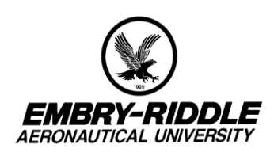IR PREVIEW
Preliminary highlights from Volume 3, Number 5 Volume
current IR studies June 2000

Office of Institutional Research http://irweb.erau.edu Daytona Beach, FL 32114-3900 (904) 226-6225

IN THIS ISSUE
- 2000 College of Career Education Student Satisfaction Survey

- 2000 Employer Feedback Survey (1998 Daytona Beach, Prescott, CCE and CDL graduates)

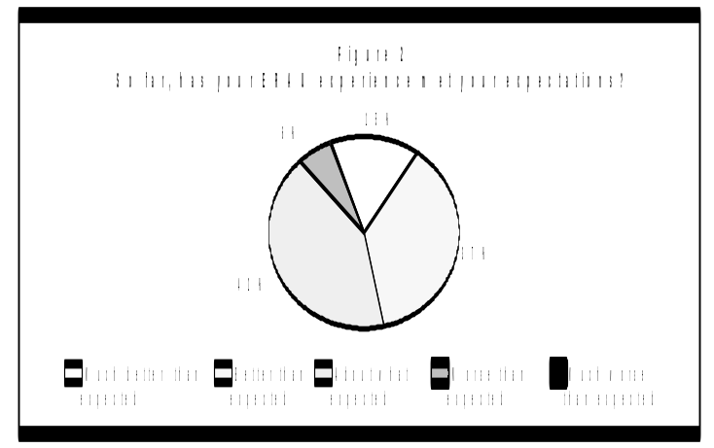

2000 CCE STUDENT SATISFACTION SURVEY

The CCE Student Satisfaction Survey was developed to assess the level of satisfaction of students enrolled at the various domestic and international centers of the College of Career Education (CCE). The in-house instrument includes questions on reasons for attending ERAU, overall experience with the university and the center attended, and perceptions on academic programs, instruction and student services.
The Office of Institutional Research administered the 2000 Student Satisfaction Survey to students enrolled in the Spring 2000 term at the College of Career Education (CCE). A random sample of students from each of the 104 domestic and international CCE centers was selected to participate in this survey. 2,500 surveys were mailed out. Of 2,443 deliverable surveys, 1,520 (62.2%) were completed and returned.
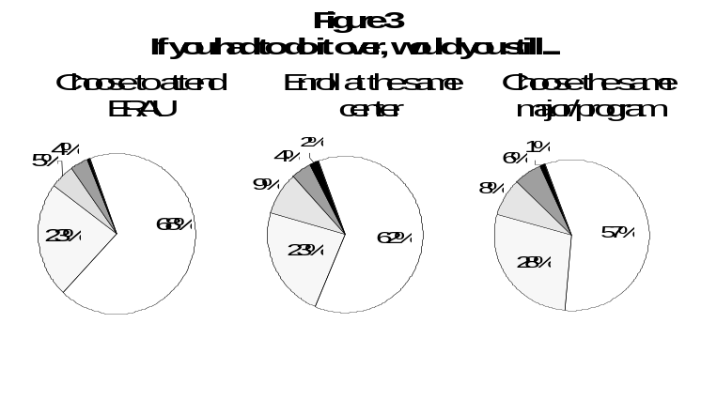
This issue of the IR Preview summarizes findings for all centers combined. Data have been statistically weighted to correct for disproportionate response rates, so that findings are representative of all CCE students in the Spring 2000. Any numeric inconsistencies are due to the rounding of data.

- Overall Satisfaction

As presented in Figure 1, the majority of respondents are satisfied with ERAU and with their college experience at their respective centers.
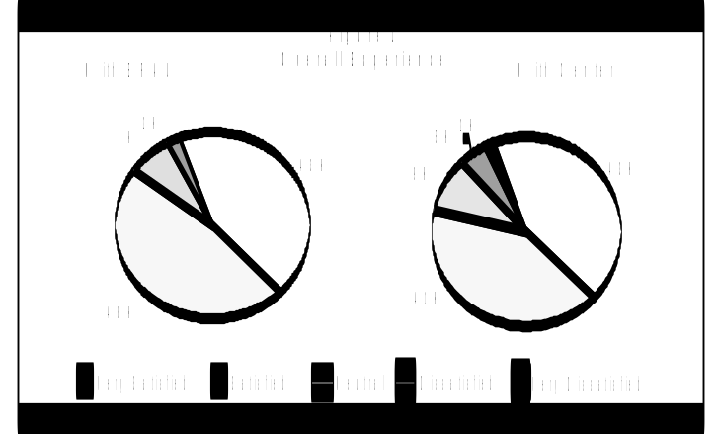
- Meeting Students’ Expectations

As a whole, over 90% of CCE students in all centers indicated that their ERAU college experience has met or exceeded their expectations (see Figure 2).

- Enrolling at ERAU again

68% of ERAU CCE students would enroll again if they had to do it over. 62% of the respondents indicated that they would enroll at the same center. 57% would still choose the same program/major (see Figure 3).

- About ERAU

Survey respondents were asked to rate the level of agreement they assign to three areas: perceiving that the ERAU academic experience is worth the cost, feeling pride and loyalty toward ERAU, and receiving adequate information about ERAU (see Figure 4).

- 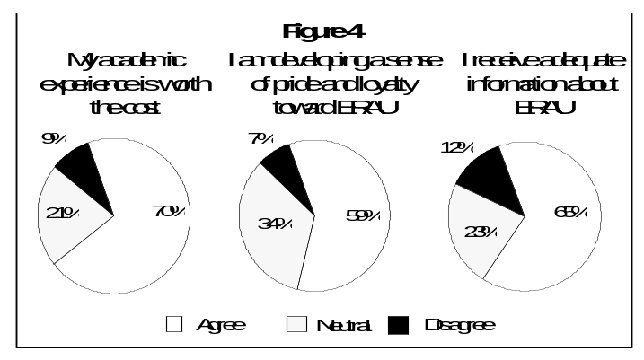Reasons for attending ERAU

Figure 5 shows the 11 factors presented to survey respondents as reasons for attending ERAU. Over 70% of respondents selected ‘Degree completion’, ‘Career advancement’ and ‘Preparation for future employment’ as major reasons for attending ERAU.

- Academic Programs and Instruction

When asked to rate the level of agreement students assign to several academic areas, respondents in general indicated positive opinions (see Table 1).

Table 1
Respondents’ Overall Perceptions of
Academic Programs and Instruction

 | Agree | Neutral | Disagree
Faculty members make me feel at ease to ask questions | 95% | 4% | 1%
I understand the methods by which I am graded | 94% | 5% | 1%
The grading procedures used at ERAU are fair and equitable | 93% | 6% | 1%
Class sizes are appropriate | 92% | 6% | 2%
I understand the goals of the courses I take | 92% | 6% | 2%
  The faculty are enthusiastic about the subjects they teach  7%  Figure 5  Reasons for Attending ERAU  18%  35%  39%  39%  50%  67%  68%  71%  73%  80%  21%  35%  42%  17%  26%  34%  22%  26%  20%  17%  72%  48%  23%  44%  35%  16%  11%  6%  9%  10%  13%  0%  20%  40%  60%  80%  100%  ERAU is a small  private university  Caring attitude of  faculty and staff  Improvement of  existing job skills  Availability of gov.  tuition assistance  Selection for promotion m raise/commission  Reputation of ERAU  in avia/aeros education  Convenience of  M center location  Personal/Self m satisfaction  Preparation for future m employment  Advancing career in aviation/aerospace  Degree completion  7%  7% | 92% | 7% | 1%
The faculty relate course subject matter to practical applications | 92% | 7% | 1%
I am given the opportunity to evaluate my instructors | 90% | 8% | 2%
The methods of instruction are appropriate to the content of the courses | 90% | 7% | 3%
ERAU provides an atmosphere which encourages learning and academic excellence | 89% | 9% | 2%
My professors are well prepared for class | 89% | 8% | 3%
Major requirements are clear and reasonable | 88% | 9% | 3%
I am satisfied with the overall quality of my program | 88% | 10% | 2%
I am satisfied with the overall quality of instruction at ERAU | 88% | 9% | 3%
My program appropriately addresses the needs of aviation, aerospace industries (military and civilian) | 87% | 11% | 2%
I receive my textbooks and course materials on time | 84% | 11% | 5%
Faculty are readily accessible for consultation through office hours or by appointment | 83% | 14% | 3%
Faculty serve as effective role models for students | 79% | 18% | 3%
There are provisions that allow me to take electives outside my area of specialization | 75% | 19% | 6%
My center has access to adequate audio/visual equipment to support my needs | 60% | 20% | 20%
I have adequate access to computer equipment | 58% | 24% | 18%
I have adequate access to the Internet | 56% | 25% | 19%
I have adequate access to appropriate software | 53% | 28% | 19%
The courses in my program are offered frequently enough for me | 53% | 24% | 23%

- Computer Use

Over 50% of survey respondents reported that they use the computer less than 10 hours a week either at the center location, home or at work (see Figure 6).
Note: All degree types are included

Note: All degree types are included
Note: All degree types re included
- General Skills

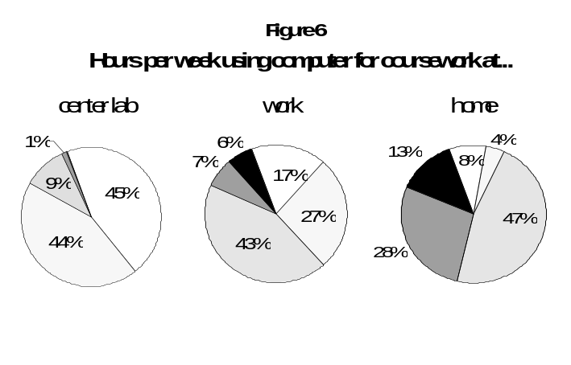
CCE Students were asked to indicate how well their ERAU education prepared them in several skill areas and how useful that skill is in their career field (see Figure 7).
Note: All degree levels are included
*Shaded boxes represent the highest campus percentage for each characteristic
Note: All degree types are included
*Shaded boxes represent the campus with the highest percentage for each characteristic

- Student Services
ERAU Skill Preparation
Usefulness of Skill at Work
56%
65%
61%
61%
62%
58%
59%
61%
61%
55%
35%
58%
29%
33%
55%
57%
56%
55%
53%
53%
52%
51%
49%
48%
46%
41%
41%
39%
33%
30%
Independent work
Speaking before an
M maudience
Planning, scheduling, carrying . out projects
Critical thinking
Defining and solving problems
Understanding other people and t tttheir views
Working in teams
Responsible action and decision m ngmaking
Writing skills
Technical writing
Political/economic awareness
Leading/guiding others
Quantitative/Mathematics
Library research
PC software software
Figure 7
Percent Responding Skill Preparation
is “Excellent” or “Very Good”
Percent Responding Skill is “Very Useful”
20%
0%
60%
40%
80%

Students were asked to rate the level of agreement they assign to eight areas of student services listed in Table 2. Most of the responses in these areas were favorable.
Table 2
Respondents’ Overall Perceptions of
Student Services

 | Agree | Neutral | Disagree
Registration procedures take place with little delay | 89% | 6% | 5%
Information regarding ERAU’s registration process is readily available to me | 86% | 11% | 3%
Financial transactions take place with little delay | 84% | 10% | 6%
ERAU shows concern for student development | 75% | 20% | 5%
My center director and center academic advisor are available to help me resolve academic problems in a timely manner | 72% | 20% | 8%
Channels for expressing students’ concerns are readily available to me | 69% | 22% | 9%
ERAU provides me with accurate academic advising | 64% | 23% | 13%
Specific information on student services is adequately communicated to me | 63% | 25% | 12%

- ERAU Library Services

Students were asked to rate the level of agreement they assign to several areas of library services (see Table 3). For each service listed in Table 3, at least 25% of survey respondents indicated that they have never used that service.
Table 3
Respondents’ Overall Perceptions of
Library Services
 | Agree | Neutral | Disagree | Never used | N/A
The combination of ERAU’s library resources, my resident center and my local libraries adequately meet my research needs | 36% | 17% | 5% | 25% | 17%
Access to web databases and indexes is helpful in obtaining information needed for my research | 34% | 12% | 4% | 30% | 20%
I have sufficient access to ERAU reference librarians | 27% | 13% | 5% | 37% | 18%
The ERAU library’s web page links me to all of the library’s services | 30% | 14% | 4% | 32% | 20%
The ERAU library staff is knowledgeable and helpful | 25% | 12% | 3% | 37% | 23%
The periodical/magazine collection at my resident center is a useful resource | 22% | 14% | 6% | 38% | 20%
Turnaround time for research assistance from reference librarians is satisfactory | 17% | 15% | 3% | 44% | 21%
I have sufficient access to interlibrary loan services from the ERAU library | 15% | 15% | 3% | 46% | 21%

- Veterans’ Affairs

55% of survey respondents indicated that Veterans’ Affairs services are applicable to them (see Table 4).

Table 4
Respondents’ Overall Perceptions of
Veterans’ Affairs Services
 | Agree | Neutral | Disagree | N/A
ERAU provides me with adequate Veterans’ Affairs information that meets my needs as a veteran | 34% | 14% | 7% | 45%
ERAU provides me with helpful and courteous Veterans’ Affairs services | 31% | 16% | 8% | 45%

- Financial Aid

About 60% of survey respondents indicated that Financial Aid services are applicable to them (see Table 5).

Table 5
Respondents’ Overall Perceptions of
Financial Aid Services
 | Agree | Neutral | Disagree | N/A
I receive adequate Financial Aid counseling that helps me understand the process | 40% | 15% | 12% | 33%
The Financial Aid office staff provides helpful, courteous service | 35% | 19% | 6% | 40%
The Financial Aid publications adequately explain types of assistance available | 31% | 20% | 8% | 41%
The Financial Aid office keeps me informed about the status of my application | 29% | 17% | 14% | 40%
There are adequate grant funds available to help financially needy students | 19% | 29% | 11% | 41%
There are adequate scholarship resources available to reward academic achievement | 17% | 28% | 15% | 40%

- CCE Resident Centers Ever Attended

As presented in Table 6, the majority of respondents have attended only one center (70%).

Table 6
Percent Noting Resident Centers Ever Attended
 | This center only | 2 centers | 3 centers | 4 or more centers
Total CCE resident centers ever attended | 70% | 20% | 6% | 4%

- CCE Terms Ever Attended

Over 85% of survey respondents have attended more than one term (Table 7).

Table 7
52%
33%
Percent Noting CCE Terms Ever Attended
 | 1 term | 2 – 3 terms | 4 – 5 terms | 6 – 10 terms | 11 or more terms
Total terms attended | 12% | 21% | 19% | 25% | 23%

- Distance Learning

Only 34% of survey respondents stated that they have taken Center for Distance Learning (CDL) classes before. 72% of these survey respondents indicated that they are satisfied with their overall experience with CDL. Moreover, 75% indicated that they would still take CDL classes if they had to do it again.

- Employer Description

Only 4% of survey respondents indicated that they are not currently employed. 52% indicated that they are employed in a military-related job, and 44% indicated that they are employed in the civilian sector (Figure 8).
59% of students with military-related jobs indicated that they are Air Force personnel. Navy and Army followed, with 20% and 17% respectively. 25% of the respondents with civilian-related jobs indicated aerospace engineering as their employment description, followed by airline and government, with 18% and 17% respectively.

4%
52%
44%
Civilian
Military
Not employed
Figure 8
Employment Description

Figure 8
Employment Description

- Forthcoming CCE Student Satisfaction Report

A full report is in progress, which includes CCE student satisfaction statistics from all 104 domestic and international resident centers classified by region (southeast, south-central, southwest, western, northwest, north-central, eastern and Europe).

- Forthcoming CDL Study

The Office of Institutional Research is developing a new survey with the purpose of assessing the level of satisfaction of students enrolled in the Center for Distance Learning (CDL). The in-house instrument will be administered in Spring 2001.


2000 EMPLOYER FEEDBACK SURVEY

The Employer Feedback Survey was created to evaluate how well Embry-Riddle’s academic programs are meeting employers’ needs and expectations. This information is best obtained from the supervisors of recent graduates. The survey instrument used includes questions about the supervisor and his company, the ERAU graduate’s overall performance, the usefulness of general and degree-specific skills in the field, and the graduate’s level of competence in these skills. Employer participation allows Embry-Riddle to tailor its programs in order to produce graduates who are better prepared to succeed in the workplace.
The Office of Institutional Research administered the 2000 Employer Feedback Survey to supervisors of the class of 1998 graduates from Daytona Beach, Prescott, College of Career Education (CCE), and Center for Distance Learning (CDL). The sample consisted of employers identified by respondents to the 1999 Alumni Survey. The supervisor was mailed a survey if the graduate (1) indicated that he was employed at a job “closely related” or “somewhat related” to his ERAU degree, (2) indicated that he was not self-employed, and (3) provided the full name and address of his supervisor. A sample of 335 supervisors received the survey. Of 315 deliverable surveys, 175 (56%) were completed and returned. Daytona Beach supervisors completed 58 surveys (60%), Prescott supervisors returned 23 surveys (54%), CCE supervisors returned 75 surveys (57%), and CDL supervisors completed 19 surveys (42%).
This issue of the IR Preview summarizes the results of the 2000 Employer Feedback Survey respondents. Data has been weighted statistically to correct for disproportionate response rates so that findings are representative of all employers of 1998 graduates employed in a job “closely related” or “somewhat related” to their ERAU degree and not self-employed.

- Employer Characteristics

To gain an understanding of the employers, some background questions were asked of the supervisors: the number of ERAU graduates they know professionally, the number of ERAU graduates they supervise, if they prefer to hire ERAU graduates, and if they too are an ERAU alumnus. The majority of employers (46%) knew between two and five Embry-Riddle graduates on a professional level. 20% of employers knew only one graduate (their employee), while 18% knew between eleven and fifty ERAU graduates. Few employers knew over 50 graduates (5%).
52% of employers supervised just one ERAU graduate (the recent alumnus) and 36% supervised between two and five ERAU graduates. 12% supervised six or more ERAU graduates.
When asked if they favored hiring Embry-Riddle graduates over graduates from other institutions, 19% of employers agreed. Most employers were neutral (74%), while only 7% disagreed.

11% of the employers who responded to the survey were Embry-Riddle alumni.

- Overall Performance of the ERAU Graduate

Assessing the overall performance of the graduate, many employers rated ERAU alumni very high. Areas evaluated were education, skill level, value to company, and candidacy for promotion.
Figure 9 shows the percentage of positive responses (“Strongly Agree” or “Agree”) for each question by campus. More Daytona Beach employers agreed that the education of the graduate was meeting their needs and that the skill level of the graduate was the same or better than the skill level of graduates from other institutions. More CCE employer’s felt that their ERAU graduates were good candidates for promotion. Regardless of campus, a high percentage of all employers agreed that the ERAU graduate was a valuable employee.

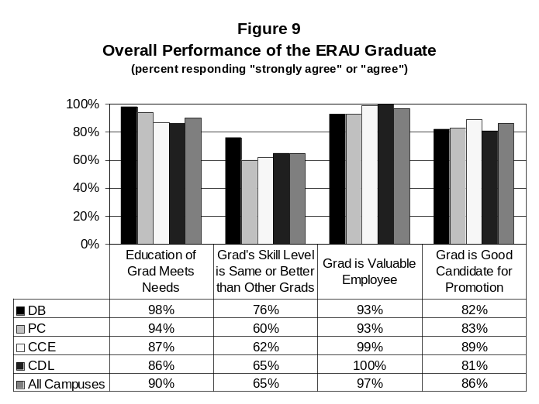
- General Skills

Using the response choices “Very Useful”, “Somewhat Useful”, and “Not Useful”, employers rated the usefulness of sixteen general education skills on the job. Figure 10 on the following page provides the percentage of employers that rated each skill as “Very Useful”. For all employers, the most useful skill was ‘Responsible Actions and Decision Making’. Other highly rated skills were ‘Critical Thinking’, ‘Defining and Solving Problems’, ‘Working in Groups/Teams’, ‘Independent Work’, ‘Planning, Scheduling, and Carrying Out Projects’, and ‘Understanding Other People and Other Points of View’. The least useful skill chosen by employers was ‘Library Research’.
Employers also rated the competence level of the ERAU graduate at the same general skills. The five response choices were “Excellent”, “Very Good”, “Good”, “Fair”, and “Poor”. For all campuses combined, employers thought that ‘Independent Work’ and ‘Working in Groups/Teams’ were the strongest skills and that ‘Political and Economic Awareness’ was the weakest. Table 8 shows the percentage of employers that assessed the graduate’s competence as “Excellent” or “Very Good” for each skill, by campus. The percentages can be compared against each other to evaluate the competence levels of graduates across the campuses. Daytona Beach graduates’ strongest skill was ‘PC Software’ (69%), Prescott graduates’ strongest skill was ‘Responsible Actions and Decision Making’ (76%), CCE graduates’ strongest skill was ‘Independent Work’ (79%), and CDL graduates’ strongest skills were ‘Defining and Solving Problems’ and ‘Responsible Actions and Decision Making’ (both at 82%). Weaker skills were ‘Political and Economic Awareness’ at Daytona Beach (22%), ‘Technical Writing’ and ‘Library Research’ at Prescott (44%), ‘Environmental Awareness’ and ‘Political and Economic Awareness’ at CCE (56%), and ‘Library Research’ at CDL (39%).
Table 8 also displays employer’s ratings of the competence of other graduates, providing a comparison between the graduates of each campus and graduates from other institutions. Employers consistently rated ERAU graduates higher than those from other institutions. The only exceptions were “Planning, Scheduling, and Carrying Out Projects” at Daytona Beach and “Political and Economic Awareness” also at Daytona Beach.

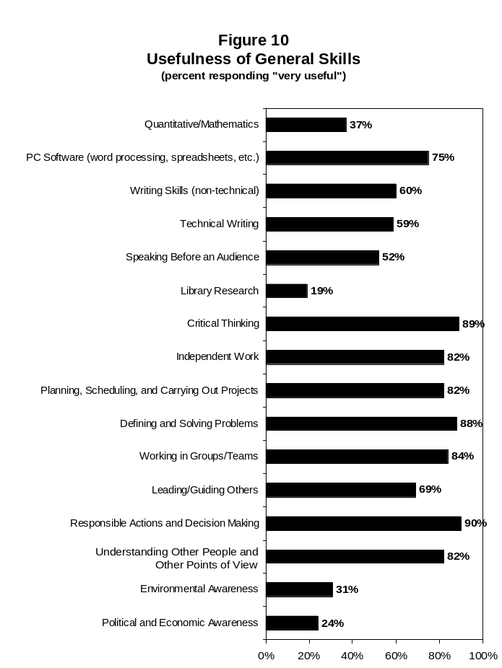
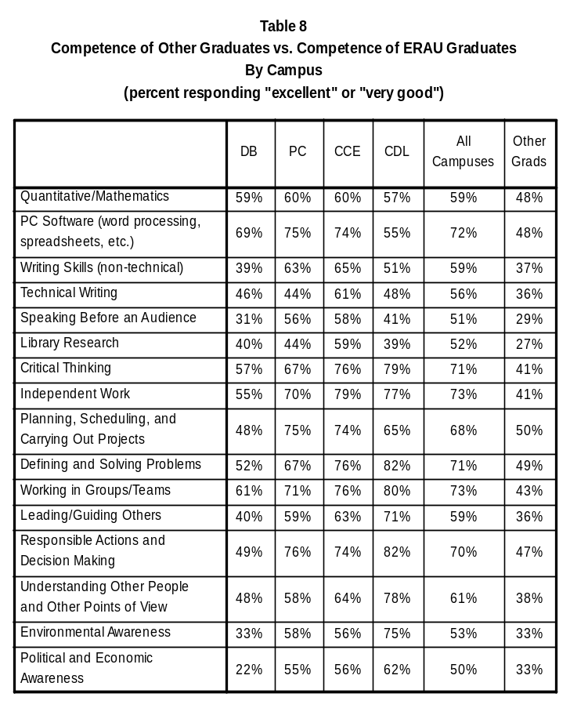
- Degree-Specific Skills

Employers were asked to evaluate the graduate’s competence at several degree-specific skills in the same manner as with the general skills. These ratings are available upon request, from the Office of Institutional Research. Caution must be used when interpreting these results since many degree programs had very few respondents.

- Future Administrations

As with this administration, the Employer Feedback Survey will continue to be conducted each spring with the employers of recent alumni (approximately one and one half years after graduation). To accommodate for small sample sizes, data will then be combined with information obtained from prior administrations, allowing for better representation and interpretation of the results, especially on the degree program level.
The IR Preview provides the ERAU community with timely information regarding current studies conducted by the Office of Institutional Research. The IR Preview is published whenever preliminary statistics of developing projects become available. Please refer to the forthcoming full reports for final and/or additional statistics.

