APPENDIX C

Survey Materials
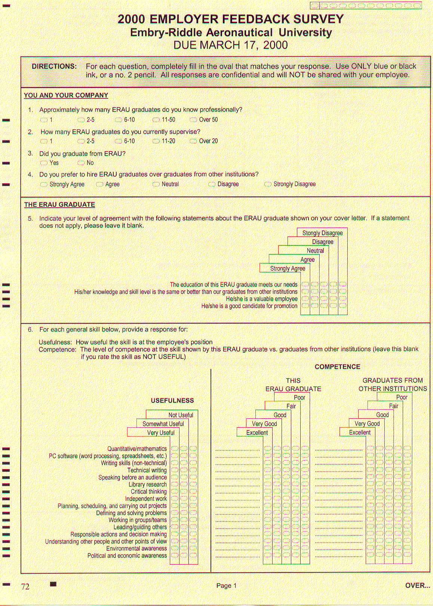
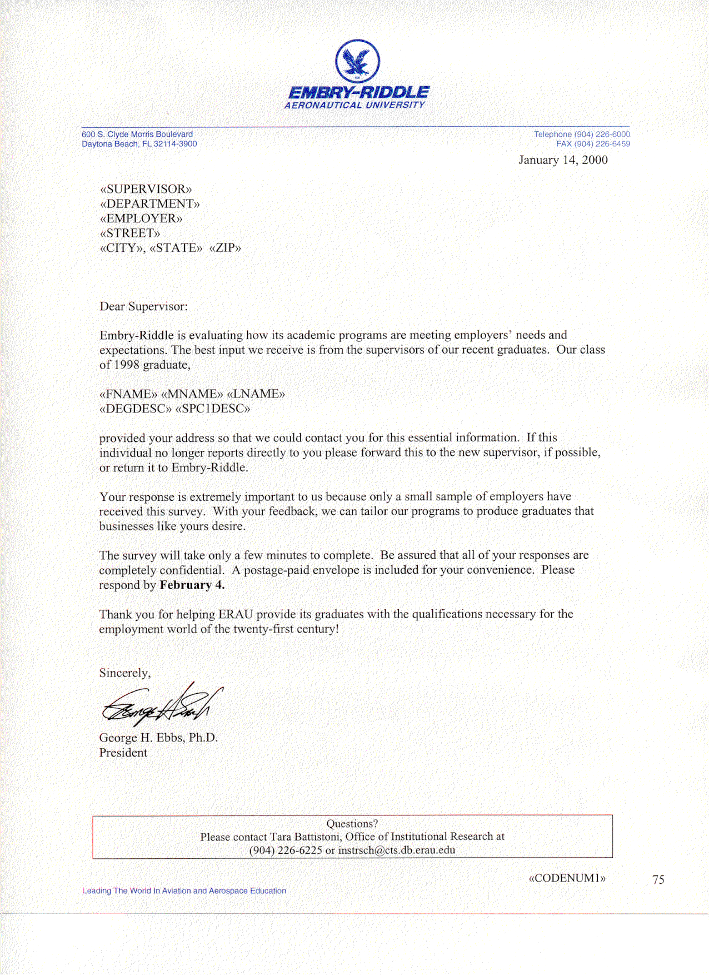
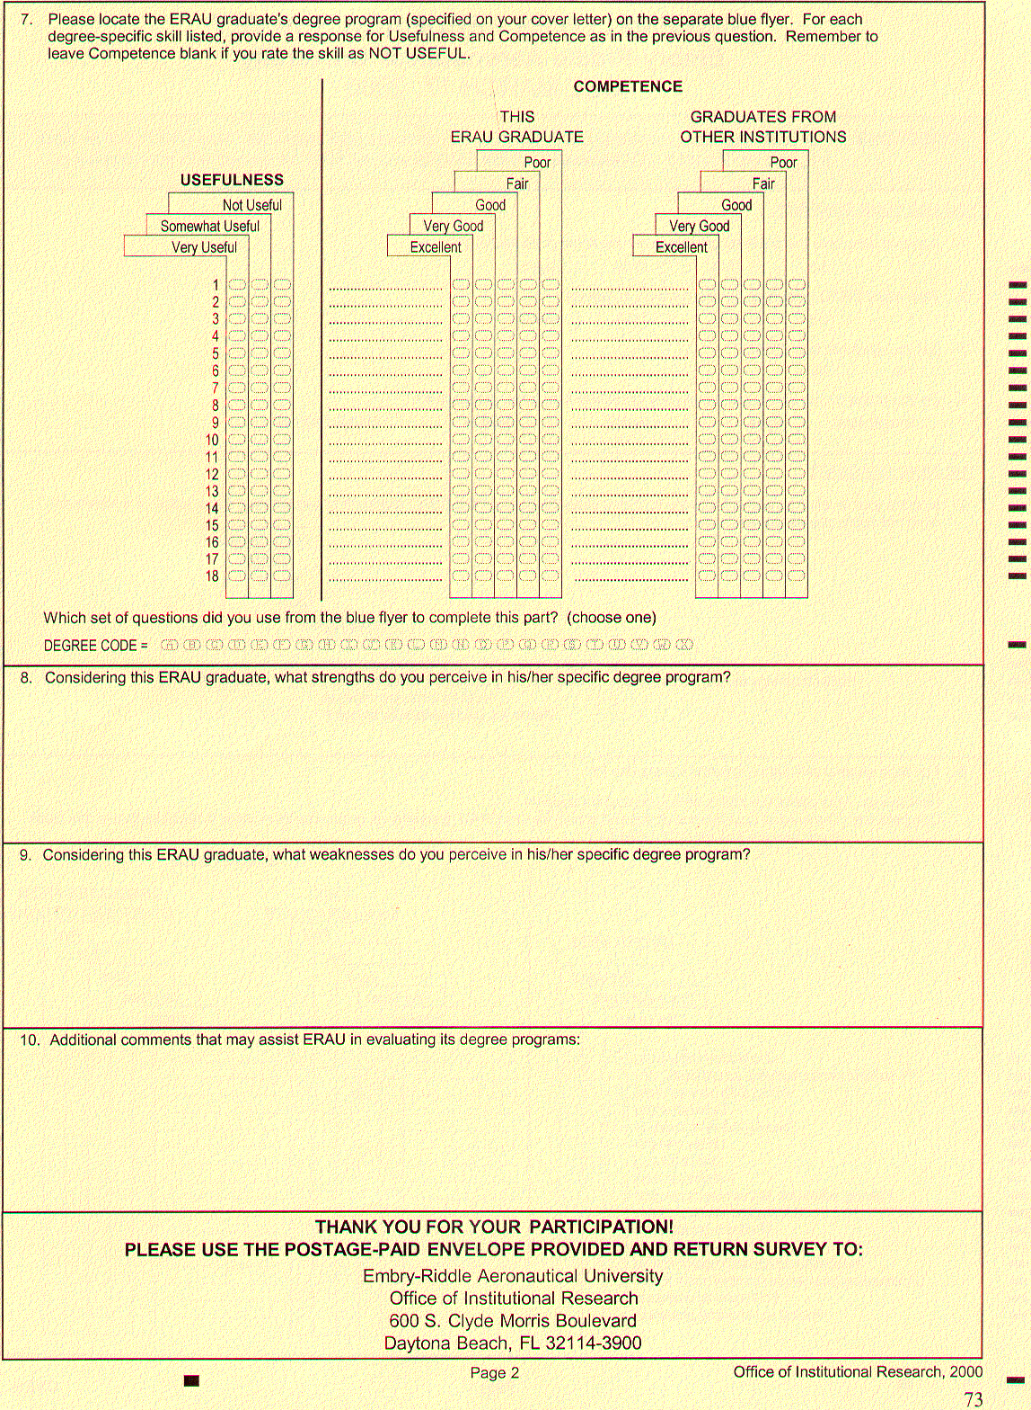

DEGREE-SPECIFIC SKILLS

DIRECTIONS: Using the information on your cover letter, locate the graduate’s degree program on this sheet and use the items listed to answer question #7. Record all ratings on the survey itself, NOT on this flyer. Use the letter in parentheses to fill in the last part of the question, asking for the degree code.

NOTE: SOME DEGREE PROGRAMS ARE NOT LISTED. IF THE GRADUATE’S DEGREE IS NOT ON THIS FLYER, LEAVE QUESTION #7 BLANK.

(A) A AVIATION MAINTENANCE TECHNOLOGY
AND
AS AIRCRAFT MAINTENANCE
1. General knowledge of maintenance operations and safety
2. Electrical and electronic systems operations
3. Skills in metallic and non-metallic structures and repair
4. Understanding of a/c systems (hydraulics, environmentals, etc.)
5. Knowledge of reciprocating and turbine engines and their respective systems
6. Knowledge and ability to work with technical publications and manuals
7. Skills in troubleshooting
8. Use of precision measuring instruments and basic and special tools
9. Understanding and knowledge of FAA regulations
(F) BS AVIATION BUSINESS ADMINISTRATION
1. Understanding and applying management theory/concept
2. Understanding and using accounting and financial information
3. Understanding how the market system works
4. Awareness of personnel procedures, collective bargaining, and the legal obligations of managements
5. Applying statistical and/or quantitative techniques to problem solving

(G) BS AVIATION MAINTENANCE MANAGEMENT
AND
BS AVIATION MAINTENANCE MANAGEMENT (AVIONICS)
1. Understanding and applying management theory/concepts
2. Understanding and using accounting and financial information
- Understanding how the market system works
- Awareness of personnel procedures, collective bargaining, and the legal obligations of managements
- Applying statistical and/or quantitative techniques to problem solving

(B) BS AEROSPACE ENGINEERING
1. Design
2. Subsonic aerodynamics
3. Supersonic aerodynamics
4. Experimental aerodynamics
5. Aircraft performance
6. Aircraft stability and control
7. Control systems
8. Stress analysis
9. Aircraft structural analysis
10. Dynamics
11. Materials selection
12. Gas turbine propulsion
13. Rocket propulsion
14. Orbital mechanics
15. Engineering test instrumentation
16. Circuits and electronics

(H) BS AVIATION MAINTENANCE MANAGEMENT (MAINTENANCE)
1. Understanding and applying management theory/concepts
2. Understanding and using accounting and financial information
3. Understanding how the market system works
- Awareness of personnel procedures, collective bargaining, and the legal obligations of managements
- Applying statistical and/or quantitative techniques to problem solving
6. General knowledge of maintenance operations and safety
7. Electrical and electronic systems operations
8. Skills in metallic and non-metallic structures and repair
9. Understanding of a/c systems (hydraulics, environmentals, etc.)
10. Knowledge of reciprocating and turbine engines and their respective systems
11. Knowledge and ability to work with technical publications and manuals
12. Skills in troubleshooting
13. Use of precision measuring instruments and basic and special tools
14. Understanding and knowledge of FAA regulations

(C) BS AERONAUTICAL SCIENCE
1. Understanding aerodynamic performance of aircraft powered by reciprocating and turbine engines
2. Use of electronic navigation and flight control systems
3. Crew coordination (cockpit resource management)
4. Knowledge of flight physiology, awareness of flight psychology (human factors)
5. Awareness of safety and accident prevention
6. Understanding the concepts and process of meteorology
7. Instrument flight skill
8. Multi-engine/high performance aircraft operations
9. Knowledge of Federal Aviation Regulations
10. Aeronautical decision making (judgement skills)

(I) BS AVIATION TECHNOLOGY (MAINTENANCE/AVIONICS)
1. General knowledge of maintenance operations and safety
2. Skills in metallic and non-metallic structures and repair
3. Understanding of a/c systems (hydraulics, environmentals, etc.)
4. Knowledge of reciprocating and turbine engines and their respective systems
5. Knowledge and ability to work with technical publications and manuals
6. Skills in troubleshooting
7. Use of precision measuring instruments and basic and special tools
8. Understanding and knowledge of FAA regulations
9. Basic and advanced electronics analysis and theory
10. Avionics equipment and system analysis
11. Avionics/electronics system test, analysis, and repair

(D) BS AEROSPACE STUDIES
1. Interpersonal communication theory and skills
2. Interpreting written materials
3. Analytical thinking
4. Leadership theory and skills
5. International perspectives
6. Understanding statistics
7. Knowledge of aviation/aerospace industries
8. Cultural awareness
9. Interdisciplinary methods

(J) BS AVIATION TECHNOLOGY (MAINTENANCE/FLIGHT)
1. General knowledge of maintenance operations and safety
2. Skills in metallic and non-metallic structures and repair
3. Understanding of a/c systems (hydraulics, environmentals, etc.)
4. Knowledge of reciprocating and turbine engines and their respective systems
5. Knowledge and ability to work with technical publications and manuals
6. Skills in troubleshooting
7. Use of precision measuring instruments and basic and special tools
8. Understanding and knowledge of FAA regulations
9. Electrical and electronic systems operations
10. Understanding aerodynamic performance of aircraft powered by reciprocating and turbine engines
11. Use of electronic navigation and flight control systems
12. Crew coordination (cockpit resource management)
13. Knowledge of flight physiology, awareness of flight psychology (human factors)
14. Awareness of safety and accident prevention
15. Understanding the concepts and process of meteorology
16. Instrument flight skill
17. Multi-engine/high performance aircraft operations
18. Aeronautical decision making (judgment skills)

(E) BS AIRCRAFT ENGINEERING TECHNOLOGY
1. Aerodynamics/performance
2. Structures
3. Propulsion
4. Dynamic systems and control
5. Material science
6. Manufacturing processes
7. Non-destructive testing
8. Measurement and testing
9. Reliability/maintainability

OVER…

78

(K) BS AVIONICS ENGINEERING TECHNOLOGY
1. Basic and advanced electronics analysis and theory
2. Avionics system analysis and design
3. Avionics/electronics system test
4. Applied mechanical engineering concepts
5. Basic design and engineering concepts
6. Applications software and programming
- Reliability/maintainability
- Systems integration

(O) BS ENGINEERING PHYSICS
1. Ability to study and master new concepts and techniques,
demonstrating a commitment to life-long learning
2. General physics and general chemistry
3. Computer skills for engineering analysis and design
- Basic Engineering: statics, dynamics, and solid mechanics
- Engineering Sciences: thermodynamics, materials science, and fluid mechanics
6. Advanced mathematics
7. Systems testing/development
8. Electrical engineering and electronics
- Optical systems
- Theoretical physics: classical mechanics, electromagnetic theory, and quantum mechanics
11. Space systems, space mechanics, and design

(L) BS CIVIL ENGINEERING
1. Airport facility design
2. Airport planning
3. Transportation engineering
4. Hydraulics/hydrology
5. Materials testing
6. Construction engineering
7. Construction management
8. Soil mechanics
9. Foundation design
10. Pavement design
11. Structural analysis
12. Structural steel design
13. Structural concrete design
14. Computer applications
15. CAD
16. Environmental engineering

(P) BS MANAGEMENT OF TECHNICAL OPERATIONS
1. Relating management concepts to prior knowledge in a technical operations specialty
2. Using accounting, financial, and statistical information in the management of technical operations
3. Applying organizational and human resources theory and concepts in the workplace
4. Using computer technology to support technical operations
5. Understanding the social, economic, ethical, political, and legal environment of a technical enterprise
6. Applying strategic and project planning principles and techniques in a technical operation

(M) BS COMPUTER SCIENCE
AND
BS AVIATION COMPUTER SCIENCE
1. Applying theory of structured programming and algorithm design to the design of computer programs
2. Applying theory of system partitioning and hierarchical
decomposition to the design of software systems
3. Applying data structures theory to the design of computer files databases
4. Understanding the fundamental concepts of computer organization and architecture
5. Understanding the fundamental concepts of computer graphics
6. Understanding the fundamental concepts of artificial intelligence
7. Understanding the fundamental concepts of modeling and simulation
8. Understanding the fundamental concepts of real-time
computing
- Understanding the fundamental concepts of software engineering
- Understanding of the theory and use of operating systems
- Applying software engineering concepts to specify, design, construct, and test a software product
12. Building software components in the context of aviation and aerospace applications
(N) BS ELECTRICAL ENGINEERING
1. Circuits and networks - analysis
2. Circuits and networks - design
3. Solid state electronics
4. Power systems
5. Rotating machines
6. Electromagnetics
7. Communications systems
8. Control systems
9. Digital electronics and computer systems
10. Aviation applications
11. Statics and dynamics
12. Thermodynamics and heat transfer
13. Materials science
14. Engineering design

(Q) BS PROFESSIONAL AERONAUTICS
1. Knowledge and understanding of aviation law and regulations
2. Understanding and application of management theory/concepts
3. Understanding and use of accounting and financial information
4. Use of statistical/quantitative techniques to solve problems
5. Understanding of safety issues, employment of accident prevention techniques, safety program practices and management, and mishap investigation
6. Knowledge and understanding of advanced management concepts, issues, and practices as applied in a variety of aviation operations and services
- Knowledge and understanding of aeronautical science, technology and
operations, concepts, theory and applications

DEGREE-SPECIFIC SKILLS

DIRECTIONS: Using the information on your cover letter, locate the graduate’s degree program on this sheet and use the items listed to answer question #7. Record all ratings on the survey itself, NOT on this flyer. Use the letter in parentheses to fill in the last part of the question, asking for the degree code.

NOTE: SOME DEGREE PROGRAMS ARE NOT LISTED. IF THE GRADUATE’S DEGREE IS NOT ON THIS FLYER, LEAVE QUESTION #7 BLANK.

(W) M BUSINESS ADMINISTRATION IN AVIATION
1. Understanding the functions and scope of the management of human resources
2. Knowledge and application of organizational concepts including group
dynamics, leadership, conflict resolution, ethics, and motivation
3. Understanding the concepts and strategies involved in planning, implementing and controlling a marketing plan
4. Application and analysis of the following managerial accounting concepts: cost accounting, cost-volume-profit relationships, budgeting, standard costs, segment analysis, and financial ratio
5. Skills in analyzing financial statements and other corporate finance concepts and techniques
6. Knowledge of general systems concepts, decisions, and information systems
7. Application of statistical and quantitative analysis
8. Application of microeconomic concepts to aviation operations demand using forecasting and pricing techniques
9. Skills to formulate strategy and policy required to obtain organizational goals in a competitive interactive environment
(X) MS TECHNICAL MANAGEMENT
1. Applying computer and communication skills in technical environments
2. Applying quantitative and statistical skills for decision making
3. Using financial, accounting, and quality control processes
4. Understanding organizational theory and work team dynamics
5. Understanding systems development and operations
6. Assessing the regulatory, ethical, and legal environment of technical operations
7. Understanding marketing techniques applicable to technical operations
8. Understanding procurement and contracting techniques and processes
- M AERONAUTICAL SCIENCE – AERONAUTICS SPECIALIZATION
1. Air transportation as part of the global, multi-modal system
2. Basic elements of Space Transportation System
3. State-of-the-art materials and practices used in manufacture and maintenance of A/A vehicles
4. Human factors problems and analysis
5. Major steps in developing a research study
6. Analysis of five major research methodologies
7. Advances in Aviation/Aerospace aerodynamics
8. Value of simulation in aviation training programs
9. Operation of high technology meteorology data computer systems
10. Evaluation of aircraft and spacecraft guidance, control, communication, and navigation systems
11. Analysis of spacecraft propulsion systems
(T) M AERONAUTICAL SCIENCE – AVIATION/AEROSPACE EDUCATION TECHNOLOGY SPECIALIZATION
1. Air transportation as part of the global, multi-modal system
2. Basic elements of Space Transportation System
3. State-of-the-art materials and practices used in manufacture and maintenance of A/A vehicles
4. Human factors problems and analysis
5. Major steps in developing a research study
6. Analysis of five major research methodologies
7. Role of education in Aviation/Aerospace industry
8. Value of simulation in aviation training programs
9. Similarities and differences between pedagogy and andragogy
10. Uniqueness and commonalities of the adult learning process

(U) M AERONAUTICAL SCIENCE – AVIATION/AEROSPACE MANAGEMENT SPECIALIZATION
1. Air transportation as part of the global, multi-modal system
2. Basic elements of Space Transportation System
3. State-of-the-art materials and practices used in manufacture and maintenance of A/A vehicles
4. Human factors problems and analysis
5. Major steps in developing a research study
6. Analysis of five major research methodologies
7. Production and procurement management in manufacturing
8. Supply and distribution functions in the logistic system
9. Strategic planning and strategic management concepts
10. Interaction of maintenance with operations, logistics, and training functions
11. Key factors impacting on R and D programs

(R) M AERONAUTICAL SCIENCE – AVIATION/AEROSPACE SAFETY SYSTEMS SPECIALIZATION,
M AERONAUTICAL SCIENCE – HUMAN FACTORS IN AVIATION SYSTEMS SPECIALIZATION,
AND
M AERONAUTICAL SCIENCE – SPACE STUDIES SPECIALIZATION
1. Air transportation as part of the global, multi-modal system
2. Basic elements of Space Transportation System
3. State-of-the-art materials and practices used in manufacture and maintenance of A/A vehicles
4. Human factors problems and analysis
5. Major steps in developing a research study
6. Analysis of five major research methodologies
(V) M AERONAUTICAL SCIENCE – AVIATION/AEROSPACE
OPERATIONS SPECIALIZATION
1. Air transportation as part of the global, multi-modal system
2. Basic elements of Space Transportation System
3. State-of-the-art materials and practices used in manufacture and
maintenance of A/A vehicles
4. Human factors problems and analysis
5. Major steps in developing a research study
6. Analysis of five major research methodologies
7. Past, present, and future airspace and ATC technology
8. Roles and responsibilities of FAA, NTSB, and military in accident investigation
9. Crash site investigation
10. Management and operations related to Air Carriers
11. Qualifications and training of aircraft dispatchers
12. Responsibilities associated with Corporate Aviation operations

Office of Institutional Research
Embry-Riddle Aeronautical University
600 S. Clyde Morris Boulevard
Daytona Beach, FL 32114-3900



HAVE YOU RESPONDED TO THE EMBRY-RIDDLE
EMPLOYER FEEDBACK SURVEY?

*If you have not yet responded, please take a few minutes to COMPLETE
and RETURN the survey.

*If you have misplaced or did not receive your Employer Feedback Survey,
please contact the Office of Institutional Research at (904) 226-6225 or
instrsch@cts.db.erau.edu

Your participation is greatly appreciated. Thank you to those who have
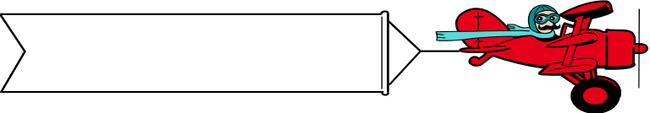 already responded!

DUE FEBRUARY 4

