APPENDIX D

IR Preview

This IR Preview has been lifted from the June 2000 issue of the IR Preview. The full IR Preview contains information on the 2000 College of Career Education Student Satisfaction Survey and the 2000 Employer Feedback Survey. Because only the information on the Employer Feedback Survey is pertinent here, it is the only part included. For the complete IR Preview please refer to IR Preview Volume 3, Number 5, published June 2000.

2000 EMPLOYER FEEDBACK SURVEY

The Employer Feedback Survey was created to evaluate how well Embry-Riddle’s academic programs are meeting employers’ needs and expectations. This information is best obtained from the supervisors of recent graduates. The survey instrument used includes questions about the supervisor and his company, the ERAU graduate’s overall performance, the usefulness of general and degree-specific skills in the field, and the graduate’s level of competence in these skills. Employer participation allows Embry-Riddle to tailor its programs in order to produce graduates who are better prepared to succeed in the workplace.
The Office of Institutional Research administered the 2000 Employer Feedback Survey to supervisors of the class of 1998 graduates from Daytona Beach, Prescott, College of Career Education (CCE), and Center for Distance Learning (CDL). The sample consisted of employers identified by respondents to the 1999 Alumni Survey. The supervisor was mailed a survey if the graduate (1) indicated that he was employed at a job “closely related” or “somewhat related” to his ERAU degree, (2) indicated that he was not self-employed, and (3) provided the full name and address of his supervisor. A sample of 335 supervisors received the survey. Of 315 deliverable surveys, 175 (56%) were completed and returned. Daytona Beach supervisors completed 58 surveys (60%), Prescott supervisors returned 23 surveys (54%), CCE supervisors returned 75 surveys (57%), and CDL supervisors completed 19 surveys (42%).
This issue of the IR Preview summarizes the results of the 2000 Employer Feedback Survey respondents. Data has been weighted statistically to correct for disproportionate response rates so that findings are representative of all employers of 1998 graduates employed in a job “closely related” or “somewhat related” to their ERAU degree and not self-employed.

- Employer Characteristics

To gain an understanding of the employers, some background questions were asked of the supervisors: the number of ERAU graduates they know professionally, the number of ERAU graduates they supervise, if they prefer to hire ERAU graduates, and if they too are an ERAU alumnus. The majority of employers (46%) knew between two and five Embry-Riddle graduates on a professional level. 20% of employers knew only one graduate (their employee), while 18% knew between eleven and fifty ERAU graduates. Few employers knew over 50 graduates (5%).
52% of employers supervised just one ERAU graduate (the recent alumnus) and 36% supervised between two and five ERAU graduates. 12% supervised six or more ERAU graduates.
When asked if they favored hiring Embry-Riddle graduates over graduates from other institutions, 19% of employers agreed. Most employers were neutral (74%), while only 7% disagreed.

11% of the employers who responded to the survey were Embry-Riddle alumni.

- Overall Performance of the ERAU Graduate

Assessing the overall performance of the graduate, many employers rated ERAU alumni very high. Areas evaluated were education, skill level, value to company, and candidacy for promotion.
Figure 9 shows the percentage of positive responses (“Strongly Agree” or “Agree”) for each question by campus. More Daytona Beach employers agreed that the education of the graduate was meeting their needs and that the skill level of the graduate was the same or better than the skill level of graduates from other institutions. More CCE employer’s felt that their ERAU graduates were good candidates for promotion. Regardless of campus, a high percentage of all employers agreed that the ERAU graduate was a valuable employee.

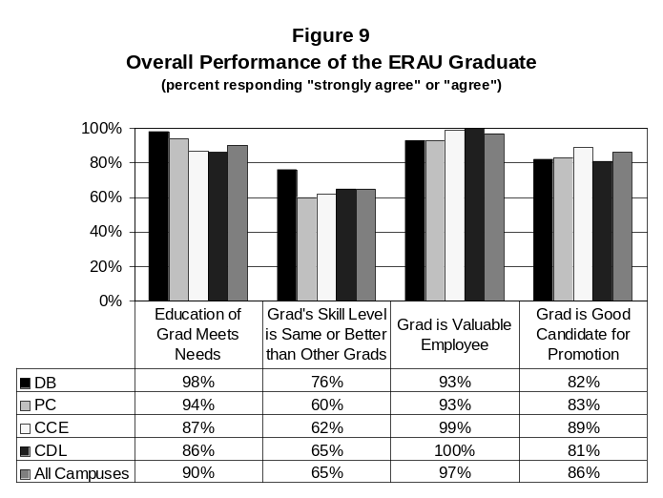
- General Skills

Using the response choices “Very Useful”, “Somewhat Useful”, and “Not Useful”, employers rated the usefulness of sixteen general education skills on the job. Figure 10 on the following page provides the percentage of employers that rated each skill as “Very Useful”. For all employers, the most useful skill was ‘Responsible Actions and Decision Making’. Other highly rated skills were ‘Critical Thinking’, ‘Defining and Solving Problems’, ‘Working in Groups/Teams’, ‘Independent Work’, ‘Planning, Scheduling, and Carrying Out Projects’, and ‘Understanding Other People and Other Points of View’. The least useful skill chosen by employers was ‘Library Research’.
Employers also rated the competence level of the ERAU graduate at the same general skills. The five response choices were “Excellent”, “Very Good”, “Good”, “Fair”, and “Poor”. For all campuses combined, employers thought that ‘Independent Work’ and ‘Working in Groups/Teams’ were the strongest skills and that ‘Political and Economic Awareness’ was the weakest. Table 8 shows the percentage of employers that assessed the graduate’s competence as “Excellent” or “Very Good” for each skill, by campus. The percentages can be compared against each other to evaluate the competence levels of graduates across the campuses. Daytona Beach graduates’ strongest skill was ‘PC Software’ (69%), Prescott graduates’ strongest skill was ‘Responsible Actions and Decision Making’ (76%), CCE graduates’ strongest skill was ‘Independent Work’ (79%), and CDL graduates’ strongest skills were ‘Defining and Solving Problems’ and ‘Responsible Actions and Decision Making’ (both at 82%). Weaker skills were ‘Political and Economic Awareness’ at Daytona Beach (22%), ‘Technical Writing’ and ‘Library Research’ at Prescott (44%), ‘Environmental Awareness’ and ‘Political and Economic Awareness’ at CCE (56%), and ‘Library Research’ at CDL (39%).
Table 8 also displays employer’s ratings of the competence of other graduates, providing a comparison between the graduates of each campus and graduates from other institutions. Employers consistently rated ERAU graduates higher than those from other institutions. The only exceptions were “Planning, Scheduling, and Carrying Out Projects” at Daytona Beach and “Political and Economic Awareness” also at Daytona Beach.

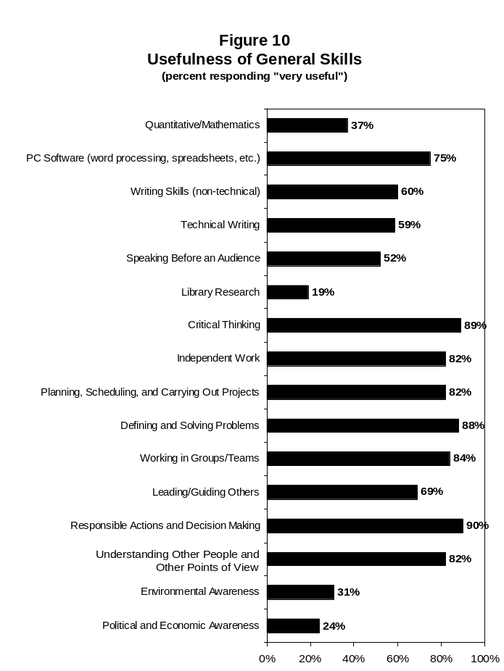
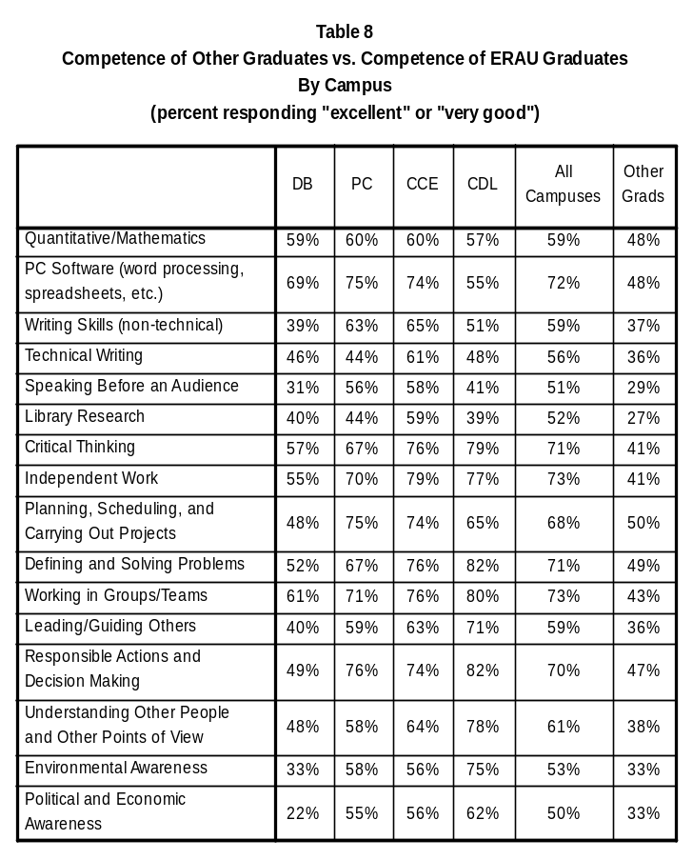
- Degree-Specific Skills

Employers were asked to evaluate the graduate’s competence at several degree-specific skills in the same manner as with the general skills. These ratings are available upon request, from the Office of Institutional Research. Caution must be used when interpreting these results since many degree programs had very few respondents.

- Future Administrations

As with this administration, the Employer Feedback Survey will continue to be conducted each spring with the employers of recent alumni (approximately one and one half years after graduation). To accommodate for small sample sizes, data will then be combined with information obtained from prior administrations, allowing for better representation and interpretation of the results, especially on the degree program level.
The IR Preview provides the ERAU community with timely information regarding current studies conducted by the Office of Institutional Research. The IR Preview is published whenever preliminary statistics of developing projects become available. Please refer to the forthcoming full reports for final and/or additional statistics.

