
IR PREVIEW
Preliminary highlights from Volume 4, Number 3 Volume
current IR studies August 2001

Office of Institutional Research http://irweb.erau.edu Daytona Beach, FL 32114-3900 (386) 226-6225

IN THIS ISSUE

- 2001 Employer Feedback Survey (Class of 1999 graduates)

2001 EMPLOYER FEEDBACK SURVEY

The Employer Feedback Survey was created to evaluate how well Embry-Riddle’s academic programs are meeting employers’ needs and expectations. This information is best obtained from the supervisors of recent graduates. The survey instrument included questions about the supervisor and his company, the ERAU graduate’s overall performance, the usefulness of general and degree-specific skills in the field, and the graduate’s level of competence in these skills. Employer participation allows Embry-Riddle to tailor its programs in order to produce graduates who are better prepared to succeed in the workplace.
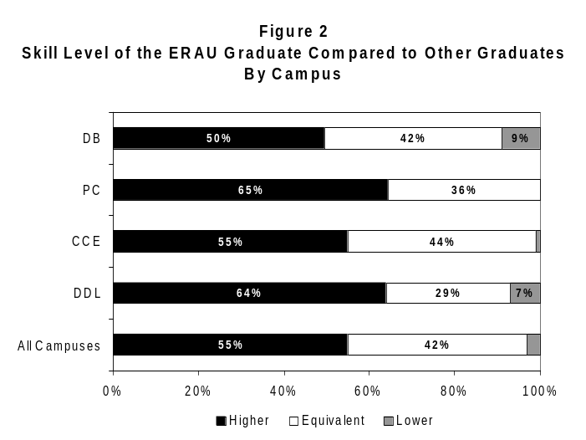The Office of Institutional Research administered the 2001 Employer Feedback Survey to supervisors of the class of 1999 graduates from Daytona Beach, Prescott, and the Extended Campus (composed of the College of Career Education [CCE] and the Department of Distance Learning [DDL]). The target group was defined as employers of recent graduates whose jobs were “closely related” or “somewhat related” to their ERAU degree, as indicated by the graduates on the 2000 Alumni Survey. 389 graduates from this target group provided the full name and address of their supervisor, who was then sent the survey. Of 363 deliverable surveys, 217 (60%) were completed and returned. Daytona Beach supervisors completed 68 surveys (60%), Prescott supervisors returned 21 surveys (50%), CCE supervisors returned 98 surveys (65%), and DDL supervisors completed 30 surveys (55%).
This issue of the IR Preview summarizes the results of the 2001 Employer Feedback Survey respondents. Data has been weighted statistically to correct for disproportionate response rates so that findings are representative of all employers in the target group. Any numeric inconsistencies are due to the rounding of weighted data.

- Employer Characteristics

The majority of employers (47%) knew between two and five Embry-Riddle graduates on a professional level. 12% of employers knew only one graduate (their employee), 20% knew between six and ten, and 17% knew between eleven and fifty. Few employers knew over fifty graduates (4%).
REVISED AUGUST 8, 2001
53% of employers supervised just one ERAU graduate (the recent alumnus) and 37% supervised between two and five ERAU graduates. 10% supervised six or more ERAU graduates.
41% of employers preferred to hire ERAU graduates (16% “Strong Preference”, 24% “Some Preference”). Most employers did not have a preference for the graduates they hired (58%).
17% of the employers who responded to the survey were Embry-Riddle alumni.

- Overall Performance of the ERAU Graduate

Assessing the overall performance of the graduate, many employers rated ERAU alumni very high. Areas

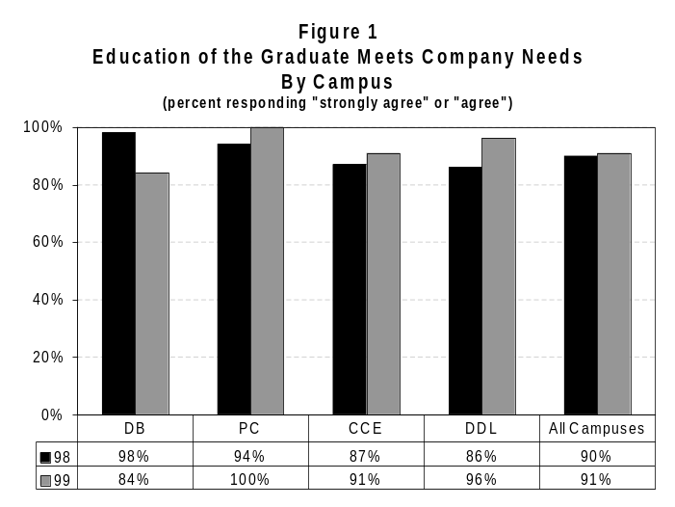
evaluated were education, skill level, value to the company, and candidacy for promotion. Figure 1 on the previous page displays the rating of the graduate’s education in terms of meeting company needs. Figure 2 also on the previous page shows the skill level of the ERAU graduate when compared to other graduates.

- General Skills

Using the response choices “Very Useful”, “Somewhat Useful”, and “Not Useful”, employers rated the usefulness of sixteen general education skills on the job. Figure 3 provides the percentage of employers that rated each skill as “Very Useful”. The most useful skills were ‘Defining and Solving Problems’ and ‘Responsible Actions and Decision Making’. The least useful skill was ‘Political and Economic Awareness’.

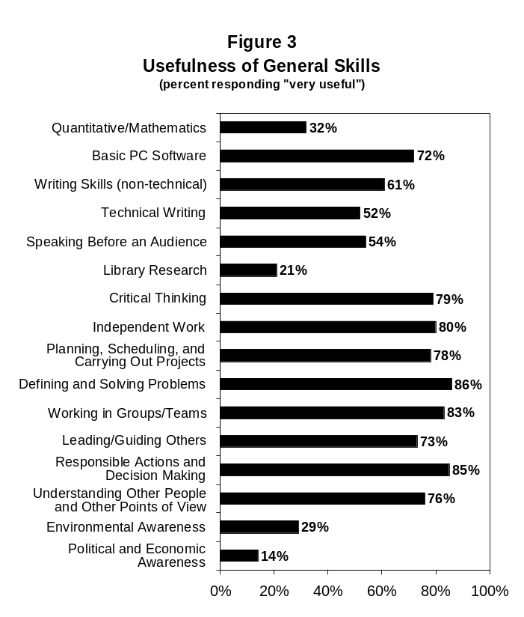
Employers also rated the competence level of the ERAU graduate at the same general skills. The five response choices were “Excellent”, “Very Good”, “Good”, “Fair”, and “Poor”. For all campuses combined, employers thought that ‘Independent Work’ was the strongest skill. It was also one of the strongest skills last year. For the second year in a row, the weakest skill for employers was ‘Political and Economic Awareness’, however, employers also rated it as the least useful skill this year. Table 1 shows the percentage of employers who assessed the graduate’s competence as “Excellent” or “Very Good” for each skill, by campus. Employers’ ratings of the competence of other graduates are also listed, providing a comparison between the ERAU graduates and graduates from other institutions.
Employers evaluated the graduate’s competence at several degree-specific skills in the same manner as the general skills. These ratings will be provided to individual programs in an addendum to the full report.

Table 1
Competence of the ERAU Grad at General Skills vs. Other Grads

By Campus
(percent responding "excellent" or "very good")
 | DB | PC | CCE | DDL | All Campuses | Other Grads
Quantitative/Mathematics | 47% | 83% | 56% | 57% | 56% | 48%
Basic PC Software | 55% | 65% | 75% | 35% | 67% | 51%
Writing Skills (non-technical) | 43% | 44% | 64% | 59% | 58% | 42%
Technical Writing | 39% | 27% | 59% | 66% | 54% | 41%
Speaking Before an Audience | 38% | 30% | 64% | 67% | 57% | 44%
Library Research | 37% | 21% | 61% | 60% | 54% | 41%
Critical Thinking | 46% | 49% | 68% | 67% | 62% | 50%
Independent Work | 62% | 61% | 84% | 70% | 76% | 55%
Planning, Scheduling, and Carrying Out Projects | 57% | 42% | 80% | 65% | 72% | 49%
Defining and Solving Problems | 52% | 63% | 74% | 63% | 67% | 46%
Working in Groups/Teams | 55% | 58% | 72% | 74% | 68% | 48%
Leading/Guiding Others | 34% | 51% | 63% | 65% | 56% | 36%
Responsible Actions and Decision Making | 49% | 59% | 76% | 77% | 70% | 46%
Understanding Other People and Other Points of View | 47% | 58% | 70% | 49% | 63% | 36%
Environmental Awareness | 39% | 33% | 49% | 62% | 46% | 32%
Political and Economic Awareness | 29% | 8% | 44% | 68% | 41% | 34%
Note: Shaded cells represent instances in which the rating for ERAU graduates is less than that for graduates from other institutions.

- Full Report and Future Administrations

The full report, detailing the results of this survey, is currently in progress. Trend data will be provided as appropriate. Data will be disaggregated to the degree program level and combined with information obtained from prior administrations allowing results to be presented across many degree programs, even those with few respondents.
In keeping with the timetable of the last two administrations, the Employer Feedback Survey will continue to be conducted every spring with employers of recent alumni (approximately one and one half years after graduation).

The IR Preview provides the ERAU community with timely information regarding current studies conducted by the Office of Institutional Research. The IR Preview is published whenever preliminary statistics of developing projects become available. Please refer to the forthcoming full report for final and/or additional statistics.

REVISED AUGUST 8, 2001

