Students who visit the Student Success Center as part of their withdrawal process are asked to complete an Exit Interview. Results are presented below. Please note that respondents are those who have taken the initiative to inform the University that they are leaving. Students who stop-out or simply bypass the withdrawal process are not represented here.

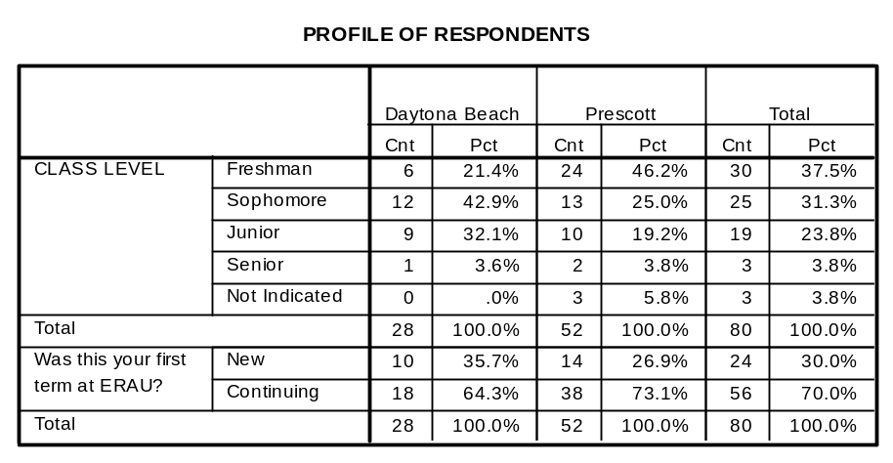
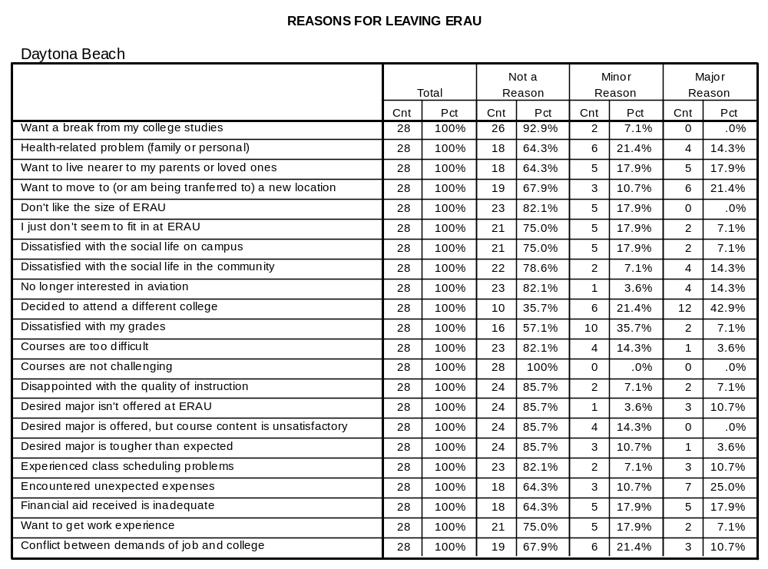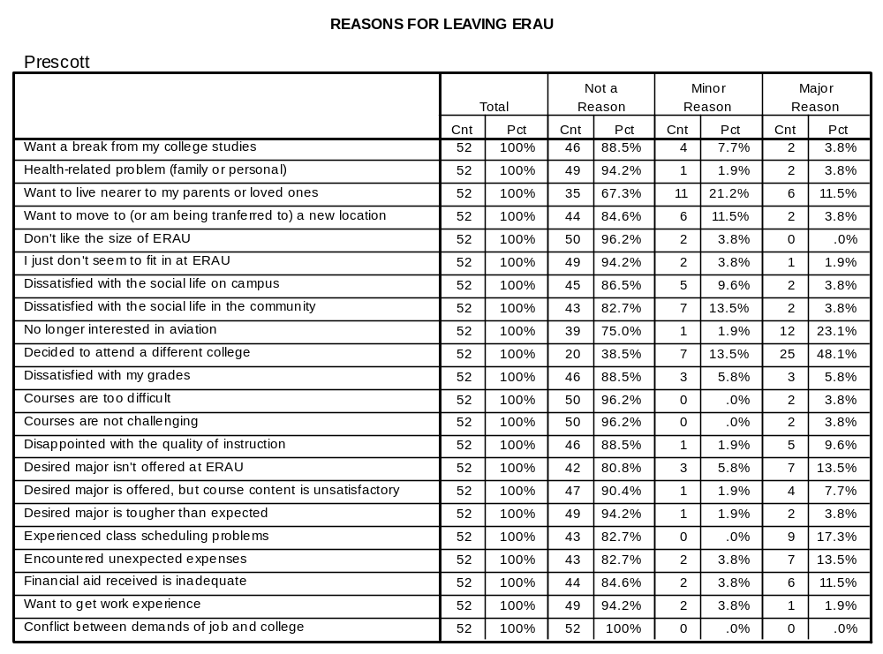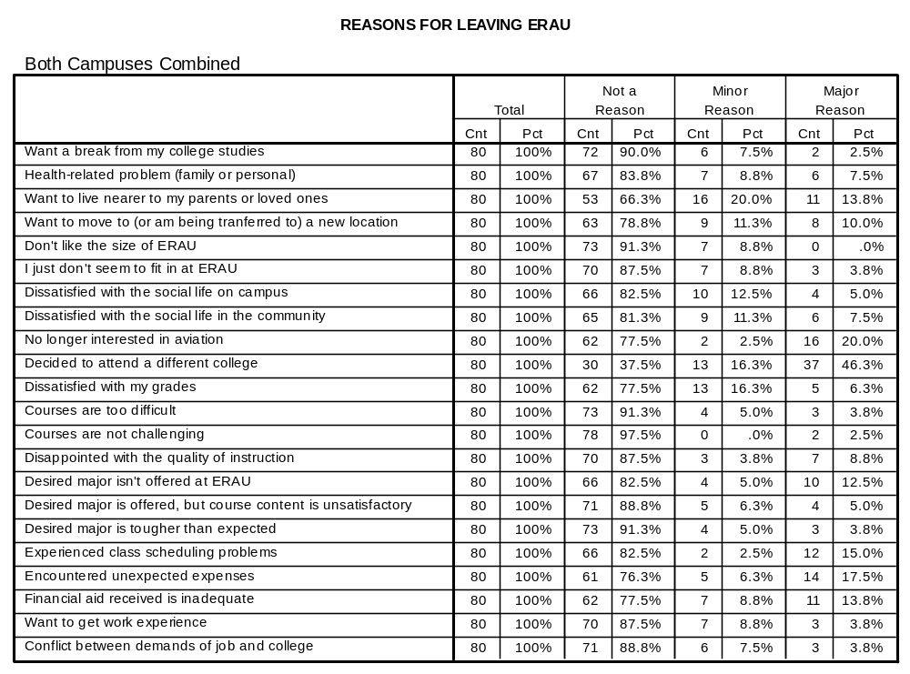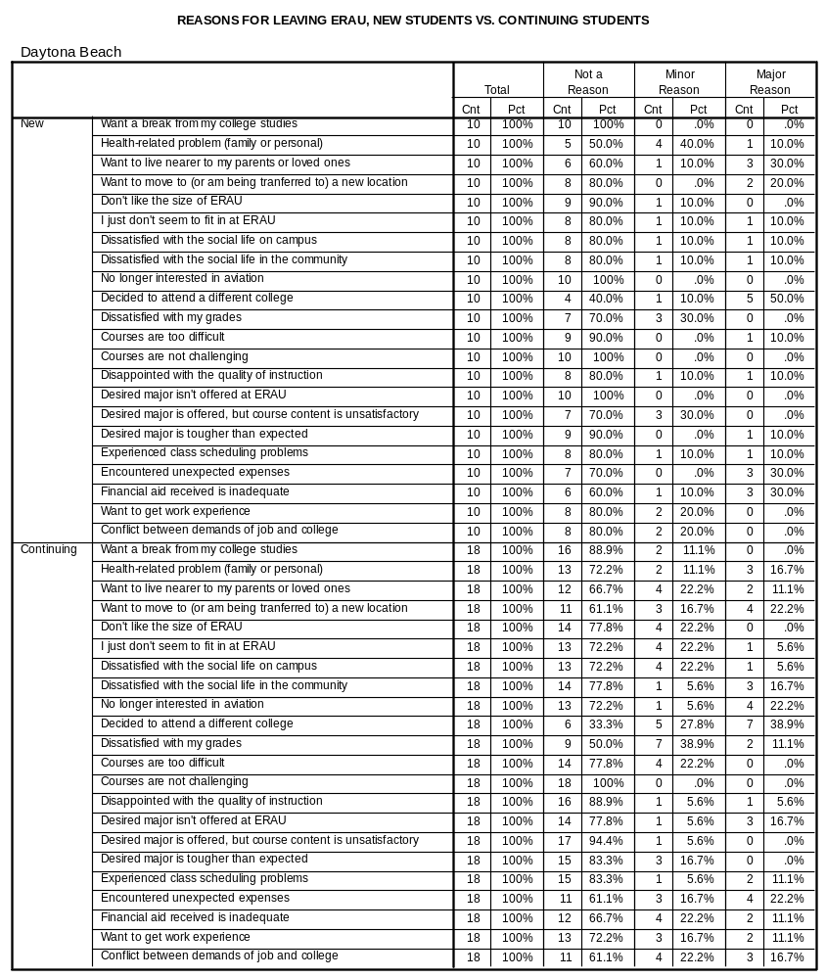
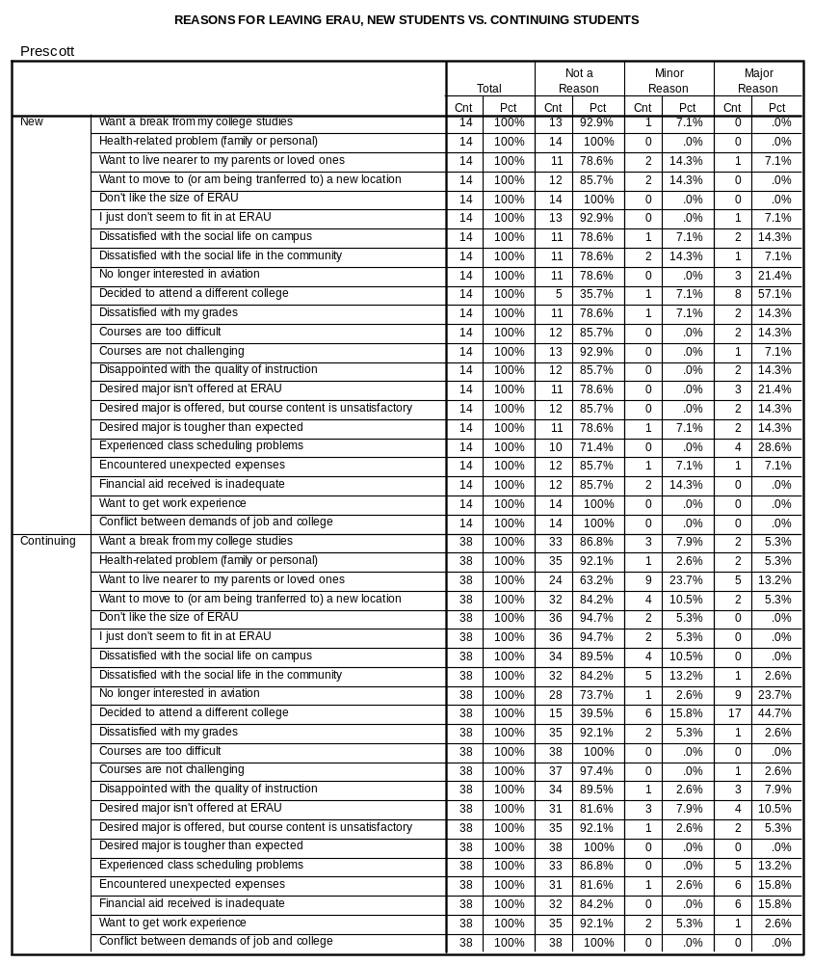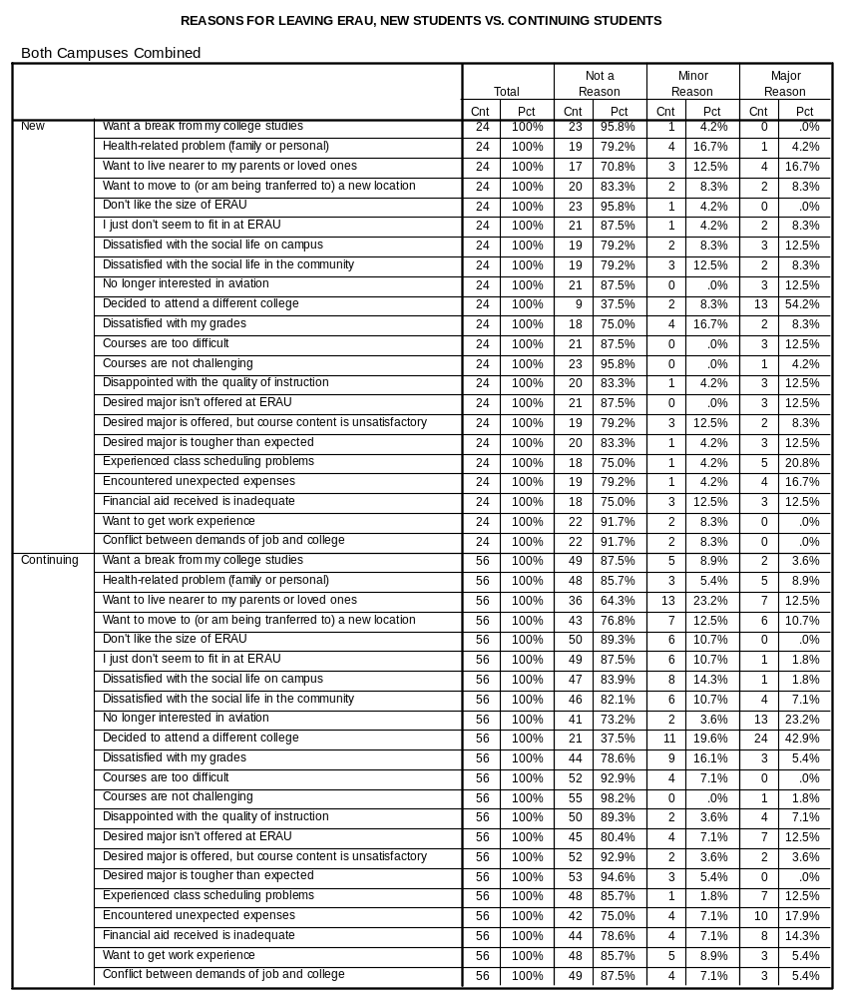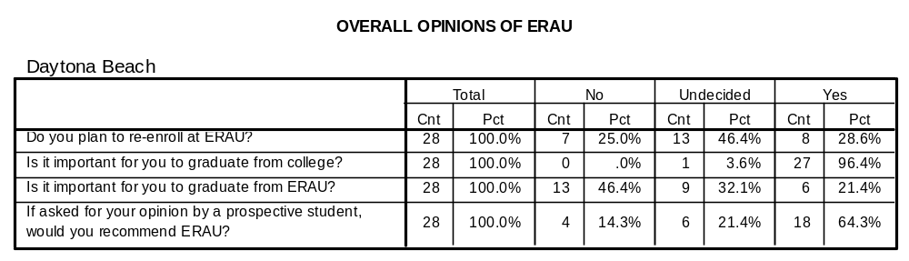
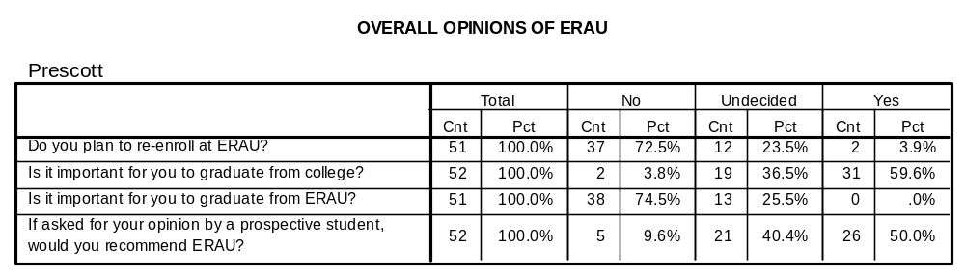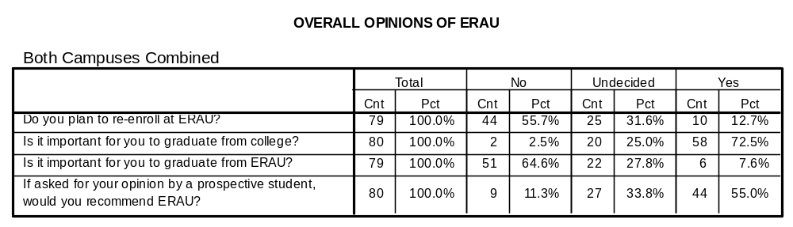
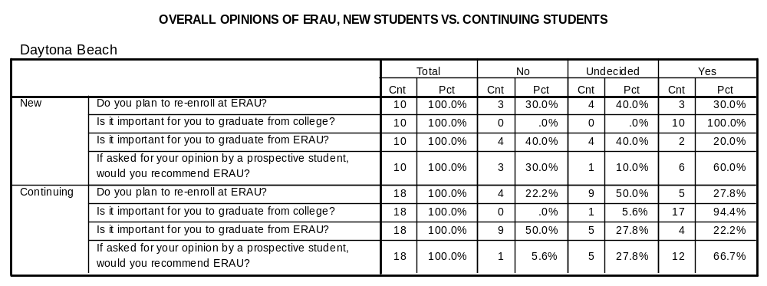
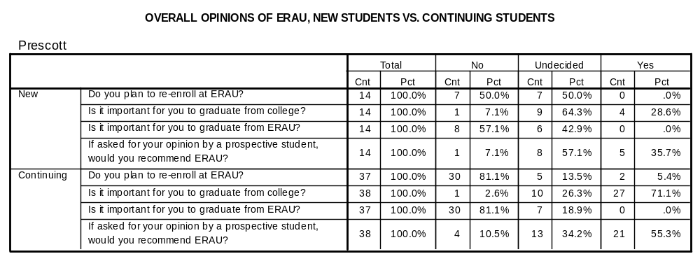
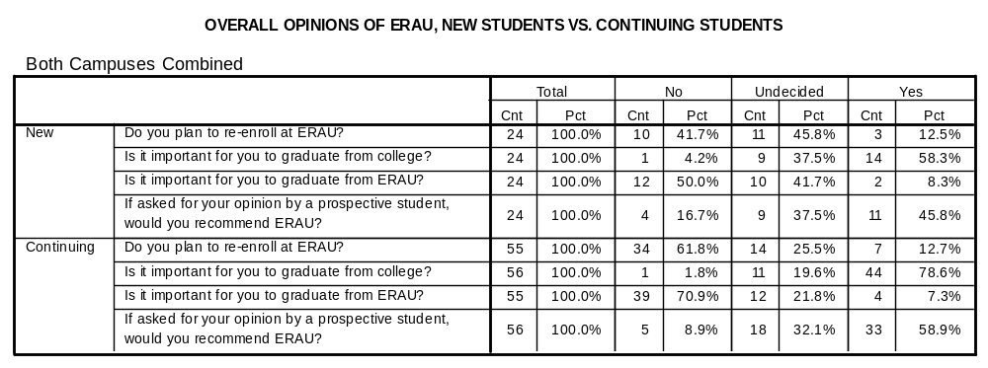
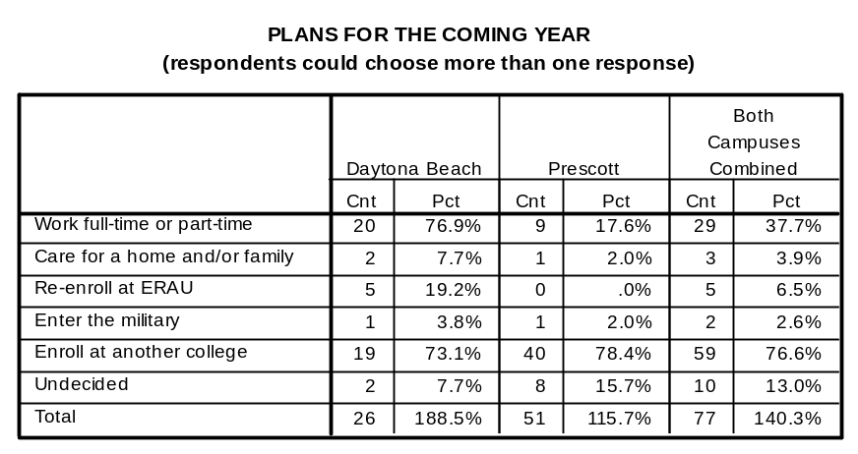
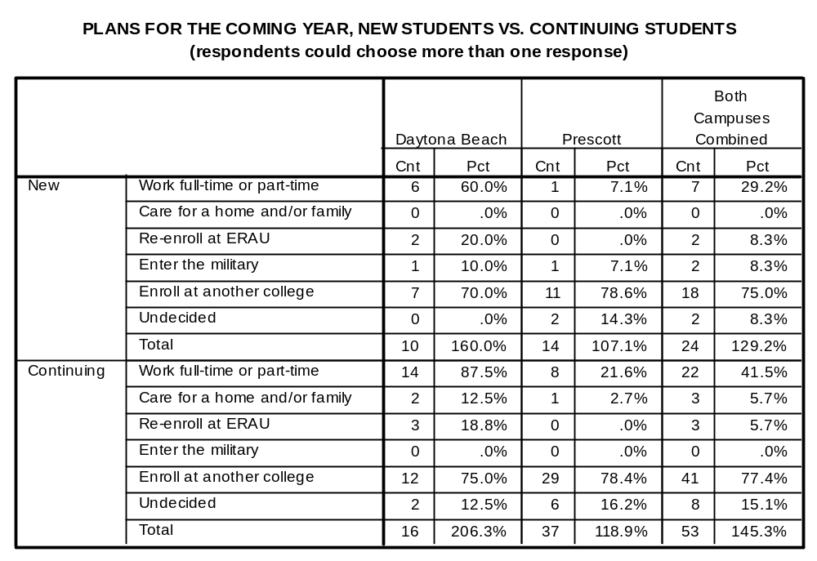

OPEN-ENDED COMMENTS – DAYTONA BEACH CAMPUS

Freshman

Courses are too difficult and I am not making any progress with my flying. I also want to change majors and I don't want to continue getting bad grades.

I am leaving ERAU because of the money problems I have encountered. ERAU is also raising their costs.

Having a hard time adjusting to campus and making friends. Not much in common with roommate doesn't want to join fraternity. Disappointed with flight delay and expense of attending ERAU. Will take courses at home.

Sophomore

Do to a lot of class scheduling problems, I have decided the ERAU doesn't care whether or not that I am enrolled here at ERAU. The campus is nice, but the help I received in scheduling was unsatisfactory, so I no longer wish to attend ERAU.

I was told it would take two years to graduate. Me and my advisor figured out it would take three. Never in my life have I had instructors that didn't want to help me. I was one semester away from my two year degree. Here I am one full year.

ERAU is an excellent institution for not just aviation but for other faculties as well. It has been my greatest wish to be enrolled at this institute however the expenses were too overbearing for me to continue here. Furthermore lack of scholarships for international students also played a part in my decision to leave. I would conclude by saying, that, for any individual who is interested in aviation , Embry-Riddle will excel in every aspect of the individual's aspirations. Thank you.

The military has made me an offer I can't resist. I feel I will learn life lessons in the next four years in the military.

Medical withdrawal for one semester.

Junior

I am leaving ERAU based on financial circumstances. Instructionally the university is top notch; administratively however, the university is severely lacking.

Since enrolling in ERAU, I have always felt called into some sort of ministry role after college. As I mature, I realized that this calling was not something I can ignore. I have transferred to Liberal Arts program at UCF and I plan to study theology in Seminary/graduate School after completing my undergraduate work. I have learned much at ERAU in and out of the classroom and I made life-long friends. I don't regret any of the time I spent here.

Cost!! Without family contribution it is almost impossible to attend this University. Due to my age I was forced to claim my parent's income. They contributed $0.

Disciplinary suspension.

Senior

There were no comments from seniors.

OPEN-ENDED COMMENTS – PRESCOTT CAMPUS

Freshman

Not enough flying time, wants to get through the program an is experiencing many delays. First flight instructor was terrible. Pleased with campus overall, though.

Transferring to Baylor University, TX home state 90 minutes from home. More cost effective. Likes ERAU campus, quality of instruction, social life and top notch flight program. Really leaving for financial reasons. Entire family Baylor alumni.

No longer interested in Aerospace Engineering and no other major of interest offered here.

No longer interested in professional pilot program. Will continue at a community college close to home. 1st year courses not very challenging.

Very dissatisfied with flight program and lack of flight activities. Dissatisfied with social life on campus and in community.

Overall a good experience. No real reason given for withdrawing.

Grew up in Prescott and is tired of it. Will attend University of Arizona in Tucson instead.

Loss of scholarship due to off campus violation of military standards.

Financial and flight difficulties. Will seek recertification as a mechanic and not continue with school.

Received baseball scholarship at another school closer to home.

Too much red tape of flight program. Prescott community is not receptive to ERAU students.

Not interested in flight anymore. Not the lifestyle he wants.

Don't want to major in engineering. Professors excellent really know their subjects and do an outstanding job. In general satisfied. The noise in the dorms disturbing not that individuals are making much noise. But can hear water running, people talking, etc. Cafeteria food not great. Other than these things it was a great experience.

Very dissatisfied with flight program.

Conflict with housing regulations and restrictions not returning Fall 2000

Wanted to be closer to home.

Father said son was not ready for the academic challenge at this point in his life. Has joined the Navy.

Sophomore

Dissatisfied with flight program. Was hoping to finish in 3 years but delays are continuing-but enjoyed school otherwise.

"Wanted more AE minors to choose from - will attend another school in WA instead. Wished he got "",ore for his money"" here, but would recommend ERAU to anyone if it fit their interests. AFROTC is best in country."

Switched from AS to STG - then desired more business oriented courses;(not offered at ERAU) Has been speaking with advisor all semester about this decision.

Not doing well w/ EE. Probation. Will enter tech school at home, get private pilot license. Not sure what he wants to do after that. Lost ROTC scholarship last year due to poor academics.

Too expensive. May re-enroll in a couple of years after getting A&P ratings elsewhere.

International student encountered major financial difficulties in home country(Kenya)

Wants an outdoor career. Transferring schools.

Student was enrolled in flight course by registration advisor when new students were restricted on enrolling. Subsequently dropped from flight. Cannot afford to stay for another 2 semesters to finish.

Flight program unsatisfactory. Student says he was not being treated right.

Decided to switch schools since changed to computer engineering instead of flight.

Personal conflicts with wrestling coach. Not good fit for STG. Uncertain of what he wants to do. Will assist in coaching H.S. wrestling team, then transfer to N. AZ Univ. Ina year or 2 to go into teacher education or business. Still uncertain.

Junior

Unhappy with flight program's pace. Only flew 15 hrs this semester.

Financial trouble. Amy attend another school.

Not all credits transferred. Decided to attend another university.

Unhappy in general - had a lot of problems with flight line - grounded and fought it.

Student does not want to be a professional pilot. Likes flying, but not as a career choice. Will attend Tavapia College locally, and explore career options through their career center and additional coursework. Happy with ERAU experience.

Senior

Dissatisfied with grades and testing. Student thinks grades are unfairly distributed in order to meet certain percentages of A's, F's etc.

Suspended for disciplinary reasons

