Students who visit the Student Success Center as part of their withdrawal process are asked to complete an Exit Interview. Results are presented below. Please note that respondents are those who have taken the initiative to inform the University that they are leaving. Students who stop-out or simply bypass the withdrawal process are not represented here.

NOTE: No surveys from Daytona Beach were returned to Institutional Research for processing. Hence, this report contains results for the Prescott Campus only.

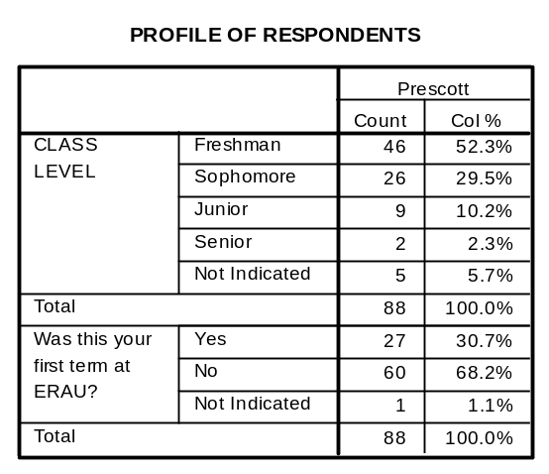
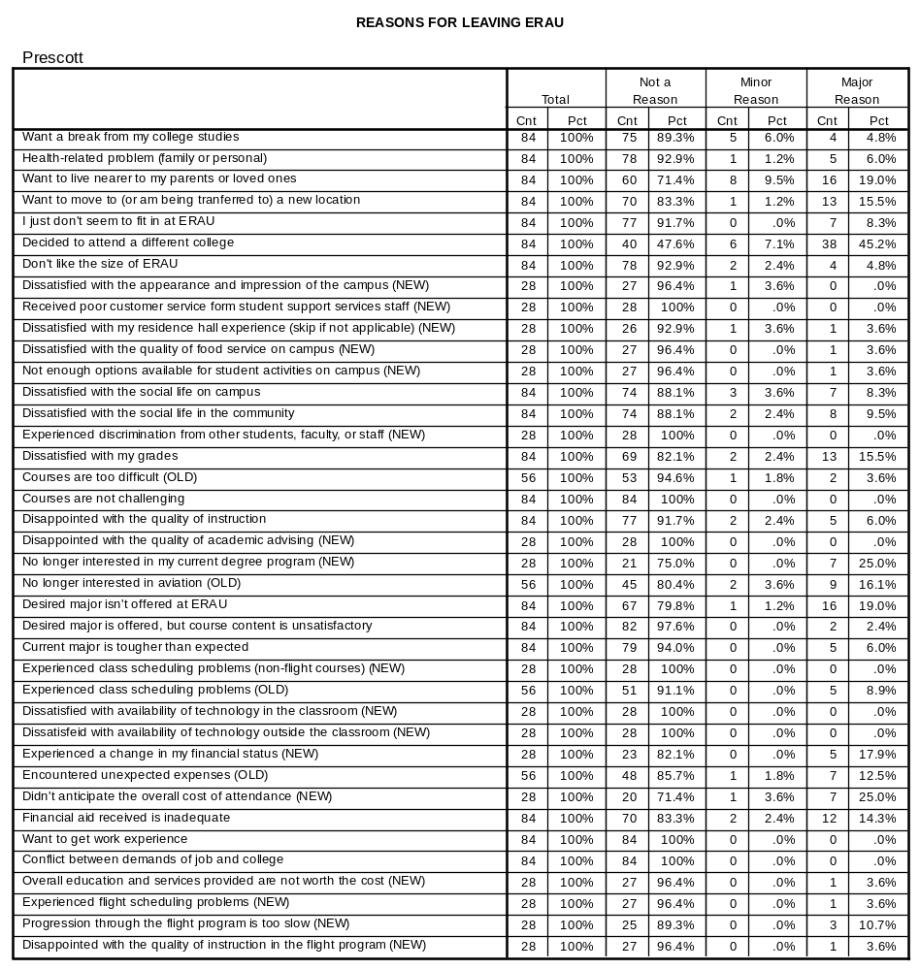
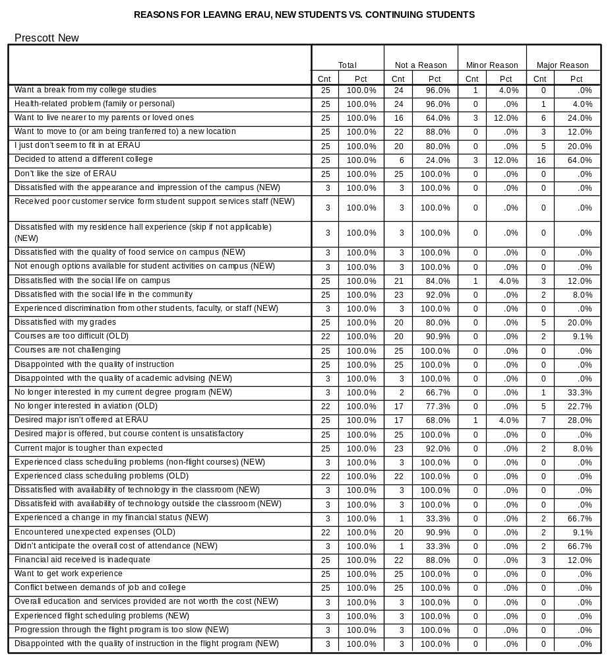

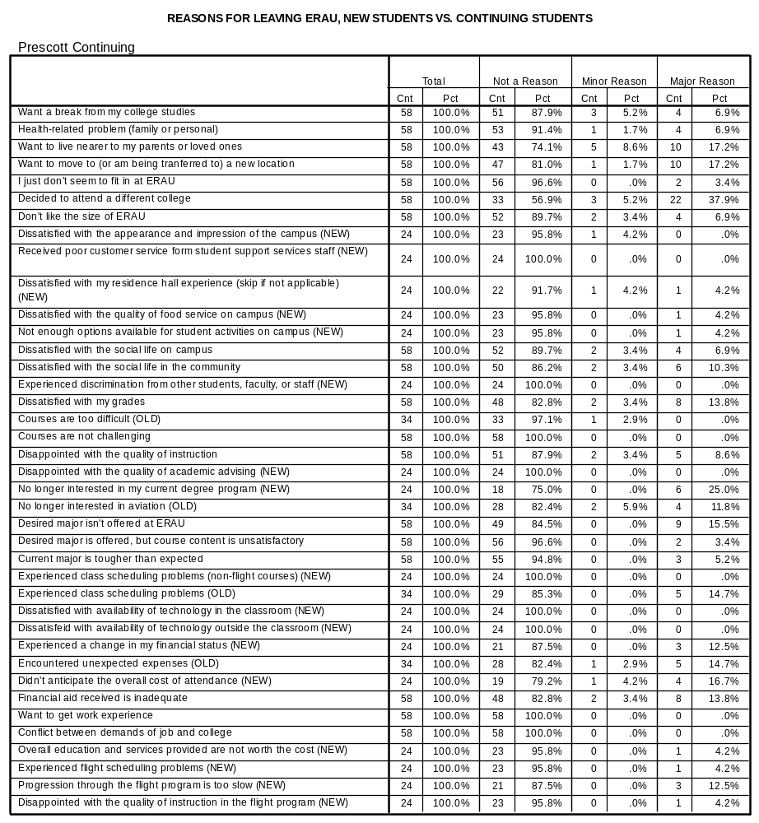

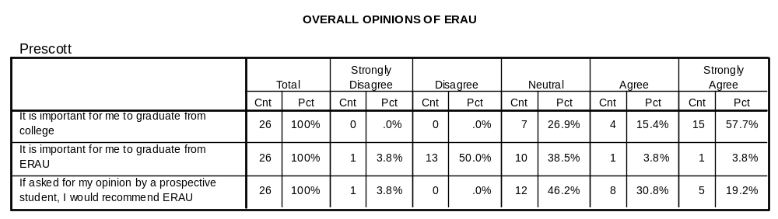
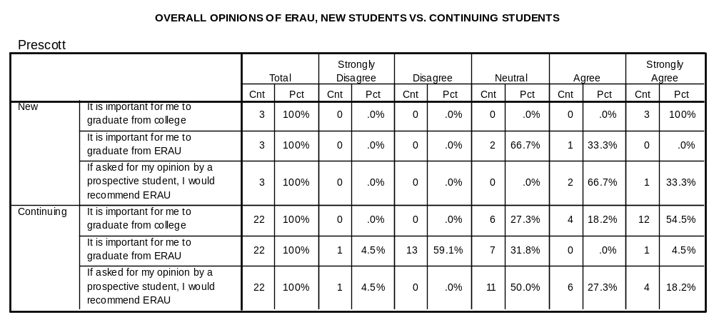
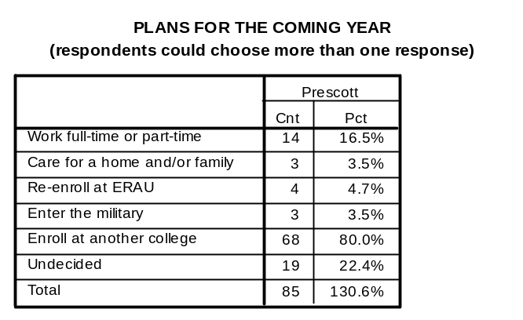
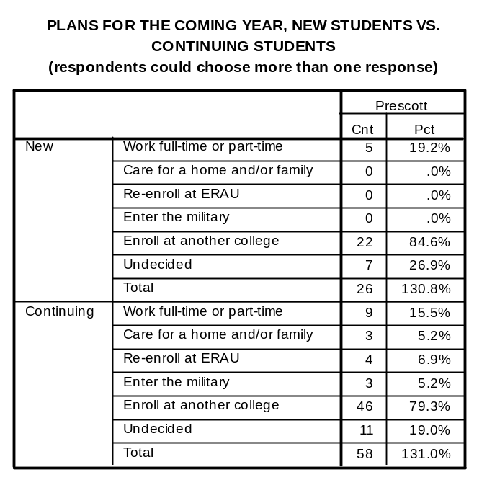

OPEN-ENDED COMMENTS – PRESCOTT CAMPUS

Freshman

Although very involved in campus (AIAA, drumline, Astronomy club), wants to go into architecture at University of Arizona.

Needing to go back to New Mexico for in-state tuition. Can't get AE. Will have to change to mechanical engineering. Mother lost job. Father looking for ways to cut expenses.

Moving to Scottsdale to live with friends. May attend Scottsdale C.C.. Wants to explore options. Aerospace Studies may not be what she wants. Attended Tri-City Prep. H.S., then came here. From Humboldt, lives with father. Looking for other options.

Not really interested in STG. Going home May or may not attend school. From very small (600) town in Idaho. Adjustment issues. Really not connected, although completed Univ 101.

Did poor academically. Quit attending classes in late October. Mother called to check on status.

LDS Church Mission. Hopes to return in 2 years.

Family financial situation changed. Will attend University of Texas in Arlington. In-state tuition. Still AE.

From Hawaii. Wants to return. Will major in Marine Biology or Oceanography. Not interested in AE. Enjoyed the experience.

Not interested in the Air Science program anymore. Will attend another University.

Decided AE was not the right major. Plans to enroll in Culinary school.

Found he didn't want to major in AS.

Too expensive; will continue flight training in Phoenix at ASU.

Student quit attending classes late October. Disconnected from campus. Unhappy. Would call mother from cell phone while sitting in the parking lot - didn't want to talk in front of roommates.

Local Prescott student on ROTC scholarship. Doesn't want to stay in ROTC. Not interested in major. Not connected to campus. Lived at home, worked in town, came to campus only for classes and minimal ROTC activities.

Changing schools for different degree program.

Said he had been accepted into UCSD Medical Program. Dad called 5 days later and said he had not even applied anywhere else. Just showed up at home Wednesday after Labor Day weekend saying he had quit school.

Will attend Glendale C.C. in Phoenix area, in order to save some money to be able to continue at ERAU. Working with success center for courses at another institution.

Harassed by a faculty member, "show me your scar" if you were out for surgery.

Unable to land aircraft. Dissatisfied with own ability, not quality of instruction or high standards. Wants to withdraw rather than being "failed" from FA110.

Has $10,000 scholarship for Nevada State Institutions. Parents influence to return home to take advantage of scholarship first to meet gen. Ed. Requirements. Then possibly return to ERAU. 9th day of summer term 60% refund.

"My only complaint here is chartwell's" Going to UNLV to study hotel management. The student didn't like the food quality, but it was not a factor in his decision to leave.

Will seek business degree.

It is way too expensive to stay here while trying to figure out what career/degree to pursue.

Failed FA110 and doesn't want to repeat it here. Wants to fly at home. Too expensive.

Needs to live at home and attend c.c. sister terminally ill in TX. Family leaving immediately to be with her.

Feels all the money goes to flight students and flight programs. Any other degree program is considered 2nd rate. No scholarships or grants available. Believes that the STG will be worthless, and feels lack of support within the department. The program is not what was presented to be.

Came straight from high school. Was not prepared for the courses or the small town. Needs to reevaluate future.

Sophomore

Failed out of flight program, will take up political sci.

If it has not been for his fraternity he would have left a year earlier.

Received an appointment to the air force academy.

New job out of state. Presently a flight line ERAU employee, plans to take more than 2 classes per semester at new location.

Seeking flight ratings elsewhere. Dissatisfied with progress in FA 110 in Fall 2000 semester and September 2001.

Wants to return to Trinity Western University in Vancouver, WA. Changed plans- wants Environmental Studies (former degree program) and to be a bush pilot. Not wanting to go with the majors. Events of 9-11 not related to decision.

Readmit after suspension for summer B. Obtained a 2.0 cumulative average, but took a downturn in fall. Not attending classes. Unable to recover this semester. Parents encouraged withdrawal, however, displeased that university did not intervene early on with son's lack of progress.

Loss of funding; not really interested in commercial airline industry.

Price/value issues- Rising costs, w/o rising benefits. Incompetent housing- Require on campus, while they force others off; insane, unpublished rules (electrical); broken door locks for a SEMESTER. Chartwells, where do I begin! Reused food; incompetent management (not Randy, he's good); 'Altitude questions' PLEASE!; idiotic pricing; silverware that can't penetrate food; 75% sickness rating, not great; standard 20 min 'hand to can' passing. Joke of Security (riddle vice)- unresponsive; known to be rude (thinking they're better than us). Parking- obviously no one cares what this place looks like, so why not build more parking! No maintenance support (or at least not competent support); horrible response times; saddest qualification you've seen (locksmith). What about the pride in how our campus looks? Anyone? Flight line- no communication at the flight line; no standards, despite an entire department; no idea what to expect from them; no published procedures (just some basic guidelines). Horrible scheduling process- no online schedule; entirely up to instructor; forgotten who pays the bill. (e.g. Students). Shuttle- sometimes just doesn't run; promised transportation, I've missed activities.

Failed many courses; need to earn money; want time to think about what to do (life direction).

Progress through flight training just too slow; delays in FA 208; expense of flight program; ERAU isn't a good fit; social opportunities limited (I.e. females). Never met his advisor; 'he's never in his office.'

Unhappy with pace of the flight program experienced unacceptable delays. Will attend University North Dakota with other ERAU friends.

Too expensive to attend ERAU will move closer to home and attend another university.

Back problems causing need to go home to have it tended to, while attending Hawaii Pacific University for one semester.

Dissatisfied with progression through flight program- transferring to University of North Dakota.

Junior

Came in as a transfer student intended to trans. To AZ state. Where more credits accepted.

Wants to be a network administrator and needs a degree in business administration.

Stopped for Fall 2001 to assist father in setting up new business. Plans to return in September 2002.

Senior

Will return as Pro Aero.

Moving to be with fiancé - will finish school there.

