Students who visit the Student Success Center as part of their withdrawal process are asked to complete an Exit Interview. Results are presented below. Please note that respondents are those who have taken the initiative to inform the University that they are leaving. Students who stop-out or simply bypass the withdrawal process are not represented here.

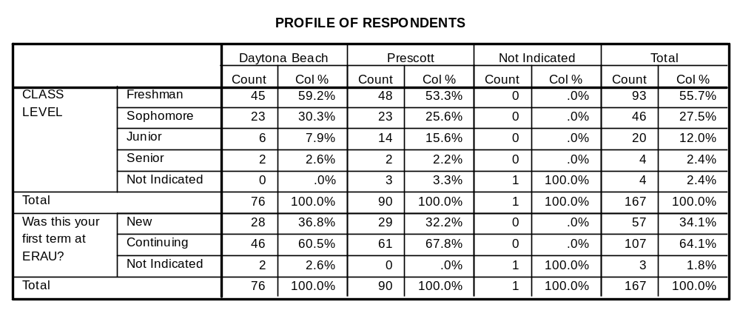
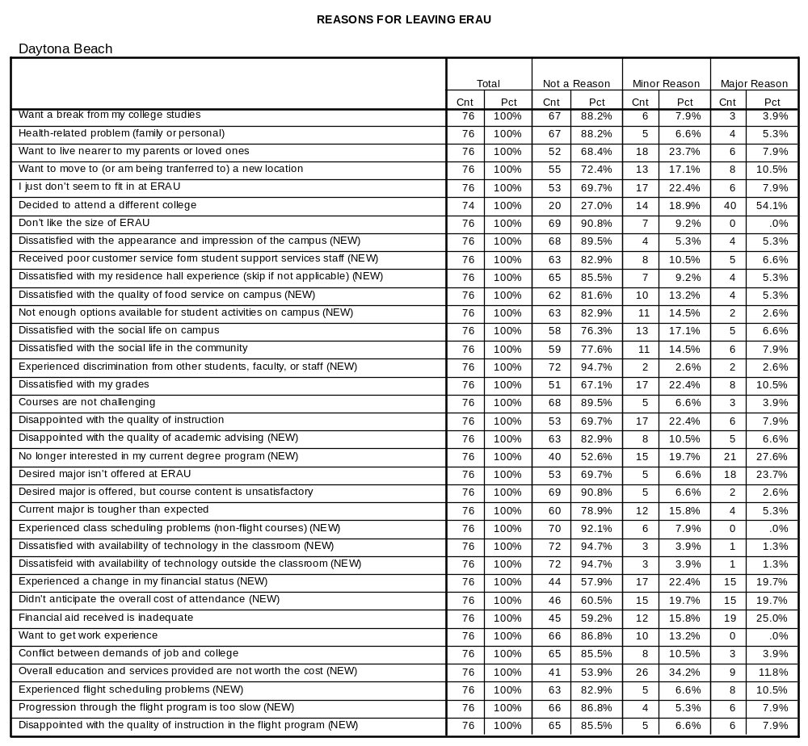

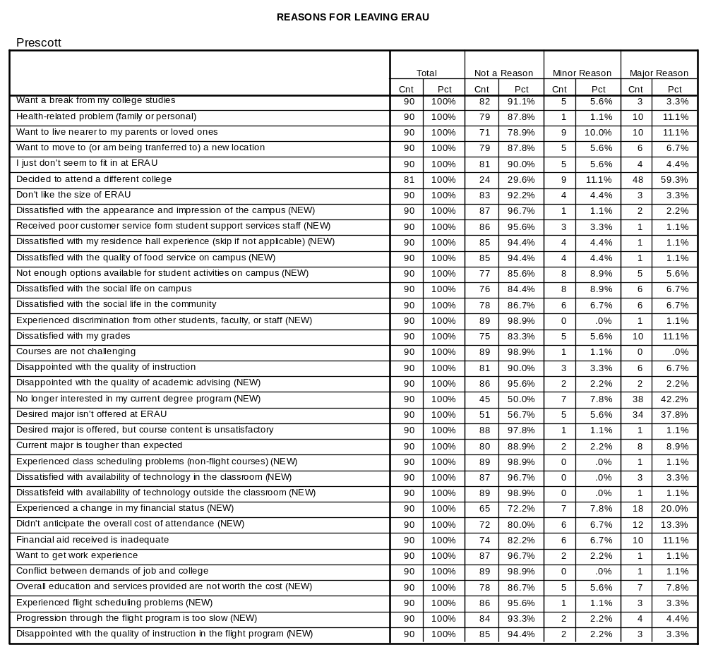

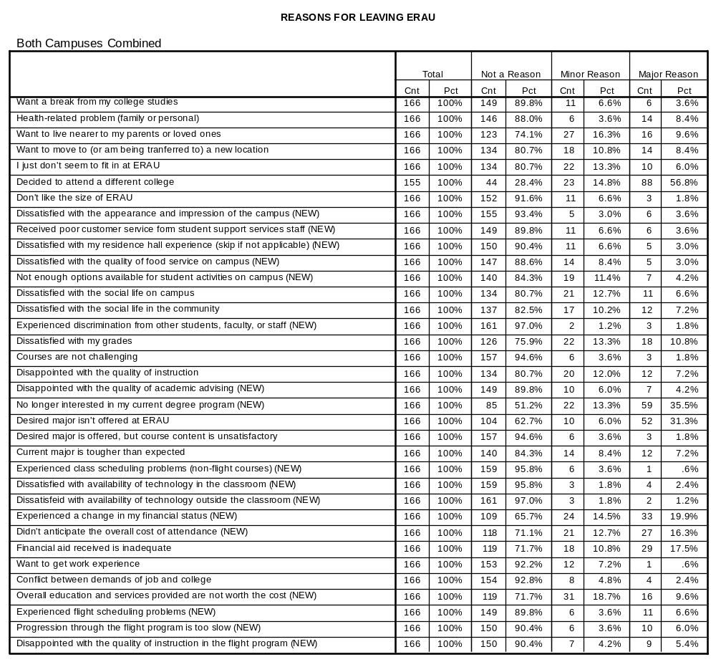

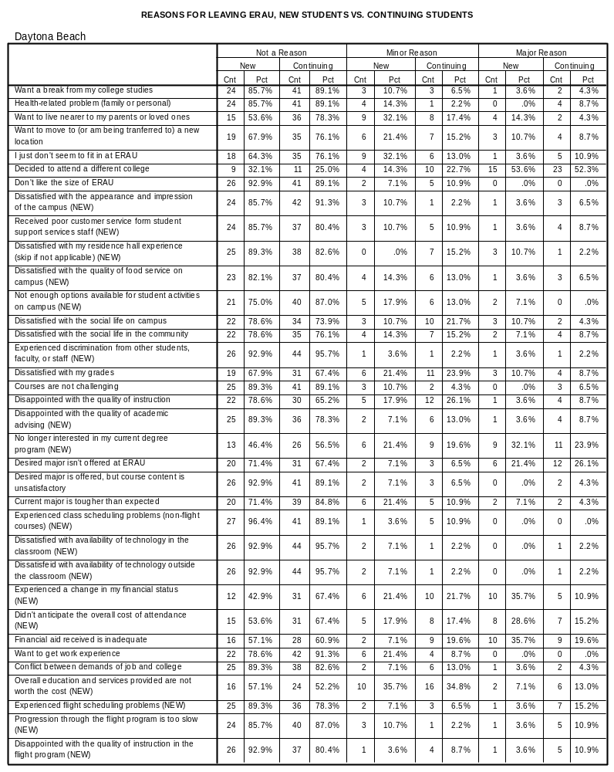
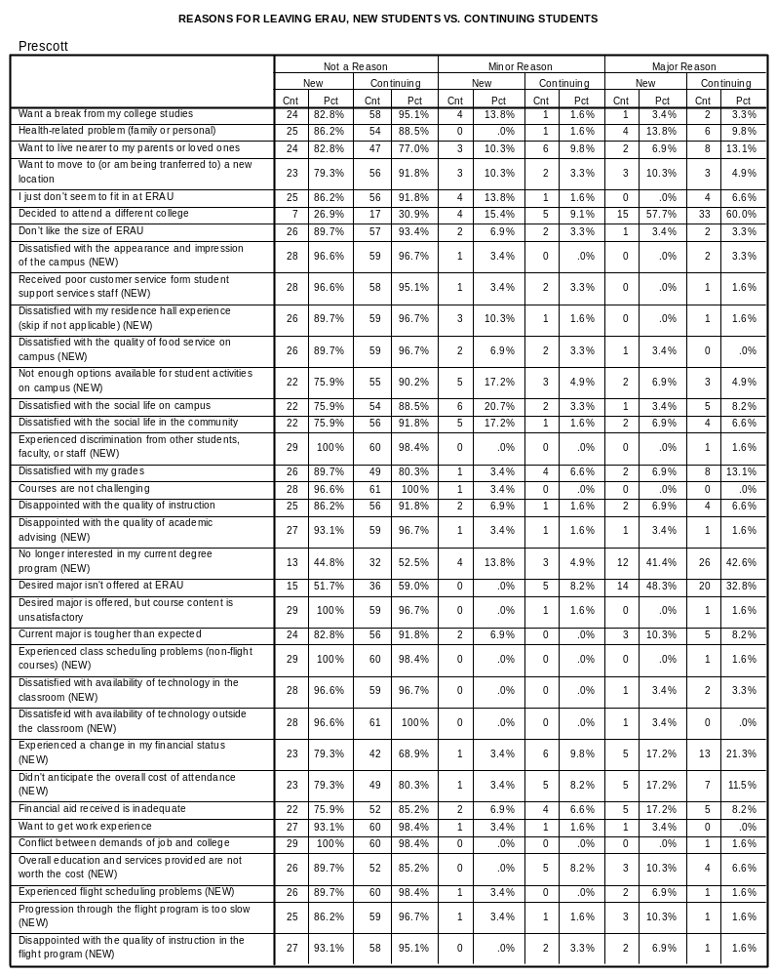
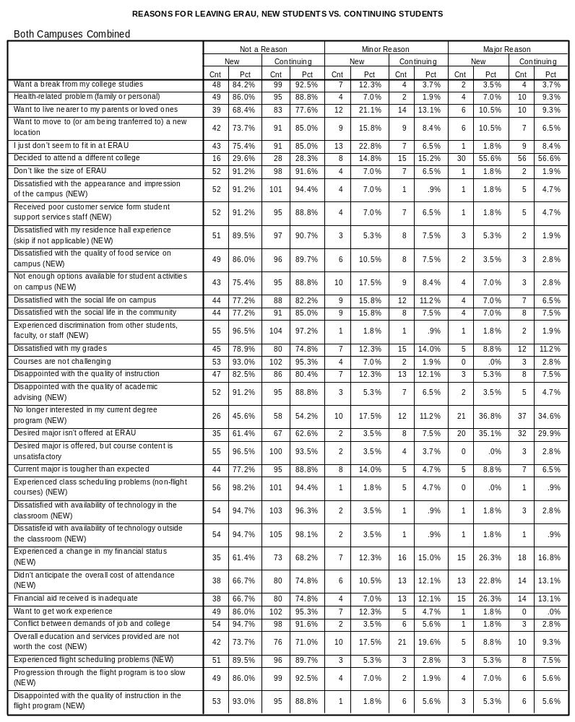

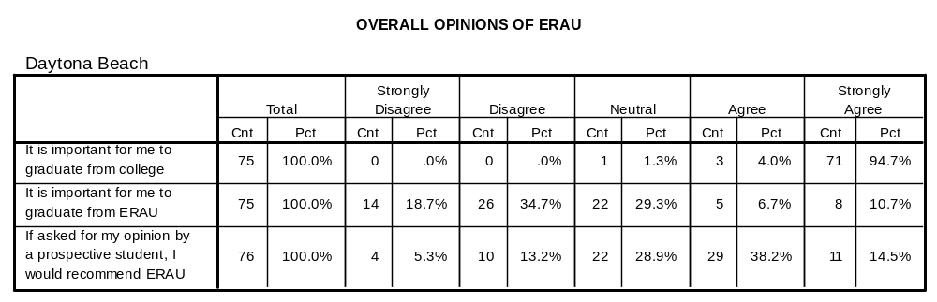

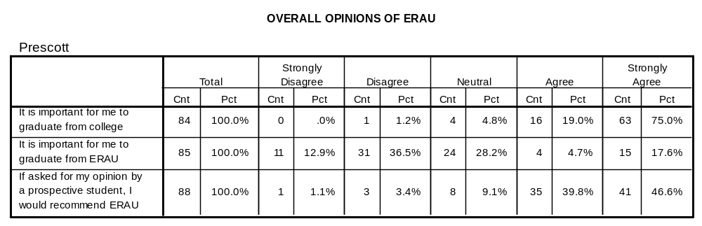

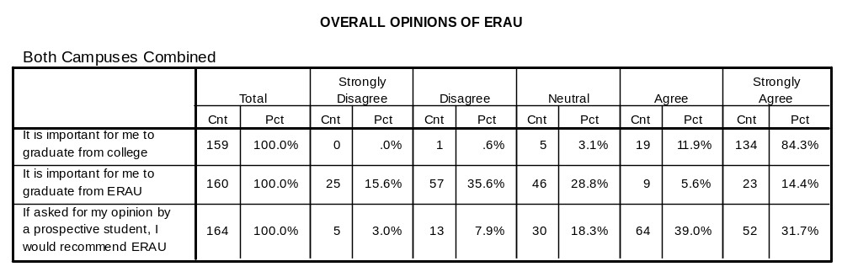

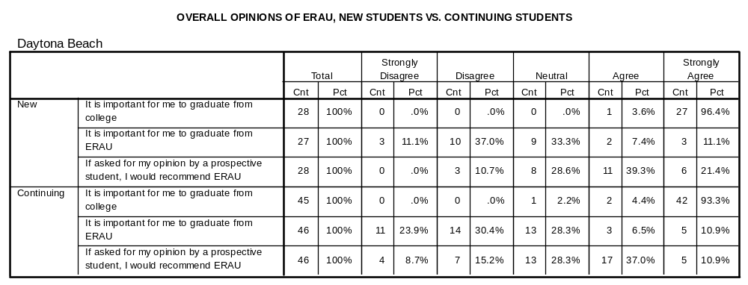
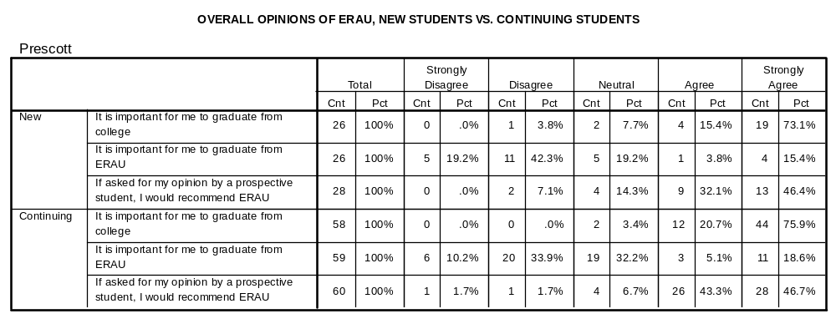
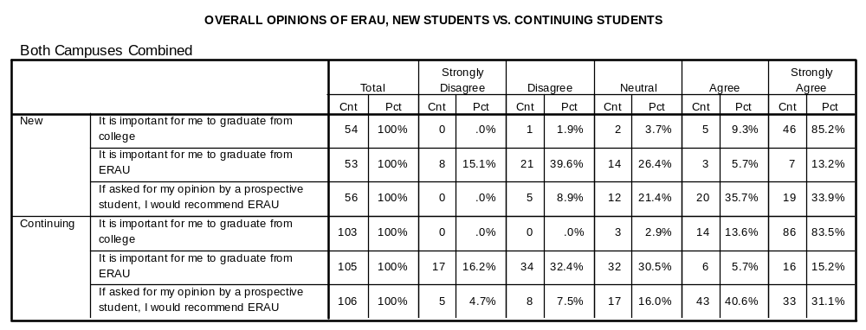

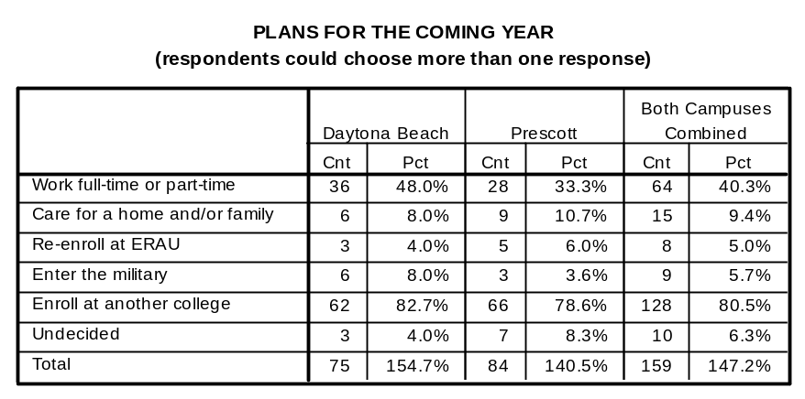
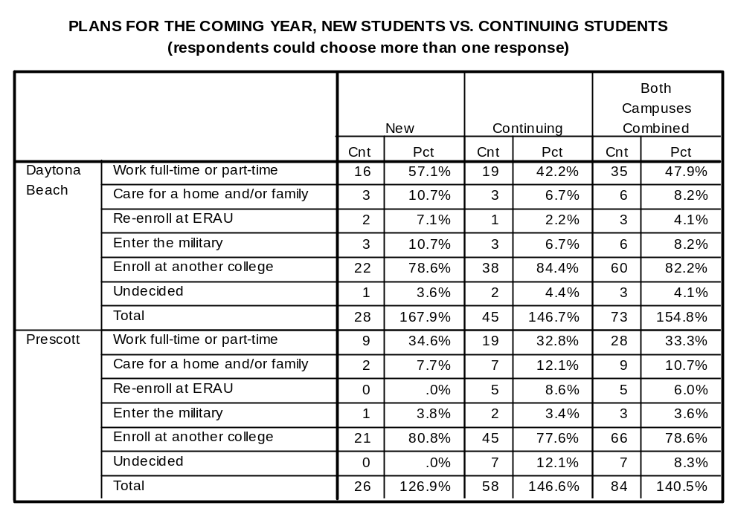

OPEN-ENDED COMMENTS – DAYTONA BEACH CAMPUS

Freshman
My number one reason for leaving is medical but I hated living in a room with two other people. There's hardly any space and NO PRIVACY. I really liked Mckay hall, though. It's unique.
It was a great learning experience.
Price get a stronger business degree elsewhere at a fraction of the cost.
I graduated high school a year early… I probably rushed into things I need a break.
Financial aid promises weren't being kept. Unhappy with AFROTC (major source for scholarship). Bursar Office was very rude and unhelpful when a problem arose. Unhappy with housing limitations.
Not enough fin. Aid only found 1 fin aid staff member caring.
Not invited back, GPA was too low.
I decided to change majors in the direction of architecture which is not offered at Embry-Riddle.
Pursuing a pastoral ministry. ERAU is a great engineering school, but not the best for philosophy/theology.
Just decided this isn't the school for me.
I am leaving ERAU because I feel that it would be better for me to help my family. Also because the financial burdens of college would be much lighter if I attended a state school near home.
Major reason for leaving is unable to afford ERAU. Job looking after college will not pay enough to pay loans.

Sophomore

The poor classroom instruction, unreasonable flight line and lack of substantial education opportunity cause a beautiful campus to be a terrible college. The finances required for these.
One of the issues I had with thes campus were the classrooms. In the future, build classrooms with at least a window, along the outside not the inside of the buildings. Also, don't be afraid to move away from a sterile atmosphere and put some bright and stimulating colors in the buildings.
National guard unit mobilized.
Flight program was inefficient and not worth the hassle or the cost. Bad customer service on the flight line.
Changing to a major not offered at ERAU, photojournalism.
I want to study in europe.
Medically purposes only. I hope to return next year. Fall 2003

Junior
The experience I had at Embry-Riddle was very disappointing. I am now very much in debt from a school with poor quality of teaching and instruction. It was definitely not worth the money. The management of the school has no concern for student success welfare and academic achievement. As far as I am concerned, Embry-Riddle is a business providing a service to its customers. I am a very dissatisfied customer and would discourage anyone who asked for my opinion from going to this school. Also, I had planned on graduating in Spring of 2004 but because of the way my classes were setup (by the school as a freshman) and because some of the classes I needed are only offered every 2-3 years it was basically setup so that I had to attend another semester (giving the school another $20,000) If many students are having the same problem, I'll bet the school is probably making big bucks off of that one area alone.

Senior

There were no comments from seniors.

OPEN-ENDED COMMENTS – PRESCOTT CAMPUS

Freshman
Wanted AS major but couldn't afford flight - switched to AE but didn't like it (too hard) – really wanted AS. Father became ill. Didn't was to incur huge student loan burden.
Undecided engineering track - maybe architecture - will attend school in home state less costly
Changing major (sports medicine or business). Not interested in flight career any longer.
Financial difficulties. Also pretty sure he wants to change degree programs. Plans to return to ERAU but unsure which degree program
Student placed on academic suspension. Plans to change a business major and attend a different college.
Changing major to architecture.
Was Air Force, came to ERAU because of the ROTC/EE "package", but dropped AF ROTC, and decided to change majors. Can get an EE degree much more cheaply at a state school.
Did not receive AF scholarship - medically disqualification AE not the right major – too technical, want another major (possibly history) not offered at ERAU.
Financial burden too much right now. Already in process of entering Coast Guard.
Financial difficulty. Cannot make tuition. GPA too low for scholarships, etc. Will go to community college. May try to come back to ERAU, but unsure.
Dislike campus, other students threatened by roommate dissatisfied with how incident was handled by housing.
Scholarship money promised by Army ROTC was much less than I was led to believe. I was told it would cover "everything but flight". But it didn't even cover 100% of tuition, and no room/board/meals/ fees. I can't afford to remain; my mother can't afford to take on that much loan debt.
Admitted conditionally; on probation 2nd semester; failing classes; unhappy here, ERAu not a good fit.
No longer interested in flying. Will get a business degree at another college.
Switching degree to program to Business Admin.
Not motivated to finish college right now. Plans to work, may finish college at a later time.
Financial difficulty. Will attend a different college and work part-time.
Changing degree program to business administration. Will attend UNLV.
Full-ride scholarship from Univ of Alaska. Wants to explore EE, but can do so at home at no cost. Might consider returning in a year.

Likes size and location. Intro level AE courses (physics) did not spark enough interest in the subject matter - too dry.
Decided AE was not for him. Uncertain of direction. Not dissatisfied with program.
Felt she experienced serious discrimnation from fellow students and a particular (female) faculty member, who gave higher grades to males. She felt "threatened and unsafe on campus due to behavior of male classmates. She spoke to a counselor regarding the issue but no action was taken; things did not improve. She tried to talk to the dept chair but he never returned calls.
Not enough variety of courses offered. Was never reassigned (advisor) when changed degree programs! Was never advised. Flight repetitive, delayed start due to loan problems. "Felt instructor wasted my time"
Very unsure of major and career direction. May return to ERAU if he decides on a major that we offer.
FA 02 at DB - too much of a party/ beach scene. SP 03 at PC - liked Prescott campus! But wanted to be closer to home. Discovered I just didn't want to be a pilot; didn't enjoy flight.
Changing degree program. Will attain an MBA. No longer interested in being a professional pilot. Started ERAU, FA/01. Stopped - out 2 years, came back. Decided this is not for me.
Stop out SP03. Hopes to return FA03. May take some c.c. classes while home.
AS at first. Money issues with flight. Father wanted him to major in CS. Wants civil engineering. Transferring to Univ. Hawaii Manoa
Father called in. Food situation makes him ill. Said intolerable living conditions largely due to food quality., yet he spoke to no one about it. 1.643 com
Changing major to criminology. Not offered at ERAU.
Going to missionary training, either in England or Montana. Definitely plans to return spring 2004.
Does not like the small campus, wants to attend a large university. Plans to go to ASU flight school.
Changing degree program to "Business Administration". Degree program and courses needed not offered at ERAU. Will continue education at another college.
In financial difficulty. Parents' business not doing well. Plans to return, 03/FA.
Prescott is incredibly boring. Transferring to a flight school in N.E. Also receiving more financial aid there.
Really dislikes Prescott community and size of ERAU. Feels it's not a real college experience. Didn't even fly at ERAU based on negative reports from peers. Never met his advisor and didn't take UNIV 101. Advisor was never available.
Decided STG not right major; had ROTC 3-year scholarship but decided against military.

Sophomore

Felt transition from DB to PC very poor - was told at DB courses would transfer but didn't/ Never found out who his advisor was. Did feel that PC's flight dept. did a much better job than DB. Also unhappy with student employment process.
Changing major, decided a flight career wasn't the right one.
Unsure about continuing in current major (AE). Wants to try out a business major at a local community college - save money.
Refused to take FA109 - "It's a waste of money because I wouldn't earn any flight ratings" Wanted a degree in "anything" just not AS; although goal is to become a comm. Pilot.
Still exploring other academic majors-enjoyed wrestling - cost too high for non-aviation related major.
Academic suspension plans to attend another college, then re-apply at ERAU.
Just can't afford it anymore. Teachers are great.
Graduated from ERAU with an AS degree; was returning to get an AE degree, but now has a baby and couldn't afford tuition.
New family business, must work 80 hours per week. Will return Spring '03.
Changing to a major not offered by ERAU (criminal justice)
Changing universities. Closer to home more flexibility. No complaints re: ERAU.
Need to go home and help out with some family problems. Will return, if possible.
Leave of absence. LDS mission.
Changing degree PGM to Business major at Univ N. Carolina.
Going home to be with family. Dad has Lou Gherig's disease.
Brother died. Returning home to assist family. Will attend college there.

Junior

Originally AS - went to CS; dissatisfied with
Student stated he was discontinuing college for personal reasons and was adamant that he did not want to discuss it further. He did say it had nothing to do with ERAU and that would recommend ERAU to a prospective student.
Attend school at home - liked dept services but newer professors not as efficient/effective as previous instructors who have been here longer. Financial aid not consistent.
09/19/02 Deployed on active duty, 08/29/02 "Operations Enduring Freedom" US Air Force
Unsure if engineering program is a good fit, unsure about continuing at ERAU. Taking time to make a decision without negatively affecting GPA.
Will enroll in Calvary Bible College to go into the ministry.
Just cannot afford to stay. Mother lost job. Parents supporting grandparents in nursing home. Not progressing academically. (Drive not evident. Failed UNIV 101 twice)
Transfer student, already has communications degree worried RE: downturn in aviation industry and poor chance of getting a good paying job. Getting married soon and has work experience and chance of good paying job in communication industry. Plans to go back to work for now, may pursue piloting later.
Student felt misled about amount of work required for CE degree and how long it would take to complete (said "they changed the requirements") Also experienced great problems with financial aid, which led to a depression, missed classes, fell behind in class work, grades slipped. He said "ERAU wouldn't take my student loan, and I don't know why."
"Worst physics class I ever took"
Transferring to a Christian University, which is a better fit - felt unable to participate in social activities. Unhappy with flight progress, felt flight instructors didn't care, had to restart and spend extra money.

Senior

Building house - taking 1 semester off

