Students who visit the Student Success Center as part of their withdrawal process are asked to complete an Exit Interview. Results are presented below. Please note that respondents are those who have taken the initiative to inform the University that they are leaving. Students who stop-out or simply bypass the withdrawal process are not represented here.

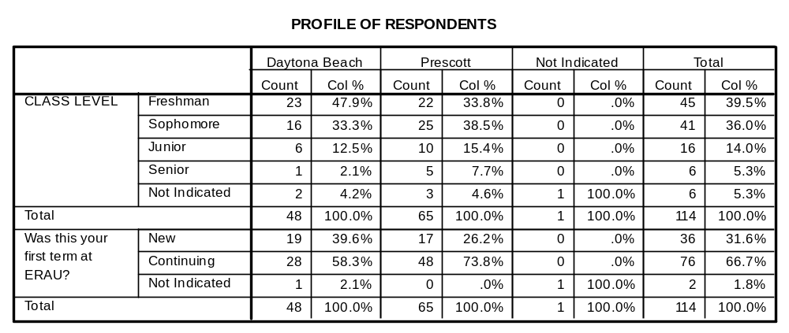
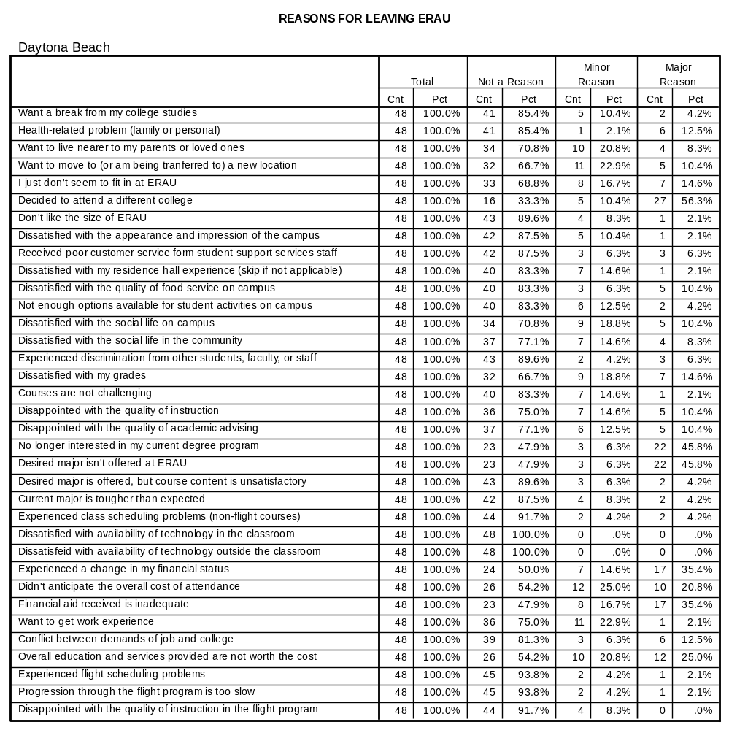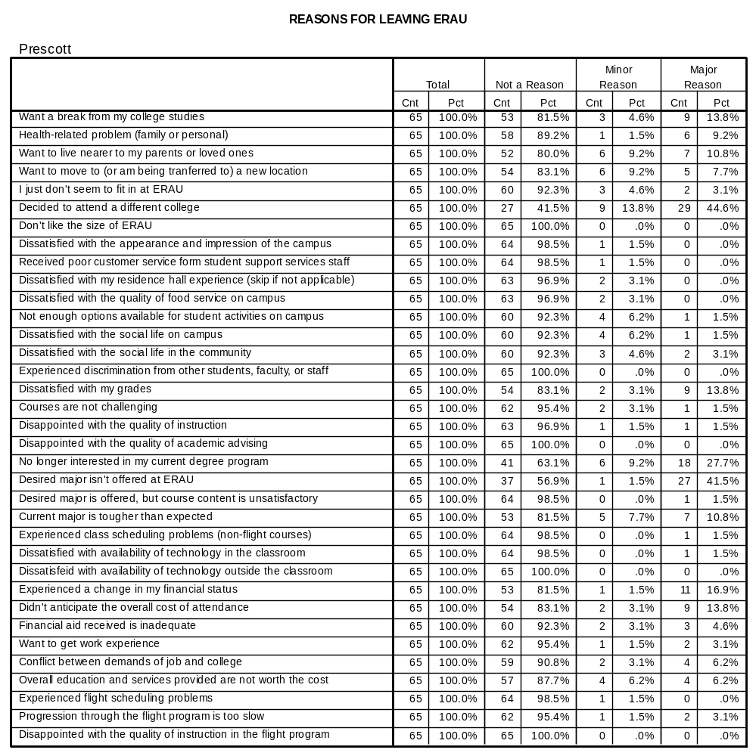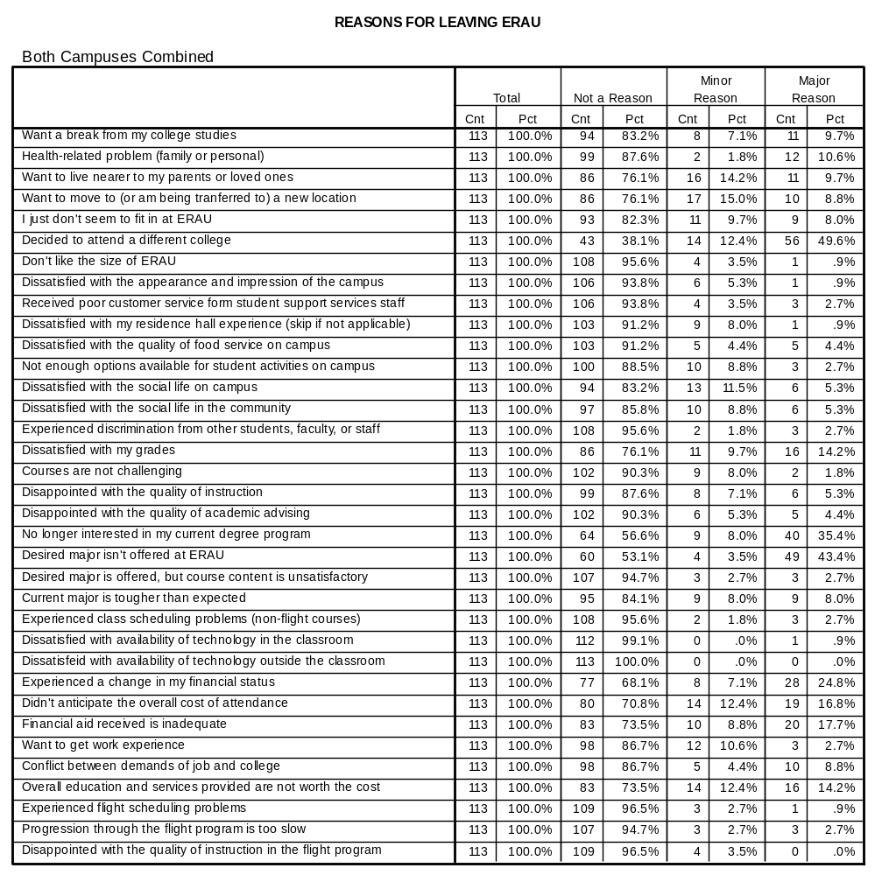
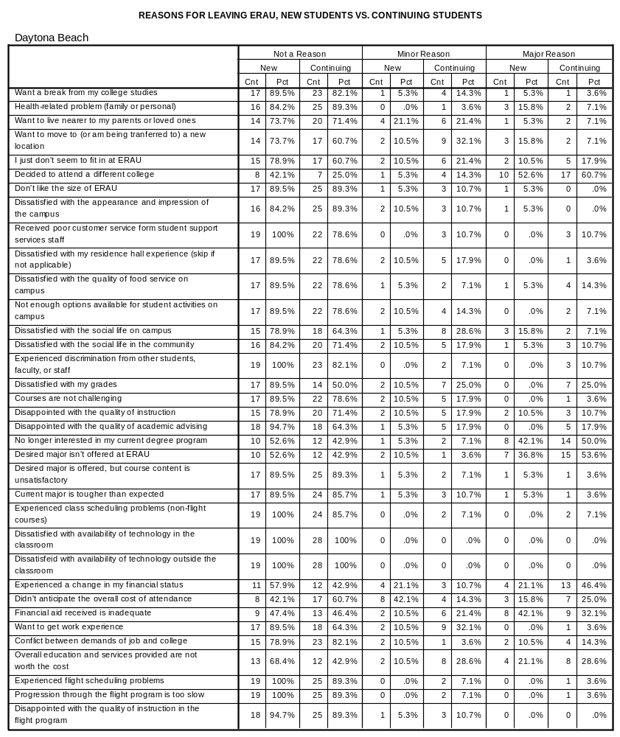
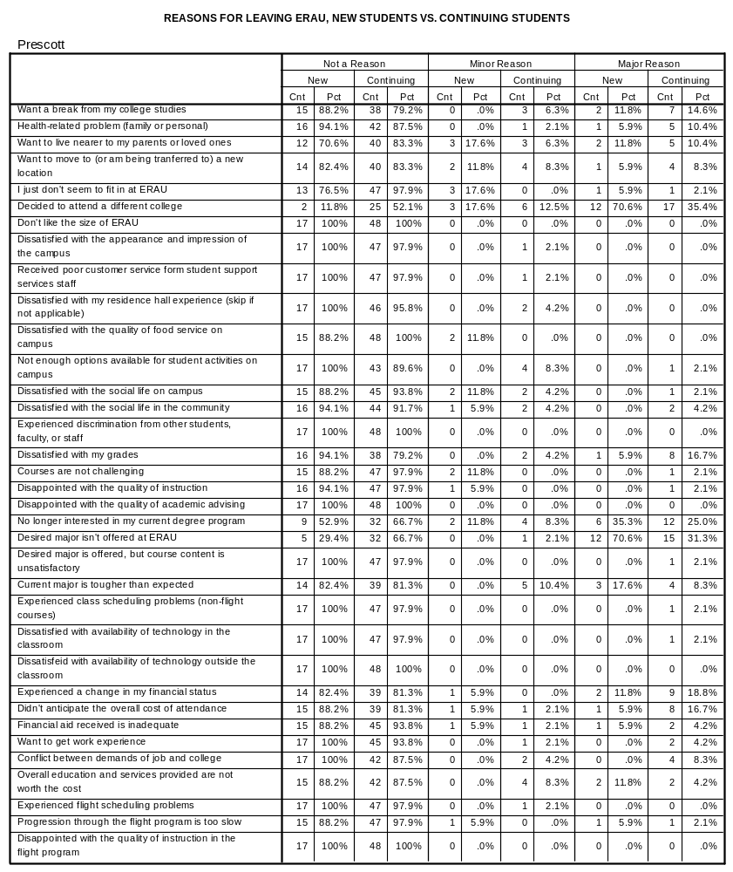
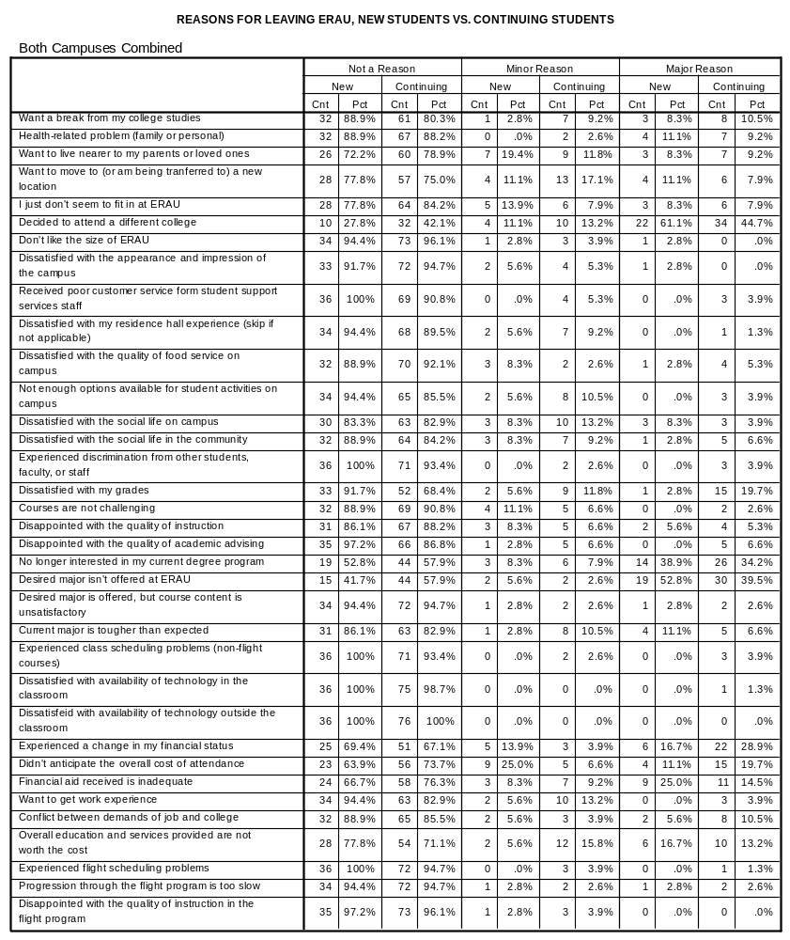
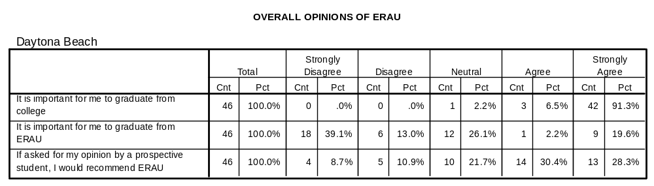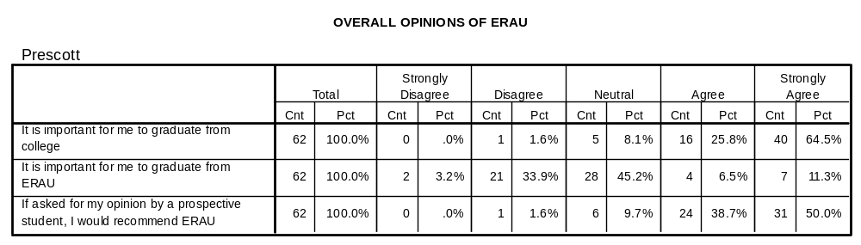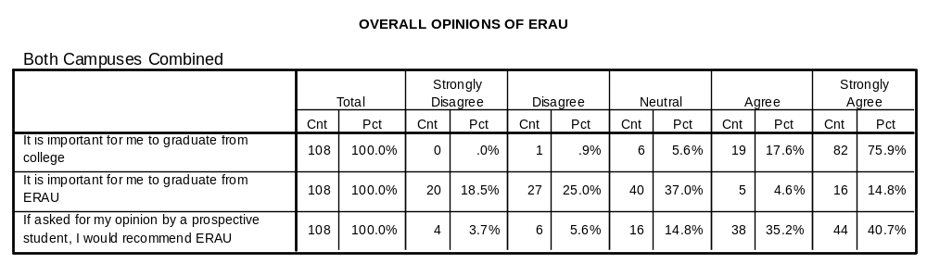
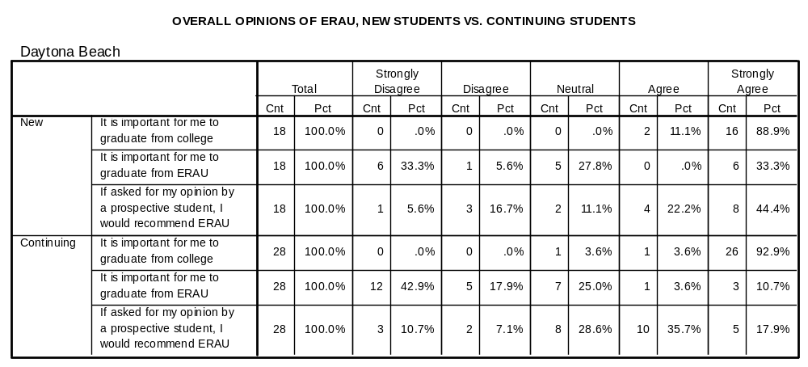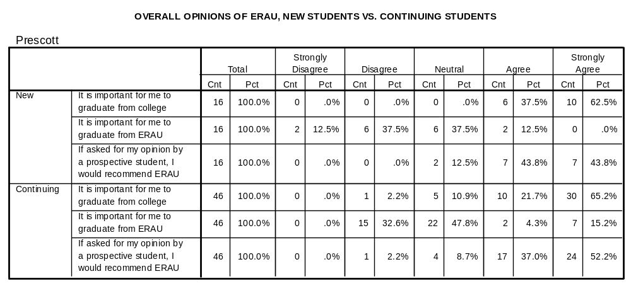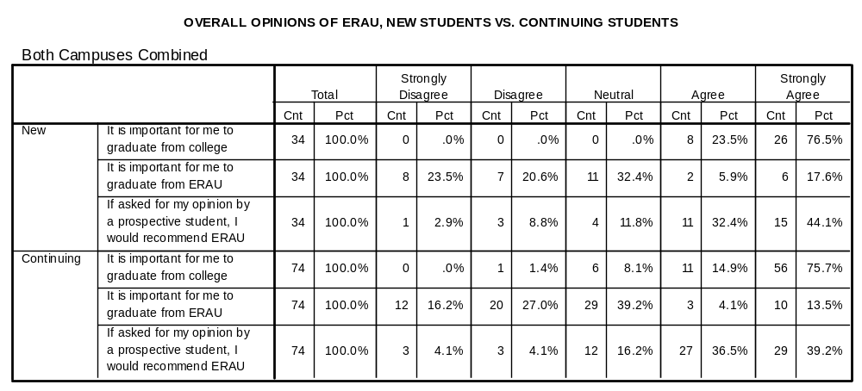
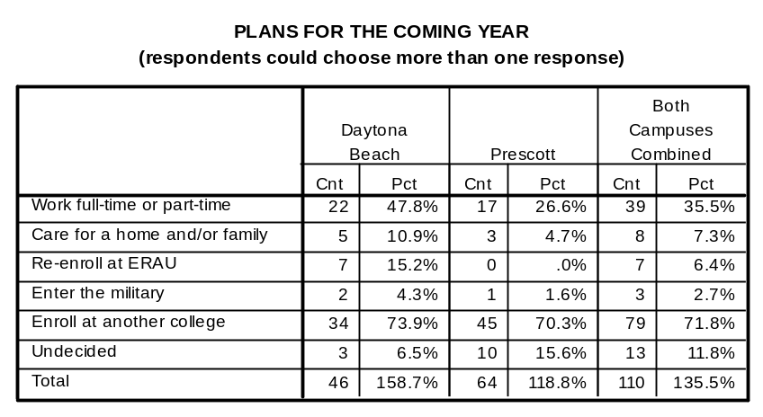
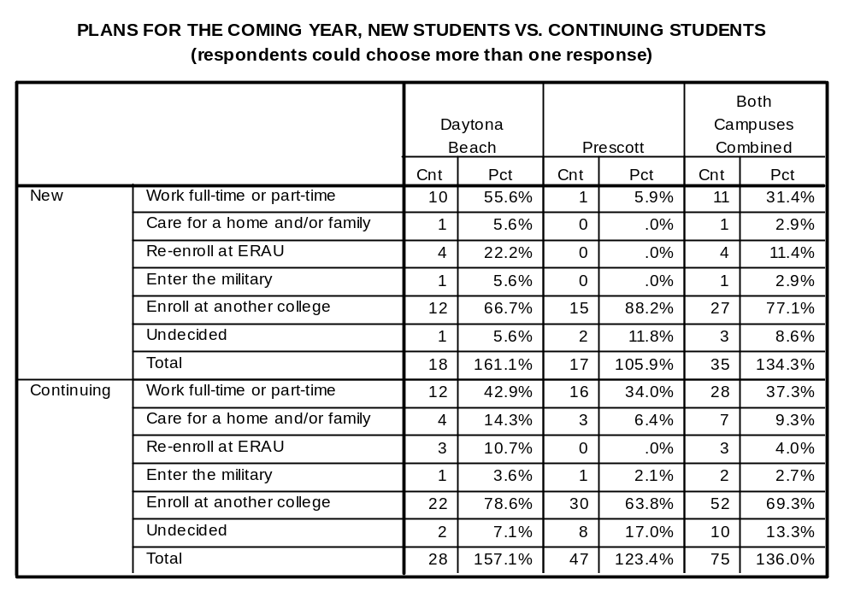

OPEN-ENDED COMMENTS – DAYTONA BEACH CAMPUS

Freshman

Decided Engineering not desired field. Will attend another college in a degree program not offered here.
Leaving for military training, will return in Spring 2005
Changing major to Forensic Science.

Sophomore

Poor instructors, unconventionally bad Physics curriculum (should be 4 credit mechanics + 1 lab, 4 credit EM + 1 lab). Ridiculous English courses; Insufficient 4 credit classes for freshman level (CS 223 and PS 195C should be 4 credit) Dr. Charles Martin was an excellent professor though. AE 101course was fun; PS 150 + 160 were too simple and badly organized; Needs more CALCULUS. We were completely unprepared for the PS 160 final exam!
Too focused. I'm going for a different field at a school with more diverse and large population. Good institution, but not mine.
I am leaving because of personal and medical reasons. I have a health condition that has been recently aggravated, and I want to live close to home with my family and doctors nearby.
Will come back to ERAU. Changing degree from AE to ASP. Taking Gen Ed and lower-level courses at community college, first.
Changing major to Electrical Engineering, not offered at ERAU.
I realized that I do not want to fly for a career and it doesn't make sense to continue my education at a specialized university.
Combination of personal and financial reasons causing me to rethink goals and future.
Besides the assistance of two very helpful recently, (Paul Bell & Pam Daniels) this university has caused much frustration through mistakes and "run-arounds". I have a lot in my life right now and it seems the university should be more understanding and helpful than just two people.

Junior

Realized three years later that I should go to college for what I want to do and not what my family wants me to do.
A change of heart calls to be acted upon. This is the time of my life to follow my heart, and THAT, is all I can honestly say.
The so called 'Harvard of the Skies' is nothing more than an amalgam of inconsiderate and defiant dolts who would rather push you to someone else than give you an answer or an option to fulfill your needs.

Senior

There were no comments from seniors.

OPEN-ENDED COMMENTS – PRESCOTT CAMPUS

Freshman

Need time to mature and get serious about school before returning.
Re-assessing commitment to Engineering Degree.
Changing degree program to Political Science. Not offered at ERAU.
Changing major to Mechanical Engineering.
Changing major to Mechanical Engineering.
Too far from home. EE tougher than he though it would be.
Don't like to fly!
Changing major to Sports Science.
Financial
Unable to continue is A.S. program due to medically-disqualifying condition.
Exhausted. Need to rest and get re-focused. Plan to return Spring, 2005.
Academic difficulty. Will attend community college and may try ERAU or another university later.
Changing major to Civil Engineering
Don't want to be a Commercial Pilot. May go into Social Work

Sophomore

Really liked ERAU, but can't afford the flight program - going to a state school for an AS degree.
Lost ROTC scholarship; transferring and changing major
Will open an automotive tune-up shop in LA with friends. Love the campus and people, but not used to small town atmosphere.
I am leaving, due to finances not being enough to pay for all my classes. My family just does not have the funds for three years. So I
am going to community college to finish up somr classes then transfer back to ERAU and finish up my major. Why pay almost 1000
dollars for some classes when I can spend 160 dollars for the same class in a community college
UNM Communications. Enjoyed ERAU experience, but rather 'small' after having been to 2 other colleges.
Transferring to Oregon. Biology doesn't want to fly professionally. W/D from FA110 to complete private cert. Prior to departing.
Flight program too regimented. May get ratings but doesn't want to fly for living. Interested in Aviation Management.
Felt harassment by other student on and off campus was affecting ability to concentrate.
Will get a degree in Accounting at a different college
Going to complete commercial certificate and AA degree at local college. Hopes to attend EC site to complete B.A.
Financial problems. Will enroll at University of Las Vegas, BSCE
Changing major to Applied Math. Will attend another university where this major is offered.
Financial difficulties
Changing major to Clinical Psychology.
Motivational problems affected academic performance.
Financial problems. Will enroll at University of Colorado, BSAE.
Changing major to Education. Inspired by HS Math teacher. Study abroad SP/04.
Would have changed to ABA degree, but it is not open to students above freshman level.

Junior

Financial considerations, but mainly have decided on a degree in Mechanical Engineering, not offered here.
Medical withdrawal - failing all courses.
Lack of funds. Will be attending Univ. Hawaii.
Financial difficulty. Will return FA/04.
Financial difficulty, will return SP/04.

Senior

Taking new job in aviation and will still finish degree by taking final courses at other institution.
2003 Iraq crisis - related deployment.
Got a job
Career advancement, flying for Horizons Regional Airline. Will be on probation 1st year, must devote full-time to that, then will finish degree.

Class Not Indicated
Financial difficulties
Pregnant, going home will transfer to U TX San Antonio. EE AE reputation so high - came here because of that.

