Students who visited the Student Success Center as part of their withdrawal process are asked to complete an Exit Interview Questionnaire. At the Daytona Beach campus, those who were withdrawn via Student Services were also asked to complete the survey. Results are presented below. Please note that respondents are those who have taken the initiative to inform the University that they are leaving. Students who stop-out or simply bypass the withdrawal process are not represented here.

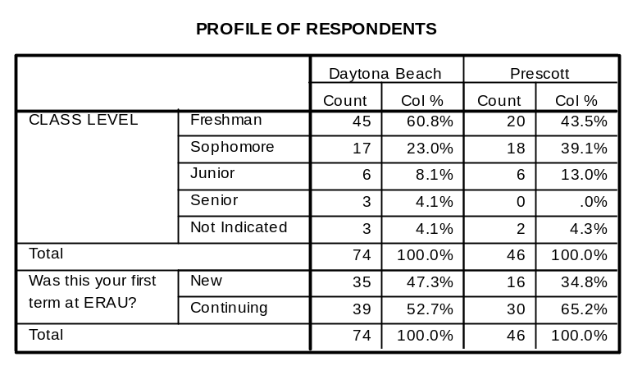
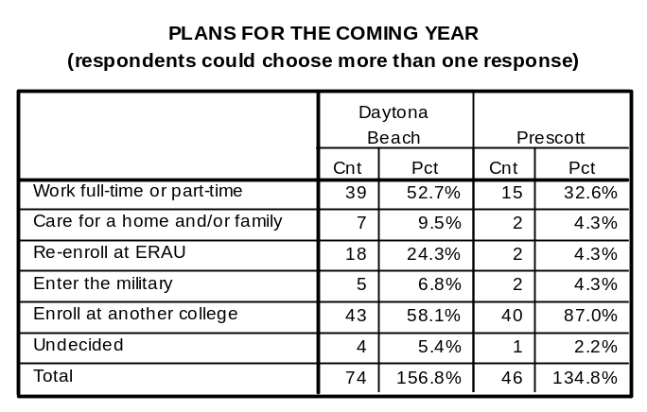
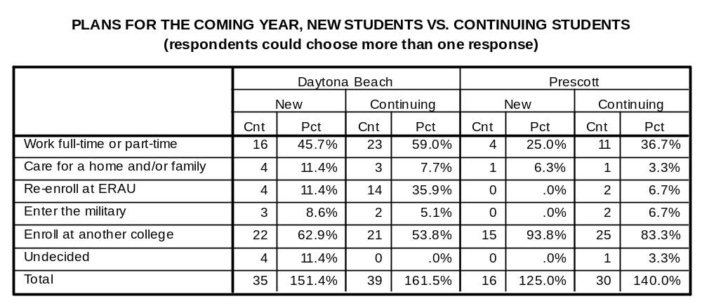

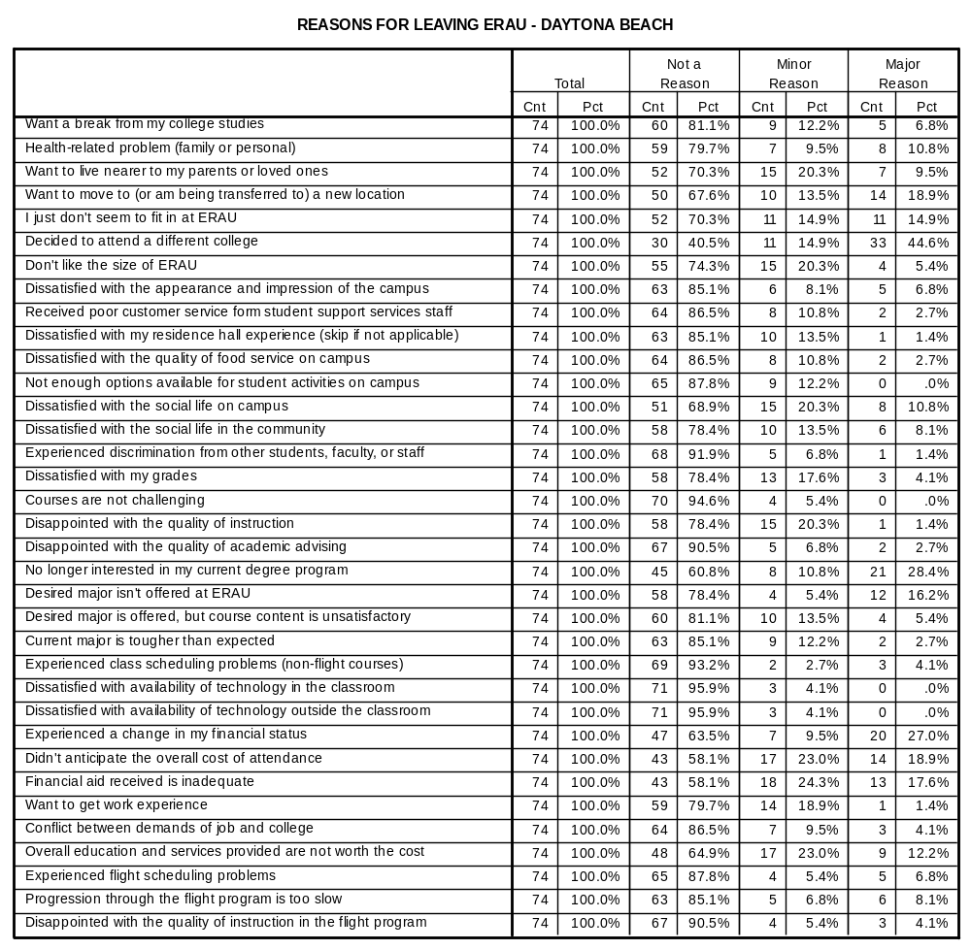
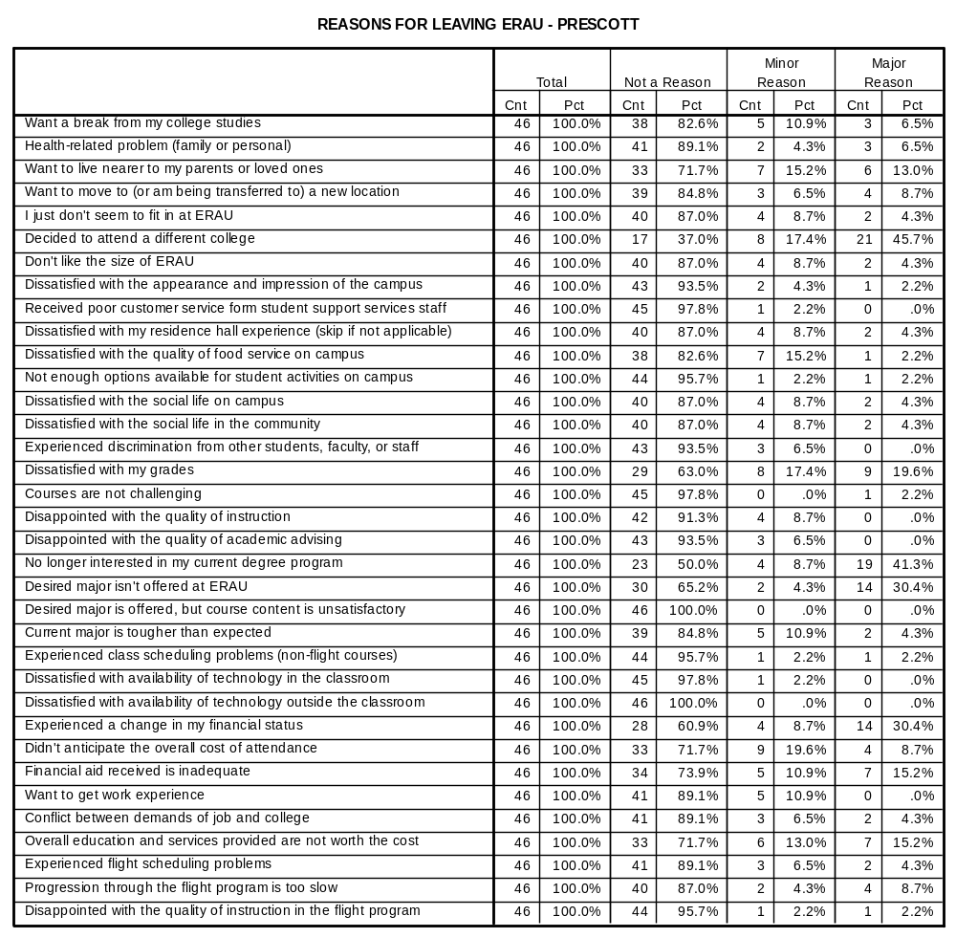

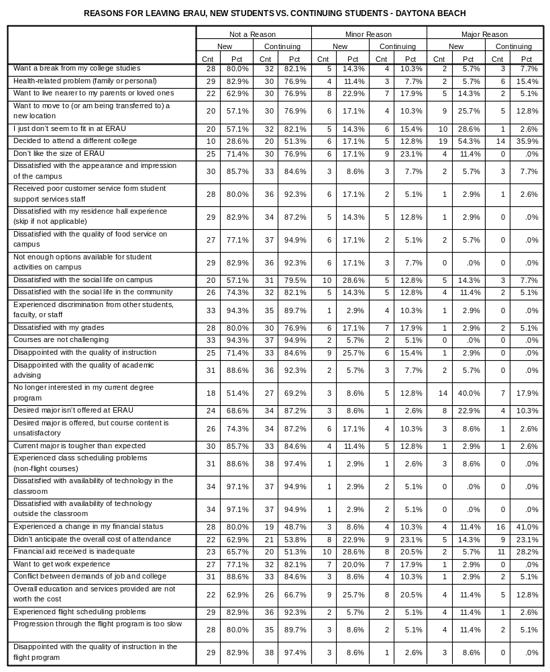
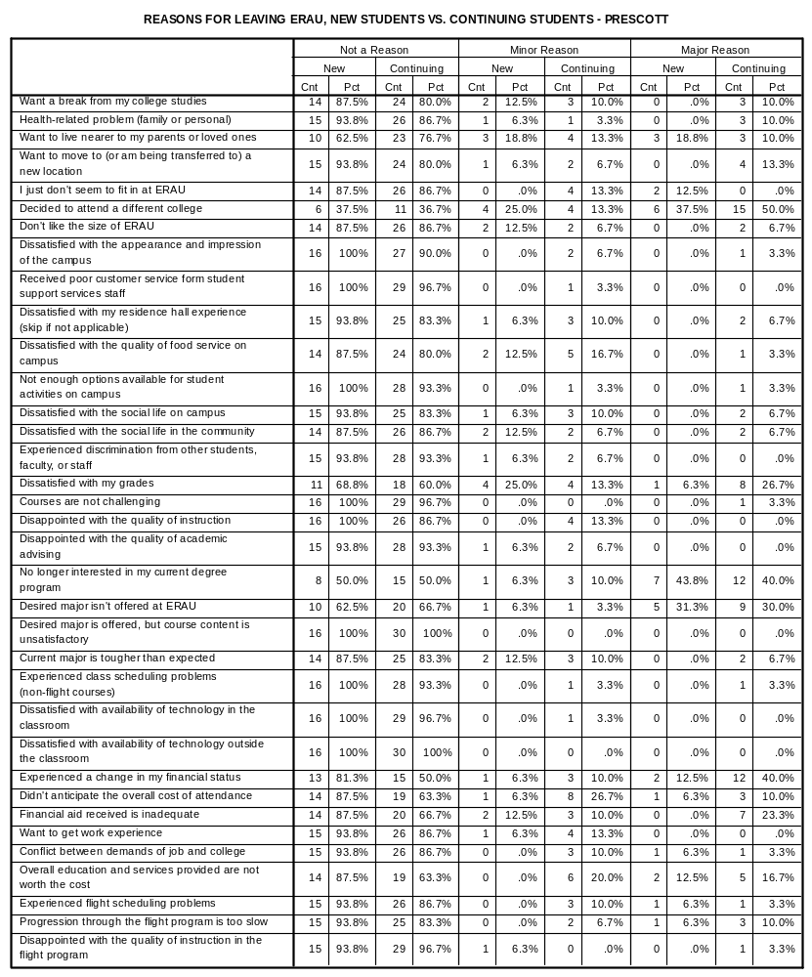

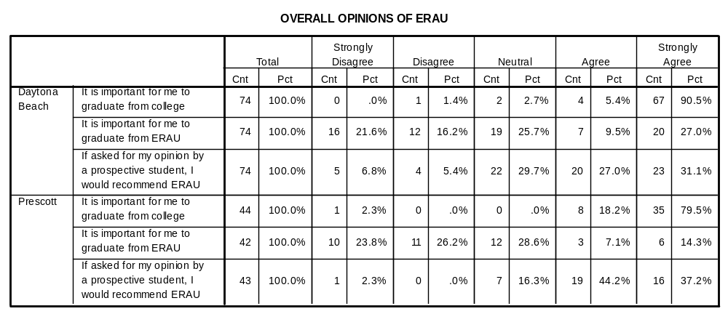
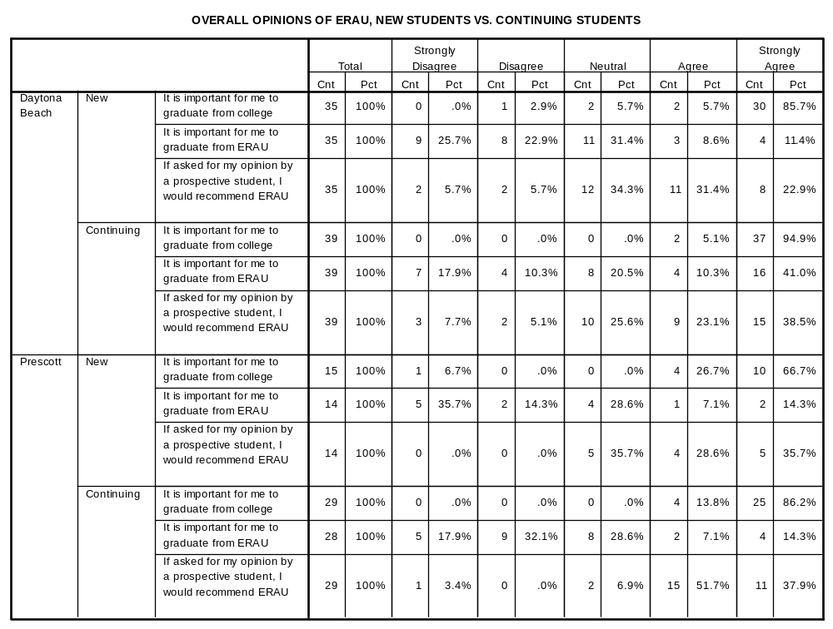

OPEN-ENDED COMMENTS – DAYTONA BEACH CAMPUS

Freshman
- Great college, good people, overall satisfactory
- Being deployed by the US Army to Iraq.
- Found a better flight school back at home.
- Changing majors
- Too expensive for flight, only one option w/ASC. "Prick" {name has been edited out} -unwillingness to help-arrogant, short, rude - icing on the cake. No flight inst.
- Expensive/ Tuition, Flights home, Flight, Living
- Social life/ not for me, more friends back home
- Interested in colleges back home
- Due to my GPA and not able to keep up
- Advisor put me in wrong course. Professor refused to teach to BSEP Program
- I was misinformed with information. I was told ROTC would be able to help me in some way, but that is not possible opportunity. I plan on coming back when my financial situation is better.
- Mostly not worth the cost.
- The recent hurricane delays compressed a critical semester in my college career, so instead of pounding through a rushed semester with 18 fewer days and 9 fewer classes (a few made up for) I'll start again in the Spring to do my studies the way I originally intended to with ample extra-curricular opportunities.
- To basically sum things up, I don't want to attend ERAU any longer because I am no longer interested in the Aerospace Engineering field, nor Aerospace in general.
- Upon entering the semester I thought I would be able to stay with pending; could not find a co-signer & flex payment plan was extremely too expensive to sign up for.

Sophomore
- Personal
- Lost financial aid due to school
- Attending a Community College due to finances. Will be back as soon as that gets straightened out.
- Generally, I'm satisfied with ERAU's college life. However, unfortunately, I can't help leaving school due to financial problems. I will come back to ERAU in 2 years after I have enough money. The only thing I want to talk to ERAU is the school must solve the problem of lack of parking lot and I'll be back.
- Decided to enlist in the Air Force
- Cheaper is better. DBCC offers same courses at better prices
- I'm leaving pretty much because I messed up in back-to-back semesters & didn't get my financial aid back. Then I couldn't afford it with the rise in tuition. Two more reasons: ratio is unfavorable (need more women) & hockey should be a varsity sport.

Junior
- Due to serious issues @ home need to temporarily leave Daytona for my and my family's safety.
- Want to complete CFI, CFII, MEI
- Finances
- Senior
- No money!

Class Level - Not Indicated
- I just came to improve my English at ERAU. Wondered to do Tower Control classes, but it was full and very expensive.
- Personal & Physical reasons

OPEN-ENDED COMMENTS – PRESCOTT CAMPUS

Freshman
- Degree he wanted was not offered here so he has to transfer to another university.
- Does not want to be a professional pilot.
- Dislike flight program - too slow, too expensive, not worth the cost.
- Want to get another major at another university and then return for AE and Aerospace Physics majors.
- Going to get General Ed courses at another university and then return.
- Will return home to live with parents. Wasn't quite ready to be away from home. Will attend college of the Desert, pick up all Gen. Ed. Requirements, then re-apply to ERAU.
- Advisor "dislikes me" - "said I was a slacker and should drop out and work at Wal-Mart."
- Needs remedial work at a community college. Needs better foundation for classes here. Might return.
- Student unconnected with campus. Faculty referrals identified this disconnect early on. Mid-term deficiency notices in nearly all classes. He had made no friends & was not attending class.
- I am leaving ERAU to regroup my person, so that when I return, I may be at my best, so that I can achieve my goals and better contribute to the academic community.
- I loved the school, the classes, and ERAU has an amazing flight program but I just cannot afford to attend.
- School was acceptable, however, I had to leave for financial purposes. I found my experience to be good, but would have been better if I didn't have to work full time.
- The financial cost has become a burden and has affected my overall standings of finances. Also, the course load and system is at a slight extreme. Not in the difficulty, but the number of courses can exceed 5 classes at a time, making it difficult to balance the workload.
- Food was terrible! But not a reason for leaving.
- Change of heart, didn't feel like pursuing a career in aviation/flying recent deaths in family also noted at end of interview.
- Unreasonably expensive

Sophomore
- Doesn't want to be a pilot; doesn't enjoy ERAU flight program. Too expensive to stay for ASP degree.
- Will attend less expensive college. Still interested in current (or related) program, but feels ERAU is not worth the cost.
- Not the right place. Hasn't connected to campus or Prescott. Lives off campus.
- Changing degree to program not offered @ ERAU
- Too Expensive
- Enjoyed his time here and wants to return.
- I will be back in Fall 07 or Fall 08
- I am leaving ERAU because I haven't been able to cope with the stress and pressure of check rides and flight in general.
- I would generally enjoy staying if there was a helicopter flight MAJOR as opposed to a minor. This lack of a course of study was the main deciding factor in my withdraw.
- This was a great experience for me, but there is no real diversity here and I feel out of place.

Junior
- Financial - unable to secure student loans.
- Social climate would benefit with more women on campus
- The reason I marked "Major reason" for "Overall education and services provided are not worth the cost " is because I am a Business student so the flightline, wind tunnels, etc. did not benefit me.

