Students who visited the Student Success Center as part of their withdrawal process are asked to complete an Exit Interview Questionnaire. At the Daytona Beach campus, those who were withdrawn via Student Services were also asked to complete the survey. Results are presented below.

Please note that respondents are those who have taken the initiative to inform the University that they are leaving. Students who stop-out or simply bypass the withdrawal process are not represented here. Please also note there are a higher proportion of new students responding to this survey than are in the actual student population, hence the results are more influenced by those perceptions.

Two summary charts are displayed first, followed by detailed tables and open-ended comments.

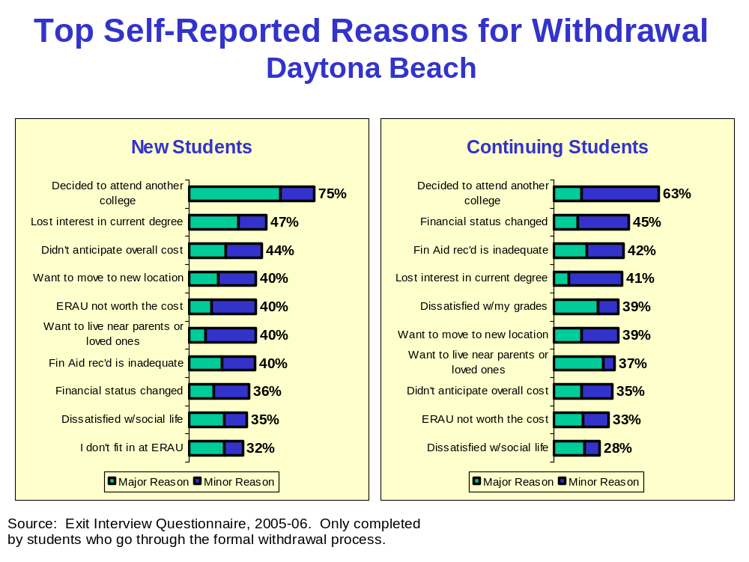
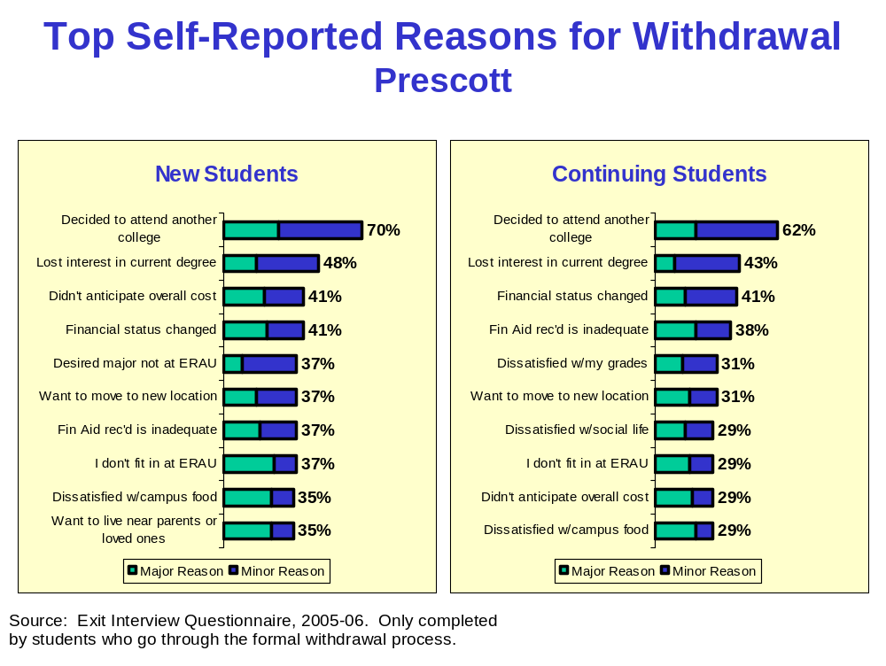
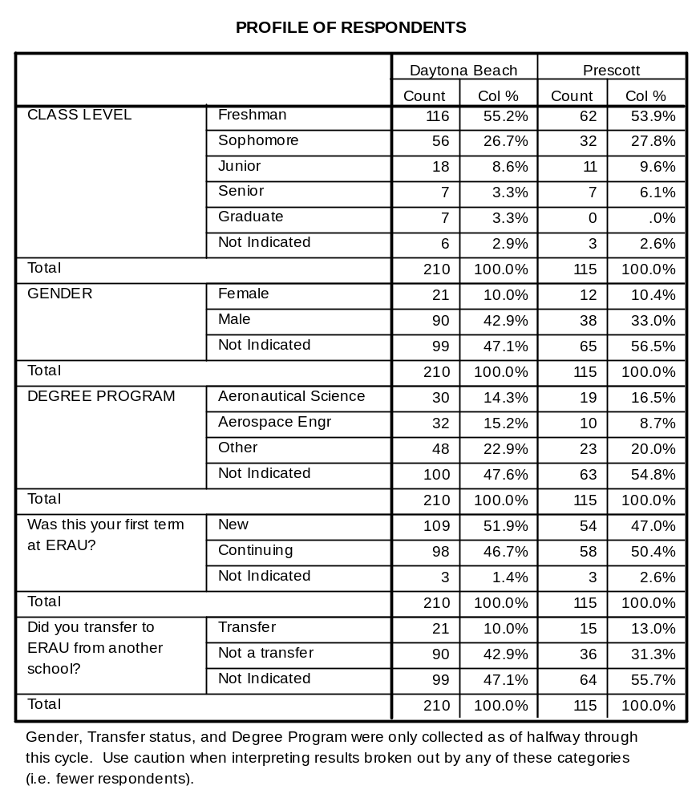

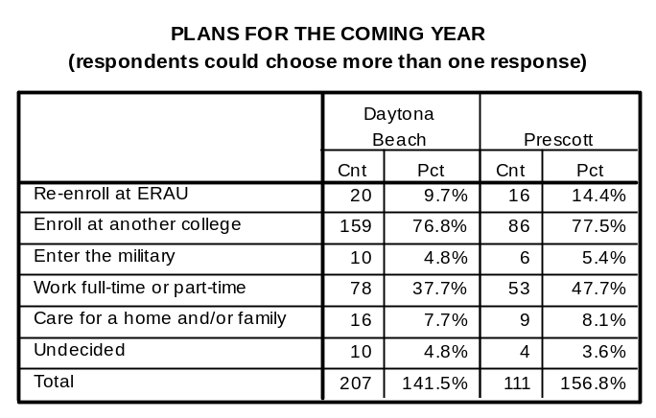

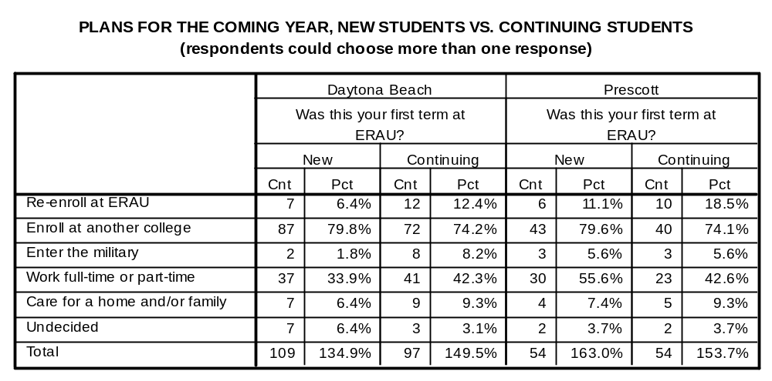

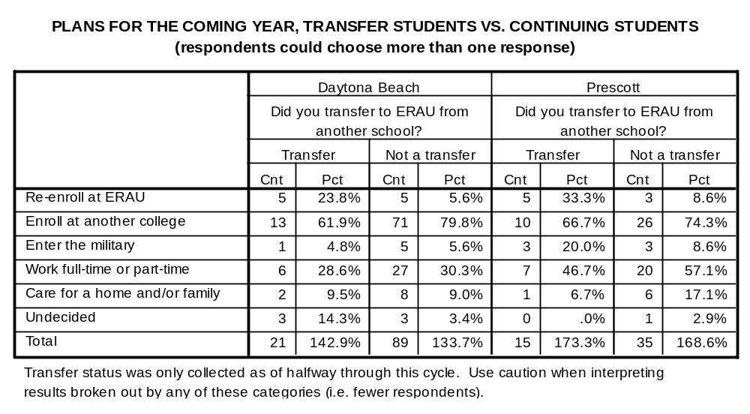

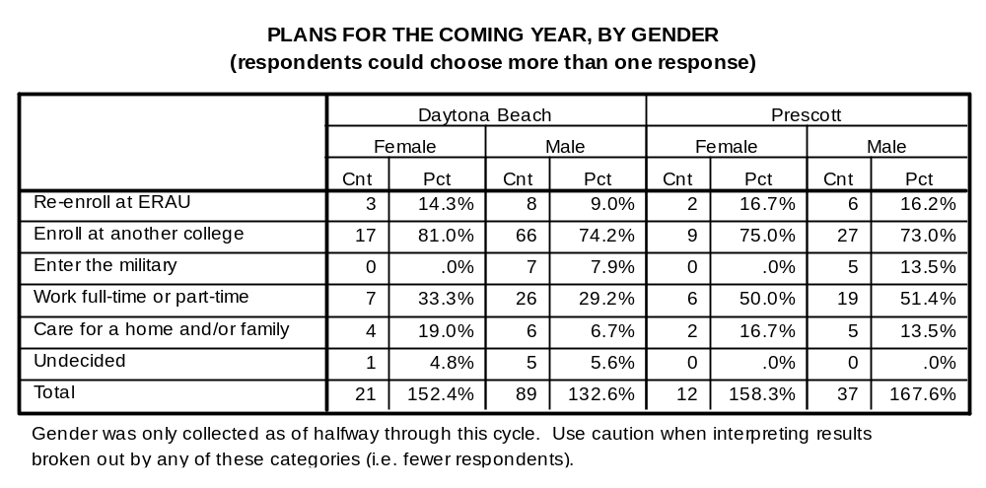

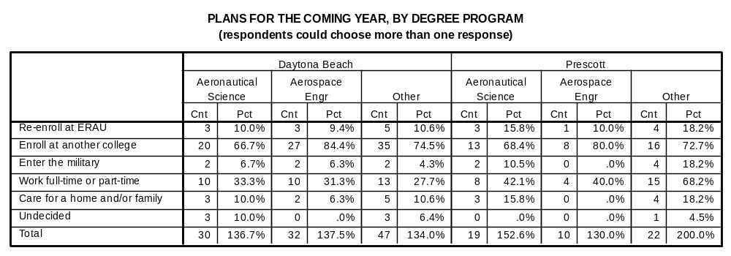

REASONS FOR LEAVING ERAU - DAYTONA BEACH
210
100.0%
182
86.7%
14
6.7%
14
6.7%
210
100.0%
187
89.0%
12
5.7%
11
5.2%
210
100.0%
130
61.9%
62
29.5%
18
8.6%
210
100.0%
127
60.5%
42
20.0%
41
19.5%
210
100.0%
150
71.4%
37
17.6%
23
11.0%
210
100.0%
64
30.5%
39
18.6%
107
51.0%
210
100.0%
169
80.5%
30
14.3%
11
5.2%
210
100.0%
167
79.5%
38
18.1%
5
2.4%
210
100.0%
184
87.6%
18
8.6%
8
3.8%
210
100.0%
180
85.7%
25
11.9%
5
2.4%
210
100.0%
177
84.3%
24
11.4%
9
4.3%
210
100.0%
179
85.2%
21
10.0%
10
4.8%
210
100.0%
145
69.0%
41
19.5%
24
11.4%
210
100.0%
162
77.1%
28
13.3%
20
9.5%
210
100.0%
199
94.8%
7
3.3%
4
1.9%
210
100.0%
141
67.1%
44
21.0%
25
11.9%
210
100.0%
188
89.5%
19
9.0%
3
1.4%
210
100.0%
159
75.7%
39
18.6%
12
5.7%
210
100.0%
195
92.9%
9
4.3%
6
2.9%
210
100.0%
119
56.7%
28
13.3%
63
30.0%
210
100.0%
156
74.3%
14
6.7%
40
19.0%
210
100.0%
185
88.1%
17
8.1%
8
3.8%
210
100.0%
180
85.7%
24
11.4%
6
2.9%
210
100.0%
194
92.4%
14
6.7%
2
1.0%
210
100.0%
202
96.2%
6
2.9%
2
1.0%
210
100.0%
201
95.7%
9
4.3%
0
.0%
210
100.0%
127
60.5%
30
14.3%
53
25.2%
210
100.0%
128
61.0%
40
19.0%
42
20.0%
210
100.0%
126
60.0%
41
19.5%
43
20.5%
210
100.0%
170
81.0%
28
13.3%
12
5.7%
210
100.0%
191
91.0%
11
5.2%
8
3.8%
210
100.0%
134
63.8%
46
21.9%
30
14.3%
210
100.0%
191
91.0%
8
3.8%
11
5.2%
210
100.0%
190
90.5%
10
4.8%
10
4.8%
210
100.0%
197
93.8%
7
3.3%
6
2.9%
Want a break from my college studies
Health-related problem (family or personal)
Want to live nearer to my parents or loved ones
Want to move to (or am being transferred to) a new location
I just don't seem to fit in at ERAU
Decided to attend a different college
Don't like the size of ERAU
Dissatisfied with the appearance and impression of the campus
Received poor customer service from student support services staff
Dissatisfied with my residence hall experience (skip if not applicable)
Dissatisfied with the quality of food service on campus
Not enough options available for student activities on campus
Dissatisfied with the social life on campus
Dissatisfied with the social life in the community
Experienced discrimination from other students, faculty, or staff
Dissatisfied with my grades
Courses are not challenging
Disappointed with the quality of instruction
Disappointed with the quality of academic advising
No longer interested in my current degree program
Desired major isn't offered at ERAU
Desired major is offered, but course content is unsatisfactory
Current major is tougher than expected
Experienced class scheduling problems (non-flight courses)
Dissatisfied with availability of technology in the classroom
Dissatisfied with availability of technology outside the classroom
Experienced a change in my financial status
Didn't anticipate the overall cost of attendance
Financial aid received is inadequate
Want to get work experience
Conflict between demands of job and college
Overall education and services provided are not worth the cost
Experienced flight scheduling problems
Progression through the flight program is too slow
Disappointed with the quality of instruction in the flight program
Cnt
Pct
Total
Cnt
Pct
Not a
Reason
Cnt
Pct
Minor
Reason
Cnt
Pct
Major
Reason

REASONS FOR LEAVING ERAU - PRESCOTT
115
100.0%
101
87.8%
10
8.7%
4
3.5%
115
100.0%
96
83.5%
7
6.1%
12
10.4%
115
100.0%
78
67.8%
24
20.9%
13
11.3%
115
100.0%
77
67.0%
19
16.5%
19
16.5%
115
100.0%
78
67.8%
24
20.9%
13
11.3%
115
100.0%
39
33.9%
28
24.3%
48
41.7%
115
100.0%
89
77.4%
16
13.9%
10
8.7%
115
100.0%
96
83.5%
11
9.6%
8
7.0%
115
100.0%
107
93.0%
5
4.3%
3
2.6%
115
100.0%
102
88.7%
9
7.8%
4
3.5%
115
100.0%
79
68.7%
25
21.7%
11
9.6%
115
100.0%
95
82.6%
18
15.7%
2
1.7%
115
100.0%
82
71.3%
16
13.9%
17
14.8%
115
100.0%
87
75.7%
15
13.0%
13
11.3%
115
100.0%
111
96.5%
2
1.7%
2
1.7%
115
100.0%
87
75.7%
16
13.9%
12
10.4%
115
100.0%
104
90.4%
9
7.8%
2
1.7%
115
100.0%
96
83.5%
14
12.2%
5
4.3%
115
100.0%
104
90.4%
8
7.0%
3
2.6%
115
100.0%
63
54.8%
16
13.9%
36
31.3%
115
100.0%
79
68.7%
9
7.8%
27
23.5%
115
100.0%
106
92.2%
6
5.2%
3
2.6%
115
100.0%
102
88.7%
6
5.2%
7
6.1%
115
100.0%
110
95.7%
3
2.6%
2
1.7%
115
100.0%
111
96.5%
2
1.7%
2
1.7%
115
100.0%
109
94.8%
4
3.5%
2
1.7%
115
100.0%
68
59.1%
22
19.1%
25
21.7%
115
100.0%
73
63.5%
24
20.9%
18
15.7%
115
100.0%
72
62.6%
22
19.1%
21
18.3%
115
100.0%
100
87.0%
13
11.3%
2
1.7%
115
100.0%
102
88.7%
9
7.8%
4
3.5%
115
100.0%
85
73.9%
13
11.3%
17
14.8%
115
100.0%
102
88.7%
3
2.6%
10
8.7%
115
100.0%
94
81.7%
7
6.1%
14
12.2%
115
100.0%
104
90.4%
3
2.6%
8
7.0%
Want a break from my college studies
Health-related problem (family or personal)
Want to live nearer to my parents or loved ones
Want to move to (or am being transferred to) a new location
I just don't seem to fit in at ERAU
Decided to attend a different college
Don't like the size of ERAU
Dissatisfied with the appearance and impression of the campus
Received poor customer service from student support services staff
Dissatisfied with my residence hall experience (skip if not applicable)
Dissatisfied with the quality of food service on campus
Not enough options available for student activities on campus
Dissatisfied with the social life on campus
Dissatisfied with the social life in the community
Experienced discrimination from other students, faculty, or staff
Dissatisfied with my grades
Courses are not challenging
Disappointed with the quality of instruction
Disappointed with the quality of academic advising
No longer interested in my current degree program
Desired major isn't offered at ERAU
Desired major is offered, but course content is unsatisfactory
Current major is tougher than expected
Experienced class scheduling problems (non-flight courses)
Dissatisfied with availability of technology in the classroom
Dissatisfied with availability of technology outside the classroom
Experienced a change in my financial status
Didn't anticipate the overall cost of attendance
Financial aid received is inadequate
Want to get work experience
Conflict between demands of job and college
Overall education and services provided are not worth the cost
Experienced flight scheduling problems
Progression through the flight program is too slow
Disappointed with the quality of instruction in the flight program
Cnt
Pct
Total
Cnt
Pct
Not a
Reason
Cnt
Pct
Minor
Reason
Cnt
Pct
Major
Reason

REASONS FOR LEAVING ERAU, NEW STUDENTS VS. CONTINUING STUDENTS - DAYTONA BEACH
94
86.2%
85
86.7%
9
8.3%
5
5.1%
6
5.5%
8
8.2%
98
89.9%
86
87.8%
8
7.3%
4
4.1%
3
2.8%
8
8.2%
65
59.6%
62
63.3%
33
30.3%
29
29.6%
11
10.1%
7
7.1%
65
59.6%
60
61.2%
25
22.9%
16
16.3%
19
17.4%
22
22.4%
74
67.9%
74
75.5%
23
21.1%
13
13.3%
12
11.0%
11
11.2%
27
24.8%
36
36.7%
22
20.2%
16
16.3%
60
55.0%
46
46.9%
88
80.7%
79
80.6%
16
14.7%
13
13.3%
5
4.6%
6
6.1%
89
81.7%
75
76.5%
18
16.5%
20
20.4%
2
1.8%
3
3.1%
96
88.1%
86
87.8%
9
8.3%
9
9.2%
4
3.7%
3
3.1%
93
85.3%
84
85.7%
14
12.8%
11
11.2%
2
1.8%
3
3.1%
89
81.7%
85
86.7%
16
14.7%
8
8.2%
4
3.7%
5
5.1%
87
79.8%
89
90.8%
16
14.7%
5
5.1%
6
5.5%
4
4.1%
71
65.1%
71
72.4%
23
21.1%
18
18.4%
15
13.8%
9
9.2%
82
75.2%
77
78.6%
16
14.7%
12
12.2%
11
10.1%
9
9.2%
105
96.3%
91
92.9%
3
2.8%
4
4.1%
1
.9%
3
3.1%
78
71.6%
60
61.2%
18
16.5%
26
26.5%
13
11.9%
12
12.2%
98
89.9%
87
88.8%
9
8.3%
10
10.2%
2
1.8%
1
1.0%
82
75.2%
74
75.5%
22
20.2%
17
17.3%
5
4.6%
7
7.1%
104
95.4%
88
89.8%
3
2.8%
6
6.1%
2
1.8%
4
4.1%
58
53.2%
58
59.2%
19
17.4%
9
9.2%
32
29.4%
31
31.6%
81
74.3%
72
73.5%
9
8.3%
5
5.1%
19
17.4%
21
21.4%
95
87.2%
87
88.8%
11
10.1%
6
6.1%
3
2.8%
5
5.1%
93
85.3%
84
85.7%
13
11.9%
11
11.2%
3
2.8%
3
3.1%
102
93.6%
89
90.8%
7
6.4%
7
7.1%
0
.0%
2
2.0%
106
97.2%
93
94.9%
1
.9%
5
5.1%
2
1.8%
0
.0%
104
95.4%
94
95.9%
5
4.6%
4
4.1%
0
.0%
0
.0%
70
64.2%
54
55.1%
16
14.7%
14
14.3%
23
21.1%
30
30.6%
61
56.0%
64
65.3%
24
22.0%
16
16.3%
24
22.0%
18
18.4%
66
60.6%
57
58.2%
22
20.2%
19
19.4%
21
19.3%
22
22.4%
91
83.5%
76
77.6%
12
11.0%
16
16.3%
6
5.5%
6
6.1%
103
94.5%
85
86.7%
5
4.6%
6
6.1%
1
.9%
7
7.1%
65
59.6%
66
67.3%
29
26.6%
17
17.3%
15
13.8%
15
15.3%
99
90.8%
89
90.8%
4
3.7%
4
4.1%
6
5.5%
5
5.1%
100
91.7%
87
88.8%
5
4.6%
5
5.1%
4
3.7%
6
6.1%
105
96.3%
89
90.8%
3
2.8%
4
4.1%
1
.9%
5
5.1%
Want a break from my college studies
Health-related problem (family or personal)
Want to live nearer to my parents or loved ones
Want to move to (or am being transferred to) a
new location
I just don't seem to fit in at ERAU
Decided to attend a different college
Don't like the size of ERAU
Dissatisfied with the appearance and impression
of the campus
Received poor customer service from student
support services staff
Dissatisfied with my residence hall experience
(skip if not applicable)
Dissatisfied with the quality of food service on
campus
Not enough options available for student activities
on campus
Dissatisfied with the social life on campus
Dissatisfied with the social life in the community
Experienced discrimination from other students,
faculty, or staff
Dissatisfied with my grades
Courses are not challenging
Disappointed with the quality of instruction
Disappointed with the quality of academic
advising
No longer interested in my current degree
program
Desired major isn't offered at ERAU
Desired major is offered, but course content is
unsatisfactory
Current major is tougher than expected
Experienced class scheduling problems (non-flight
courses)
Dissatisfied with availability of technology in the
classroom
Dissatisfied with availability of technology outside
the classroom
Experienced a change in my financial status
Didn't anticipate the overall cost of attendance
Financial aid received is inadequate
Want to get work experience
Conflict between demands of job and college
Overall education and services provided are not
worth the cost
Experienced flight scheduling problems
Progression through the flight program is too slow
Disappointed with the quality of instruction in the
flight program
Cnt
Pct
New
Cnt
Pct
Continuing
Not a Reason
Cnt
Pct
New
Cnt
Pct
Continuing
Minor Reason
Cnt
Pct
New
Cnt
Pct
Continuing
Major Reason
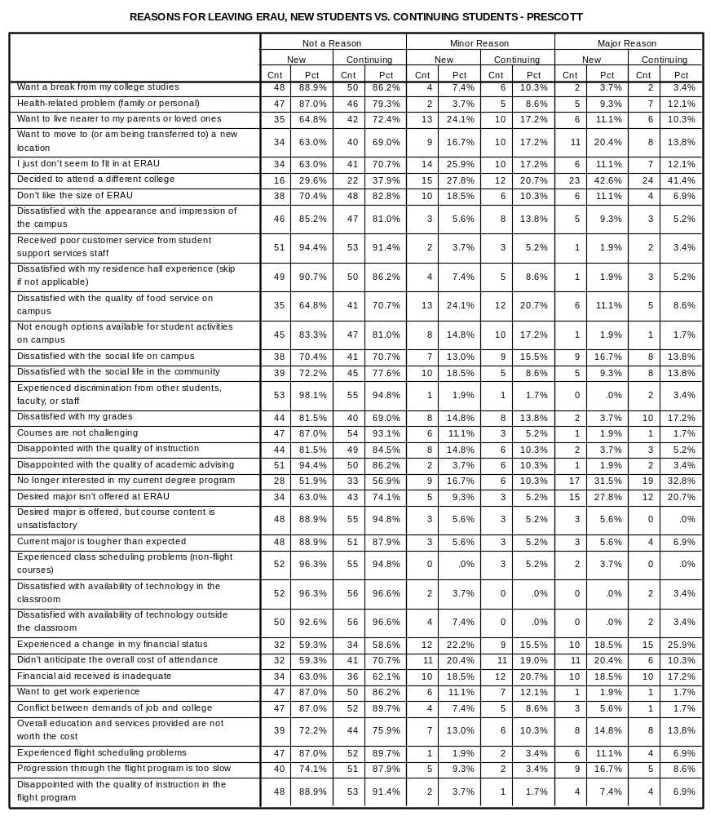

REASONS FOR LEAVING ERAU, TRANSFER STUDENTS - DAYTONA BEACH
18
85.7%
78
86.7%
0
.0%
4
4.4%
3
14.3%
8
8.9%
19
90.5%
81
90.0%
2
9.5%
3
3.3%
0
.0%
6
6.7%
16
76.2%
52
57.8%
3
14.3%
28
31.1%
2
9.5%
10
11.1%
18
85.7%
45
50.0%
2
9.5%
22
24.4%
1
4.8%
23
25.6%
18
85.7%
69
76.7%
3
14.3%
9
10.0%
0
.0%
12
13.3%
9
42.9%
29
32.2%
3
14.3%
12
13.3%
9
42.9%
49
54.4%
20
95.2%
68
75.6%
1
4.8%
16
17.8%
0
.0%
6
6.7%
19
90.5%
71
78.9%
2
9.5%
18
20.0%
0
.0%
1
1.1%
19
90.5%
78
86.7%
2
9.5%
8
8.9%
0
.0%
4
4.4%
21
100.0%
75
83.3%
0
.0%
12
13.3%
0
.0%
3
3.3%
20
95.2%
73
81.1%
1
4.8%
12
13.3%
0
.0%
5
5.6%
21
100.0%
77
85.6%
0
.0%
11
12.2%
0
.0%
2
2.2%
20
95.2%
55
61.1%
0
.0%
25
27.8%
1
4.8%
10
11.1%
21
100.0%
65
72.2%
0
.0%
15
16.7%
0
.0%
10
11.1%
21
100.0%
81
90.0%
0
.0%
6
6.7%
0
.0%
3
3.3%
18
85.7%
48
53.3%
2
9.5%
26
28.9%
1
4.8%
16
17.8%
21
100.0%
81
90.0%
0
.0%
9
10.0%
0
.0%
0
.0%
18
85.7%
71
78.9%
2
9.5%
15
16.7%
1
4.8%
4
4.4%
19
90.5%
85
94.4%
0
.0%
4
4.4%
2
9.5%
1
1.1%
16
76.2%
54
60.0%
2
9.5%
14
15.6%
3
14.3%
22
24.4%
17
81.0%
66
73.3%
1
4.8%
8
8.9%
3
14.3%
16
17.8%
19
90.5%
75
83.3%
1
4.8%
8
8.9%
1
4.8%
7
7.8%
19
90.5%
73
81.1%
2
9.5%
15
16.7%
0
.0%
2
2.2%
20
95.2%
81
90.0%
0
.0%
8
8.9%
1
4.8%
1
1.1%
20
95.2%
84
93.3%
1
4.8%
5
5.6%
0
.0%
1
1.1%
21
100.0%
83
92.2%
0
.0%
7
7.8%
0
.0%
0
.0%
10
47.6%
52
57.8%
4
19.0%
16
17.8%
7
33.3%
22
24.4%
9
42.9%
51
56.7%
4
19.0%
19
21.1%
8
38.1%
20
22.2%
12
57.1%
50
55.6%
2
9.5%
21
23.3%
7
33.3%
19
21.1%
18
85.7%
72
80.0%
2
9.5%
13
14.4%
1
4.8%
5
5.6%
18
85.7%
80
88.9%
2
9.5%
8
8.9%
1
4.8%
2
2.2%
16
76.2%
63
70.0%
1
4.8%
18
20.0%
4
19.0%
9
10.0%
21
100.0%
81
90.0%
0
.0%
4
4.4%
0
.0%
5
5.6%
21
100.0%
79
87.8%
0
.0%
8
8.9%
0
.0%
3
3.3%
21
100.0%
83
92.2%
0
.0%
5
5.6%
0
.0%
2
2.2%
Want a break from my college studies
Health-related problem (family or personal)
Want to live nearer to my parents or loved ones
Want to move to (or am being transferred to) a
new location
I just don't seem to fit in at ERAU
Decided to attend a different college
Don't like the size of ERAU
Dissatisfied with the appearance and impression
of the campus
Received poor customer service from student
support services staff
Dissatisfied with my residence hall experience
(skip if not applicable)
Dissatisfied with the quality of food service on
campus
Not enough options available for student
activities on campus
Dissatisfied with the social life on campus
Dissatisfied with the social life in the community
Experienced discrimination from other students,
faculty, or staff
Dissatisfied with my grades
Courses are not challenging
Disappointed with the quality of instruction
Disappointed with the quality of academic
advising
No longer interested in my current degree
program
Desired major isn't offered at ERAU
Desired major is offered, but course content is
unsatisfactory
Current major is tougher than expected
Experienced class scheduling problems
(non-flight courses)
Dissatisfied with availability of technology in the
classroom
Dissatisfied with availability of technology
outside the classroom
Experienced a change in my financial status
Didn't anticipate the overall cost of attendance
Financial aid received is inadequate
Want to get work experience
Conflict between demands of job and college
Overall education and services provided are not
worth the cost
Experienced flight scheduling problems
Progression through the flight program is too
slow
Disappointed with the quality of instruction in
the flight program
Cnt
Pct
Transfer
Cnt
Pct
Not a
transfer
Not a Reason
Cnt
Pct
Transfer
Cnt
Pct
Not a
transfer
Minor Reason
Cnt
Pct
Transfer
Cnt
Pct
Not a
transfer
Major Reason
Transfer status was only collected as of halfway through this cycle. Use caution when interpreting results broken out by any of these categories (i.e.
fewer respondents).
REASONS FOR LEAVING ERAU, TRANSFER STUDENTS - PRESCOTT
12
80.0%
29
80.6%
2
13.3%
7
19.4%
1
6.7%
0
.0%
13
86.7%
29
80.6%
1
6.7%
4
11.1%
1
6.7%
3
8.3%
10
66.7%
23
63.9%
4
26.7%
7
19.4%
1
6.7%
6
16.7%
7
46.7%
23
63.9%
4
26.7%
8
22.2%
4
26.7%
5
13.9%
10
66.7%
23
63.9%
4
26.7%
8
22.2%
1
6.7%
5
13.9%
6
40.0%
14
38.9%
3
20.0%
8
22.2%
6
40.0%
14
38.9%
12
80.0%
26
72.2%
3
20.0%
5
13.9%
0
.0%
5
13.9%
14
93.3%
27
75.0%
0
.0%
8
22.2%
1
6.7%
1
2.8%
13
86.7%
33
91.7%
2
13.3%
1
2.8%
0
.0%
2
5.6%
14
93.3%
28
77.8%
1
6.7%
4
11.1%
0
.0%
4
11.1%
12
80.0%
21
58.3%
2
13.3%
13
36.1%
1
6.7%
2
5.6%
14
93.3%
28
77.8%
1
6.7%
8
22.2%
0
.0%
0
.0%
11
73.3%
25
69.4%
3
20.0%
5
13.9%
1
6.7%
6
16.7%
12
80.0%
25
69.4%
3
20.0%
6
16.7%
0
.0%
5
13.9%
15
100.0%
35
97.2%
0
.0%
1
2.8%
0
.0%
0
.0%
13
86.7%
24
66.7%
0
.0%
6
16.7%
2
13.3%
6
16.7%
13
86.7%
31
86.1%
2
13.3%
5
13.9%
0
.0%
0
.0%
11
73.3%
29
80.6%
3
20.0%
5
13.9%
1
6.7%
2
5.6%
14
93.3%
30
83.3%
1
6.7%
5
13.9%
0
.0%
1
2.8%
11
73.3%
17
47.2%
2
13.3%
7
19.4%
2
13.3%
12
33.3%
11
73.3%
23
63.9%
2
13.3%
4
11.1%
2
13.3%
9
25.0%
13
86.7%
32
88.9%
2
13.3%
2
5.6%
0
.0%
2
5.6%
14
93.3%
30
83.3%
0
.0%
3
8.3%
1
6.7%
3
8.3%
14
93.3%
34
94.4%
1
6.7%
1
2.8%
0
.0%
1
2.8%
13
86.7%
35
97.2%
1
6.7%
1
2.8%
1
6.7%
0
.0%
13
86.7%
35
97.2%
1
6.7%
1
2.8%
1
6.7%
0
.0%
10
66.7%
15
41.7%
2
13.3%
10
27.8%
3
20.0%
11
30.6%
9
60.0%
22
61.1%
3
20.0%
7
19.4%
3
20.0%
7
19.4%
9
60.0%
17
47.2%
2
13.3%
11
30.6%
4
26.7%
8
22.2%
15
100.0%
26
72.2%
0
.0%
8
22.2%
0
.0%
2
5.6%
15
100.0%
26
72.2%
0
.0%
7
19.4%
0
.0%
3
8.3%
13
86.7%
24
66.7%
1
6.7%
4
11.1%
1
6.7%
8
22.2%
13
86.7%
30
83.3%
0
.0%
3
8.3%
2
13.3%
3
8.3%
12
80.0%
29
80.6%
1
6.7%
2
5.6%
2
13.3%
5
13.9%
13
86.7%
31
86.1%
0
.0%
2
5.6%
2
13.3%
3
8.3%
Want a break from my college studies
Health-related problem (family or personal)
Want to live nearer to my parents or loved ones
Want to move to (or am being transferred to) a
new location
I just don't seem to fit in at ERAU
Decided to attend a different college
Don't like the size of ERAU
Dissatisfied with the appearance and impression
of the campus
Received poor customer service from student
support services staff
Dissatisfied with my residence hall experience
(skip if not applicable)
Dissatisfied with the quality of food service on
campus
Not enough options available for student
activities on campus
Dissatisfied with the social life on campus
Dissatisfied with the social life in the community
Experienced discrimination from other students,
faculty, or staff
Dissatisfied with my grades
Courses are not challenging
Disappointed with the quality of instruction
Disappointed with the quality of academic
advising
No longer interested in my current degree
program
Desired major isn't offered at ERAU
Desired major is offered, but course content is
unsatisfactory
Current major is tougher than expected
Experienced class scheduling problems
(non-flight courses)
Dissatisfied with availability of technology in the
classroom
Dissatisfied with availability of technology
outside the classroom
Experienced a change in my financial status
Didn't anticipate the overall cost of attendance
Financial aid received is inadequate
Want to get work experience
Conflict between demands of job and college
Overall education and services provided are not
worth the cost
Experienced flight scheduling problems
Progression through the flight program is too
slow
Disappointed with the quality of instruction in
the flight program
Cnt
Pct
Transfer
Cnt
Pct
Not a
transfer
Not a Reason
Cnt
Pct
Transfer
Cnt
Pct
Not a
transfer
Minor Reason
Cnt
Pct
Transfer
Cnt
Pct
Not a
transfer
Major Reason
Transfer status was only collected as of halfway through this cycle. Use caution when interpreting results broken out by any of these categories (i.e.
fewer respondents).
REASONS FOR LEAVING ERAU, BY GENDER - DAYTONA BEACH
18
85.7%
79
87.8%
1
4.8%
2
2.2%
2
9.5%
9
10.0%
18
85.7%
82
91.1%
1
4.8%
4
4.4%
2
9.5%
4
4.4%
13
61.9%
57
63.3%
5
23.8%
25
27.8%
3
14.3%
8
8.9%
12
57.1%
52
57.8%
5
23.8%
18
20.0%
4
19.0%
20
22.2%
17
81.0%
69
76.7%
1
4.8%
11
12.2%
3
14.3%
10
11.1%
5
23.8%
34
37.8%
2
9.5%
12
13.3%
14
66.7%
44
48.9%
19
90.5%
69
76.7%
1
4.8%
16
17.8%
1
4.8%
5
5.6%
20
95.2%
70
77.8%
1
4.8%
18
20.0%
0
.0%
2
2.2%
18
85.7%
78
86.7%
2
9.5%
8
8.9%
1
4.8%
4
4.4%
18
85.7%
79
87.8%
1
4.8%
10
11.1%
2
9.5%
1
1.1%
16
76.2%
77
85.6%
3
14.3%
11
12.2%
2
9.5%
2
2.2%
18
85.7%
81
90.0%
1
4.8%
9
10.0%
2
9.5%
0
.0%
18
85.7%
58
64.4%
1
4.8%
23
25.6%
2
9.5%
9
10.0%
20
95.2%
67
74.4%
0
.0%
14
15.6%
1
4.8%
9
10.0%
18
85.7%
85
94.4%
2
9.5%
4
4.4%
1
4.8%
1
1.1%
13
61.9%
54
60.0%
7
33.3%
21
23.3%
1
4.8%
15
16.7%
19
90.5%
84
93.3%
2
9.5%
6
6.7%
0
.0%
0
.0%
16
76.2%
73
81.1%
4
19.0%
12
13.3%
1
4.8%
5
5.6%
18
85.7%
86
95.6%
1
4.8%
3
3.3%
2
9.5%
1
1.1%
15
71.4%
54
60.0%
0
.0%
16
17.8%
6
28.6%
20
22.2%
16
76.2%
67
74.4%
1
4.8%
7
7.8%
4
19.0%
16
17.8%
18
85.7%
77
85.6%
1
4.8%
7
7.8%
2
9.5%
6
6.7%
16
76.2%
76
84.4%
5
23.8%
12
13.3%
0
.0%
2
2.2%
18
85.7%
83
92.2%
2
9.5%
6
6.7%
1
4.8%
1
1.1%
19
90.5%
85
94.4%
2
9.5%
4
4.4%
0
.0%
1
1.1%
19
90.5%
85
94.4%
2
9.5%
5
5.6%
0
.0%
0
.0%
9
42.9%
55
61.1%
5
23.8%
15
16.7%
7
33.3%
20
22.2%
9
42.9%
53
58.9%
4
19.0%
19
21.1%
8
38.1%
18
20.0%
10
47.6%
54
60.0%
4
19.0%
18
20.0%
7
33.3%
18
20.0%
18
85.7%
74
82.2%
2
9.5%
12
13.3%
1
4.8%
4
4.4%
18
85.7%
81
90.0%
3
14.3%
6
6.7%
0
.0%
3
3.3%
14
66.7%
65
72.2%
2
9.5%
18
20.0%
5
23.8%
7
7.8%
21
100.0%
80
88.9%
0
.0%
5
5.6%
0
.0%
5
5.6%
21
100.0%
78
86.7%
0
.0%
8
8.9%
0
.0%
4
4.4%
21
100.0%
82
91.1%
0
.0%
5
5.6%
0
.0%
3
3.3%
Want a break from my college studies
Health-related problem (family or personal)
Want to live nearer to my parents or loved ones
Want to move to (or am being transferred to) a
new location
I just don't seem to fit in at ERAU
Decided to attend a different college
Don't like the size of ERAU
Dissatisfied with the appearance and impression
of the campus
Received poor customer service from student
support services staff
Dissatisfied with my residence hall experience
(skip if not applicable)
Dissatisfied with the quality of food service on
campus
Not enough options available for student
activities on campus
Dissatisfied with the social life on campus
Dissatisfied with the social life in the community
Experienced discrimination from other students,
faculty, or staff
Dissatisfied with my grades
Courses are not challenging
Disappointed with the quality of instruction
Disappointed with the quality of academic
advising
No longer interested in my current degree
program
Desired major isn't offered at ERAU
Desired major is offered, but course content is
unsatisfactory
Current major is tougher than expected
Experienced class scheduling problems
(non-flight courses)
Dissatisfied with availability of technology in the
classroom
Dissatisfied with availability of technology
outside the classroom
Experienced a change in my financial status
Didn't anticipate the overall cost of attendance
Financial aid received is inadequate
Want to get work experience
Conflict between demands of job and college
Overall education and services provided are not
worth the cost
Experienced flight scheduling problems
Progression through the flight program is too
slow
Disappointed with the quality of instruction in
the flight program
Cnt
Pct
Female
Cnt
Pct
Male
Not a Reason
Cnt
Pct
Female
Cnt
Pct
Male
Minor Reason
Cnt
Pct
Female
Cnt
Pct
Male
Major Reason
Gender was only collected as of halfway through this cycle. Use caution when interpreting results broken out by any of these categories (i.e. fewer
respondents).
REASONS FOR LEAVING ERAU, BY GENDER - PRESCOTT
10
83.3%
31
81.6%
2
16.7%
6
15.8%
0
.0%
1
2.6%
8
66.7%
33
86.8%
2
16.7%
3
7.9%
2
16.7%
2
5.3%
8
66.7%
24
63.2%
2
16.7%
10
26.3%
2
16.7%
4
10.5%
8
66.7%
22
57.9%
3
25.0%
9
23.7%
1
8.3%
7
18.4%
10
83.3%
23
60.5%
0
.0%
12
31.6%
2
16.7%
3
7.9%
4
33.3%
14
36.8%
4
33.3%
8
21.1%
4
33.3%
16
42.1%
11
91.7%
28
73.7%
1
8.3%
6
15.8%
0
.0%
4
10.5%
10
83.3%
31
81.6%
2
16.7%
5
13.2%
0
.0%
2
5.3%
11
91.7%
34
89.5%
0
.0%
3
7.9%
1
8.3%
1
2.6%
9
75.0%
32
84.2%
2
16.7%
3
7.9%
1
8.3%
3
7.9%
9
75.0%
25
65.8%
3
25.0%
11
28.9%
0
.0%
2
5.3%
10
83.3%
32
84.2%
2
16.7%
6
15.8%
0
.0%
0
.0%
10
83.3%
27
71.1%
1
8.3%
6
15.8%
1
8.3%
5
13.2%
11
91.7%
27
71.1%
0
.0%
8
21.1%
1
8.3%
3
7.9%
12
100.0%
37
97.4%
0
.0%
1
2.6%
0
.0%
0
.0%
8
66.7%
30
78.9%
1
8.3%
5
13.2%
3
25.0%
3
7.9%
11
91.7%
32
84.2%
1
8.3%
6
15.8%
0
.0%
0
.0%
10
83.3%
30
78.9%
1
8.3%
6
15.8%
1
8.3%
2
5.3%
11
91.7%
33
86.8%
0
.0%
5
13.2%
1
8.3%
0
.0%
6
50.0%
21
55.3%
2
16.7%
8
21.1%
4
33.3%
9
23.7%
8
66.7%
24
63.2%
1
8.3%
6
15.8%
3
25.0%
8
21.1%
9
75.0%
35
92.1%
3
25.0%
1
2.6%
0
.0%
2
5.3%
10
83.3%
33
86.8%
1
8.3%
2
5.3%
1
8.3%
3
7.9%
12
100.0%
36
94.7%
0
.0%
1
2.6%
0
.0%
1
2.6%
12
100.0%
35
92.1%
0
.0%
2
5.3%
0
.0%
1
2.6%
12
100.0%
35
92.1%
0
.0%
2
5.3%
0
.0%
1
2.6%
3
25.0%
23
60.5%
5
41.7%
7
18.4%
4
33.3%
8
21.1%
6
50.0%
25
65.8%
4
33.3%
6
15.8%
2
16.7%
7
18.4%
4
33.3%
23
60.5%
5
41.7%
7
18.4%
3
25.0%
8
21.1%
8
66.7%
33
86.8%
3
25.0%
4
10.5%
1
8.3%
1
2.6%
10
83.3%
31
81.6%
1
8.3%
5
13.2%
1
8.3%
2
5.3%
9
75.0%
28
73.7%
1
8.3%
4
10.5%
2
16.7%
6
15.8%
10
83.3%
32
84.2%
0
.0%
3
7.9%
2
16.7%
3
7.9%
10
83.3%
30
78.9%
1
8.3%
2
5.3%
1
8.3%
6
15.8%
10
83.3%
33
86.8%
0
.0%
2
5.3%
2
16.7%
3
7.9%
Want a break from my college studies
Health-related problem (family or personal)
Want to live nearer to my parents or loved ones
Want to move to (or am being transferred to) a
new location
I just don't seem to fit in at ERAU
Decided to attend a different college
Don't like the size of ERAU
Dissatisfied with the appearance and impression
of the campus
Received poor customer service from student
support services staff
Dissatisfied with my residence hall experience
(skip if not applicable)
Dissatisfied with the quality of food service on
campus
Not enough options available for student
activities on campus
Dissatisfied with the social life on campus
Dissatisfied with the social life in the community
Experienced discrimination from other students,
faculty, or staff
Dissatisfied with my grades
Courses are not challenging
Disappointed with the quality of instruction
Disappointed with the quality of academic
advising
No longer interested in my current degree
program
Desired major isn't offered at ERAU
Desired major is offered, but course content is
unsatisfactory
Current major is tougher than expected
Experienced class scheduling problems
(non-flight courses)
Dissatisfied with availability of technology in the
classroom
Dissatisfied with availability of technology
outside the classroom
Experienced a change in my financial status
Didn't anticipate the overall cost of attendance
Financial aid received is inadequate
Want to get work experience
Conflict between demands of job and college
Overall education and services provided are not
worth the cost
Experienced flight scheduling problems
Progression through the flight program is too slow
Disappointed with the quality of instruction in the
flight program
Cnt
Pct
Female
Cnt
Pct
Male
Not a Reason
Cnt
Pct
Female
Cnt
Pct
Male
Minor Reason
Cnt
Pct
Female
Cnt
Pct
Male
Major Reason
Gender was only collected as of halfway through this cycle. Use caution when interpreting results broken out by any of these categories (i.e. fewer
respondents).
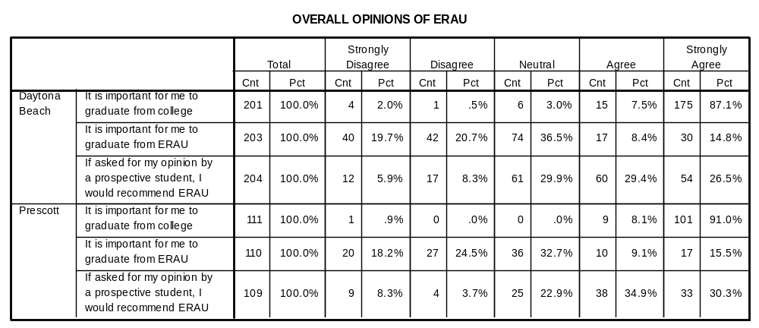

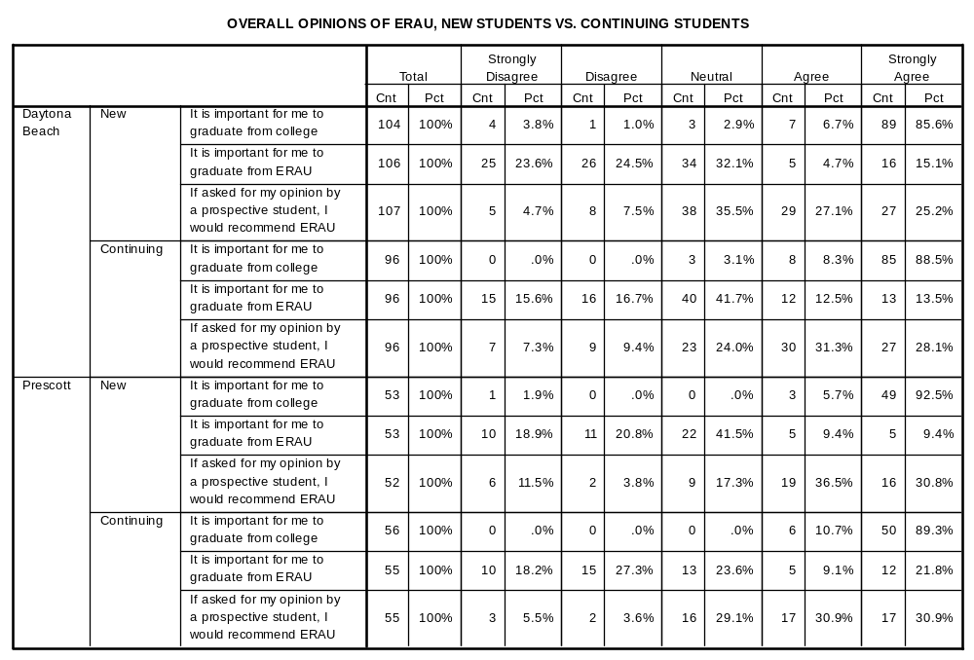

OPEN-ENDED COMMENTS – DAYTONA BEACH

Freshman
- There needs to be more communication between financial offices within ERAU to keep students informed. More programs to help with student loans.
- School is too technical and too expensive to continue.
- Gone Fishing
- Also, want a minor/major in mass media productions and going for Dance Team.
- Getting married & can't convince her to come down here.
- Social imbalance created a disgusting social atmosphere in cafeterias, classrooms and other facilities. Has spread to some degree into community abroad. Other than that, great school!
- Just family problems
- Have EGR 115 in a computer lab
- Quality of flight instruction was poor. Failure of the University to deliver a quality product.
- Flight Instructor had little motivation for my progression.
- Just can't pay the money or get into this amount of debt.
- Great school! I just can't afford it and fell behind.
- Change of interest
- Change in financial status, tuition/flight too expensive.
- To pursue a degree in Criminal Investigations
- Heart is just not in Aviation
- Flight cost is very expensive
- No "minor reasons' listed above are the main reason of leaving, however, they are reinforcements
- I have decided to withdraw from ERAU because I am uncertain of my specific field of interest and have concluded the tuition cost of ERAU to be unjustified while I am still exploring my interests.
- I'm giving them to Frank Ayers on a flight Dept. survey later today.
- ERAU is a great school, but I wasn’t ready to come to a new environment.
- My overall experience at ERAU was great, but it does not offer the major I want to pursue.

Sophomore
- Too much money spent so far, haven't even started flying.
- Military duty
- Undesirable grades compounded w/ situation @ home, mom divorced 12/05, choose between ERAU ($30,000) or house, I can no longer afford
- ERAU.
- Personal reason. It is best for myself and parents if I went home for a couple of years.
- The scholarships and grants available to me will be over, after doing a cost analysis from ERAU to MSU it will be substantially lower in cost if I attend MSU.
- I just don't want to do HuF anymore. I have always wanted to do psychology.

Junior
- Student Body
- I have received a full ride at Syracuse University
- I need to sort out my student visa in my country.
- Wonderful School! I like it a lot and I think it's great for the programs it has. I just can't keep up w/ the academics in engineering physics and I believe I would be happier pursuing nursing. If you had nursing at ERAU, I'd stay. I would recommend this school for people in the field. Thank you for the experience!
- Simply transferring to another University for various reasons.

Senior
- I don't feel AE is for me because I want to explore other options.

OPEN-ENDED COMMENTS – PRESCOTT

Freshman
- Life is to slow here and I believe that flight expenses should be include in tuition and more flying and learning should take place. (everyday)
- School is not diverse enough for student
- Does not feel flying is the right career choice; considering law enforcement
- Had a concussion and lost ROTC scholarship.
- Does not offer a better variety of EE courses like local university (ASU)
- No longer interested in engineering
- ERAU too expensive. Will accept a full ride scholarship offered at another university in Las Cruces, N. Mex.
- A lot of problems w/ Flight program
Poor instruction
Poor scheduling
- Difficult to work and fly at ERAU. More flexible flight schedule would support working and therefore cost of flight.
- Going to service academy
- Mainly Financial Issues

Sophomore
- Went home to have an operation
- Yavapai 1x semester Back Summer 06
- Just wanted a break & wanted to fly all the time & finish most of flying.
- Medical withdrawal
- I feel that the flight program is getting progressively worse and I intend on graduating one year earlier than expected with a minor. This is only possible if I receive my instrument training somewhere else.
- Did not like Prescott
- Transfer
- Medical Withdrawal
- Changing major - 3 dimensional graphics
- Leaving Prescott too much redneck people owning around and because my professor threatened me that he was going to chop off my head.
- There needs to be more scholarships provided for transfer students.

Junior
- Family reasons
- Customer service with different offices are unacceptable. Need to learn that discrimination is not a matter to be taken likely
- Temporarily leaving to attend study abroad through University. Studies Abroad Program w/ UNLV - Reno. Summer sessions & Fall credits to be transferred back to ERAU.
- This is my third time trying here & the students & classes make me feel as if my previous education wasn't good enough. I have also fallen into a depression that is becoming uncontrollable & need to take care of myself first

Senior
- Father diagnosed with cancer. Need to be at home this semester
- Missionary experience
- Family emergency

Class Level – Not Indicated
- Would recommend ERAU if you can afford it

