Students who visited the Student Success Center as part of their withdrawal process are asked to complete an Exit Interview Questionnaire. At the Daytona Beach campus, those who were withdrawn via Student Services were also asked to complete the survey. Results are presented below.

Please note that respondents are those who have taken the initiative to inform the University that they are leaving. Students who stop-out or simply bypass the withdrawal process are not represented here. Please also note there is a higher proportion of new students responding to this survey than there are in the actual student population; hence the results are more influenced by those perceptions.

Two summary charts are displayed first, followed by detailed tables and open-ended comments.

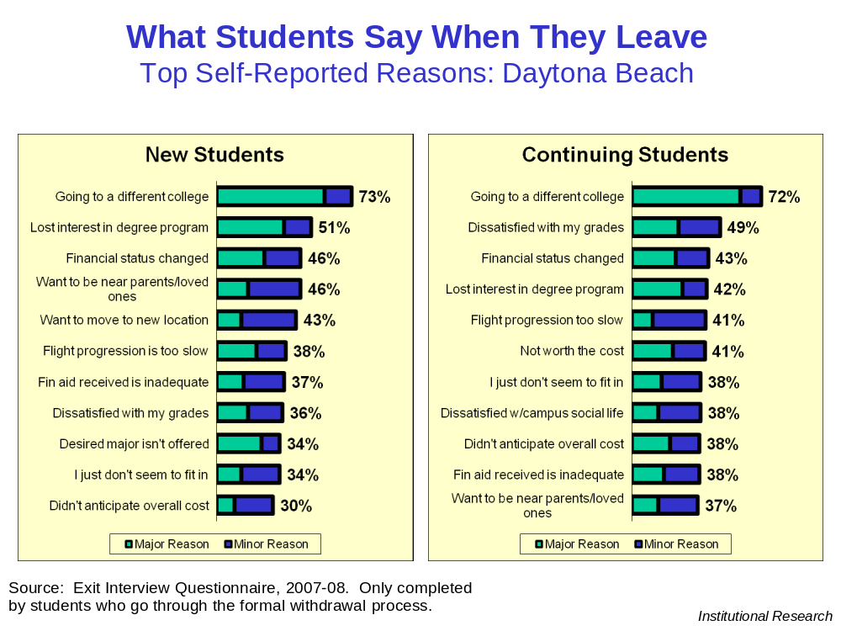
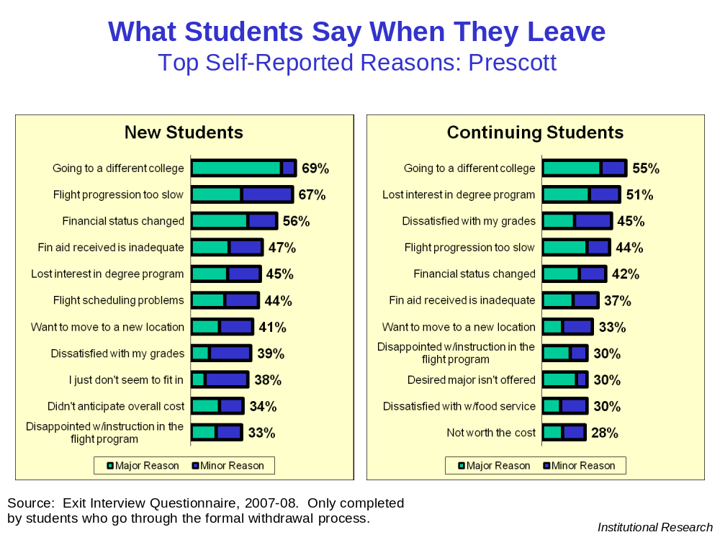
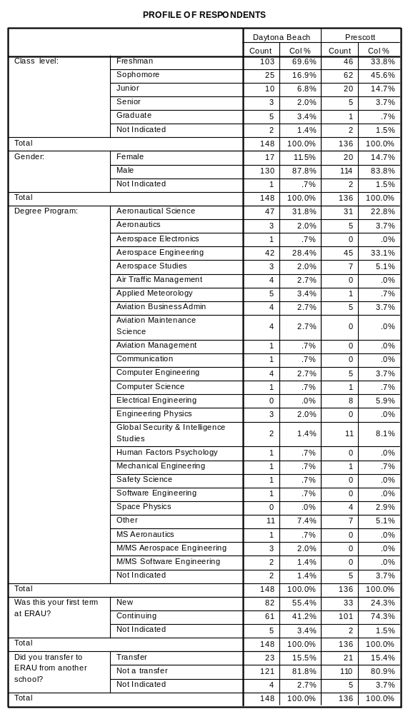

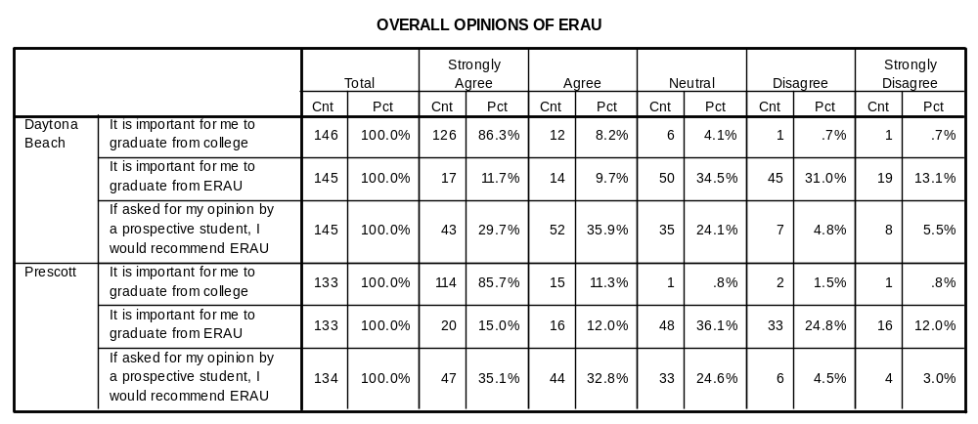

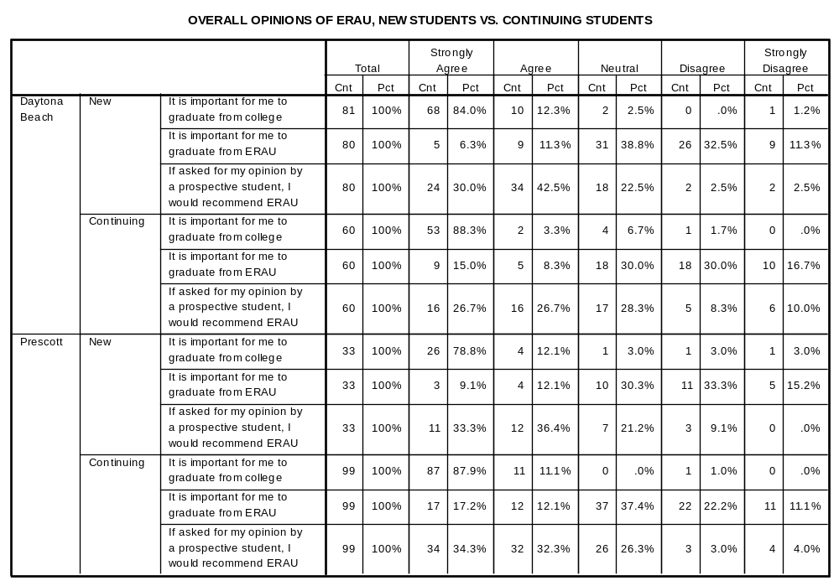

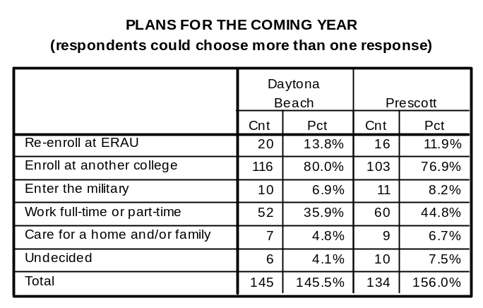

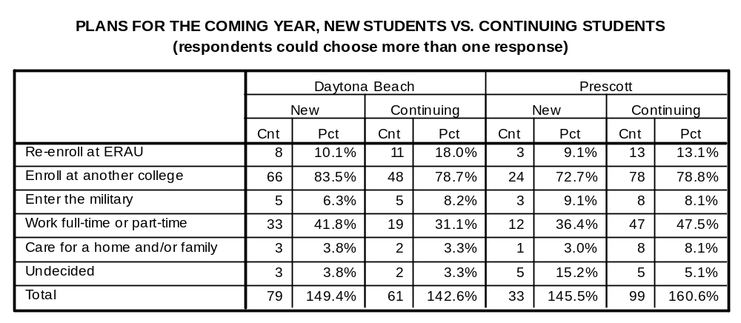

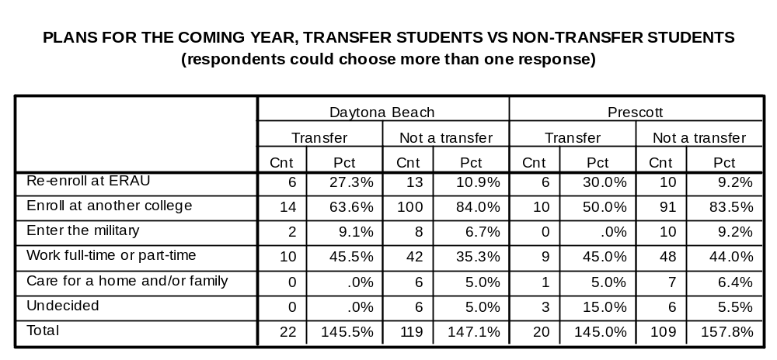

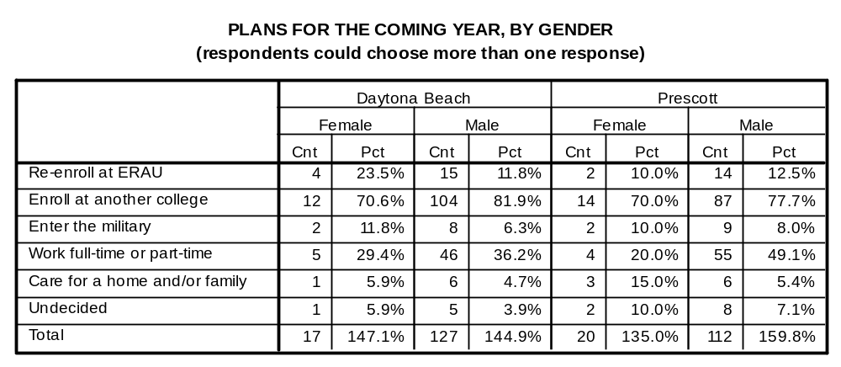

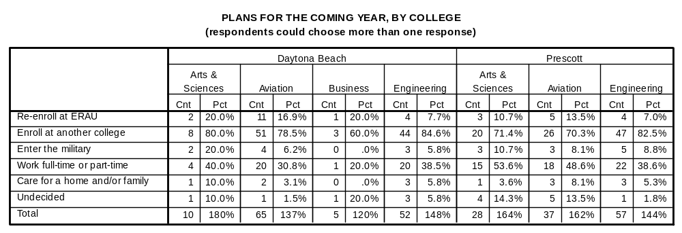

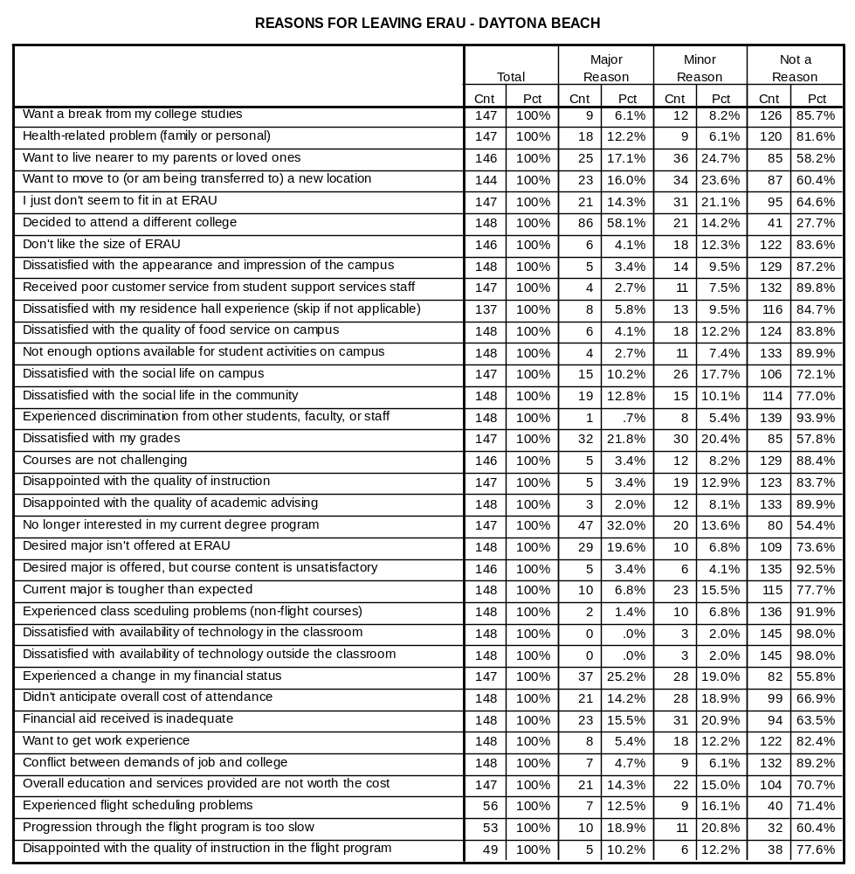

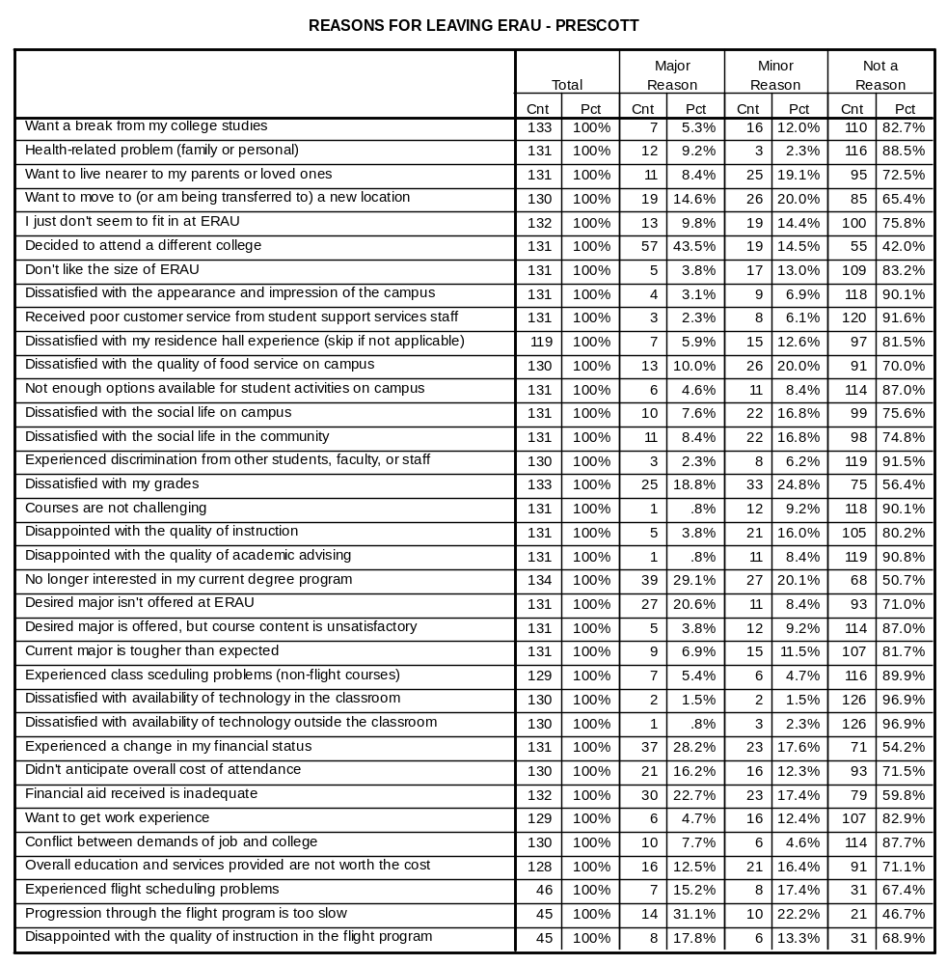

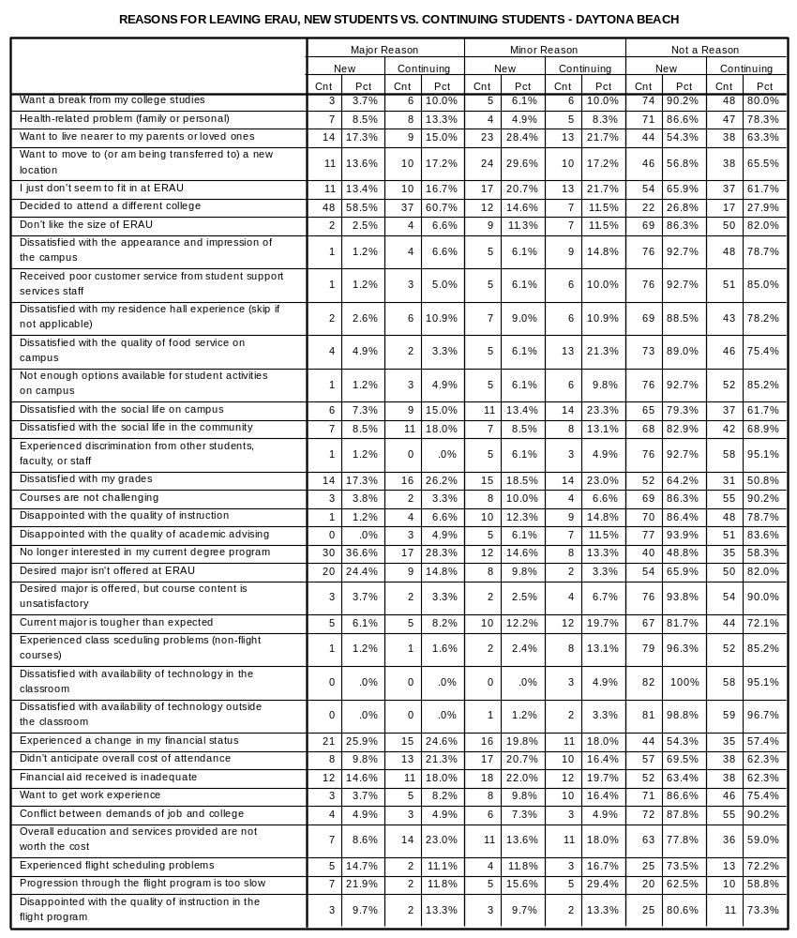

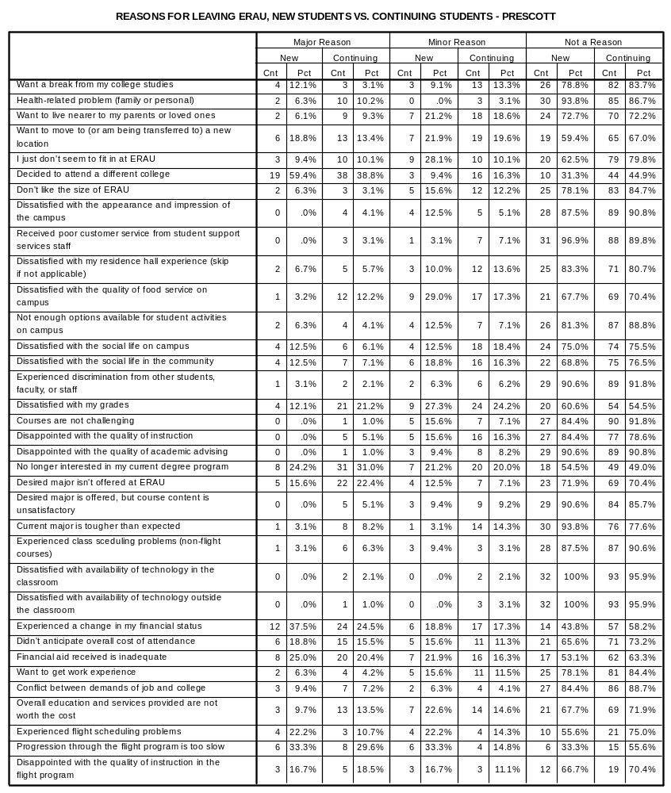

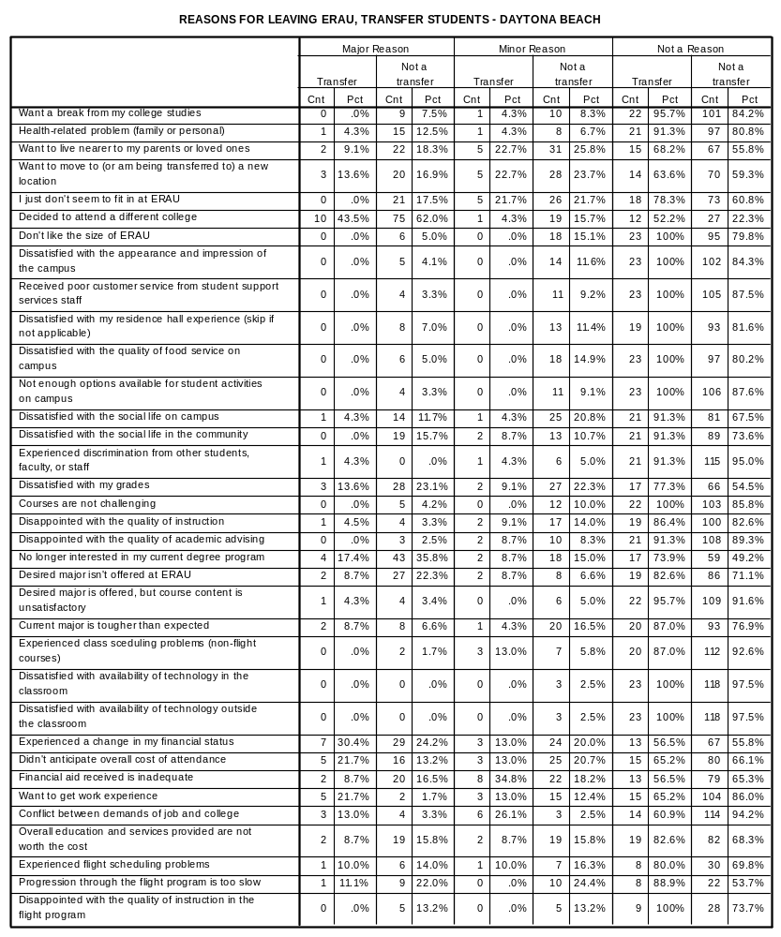

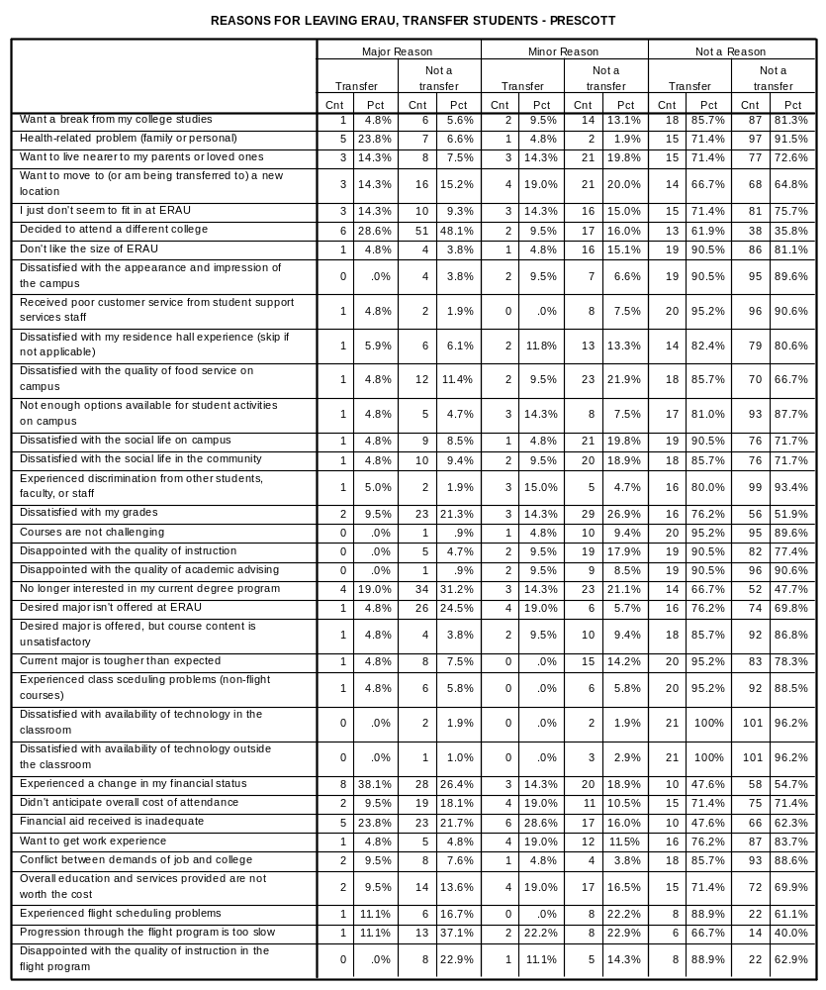

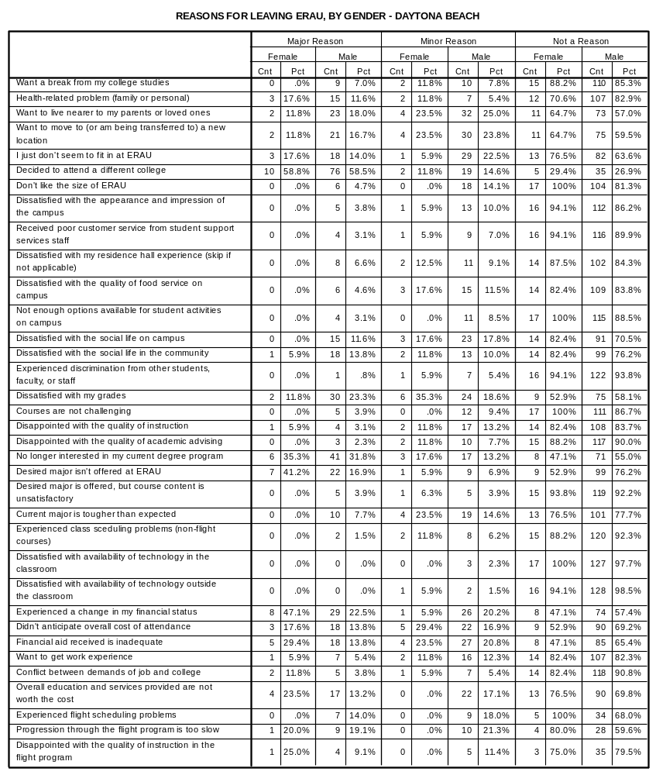

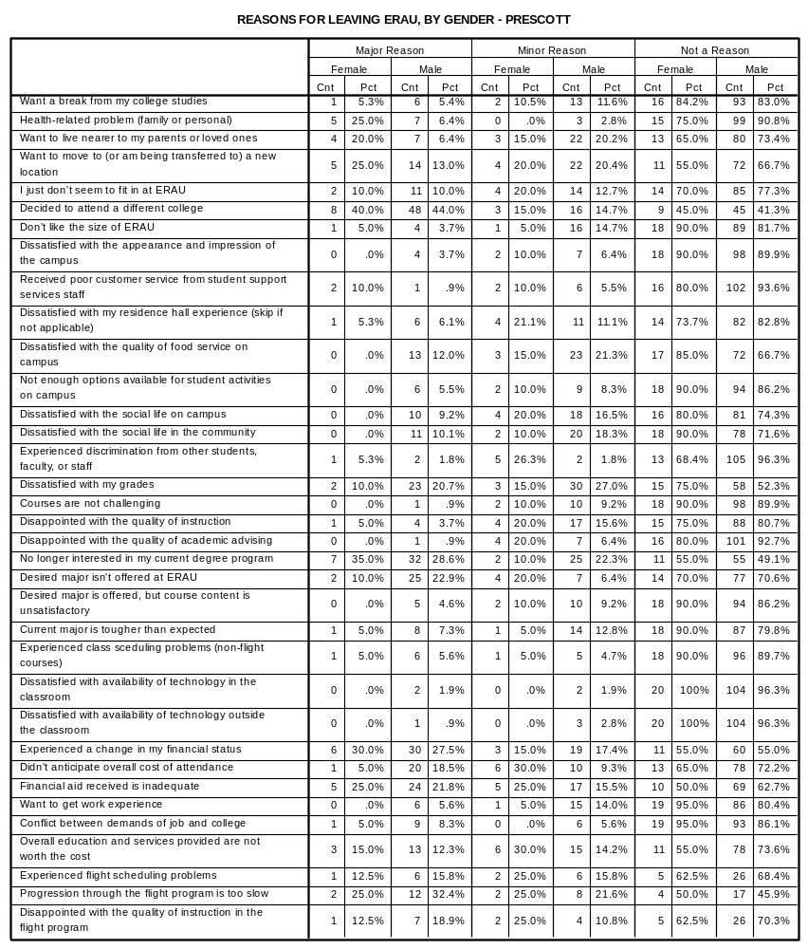

OPEN-ENDED COMMENTS – DAYTONA BEACH

New
- I really liked ERAU a lot. I am very proud to have had the ability to attend this school. Unfortunately, I was not doing a good enough job to get good grad
- Financial Reasons
- It is too much money to complete GE courses here. I have a 100% scholarship to attend a community college. I will come back to ERAU.
- Just bad study habits
- very easy course; no challenge. nothing to do.
- I've come to the realization that engineering isn't my passion and that I wasn't here at Riddle for the right reasons.
- Change in major, not offered here.
- Want to be closer to home and pursue a different degree.
- Not doing what my heart desires and it is expensive now and later.
- It took a little college to open my eyes and realize I'm not sure if this is what I want to do with my life. Want to take some time to explore myself.
- Really homesick.
- Finances aren't there to support cost.
- I am unable to pay tuition required from ERAU without supposrt from ROTC: Army
- I am an exchange student so I go back to my country to resume my engineering school program there.
- No teaching assistanship
- Due to financial status and courses.
- Tuition fees should be lowered.
- As my background in Bachelor's is mechanical and I have got 6 pre for which I cannot pay and my grades are not satisfactory

Continuing
- I like the campus & would love to graduate here, bbut the cost is too much right now.
- Attending another college.
- Tuition/ loans
- My flight medical is being recieved so it doesn't make much sense to stay for right now if I can't fly.
- Change of educational interests
- Airsickness, ERAU Flight Program will no longer let me fly (safety & finances)
- Expectation high, delivery very low. Cost of education is far too high compared to amount of financial aid given to students.
- I want to improve my GPA to receive good academic standing with ERAU
- I couldn't get a loan because NO ONE would co-sign for me. I will become a professional pilot regardless of the weather!
- Multiple personal obligations out of state & minor money problems
- Got sick and cannot make up sufficiently to get the grades I need and want as well as having personal problems.
- I found the school completely satisfying. The only problem I had was my financial situation.
- Got sick and behind. Cannot make-up sufficiently to get the grades I need and want as well as having personal family problems.
- Extreme family problems
- The amount I pay for tuition is not equivalent to the quality of instruction. I would see myself paying a lot less to recieve a better education from a com
- I hope you all get rich off the other dumb kids who pay your outlandish prices.
- coop plans changed I will return for classes

OPEN-ENDED COMMENTS – PRESCOTT

New
- Transfer to Law major.
- Going into Ministry work for Christ
- I really liked the school. My choice on my degree simply changed.
- General Ed.
- Didn't fit in well at the school. Had some social problems.
- Great school, just not where I need to be.
- MEDICAL
- Would love to stay if not for financial difficulties!
- too expensive
- Transfering to ASU

Continuing
- Do not have a well defined goal for life. Do not know what I want to do and thus do not want to pay ERAU's tuition while finding out.
- Cost of school. Did not meet the financial requirement
- Deployment
- Just a change in interest & degree program.
- I'm taking some courses @ a different college then transfer back
- Financial aid department needs to care about individual students. More GSIS Proffs.
- too expensive
- Change of degree
- I'm going on a mission for 2 yrs, and plan on coming back to ERAU
- having a child
- Work
- Disappointed with number of girls
- ERAU was a good school- Faculty were great
- New desich of chartwells could have been more efficient. Should be able to loft a bed.
- I've decided to try farming for at least a year. I may have been persuaded to stay if there was a psychology major.
- Father would like me to take a break
- confusion with flight program; over a year w/o private pilot's license; bad instructors; ENJOYED FLYING UNTIL HERE
- Personal Family Reasons
- Financial status has changed, flight currency is to slow
- Couldn't afford it anymore coming back in a year
- Cost of school not worth it for degree. Also, level of instruction was not adequate in some cases.
- I'm unsure what I want to be doing, and need to regroup.
- MEDICAL/FINANCIAL
- This school has smashed all desire I had in the aerospace field. It's now a distasteful idea I don't want anything to with this horrible place.
- I transferred into Auburn who has a flight program, a better and nationally ranked business program. Cheaper and has a greater social atmosphere.
- Going to NAV.
- CANNOT AFFORD TO STAY HERE RIGHT NOW
- Financial Aid & Bursar's Office not cooperative with withdrawal process. Recieved unfriendly & threatening letters. Even after explaining circumstances.
- THE RIDDLE RUNAROUND.

