Students who visit the Student Success Center as part of their withdrawal process are asked to complete an Exit Interview. Results are presented below. Please note that respondents are those who have taken the initiative to inform the University that they are leaving. Students who stop-out or simply bypass the withdrawal process are not represented here.

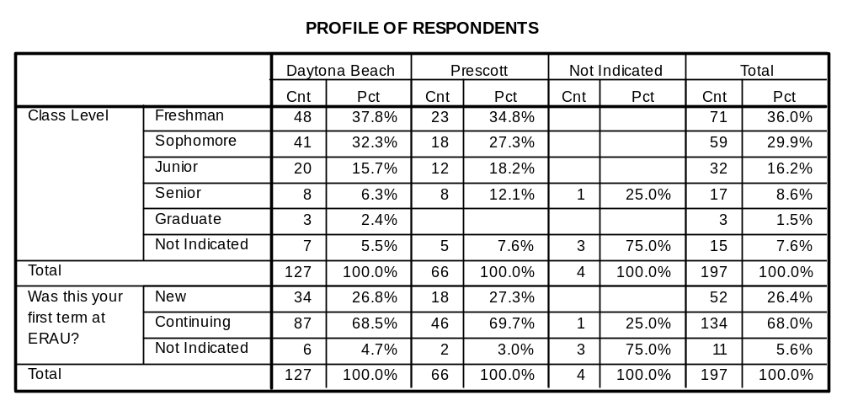
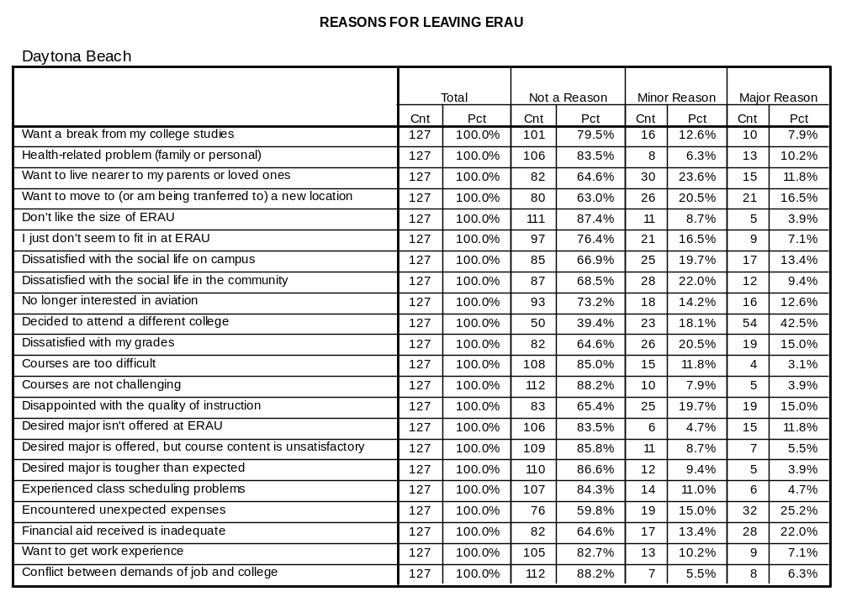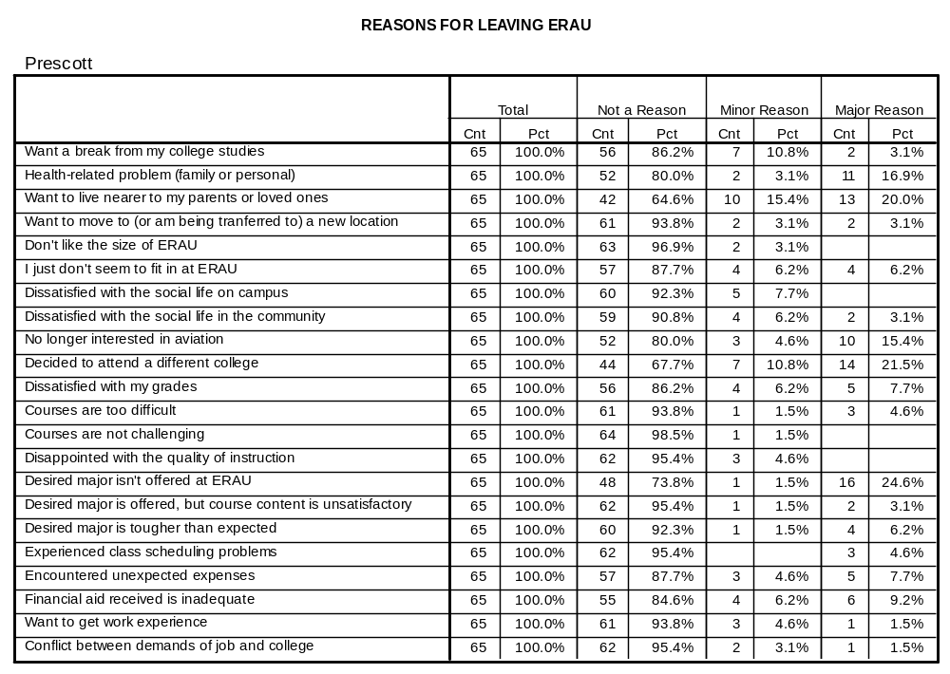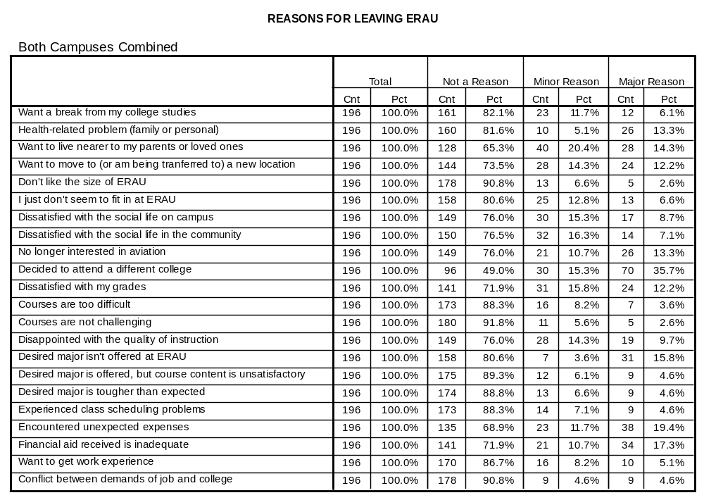
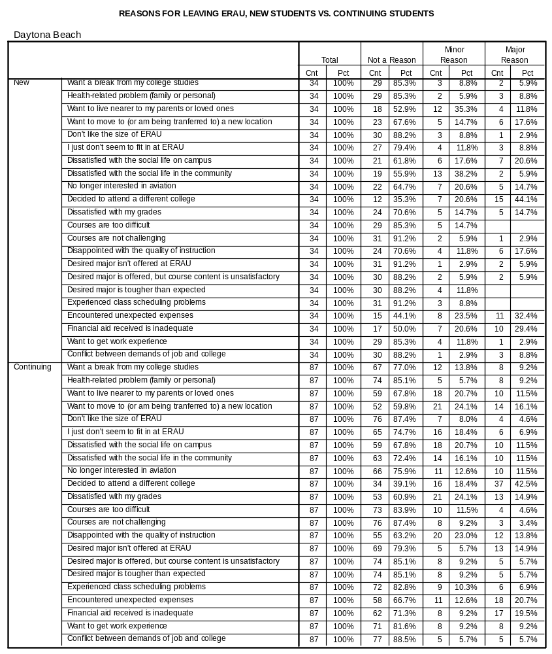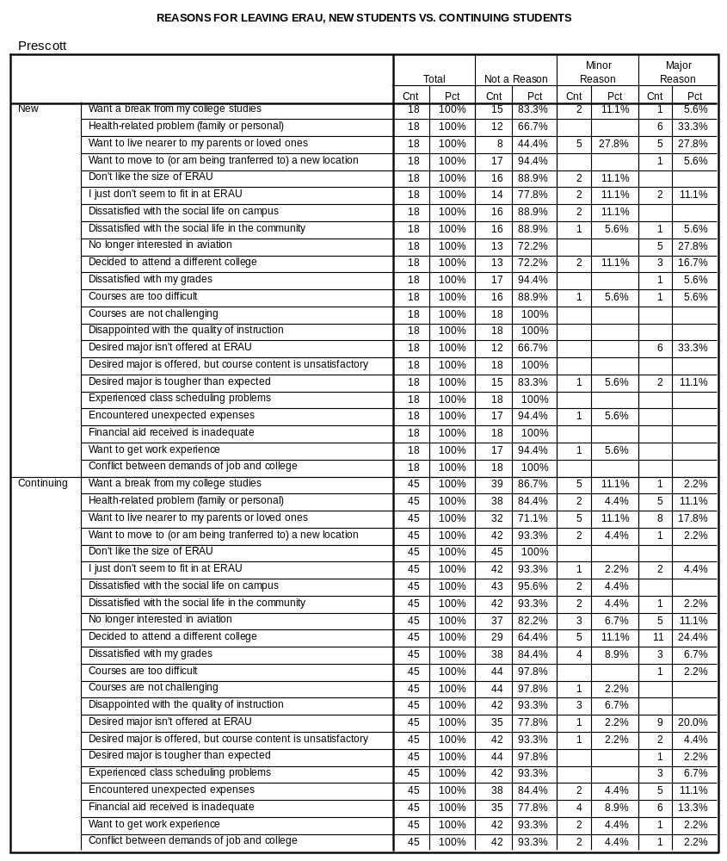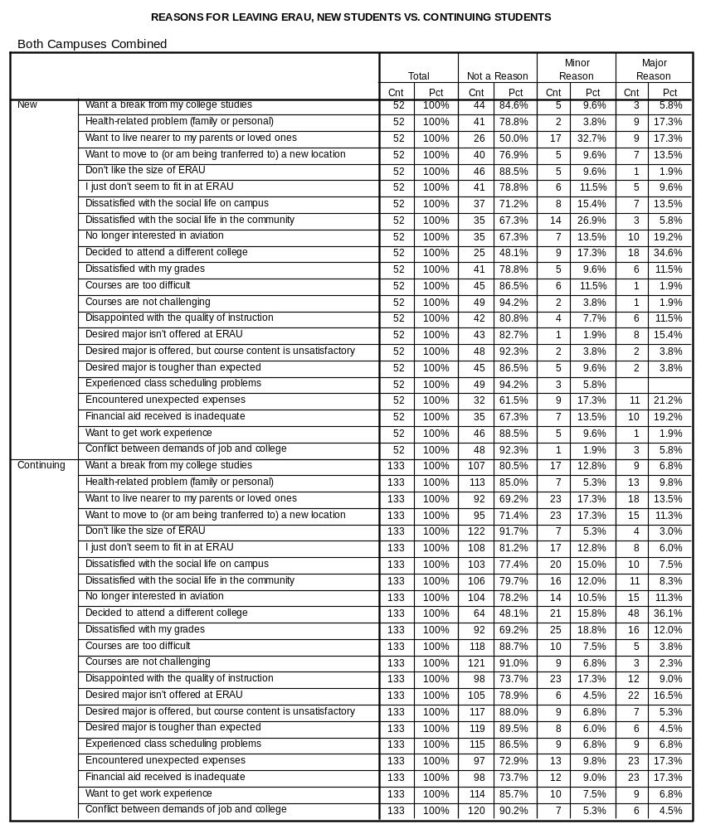
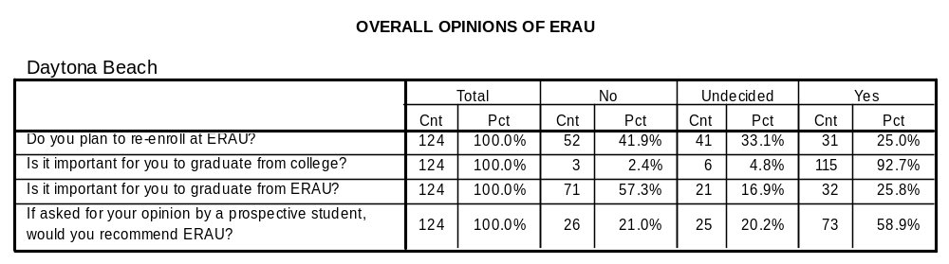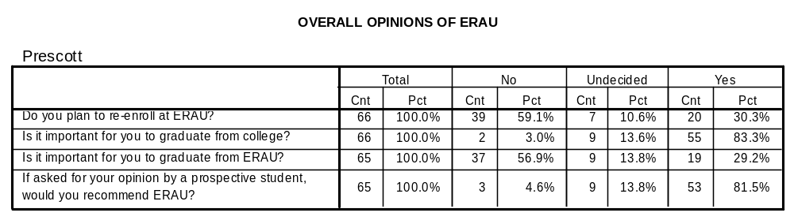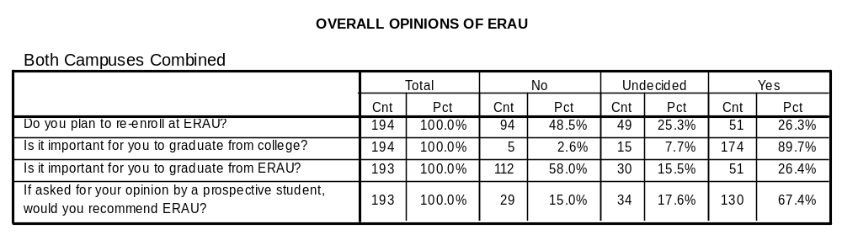
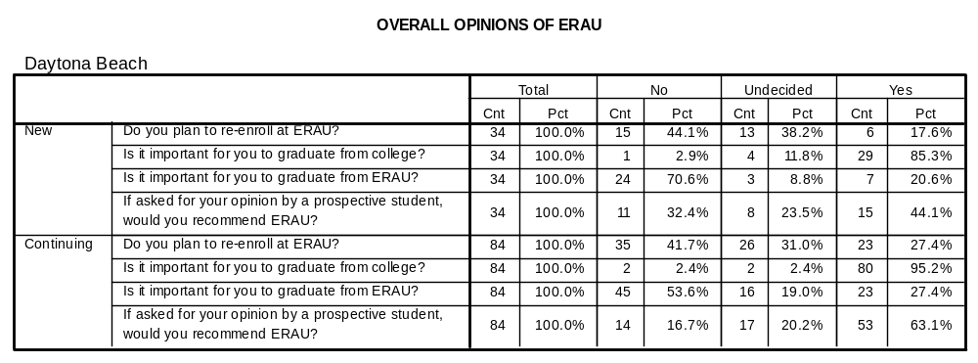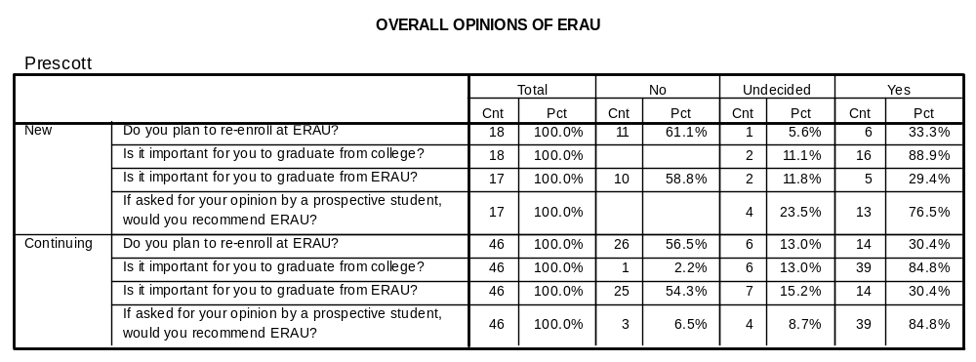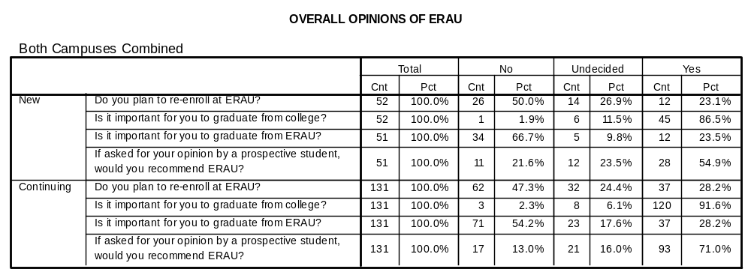
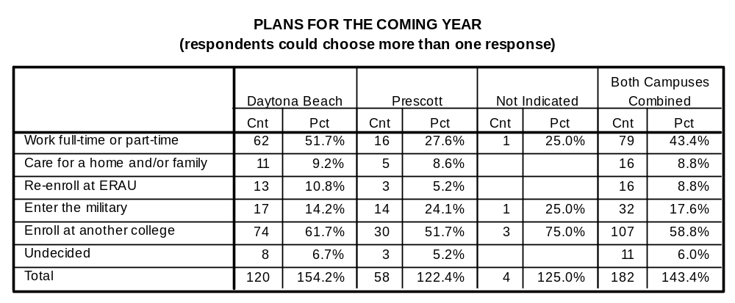
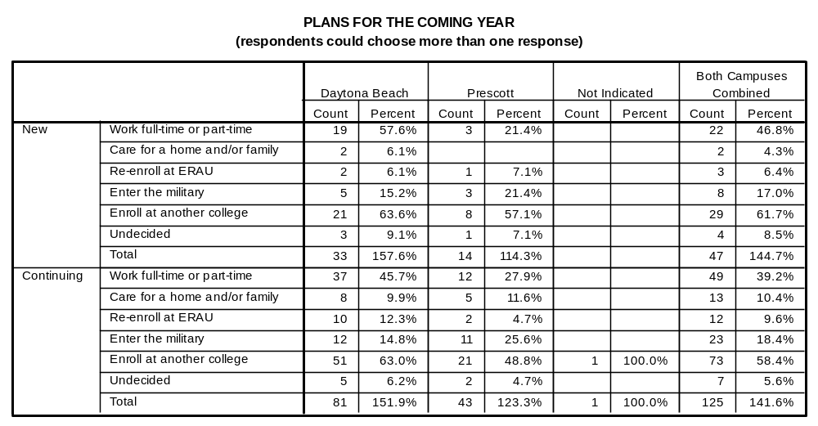

OPEN-ENDED COMMENTS – DAYTONA BEACH CAMPUS

Freshman

It was too expensive for me in particular because I had no assistance from the government or my parents.

Medical problems and having medical treatment.

Because of health problem.

Financial unstability and I am not as interested in degree program I was in.

Just could not afford the tuition.

I am too much of a slacker and need to grow up a little bit before I can sit down and study.

Diagnosed with diabetes. Inadequate physician. My health deteriorating and I am losing the ability to do the homework in my remaining two uncredited classes. I must get my health straightened first, then I can resume my studies.

Flight was disorganized and needs a major scheduling and management overhaul. Cost not competitive with other options.

The main reason is I'm changing my major. Second there aren't enough girls here.

Doesn't know if he's coming back.

ERAU, as a school, is a great place; however, I prefer a location that is closer to home. I also did not enjoy the city-like area. Upon my arrival at ERAU, I wanted to work for NASA. Now that I have realized my unhappiness with the south, I know that working for NASA would require me to reside in a place where I would rather not reside.

Good school but I've been out of school for to long. I'm having a hard time making ends meet financially. Working has taken a toll on my grades. I have a really difficult time learning from a textbook. I'm a lot better at figuring things out on the job.

Too much $. Everybody hates Arts and Humanities. Well almost everybody. And that sucks.

I just don't like this school. It's too expensive for the level of quality.

Flying no fun, me like to go vroom-vroom in car more.

This college is ideal for American students on scholarships. But not necessarily for International students.

Changes in policy for flight program, specifically in finance, remained unannounced until the last minute. Notified at the last minute I would not be flying this semester.

Financial problems is the major reason behind my withdrawal from the school. I am going to be enrolling for fall of this year.

I cannot afford to go to this school.

Want a new start at a bigger university!

Nothing much to say really. I enjoyed ERAU immensely and intend to return when I have improved my grades and reorganized my priorities.

The major of interest to me is not offered at Embry Riddle.

Sophomore

I found a chance of a lifetime opportunity with a company that I can be my own boss and work from home and establish residual income all while saving the environment, helping reduce cancer risk and save children and pets from being poisoned by household chemicals.

The main reason I am leaving is because to change from the major I am in to the one I want will take me about 1 1/2 to 2 years.

I have changed my mind for future goals to become a racing driver. I wanted to become a fighter pilot but my eyesight is bad. I now realize the differences between becoming a fighter pilot and an airline pilot.

Quality of instruction needs improvement.

"Reference to all students, by professors, as ""used to be"" student pilots. I haven't flown and am therefore STILL a student pilot."

I don't have scholarship anymore.

I'm leaving ERAU, because in general, I'm not happy here. The major upset, however, would have to be the general attitudes by some of the departments on campus. This would greatly need to be improved before I ever consider returning.

I have to served the military duty. In the South Korea, it is mandatory. So I decided to go back to my country, before I graduate University. After I finish my duty, I like to come back and finish my major.

Transferring

Have not found the right major.

I had a really good experience here. This is an awesome school and I highly recommend it to anyone. The reason I am leaving is that I want to teach history. Thank you

For personal reasons I have to withdraw from Spring 2000. I'll be back for summer and fall.

First off, nowhere in any literature or correspondence from ERAU was I told that flight lessons would require private loans and aren't covered my Stafford loans. I moved my entire life and belongings here to Daytona from San Diego, CA just to attend ERAU at this campus. Second, I'm 32 years old and it wasn't until I got here that my advisor told me that I might be too old to be picked by any airlines, that the commercial pilot rating still isn't enough hours to be hired by an airlines and that after spending $40-50,000 I would more than likely be a flight instructor to pick up flight hours in hopes that a major airlines would even consider hiring me at my age which would be probably 35 years old or greater when I finished school. None of this was told to me before I moved here or I would have never enrolled at ERAU. I would have stayed in San Diego and attending a school(accelerated) like Kaiser college or ITT tech. Now that I'm here I'm transferring to Kaiser College in hopes of salvaging this whole bad experience with ERAU. Not to mention wasting $5000 in financial to attend Fall '99 for nothing. I got out of the Navy in Feb '99 and planned to start a new career. I explored my options and chose to apply at ERAU and now hindsight being 20/20 I wish I'd never heard of this school. I didn't know and wasn't told that age would be a factor with the airlines or that flight lessons weren't covered under Stafford loans(that private loans had to obtained). I hope that in the future older/transfer students like myself are better informed by this school before they make a mistake like I did. Apparently the airline industry isn't interested in 30's something pilots for their companies who are just starting out.

School policy over common sense. I was placed on academic probation during fall of '99 mainly due to troubles in math(MA006) I was determined to overcome the problems during fall '99. I had a 90% average going in the MA006 final exam. I had a bad day, because of school policy I failed the course. My efforts to contact the teacher(left messages, etc.) were not returned. No help from the math dept. Just recitment of school policy. No attempt was made by anyone to help solve my problem. ERAU is a machine and I am a number that does not compute. I think a more human approach to students' problems would generate good results. As for me, I have changed my goals and will pursue them another way.

Personal reasons

The flight dept. was the biggest problem. It grew way too BIG way too fast. The scheduling was little. It is very hard to learn the skills of your trade when you fly once or twice a week.

"The school is great for ""die-hard"" aviation enthusiast, but lacks the broad curriculum that most major universities offer. The degree programs are set up solely for you to finish at Riddle in 1 degree program and offer little flexibility between degrees."

Junior

"Financial aid office should consider helping students get financial aid instead of telling them "There's not much else we can do for you"

Level of flight instructors low. Reasons will be explained thoroughly in the exit interview.

Financial problems from family.

Personally think ERAU is too technical and a waste of money. The school does not offer you a well rounded education. They give you more technical skills rather than a broad range of liberal art courses. In addition I also feel the teachers are not that well knowledgeable in their fields.

I am dismayed by the lack of humanities courses and professors, the indifference of the flight department to students needs, and the tremendous lack of communication between Aero Sci. dept, Flight dept., and administration. I have been accepted into a scholarship program at another school which will allow me to attend for roughly 1/3 the cost of ERAU, as well as being closer to work, friends, and family.

Needs a break.

I lost my scholar ship and the ever increasing cost is more than I can afford.

Want to leave I'm done with ERAU.

Senior

Damn you and your beaurcracy! You dismissed me and expect me to fill out all this paperwork. I'm doing this as a courtesy (though I don't know why…)

It would be in ERAU's best interest to seek greater worldwide recognition/publicity.

Housing situation (non-related to ERAU). Dissatisfied with Daytona Beach, FL. Desire to move to Atlanta and can graduate ahead of schedule and cheaper.

The reason I am withdrawing is because I have completed all the classes I need in order to graduate except for a flight course. Once I complete the flight course in the next couple of weeks my time will be done here. I would like to add though, that I don't feel that very much is asked of the students. What I mean is that I don't feel it takes much effort in academics to graduate from this school and since 95% of the tests I received were multiple choice, I don't feel I was adequately challenged. As a result I worry about how many incompetent people I will be running into in the industry who share the same diploma. The reason I registered for the two classes I don't need was because of money problems earlier this summer. I needed a job but since I am not American I cannot work off campus. The only was I could work off campus was if I registered for the fall semester. It would be nice if International students had other options but since we don't we sometimes have to become creative.

OPEN-ENDED COMMENTS – PRESCOTT CAMPUS

Freshman

Unsure whether he wants to stay in aviation(be a pilot) Parents want him to go to local (state) school until he decides.

Must leave because of a medical emergency at home. Want to return

Not the college atmosphere expected. Offering too restricted to western like physical area. Want Midwest.

Since spring, interest in aviation has diminished. Need time to evaluate interest and goals before committing to a major.

Family situation which requires presence at home. Must withdraw now and hope to return to ERAU Prescott Fall 2000.

Couldn't adjust to the physical environment. Was ill all year. Will go to a local school for a year or two and then transfer to Daytona Beach.

Pleased with the school but want a different profession. Can't think of anything to change except humanities courses a little weak. One instructor lets students run the course too much

Personal issues all semester. Back and forth home. Although involved in sorority was not enough to keep motivated in school.

Stop-out one semester. Attend community college at home to pick up Gen-Ed courses. Needs to reduce costs of college. Will return FA 2000.

"Want to be a state trooper in NJ. Not a good recruiting "fit".

Loves the school, but has decided on a different major.

Doesn't want engineering. Not sure what want. Pleased with school except for maintenance and cleanliness of residence halls. There was a problem with one instructor but that was taken care of.

When he came he was wavering between two degree programs. Tried the one; now knows he wants the other. Please with education - particularly the faculty.

Did not start flying until Nov. 99 and is afraid he will not be able to finish in spring 2000. Does not want to get behind in credits and out of sync with his class. Disappointed that he could not do what he came here to do.

Want to stay at home.

Not happy here. Not happy with any aspect of the university.

Grades have been terrible. Great school, but need to mature before attending college. Will change major from AE to flight. Only positive things to say about school.

"Doing very poorly. No longer interested in engineering. Instruction here good. Unhappy with housing. Felt their suite was ""targeted"". He came in their room without knocking."

Came for wrestling. Desired major not offered. Completed one term.

Had academic difficulties. Curriculum good. Some faculty members need attitude adjustments. Had personality conflicts with most professors. Will attend a school that is not as demanding

Having personal problems several problems developed recently that must be addressed. Although doing well, unsure how interested in aviation. Likes small classes and quality of education.

Diagnosed with rare terminal cancer. Not a good prognosis.

No longer enjoy flying. Not a fit here. It is a good place for the night people.

Sophomore

Had personal problems last year. Thought of changing to a different school would solve them. Now realizes need to drop out and concentrate on problem.

Lack of pre-requisites and experience for upper level division CS courses. Working with VA counselors to take courses at community college to acquire pre-reqs and the re-apply at ERAU.

Going to major in business and is enrolling at a college near home so he can work in the family business.

Lot from DB FA99. Personal issues interfering with academics. Not on track academically. Not focused on school.

Will attend local C.C. to work on gen ed. Requirements. Chemistry cancelled for SP 2000. Need for STG. Car totaled in fall. Need to be home to obtain new(used) vehicle.

Victim of Physical attack while attending conference. Not assaulted, however, needs break in studies temporarily.

No longer interested in aviation. Will major in elementary education at another private schools. Extremely pleased with faculty - loved all of my classes. Not happy with some of staff- library or freshman advisors- they weren't always helpful.

Tried CE after AS. Not committed to studies. Had difficulty adjusting to community(Prescott). Had many close friends on campus.

Doesn't want to fly professionally. Wants to major in business. Wants a school with a wider focus.

Must step out for a term in order to work. Don't have the money to pay tuition. Pleased with the school and education.

Transferring ROTC scholarships to NAU. Changing major to criminal justice. Will go into military police with future aspirations with US Marshal or Texas Rangers

Traumatic brain injury victim not fully recovered. Will attend a community college. Can no longer consider flight as an option.

Was not allowed to live off campus, even though he would be married by the beginning of fall semester. Could not resolve this issue. Study habits also adversely affected by living in dorms. Grades were suffering.

Had illness that caused me to get off to bad start. Have strong desire to graduate from ERAU.

Want a temporary break from college studies. May transfer to ASU, still in Electrical Engineering. Feeling pressure w/ ROTC and school. Not managing time effectively.

Junior

Always wanted a field that isn't offered here, but didn’t want to disappoint father. Love the close contact with faculty. All the help available from faculty and tutors. Would stay if had desired major here.

Want to work and save up money so he won't have such high debt load when he graduates.

Student has decided to become a missionary rather than a pilot.

Going to work at O'Hare and continue extended campus classes. Will return fall 2000.

Is having financial difficulty. Have personal debts to pay off. Will return. Pleased with school especially faculty.

Want to be near fiancée. Pleased with the education especially the faculty.

Can't afford to stay. Not happy with flight program here. Would not recommend the flight at ERAU. Had attended both campuses. Is not doing well.

Family is returning to Korea and he needs to join them.

Must take care urgent family business that must be resolved this fall.

Stop-out Return SP2000 Mother diagnosed with breast cancer. Has made several trips home this semester, and feels she needs to be there now. Will change majors upon returning AE to ATG and seek academic assistance from SSC.

Unhappy with CS program - too hardware oriented. Sisters and high school friends attend NAU. Think ERAU programs are good except CE and CS - too many changes in program and philosophy. Transferring to NAU in Spring 2000.

Senior

Need to work and take care of family this semester and prepare for re-enroll in Spring 2000.

Financial advisor was no help first year. He didn't receive 1st semester money until second semester. Has family issues to deal with and then is going to get golf course management degree in California.

Loves the school, most people very helpful. Especially pleased with faculty. Can't afford the tuition. Am joining the military. Will finish at EC.

"Very serious financial problems. "ERAU is the best thing that has happened to me "

Must care for a family member. Plan to return.

No longer desire engineering degree. Would have to wait until spring '01 to complete required design course. Will attend Univ. of Arizona for accounting. ERAU makes it too difficult to finish in 4 yrs. was not informed that FA 109 could take just 6 weeks. So loan was not ready when needed sooner. Financial Aid was not helpful.

Not motivated to return to academics following traffic accident at beginning of fall semester.

Lost interest in aerospace engineering and decided to follow dream of being an elementary school teacher. Stressed out due to forcing self to continue with engineering classes. Will enroll at community college and then a state university to pursue a degree in education.

