
ENROLLMENT SPRING 2009
FACT SHEET 2008-2009 Academic Year, Issue 2
Office of Institutional Research http://irweb.erau.edu Daytona Beach, FL 32114-3900 (386) 226-6225

Overall figures for unduplicated headcount (each student counted once, regardless if they are currently enrolled in both an undergraduate and graduate program) are presented in this fact sheet. The Spring 2009 undergraduate enrollment of 4,271 at Daytona Beach is a 2% increase since Spring 2008, while the undergraduate enrollment of 1,537 at Prescott is a 1.4% increase. The Daytona Beach on-campus graduate enrollment of 383 is a 20% increase since last year, while the online graduate enrollment of 69 is an increase of 21%. Prescott’s graduate enrollment of 35 is a 16.7% increase from last year. At Daytona Beach, there were 174 new undergraduates (a 5.4% decrease from last year), and at Prescott, there were 47 new undergraduates (a 7.8% decrease from last year).

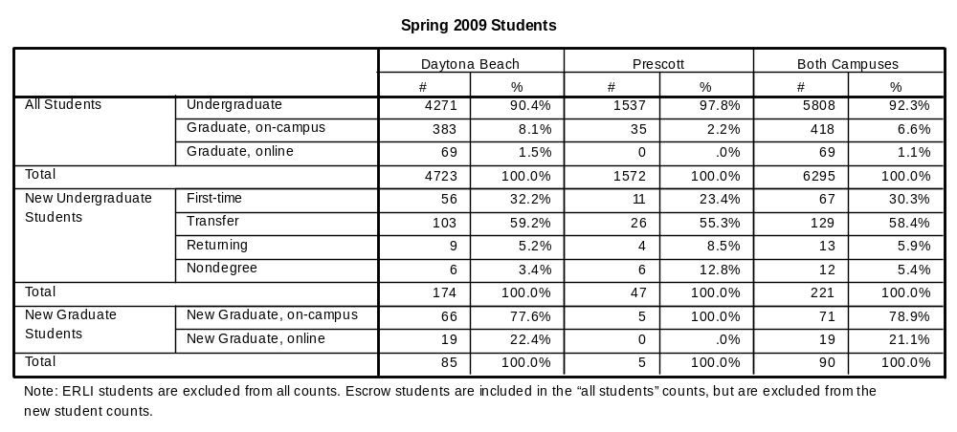

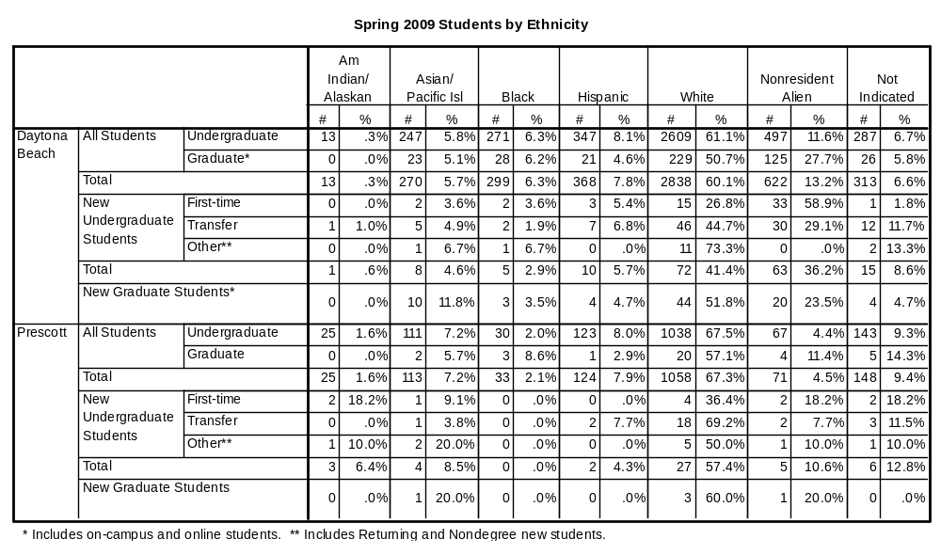

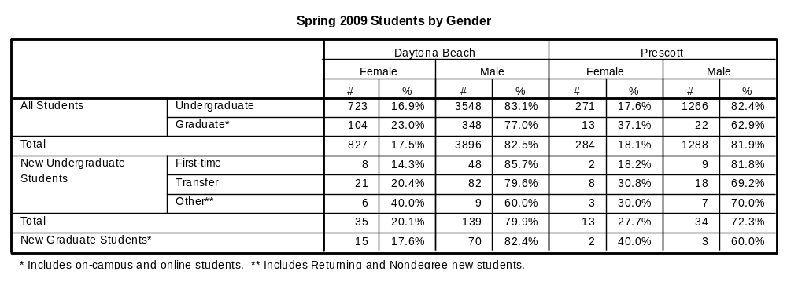

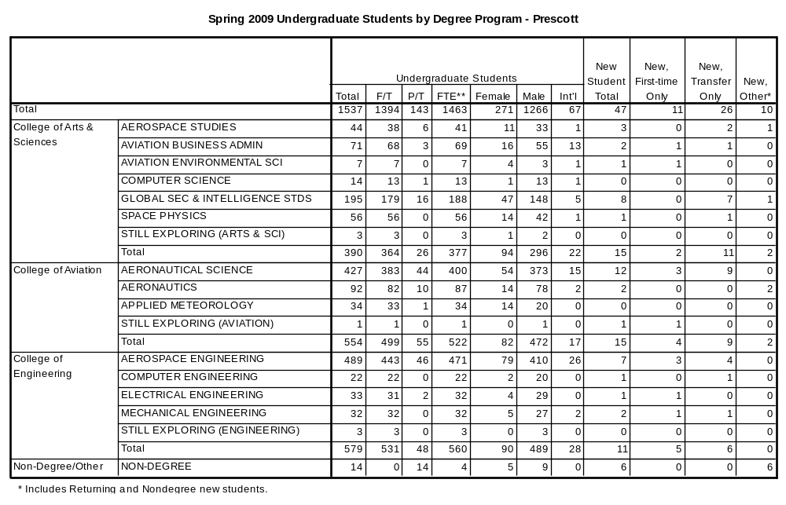

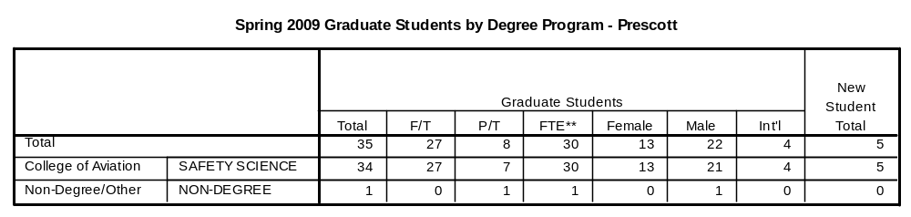

**
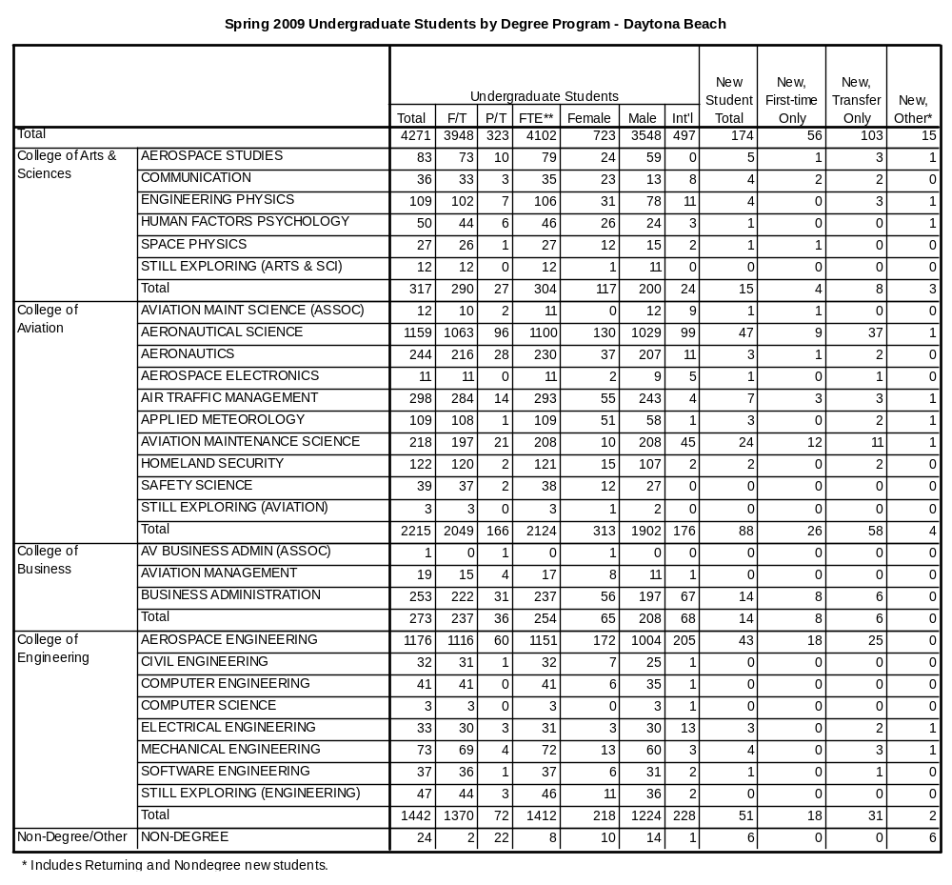

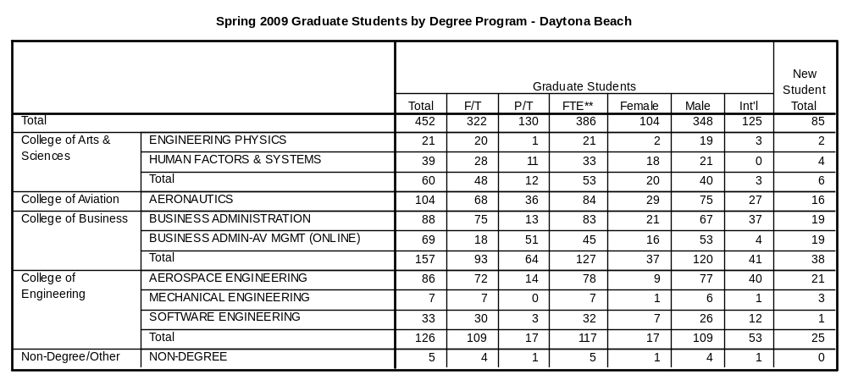

The remaining tables describe first-time college students only.

